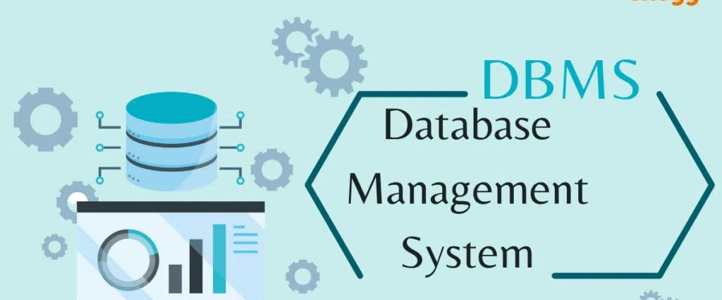

**Acropolis Institute of Technology and Research, Indore(M.P. )**

**Name - Riya Dubey**

**Enrollment No.- 0827CY221052**

**Subject - DBMS (CY-405)**

**Semester – 4th(2nd year)**

**Submitted To:- Submitted By:-**

**Prof. Nidhi Nigam Riya Dubey**

**(0827CY221052)**

**Index**

|  |  |  |  |  |
| --- | --- | --- | --- | --- |
| **Sr. No.** | **Experiment** | **Date of Exp.** | **Date of sub.** | **Grade** |
| 1. | To study DBMS and RDBMS, its characteristic comparisons and study of popular DB software. | 11/03/24 | 18/03/24 |  |
|  |  |  |  |  |
|  |  |  |  |  |
|  |  |  |  |  |
|  |  |  |  |  |
|  |  |  |  |  |
|  |  |  |  |  |
|  |  |  |  |  |

# Database management system (DBMS)

**DBMS allows access, operation, and manipulation of databases. It manages the data in files through manipulation like sorting, deletion, and insertion to improve, refine, and control the database. It allows tasks like defining, updating, retrieving, and administration of data**

**Defining data:** It is the modification, creation and removal of definitions, which are the base of data organisation in the database. General examples of data definition commands are create, alter, drop, truncate, comment, rename, and use.

**Data updating:** Data updating involves modifying data in a database. The "UPDATE" command for data updation comes with "SET" and "WHERE" conditions. The "SET" signifies the values, and the "WHERE" specifies the update location. You can perform these for specific single and multiple columns. However, you can skip "WHERE" to update all the rows.

**Data retrieval:** Data retrieval or selection is possible in an unambiguous database represented in a structured format. It has a "SELECT" clause, which can be further used with optional clauses such as from, order by, where, as, group by, and having. For instance, the possible combination can be "SELECT", "FROM", and "WHERE".

**Data administration:** The data administration option is used for security, integrity, conflict resolution, monitoring the performance and action of users, and recovery of information.

# Characteristics of DBMSs

The primary characteristics of a DBMS are as follows:

**Multithreading:** Error-free simultaneous usage of multiple databases

**Security:** Secures the database with limited access to users according to the requirements **Efficiency:** Strong query language

**Preservation:** Backup and recovery

**Integrity:** Better quality and reliability due to data integrity

**Self-explaining nature:** Self-definition of data

**Versatility:** Takes up any datatype

**ACID (atomicity, consistency, isolation, durability) compliant:** Adheres to crucial database properties of atomicity, consistency, isolation, and durability

# Relational database management system (RDBMS)

A RDBMS is a highly common and structured representation method. It focuses on multiple rows and columns in tables rather than files. Launched in the 1970s, it came with better productivity, innovation, efficiency, and speed than the DBMS.

It incorporates integrity rules that preserve the accuracy and accessibility of data. RDBMSs also keep physical storage structures separate from logical data structures, allowing for easier data manipulation and access.

# Characteristics of RDBMS

The primary characteristics of RDBMS are as follows:

**Accuracy:** Eliminates erroneous data duplication since data is stored only once

**Categorisation:** Data is easily categorised to filter and extract efficiently

**SQL efficiency:** SQL facilitates complex queries

**Security:** Permissions prevent unauthorised access

**Flexibility:** Data is automatically updated throughout the system when a change is made  **Automation:** Stored procedures eliminate the need for constant coding

**ACID compliant:** Adheres to crucial database properties of atomicity, consistency, isolation, and durability

**Difference between RDBMS and DBMS**

|  |  |
| --- | --- |
| **RDBMS** | **DBMS** |
| Data stored is in table format | Data stored is in the file format |
| Multiple data elements are accessible together | Individual access of data elements |
| Data in the form of a table are linked together | No connection between data |
| Normalisation is not achievable | There is normalisation |
| Support distributed database | No support for distributed database |
| Data is stored in a large amount | Data stored is a small quantity |
| Here, redundancy of data is reduced with the help of key and indexes in RDBMS | Data redundancy is common |
| RDBMS supports multiple users | DBMS supports a single user |
| It features multiple layers of security while handling data | There is only low security while handling data |
| The software and hardware requirements are higher | The software and hardware requirements are low |
| Oracle, SQL Server. | XML, Microsoft Access. |

# SQL (Structured Query Language)

**SQL is a programming language used for managing and manipulating relational databases. It is widely used in various applications, from simple web apps to complex enterprise systems, to interact with databases and perform operations such as querying, updating, and deleting data.**

1. **SQL Basics:**

SQL is used to communicate with a database. It allows you to create, update, delete, and query data.

SQL is not case-sensitive, meaning **SELECT** is the same as **select** .

SQL statements are typically executed using a database management system (DBMS) such as MySQL, PostgreSQL, SQLite, or Microsoft SQL Server.

1. **Data Types in SQL:**

**Numeric Types:** **INT** , **BIGINT** , **FLOAT** , **DOUBLE** , **DECIMAL** , etc., used for storing numeric values.

**Character/String Types:** **CHAR** , **VARCHAR** , **TEXT** , etc., used for storing character strings.

**Date and Time Types:** **DATE** , **TIME** , **DATETIME** , **TIMESTAMP** , etc., used for storing date and time values.

**Boolean Type:** **BOOLEAN** or **BOOL** , used for storing true/false values.

**Binary Types:** **BLOB** , **BINARY** , **VARBINARY** , etc., used for storing binary data.

1. **SQL Commands:**

**SELECT** : Retrieves data from a database.

**INSERT INTO** : Inserts new records into a table.

**UPDATE** : Modifies existing records in a table.

**DELETE FROM** : Deletes records from a table.

**CREATE TABLE** : Creates a new table in the database.

**ALTER TABLE** : Modifies an existing table structure.

**DROP TABLE** : Deletes a table and its data from the database.

**CREATE DATABASE** : Creates a new database.

**USE DATABASE** : Specifies the current database for use.

**GRANT** : Grants privileges to database users.

**REVOKE** : Revokes privileges from database users.

4. **SQL Constraints:**

Constraints are rules that enforce data integrity.

Common constraints include **PRIMARY KEY** , **FOREIGN KEY** , **NOT NULL** , **UNIQUE** , and **CHECK** .