- Create a table Customer (CustomerID , CustomerName, ContactNo, Address, City, PostalCode, Country) with CustomerID as PK.

CREATE TABLE Customer1 (CustomerID INT PRIMARY KEY, CustomerName VARCHAR(100) NOT NULL, ContactNo VARCHAR(15), Address VARCHAR(255), City VARCHAR(100), PostalCode VARCHAR(20), Country VARCHAR(50);
2. · Create a table Orders (OrderID, CustomerID, EmployeeID, OrderDate, ShipperID)with OrderID as PK and CustomerID, EmployeeID as FK from Customer and Employee table respectively.
CREATE TABLE Orders (OrderID INT PRIMARY KEY, CustomerID INT, EmployeeID INT, OrderDate DATE, ShipperID INT, FOREIGN KEY (CustomerID) REFERENCES Customer1(CustomerID), FOREIGN KEY (EmployeeID) REFERENCES Employee2(EmployeeID));

- Create a table Employees (EmployeeID LastName FirstName BirthDate Photo) with EmployeeID as PK.
CREATE TABLE Employee2 (EmployeeID INT PRIMARY KEY, LastName VARCHAR(50), FirstName VARCHAR(50), BirthDate DATE, Photo VARCHAR(100));

· Insert 5 tuples in each table

SELECT * FROM Customer1;
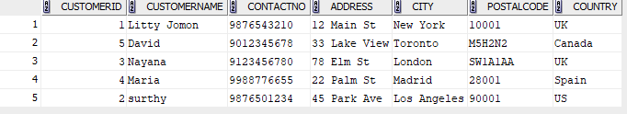
SELECT * FROM Employee2;
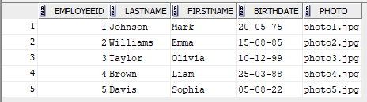
SELECT * FROM Orders;
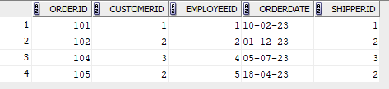
SELECT * FROM Customer1 ORDER BY CustomerName ASC;

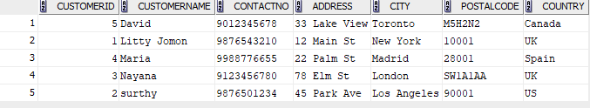
SELECT * FROM Orders ORDER BY OrderDate ASC;
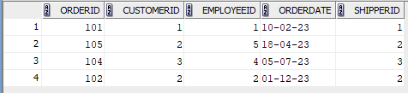
SELECT * FROM Employee2 WHERE BirthDate > '01-01-1980' ORDER BY BirthDate DESC;
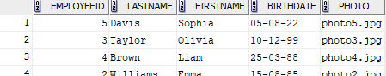
FROM Orders O JOIN Customer C ON O.CustomerID = C.CustomerID WHERE C.Country = 'USA' ORDER BY O.OrderDate DESC;
SELECT CustomerID, COUNT(OrderID) AS TotalOrders FROM Orders GROUP BY CustomerID;
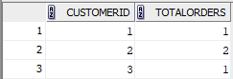
SELECT City, COUNT(CustomerID) AS TotalCustomers FROM Customer1 GROUP BY City;
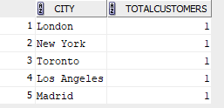
SELECT CustomerID, COUNT(OrderID) AS TotalOrders FROM Orders GROUP BY CustomerID HAVING COUNT(OrderID) > 2;
SELECT City, COUNT(CustomerID) AS TotalCustomers FROM Customer1 GROUP BY City HAVING COUNT(CustomerID) > 3;
SELECT CustomerID, COUNT(OrderID) AS TotalOrders FROM Orders GROUP BY CustomerID HAVING COUNT(OrderID) > 2

