TABLE CREATION AND VALUE INSERTION
1.Instructor
CREATE TABLE Instructor_66(instructor_ID int primary key,instructor_Name VARCHAR(40),Department VARCHAR(40);
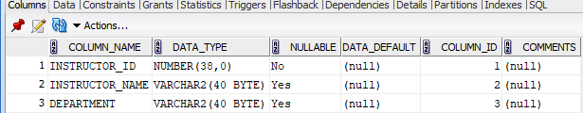

2.course
CREATE TABLE course_66(course_ID int primary key,Title VARCHAR(40) NOT NULL,Credits int check(Credits >0),Instructor_id int ,foreign key (Instructor_id) REFERENCES Instructor_66);

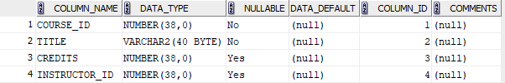

3.Student
CREATE TABLE student_66_(Roll_No int primary key, s_Name VARCHAR(40) NOT NULL, DOB DATE, Department VARCHAR(30));
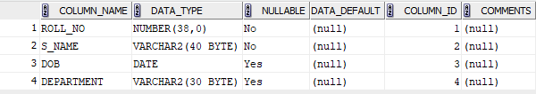

4.Enrollment
CREATE TABLE Enrollment_ (Roll_No int ,Course_id int, Grade CHAR(2), primary key(Roll_No, Course_id) ,foreign key(Roll_No) REFERENCES Student_66_(Roll_No) ON DELETE CASCADE,foreign key(course_id) REFERENCES Course_66(Course_id) ON DELETE CASCADE );
