Marwadi University
Faculty of Computer Applications

BCA 4E Python Mid-1 Exam

Enrollment No. : 92520527001
Name : Riya Ramani
Class : 4-E
Date : 12-3-26

Answer – 1
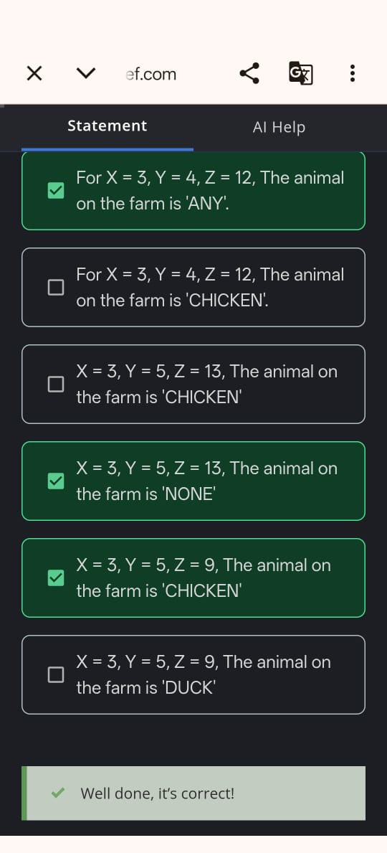
Answer – 2
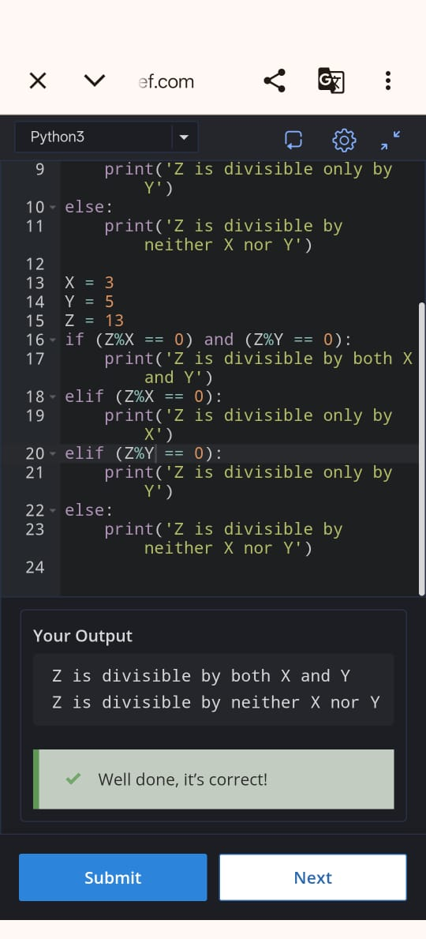
Answer – 3
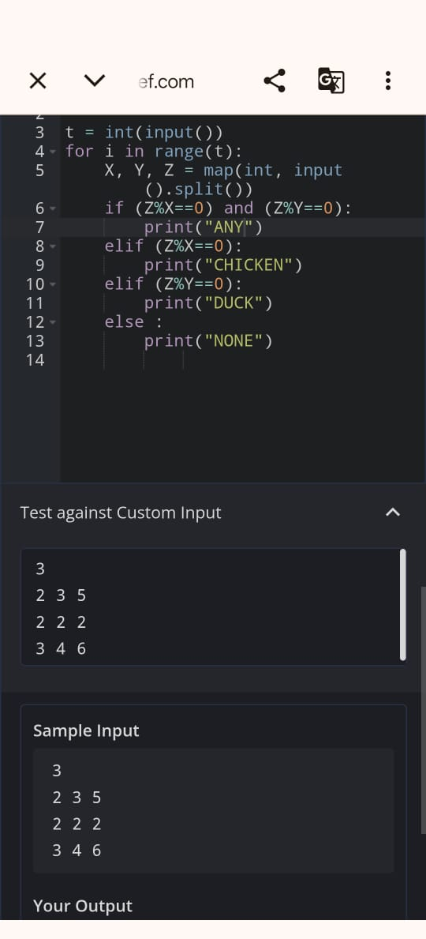
Answer – 4
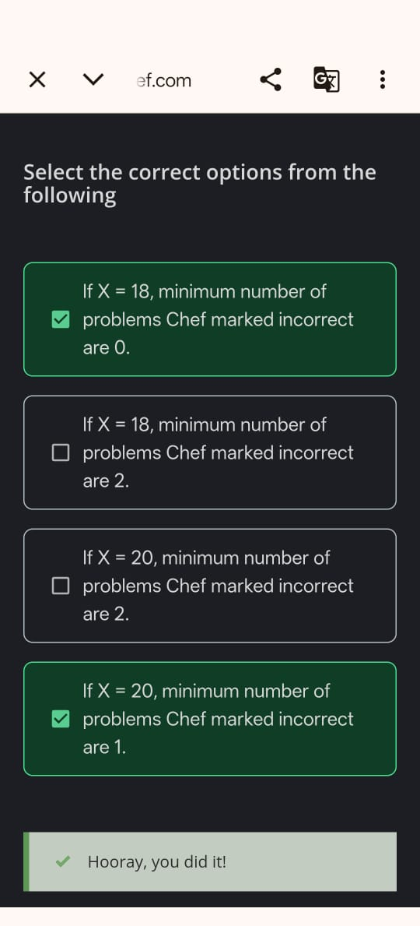
Answer – 5
