Marwadi University
Faculty of Computer Applications

BCA 4E Python TW Exam
SET - 1 or 2
Enrollment No. : 92520527001
Name : Riya Ramani
Class : BCA 4E
Date : 3rd April, 2026

Answer – 1
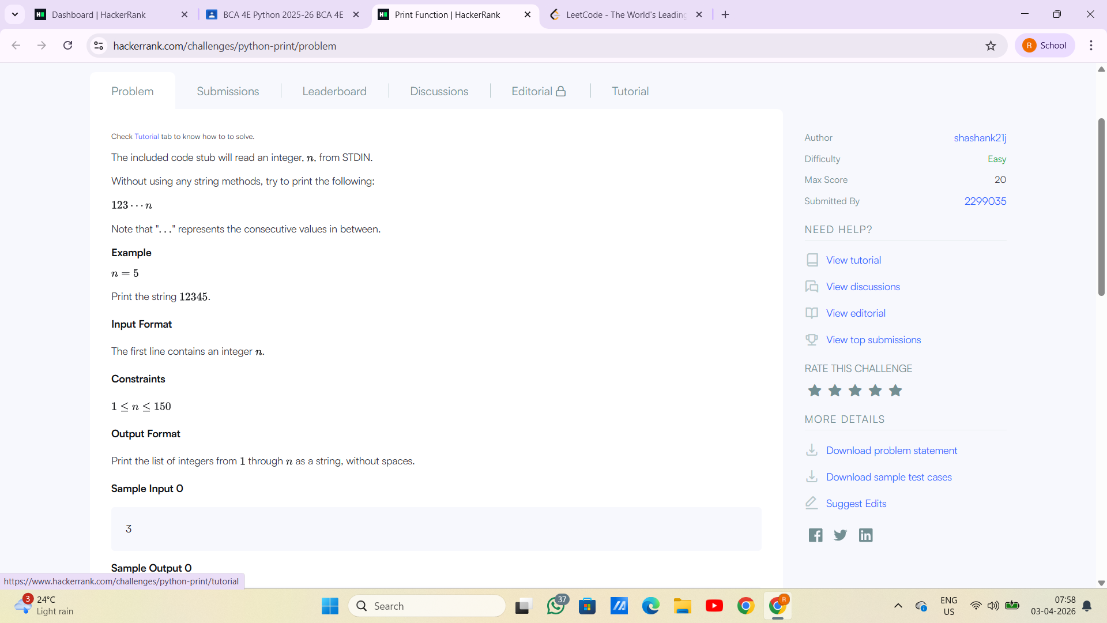

Answer – 2
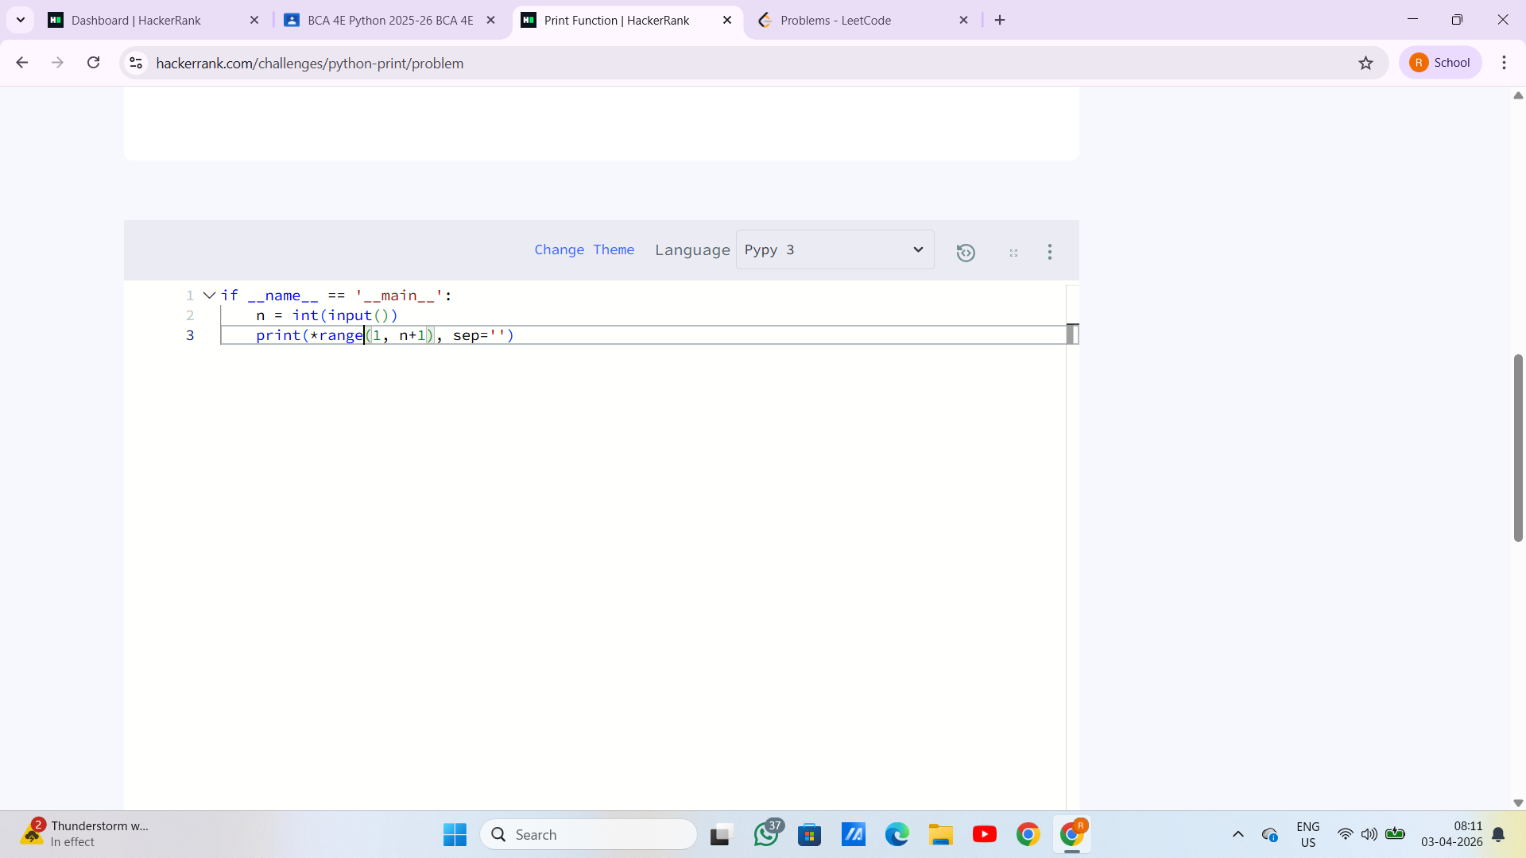
Answer – 3
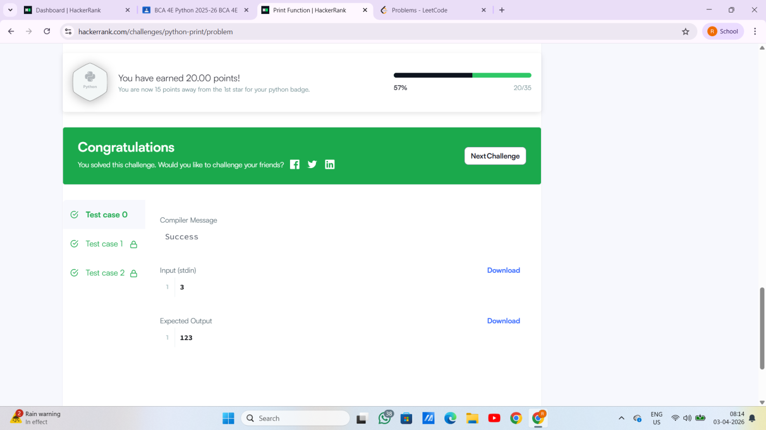
Answer – 4

Answer - 5

