SYSC 2310 L2E

Riya Arora (101190033)

September 21st, 2021

**Screenshot 1: Circuit #1 with corresponding logging file screenshot**

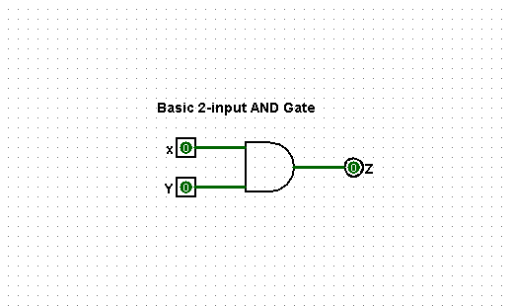

**Screenshot 2: Circuit #2 with corresponding logging file screenshot**

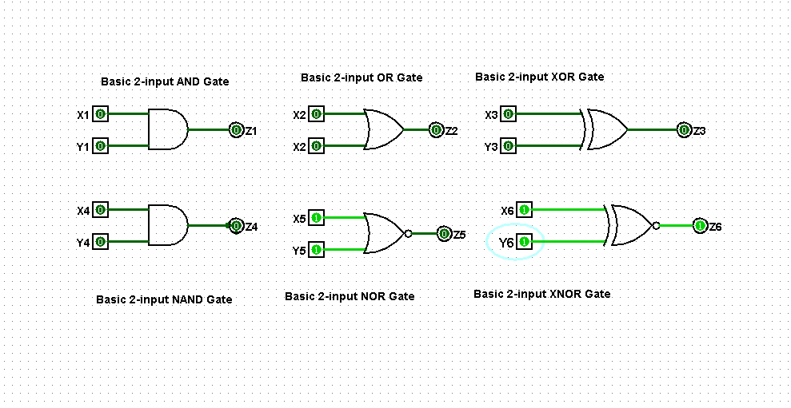

**Screenshot 3: Circuit #3 with corresponding logging file screenshot**



