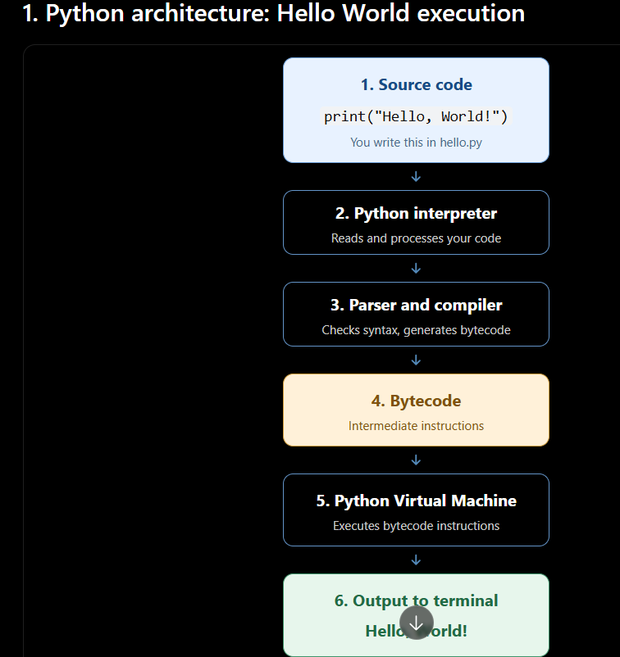

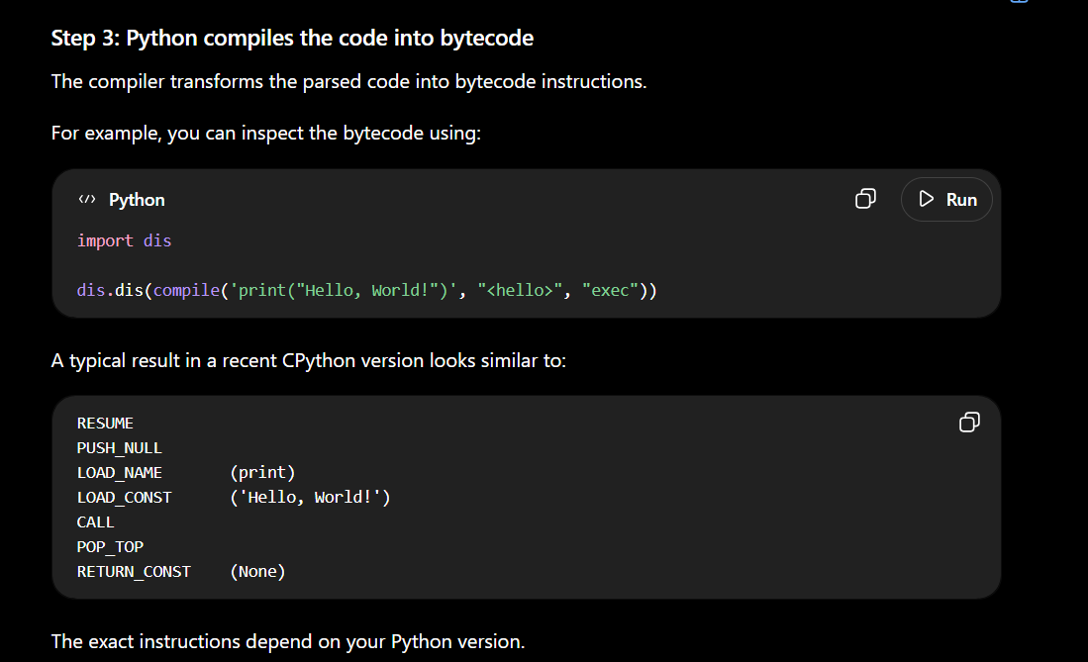
Here's what they mean:
- LOAD_NAME: Find the print function.
- LOAD_CONST: Load the string "Hello, World!".
- CALL: Call the function with the string as its argument.
- POP_TOP: Discard the function's return value.
- RETURN_CONST: Finish executing the code.

You write
↓
print("Hello World!")
↓
┌─────────────────┐
│ Python Parser │
└────────┬────────┘
↓
Syntax Check
↓
┌─────────────────┐
│ Python Compiler │
└────────┬────────┘
↓
Bytecode
(.pyc)
↓
┌─────────────────┐
│ Python Virtual │
│ Machine (PVM) │
└────────┬────────┘
↓
Execute bytecode
↓
Python objects /
operations
↓
Operating System
↓
Terminal
↓
Hello, World!

"Sure. When I write a Python program, for example print("Hello World!"), the source code first goes to the Python parser.
The parser checks whether the code follows Python's syntax rules. If there is a syntax error, Python reports it.
If the syntax is valid, the code is passed to the Python compiler, which compiles the source code into bytecode.
This bytecode can be stored in .pyc files in situations where Python caches compiled modules.
Then the Python Virtual Machine, or PVM, executes the bytecode.
During execution, Python creates and works with objects and performs the required operations. Python interacts with the underlying operating system for things such as writing output.
Finally, the output is displayed in the terminal, so in this example I would see Hello World!.
So, in simple terms, the flow is:
Python source code → Parser → Compiler → Bytecode → PVM → Execution → Output."
What is the difference between bytecode and machine code?"
You can say:
"Bytecode is an intermediate form of instructions generated from Python source code, which is executed by the Python Virtual Machine. Machine code is low-level native instructions that can be executed directly by the CPU. So, bytecode is not the same as machine code."
Python Source Code
↓
Python Compiler
↓
BYTECODE
↓
PVM
↓
Machine-level
execution
↓
CPU

