DATE STAMP ➔

**COLLEGE OF BUSINESS, LAW & GOVERNANCE**

**INDIVIDUAL TASK COVER SHEET**



|  |  |  |  |  |  |  |  |  |  |
| --- | --- | --- | --- | --- | --- | --- | --- | --- | --- |
| *Student*  *Please sign, date and attach cover sheet to front of written assessment task OR submit as a separate document for non-written assessment task.*  *A cover sheet is to be completed for each assessment task.* | | | | | | | | | |
| **SUBJECT CODE** | BX2051 | | | | | | | | |
| **SUBJECT TITLE** | **Managing People** |  | | | | | | | |
| **STUDENT FAMILY NAME** | **Student Given Name** | **JCU Student Number** | | | | | | | |
| Sen | Riya Shankar | 1 | 3 | 1 | 0 | 6 | 6 | 3 | 1 |
| **ASSESSMENT TITLE** | HUMAN RESOURCES MANAGEMENT PORTFOLIO | | | | | | | | |
| **DUE DATE** | 26/10/18 | | | | | | | | |
| **LECTURER NAME** | Jane Oorschot | | | | | | | | |
| **TUTOR NAME** | Jane Oorschot | | | | | | | | |
| **Student Declaration**     1. This assignment is my original work and no part has been copied/ reproduced from any other person’s work or from any other source, except where acknowledgement has been made (see *Learning, Teaching and Assessment Policy*   *5.1*).   1. This work has not been submitted for any other course/subject (see *Learning, Teaching and Assessment Policy 5.9*). 2. This assignment has not been written for me. 3. I hold a copy of this assignment and can produce a copy if requested. 4. This work may be used for the purposes of moderation and identifying plagiarism. 5. I give permission for a copy of this marked assignment to be retained by the College for benchmarking and course review and accreditation purposes.     Learning, Teaching and Assessment Policy 5.1. A student who submits work containing plagiarised material for assessment will be subject to the provisions of the Student Academic Misconduct Requirements.    **Note definition of plagiarism and self plagiarism in Learning, Teaching and Assessment Policy:**  **Plagiarism:** reproduction without acknowledgement of another person’s words, work or expressed thoughts from any source. The definition of words, works and thoughts includes such representations as diagrams, drawings, sketches, pictures, objects, text, lecture hand-outs, artistic works and other such expressions of ideas, but hereafter the term ‘work’ is used to embrace all of these. Plagiarism comprises not only direct copying of aspects of another person’s work but also the reproduction, even if slightly rewritten or adapted, of someone else’s ideas. In both cases, someone else’s work is presented as the student’s own. Under the Australian *Copyright Act 1968* a copyright owner can take legal action in the courts against a party who has infringed their copyright.  **Self Plagiarism:** theuse of one’s own previously assessed material being resubmitted without acknowledgement or citing of the original. | | | | | | | | | |
| **Student Signature**    **…………………………………………………… Submission date …03../…11…../..18......** | | | | | | | | | |

**HUMAN RESOURCES MANAGEMENT PORTFOLIO**

**NAME:** Riya Sen

**STUDENT ID:** 13106631

**SUBJECT:** Managing People

**SUBJECT CODE:** BX2051

**LECTURER:** Jane Oorschot

**ASSESSMENT:** Task 3- HRM Portfolio

1. **ESSAY ON JOB DESCRIPTIONS**

Sets of responsibilities are a basic piece of the enlistment of value staff, and a viable method to oversee staff execution on a progressing premise. It is basic that current and potential workers are very much educated to not just pull in the correct staff and guarantee the enlistment procedure is more effective, yet in addition to hold staff to a standard and help in execution the board.

A compelling set of working responsibilities will plot the motivation behind the position, the jobs, duties, required and wanted capabilities and encounter, and the key choice criteria used while picking an effective competitor. Having the fitting points of interest enables possibility to be educated on what they are applying for and decreases the quantity of 'ineligible competitors' that may not meet a portion of the prerequisites recorded. On the off chance that these prerequisites were not suitably expressed, a more prominent number of 'ineligible hopefuls' would apply, requiring additional applications to be investigated which causes time-wastage and wastefulness.

There are numerous utilizations for a decent quality expected set of responsibilities, starting at the simple introductory phases of enrolment and streaming on long into a representative's profession. Notwithstanding enlistment, sets of expectations can be utilized for execution the executives, preparing and worker improvement, pay, acknowledgment and prizes, discipline, come back to-work projects, and basic employment work investigation.

It is basic that organizations use succinct, precise sets of responsibilities so it is clear what the desires for each position are and representatives are generally moving in the direction of similar objectives.

Sets of expectations can be helpful apparatuses when made to an exclusive requirement. They can be utilized all through the whole pulling in, preparing and holding process as a desires benchmark for representatives. Whenever used accurately, sets of expectations can pull in the best representatives, as well as enhance the execution and improvement of said workers all through the business venture.

1. **JOB DESCRIPTION**
2. **SELECTION CRITERIA**

# Job description

| **Classification** | Nurse Grade 5 |
| --- | --- |
| **Role title** | Community Health Registered Nurse |
| **Salary** | $64292-$86316 per annum |
| **Unit/Branch** | North West Regional Hospital |
| **Location** | Various Regional Outreach Sites |

**Overview:**

NWRH (North West Regional Hospital) is the largest local hospital with 180 bed inpatient facility in Queensland. Further the organization has 15 more branches based throughout northern Australia operated by 700 staff members, with each branch headed by 17 staff members. Chairmen, medical attendants, associated staff and specialists all give a quality and moral wellbeing administration to provincial and country networks all through the state. The organization further plans to expand its locations and would be recruiting appropriate staff in the respective fields to help and cater the increasing heath issues in the respective neighbourhood.

**Job Purpose**

The motivation behind this position is to give all-encompassing consideration and proof based, experienced nursing to the general population of our different effort site networks. This will incorporate working in every aspect of crisis, inpatient, and outpatient administrations while likewise teaching provincial network individuals on methods for sound living.

**Your Role**

* Works autonomously and in addition part of a group
* Assumes obligation regarding own activities alongside the choices made when appointing to enlisted medical caretakers and collaborators
* Educating more beneficial methods for living for territorial network individuals
* Exercising proficient judgment in the clinical condition
* Developing believing associations with network individuals to empower better administration conveyance
* Exercising due consideration consistently while treating and teaching patients

**Essential Skills, qualifications, and other prerequisites:**

* **Nursing:** Arrangement to this position requires verification of capability and enrolment with the Australian Health Practitioner Regulation Agency (AHPRA) and ownership of a current rehearsing declaration. Affirmed duplicates of the required data must be given to the suitable chief/administrator preceding initiation of clinical obligations.
* **VPD** : Health care staff in Queensland Health whose occupation represents a potential danger of presentation to blood or body liquids are required to give proof of immunizations or evidence that they are not vulnerable (due to earlier introduction to the illness and consequently have regular insusceptibility) to coming up next VPD's Hepatitis B, Measles, Mumps, Rubella, Varicella and Pertussis (diphtheria, lockjaw and pertussis containing antibody) as per the Queensland Health Policy.
* **Mandatory:** Requirement of a Bachelor of Nursing Degree or any degree proportionate to the same
* **Shift Workers:** The said aide will be required to work all shifts as per the unit program, which will incorporate cooperation in an accessible if the need arises list.
* **On call:** The said aide would need to be there if called during an emergency or in a similar situation.
* **Travel:** On air travel would be essential to reach out of reach sites.
* Accommodation: The staff would be provided with accommodation in their said posting.
* **RANIP (Rural and Remote Incentive Package):** Staff who are qualified may apply for this program.

**NOTE: THESE HAVE BEEN SOURCED FROM A QUEENSLAND HEALTH JOB DESCRIPTION (Queensland Health, 2018).**

**Key Selection Criteria**

* Meet the obligatory capabilities/prerequisites (see above)
* Ability to give viable nursing care (survey, plan, actualize and assess)
* Knowledge of expert and lawful duties
* High quality relational abilities, both composed and oral
* Experience and competency utilizing suitable data frameworks
* Commitment to proficient improvement and preparing of individual staff
* Ability to successfully instruct with respect to solid living decisions

**Reference:** Queensland Health. (2018). Role Description- Registered Nurse. Retrieved from: <https://smartjobs.qld.gov.au/jobtools/b_fileupload.proc_download?in_file_id=20734071&in_servicecode=CUSTOMSEARCH&in_organid=14904&in_sessionid=0&in_hash_key=4E16F94FD8C2E7A7618D8EF0178A5ADA>

1. **RECRUITMENT ADVERTISEMENT**



**GREETINGS FROM NORTH WEST REGIONAL HOSPITAL!**

**COMMUNITY HEALTH REGISTERED NURSE**

North West Regional Hospital (NWRH) is developing! Our 15 outreach locales give all-encompassing consideration and wellbeing conveyance to territorial Northern Australia, and our aspiration is to grow our scope considerably further.

We require your assistance to develop our administration, to teach the neighbourhood networks and to enhance our wellbeing administration conveyance to those provincial territories in need. This is a full-time, energizing open door for an accomplished enrolled nurture who is proactive about expert advancement through increasing new encounters in a territorial setting.

KEY TASKS:

* Provide experienced, proof-based nursing to patients in all regions
* Maintain persistent records, both composed and/or the database,
* Communicate successfully with individual staff and patients
* Educate patients and network on solid methods for living
* Utilise sound judgment while surveying, arranging, executing and assessing nursing care

EXPERIENCE, SKILLS AND KNOWLEDGE:

* Bachelor's Degree in Nursing and experience (no less than three years)
* Registration with AHPRA, evidence of Vaccine to Preventable Diseases (VPD)
* Passionate about enhancing network wellbeing in local zones
* Professional relational abilities (with patients and staff)
* Efficient time executive abilities

If you are energized and energetic about the possibility of conveying social insurance and instructing provincial networks about enhancing their wellbeing and prosperity, at that point this is the ideal open door for you!

Contact 4265 7892 or [riya.sen@my.jcu.edu.au](mailto:riya.sen@my.jcu.edu.au) for more details. Thanks!

**6) BEHAVIOURAL INTERVIEW QUESTIONS**

**GENERAL QUESTIONS:**

* 1. What capabilities and experience do you have?
  2. Where did you grow up and how could you come to fruition needing to be an enrolled medical attendant?
  3. Do you have any close to home or expert encounters from territorial Northern Australia?
  4. Are you mindful of any issues/worries for wellbeing or generally in territorial Northern Australia? What is your opinion about these issues/concerns? How might we act to enhance the conditions?
  5. What data frameworks have you utilized already?
  6. Have you worked in a group already? If you don't mind give a few precedents
  7. Have you worked self-ruling beforehand? Kindly give a few precedents
  8. Give a case of some administration you have appeared previously
  9. How do you approach advancing your vocation? How would you guarantee you keep on learning as a medical caretaker?
  10. Do you have any intrigue or involvement in instructing about wellbeing?
  11. Name one of your qualities?
  12. Name one of your shortcomings?
  13. How might you be able to conceivably deliver your shortcoming to transform it into a quality?
  14. Why did you apply for this activity?
  15. What are your plans for what's to come?
  16. Do you know much about the North West Regional Hospital and its effort destinations?
  17. Do you have any inquiries you might want to inquire?

**7) INTERVIEW PANEL**

**HUMAN RESOURCES MANAGER**: To guarantee the right procedures are pursued, predisposition is dodged, questions are reasonable.

**DIRECTOR OF NURSING: HUMAN RESOURCES OFFICER (IN CHARGE OF ADVERTISING POSITION):** To give a depiction of the position, guarantee questions are in accordance with the position prerequisites, to have some recognition with candidate from past contact.

**TEAM-LEADER IN NURSING**: Master learning in the nursing field, to guarantee the candidate has the suitable aptitudes/strategies required. Can cross-check any information if a candidate endeavours to make false understanding/skill.

**SUPERVISOR OF SPECIFIC OUTREACH SITE**: To choose if the candidate will be a fitting fit for the region. To give a portrayal of the local/social issues that will be met by the candidate if effective.

**8) ORIENTATION AND INDUCTION:**

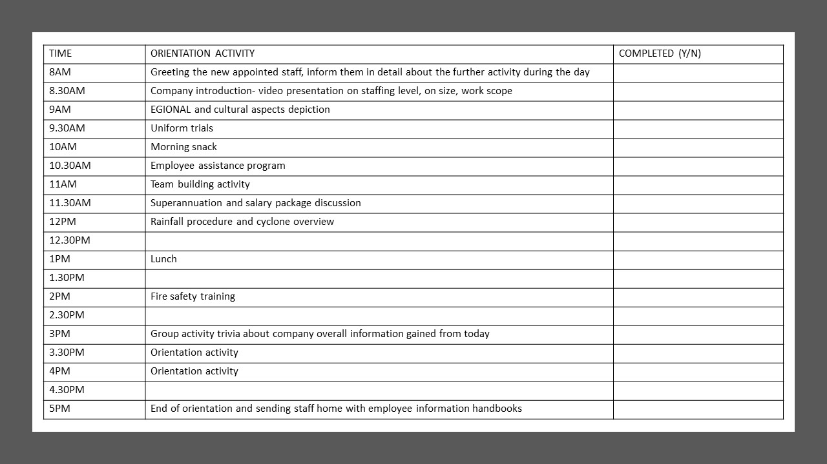

**9) HR AUDIT PROCESS:**

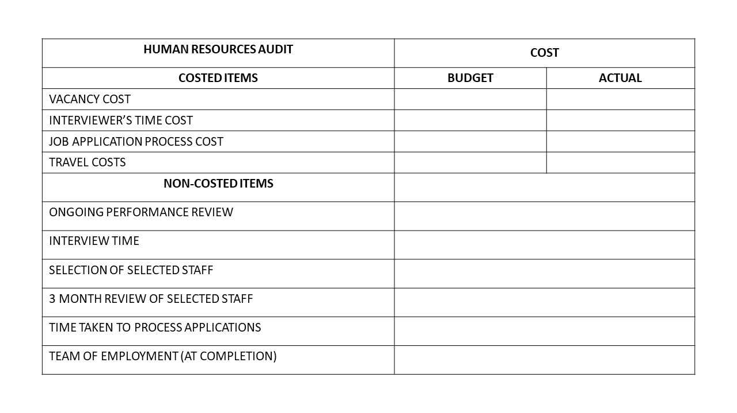

**LIST OF SOURCES**

Massad, M. (2006, July). The many uses of a job description. *Entrepreneur: Asia Pacific.* Retrieved from: <https://www.entrepreneur.com/article/159752>

Queensland Health. (2018). Role Description- Registered Nurse. Retrieved from: <https://smartjobs.qld.gov.au/jobtools/b_fileupload.proc_download?in_file_id=20734071&in_servicecode=CUSTOMSEARCH&in_organid=14904&in_sessionid=0&in_hash_key=4E16F94FD8C2E7A7618D8EF0178A5ADA>

Queensland Health. (2018). Wage Rates- Nursing Stream. Retrieved from: <https://www.health.qld.gov.au/hrpolicies/wage_rates/nursing>

The University of Texas at Austin. (2018). Selection Panel or Matrix. Retrieved from: <https://hr.utexas.edu/manager/hiring/selection-panel-matrix>

Zeiger, S. (no date). Characteristics of a job description. *Chron.* Retrieved from: <https://work.chron.com/characteristics-job-description-3774.html>