

|  |  |
| --- | --- |
| CP1402 –NETWORKING CASE STUDY | |
| NAME | RIYA SEN |
| JCU ID | 13106631 |
| SUBJECT NAME&CODE | NETWORKING, CP 1402 |
| ASSIGNMENT | Case Study |

**PART1**

INTRODUCTION:

The overview of this project id to install network devices for a company which is trying to build new offices in Australia and New Zealand, four in Australia and two in New Zealand. The Brisbane office has one web server and one database server whereas the office in Perth has three backup servers. The cities Brisbane, Auckland, Bendigo and Newcastle have WLANs respectively. The offices at Auckland and Dunedin are new offices so both the places need new routers, switches and wireless access points. The feasibility outcome for this project is to the man working for this project should be more and intelligent one’s. Total network devices used in this are 2 switches, 2 routers and 1 wireless access point. Most of the major men will be working at the Brisbane office and to do this work at Brisbane and Sydney offices it will take 30days and remaining 15days are for redesigning the network system. The main goal of this project is to achieve it within time period and provide the company with best products within the allocated budget, satisfy the company and the customer. To do this project firstly you need to subnet the Brisbane network and then work on the other parts of the project, so it may help to achieve within time period and budget.

**PART2**

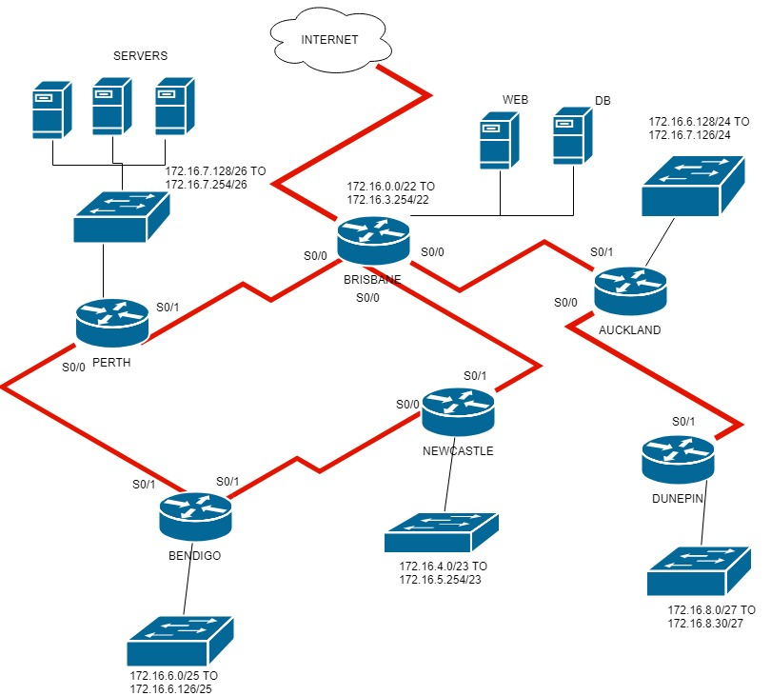

**PART3**

SUBNETS:

|  |  |
| --- | --- |
| BRISBANE |  |
| Subnet address | 172.16.0.0/22 |
| Subnet Mask | 255.255.252.0/22 |
| First useable address | 172.16.0.1/22 |
| Last useable address | 172.16.3.254/22 |
| Broadcast address | 172.16.3.255/22 |
| Router IP | 29.162.49.102/30 |
| Static address range | 172.16.0.1/22-172.16.3.230/22 |
| DHCP address range | 172.16.3.231/22-172.16.3.254/22 |
|  |  |
|  |  |
| NEWCASTLE |  |
| Subnet address | 172.16.4.0/23 |
| Subnet Mask | 255.255.254.0/23 |
| First useable address | 172.16.4.1/23 |
| Last useable address | 172.16.5.254/23 |
| Broadcast address | 172.16.5.255/23 |
| Router IP | 29.162.49.102/30 |
| Static address range | 172.16.4.1/23-172.16.4.244/23 |
| DHCP address range | 172.16.4.245/23-172.16.4.254/23 |
|  |  |
|  |  |
| BENDIGO |  |
| Subnet address | 172.16.6.0/25 |
| Subnet Mask | 255.255.255.128/25 |
| First useable address | 172.16.6.0/25 |
| Last useable address | 172.16.6.126/25 |
| Broadcast address | 172.16.6.127/25 |
| Router IP | 29.162.49.102/30 |
| Static address range | 172.16.6.1/25-172.16.6.119/25 |
| DHCP address range | 172.16.6.120/25-172.16.6.126/25 |
|  |  |
|  |  |
| AUCKLAND |  |
| Subnet address | 172.16.6.128/24 |
| Subnet Mask | 255.255.255.0/24 |
| First useable address | 172.16.6.128/24 |
| Last useable address | 172.16.7.126/24 |
| Broadcast address | 172.16.7.127/24 |
| Router IP | 29.162.49.102/30 |
| Static address | 172.16.6.128/24-172.16.6.254/24 |
| DHCP range | 172.16.7.0/24-172.16.7.126/24 |
|  |  |
|  |  |
| PERTH |  |
| Subnet address | 172.16.7.128/26 |
| Subnet Mask | 255.255.255.192/26 |
| First useable address | 172.16.7.128/26 |
| Last useable address | 172.16.7.254/26 |
| Broadcast address | 172.16.7.255/26 |
| Router IP | 29.162.49.102/30 |
| Static address range | 172.16.7.128/26-172.16.7.249/26 |
| DHCP range | 172.16.7.250/26-172.16.7.254/26 |
|  |  |
|  |  |
| DUNEDIN |  |
| Subnet address | 172.16.8.0/27 |
| Subnet Mask | 255.255.255.224/27 |
| First useable address | 172.16.8.0/27 |
| Last useable address | 172.16.8.30/27 |
| Broadcast address | 172.16.8.31/27 |
| Router IP | 29.162.49.102/30 |
| Static address range | 172.16.8.0/27-172.16.8.21/27 |
| DHCP range | 172.16.8.22/27-172.16.8.30/27 |

|  |  |  |  |
| --- | --- | --- | --- |
| **DUNEDIN** | S0/0 | 172.16.12.21/30 | 255.255.255.252/30 |
| S0/1 | 172.16.12.22/30 |

|  |  |  |  |
| --- | --- | --- | --- |
| **Location** | **Server Name** | **IP Address** | **Subnet Mask** |
|  |  |  |  |
| **BRISBANE** | S0/0 | 172.16.12.1/30 | 255.255.255.252/30 |
| S0/1 | 172.16.12.2/30 |
|  |  |  |  |
| **NEWCASTLE** | S0/0 | 172.16.12.5/30 | 255.255.255.252/30 |
| S0/1 | 172.16.12.6/30 |
|  |  |  |  |
| **BENDIGO** | S0/0 | 172.16.12.9/30 | 255.255.255.252/30 |
| S0/1 | 172.16.12.10/30 |
|  |  |  |  |
| **AUCKLAND** | S0/0 | 172.16.12.13/30 | 255.255.255.252/30 |
| S0/1 | 172.16.12.14/30 |
|  |  |  |  |
| **PERTH** | S0/0 | 172.16.12.17/30 | 255.255.255.252/30 |
| S0/1 | 172.16.12.18/30 |

ROUTER INTERFACE

|  |  |  |  |
| --- | --- | --- | --- |
| **Location** | **Server Name** | **IP Address** | **Subnet Mask** |
|  |  |  |  |
| **BRISBANE** | Server 1 | 172.16.9.128/30 | 255.255.255.252/30 |
|  | Server 2 | 172.16.9.130/30 |  |
|  |  |  |  |
|  |  |  |  |

|  |  |  |  |
| --- | --- | --- | --- |
| **PERTH** | Server 3 | 172.16.9.132/30 | 255.255.255.252/30 |
| Server 4 | 172.16.9.136/30 |
| Server 5 | 172.16.9.140/30 |

SERVER INTERFACE

**PART 4**

### Weighted Decision Matrix:

### For Switch in Auckland Office (First floor) and Office in Dunedin

Table1.0:

|  |  |  |  |  |
| --- | --- | --- | --- | --- |
| Model | Cost | No of Ports | Speed | PoE(RJ-45) Port |
| HP pro Curve 1700-24HP | $ 400.55 | 48 | 800 | No |
| D-Link x Stack DGS-3627 | $ 460.32 | 64 | 1000 | No |
| Net Gear pro safe-GS724TS | $500.49 | 64+4 SPF | 1200 | Yes |

Table1.1:

Table1.2:

|  |  |  |  |  |  |
| --- | --- | --- | --- | --- | --- |
| Requirement | Cost | Speed | Weight | PoE (RJ-54) Port | Ports |
| Description | < $550 | > 1000 | < 1kg | Yes | >= 48 |
| Weight | 5 | 5 | 0 | 1 | 3 |
|  |  |  |  |  |  |
| HP pro Curve 1700-24HP | 4 | 0 | 6 | 0 | 4 |
| D-Link x Stack DGS-3627 | 4 | 4 | 0 | 0 | 4 |
| Net Gear pro safe-GS724TS | 6 | 4 | 2 | 4 | 6 |

|  |  |  |  |  |  |  |  |
| --- | --- | --- | --- | --- | --- | --- | --- |
| SWITCH |  |  |  |  |  |  |  |
| Requirement | Cost | Speed | Ports | PoE(RJ-54) Port | Weight |  | TOTAL WEIGHTED |
| Description | < $550 | > 1000 | >= 48 | yes | < 1kg |  |  |
| Weight | 5 | 5 | 3 | 1 | 0 |  |  |
|  |  |  |  |  |  |  |  |
| HP pro Curve 1700-24HP | 4 | 0 | 4 | 0 | 6 |  | 32 |
| D-Link x Stack DGS-3627 | 4 | 4 | 4 | 0 | 0 |  | 52 |
| Net Gear pro safe-GS724TS | 6 | 4 | 6 | 4 | 2 |  | 72 |

### For Switch in Auckland office second floor and database server

Table 2.0:

|  |  |  |  |  |
| --- | --- | --- | --- | --- |
| Model | Cost | No of Ports | Compatibility | Management |
| Trend Net- TEG-448ws | $574.99 | 48+4 SPF ports | 1000 | Yes |
| Net Gear pro safe-GSM7224 | $532.98 | 64 | 1300 | Yes |
| D-Link web smart-DGS-1210 | $499.99 | 24 | 800 | NO |

Table2.1:

|  |  |  |  |  |  |
| --- | --- | --- | --- | --- | --- |
| SWITCH |  |  |  |  |  |
| Requirement | Cost | Speed | Ports | Compatibility | Management |
| Description | <$600 | > 1000 | >= 48 | > 1000 gigabit NIC’s | Automatically configuration |
| Weight | 5 | 3 | 3 | 3 | 1 |
| Products: |  |  |  |  |  |
| Trend Net- TEG-448ws | 6 | 6 | 2 | 4 | 4 |
| Net Gear pro safe-GSM7224 | 6 | 4 | 6 | 0 | 4 |
| D-Link web smart-DGS-1210 | 6 | 4 | 4 | 4 | 2 |

Table2.2:

|  |  |  |  |  |  |  |
| --- | --- | --- | --- | --- | --- | --- |
| SWITCH |  |  |  |  |  |  |
| Requirement | Cost | Speed | Management | Ports | Compatibility | Total Weight |
| Description | <$600 | > $1000 | Automatically configuration | >= 48 | > 100 gigabit NIC’s |  |
| Weight | 5 | 3 | 3 | 3 | 1 |  |
| Products: |  |  |  |  |  |  |
| Trend Net- TEG-448ws | 6 | 6 | 4 | 2 | 4 | 70 |
| Net Gear pro safe-GSM7224 | 6 | 4 | 4 | 6 | 0 | 72 |
| D-Link web smart-DGS-1210 | 6 | 4 | 2 | 4 | 4 | 64 |

## For router in Auckland Office (First floor) and Office in Dunedin

Table3.0:

|  |  |  |  |  |
| --- | --- | --- | --- | --- |
| Model | Cost | Frequency | Transmission Speed | Warranty  > 24 months |
| Net Gear  IEEE-802.11 | $746.74 | 2.4GHz | 350 Mbps | Yes |
| Ubiquiti-UniFi-IEEE | $788.93 | 3.5GHz | 450Mbps | Yes |
| ZyXEL-IEEE-802.11n | $850.27 | 4.15GHz | 400Mbps | Yes |

Table3.1:

|  |  |  |  |  |
| --- | --- | --- | --- | --- |
| ROUTER |  |  |  |  |
| Requirement | Cost | Frequency band | Transmission Speed | Warranty |
| Description | <$800 | > 3GHz | > 350 Mbps | > 24 months |
| Weight | 3 | 3 | 5 | 3 |
| Products: |  |  |  |  |
| Net Gear  IEEE-802.11 | 6 | 2 | 2 | 4 |
| Ubiquiti-UniFi-IEEE | 4 | 4 | 6 | 4 |
| ZyXEL-IEEE-802.11n | 4 | 6 | 4 | 2 |

Table 3.2:

|  |  |  |  |  |  |
| --- | --- | --- | --- | --- | --- |
| **ROUTER** |  |  |  |  |  |
| **Requirement** | **Cost** | **Frequency band** | **Transmission Speed** | **Warranty** | **Total Weight** |
| Description | < $800 | > 3GHz | > 350 Mbps | > 24 months |  |
| Weight | 3 | 3 | 5 | 3 |  |
| Products: |  |  |  |  |  |
| Net Gear  IEEE-802.11 | 6 | 2 | 2 | 4 | 46 |
| Ubiquiti-UniFi-IEEE | 4 | 4 | 6 | 4 | 66 |
| ZyXEL-IEEE-802.11n | 4 | 6 | 4 | 2 | 56 |

### For router in Auckland Office (second floor)

Table4.0:

|  |  |  |  |  |
| --- | --- | --- | --- | --- |
| **Model** | **Cost** | **Frequency** | **Transmission Speed** | **Warranty**  **> 24 months** |
| Cisco-Aironet-1242 | $679.88 | 3.3GHz | 300 Mbps | Yes |
| HP-E Dual Radio | $757.11 | 4.1GHz | 400Mbps | Yes |
| D-Link-8600AP | $703.41 | 3.9GHz | 450Mbps | Yes |

Table4.1:

|  |  |  |  |  |
| --- | --- | --- | --- | --- |
| **ROUTER** |  |  |  |  |
| **Requirement** | **Cost** | **Frequency band** | **Transmission Speed** | **Warranty** |
| Description | <$800 | > 3.5GHz | > 350 Mbps | > 24 months |
| Weight | 5 | 3 | 5 | 1 |
| Products: |  |  |  |  |
| Cisco-Aironet-1242 | 6 | 2 | 0 | 2 |
| HP-E Dual Radio | 4 | 6 | 4 | 2 |
| D-Link-8600AP | 4 | 4 | 6 | 2 |

Table4.2:

|  |  |  |  |  |  |
| --- | --- | --- | --- | --- | --- |
| **ROUTER** |  |  |  |  |  |
| **Requirement** | **Cost** | **Frequency band** | **Transmission Speed** | **Warranty** | **Total Weight** |
| Description | < $800 | > 3.5GHz | > 400 Mbps | > 24 months |  |
| Weight | 5 | 3 | 5 | 1 |  |
| Products: |  |  |  |  |  |
| Cisco-Aironet-1242 | 6 | 2 | 0 | 2 | 38 |
| HP-E Dual Radio | 4 | 6 | 4 | 2 | 60 |
| D-Link-8600AP | 4 | 4 | 6 | 2 | 64 |

**Wireless Access Point:**

Table 5.0:

|  |  |  |  |
| --- | --- | --- | --- |
| **Description** | **Speed** | **Frequency band** | **Cost** |
| Cisco AIR-CAP2602E-Z-K9 | 450Mbps | 2.4Ghz | $1199.0 |
| Net gear WAC730 | 1.3Gbps | 5Ghz | $699.0 |
| Ubiquiti AP AC PRO | 1.3Gbps | 5Ghz | $999.0 |

Table 5.1:

|  |  |  |  |  |  |  |
| --- | --- | --- | --- | --- | --- | --- |
| Requirements | Cost | Frequency band | Feasibility | Efficiency | Managed | Total score |
| Description | (Manageable) | 5Ghz | Ease of use | All factors considered | Yes/No |  |
| Weight | 3 | 5 | 3 | 3 | 3 |  |
| Cisco AIR-CAP2602E-Z-K9 | 2 | 2 | 2 | 2 | 2 | 36 |
| Net gear WAC730 | 6 | 4 | 4 | 4 | 4 | 74 |
| Ubiquiti AP AC PRO | 4 | 4 | 4 | 4 | 4 | 68 |

|  |  |  |  |  |
| --- | --- | --- | --- | --- |
| MATERIAL TYPE | MATERIALS | COST OF EACH ITEM (IN USD$) | NUMBER OF ITEMS | TOTAL COST (IN USD$) |
| Switch | Net Gear pro-safe GS-724TS | 500.49 | 2 | 1000.98 |
| Switch | Net Gear pro-safe GSM 7224 | 532.98 | 2 | 1065.96 |
| Router | Ubiquiti-Unifi-IEEE | 788.93 | 2 | 1577.86 |
| Router | D-Link 8600AP | 703.41 | 1 | 703.41 |
| Wireless  Access Point | Net Gear WAC730 | 699 | 1 | 699 |
|  |  |  |  |  |
| Total Amount (IN USD$) |  |  |  | 5047.21 |
|  |  |  |  |  |