HR Employee Attrition Analysis
Analyzing workforce attrition drivers using Python, PostgreSQL, and Power BI

1. Project Overview
This project investigates employee attrition at a mid-sized organization using the IBM HR Employee Attrition dataset (WA_Fn-UseC_-HR-Employee-Attrition.csv). The workflow follows a full analytics pipeline: data cleaning and exploration in Python, structured business-question analysis in PostgreSQL, and an interactive Power BI dashboard for stakeholder reporting. The goal is to identify which factors most strongly predict attrition — overtime, job role, satisfaction, tenure, and compensation — and to translate those findings into retention recommendations for HR.

2. Dataset Summary
- Source: WA_Fn-UseC_-HR-Employee-Attrition.csv (IBM/Kaggle HR Analytics dataset)
- Records: ~1,470 employees (shown as “1K” on the dashboard KPI card)
- Key attributes: Age, Department, JobRole, MonthlyIncome, DailyRate, OverTime, JobSatisfaction, PerformanceRating, WorkLifeBalance, YearsAtCompany, TotalWorkingYears, and Attrition (Yes/No)
- Constant / non-informative columns identified: Over18 (all ‘Y’), EmployeeCount (all 1), and StandardHours (all 80) — flagged during EDA as carrying no analytical value and dropped before analysis
- Column naming: All column headers standardized to lowercase for consistent, case-safe querying in SQL

3. Data Cleaning & EDA using Python
Initial exploration and cleaning were performed in Python using pandas, then the cleaned dataset was pushed into PostgreSQL for SQL-based analysis.

Loading & structural checks
import pandas as pd

df = pd.read_csv("WA_Fn-UseC_-HR-Employee-Attrition.csv")

df.shape
df.head(10)
df.info()
df.isnull().sum()
df.duplicated()
df.describe()
df.nunique()
This confirmed the dataset had no missing values and no duplicate rows — a clean starting point that let the analysis move straight to feature review.

Identifying redundant columns
df['Over18'].unique() # -> ['Y']
df['EmployeeCount'].unique() # -> [1]
df['StandardHours'].unique() # -> [80]
Since these three columns held a single constant value across every row, they add no predictive or descriptive value and were removed.

Standardizing & cleaning
df.columns = df.columns.str.lower()
df.drop(['over18', 'employeecount', 'standardhours'], axis=1)

Quick exploratory grouping
df.groupby("attrition")["dailyrate"].mean()
df.groupby(["department"])["attrition"].value_counts(normalize=True) * 100
df.groupby(['gender'])['attrition'].value_counts(normalize=True) * 100
df.agg({"dailyrate": ["mean", "max", "min"], "age": ["median"]})
These early group-by checks gave a first read on how pay and demographics relate to attrition before moving to the more structured SQL analysis.

Loading cleaned data into PostgreSQL
from sqlalchemy import create_engine

engine = create_engine("postgresql+psycopg2://<user>:<password>@localhost:5432/postgres")

# 'hr_table' is the new table name in PostgreSQL
df.to_sql("hr_table", engine, if_exists="replace", index=False)

df_sql = pd.read_sql("SELECT * FROM hr_table;", engine)
print(df_sql.head())
Note: connection credentials above are placeholders — the real username/password should never be committed to a public repo (use environment variables or a .env file instead).

4. Data Analysis using SQL (PostgreSQL)
With the cleaned data loaded into hr_table, ten business questions were answered directly in PostgreSQL.
1. What is the overall attrition rate across the company?
SELECT
(COUNT(CASE WHEN attrition = 'Yes' THEN 1 END) * 1.0
/ COUNT(*)) * 100 AS overall_attrition_rate
FROM hr_table;
Insight: The dashboard confirms an overall attrition rate of 16.12% — roughly 1 in 6 employees left.
2. Which department has the highest attrition rate?
SELECT department,
((COUNT(CASE WHEN attrition = 'Yes' THEN 1 END) * 1.0
/ COUNT(*)) * 100) AS attrition_rate
FROM hr_table
GROUP BY department
ORDER BY attrition_rate DESC
LIMIT 1;
Insight: Identifies the single highest-attrition department so retention budget can be targeted where it matters most.
3. Does working overtime affect the attrition rate?
SELECT overtime,
((COUNT(CASE WHEN attrition = 'Yes' THEN 1 END) * 1.0
/ COUNT(*)) * 100) AS attrition_rate
FROM hr_table
GROUP BY overtime;
Insight: Yes — the dashboard shows attrition near 30% for employees who work overtime versus a much lower rate for those who don't, making overtime one of the clearest risk signals in the data.
4. Which job roles have the highest average monthly income?
SELECT jobrole, AVG(monthlyincome) AS avg_monthincome
FROM hr_table
GROUP BY jobrole
ORDER BY avg_monthincome DESC
LIMIT 1;
Insight: Surfaces the best-compensated role, useful context when interpreting whether pay is a driver of attrition in other roles.
5. How does attrition rate vary across different age groups?
SELECT
CASE
WHEN age BETWEEN 18 AND 25 THEN '18-25'
WHEN age BETWEEN 26 AND 35 THEN '26-35'
WHEN age BETWEEN 36 AND 45 THEN '36-45'
WHEN age BETWEEN 46 AND 55 THEN '46-55'
ELSE '56+'
END AS age_group,
COUNT(*) AS total_employees,
(COUNT(CASE WHEN attrition = 'Yes' THEN 1 END) * 1.0
/ COUNT(*)) * 100 AS attrition_rate
FROM hr_table
GROUP BY age_group
ORDER BY age_group;
Insight: The 26-35 age band makes up the largest share of attrition cases on the dashboard (41%), pointing to early/mid-career staff as the group most likely to leave.
6. Is there a relationship between job satisfaction level and attrition?
SELECT jobsatisfaction,
(COUNT(CASE WHEN attrition = 'Yes' THEN 1 END) * 1.0
/ COUNT(*)) * 100 AS attrition_rate
FROM hr_table
GROUP BY jobsatisfaction
ORDER BY jobsatisfaction;
Insight: Lower satisfaction scores line up with higher attrition, reinforcing satisfaction as a leading indicator HR can track proactively.
7. Do higher performance ratings translate into higher salary hikes?
SELECT
CASE performancerating
WHEN 1 THEN 'Low'
WHEN 2 THEN 'Average'
WHEN 3 THEN 'Good'
WHEN 4 THEN 'Outstanding'
END AS rating_label,
AVG(percentsalaryhike) AS avg_salary_hike
FROM hr_table
GROUP BY performancerating
ORDER BY performancerating;
Insight: Checks whether the salary-hike policy actually rewards top performers, or whether hikes are flat regardless of rating — a common hidden source of attrition among high performers.
8. Does time since last promotion relate to work-life balance / attrition risk?
SELECT totalworkingyears, AVG(worklifebalance) AS avg_worklifebalance
FROM hr_table
GROUP BY totalworkingyears
ORDER BY totalworkingyears;
Insight: Tracks how perceived work-life balance shifts across career length, helping flag whether tenure alone erodes balance and, by extension, retention.
9. Within each department, which job roles are riskiest for attrition?
SELECT department, jobrole,
(COUNT(CASE WHEN attrition = 'Yes' THEN 1 END) * 1.0
/ COUNT(*)) * 100 AS attrition_rate,
RANK() OVER (
PARTITION BY department
ORDER BY (COUNT(CASE WHEN attrition = 'Yes' THEN 1 END) * 1.0
/ COUNT(*)) DESC
) AS role_rank
FROM hr_table
GROUP BY department, jobrole
ORDER BY department, role_rank;
Insight: Ranks roles inside each department using a window function — the dashboard's Attrition Rate by JobRole chart shows Sales Representative, Laboratory Technician, and Human Resources as the standout high-risk roles.
10. Which employees should HR prioritize for retention (risk segmentation)?
SELECT jobrole, overtime, jobsatisfaction, yearsatcompany,
CASE
WHEN overtime = 'Yes'
AND jobsatisfaction <= 2
AND yearsatcompany < 3
THEN 'High Risk'

WHEN (overtime = 'Yes' AND jobsatisfaction = 3)
OR (yearsatcompany BETWEEN 3 AND 6)
THEN 'Medium Risk'

ELSE 'Low Risk'
END AS attrition_risk_category
FROM hr_table;
Insight: Combines overtime, satisfaction, and tenure into a single risk label per employee — giving HR a ready-made priority list for retention conversations rather than reading each metric in isolation.

5. Dashboard in Power BI
The cleaned, SQL-analyzed data was connected to Power BI to build an interactive dashboard for non-technical stakeholders.
1K  Total Employees | 16.12%  Attrition Rate | 6.50K  Avg Monthly Salary | 7.01 yrs  Average Tenure

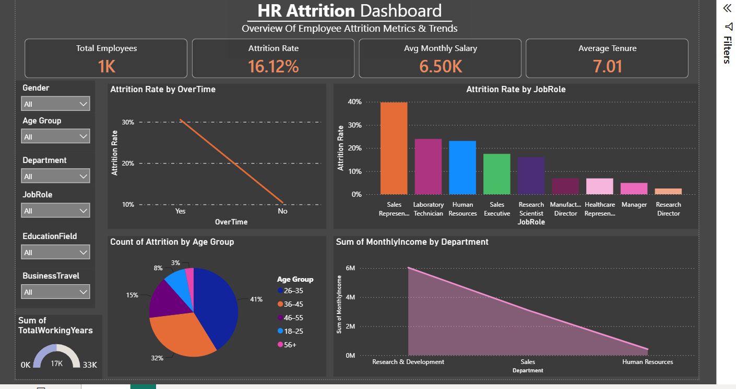
HR Attrition Dashboard — Power BI
- Attrition Rate by OverTime: a steep line chart showing attrition near 30% for overtime workers, dropping sharply for those without overtime — the single strongest visual signal on the page.
- Attrition Rate by JobRole: bar chart ranking roles from Sales Representative (highest) down to Research Director (lowest), directly reflecting the Q9 SQL ranking.
- Count of Attrition by Age Group: donut chart showing the 26-35 group at 41% — the largest single slice of employees who left.
- Sum of MonthlyIncome by Department: area chart comparing total income exposure across Research & Development, Sales, and Human Resources.
- Filters: Gender, Age Group, Department, Job Role, Education Field, and Business Travel slicers let stakeholders drill into any segment interactively.

6. Business Recommendations
- Address overtime culture: overtime is the clearest driver of attrition in the data (~30% vs. much lower without it). Review workload distribution and staffing levels in teams with chronic overtime.
- Prioritize high-risk roles: Sales Representatives, Laboratory Technicians, and HR staff show the highest attrition — build role-specific retention plans (career paths, mentorship, workload review) for these groups first.
- Focus on early/mid-career staff: the 26-35 age group accounts for the largest share of attrition. Invest in growth and development programs aimed at this cohort specifically.
- Fix the performance-to-reward link: verify that salary hikes meaningfully scale with performance ratings (Q7) — flat hikes regardless of rating quietly push high performers out.
- Operationalize the risk score: use the High/Medium/Low risk segmentation (Q10) as a living HR report — proactively reach out to “High Risk” employees (overtime + low satisfaction + short tenure) before they resign.

