Cloud, Microservices & Applications

Lab Assignment

Riya Autade
22BBS0079

________________________________________________________________________________

Launching an EC2 Instance

Steps:
1. Go to EC2---> Dashboard---> Click on Launch Instance

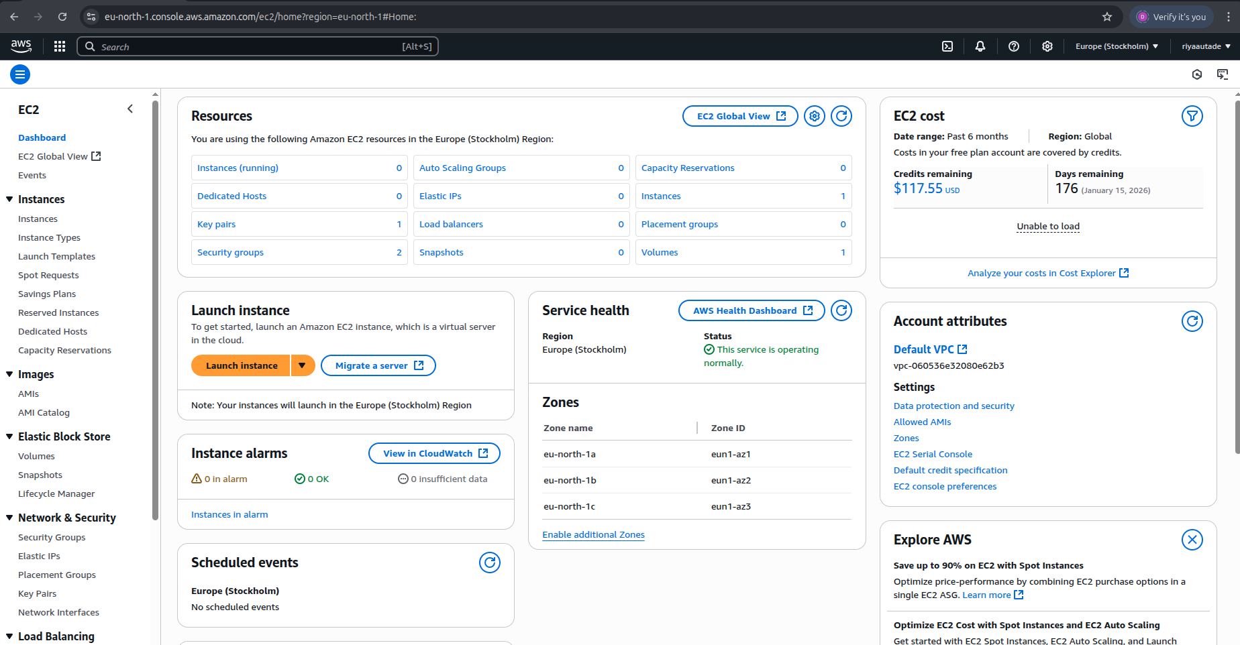

2. Give the instance a name (ECm2) & select an OS (Ubuntu)

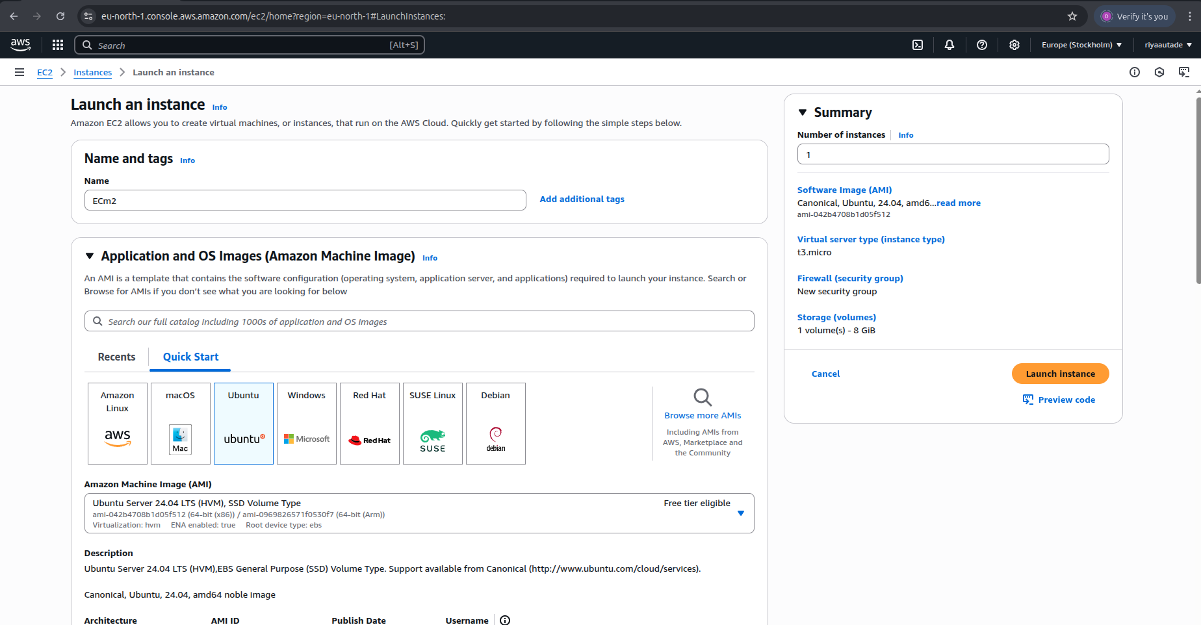

3. Select Instance type (t3.micro)

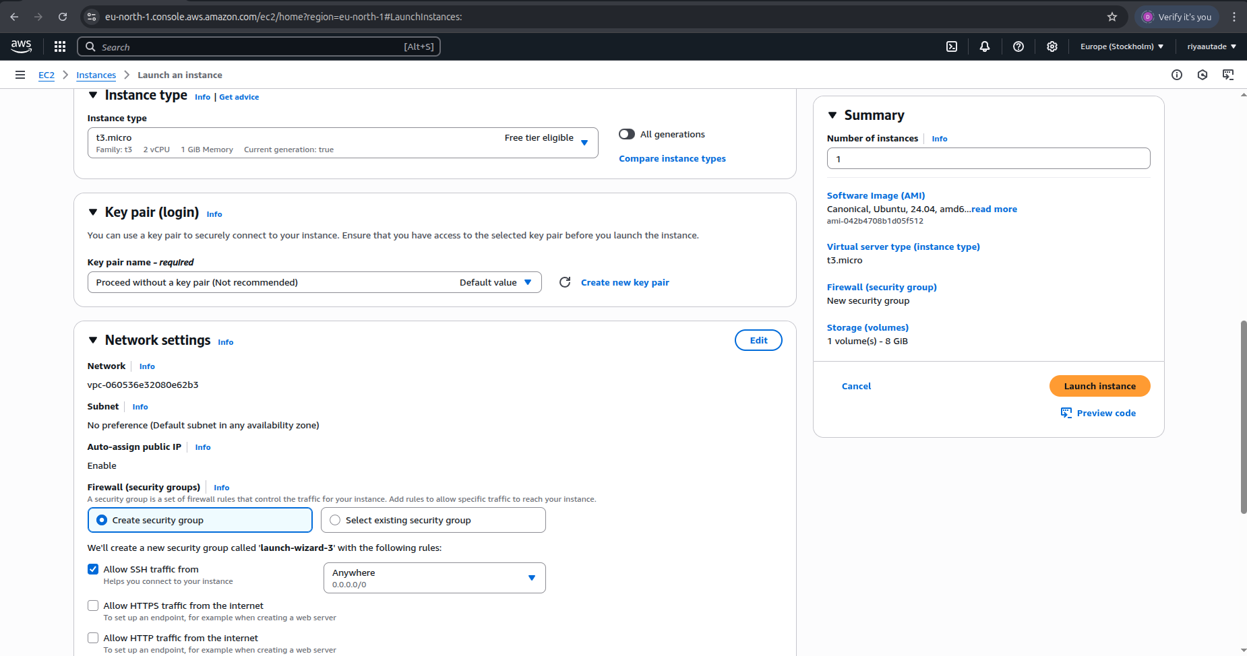

4. Choose proceed without a key pair

5. Keep Network Settings as default

6. Keep storage settings default

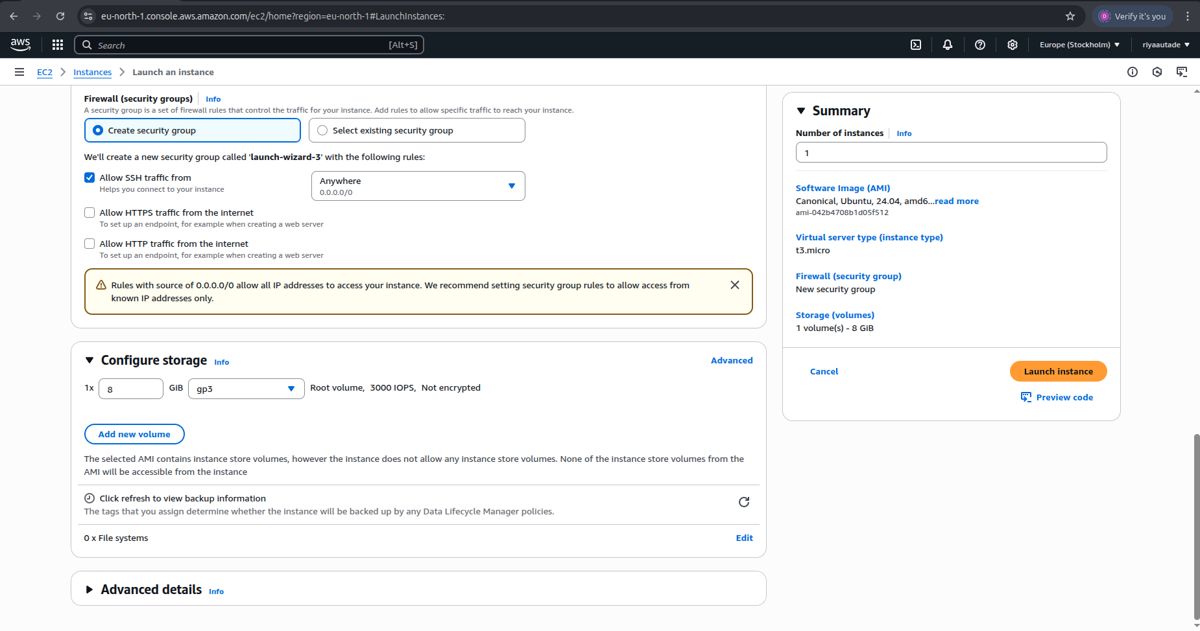

7. Click on Launch Instance

Result:

1. EC2 instance launched successfully

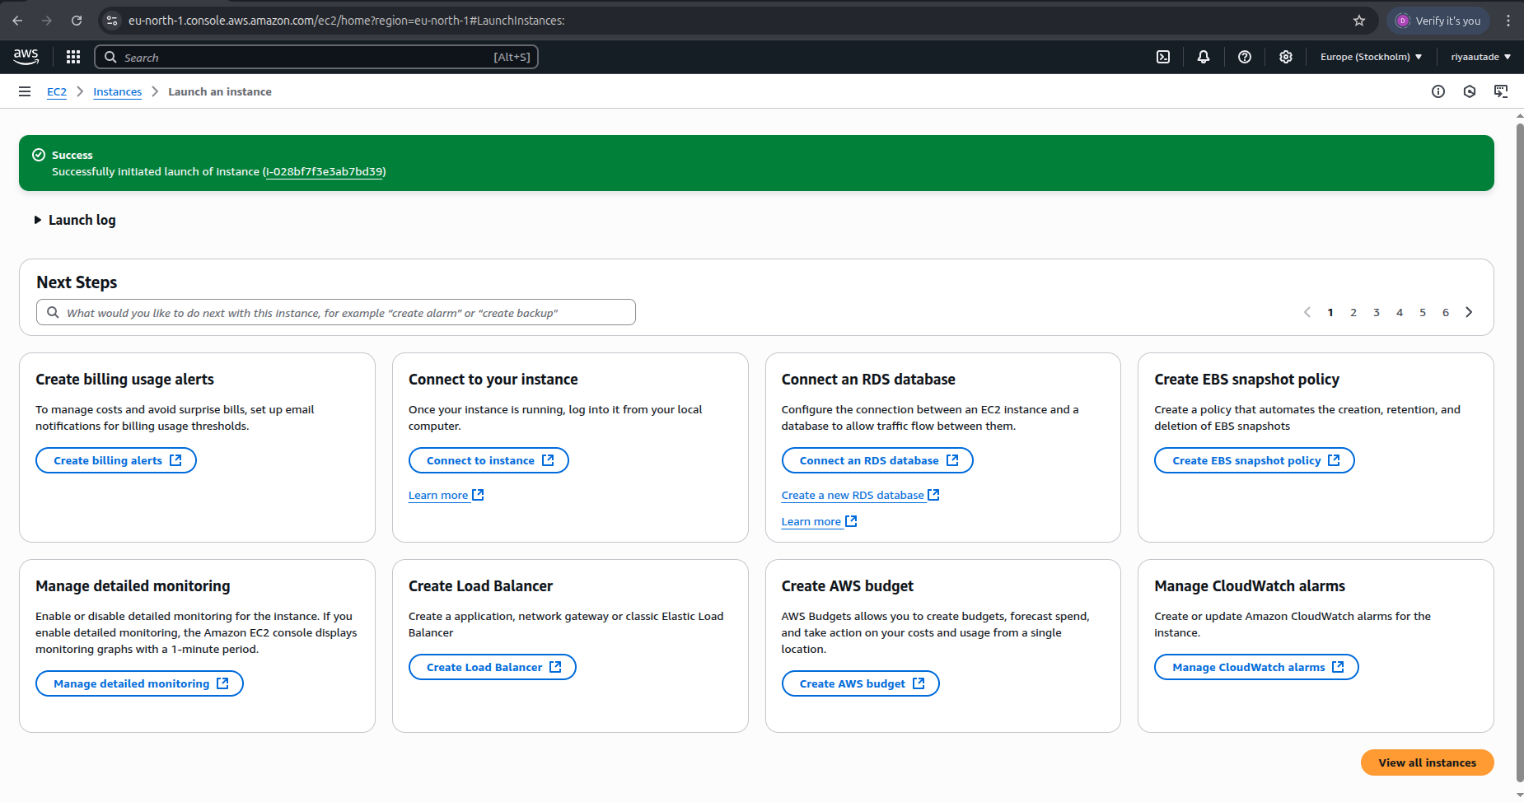

2. Go to EC2---> Dashboard---> Resources--→instances running

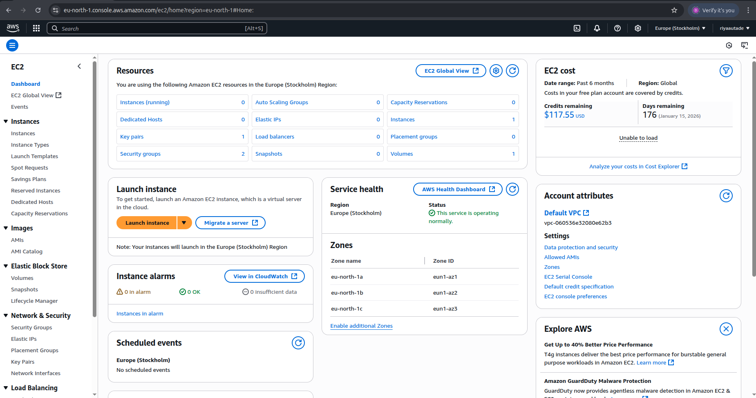

EC2 instance (named ECm2) is successfully launched & running:

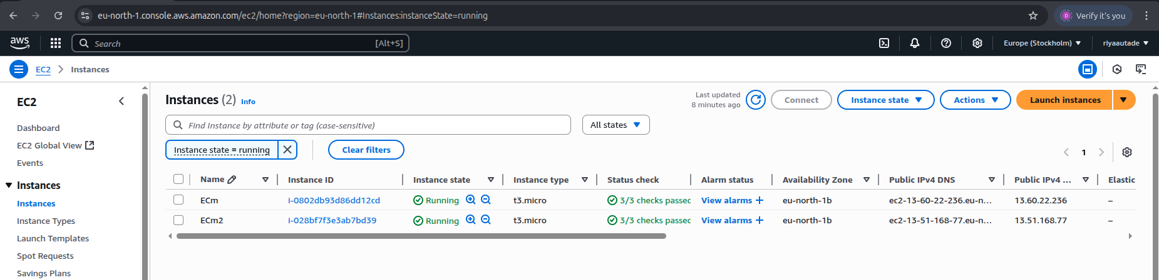
Deleting an EC2 Instance

Steps:

1. Go to EC2---> Dashboard---> Resources--→instances running & select the instance to delete (ECm2)

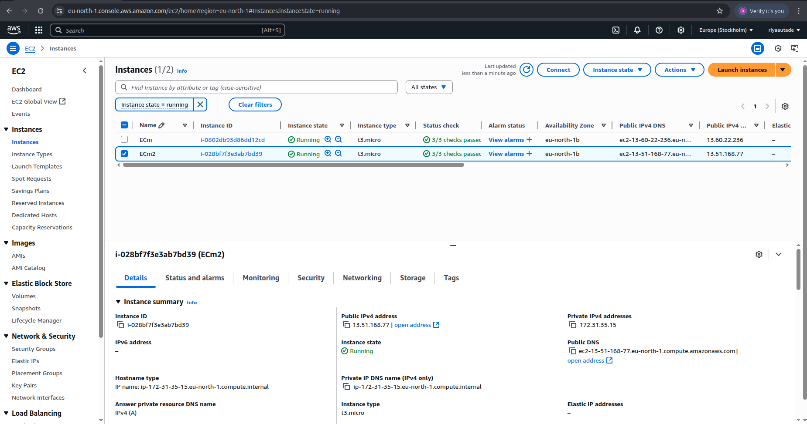
2. Click on Instance State

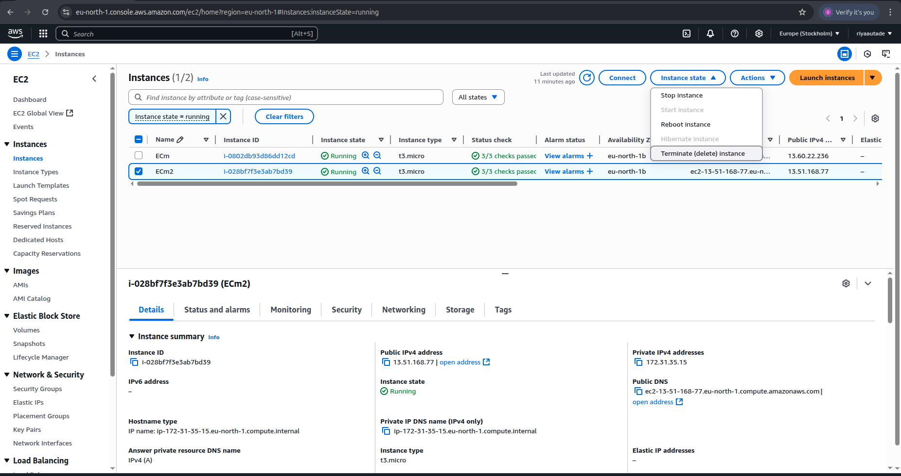
3. Click on Terminate(delete) instance & then Terminate delete button

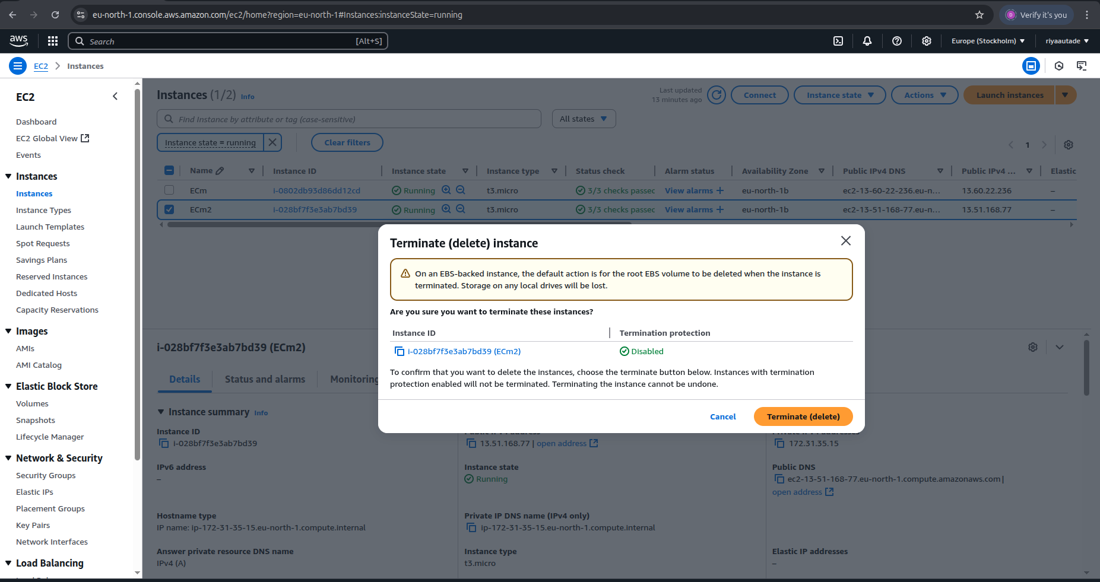
Result:
1. Termination of EC2 instance (ECm2) is successfully initiated:

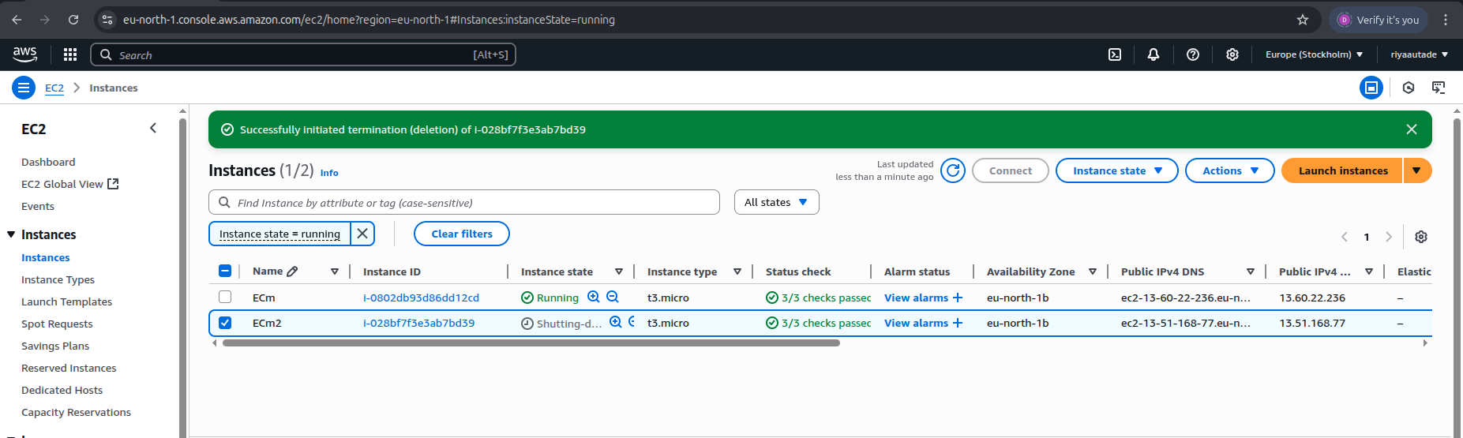
2. EC2 instance successfully deleted/terminated:

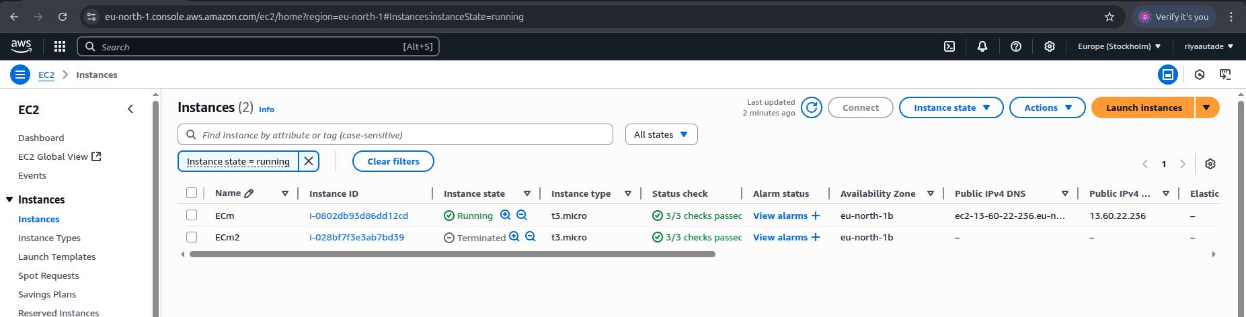
3. Check terminated status in details too upon selecting the instance:

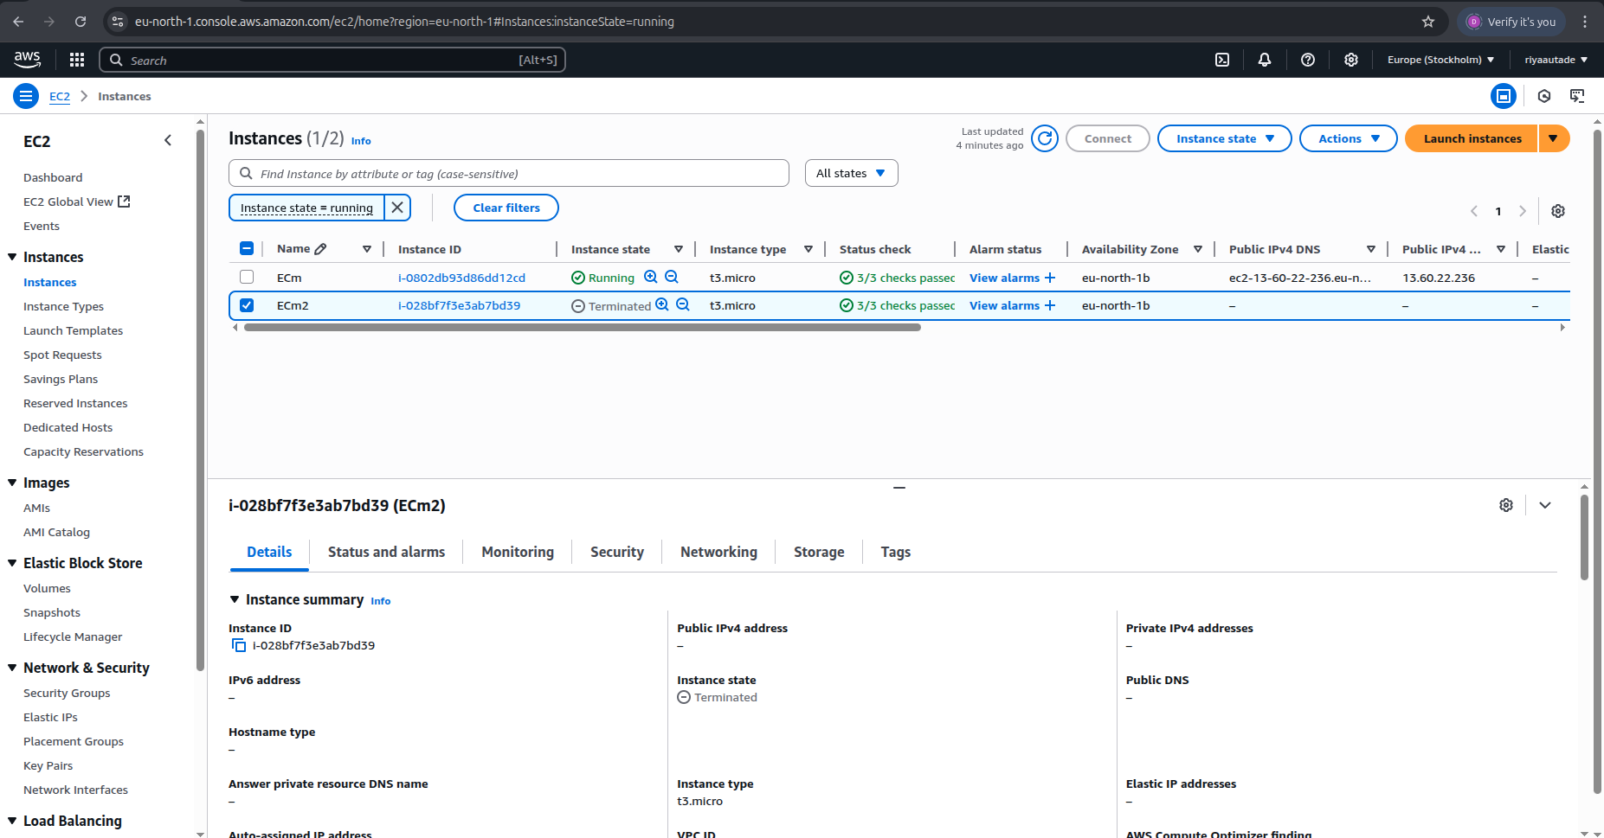
Creating S3 Bucket

Steps:
1. Search for S3 and click on S3 bucket

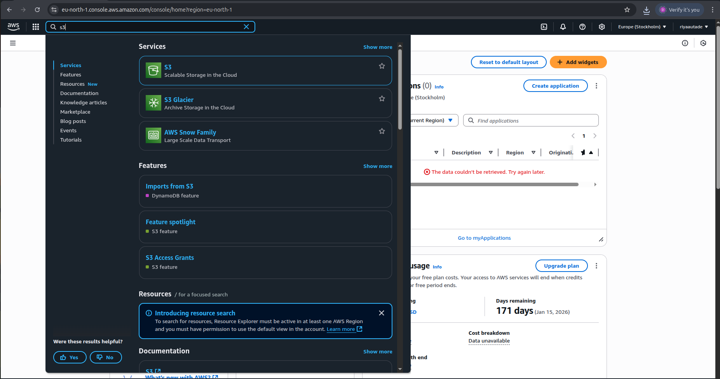

2. Click on Create Bucket

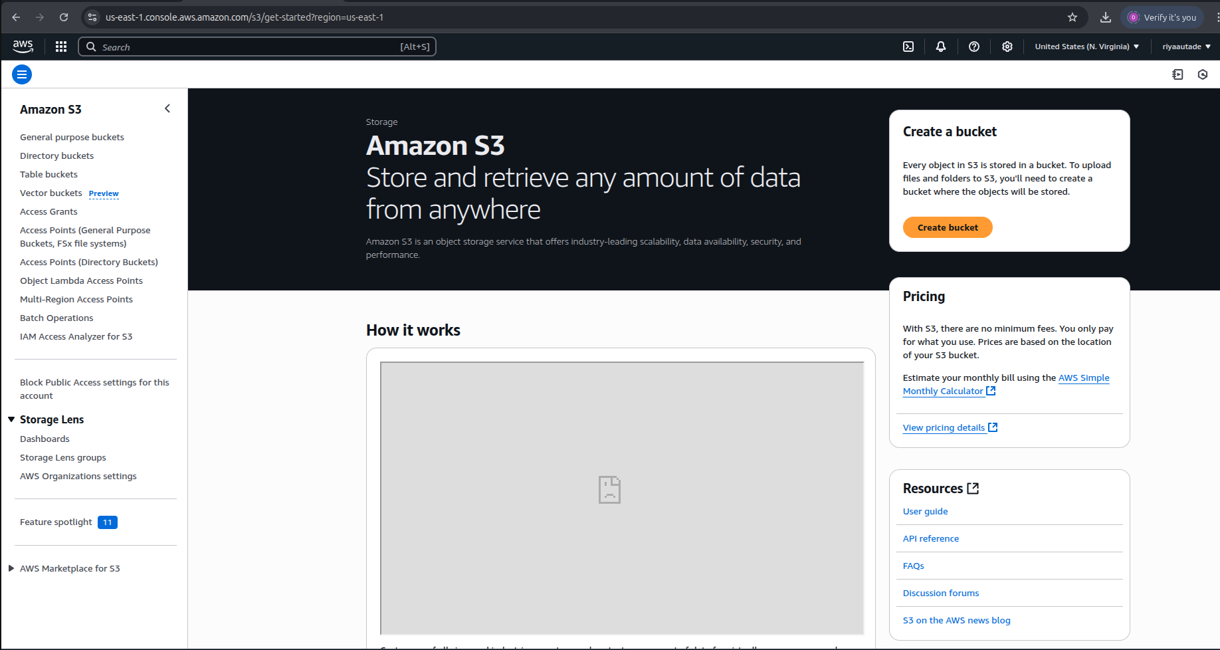

3. Name the bucket (rs3bk here)

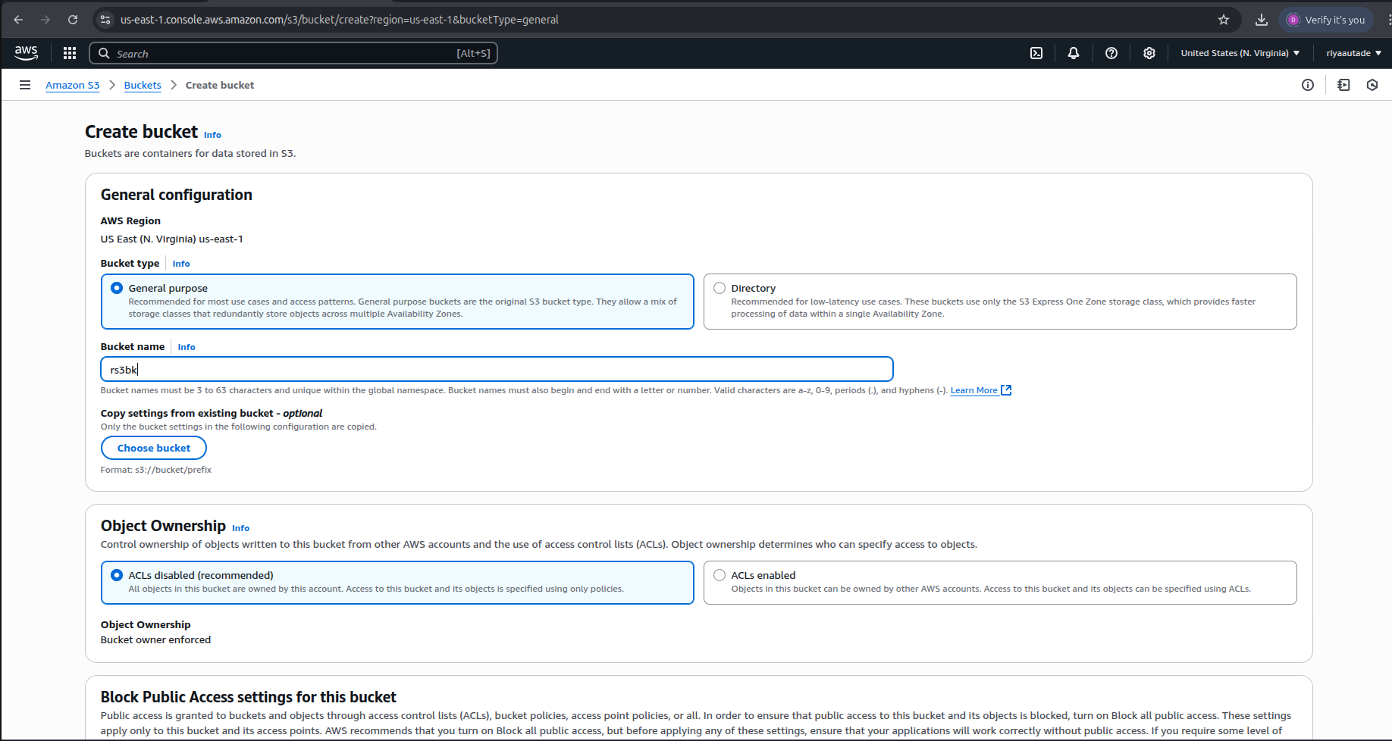
4. Uncheck “Block all public access” and check “I acknowledge”

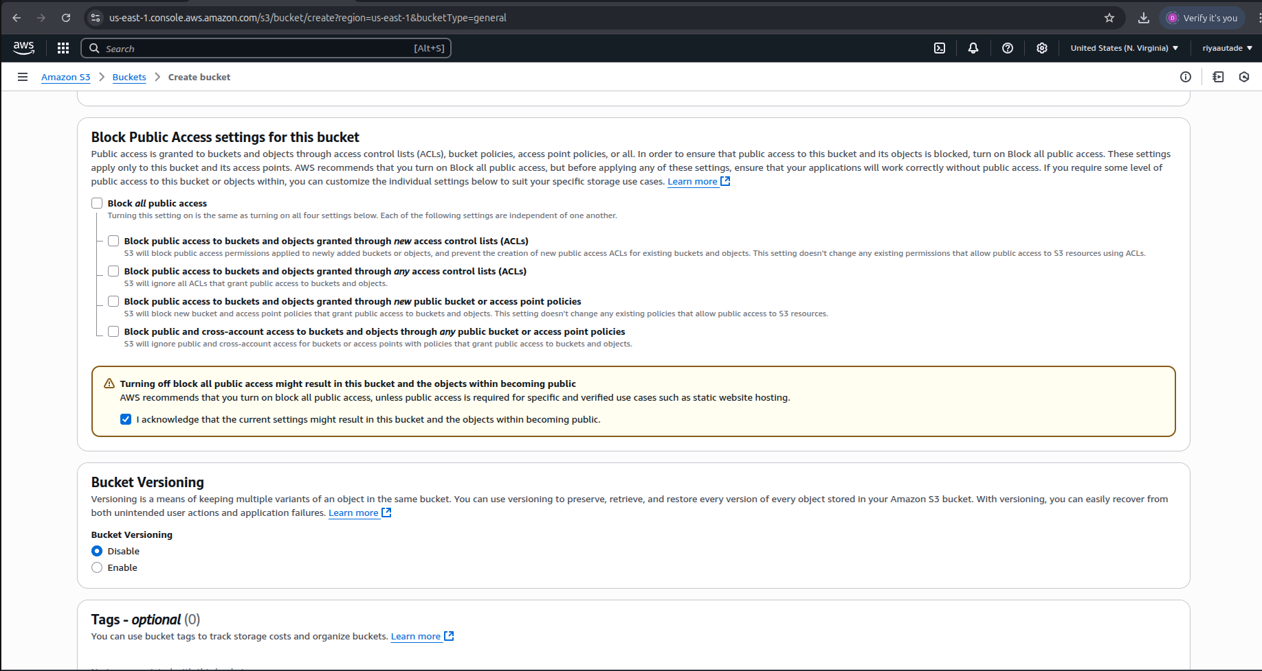

5. Keep all remaining settings default and click on “Create Bucket”

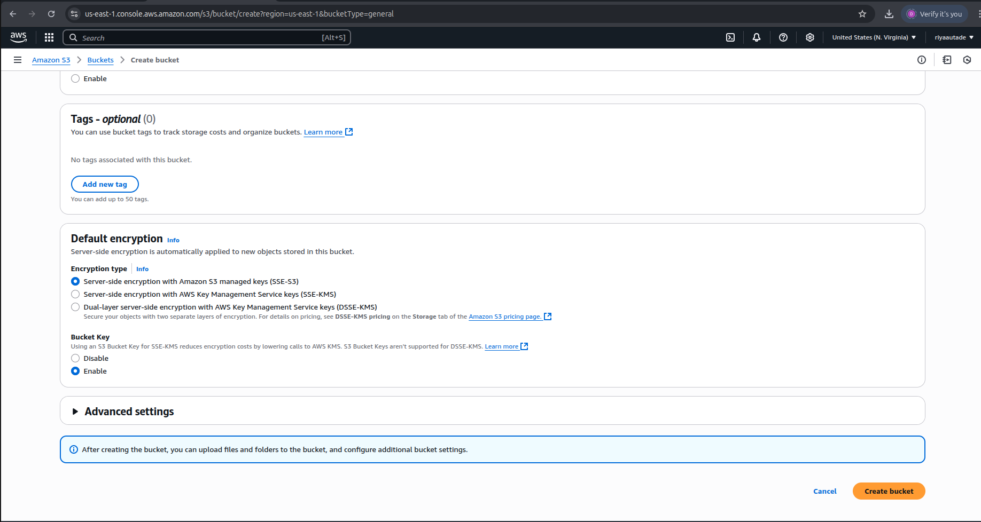
6. S3 bucket (rs3bk) is created successfully

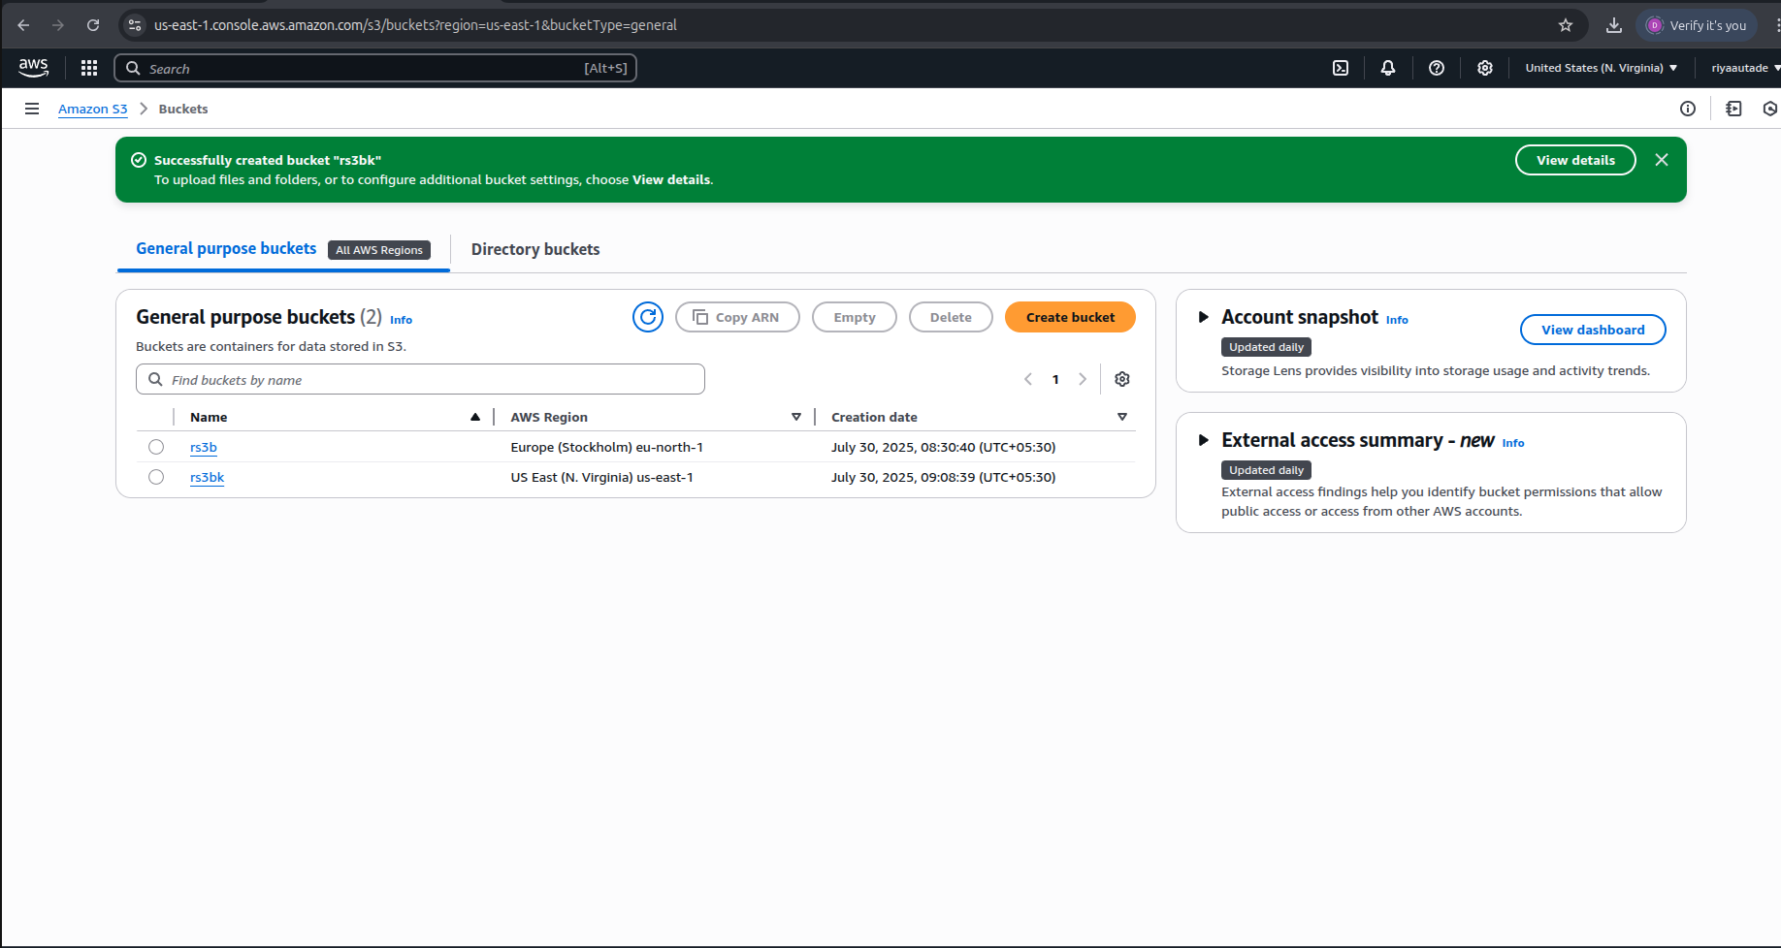

7. Go to General purpose buckets to check for the new bucket & click on the bucket name (rs3bk)

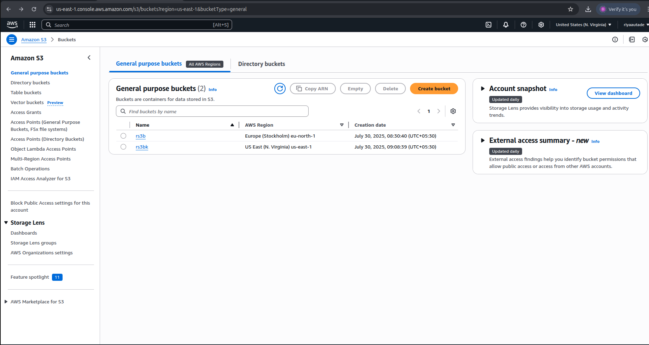
8. Click on Upload to upload a file

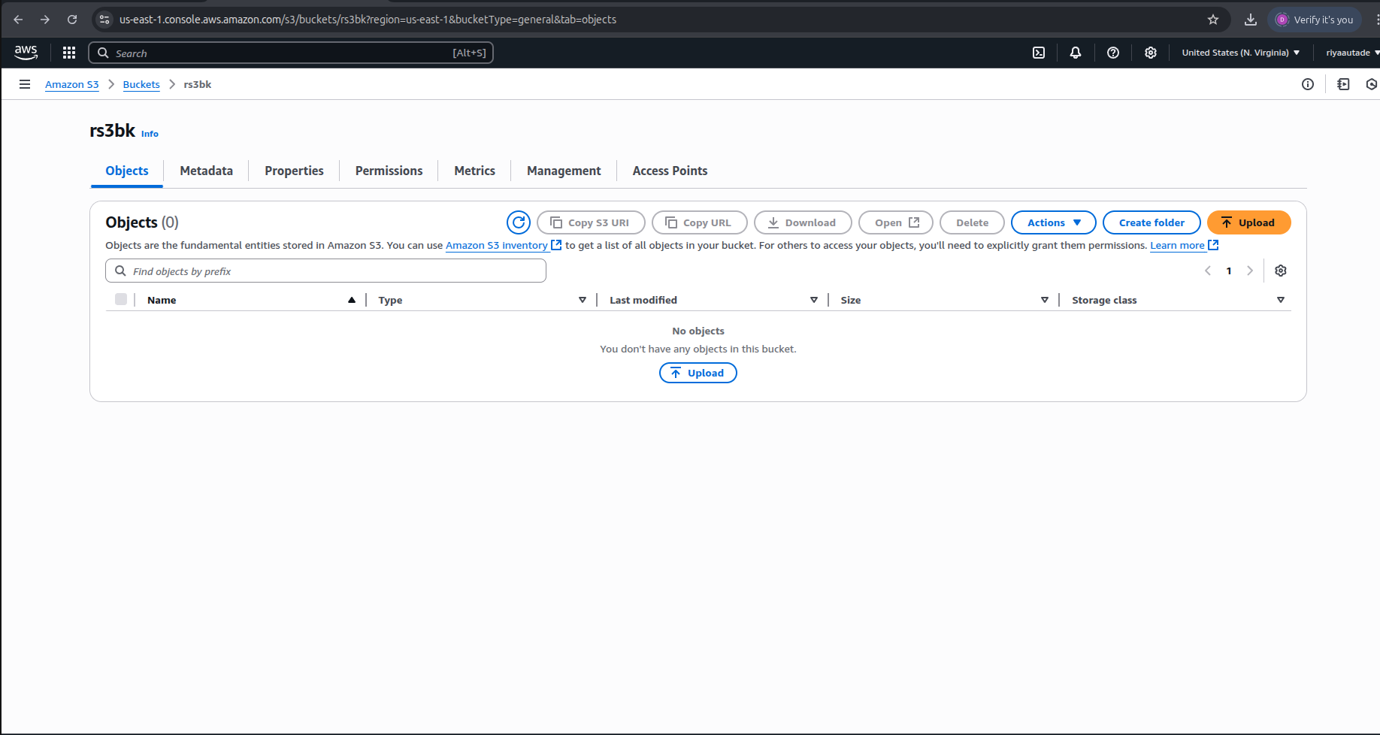

9. Choose a file from the device

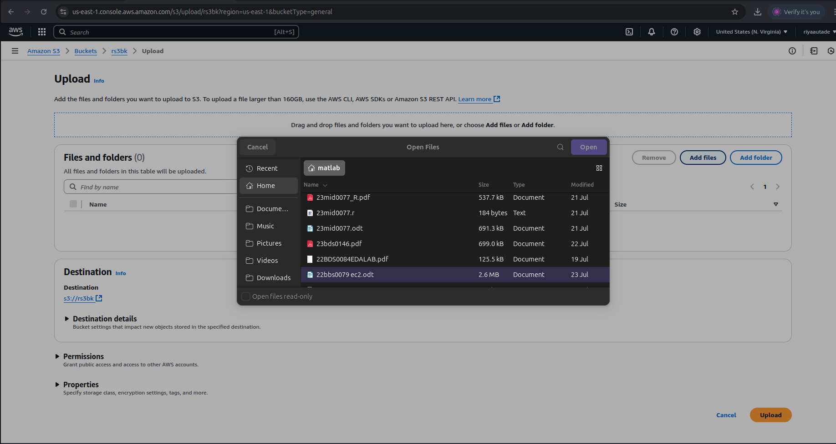
10. Click on Upload to upload it to our S3 bucket

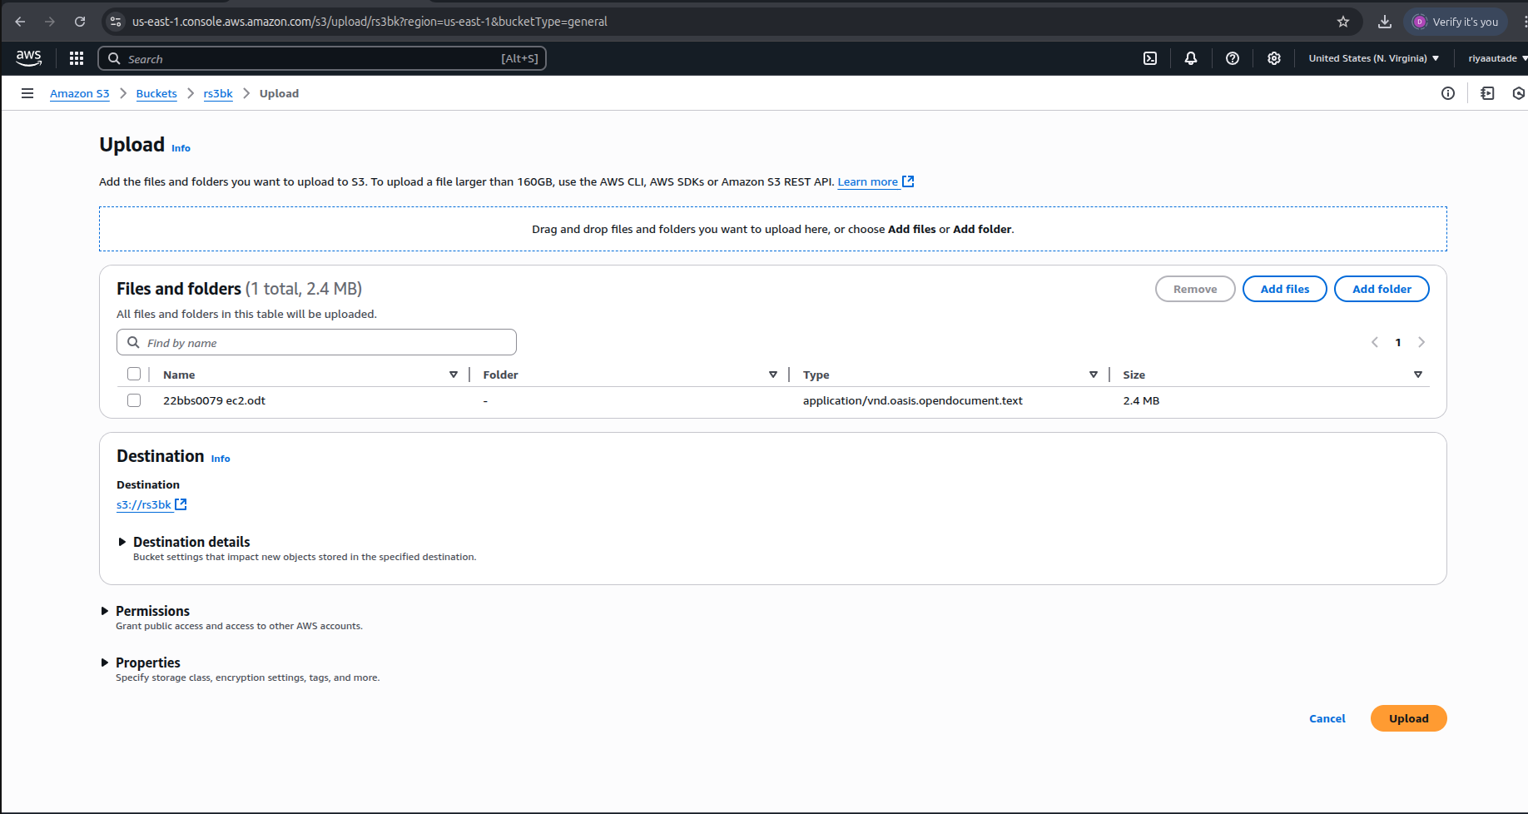

11. File uploaded successfully to the bucket

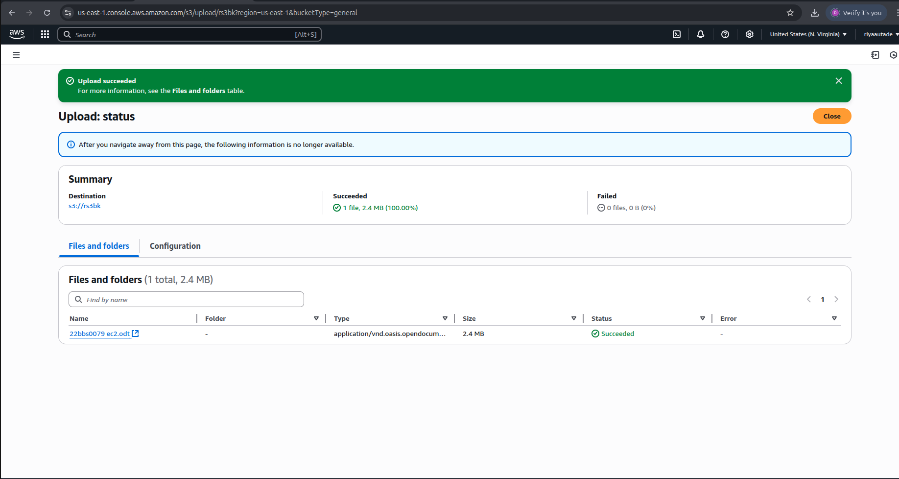
12. Check the uploaded file & copy the Object URL to check for public access

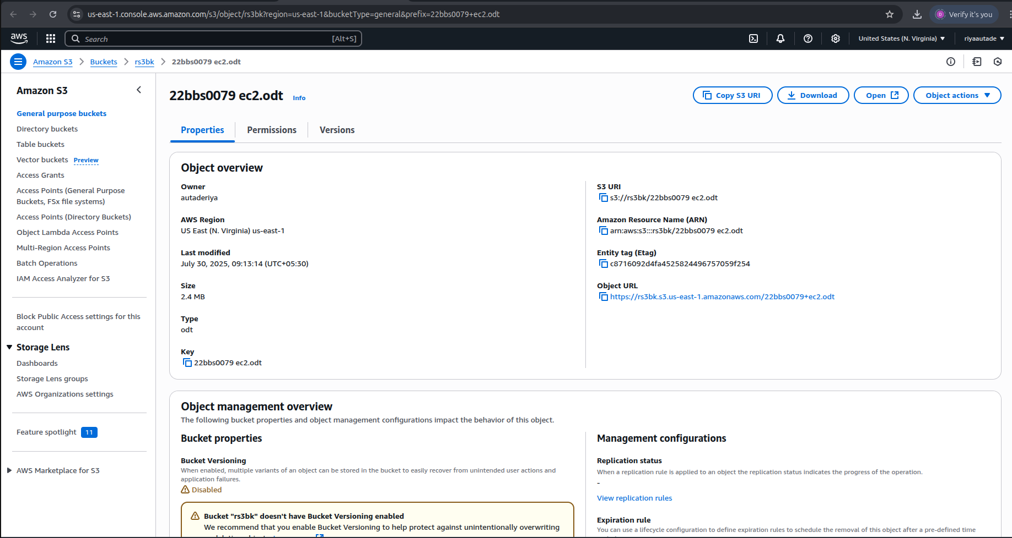

13. Paste the Object URL in the browser. Public access is denied.

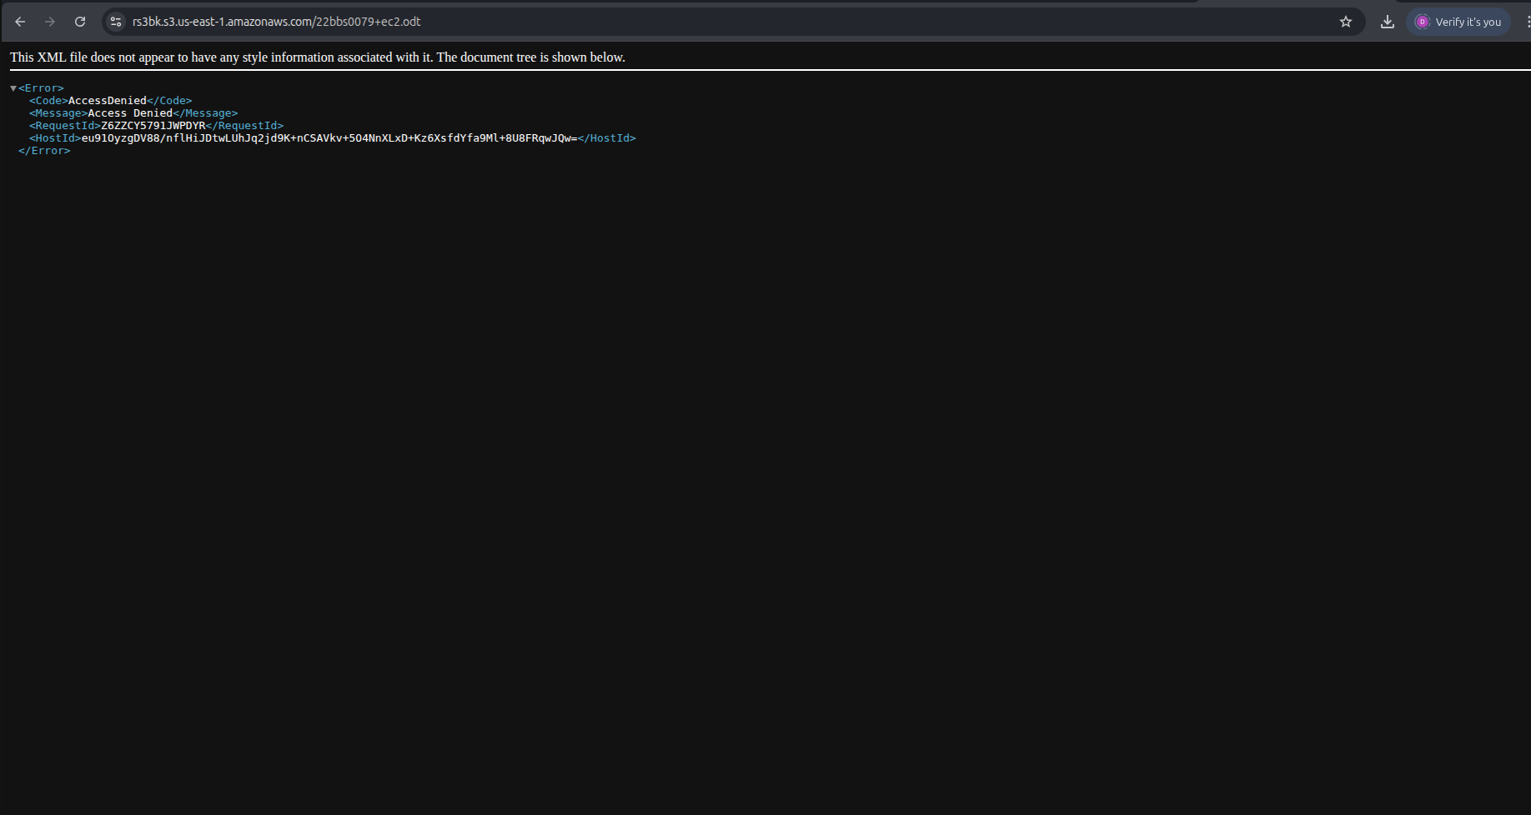
14. Go to the S3 bucket and in the Permissions tab

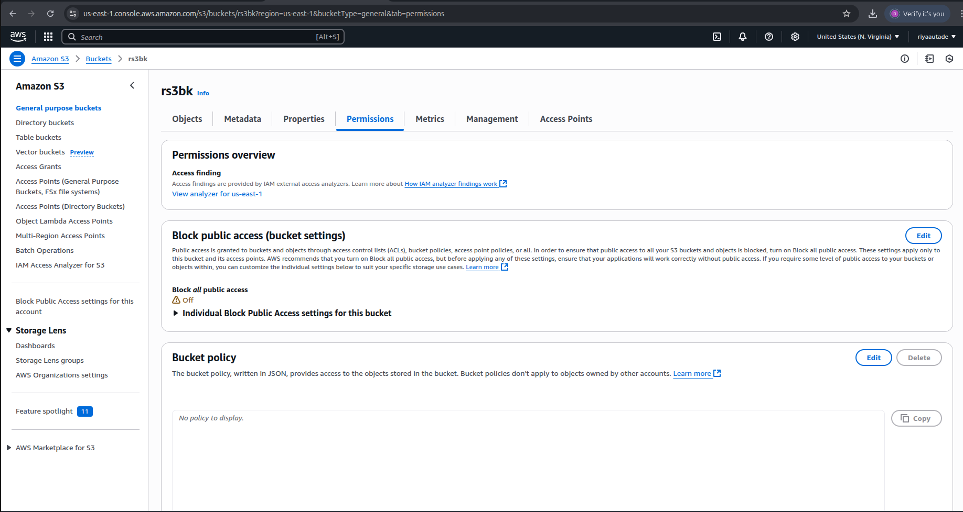

15. Click on Edit bucket policy and write the following code with the bucket ARN

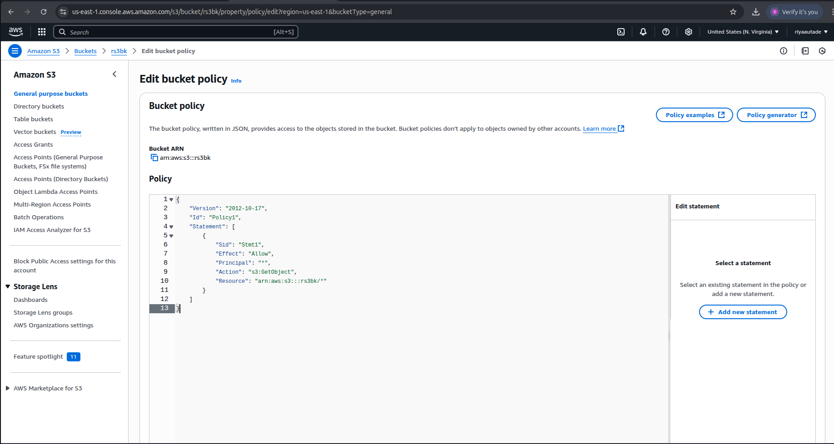
Code:
{
"Version": "2012-10-17",
"Id": "Policy1",
"Statement": [
{
"Sid": "Stmt1",
"Effect": "Allow",
"Principal": "*",
"Action": "s3:GetObject",
"Resource": "arn:aws:s3:::rs3bk/*"
}
]
}

16. The bucket policy is successfully updated
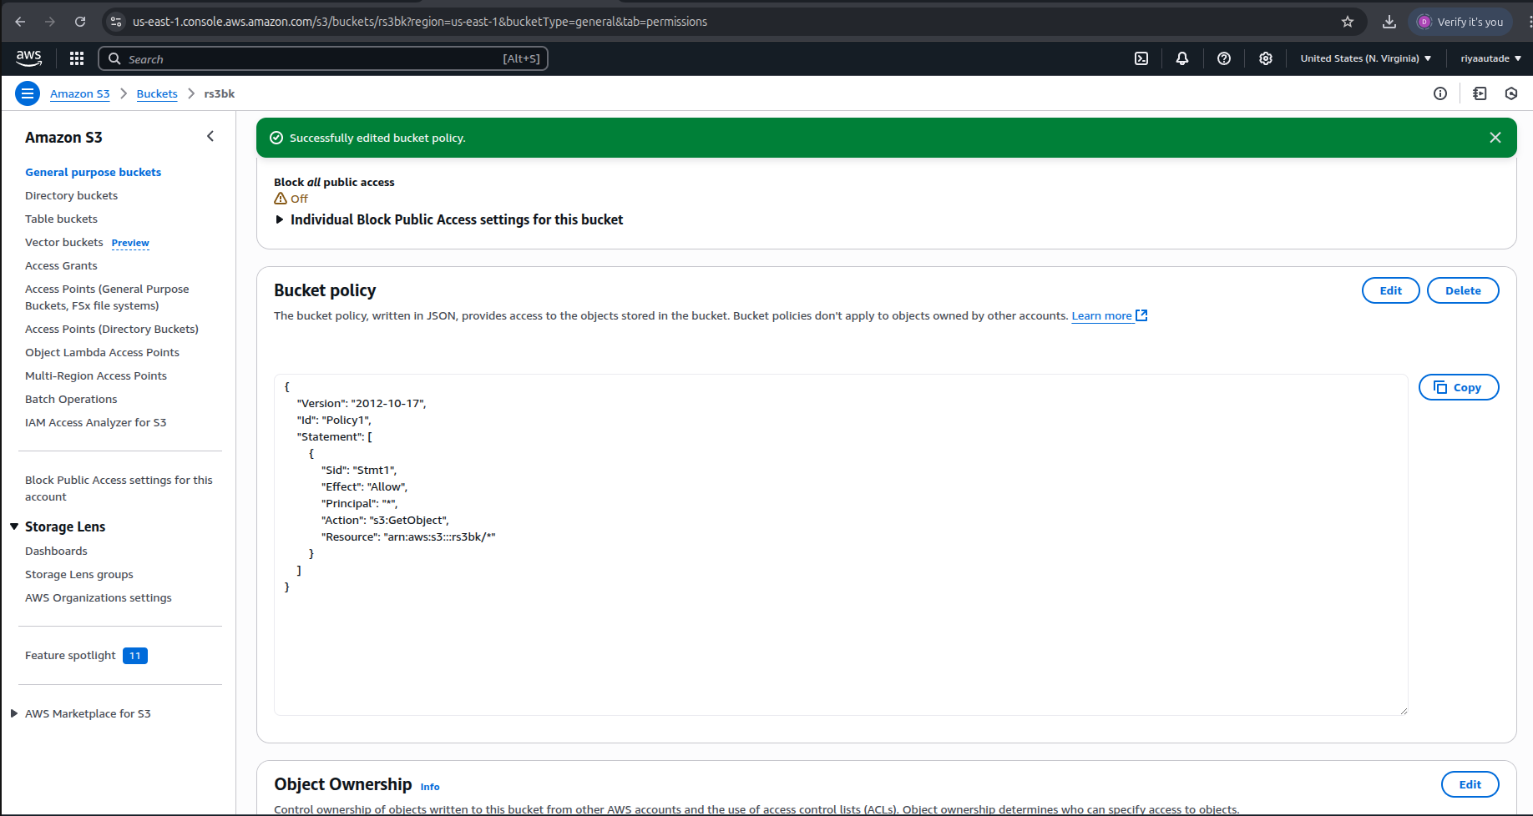

17. Again, go to the bucket in General purpose buckets & click on the bucket name

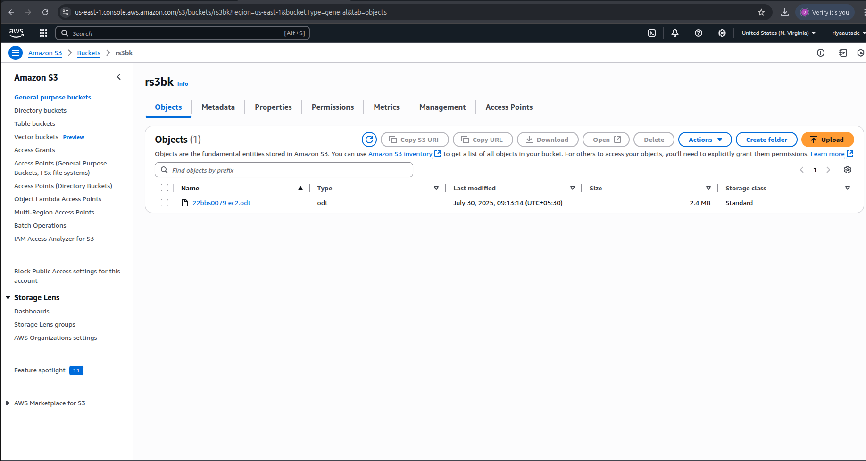

18. Copy the bucket URL & paste it in your browser

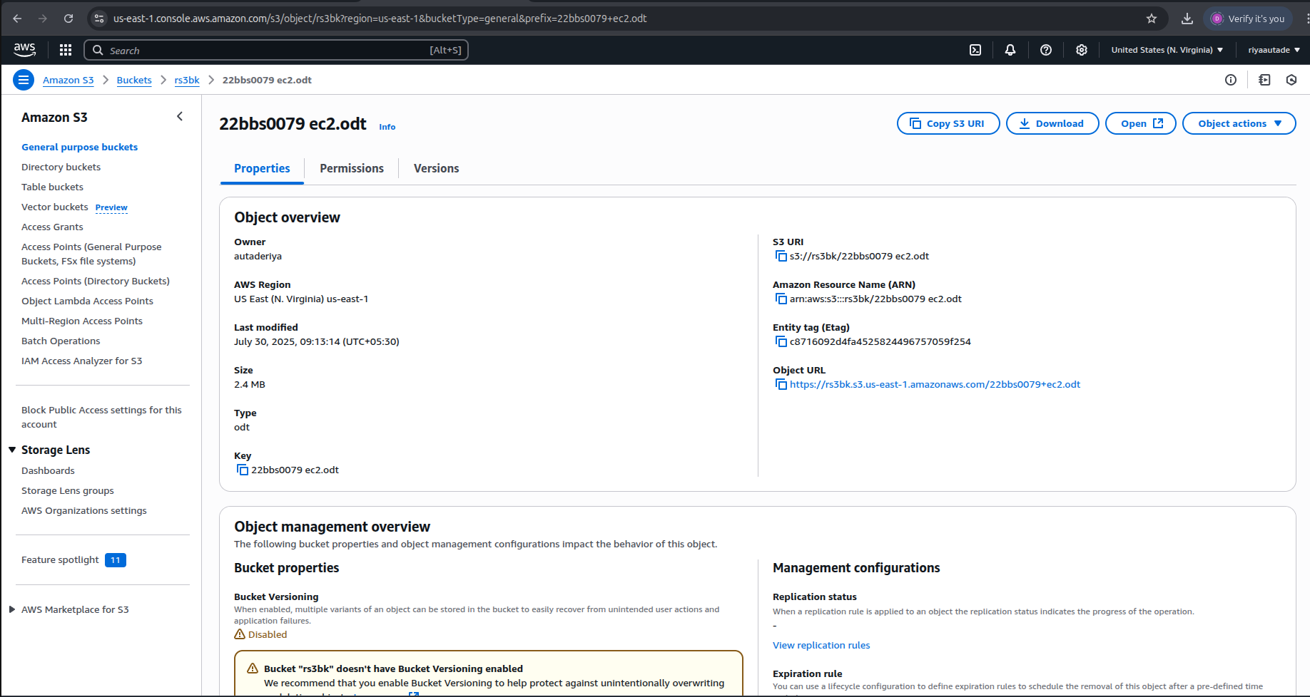
19. The file is publicly accessible and gets downloaded successfully.



