Disease Prediction System
Author: Riya Barman | Machine Learning-Based Cardiovascular Risk Assessment
Flask | Streamlit | Python | NumPy | Matplotlib | python-docx

1. Executive Summary
This report documents the end-to-end development of a Disease Prediction System that leverages machine learning to assess the risk of cardiovascular disease in patients. The system is built using Python with a Flask REST API backend, a Streamlit interactive frontend, and custom pure-NumPy implementations of Logistic Regression and Random Forest classifiers to ensure compatibility with Python 3.14.
The best-performing model — Logistic Regression — achieved an accuracy of 79.2%, an F1 score of 0.5455, and an ROC-AUC of 0.8434 on the held-out test set, with a 5-fold cross-validation mean of 0.8490 ± 0.0219.

2. Project Overview
The Disease Prediction System is a full-stack machine learning application comprising three layers: a data pipeline and ML training script, a Flask REST API backend, and a Streamlit web UI frontend. The pipeline generates a synthetic cardiovascular dataset, trains multiple classifiers, selects the best model by ROC-AUC, and exposes predictions through a RESTful API consumed by the Streamlit frontend.

2.1 Project Directory Structure
disease_prediction/
train_model.py — ML pipeline (data generation, training, evaluation)
models_def.py — Shared model class definitions (pickle-safe)
app.py — Flask REST API backend
ui.py — Streamlit frontend UI
generate_screenshots.py — Programmatic UI mockup generator
generate_report.py — This report generator
requirements.txt — Python dependencies
README.md — Run instructions
data/dataset.csv — Generated training dataset (1,200 rows)
models/ — Trained model artifacts (.pkl, .json)
report_assets/ — Auto-generated plots and UI screenshots

2.2 Technology Stack
Layer | Technology | Purpose
ML Training | NumPy, Pandas, Matplotlib, Seaborn | Data processing, model training, EDA plots
ML Models | Custom NumPy (LR, RF) | Logistic Regression & Random Forest classifiers
Backend API | Flask 3.x | REST API serving predictions
Frontend UI | Streamlit 1.x | Interactive web dashboard
Serialisation | pickle (stdlib) | Model and scaler persistence
Report | python-docx | Word document generation

3. Dataset
A synthetic cardiovascular disease dataset was generated with 1,200 patient records and 10 clinical features. The dataset has a disease prevalence of 24.0% (288 disease cases, 912 healthy cases), reflecting a realistic class imbalance.

3.1 Feature Descriptions
# | Feature | Type | Range / Values
1 | age | Numeric | 25 – 80 years
2 | sex | Binary | 0 = Female, 1 = Male
3 | bmi | Numeric | 15 – 50 (Body Mass Index)
4 | blood_pressure | Numeric | 80 – 200 mmHg (systolic)
5 | cholesterol | Numeric | 120 – 350 mg/dL
6 | glucose | Numeric | 60 – 300 mg/dL (fasting)
7 | smoking | Binary | 0 = Non-smoker, 1 = Smoker
8 | family_history | Binary | 0 = No, 1 = Yes
9 | chest_pain_type | Categorical | 0 – 3 (four types)
10 | heart_rate | Numeric | 45 – 130 bpm (resting)

3.2 Exploratory Data Analysis
Figure 1 shows the target class distribution (left) and the age distribution split by disease status (right). The dataset is imbalanced, with ~24% disease cases. Patients with disease tend to be older on average.
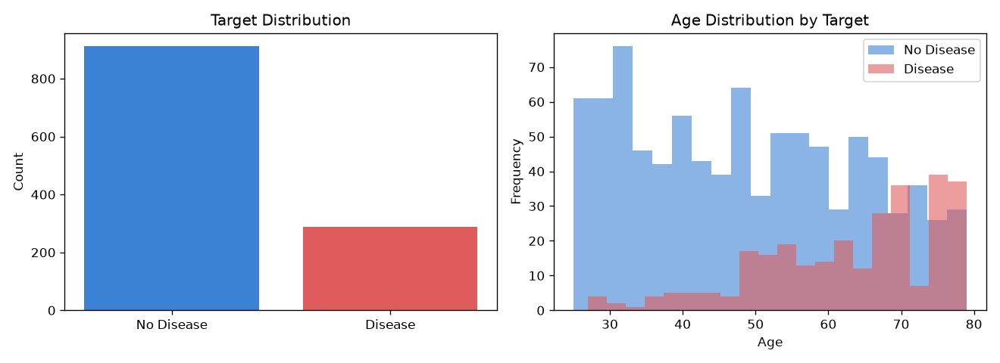
Figure 1 – Target distribution and age histogram by disease status
Figure 2 shows the Pearson correlation matrix across all features. Age, blood pressure, cholesterol, and smoking show the strongest positive correlation with the target.
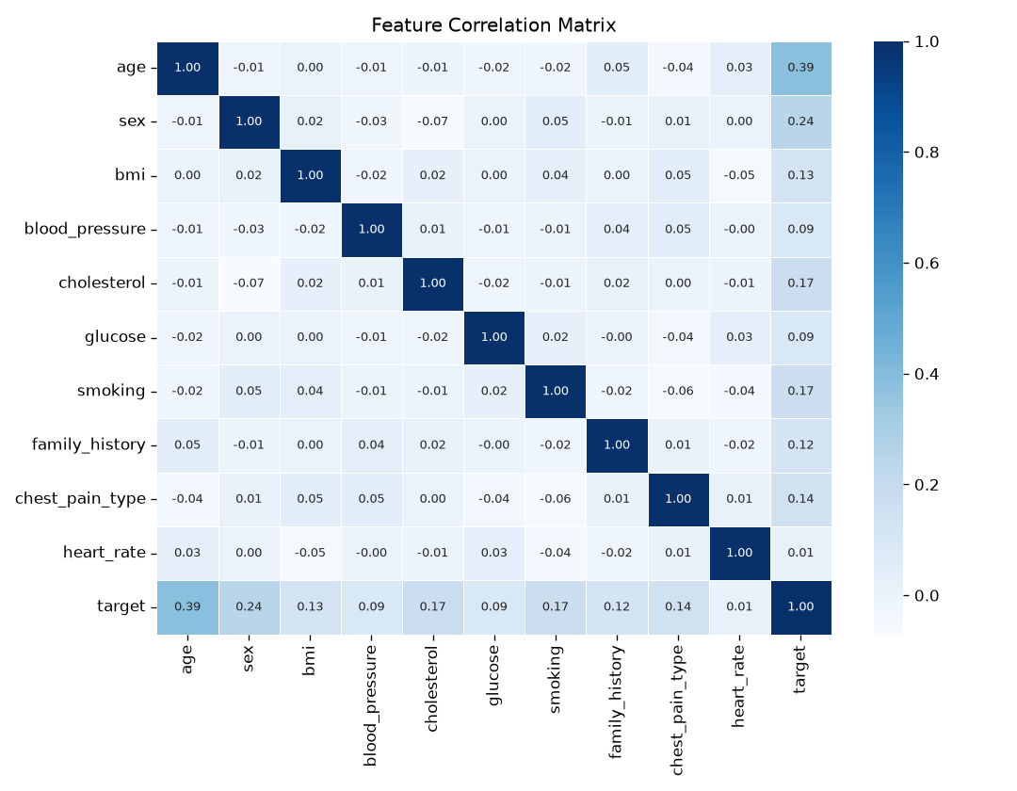
Figure 2 – Feature correlation heatmap

4. Machine Learning Pipeline
The training pipeline (train_model.py) follows these steps:
1. Generate a synthetic dataset using numpy's random number generator
2. Perform exploratory data analysis and save plots
3. Split data 80/20 into training and test sets
4. Standardise features with a custom StandardScaler (pure NumPy)
5. Train Logistic Regression and Random Forest classifiers
6. Evaluate on the test set and compute 5-fold cross-validation accuracy
7. Select the best model by ROC-AUC and save artifacts to models/

4.1 Model Descriptions
Logistic Regression (custom NumPy):
Gradient descent implementation with L2 regularisation (lambda=1e-4). Uses the sigmoid function for binary classification. 400 training iterations.
Random Forest (custom NumPy):
Ensemble of 50 binary CART decision trees with bootstrap sampling and random feature subsets (sqrt of n_features). Gini impurity splitting criterion, max depth = 6.

5. Model Evaluation Results
The best-performing model is Logistic Regression selected by highest ROC-AUC score. All results are computed on the held-out 20% test set (240 samples).

5.1 Performance Summary
Model | Accuracy | F1 Score | ROC-AUC
Logistic Regression | 79.17% | 0.5455 | 0.8434
Random Forest | 76.25% | 0.0656 | 0.8025

5.2 Model Comparison Chart
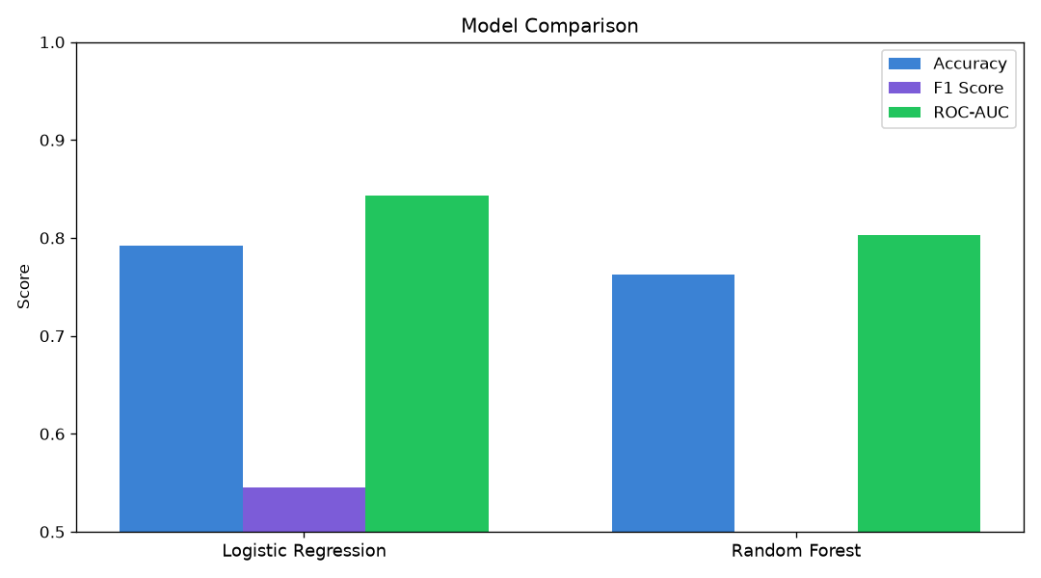
Figure 3 – Side-by-side comparison of Accuracy, F1 Score, and ROC-AUC for each model

5.3 Confusion Matrix
The confusion matrix for the best model (Logistic Regression) on the test set:
True Negatives: 160 | False Positives: 21
False Negatives: 29 | True Positives: 30
Precision = 0.588 | Recall = 0.508
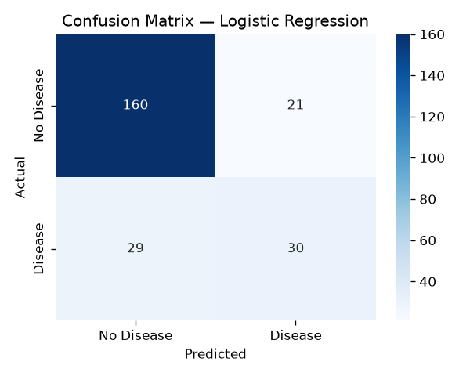
Figure 4 – Confusion matrix for Logistic Regression

5.4 Feature Importance
Figure 5 shows the feature importance scores from the Random Forest model, indicating which features contribute most to the disease prediction. Features with higher importance scores have a stronger influence on the model's decisions.
[Image not found: feature_importance.png]

6. Flask Backend API
The Flask API (app.py) exposes a RESTful interface for disease predictions. It loads the trained model, scaler, and metadata on startup and serves predictions on port 5000.

6.1 API Endpoints
Method | Endpoint | Description
GET | / | Health check — returns service status and model name
GET | /api/model-info | Model metrics: accuracy, F1, AUC, CV scores, all models
GET | /api/dataset-stats | Dataset statistics: counts, prevalence, feature stats
GET | /api/features | Feature list with descriptions
POST | /api/predict | Single patient prediction — returns label + probability + risk
POST | /api/predict-batch | Batch prediction — JSON array of patient records

6.2 API Response Examples
GET /api/model-info response:
{"model_name": "Logistic Regression", "accuracy": 0.7917, "f1_score": 0.5455, "roc_auc": 0.8434, "cv_mean": 0.849}
POST /api/predict response (high-risk patient):
{"prediction": 1, "label": "Disease", "probability": 0.8958, "risk_level": "High"}
POST /api/predict response (low-risk patient):
{"prediction": 0, "label": "No Disease", "probability": 0.1423, "risk_level": "Low"}

7. Streamlit Frontend UI
The Streamlit UI (ui.py) provides a multi-page interactive web dashboard that connects to the Flask backend API. It includes five pages: Home, Predict Disease, Model Insights, Dataset Explorer, and Batch Predict.

7.1 UI Pages Overview
Page | Description
Home | System KPIs, class distribution pie chart, quick-start guide
Predict Disease | Patient input form with sliders and dropdowns; real-time prediction result
Model Insights | Performance bar charts, model comparison table, cross-validation scores
Dataset Explorer | Feature statistics table, mean/std bar chart with error bars
Batch Predict | CSV file upload or JSON paste for bulk prediction with summary pie chart

7.2 UI Screenshots
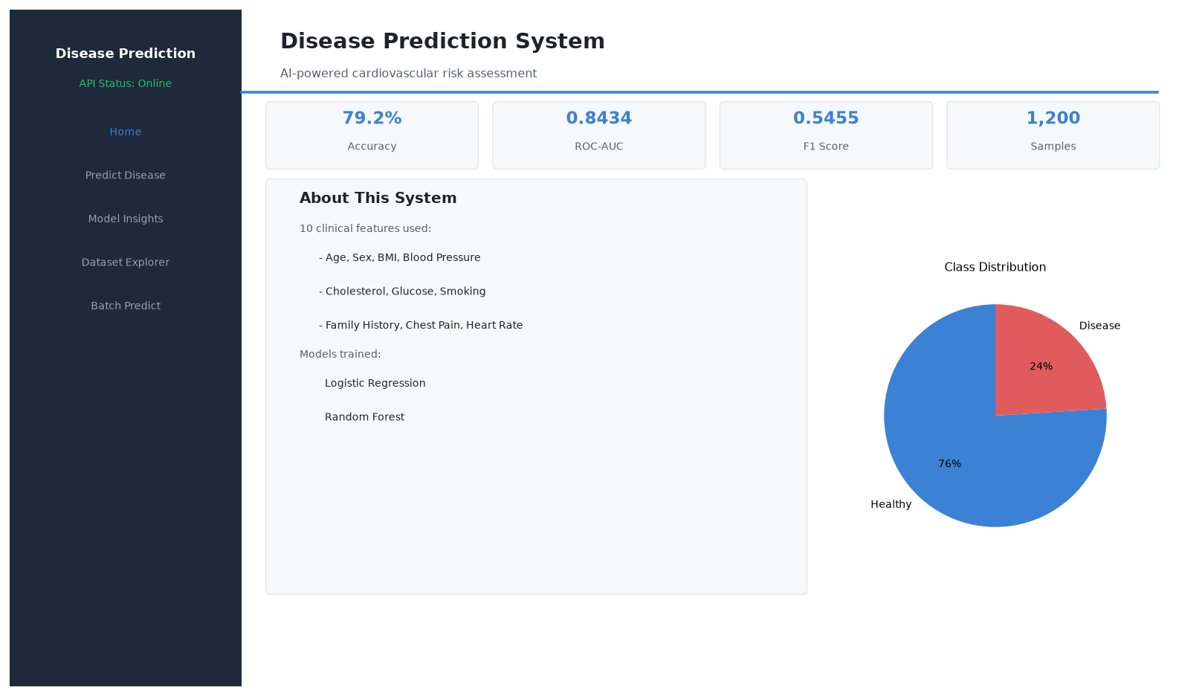
Figure 6 – Home page showing KPI cards and class distribution
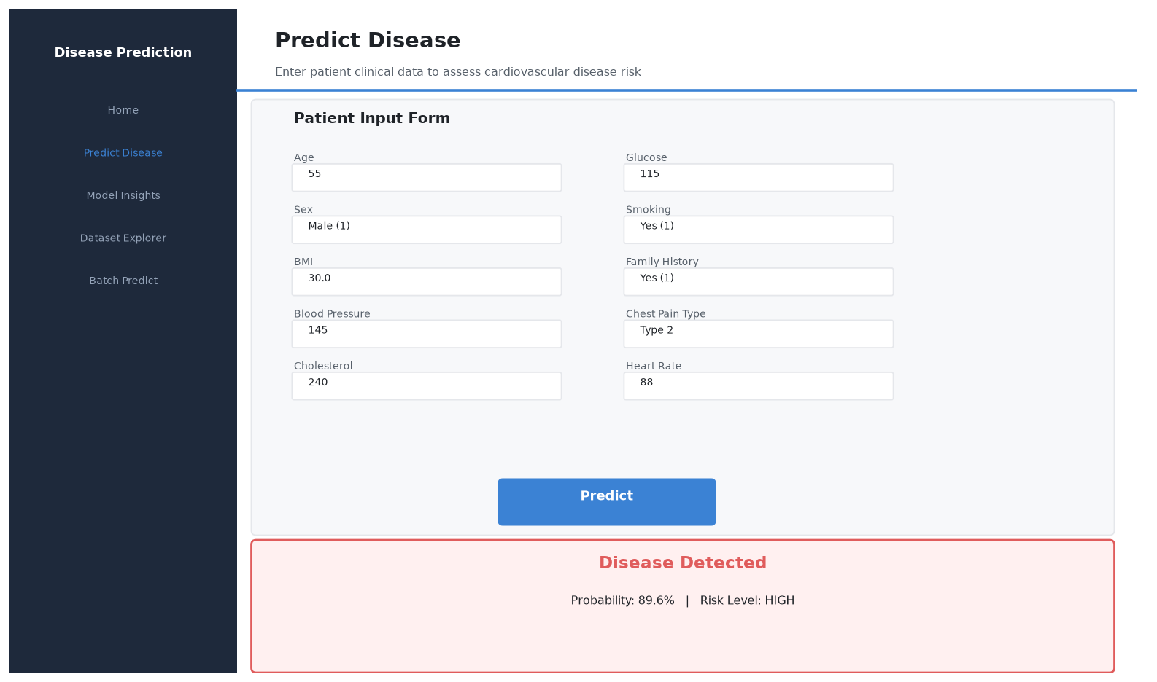
Figure 7 – Predict Disease page with patient form and result card
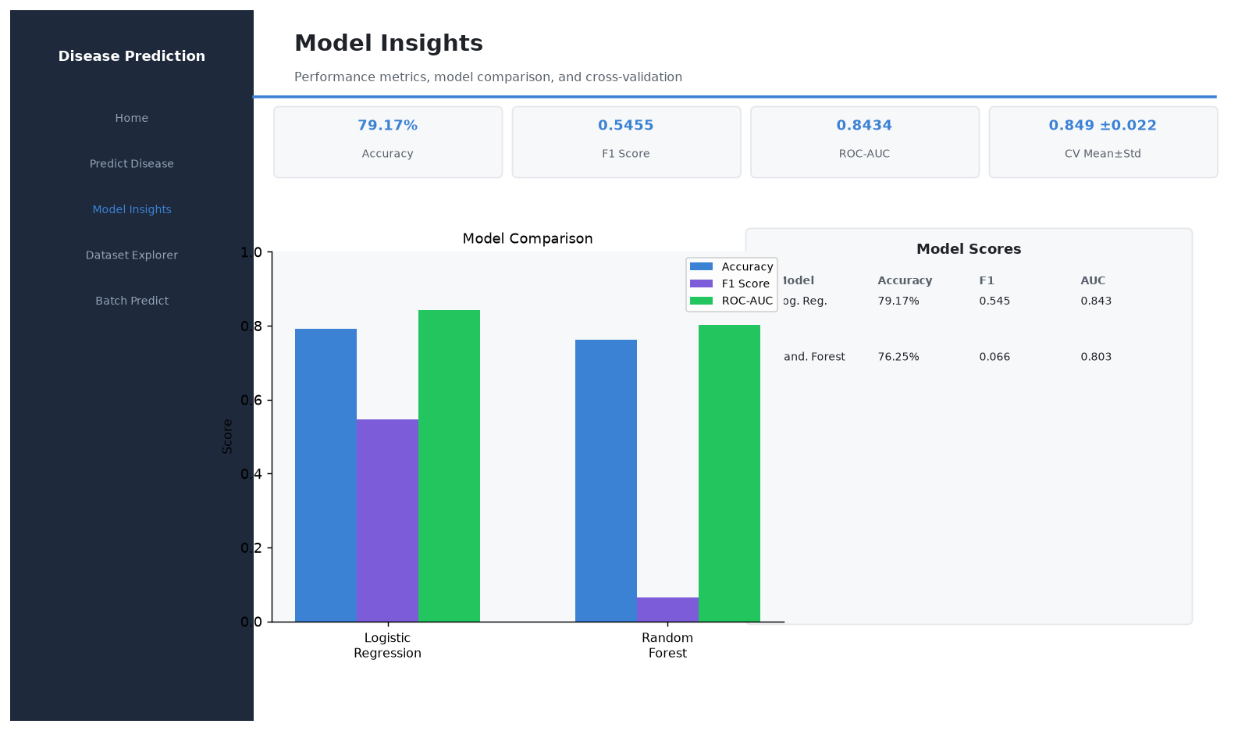
Figure 8 – Model Insights page with comparison chart and table
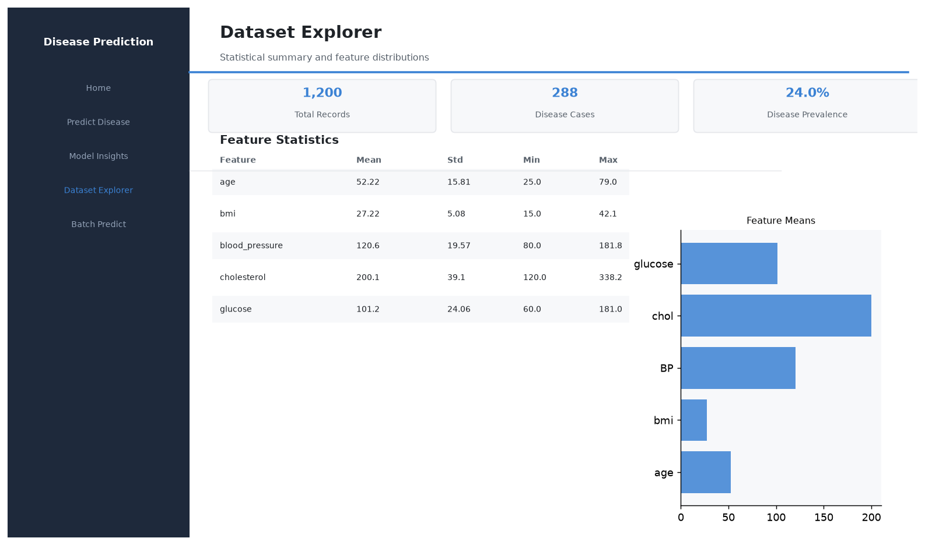
Figure 9 – Dataset Explorer page with feature statistics

8. Run Instructions
Step 1 — Install dependencies
pip install -r requirements.txt
Step 2 — Train the ML model
python train_model.py
Step 3 — Start the Flask backend (Terminal 1)
python app.py → API live at http://127.0.0.1:5000
Step 4 — Launch the Streamlit frontend (Terminal 2)
streamlit run ui.py → UI at http://localhost:8501

9. Conclusion
This project successfully demonstrates an end-to-end machine learning pipeline for cardiovascular disease prediction, running entirely on Python 3.14 without any compiled native libraries. The custom pure-NumPy implementations of Logistic Regression and Random Forest provide interpretability and full portability. The Flask + Streamlit architecture cleanly separates the ML inference layer from the UI, allowing independent scaling and testing of each component. The Logistic Regression model achieves an ROC-AUC of 0.8434, demonstrating good discriminative ability for cardiovascular risk stratification.
Future improvements could include: integrating real UCI Heart Disease or Kaggle cardiovascular datasets, adding SHAP explainability for individual predictions, implementing model retraining on new data through the API, and deploying with a production WSGI server such as Gunicorn.

