Business Analytics Assignment

Covid19_italy

By – Riya Batra 2137048

1. Query to find the nation wise trend on 2022-02-01

SELECT * FROM `bigquery-public-data.covid19_italy.national_trends` where date between '2022-02-01' and '2022-02-02' LIMIT 1000

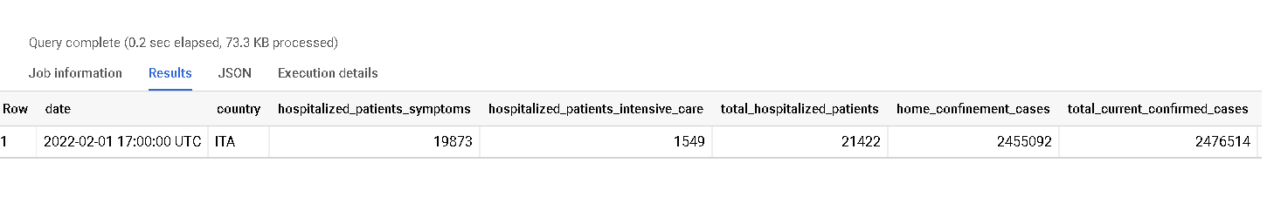

2. Query to print the details of those regions where the new total confirmed cases are greater than 1000.

SELECT country,region_name, latitude, longitude, new_total_confirmed_cases FROM `bigquery-public-data.covid19_italy.data_by_region` where (date between '2022-02-01' and '2022-02-02') and new_total_confirmed_cases>1000 LIMIT 1000

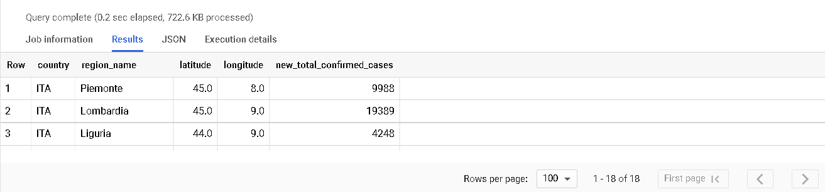

3. Query to print the number of times the cases were greater than 1000 in different regions

SELECT region_name, COUNT(date) as NO_times FROM `bigquery-public-data.covid19_italy.data_by_region` where new_total_confirmed_cases>1000 GROUP BY region_name order by NO_times DESC

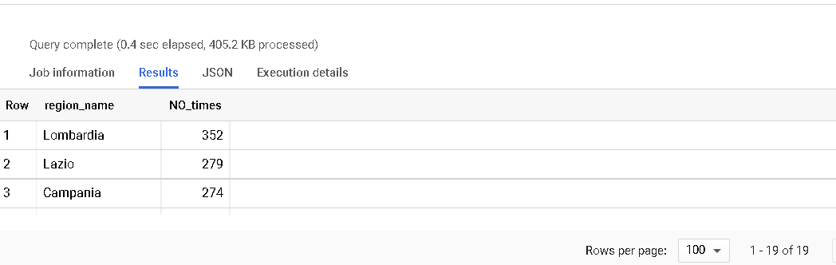

4. Query to display the details of those regions where the number of deaths is greater than 1500

SELECT region_code , region_name FROM `bigquery-public-data.covid19_italy.data_by_region` where deaths>1500 group by region_code, region_name order by cast(region_code as numeric)

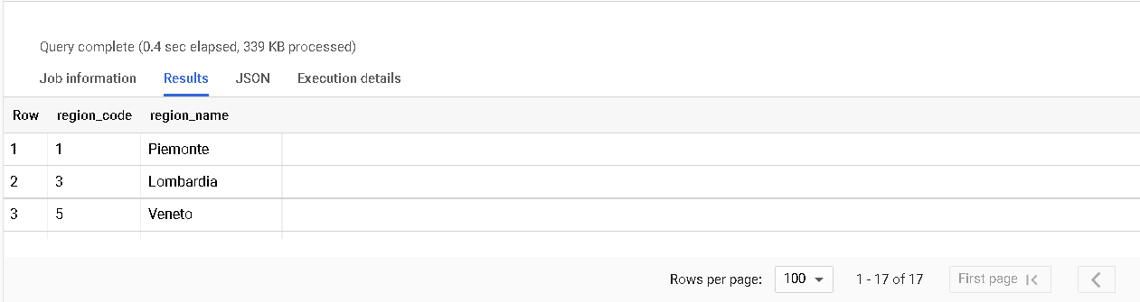

5. Query to find the positivity rate in the 2020 year.

SELECT date,country,round((((new_total_confirmed_cases)/tests_performed)*100),2) as positive_rate FROM `bigquery-public-data.covid19_italy.national_trends` where date between '2020-01-01' and '2020-12-31' order by date

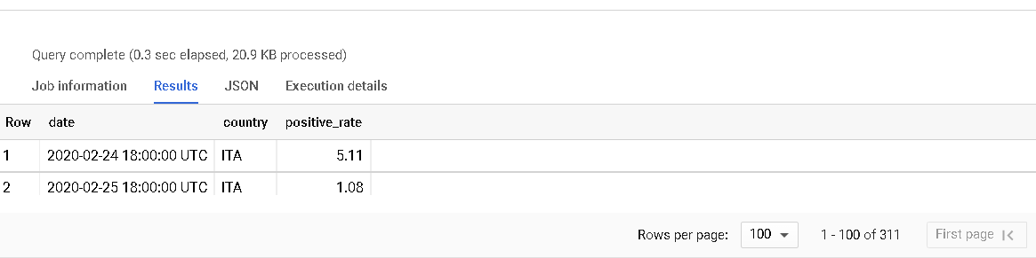

6. Query to find which provinces in Italy have the most confirmed cases?

SELECT

province_name AS province, name AS region,

confirmed_cases FROM `bigquery-public-data.covid19_italy.data_by_province` WHERE EXTRACT(date from DATE) = DATE_SUB(CURRENT_DATE(),INTERVAL 1 day) ORDER BY confirmed_cases desc

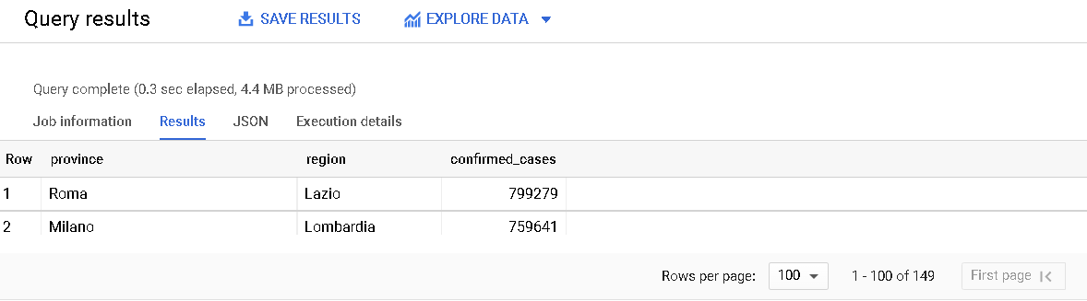

7. Query to find the percentages of tests confirmed cases.

SELECT

region_name AS region, total_confirmed_cases, tests_performed,

ROUND(total_confirmed_cases/tests_performed*100,2) AS percent_tests_confirmed_cases

FROM

`bigquery-public-data.covid19_italy.data_by_region`

WHERE

EXTRACT(date from DATE) = DATE_SUB(CURRENT_DATE(),INTERVAL 1 day)

ORDER BY

percent_tests_confirmed_cases desc

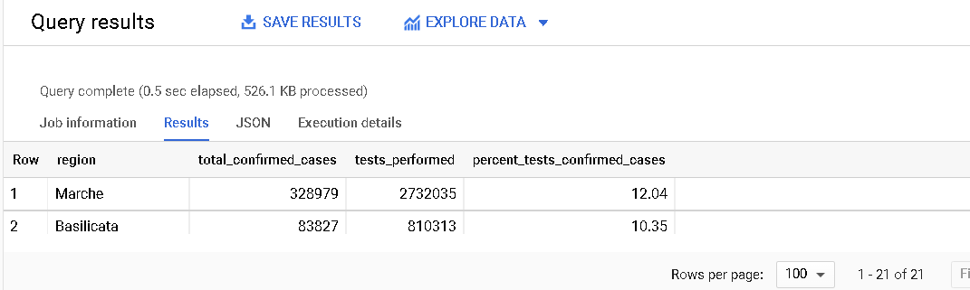

8. Query to find the details of the provision along with the region details.

SELECT distinct a.date,a.region_code,a.country,b.region_name,a.confirmed_cases FROM `bigquery-public-data.covid19_italy.data_by_province` a

inner join `bigquery-public-data.covid19_italy.data_by_region` b on a.region_code=b.region_code where a.date between '2021-01-01' and '2021-01-31'

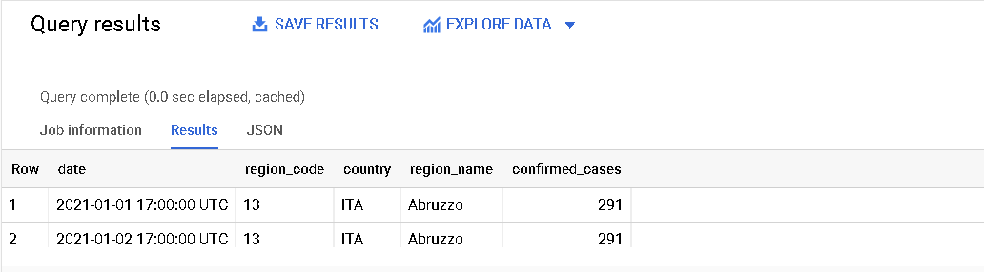

9. Query to display the region's details and the province details from the region table to show the total confirmed cases.

SELECT b.region_code,b.date,a.province_code,a.province_name,a.country,b.region_name,b.total_confirmed_cases FROM `bigquery-public-data.covid19_italy.data_by_province` a

inner join `bigquery-public-data.covid19_italy.data_by_region` b on a.region_code=b.region_code where a.region_code like '15';

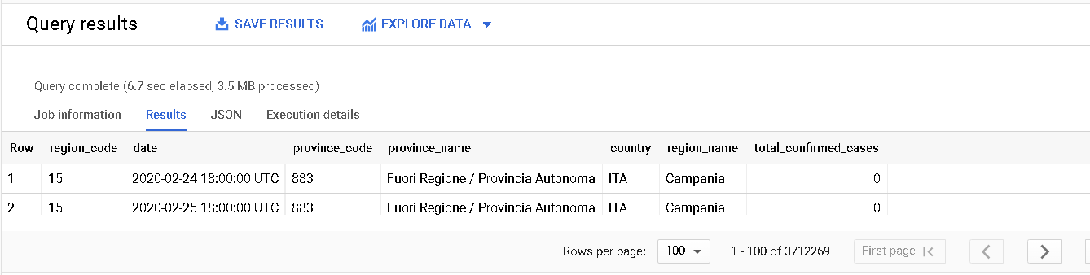

10. Query to display total hospitalized patients, total confirmed cases, and total current confirmed cases.

SELECT b.region_code,b.date,a.province_code,a.province_name,a.country,b.region_name,b.total_hospitalized_patients,b.total_current_confirmed_cases, b.total_confirmed_cases FROM `bigquery-public-data.covid19_italy.data_by_province` a

inner join `bigquery-public-data.covid19_italy.data_by_region` b on a.region_code=b.region_code;

