**ABSTRACT:**

In the recent era , due to the drastic change in the way of the thinking of the individual it had become very important to be innovative for business to run efficiently. There are lots of products available for the customer , hence it become very important for the company to decide the group of the customers to be targeted for the growth of their business . Hence , it is place where the technology come in play , we can apply various algorithms that can helps us to find the hidden pattern from the available data which can be used for better decision making. These process of segregating the customers based on their characteristics or the behaviour in a groups is known as customer segmentation . In these document the customer segmentation is done using the K-Means clustering algorithm and the visualization is done for better understanding.

**TABLE OF CONTENTS:**

1. Introduction
   1. What is customer segmentation? …………………………….. 03
   2. Customer segmentation procedure …………………………… 03
   3. Why customer segmentation? …………………………………. 03
2. Existing method ………………………………………………….. 05
3. Proposed method with architecture ………………………………. 06
4. Methodology ……………………………………………………… 08
5. Implementation …………………………………………………… 09
6. Conclusion ………………………………………………………… 10

**INTRODUCTION:**

What is customer segmentation?

Customer segmentation is the process of grouping customers together based on common characteristics. These customer groups are beneficial in marketing campaigns, in identifying potentially profitable customers . Here we were given the dataset of the customers in the mall for example let us assume it is for Mart then there are wide range of the customers that come to buy various products according to their needs and taste . The quality and the quantity of the items customers buys mainly depends on their annual salary , age , etc. Customer segmentation offers the technique to divide these customers into the groups so that they can be offered appropriate products and also the one can also identify the profitable group to target .

Customer segmentation procedure:

1. Deciding what data will be collected and how it will be gathered
2. Collecting data and integrating data from various sources
3. Developing methods of data analysis for segmentation
4. Establishing effective communication among relevant business units(such as marketing and customer service)about the segmentation
5. Implementing applications to effectively deal with the data and respond to the information it provides

Why customer segmentation?

Earlier the vendors used to focused on each and every customer for attracting them to sale their products in their shop . However , targeting the wrong customers lead to waste of lots of capital . Therefore, customer segmentation helps to grow company in various aspects such as increased customer retention , price optimization , ability to expand , capitalized at right time and many more.

Various types in which the company segments the customers are:

1. Demographic information – Segmentation based on gender, age , family and marital status , income , education , occupation , etc
2. Geographical information – Which differs depending on the scope of the company. For localized businesses, this info might pertain to specific towns or countries . For larger companies , it might mean a customer’s city, state ,or even country of residence.
3. Psychographics – Segmentation based on social class, lifestyle and personality traits
4. Behavioural data – Segmentation based on spending and consumption habits , Products/Service usage , and desired benefit.

**EXISTING METHOD:**

The existing method is from the various e-commerce websites and also many other sectors as well .Many of the e-commerce site uses the demographic method of segmenting the customers into the different groups according to the needs that benefits the company.

There are various clusters formed using various different behaviour of the customer depending on the business for example many companies like H&M , Nykaa and many more mainly make the cluster of the customers on the basis of their age because mostly their main target is the teenage or the universities students .They provide various offers at the times when the colleges or schools are about to starts so that they can attract large number of the people towards their products and eventually can maximize their sales.

However , the many branded companies mainly target the socio-economically stabled customers as they known that their costly products are most of times shopped by the customers who has income or by the customers who work in the field where they need to keep them updated with the latest trends such as designers or models.

After analysing this result the companies mainly target the customers with various offers which they may send through emails or mobile number that they ask at the time of registration of customers account. They make the automated tool that can automatically send the email or message of the offers to the customers to notify them about various offers and attracts them to purchase their products . These strategies help them to develop their business to grow at the another level using such a marketing techniques that maximize the profit of the company.

**PROPOSED METHOD WITH ARCHITECTURE:**

The dataset we are provided is for the customers of the mall having the various fields such as customer Ids, age, gender, spending score , annual income . Through these dataset we can make the clusters of the customers depending on their annual income and spending score using the unsupervised K-Means clustering algorithm . The flow of the work is as follow:

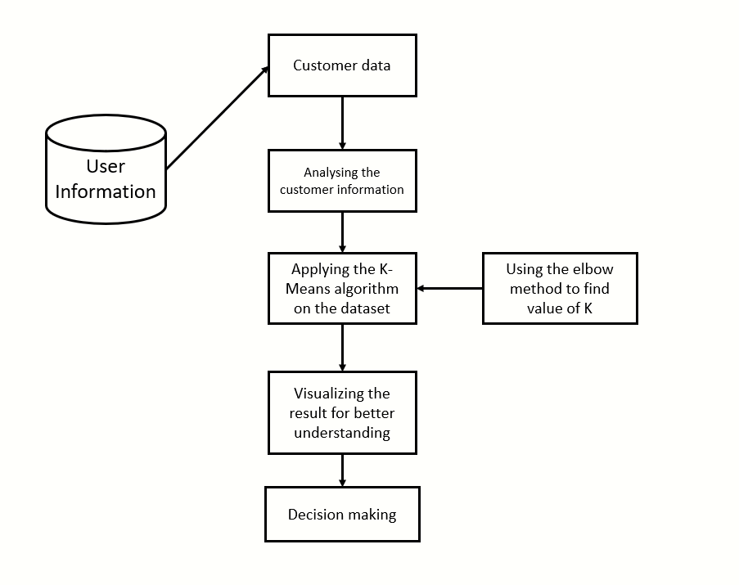

1. Customer data- The customer’s data basically include the demographic data of the customer that is customer id , gender , age , spending score, annual income . These data is extracted from the database and is used for customer segmentation using K-Means Algorithm.
2. Analysing the customer information- The data from the dataset is analysed to check the size , shape , dimension , null values and various other factors of the data .
3. Applying K-Means algorithm on the dataset- The K-Means algorithm returns the groups of customers depending on their annual income and spending score . The clusters have been formed such as customers having high spending low income and vice versa and customers having balanced between their income and spending.
4. Using elbow method to find value of K- Using elbow method we can find the value of the K i.e. the number of the clusters to be formed so that the data can be analysed and visualized more efficiently.
5. Visualizing the result for better understanding- The visualization of the cluster help us to see that there are different types of the customers who vary according to their needs and requirements . Many others visualization are also done to see that the more number of which gender mostly visit the mall , the age group of the customers that mostly visit the mall and have the large impact on the sales.
6. Decision making- After the result the appropriate BI decision is made in accordance with the need of the company to maximize their profit.

**METHODOLOGY:**

The methodology used for the segmentation of the customers is as follows:

Step 1:- Understand the potential market

One should keep tract of the numbers of customers or the end users jointed with the company . One should also keep the record of the regional wise sale of the company.

Step 2:- Select the effective factors for the development

For whole market ,group the customers into the appropriate number of groups , based on the factors that define the potential value for the company

Step 3:-Developing potential criteria

Evaluate the different number of ways of segmenting the market based on qualitative factors such as age , gender , income .

Select the best way of the segmentation.

Step 4:- Targeting

Confirm the market potential of each segment ,prioritize target in target segment. Make the attractive offer for the customers .

Step 5:- Planning

Develop each targeted segment a marketing mix action plain to support the brand position, Target the customer accounts following the segmentation guidelines and maximize the sale of the company.

**IMPLEMENTATION:**

In these competitive era, for establishing the successful business it is very important for one company to select the most useful and required for the company for its development .The company can select the any of the following methods which perform best for their company.

A priori**segmentation,** the simplest approach, uses a classification scheme based on publicly available characteristics — such as industry and company size — to create distinct groups of customers within a market. However, a priori market segmentation may not always be valid, since companies in the same industry and of the same size may have very different needs.

Needs-based**segmentation** is based on differentiated, validated drivers (needs) that customers express for a specific product or service being offered. The needs are discovered and verified through primary market research, and segments are demarcated based on those different needs rather than characteristics such as industry or company size.

Value-based **segmentation** differentiates customers by their economic value, grouping customers with the same value level into individual segments that can be distinctly targeted.

Also along with using this method one should always keep updating its segmentation in fixed interval of time so that they can maximize their sale and can bring more and more profit to their company.

**CONCLUSION:**

From this we can conclude that the factors such as annual income and spending score are the main factors that are used to form the groups of the customers to be target to maximize the profit for the company and also these information of the groups can also be used to provide the better service to the customer as we can easily analyse what they need and what they don’t.