|  |
| --- |
| **ONLINE SHOPPING DATABASE MANAGEMENT SYSTEM** |
| NAME-RIYA BHATT |
|  |
|  |

ABSTRACT

The Online Shopping is a web-based application intended for online retailers.

The main objective of this application is to make it interactive and its ease of use. It

would make searching, viewing and selection of a product easier. It contains a

sophisticated search engine for users to search for products specific to their needs.

The search engine provides an easy and convenient way to search for products where

a user can Search for a product interactively and the search engine would refine the

products available based on the user’s input. The user can then view the complete

specification of each product. They can also view the product reviews and also write

their own reviews. The application also provides a drag and drop feature so that a

user can add a product to the shopping cart by dragging the item in to the shopping

cart. The main emphasis lies in providing a user-friendly search engine for effectively

showing the desired results and its drag and drop behavior.

This project is an attempt to provide the advantages of online shopping to

customers of a real shop. It helps buying the products in the shop anywhere through

internet by using an android device. Thus, the customer will get the service of online

shopping and home delivery from his favorite shop. This system can be implemented

to any shop in the locality or to multinational branded shops having retail outlet

chains.

If shops are providing an online portal where their customers can enjoy

easy shopping from anywhere, the shops won’t be losing any more customers to the

trending online shops such as flipchart or eBay. Since the application is available in

the Smartphone it is easily accessible and always available.

ABSTRACT

The Online Shopping is a web-based application intended for online retailers.

The main objective of this application is to make it interactive and its ease of use. It

would make searching, viewing and selection of a product easier. It contains a

sophisticated search engine for users to search for products specific to their needs.

The search engine provides an easy and convenient way to search for products where

a user can Search for a product interactively and the search engine would refine the

products available based on the user’s input. The user can then view the complete

specification of each product. They can also view the product reviews and also write

their own reviews. The application also provides a drag and drop feature so that a

user can add a product to the shopping cart by dragging the item in to the shopping

cart. The main emphasis lies in providing a user-friendly search engine for effectively

showing the desired results and its drag and drop behavior.

This project is an attempt to provide the advantages of online shopping to

customers of a real shop. It helps buying the products in the shop anywhere through

internet by using an android device. Thus, the customer will get the service of online

shopping and home delivery from his favorite shop. This system can be implemented

to any shop in the locality or to multinational branded shops having retail outlet

chains.

If shops are providing an online portal where their customers can enjoy

easy shopping from anywhere, the shops won’t be losing any more customers to the

trending online shops such as flipchart or eBay. Since the application is available in

the Smartphone it is easily accessible and always available.

The Online Shopping is a web-based application intended for online retailers.

The main objective of this application is to make it interactive and its ease of use. It

would make searching, viewing and selection of a product easier. It contains a

sophisticated search engine for users to search for products specific to their needs.

The search engine provides an easy and convenient way to search for products where

a user can Search for a product interactively and the search engine would refine the

products available based on the user’s input. The user can then view the complete

specification of each product. They can also view the product reviews and also write

their own reviews. The application also provides a drag and drop feature so that a

user can add a product to the shopping cart by dragging the item in to the shopping

cart. The main emphasis lies in providing a user-friendly search engine for effectively

showing the desired results and its drag and drop behavior.

This project is an attempt to provide the advantages of online shopping to

customers of a real shop. It helps buying the products in the shop anywhere through

internet by using an android device. Thus, the customer will get the service of online

shopping and home delivery from his favorite shop. This system can be implemented

to any shop in the locality or to multinational branded shops having retail outlet

chains.

If shops are providing an online portal where their customers can enjoy

easy shopping from anywhere, the shops won’t be losing any more customers to the

trending online shops such as flipchart or eBay. Since the application is available in

the Smartphone it is easily accessible and always available.

The Online Shopping is a web-based application intended for online retailers.

The main objective of this application is to make it interactive and its ease of use. It

would make searching, viewing and selection of a product easier. It contains a

sophisticated search engine for users to search for products specific to their needs.

The search engine provides an easy and convenient way to search for products where

a user can Search for a product interactively and the search engine would refine the

products available based on the user’s input. The user can then view the complete

specification of each product. They can also view the product reviews and also write

their own reviews. The application also provides a drag and drop feature so that a

user can add a product to the shopping cart by dragging the item in to the shopping

cart. The main emphasis lies in providing a user-friendly search engine for effectively

showing the desired results and its drag and drop behavior.

**INTRODUCTION:-**

The Online Shopping is a web – based application intended for online retailers .The main objective of this application is to make it interactive and its ease of use.It would make searching,viewing and selection of a products easier.This system involves its own database to be maintained .As information are stored in the database.The application design contains two modules one is for the customer who wish to buy the products. And another is for the store owners who maintain and updates the information regarding the products and about the customers .

**SCHEMA DIAGRAM:-**

**BILLS :-** Bill_no , cust_id , itemcode ,delivery_address,Bill_date , mode_of_payment, expected_delivery , date .

**Category :-** cat_id , cat name

**Delivery service:-** delivery_address , delivery_charge,contact_no.

**Wishes_to_buy :-** cust_id ,itemcode

**Customer:-** cust_id , fname , lname , contact , email_id

**Purchased:-**itemcode , cust_id , quantity , purchased_date .

**Customer address:-**cust_id , address .

**Items :-** itemcode , name , cat_id , stock , brand , discount , price , rating , description .

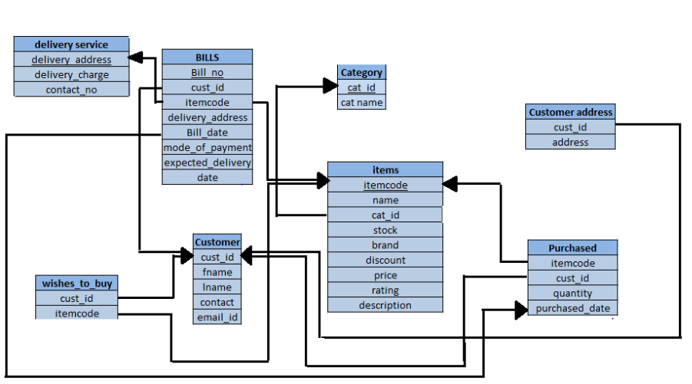

CREATE TABLE QUERY:-

CREATE TABLE Customer (

custID char(9) NOT NULL,

fname Varchar(15),

lname Varchar(15),

Contact Varchar(13),

Email_id Varchar(20),

PRIMARY KEY (custID)

);

CREATE TABLE CustomerAddress (

custID char(9) NOT NULL,

Address Varchar(30),

PRIMARY KEY (custID,Address),

FOREIGN KEY (custID) REFERENCES Customer(custID));

CREATE TABLE Category(

catID char(9),

catName Varchar(20),

PRIMARY KEY (catID)

);

CREATE TABLE Items (

itemCode Varchar(5) NOT NULL,

Name Varchar(20),

catID char(9),

Stock int,

Brand Varchar(20),

Discount numeric(3,1),

Price Decimal(8,2),

Rating numeric(2,1),

Description Varchar(30),

PRIMARY KEY (itemCode),

FOREIGN KEY (catID) REFERENCES Category(catID) );

CREATE TABLE DeliveryService (

delivery_address Varchar(30),

delivery_charge numeric(5,2),

contact_no Varchar(13),

PRIMARY KEY (delivery_address)

);

CREATE TABLE purchased(

itemCode Varchar(5),

custID char(9),

Quantity int,

purchased_date date,

PRIMARY KEY ( purchased_date),

FOREIGN KEY (itemCode) REFERENCES Items(itemCode),

FOREIGN KEY (custID) REFERENCES Customer(custID)

);

CREATE TABLE Bills(

Bill_no Varchar(5) NOT NULL,

custID char(9),

itemCode Varchar(5),

delivery_address Varchar(30),

bill_date date,

Mode_of_Payment Varchar(15),

expected_delivery_date Date,

PRIMARY KEY(bill_no),

FOREIGN KEY (custID) REFERENCES customer,

FOREIGN KEY (itemCode)REFERENCES items,

FOREIGN KEY (delivery_address) REFERENCES DeliveryService,

FOREIGN KEY (Bill_date) REFERENCES PURCHASED);

CREATE TABLE wishes_to_buy(

custID char(9),

itemCode Varchar(5),

FOREIGN KEY (itemCode) REFERENCES Items,

FOREIGN KEY (custID) REFERENCES Customer );

The Online Shopping is a web-based application intended for online retailers.

The main objective of this application is to make it interactive and its ease of use. It

would make searching, viewing and selection of a product easier. It contains a

sophisticated search engine for users to search for products specific to their needs.

The search engine provides an easy and convenient way to search for products where

a user can Search for a product interactively and the search engine would refine the

products available based on the user’s input. The user can then view the complete

specification of each product. They can also view the product reviews and also write

their own reviews. The application also provides a drag and drop feature so that a

user can add a product to the shopping cart by dragging the item in to the shopping

cart. The main emphasis lies in providing a user-friendly search engine for effectively

showing the desired results and its drag and drop behavior.

The Online Shopping is a web-based application intended for online retailers.

The main objective of this application is to make it interactive and its ease of use. It

would make searching, viewing and selection of a product easier. It contains a

sophisticated search engine for users to search for products specific to their needs.

The search engine provides an easy and convenient way to search for products where

a user can Search for a product interactively and the search engine would refine the

products available based on the user’s input

The Online Shopping is a web-based application intended for online retailers.

The main objective of this application is to make it interactive and its ease of use. It

would make searching, viewing and selection of a product easier. It contains a

sophisticated search engine for users to search for products specific to their needs.

The search engine provides an easy and convenient way to search for products where

a user can Search for a product interactively and the search engine would refine the

products available based on the user’s input

The Online Shopping is a web-based application intended for online retailers.

The main objective of this application is to make it interactive and its ease of use. It

would make searching, viewing and selection of a product easier. It contains a

sophisticated search engine for users to search for products specific to their needs.

The search engine provides an easy and convenient way to search for products where

a user can Search for a product interactively and the search engine would refine the

products available based on the user’s input

The Online Shopping is a web-based application intended for online retailers.

The main objective of this application is to make it interactive and its ease of use. It

would make searching, viewing and selection of a product easier. It contains a

sophisticated search engine for users to search for products specific to their needs.

The search engine provides an easy and convenient way to search for products where

a user can Search for a product interactively and the search engine would refine the

products available based on the user’s input

The Online Shopping is a web-based application intended for online retailers.

The main objective of this application is to make it interactive and its ease of use. It

would make searching, viewing and selection of a product easier. It contains a

sophisticated search engine for users to search for products specific to their needs.

The search engine provides an easy and convenient way to search for products where

a user can Search for a product interactively and the search engine would refine the

products available based on the user’s input

**BILLS TABLE**

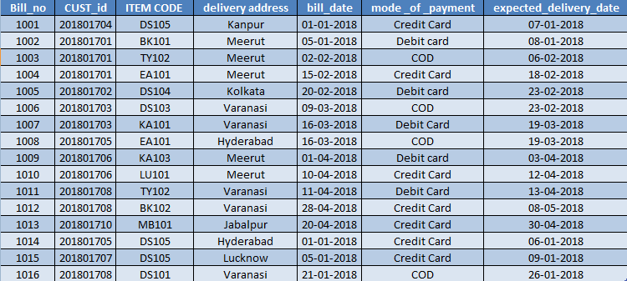

**CATEGORY**

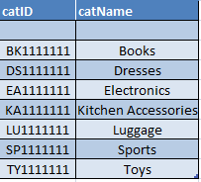

**CUSTOMER**





**WISHES TO BUY**

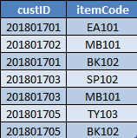

**CUSTOMER ADDRESS**

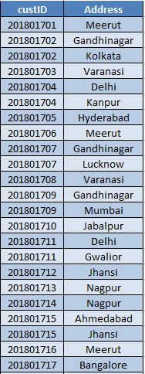

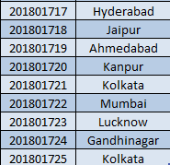

**Delivery_service**

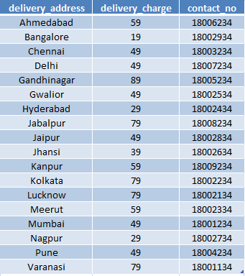

**Items**

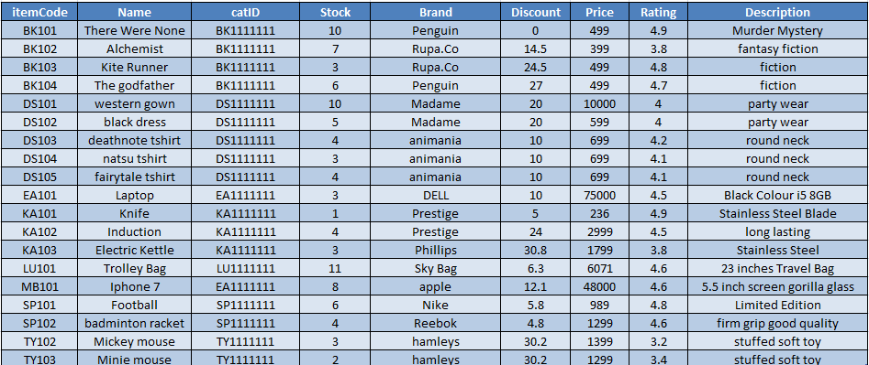

**Purchased**

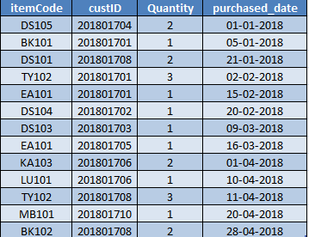

**DATABASE DIAGRAM:-**

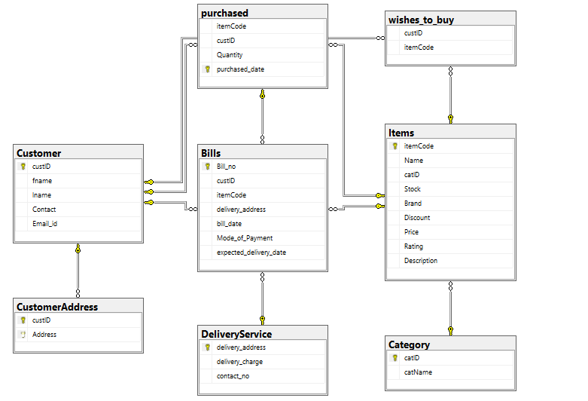

**ERD DIAGRAM:-**

