**Process Name: Update mapping (if needed) generating assessment plan and course outline**

**Activities:**

1. Faculty, Collect all information from OBE storage which is stored by the department.
2. Now If the faculty wants to change something new in PLO vs course initial mapping then s/he can change that mapping and store it in OBE storage.
3. If faculty wants to check the previous course outline then they have to collect it from OBE storage. Then if needed then they have to prepare the new course outline with course outcomes.
4. Now identify for each course main objectives.
5. Then create mapping Co's with PLO like:  
   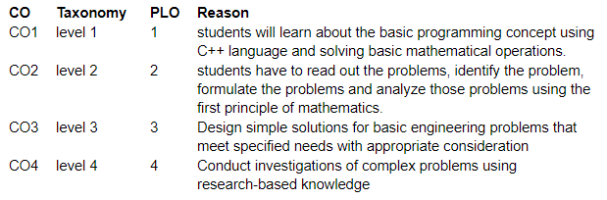
6. Here, CO1 is considered as a "first level(remembering)"(That's provided "Level of learning bloom Taxonomy") of this course. But in bloom taxonomy:(remembering, understanding, Applying, Analyzing, Evaluation, and lastly creating).
7. Now in PLO, which is more appropriate for the first level of CO.
8. After this, then write down the reason.

6. Then they have to find the course outline of a single course, mapped with the course outline to PLO and store it to OBE storage.

7. Now, Faculty members will create the course assessment based based on CO and PLO updated mapping like:

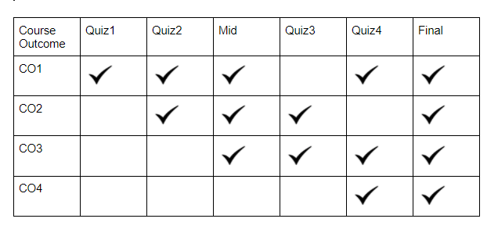

1. In this course the first quiz will be very fundamental theory. There are 4 CO's(CO1, CO2, CO3, CO4).Here CO1 Mapped with PLO(Engineering knowledge) which is a very basic thing. And also used in (Quiz-2, MID ,Quiz-4,Final).
2. In the 2nd CO: this is a little more difficult. Read out the problems, formulated the problems using the first principle of mathematics. so this CO2 is actually represented by the "Quiz-2" and "MID term" exam. In this way faculty can create assessment planning and also update course outline.

8. Store course assessments and course outline information to OBE storage.