## Riya Desai

## Phase 1 - Project

## Due Date 06/19/2023

library(readr)  
library(tidyverse)

## ── Attaching core tidyverse packages ──────────────────────── tidyverse 2.0.0 ──  
## ✔ dplyr 1.1.2 ✔ purrr 1.0.1  
## ✔ forcats 1.0.0 ✔ stringr 1.5.0  
## ✔ ggplot2 3.4.2 ✔ tibble 3.2.1  
## ✔ lubridate 1.9.2 ✔ tidyr 1.3.0  
## ── Conflicts ────────────────────────────────────────── tidyverse_conflicts() ──  
## ✖ dplyr::filter() masks stats::filter()  
## ✖ dplyr::lag() masks stats::lag()  
## ℹ Use the conflicted package (<http://conflicted.r-lib.org/>) to force all conflicts to become errors

library(tidyr)  
student <- read_csv("~/Desktop/UNCW/ames_student.csv")

## Rows: 2053 Columns: 81  
## ── Column specification ────────────────────────────────────────────────────────  
## Delimiter: ","  
## chr (47): MS_SubClass, MS_Zoning, Street, Alley, Lot_Shape, Land_Contour, Ut...  
## dbl (34): Lot_Frontage, Lot_Area, Year_Built, Year_Remod_Add, Mas_Vnr_Area, ...  
##   
## ℹ Use `spec()` to retrieve the full column specification for this data.  
## ℹ Specify the column types or set `show_col_types = FALSE` to quiet this message.

str(student)

## spc_tbl_ [2,053 × 81] (S3: spec_tbl_df/tbl_df/tbl/data.frame)  
## $ MS_SubClass : chr [1:2053] "One_Story_1946_and_Newer_All_Styles" "One_Story_1946_and_Newer_All_Styles" "One_Story_1946_and_Newer_All_Styles" "One_Story_1946_and_Newer_All_Styles" ...  
## $ MS_Zoning : chr [1:2053] "Residential_Low_Density" "Residential_High_Density" "Residential_Low_Density" "Residential_Low_Density" ...  
## $ Lot_Frontage : num [1:2053] 141 80 81 93 74 78 43 39 0 85 ...  
## $ Lot_Area : num [1:2053] 31770 11622 14267 11160 13830 ...  
## $ Street : chr [1:2053] "Pave" "Pave" "Pave" "Pave" ...  
## $ Alley : chr [1:2053] "No_Alley_Access" "No_Alley_Access" "No_Alley_Access" "No_Alley_Access" ...  
## $ Lot_Shape : chr [1:2053] "Slightly_Irregular" "Regular" "Slightly_Irregular" "Regular" ...  
## $ Land_Contour : chr [1:2053] "Lvl" "Lvl" "Lvl" "Lvl" ...  
## $ Utilities : chr [1:2053] "AllPub" "AllPub" "AllPub" "AllPub" ...  
## $ Lot_Config : chr [1:2053] "Corner" "Inside" "Corner" "Corner" ...  
## $ Land_Slope : chr [1:2053] "Gtl" "Gtl" "Gtl" "Gtl" ...  
## $ Neighborhood : chr [1:2053] "North_Ames" "North_Ames" "North_Ames" "North_Ames" ...  
## $ Condition_1 : chr [1:2053] "Norm" "Feedr" "Norm" "Norm" ...  
## $ Condition_2 : chr [1:2053] "Norm" "Norm" "Norm" "Norm" ...  
## $ Bldg_Type : chr [1:2053] "OneFam" "OneFam" "OneFam" "OneFam" ...  
## $ House_Style : chr [1:2053] "One_Story" "One_Story" "One_Story" "One_Story" ...  
## $ Overall_Qual : chr [1:2053] "Above_Average" "Average" "Above_Average" "Good" ...  
## $ Overall_Cond : chr [1:2053] "Average" "Above_Average" "Above_Average" "Average" ...  
## $ Year_Built : num [1:2053] 1960 1961 1958 1968 1997 ...  
## $ Year_Remod_Add : num [1:2053] 1960 1961 1958 1968 1998 ...  
## $ Roof_Style : chr [1:2053] "Hip" "Gable" "Hip" "Hip" ...  
## $ Roof_Matl : chr [1:2053] "CompShg" "CompShg" "CompShg" "CompShg" ...  
## $ Exterior_1st : chr [1:2053] "BrkFace" "VinylSd" "Wd Sdng" "BrkFace" ...  
## $ Exterior_2nd : chr [1:2053] "Plywood" "VinylSd" "Wd Sdng" "BrkFace" ...  
## $ Mas_Vnr_Type : chr [1:2053] "Stone" "None" "BrkFace" "None" ...  
## $ Mas_Vnr_Area : num [1:2053] 112 0 108 0 0 20 0 0 0 0 ...  
## $ Exter_Qual : chr [1:2053] "Typical" "Typical" "Typical" "Good" ...  
## $ Exter_Cond : chr [1:2053] "Typical" "Typical" "Typical" "Typical" ...  
## $ Foundation : chr [1:2053] "CBlock" "CBlock" "CBlock" "CBlock" ...  
## $ Bsmt_Qual : chr [1:2053] "Typical" "Typical" "Typical" "Typical" ...  
## $ Bsmt_Cond : chr [1:2053] "Good" "Typical" "Typical" "Typical" ...  
## $ Bsmt_Exposure : chr [1:2053] "Gd" "No" "No" "No" ...  
## $ BsmtFin_Type_1 : chr [1:2053] "BLQ" "Rec" "ALQ" "ALQ" ...  
## $ BsmtFin_SF_1 : num [1:2053] 2 6 1 1 3 3 1 3 1 3 ...  
## $ BsmtFin_Type_2 : chr [1:2053] "Unf" "LwQ" "Unf" "Unf" ...  
## $ BsmtFin_SF_2 : num [1:2053] 0 144 0 0 0 0 0 0 0 0 ...  
## $ Bsmt_Unf_SF : num [1:2053] 441 270 406 1045 137 ...  
## $ Total_Bsmt_SF : num [1:2053] 1080 882 1329 2110 928 ...  
## $ Heating : chr [1:2053] "GasA" "GasA" "GasA" "GasA" ...  
## $ Heating_QC : chr [1:2053] "Fair" "Typical" "Typical" "Excellent" ...  
## $ Central_Air : chr [1:2053] "Y" "Y" "Y" "Y" ...  
## $ Electrical : chr [1:2053] "SBrkr" "SBrkr" "SBrkr" "SBrkr" ...  
## $ First_Flr_SF : num [1:2053] 1656 896 1329 2110 928 ...  
## $ Second_Flr_SF : num [1:2053] 0 0 0 0 701 678 0 0 0 0 ...  
## $ Low_Qual_Fin_SF : num [1:2053] 0 0 0 0 0 0 0 0 0 0 ...  
## $ Gr_Liv_Area : num [1:2053] 1656 896 1329 2110 1629 ...  
## $ Bsmt_Full_Bath : num [1:2053] 1 0 0 1 0 0 0 1 1 1 ...  
## $ Bsmt_Half_Bath : num [1:2053] 0 0 0 0 0 0 0 0 0 0 ...  
## $ Full_Bath : num [1:2053] 1 1 1 2 2 2 2 2 2 1 ...  
## $ Half_Bath : num [1:2053] 0 0 1 1 1 1 0 0 0 1 ...  
## $ Bedroom_AbvGr : num [1:2053] 3 2 3 3 3 3 2 2 3 2 ...  
## $ Kitchen_AbvGr : num [1:2053] 1 1 1 1 1 1 1 1 1 1 ...  
## $ Kitchen_Qual : chr [1:2053] "Typical" "Typical" "Good" "Excellent" ...  
## $ TotRms_AbvGrd : num [1:2053] 7 5 6 8 6 7 5 5 6 5 ...  
## $ Functional : chr [1:2053] "Typ" "Typ" "Typ" "Typ" ...  
## $ Fireplaces : num [1:2053] 2 0 0 2 1 1 0 1 0 1 ...  
## $ Fireplace_Qu : chr [1:2053] "Good" "No_Fireplace" "No_Fireplace" "Typical" ...  
## $ Garage_Type : chr [1:2053] "Attchd" "Attchd" "Attchd" "Attchd" ...  
## $ Garage_Finish : chr [1:2053] "Fin" "Unf" "Unf" "Fin" ...  
## $ Garage_Cars : num [1:2053] 2 1 1 2 2 2 2 2 2 2 ...  
## $ Garage_Area : num [1:2053] 528 730 312 522 482 470 506 608 420 506 ...  
## $ Garage_Qual : chr [1:2053] "Typical" "Typical" "Typical" "Typical" ...  
## $ Garage_Cond : chr [1:2053] "Typical" "Typical" "Typical" "Typical" ...  
## $ Paved_Drive : chr [1:2053] "Partial_Pavement" "Paved" "Paved" "Paved" ...  
## $ Wood_Deck_SF : num [1:2053] 210 140 393 0 212 360 0 237 483 192 ...  
## $ Open_Porch_SF : num [1:2053] 62 0 36 0 34 36 82 152 21 0 ...  
## $ Enclosed_Porch : num [1:2053] 0 0 0 0 0 0 0 0 0 0 ...  
## $ Three_season_porch: num [1:2053] 0 0 0 0 0 0 0 0 0 0 ...  
## $ Screen_Porch : num [1:2053] 0 120 0 0 0 0 144 0 0 0 ...  
## $ Pool_Area : num [1:2053] 0 0 0 0 0 0 0 0 0 0 ...  
## $ Pool_QC : chr [1:2053] "No_Pool" "No_Pool" "No_Pool" "No_Pool" ...  
## $ Fence : chr [1:2053] "No_Fence" "Minimum_Privacy" "No_Fence" "No_Fence" ...  
## $ Misc_Feature : chr [1:2053] "None" "None" "Gar2" "None" ...  
## $ Misc_Val : num [1:2053] 0 0 12500 0 0 0 0 0 500 0 ...  
## $ Mo_Sold : num [1:2053] 5 6 6 4 3 6 1 3 3 2 ...  
## $ Year_Sold : num [1:2053] 2010 2010 2010 2010 2010 2010 2010 2010 2010 2010 ...  
## $ Sale_Type : chr [1:2053] "WD" "WD" "WD" "WD" ...  
## $ Sale_Condition : chr [1:2053] "Normal" "Normal" "Normal" "Normal" ...  
## $ Longitude : num [1:2053] -93.6 -93.6 -93.6 -93.6 -93.6 ...  
## $ Latitude : num [1:2053] 42.1 42.1 42.1 42.1 42.1 ...  
## $ Above_Median : chr [1:2053] "Yes" "No" "Yes" "Yes" ...  
## - attr(*, "spec")=  
## .. cols(  
## .. MS_SubClass = col_character(),  
## .. MS_Zoning = col_character(),  
## .. Lot_Frontage = col_double(),  
## .. Lot_Area = col_double(),  
## .. Street = col_character(),  
## .. Alley = col_character(),  
## .. Lot_Shape = col_character(),  
## .. Land_Contour = col_character(),  
## .. Utilities = col_character(),  
## .. Lot_Config = col_character(),  
## .. Land_Slope = col_character(),  
## .. Neighborhood = col_character(),  
## .. Condition_1 = col_character(),  
## .. Condition_2 = col_character(),  
## .. Bldg_Type = col_character(),  
## .. House_Style = col_character(),  
## .. Overall_Qual = col_character(),  
## .. Overall_Cond = col_character(),  
## .. Year_Built = col_double(),  
## .. Year_Remod_Add = col_double(),  
## .. Roof_Style = col_character(),  
## .. Roof_Matl = col_character(),  
## .. Exterior_1st = col_character(),  
## .. Exterior_2nd = col_character(),  
## .. Mas_Vnr_Type = col_character(),  
## .. Mas_Vnr_Area = col_double(),  
## .. Exter_Qual = col_character(),  
## .. Exter_Cond = col_character(),  
## .. Foundation = col_character(),  
## .. Bsmt_Qual = col_character(),  
## .. Bsmt_Cond = col_character(),  
## .. Bsmt_Exposure = col_character(),  
## .. BsmtFin_Type_1 = col_character(),  
## .. BsmtFin_SF_1 = col_double(),  
## .. BsmtFin_Type_2 = col_character(),  
## .. BsmtFin_SF_2 = col_double(),  
## .. Bsmt_Unf_SF = col_double(),  
## .. Total_Bsmt_SF = col_double(),  
## .. Heating = col_character(),  
## .. Heating_QC = col_character(),  
## .. Central_Air = col_character(),  
## .. Electrical = col_character(),  
## .. First_Flr_SF = col_double(),  
## .. Second_Flr_SF = col_double(),  
## .. Low_Qual_Fin_SF = col_double(),  
## .. Gr_Liv_Area = col_double(),  
## .. Bsmt_Full_Bath = col_double(),  
## .. Bsmt_Half_Bath = col_double(),  
## .. Full_Bath = col_double(),  
## .. Half_Bath = col_double(),  
## .. Bedroom_AbvGr = col_double(),  
## .. Kitchen_AbvGr = col_double(),  
## .. Kitchen_Qual = col_character(),  
## .. TotRms_AbvGrd = col_double(),  
## .. Functional = col_character(),  
## .. Fireplaces = col_double(),  
## .. Fireplace_Qu = col_character(),  
## .. Garage_Type = col_character(),  
## .. Garage_Finish = col_character(),  
## .. Garage_Cars = col_double(),  
## .. Garage_Area = col_double(),  
## .. Garage_Qual = col_character(),  
## .. Garage_Cond = col_character(),  
## .. Paved_Drive = col_character(),  
## .. Wood_Deck_SF = col_double(),  
## .. Open_Porch_SF = col_double(),  
## .. Enclosed_Porch = col_double(),  
## .. Three_season_porch = col_double(),  
## .. Screen_Porch = col_double(),  
## .. Pool_Area = col_double(),  
## .. Pool_QC = col_character(),  
## .. Fence = col_character(),  
## .. Misc_Feature = col_character(),  
## .. Misc_Val = col_double(),  
## .. Mo_Sold = col_double(),  
## .. Year_Sold = col_double(),  
## .. Sale_Type = col_character(),  
## .. Sale_Condition = col_character(),  
## .. Longitude = col_double(),  
## .. Latitude = col_double(),  
## .. Above_Median = col_character()  
## .. )  
## - attr(*, "problems")=<externalptr>

summary(student)

## MS_SubClass MS_Zoning Lot_Frontage Lot_Area   
## Length:2053 Length:2053 Min. : 0.00 Min. : 1300   
## Class :character Class :character 1st Qu.: 43.00 1st Qu.: 7500   
## Mode :character Mode :character Median : 62.00 Median : 9548   
## Mean : 57.38 Mean : 10258   
## 3rd Qu.: 78.00 3rd Qu.: 11600   
## Max. :313.00 Max. :215245   
## Street Alley Lot_Shape Land_Contour   
## Length:2053 Length:2053 Length:2053 Length:2053   
## Class :character Class :character Class :character Class :character   
## Mode :character Mode :character Mode :character Mode :character   
##   
##   
##   
## Utilities Lot_Config Land_Slope Neighborhood   
## Length:2053 Length:2053 Length:2053 Length:2053   
## Class :character Class :character Class :character Class :character   
## Mode :character Mode :character Mode :character Mode :character   
##   
##   
##   
## Condition_1 Condition_2 Bldg_Type House_Style   
## Length:2053 Length:2053 Length:2053 Length:2053   
## Class :character Class :character Class :character Class :character   
## Mode :character Mode :character Mode :character Mode :character   
##   
##   
##   
## Overall_Qual Overall_Cond Year_Built Year_Remod_Add  
## Length:2053 Length:2053 Min. :1875 Min. :1950   
## Class :character Class :character 1st Qu.:1953 1st Qu.:1965   
## Mode :character Mode :character Median :1972 Median :1993   
## Mean :1971 Mean :1984   
## 3rd Qu.:2000 3rd Qu.:2004   
## Max. :2010 Max. :2010   
## Roof_Style Roof_Matl Exterior_1st Exterior_2nd   
## Length:2053 Length:2053 Length:2053 Length:2053   
## Class :character Class :character Class :character Class :character   
## Mode :character Mode :character Mode :character Mode :character   
##   
##   
##   
## Mas_Vnr_Type Mas_Vnr_Area Exter_Qual Exter_Cond   
## Length:2053 Min. : 0.0 Length:2053 Length:2053   
## Class :character 1st Qu.: 0.0 Class :character Class :character   
## Mode :character Median : 0.0 Mode :character Mode :character   
## Mean : 103.8   
## 3rd Qu.: 164.0   
## Max. :1600.0   
## Foundation Bsmt_Qual Bsmt_Cond Bsmt_Exposure   
## Length:2053 Length:2053 Length:2053 Length:2053   
## Class :character Class :character Class :character Class :character   
## Mode :character Mode :character Mode :character Mode :character   
##   
##   
##   
## BsmtFin_Type_1 BsmtFin_SF_1 BsmtFin_Type_2 BsmtFin_SF_2   
## Length:2053 Min. :1.00 Length:2053 Min. : 0.00   
## Class :character 1st Qu.:3.00 Class :character 1st Qu.: 0.00   
## Mode :character Median :3.00 Mode :character Median : 0.00   
## Mean :4.21 Mean : 52.57   
## 3rd Qu.:7.00 3rd Qu.: 0.00   
## Max. :7.00 Max. :1526.00   
## Bsmt_Unf_SF Total_Bsmt_SF Heating Heating_QC   
## Min. : 0.0 Min. : 0 Length:2053 Length:2053   
## 1st Qu.: 226.0 1st Qu.: 793 Class :character Class :character   
## Median : 460.0 Median : 988 Mode :character Mode :character   
## Mean : 561.2 Mean :1055   
## 3rd Qu.: 801.0 3rd Qu.:1304   
## Max. :2336.0 Max. :5095   
## Central_Air Electrical First_Flr_SF Second_Flr_SF   
## Length:2053 Length:2053 Min. : 432 Min. : 0.0   
## Class :character Class :character 1st Qu.: 882 1st Qu.: 0.0   
## Mode :character Mode :character Median :1088 Median : 0.0   
## Mean :1168 Mean : 326.1   
## 3rd Qu.:1402 3rd Qu.: 701.0   
## Max. :5095 Max. :1862.0   
## Low_Qual_Fin_SF Gr_Liv_Area Bsmt_Full_Bath Bsmt_Half_Bath   
## Min. : 0.000 Min. : 480 Min. :0.0000 Min. :0.00000   
## 1st Qu.: 0.000 1st Qu.:1137 1st Qu.:0.0000 1st Qu.:0.00000   
## Median : 0.000 Median :1447 Median :0.0000 Median :0.00000   
## Mean : 4.973 Mean :1499 Mean :0.4301 Mean :0.05796   
## 3rd Qu.: 0.000 3rd Qu.:1737 3rd Qu.:1.0000 3rd Qu.:0.00000   
## Max. :1064.000 Max. :5095 Max. :3.0000 Max. :2.00000   
## Full_Bath Half_Bath Bedroom_AbvGr Kitchen_AbvGr   
## Min. :0.000 Min. :0.0000 Min. :0.000 Min. :1.000   
## 1st Qu.:1.000 1st Qu.:0.0000 1st Qu.:2.000 1st Qu.:1.000   
## Median :2.000 Median :0.0000 Median :3.000 Median :1.000   
## Mean :1.564 Mean :0.3751 Mean :2.855 Mean :1.047   
## 3rd Qu.:2.000 3rd Qu.:1.0000 3rd Qu.:3.000 3rd Qu.:1.000   
## Max. :4.000 Max. :2.0000 Max. :6.000 Max. :3.000   
## Kitchen_Qual TotRms_AbvGrd Functional Fireplaces   
## Length:2053 Min. : 3.000 Length:2053 Min. :0.000   
## Class :character 1st Qu.: 5.000 Class :character 1st Qu.:0.000   
## Mode :character Median : 6.000 Mode :character Median :1.000   
## Mean : 6.442 Mean :0.603   
## 3rd Qu.: 7.000 3rd Qu.:1.000   
## Max. :15.000 Max. :4.000   
## Fireplace_Qu Garage_Type Garage_Finish Garage_Cars   
## Length:2053 Length:2053 Length:2053 Min. :0.000   
## Class :character Class :character Class :character 1st Qu.:1.000   
## Mode :character Mode :character Mode :character Median :2.000   
## Mean :1.774   
## 3rd Qu.:2.000   
## Max. :5.000   
## Garage_Area Garage_Qual Garage_Cond Paved_Drive   
## Min. : 0 Length:2053 Length:2053 Length:2053   
## 1st Qu.: 320 Class :character Class :character Class :character   
## Median : 478 Mode :character Mode :character Mode :character   
## Mean : 472   
## 3rd Qu.: 576   
## Max. :1488   
## Wood_Deck_SF Open_Porch_SF Enclosed_Porch Three_season_porch  
## Min. : 0.00 Min. : 0.00 Min. : 0.00 Min. : 0.000   
## 1st Qu.: 0.00 1st Qu.: 0.00 1st Qu.: 0.00 1st Qu.: 0.000   
## Median : 0.00 Median : 27.00 Median : 0.00 Median : 0.000   
## Mean : 93.52 Mean : 48.17 Mean : 23.02 Mean : 2.799   
## 3rd Qu.: 168.00 3rd Qu.: 72.00 3rd Qu.: 0.00 3rd Qu.: 0.000   
## Max. :1424.00 Max. :742.00 Max. :584.00 Max. :407.000   
## Screen_Porch Pool_Area Pool_QC Fence   
## Min. : 0.00 Min. : 0.000 Length:2053 Length:2053   
## 1st Qu.: 0.00 1st Qu.: 0.000 Class :character Class :character   
## Median : 0.00 Median : 0.000 Mode :character Mode :character   
## Mean : 16.68 Mean : 1.339   
## 3rd Qu.: 0.00 3rd Qu.: 0.000   
## Max. :576.00 Max. :800.000   
## Misc_Feature Misc_Val Mo_Sold Year_Sold   
## Length:2053 Min. : 0.00 Min. : 1.000 Min. :2006   
## Class :character 1st Qu.: 0.00 1st Qu.: 4.000 1st Qu.:2007   
## Mode :character Median : 0.00 Median : 6.000 Median :2008   
## Mean : 60.12 Mean : 6.189 Mean :2008   
## 3rd Qu.: 0.00 3rd Qu.: 8.000 3rd Qu.:2009   
## Max. :17000.00 Max. :12.000 Max. :2010   
## Sale_Type Sale_Condition Longitude Latitude   
## Length:2053 Length:2053 Min. :-93.69 Min. :41.99   
## Class :character Class :character 1st Qu.:-93.66 1st Qu.:42.02   
## Mode :character Mode :character Median :-93.64 Median :42.03   
## Mean :-93.64 Mean :42.03   
## 3rd Qu.:-93.62 3rd Qu.:42.05   
## Max. :-93.58 Max. :42.06   
## Above_Median   
## Length:2053   
## Class :character   
## Mode :character   
##   
##   
##

student$Year_Built

## [1] 1960 1961 1958 1968 1997 1998 1992 1995 1992 1990 1985 2003 1988 2010  
## [15] 1977 2000 1970 1971 1968 1970 1999 1971 1971 1971 1975 2009 2007 2005  
## [29] 2005 2009 2009 2003 2006 2003 2006 2004 2004 2002 2004 2000 2001 1999  
## [43] 1998 1996 1994 1999 1995 2005 2009 2009 2008 2005 2004 2004 1994 1992  
## [57] 1979 1984 1980 1920 1965 1993 1992 2004 2004 1999 2003 2010 1980 1978  
## [71] 1976 2002 1993 1977 1978 1988 1972 1971 1966 1963 1959 1962 1952 1954  
## [85] 1955 1954 1966 1960 1970 1958 2003 1959 1957 1959 1959 1959 1952 1955  
## [99] 1958 1953 1920 1955 1948 1980 1967 1948 1959 1952 1962 1960 1963 1900  
## [113] 1910 1920 1927 1957 1915 1945 1940 1923 1900 1910 1957 1910 1885 1922  
## [127] 1950 1925 1948 1923 1921 1920 1963 1900 1959 1917 1915 1940 1907 1875  
## [141] 1968 1957 1967 1968 1966 1969 1978 1968 1977 1950 1979 1978 1956 2009  
## [155] 1964 1946 1985 1993 1993 2008 2009 2010 1996 1998 1977 1976 1972 2003  
## [169] 1997 1998 2004 2003 2004 1954 1965 1968 2003 1941 1957 1924 1915 1939  
## [183] 1967 1931 1919 1941 1959 1922 1921 1900 1977 1976 1976 1948 2009 2006  
## [197] 2009 2002 2002 2008 1965 1971 1999 1973 1970 1972 1970 1972 1971 1962  
## [211] 1984 1956 1974 2006 1995 2000 1998 1995 1998 1993 1994 1992 1999 2008  
## [225] 2008 2005 1977 1980 1979 1977 1977 1978 1980 1980 1978 1981 1978 1976  
## [239] 2003 2002 1975 1974 1974 1972 1974 1969 1970 1971 1970 1970 1971 1971  
## [253] 1970 1971 1972 1972 1976 1976 1976 1975 1974 1977 1978 1978 1976 1967  
## [267] 1966 2007 2008 2008 2008 2009 2008 2007 2008 2004 2007 2006 2008 2008  
## [281] 2004 2003 2003 2009 2003 2003 2006 2005 2005 2005 2007 2004 2003 2008  
## [295] 2003 2005 2005 2005 2007 2005 2005 2005 2005 2004 2002 2004 2004 2002  
## [309] 2000 2002 2000 2000 1999 1999 1999 1999 1995 2000 1998 1996 1994 1993  
## [323] 1994 1994 2008 2008 2008 2008 2007 2006 2005 2009 2008 2009 2008 2009  
## [337] 2008 2009 2006 2006 2008 2006 2003 2003 2004 2004 2003 2008 1996 2005  
## [351] 2001 1992 1980 1990 1994 1986 1950 1928 1962 1977 1961 1961 1965 1963  
## [365] 1961 1965 1980 1991 2004 2009 1999 2000 1977 1981 1981 1976 1976 1968  
## [379] 1970 1973 1972 1967 1967 1969 1977 1977 1998 1967 1965 1967 1960 1959  
## [393] 1959 1956 1958 1964 1961 1964 1966 1964 1955 1940 1950 1953 1967 1953  
## [407] 1956 1950 1950 1967 1961 1963 1966 1965 1968 1920 1956 1958 1958 1956  
## [421] 1962 1954 1958 1954 1953 1951 1955 1951 1945 1900 1948 1950 1948 1958  
## [435] 1916 1939 1925 1915 1910 1920 1890 1969 1967 1958 1957 1957 1960 1958  
## [449] 1949 1950 1949 1950 1958 1952 1959 1949 1948 1964 1978 1963 1926 1910  
## [463] 1935 1910 1910 1920 1952 1946 1910 1953 1954 1920 1940 1923 1920 1910  
## [477] 1947 1898 1880 1917 1882 1910 1910 1890 1920 1910 1920 1900 1923 1925  
## [491] 1916 1936 1925 1939 1924 1926 1924 1935 1931 1938 1925 1916 1910 1915  
## [505] 1912 1922 1927 1925 1915 1902 1927 1923 1946 1987 1987 1978 1922 1925  
## [519] 1934 1963 1967 1967 1978 1982 1962 1961 1960 1956 1947 1968 1940 1955  
## [533] 1954 1956 1946 1941 1957 1984 1949 1940 1990 1983 1990 1993 1993 1995  
## [547] 1880 1979 1979 1979 1979 1979 2000 2000 2009 2008 2007 2007 2006 2007  
## [561] 2008 2005 2005 1989 1996 1997 1996 1994 1994 1998 1999 1998 2002 2001  
## [575] 2002 1978 1978 1979 1977 1978 1977 1972 1972 2002 2003 2001 1996 2002  
## [589] 1997 2001 2003 2007 2004 2005 2007 1949 1964 2003 1960 1976 2005 1959  
## [603] 1945 1922 1952 1956 1920 1941 1941 1938 1940 1920 1928 1916 1925 1918  
## [617] 1926 1940 1942 1940 1921 1941 1960 1949 1950 1954 1980 1980 1980 1971  
## [631] 1988 1920 1920 1915 1925 2007 2000 2003 2004 2001 1977 1977 1990 1991  
## [645] 1965 2007 2008 2007 1988 1980 1987 2001 2003 2006 2007 1998 1999 1973  
## [659] 1968 1969 1970 1970 1970 1985 1992 1993 1992 1958 1969 1995 1998 1996  
## [673] 1996 1996 2001 1993 1992 1988 2005 1952 2007 1950 1986 1988 1978 1977  
## [687] 1976 1977 1980 1978 1976 1973 1996 1969 1971 1972 1998 1973 1972 1970  
## [701] 1971 1972 1977 1975 1966 2008 2007 2007 2007 2007 2007 2005 2005 2007  
## [715] 2003 2003 2003 2003 2001 2008 2008 2005 2003 2005 2003 2004 2005 2007  
## [729] 2007 2004 2004 2005 2005 2003 2000 2000 2004 2002 1997 1998 2000 1998  
## [743] 1995 1995 1993 1994 2007 2007 2006 2006 2007 2008 2007 2006 2007 2007  
## [757] 2007 2005 2005 2007 2007 2007 2007 2003 2003 2003 2004 2007 1993 1994  
## [771] 1994 2001 1992 1993 1963 1968 1961 1972 1990 2004 2006 2004 2005 2007  
## [785] 1999 1999 2000 2001 2001 1999 1999 1998 1996 1995 1977 1976 1970 1969  
## [799] 1971 1967 1974 1965 1965 1965 1973 1971 1976 1961 1968 1956 1957 1956  
## [813] 1963 1964 1966 1964 1965 1961 1959 1959 1960 1949 1935 1939 1937 1950  
## [827] 1950 1955 1953 1961 1962 1955 1963 1962 1957 1959 1958 1958 1956 1957  
## [841] 1956 1953 1953 1951 1957 1957 1948 1925 1945 1940 1922 1900 1962 1968  
## [855] 1958 1960 1960 1960 1953 1951 1960 1959 1962 1960 1948 1954 1954 1954  
## [869] 1961 1955 1954 1964 1925 1904 1948 1910 1920 1940 1915 1910 2003 1940  
## [883] 1920 1920 1940 1890 1948 1946 1957 1954 1949 1900 1915 1916 1900 1920  
## [897] 1917 1905 1928 1893 1920 1890 1959 1954 1956 1958 1928 1945 1930 1935  
## [911] 1924 1941 1900 1940 1924 1929 1937 1939 1926 1929 1939 1923 1931 1920  
## [925] 1927 1948 1925 1915 1940 1918 1910 1925 1930 1952 1938 1915 1925 1925  
## [939] 1920 1948 1959 1940 1963 1965 1978 1966 1967 1978 1967 1984 1969 1920  
## [953] 1966 1963 1954 1960 1940 1960 1941 1970 1996 1979 1954 1959 1948 1953  
## [967] 1908 1940 1918 1956 1975 1900 1910 1924 1941 1994 1993 1996 2007 2008  
## [981] 1966 1994 1995 1994 1997 2000 1998 1999 2002 2000 1977 1978 1975 1975  
## [995] 1975 1972 1972 2002 2000 2001 1999 1998 2001 2002 2003 2003 2003 1994  
## [1009] 2003 2004 1997 2002 2003 2004 2004 2007 2007 2007 2005 2004 2004 1910  
## [1023] 1900 1976 1976 1972 2003 1976 2005 1959 2005 1955 1955 1938 1947 1953  
## [1037] 1946 1954 1955 1954 1923 1925 1914 1912 1925 1939 1925 1921 1911 1921  
## [1051] 1922 1915 1914 1923 1931 1934 1937 1938 1935 1935 1939 1950 1956 1954  
## [1065] 1926 1922 1930 1930 1967 1930 1958 1952 1910 1935 1920 2008 2007 1996  
## [1079] 2002 1996 1977 1976 1991 1965 1986 2006 2007 2007 2006 2006 2008 1989  
## [1093] 1986 1986 2003 2003 2007 1997 1997 2007 1997 1964 1975 1976 1973 1968  
## [1107] 1972 1954 1983 1940 1969 1900 1971 1973 1970 1995 1997 1997 1997 2000  
## [1121] 1994 1999 1996 1999 1992 1991 1986 1984 1990 2006 2006 2007 2006 2006  
## [1135] 1984 1981 1979 1977 1978 1984 1979 1969 1971 1968 1971 1972 1971 1971  
## [1149] 1971 1998 1997 1973 1973 1973 1970 1971 1976 2006 2007 2007 2007 2006  
## [1163] 2005 2006 2006 2006 2005 2007 2007 2007 2006 2004 2003 2007 2005 2005  
## [1177] 2006 2005 2005 2006 2006 2006 2005 2005 2007 2006 2005 2005 2006 2006  
## [1191] 2005 2007 2007 2006 2007 2007 2007 2006 2006 2003 2007 2004 2004 2004  
## [1205] 2006 2004 2003 2000 2002 1999 2000 2003 2000 1999 2000 2001 1998 1998  
## [1219] 1998 1996 1995 1995 1992 1992 2007 2007 2006 2007 2007 2006 2007 2006  
## [1233] 2007 2004 2006 2006 2006 2007 2007 2007 2006 2006 2004 2006 2006 2003  
## [1247] 2006 1994 2000 1998 1992 1977 1962 1962 1961 1962 1961 1967 1974 1974  
## [1261] 1975 1973 1990 1992 2004 2006 2006 2006 1999 1999 2000 2000 2000 2004  
## [1275] 1997 2003 1998 1980 1978 1978 1976 1981 1977 2001 1968 1970 1969 1968  
## [1289] 1972 1993 1993 1976 1967 1967 1965 1958 1964 1960 1960 1960 1958 1958  
## [1303] 1956 1959 1961 1960 1966 1965 1964 1964 1959 1960 1959 1962 1940 1945  
## [1317] 1964 1955 1948 1941 1942 1966 1961 1958 1958 1965 1957 1956 1963 1958  
## [1331] 1954 1957 1957 1970 1955 1953 1958 1952 1953 1955 1956 1953 1952 1890  
## [1345] 1949 1953 1935 1940 1925 1927 1895 1963 1968 1969 1949 1948 1949 1950  
## [1359] 1950 1950 1958 1960 1960 1961 1961 1962 1962 1926 1927 1922 1980 1920  
## [1373] 1940 1900 1948 1937 1900 1920 1900 1923 1910 1927 1925 1910 1900 1910  
## [1387] 1880 1930 1879 1910 1926 1948 1930 1949 1925 1920 1939 1939 1939 1930  
## [1401] 1926 1920 1926 1919 1920 1915 1929 1901 1901 1931 1930 1914 1950 1915  
## [1415] 1958 1920 1941 1910 1930 1910 1937 1942 1964 1964 1964 1966 1966 1966  
## [1429] 1968 1968 1967 1977 1966 1956 1920 1918 1940 1954 1958 1945 1984 1988  
## [1443] 1948 1953 1946 1954 1950 1954 1958 1958 1977 1984 1951 1957 1990 1986  
## [1457] 1991 1994 2007 2007 2007 2005 2006 2007 2005 2005 2005 2006 1988 1958  
## [1471] 1992 1966 1976 1994 1995 1998 1996 1994 1997 1999 1998 2001 2000 2003  
## [1485] 1974 1976 1977 1977 1975 1972 1972 2004 2002 2000 2002 2003 2002 1994  
## [1499] 2001 1996 2002 2003 1999 2003 2006 2006 2006 2005 1965 1963 1965 1925  
## [1513] 1960 1990 1976 1976 1979 2005 2005 2008 2005 1959 1955 1954 1920 1910  
## [1527] 1955 1955 1954 1923 1923 1926 1921 1937 1930 1921 1918 1926 1941 1910  
## [1541] 1938 1946 1949 1927 1918 1934 1930 1932 1941 1957 1940 1953 1960 1980  
## [1555] 1988 1957 1986 1919 1925 1950 1895 2006 2006 1979 1978 1983 2002 2002  
## [1569] 1974 1987 1959 1958 2006 2006 2006 2007 2006 1985 1990 1996 2001 2003  
## [1583] 2002 1996 2003 1963 2006 2006 2005 1953 1996 1967 1961 1976 1976 1972  
## [1597] 1970 1970 1970 1976 1977 1977 1977 1977 1970 1961 1982 1976 1982 1983  
## [1611] 1991 1954 1956 1957 1969 1997 1997 1995 1996 1997 2005 2006 2005 2005  
## [1625] 1994 1993 1998 1987 2005 2006 2006 2005 2006 2006 2005 2006 1948 2005  
## [1639] 2005 2005 1984 1988 1977 1976 1980 1988 1978 1980 1975 1976 1975 1975  
## [1653] 1976 1974 1974 1969 1971 1971 2002 1972 1971 1972 1972 1972 1975 1967  
## [1667] 1967 1976 2004 2006 2005 2004 2005 2005 2005 2005 2006 2005 2006 2004  
## [1681] 2003 2005 2004 2005 2005 2006 2003 2005 2005 2006 2006 2006 2006 2006  
## [1695] 2004 2003 2004 2004 2005 2005 2005 2002 2004 2004 2003 2000 1998 1997  
## [1709] 1998 2000 1995 2000 1998 1993 1994 1994 2006 2005 2006 2005 2006 2006  
## [1723] 2005 2005 2006 2006 2005 2005 2005 2004 2005 2005 1997 1992 1992 1990  
## [1737] 1991 1994 1966 1965 1963 1977 1962 1977 1968 1965 1964 1967 1974 1992  
## [1751] 1994 2005 2005 2000 1999 2000 1997 2001 1995 1977 1980 1980 1980 1972  
## [1765] 1968 1968 1968 1972 1967 1969 1967 1968 1968 1968 1966 1965 1971 1961  
## [1779] 1959 1965 1964 1964 1964 1958 1958 1960 1934 1954 1947 1946 1923 1926  
## [1793] 1908 1961 1952 1951 1941 1949 1967 1966 1963 1962 1960 1958 1956 1956  
## [1807] 1957 1954 1952 1951 1956 1955 1951 1941 1956 1925 1924 1930 1921 1929  
## [1821] 1900 1915 1910 1915 1900 1936 1965 1963 1962 1964 1959 1959 1957 1961  
## [1835] 1959 1957 1949 1950 1950 1959 1949 1950 1960 1966 1962 1962 1900 1925  
## [1849] 1948 1900 1900 1930 1900 1925 1905 1955 1924 1945 1955 1920 1900 1914  
## [1863] 1910 1916 1910 1920 1923 1892 1920 1958 1918 1924 1947 1939 1934 1930  
## [1877] 1925 1947 1928 1930 1925 1921 1922 1962 1970 1941 1910 1919 1937 1935  
## [1891] 1930 1951 1964 1958 1935 1936 2004 1963 1967 1963 1967 1966 1964 1966  
## [1905] 1968 1967 1968 1958 1957 1955 1965 1956 1967 1963 1953 1971 1974 1980  
## [1919] 1986 1954 1928 1962 1954 1952 1954 1948 1985 1993 2005 2006 2006 2006  
## [1933] 2006 2005 2005 2005 2005 1964 1969 1968 1996 1996 1995 1998 1997 1999  
## [1947] 1999 1999 2002 2002 1976 1978 1969 1972 1972 1972 1993 2002 2002 1999  
## [1961] 2001 1999 1996 1998 2003 2003 2003 2006 2005 2005 2004 2005 2005 2005  
## [1975] 1951 2002 2003 2005 2005 2004 2004 2004 2004 2004 1910 1924 1955 1954  
## [1989] 1922 1912 1922 1940 1938 1945 1926 1914 1920 1926 1919 1920 1939 1920  
## [2003] 1929 1940 1922 1936 1929 1932 1930 1956 1977 1950 1953 1969 1942 1925  
## [2017] 1936 1920 1945 1949 1951 2005 2004 1978 2001 1975 1988 1989 1986 1958  
## [2031] 1981 1987 1990 1990 2005 2005 1951 1997 1998 1998 1968 1970 1970 1972  
## [2045] 1970 1970 1970 1976 1977 1960 1983 1992 1974

ggplot(student,aes(x=student$Year_Built,y=student$Bedroom_AbvGr,col=student$Above_Median))+geom_col() + theme(axis.text = element_text(angle = 90,vjust = 0.05)) + scale_y_continuous(name = "bedroom",labels = scales::comma) +  
 xlab("Year Build") + ylab("Bedroom") + labs(col = "House Sale")

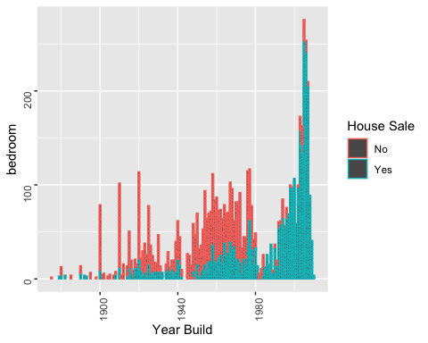

ggplot(student,aes(x=student$Year_Remod_Add,y=student$Bedroom_AbvGr,col=student$Above_Median))+geom_col() + theme(axis.text = element_text(angle = 90,vjust = 0.05)) + scale_y_continuous(name = "bedroom",labels = scales::comma) +  
 xlab("Year Remodeled") + ylab("Bedroom") + labs(col = "House Sale")

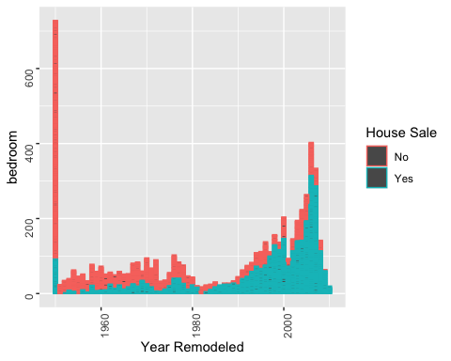

ggplot(student,aes(x=student$Year_Remod_Add,y=student$Full_Bath,col=student$Above_Median))+geom_col() + theme(axis.text = element_text(angle = 90,vjust = 0.05)) + scale_y_continuous(name = "Full Bath",labels = scales::comma) +  
 xlab("Year Remodeled") + ylab("Full Bath") + labs(col = "House Sale")

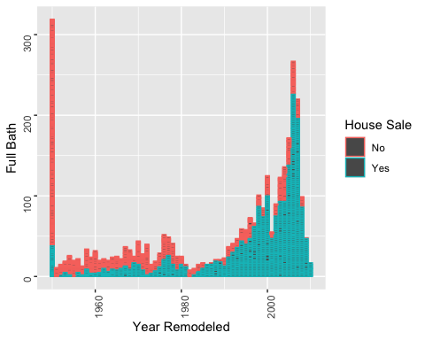

ggplot(student,aes(x=student$Year_Remod_Add,y=student$Half_Bath,col=student$Above_Median))+geom_col() + theme(axis.text = element_text(angle = 90,vjust = 0.05)) + scale_y_continuous(name = "Half Bath",labels = scales::comma) +  
 xlab("Year Remodeled") + ylab("Half Bath") + labs(col = "House Sale")

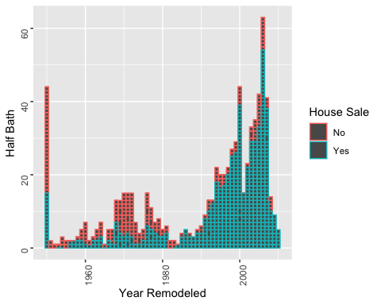

sales <- ggplot(student,aes(Sale_Condition))  
sales + geom_bar()

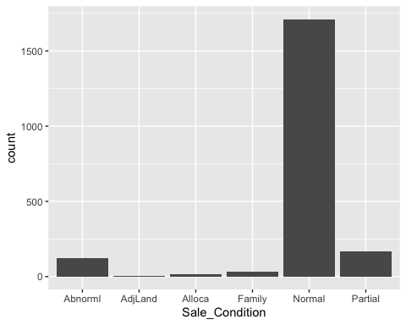

sales + geom_bar(aes(fill = Above_Median)) + xlab("Sale Condition") + ylab("Sale") + labs(fill = "House Sale")

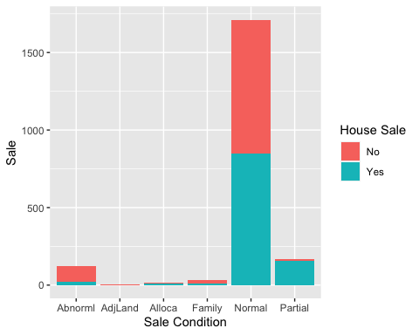

ggplot(student) + geom_bar(aes(y = Neighborhood, fill = Above_Median)) + xlab("Sale") + ylab("Neighborhood") + labs(fill = "House Sale")

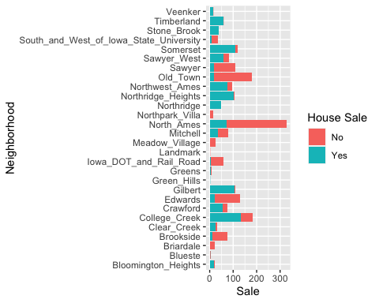

ggplot(student,aes(x=student$Year_Sold,y=student$Lot_Area,col=student$Above_Median))+geom_point() + theme(axis.text = element_text(angle = 90,vjust = 0.05)) + scale_y_continuous(name = "Lot Area",labels = scales::comma) +  
 xlab("Year Sold") + ylab("LoT Area") + labs(col = "House Sale")

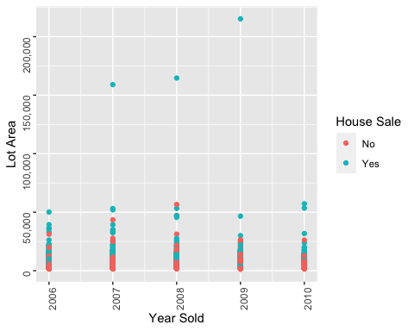

ggplot(student,aes(x=student$Year_Built,y=student$Lot_Area,col=student$Above_Median))+geom_col() + theme(axis.text = element_text(angle = 90,vjust = 0.05)) + scale_y_continuous(name = "Lot Area",labels = scales::comma) +  
 xlab("Year Build") + ylab("LoT Area") + labs(col = "House Sale")

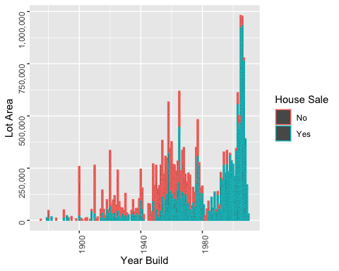

ggplot(student,aes(x=student$House_Style,y=student$Lot_Area,col=student$Above_Median))+geom_col() + theme(axis.text = element_text(angle = 90,vjust = 0.05)) + scale_y_continuous(name = "Lot Area",labels = scales::comma) +  
 xlab("House Style") + ylab("House Style") + labs(col = "House Sale")

