Leakage-Aware Probabilistic Flood Forecasting for Bangladesh: A Spatiotemporal Evaluation of Machine Learning and Deep Learning Models
Author Names and Affiliations Omitted for Double-Blind Review

Abstract—Flood models can appear overly skillful when temporal dependence, station overlap, or forward-looking features leak information. We present a leakage-aware framework for probabilistic danger-level forecasting at 133 Bangladesh Flood Forecasting and Warning Centre (FFWC) stations over 24, 48, and 72 h. The 200,665 station-day dataset combines 3-hourly water levels with meteorological, geospatial, upstream-discharge, soil-wetness, and neighbouring-station information. Predictors obey an issue-time boundary, and evaluation uses chronological validation, rolling-origin refits, station-disjoint folds, and a frozen post-2022 test. Twenty-four baseline, classical-ML, and deep-learning configurations are compared through one scoring pathway. The selected per-horizon model (D16) achieves mean PR-AUC 0.9574 on 2022 validation and 0.7708 on the frozen test, versus 0.6675 for persistence, outperforming persistence on all 21 test cell–horizon points. The best deep configuration reaches 0.9356 on validation; a matched fusion rematch remains 0.0206 below XGBoost. Test ECE is 0.003–0.009, and TreeSHAP assigns 64% of 24 h attribution to local hydrology. A protocol audit also identified and corrected an intermediate in-sample scoring defect without changing the selected model or frozen-test result. The findings show that credible flood-AI evidence depends as much on leakage-aware evaluation and strong baselines as on model complexity.
Index Terms—Flood forecasting, Bangladesh, probabilistic prediction, data leakage, spatiotemporal validation, gradient boosting, deep learning, calibration, SHAP.
I. Introduction
Bangladesh is among the most flood-exposed countries in the world, and its densely populated riverine and coastal districts depend on timely warnings rather than on a single forecast of water level [1]. The Flood Forecasting and Warning Centre (FFWC) of the Bangladesh Water Development Board issues station-specific warnings relative to a danger level: a fixed, administrative threshold above which a station is considered to be in flood [2]. The operationally relevant question is therefore not the exact future stage in metres, but whether a station will cross that threshold within the next 24, 48, or 72 h. A probabilistic answer is more useful than a binary one because it allows warning officers to trade missed events against false alarms and to communicate uncertainty.
Machine learning (ML) and deep learning (DL) are widely used for short-term flood forecasting [3]–[5]. Bangladesh studies have examined rainfall–runoff behaviour, water-level regression, and climate scenarios [6]–[11], while broader work spans gradient boosting, recurrent networks, temporal convolutions, attention, and graph models [3], [4], [12]. However, many studies predict continuous stage, use a single split, or compare models under different inputs and tuning budgets; such results do not directly establish danger-level warning skill.
Three issues are central to warning-oriented evaluation. Hydro-meteorological autocorrelation makes random splits optimistic [13]; feature engineering and preprocessing can leak future or cross-fold information [14], [15]; and rare, drifting exceedance rates can make accuracy or ROC-AUC misleading [16]. We therefore combine an issue-time information boundary, temporal and spatial refitting, persistence benchmarking, calibration, and event-oriented metrics.
We make three contributions. First, we formulate 24/48/72 h station-specific danger-level exceedance with leakage-controlled rolling-origin and station-disjoint evaluation, including a documented protocol correction. Second, we compare 24 configurations—seven baselines, five classical models, and twelve DL configurations—under common partitions, labels, seeds, metric code, and tuning budgets, with a matched fusion rematch. Third, we evaluate the selected model against persistence on trained, new-network, and unseen stations using calibration, cost-sensitive thresholds, event detection, and TreeSHAP. The goal is a decision-oriented benchmark, not a claim that one architecture is universally superior.

II. Related Work and Research Gap
Data-driven flood forecasting now spans tree ensembles, recurrent and convolutional sequence models, transformers, and graph networks [12], [17]–[26]. LSTM-based rainfall–runoff modelling has shown strong sequence-learning capability [21], [38], while XGBoost and LightGBM remain competitive for engineered tabular predictors [17], [18]. Reviews increasingly emphasise interpretability and genuine out-of-sample testing alongside predictive accuracy [39], [40].
In Bangladesh, recent work has demonstrated useful signal for water-level and discharge prediction and has begun to examine spatial transferability [6]–[11]. Yet the operational FFWC task differs from generic regression: the target is a rare station-specific threshold crossing, miss and false-alarm costs differ, and useful evidence must distinguish future-time from unseen-station generalisation.
The research gap is therefore methodological: leakage-controlled, multi-horizon station-level evidence that uses a persistence reference, separates temporal and spatial generalisation, reports calibration and event detection, and explains predictions hydrologically remains limited [13], [16], [29]–[32]. We address this gap by treating evaluation design as a first-class contribution and by reporting an internal protocol correction transparently.
III. Dataset and Forecast Formulation
A. Data Sources and Coverage
Primary hydrological data comprise the FFWC station master and 1,052,044 three-hourly water-level readings from January 2017 to October 2026. Of 153 listed stations, 133 have both a usable danger level and at least one valid label; 2018 is absent and retained as missing. Predictors additionally use NASA POWER/MERRA-2 meteorology [37], SRTM terrain [36], OpenStreetMap and geoBoundaries attributes [41], [42], GloFAS discharge [35], and POWER soil wetness. ERA5-Land [34] was tested but not retained because it did not improve validation skill.
Three-hourly observations were aggregated to daily maximum, mean, minimum, last-observed level, and reading count on a complete station-day calendar. After quality control, the dataset contains 200,665 station-days from 133 stations. The network grows from 85 stations in 2017 to 133 by the end of the record, and this growth is preserved in the validation design (Table I).
TABLE I
Data Partitions and Danger-Level Base Rates
Partition | Rows | Stations | 24 h | 48 h | 72 h
Training | 77,571 | 105 | 9.60 | 10.72 | 11.73
Validation | 21,920 | 105 | 5.08 | 5.96 | 6.64
Frozen test | 101,174 | 133 | 1.41 | 1.77 | 2.12
Base rates are percentages of labelled station-days. The test period is 2023-01-27 to 2026-10-05; 2018 is absent from the FFWC archive.
Table note: Training and validation row counts (77,571 / 21,920) include station-holdout rows (fold 0, 26 stations) that are excluded from model fitting under P1. Fitting-only counts are 61,991 training and 17,538 validation rows; the frozen test (101,174 rows, 133 stations) is unchanged.
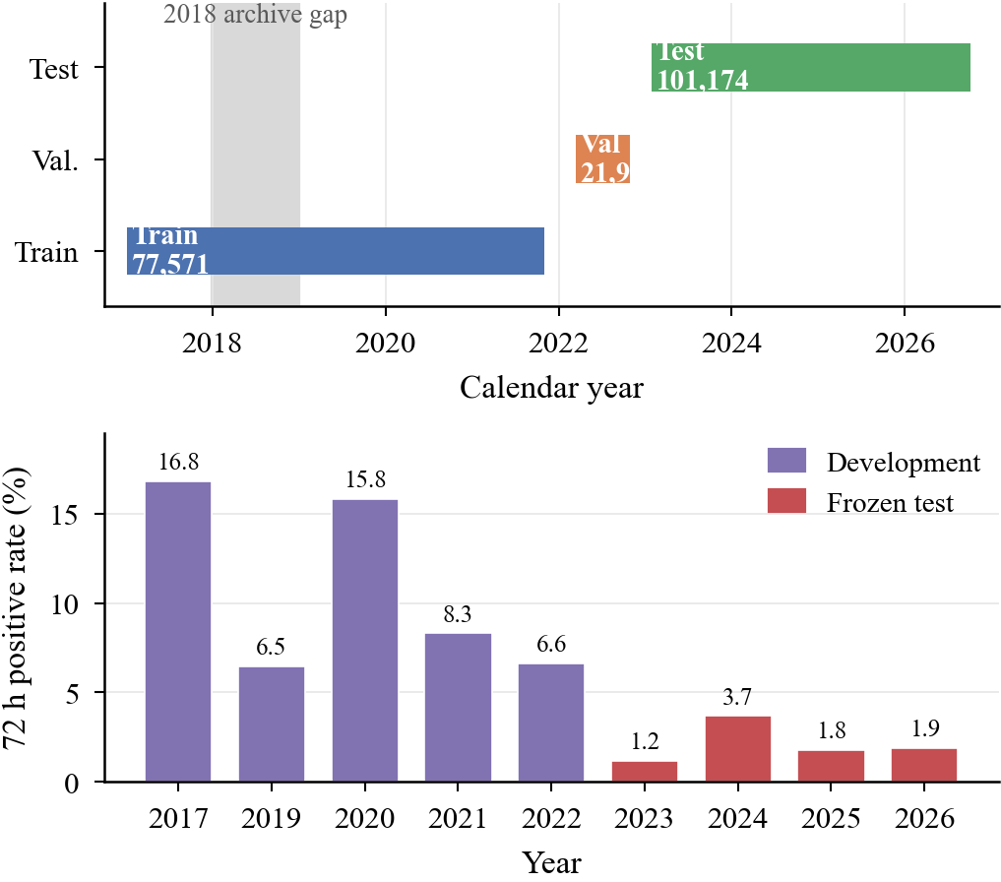
Fig. 1. Temporal coverage and label prevalence. (a) Training, validation, and frozen-test spans; the 2018 archive gap is preserved as missing. (b) Annual 72 h positive rate, showing the 14-fold decline from 2017 to 2023 and the higher prevalence of the development years. Cell-level, not pooled, evaluation follows from this drift.
B. Forecast Formulation and Labels
Let s index a station, t an issue day, and h ∈ {24,48,72} the lead time in hours. The model estimates the probability that station s reaches its danger level D_{s} within the next h hours, using only information available at the end of day t:
P_{s,t,h} = Pr(Y_{s,t,h} = 1 | I_{s,t}) (1)
where I_{s,t} is the issue-time information set. The label is an indicator of any observed 3-hourly reading in the forward window reaching the station danger level:
Y_{s,t,h} = 1{max_{u}∈(t,t+h] W_{s,u} ≥ D_{s}} (2)
A negative label is assigned only when the full forecast window is sufficiently observed and no reading reaches danger level; otherwise the label is missing. Positives are retained when any observed exceedance occurs. Valid labels number 200,559, 197,748, and 195,174 at 24, 48, and 72 h, with positive rates of 4.98%, 5.68%, and 6.32%. Strong temporal drift—the 72 h rate falls from 16.81% in 2017 to 1.19% in 2023—and a 5.4× monsoon/non-monsoon contrast motivate cell- and season-specific reporting.
C. Spatiotemporal Partitions
Random partitioning is avoided. The chronological split uses 2017–2021 for training (77,571 rows), 2022 for validation (21,920), and 2023–2026 for the frozen test (101,174). Natural dry-season gaps of 88–131 days separate the periods; a seven-day embargo is retained as a safety rule.
Spatial generalisation uses five station-disjoint folds. Fold 0 is the frozen unseen holdout (26 stations); folds 1–4 support development. Test stations are also classified as trained, new-network, or unseen. Five protocols are used: P1 primary 2022 validation; P2 rolling-origin 2020–2022 refits; P3 four-fold station-disjoint refits; P4 frozen unseen-station testing; and P5 monsoon/non-monsoon stratification. The seven development cells are val_2020, val_2021, val_2022, and spatial folds 1–4.
IV. Methodology
A. Features and Leakage Control
FULL contains 62 predictors spanning weather, rainfall history, geography, local hydrology, and station network. The governed FULL_V2 representation contains 110 predictors after adding soil wetness, GloFAS discharge, water-level memory/antecedent-precipitation, and interaction terms. Key hydrological variables include level relative to danger, distance to danger, recent extrema, rise rates, exceedance counts, and antecedent rainfall.
All predictors for issue day t use information available by the end of t. Identifiers, dates, labels, source descriptors, and future-observation counts are excluded; lags and rolling statistics are backward-looking; preprocessing is fitted within each training fold; and sequence windows cannot cross station or split boundaries. Neighbour/upstream covariates are constructed on the operational station network before fold assignment, so target rows are station-disjoint but covariates are not fully isolated; this is retained as a limitation.
B. Models and Tuning
We compare 24 configurations: seven baselines (including D7 hydrological persistence), five classical models—random forest [19], gradient boosting [20], XGBoost [17], LightGBM [18], and selected-feature XGBoost—and twelve DL configurations spanning LSTM [21], GRU [22], TCN [23], fusion/hybrid models, GCN [25], GAT [26], GNN–LSTM, and Transformer [24]. Models are trained separately by horizon. Classical models use engineered tabular predictors; sequence models use a 12-variable raw sequence; fusion models combine both.
Hyperparameters use a fixed development budget with common partitions, labels, seeds, and metric code. D16 is selected on val_2022 by horizon-mean PR-AUC, subject to beating D7 across development cells and ECE ≤0.02; it uses LightGBM at 24/48 h and XGBoost at 72 h on FULL_V2. A supplementary matched fusion rematch uses the same engineered vector, five anchors, three seeds, and station bootstrap; because only the fusion family completed this rig, it is confirmatory rather than a full DL rerun.
C. Metrics and Decision Rules
The primary metric is area under the precision–recall curve (PR-AUC, average precision) for each horizon, cell, and season [16]. ROC-AUC is reported as a secondary measure. Average precision is
AP = Σ_{n} (R_{n} − R_{n−1}) P_{n} (3)
where P_{n} and R_{n} are precision and recall at the n-th threshold. Operational metrics are recall, precision, missed flood rows, and false-alarm rate at a cost-sensitive threshold. Calibration is measured with the Brier score [31] and expected calibration error (ECE) with ten equal-width bins:
ECE = Σ_{b=1}^{B} (n_{b}/N) |_{ȳb} − _{p̄b}| (4)
The operating threshold minimizes the row cost
C(τ) = C_{FN} FN(τ) + C_{FP} FP(τ) (5)
with C_{FN}:C_{FP}=10:1 as the primary setting and 5:1 and 20:1 as sensitivities. Thresholds are derived on development data and frozen before the test read. Four research risk bands (low, moderate, high, very high) are derived from the cost-optimal thresholds; they are not official FFWC warning categories. Event-level evaluation groups consecutive positive days at a station into events, bridging one-day gaps. The permissive definition used in the frozen-test read counts an event as detected if any warning occurs in [start-h,end]. The stricter development definition requires a warning before onset, excludes unverifiable events, and counts false-alarm episodes outside the event and lead window. The two definitions are reported separately and never mixed.
Explanations use exact TreeSHAP on each frozen booster [27], [28]. SHAP values are aggregated to the nine feature groups, and cross-model agreement is measured by Spearman rank correlation against the Phase-33 XGBoost incumbent. Permutation importance is computed as a second opinion, but it is known to be unstable under collinearity; disagreements are reported rather than hidden.
D. Reproducibility and Test Discipline
All runs use seed 20261008; uncertainty uses station bootstrap, and scripts/configurations are preserved with a SHA-256 manifest. The programme-level frozen test was opened six times (five predictive reads, one invalid and retracted, plus one label-statistics read). D16's reported MI-6 read was pre-registered and reproduced bit-for-bit by MI-9. Thus the test is frozen for D16 but not pristine for the programme, and this history is disclosed explicitly.
V. Results
A. Classical ML versus Deep Learning
Table II reports validation PR-AUC on P1 val_2022 for representative models; the full 24-configuration table is preserved in the reproducibility package. The best classical model is XGBoost, with a horizon mean of 0.9546 (0.9681, 0.9549, and 0.9408 at 24, 48, and 72 h). LightGBM is statistically indistinguishable at 0.9534, and the top four classical models lie within 0.0023 of one another. The best deep configuration is the fusion model at 0.9356 (0.9444, 0.9385, and 0.9238), 0.0190 below XGBoost. Every classical leader clears every DL leader at every horizon. The gap is not uniform across architectures—the transformer and GCN sit mid-pack among DL configurations (above TCN but below fusion)—but no DL configuration closes it.
TABLE II
P1 Validation PR-AUC on val_2022 (all season)
Model | 24 h | 48 h | 72 h | Mean
D7 persistence | 0.9203 | 0.8954 | 0.8683 | 0.8947
Climatology | 0.0509 | 0.0594 | 0.0658 | 0.0587
Logistic regression | 0.9401 | 0.9241 | 0.9053 | 0.9232
Gradient boosting | 0.9618 | 0.9457 | 0.9338 | 0.9471
Random forest | 0.9665 | 0.9516 | 0.9389 | 0.9523
XGBoost-selected | 0.9663 | 0.9533 | 0.9422 | 0.9539
LightGBM | 0.9682 | 0.9538 | 0.9384 | 0.9534
XGBoost | 0.9681 | 0.9549 | 0.9408 | 0.9546
LSTM-3 | 0.9421 | 0.9253 | 0.9129 | 0.9268
GRU | 0.9359 | 0.9263 | 0.9086 | 0.9236
TCN | 0.9405 | 0.9224 | 0.9008 | 0.9212
Fusion | 0.9444 | 0.9385 | 0.9238 | 0.9356
GCN | 0.9421 | 0.9353 | 0.9141 | 0.9305
GAT | 0.9408 | 0.9315 | 0.9136 | 0.9286
GNN–LSTM | 0.9424 | 0.9264 | 0.9153 | 0.9280
Transformer | 0.9437 | 0.9330 | 0.9183 | 0.9317
Representative subset of the 24 configurations. D16 is the selected per-horizon ensemble (0.9708/0.9565/0.9450; mean 0.9574), not a single row in this table.
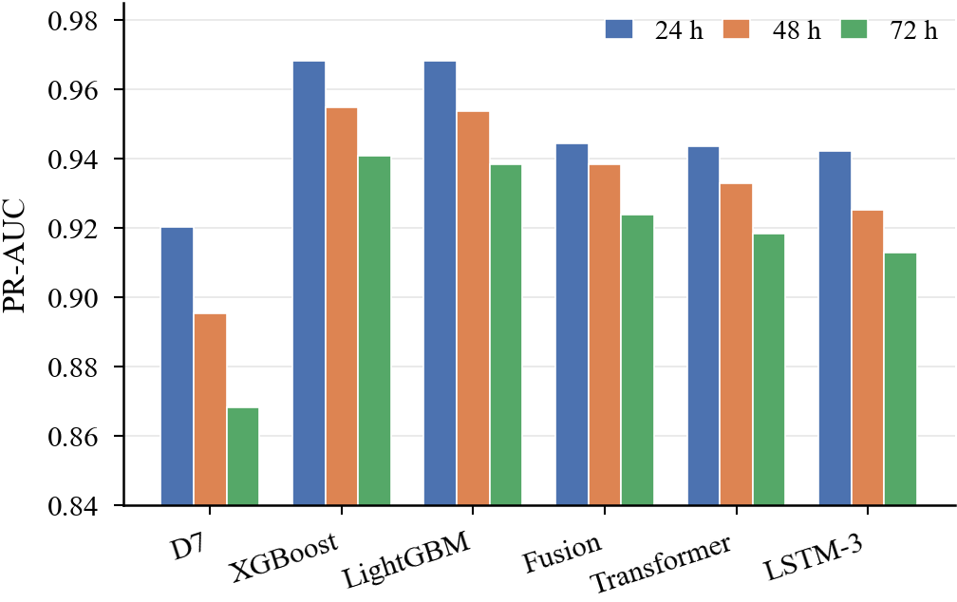
Fig. 2. Validation PR-AUC by horizon for representative models. Gradient-boosted trees occupy the top of every horizon; the fusion model is the strongest DL configuration but remains below the classical leaders. Values are from the P1 val_2022 cell.
Cell-level intervals overlap because only 84 validation stations contribute to one year, but paired bootstrap comparisons favour XGBoost over the matched fusion model at all horizons: −0.0228, −0.0190, and −0.0165 (fusion minus XGBoost), with all 95% intervals excluding zero. The mean gap is −0.0194; fusion is well calibrated but ranks worse and yields more false alarms.
Model complexity does not improve this task: the fusion model has 58,817 weights and is slower than XGBoost-selected, while its spatial-fold performance degrades more sharply. Engineered lag features therefore capture local persistence more efficiently than the tested DL representations.
B. Selected Model and Frozen Test
D16 achieves 0.9708, 0.9565, and 0.9450 on val_2022 (mean 0.9574), marginally above the best single classical model because it selects the best per-horizon learner rather than forcing one family. On the frozen test (Table III), D16 achieves 0.8362, 0.7690, and 0.7071 (mean 0.7708), against D7 persistence at 0.7340, 0.6625, and 0.6062 (mean 0.6676). The margin is +0.102, +0.106, and +0.101 by horizon, and +0.103 on the horizon mean. D16 beats D7 on all 21 cell–horizon test points; the minimum point margin is +0.0424 at unseen stations and 72 h, and the largest cell-mean margin is +0.1326 at trained stations.
TABLE III
Frozen-Test PR-AUC: D16 versus D7 Persistence
Test cell | 24 h | 48 h | 72 h | Mean Δ
2023 | 0.796 / 0.628 | 0.681 / 0.552 | 0.626 / 0.511 | +0.137
2024 | 0.918 / 0.802 | 0.857 / 0.730 | 0.804 / 0.673 | +0.125
2025 | 0.805 / 0.733 | 0.760 / 0.667 | 0.702 / 0.604 | +0.088
2026 | 0.794 / 0.723 | 0.747 / 0.649 | 0.702 / 0.593 | +0.092
Trained | 0.869 / 0.747 | 0.806 / 0.702 | 0.764 / 0.593 | +0.133
New network | 0.843 / 0.736 | 0.787 / 0.693 | 0.713 / 0.646 | +0.090
Unseen | 0.830 / 0.770 | 0.742 / 0.669 | 0.641 / 0.599 | +0.058
Mean | 0.836 / 0.734 | 0.769 / 0.663 | 0.707 / 0.606 | +0.103
Each cell shows D16 / D7. Mean Δ is the mean of the three per-horizon differences, not a difference of means. All 21 cell–horizon comparisons favour D16.
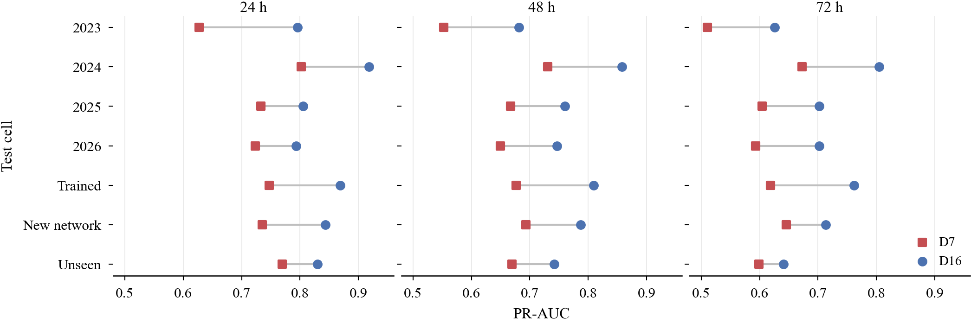
Fig. 3. Frozen-test PR-AUC by cell and horizon. Circles are D16 and squares are D7 persistence. D16 is above persistence in every cell–horizon pair; the smallest margin is unseen stations at 72 h (+0.0424).
Absolute test scores are lower than validation because prevalence shifts sharply: the 24 h base rate falls from 5.08% in validation to 1.41% in test. D16 still exceeds persistence across every test cell–horizon pair, but 72 h and 2023 are the weakest conditions. This gap between validation and test reinforces the need for temporally separated evaluation.
Against the Phase-33 XGBoost incumbent, D16 wins six of seven test cells; the exception is 2025, and XGBoost is marginally higher at the 72 h test mean (0.7092 vs. 0.7071). We therefore claim robust gains over persistence, not uniform superiority over every classical alternative.
Test calibration remains good: mean ECE is 0.0028, 0.0042, and 0.0085 at 24/48/72 h, with all 21 cell–horizon values below 0.02. At frozen 10:1 thresholds, recall is 0.918, 0.903, and 0.856 and precision 0.549, 0.388, and 0.351. The operating point should ultimately be selected by the warning service.
The validation very-high risk band contains roughly 5–6% of rows with an observed flood rate near 90%, but these are research categories, not FFWC warning levels. Under the permissive frozen-test event definition, D16 detects 93.0%, 96.5%, and 96.9% of events versus 86.4%, 92.7%, and 91.2% for D7 at 24/48/72 h.
C. Temporal and Spatial Generalisation
After the pre-registered correction, D16 beats D7 on all 21 development cell–horizon points (minimum margin +0.0156). The corrected seven-cell mean is 0.9665, but we treat it descriptively because four spatial folds are near saturation and the test base rate is much lower.
The three classical leaders beat D7 in all 63 all-season development comparisons, but not under every stress condition: extreme rainfall and a stricter one-day issue-time shift produce some losses. The appropriate claim is therefore robust all-season improvement, not universal dominance.
Ablation shows where skill comes from. Adding local hydrology to weather and geography raises mean PR-AUC by +0.4702 (95% CI +0.389 to +0.539), whereas the station-network layer adds only +0.0009 and dropping four upstream columns changes the mean by −0.0001. The model is therefore driven primarily by local hydrology and rainfall history, consistent with SHAP and the modest GNN gains.
D. Protocol Audit and the P2/P3 Correction
The protocol audit found that an intermediate MI-8 probe scored six of seven development cells using a model already fitted on those rows. Correct per-cell refitting reduces the seven-cell means for FULL, FULL_V2, and FULL_V3 from 0.9834/0.9868/0.9882 to 0.9641/0.9659/0.9678 (Table IV). The feature audit still passes, and val_2022 and the frozen test were unaffected.
TABLE IV
P2/P3 Re-Scoring Correction
Quantity | Archived | Corrected | Change
FULL, 7-cell mean | 0.9834 | 0.9641 | −0.0194
FULL_V2, 7-cell mean | 0.9868 | 0.9659 | −0.0209
FULL_V3, 7-cell mean | 0.9882 | 0.9678 | −0.0204
FULL_V3 − FULL_V2 | +0.00136 | +0.00187 | +0.00051
V3 wins, cell–horizon points | 21/21 | 20/21 | −1
D16 − D7 floor | +0.0225 | +0.0156 | −0.0069
The archived values scored six cells with a model fitted on those cells. Corrected values refit every cell. The champion and the frozen-test read are unaffected because val_2022 was always out-of-sample.
The correction changes magnitudes, not the selected model: FULL_V3 exceeds FULL_V2 by +0.00187 and wins 20/21 points; D16's minimum margin over D7 becomes +0.0156. The episode is reported because leakage-aware evaluation must audit scoring masks as well as predictor construction.
E. Strict Event-Level Evaluation
The strict development analysis asks whether a warning is issued before an event begins, not merely somewhere in the event window. D16 recall is 50.9%, 72.4%, and 88.1% at 24, 48, and 72 h, against 45.2%, 64.9%, and 76.7% for D7 (Table V). D16 also produces fewer false-alarm episodes per station-year at every horizon: 0.58, 0.98, and 2.30 versus 1.56, 1.97, and 2.44. The advantage grows with lead time, which is the operationally important direction. At 24 h, however, D16 loses strict recall on two cells (val_2021 and spatial fold 1), and the mean margin is only 5.7 percentage points. The model is not uniformly better at short lead times.
TABLE V
Strict Event-Level Performance on Development Cells
Horizon | D16 recall | D7 recall | D16 FA | D7 FA
24 h | 50.9% | 45.2% | 0.58 | 1.56
48 h | 72.4% | 64.9% | 0.98 | 1.97
72 h | 88.1% | 76.7% | 2.30 | 2.44
Mean over the seven development cells. Recall requires a warning before event onset; FA is false-alarm episodes per station-year. The frozen test was not reopened for this analysis.
The permissive frozen-test event definition yields higher recall because any warning in the lead/event window counts [32]. The stricter development definition requires warning before onset and counts false-alarm episodes outside event windows. Reporting them separately avoids turning a definitional difference into an apparent gain.
F. Hydrologically Interpretable Explanations
TreeSHAP on the frozen D16 boosters attributes 64.0% of mean absolute 24 h attribution to the local hydrology group (Fig. 4). Geography contributes 8.4%, station network 6.1%, weather 4.7%, GloFAS 4.6%, interactions 4.1%, soil wetness 4.1%, water-level memory 2.4%, and rainfall history 1.5%. The top individual features are current water level as a fraction of danger level, distance to danger, seven-day maximum water level, upstream water level, and 72 h rainfall. This is the explanation a hydrologist would expect: local stage relative to the threshold dominates, with upstream and rainfall information providing context.
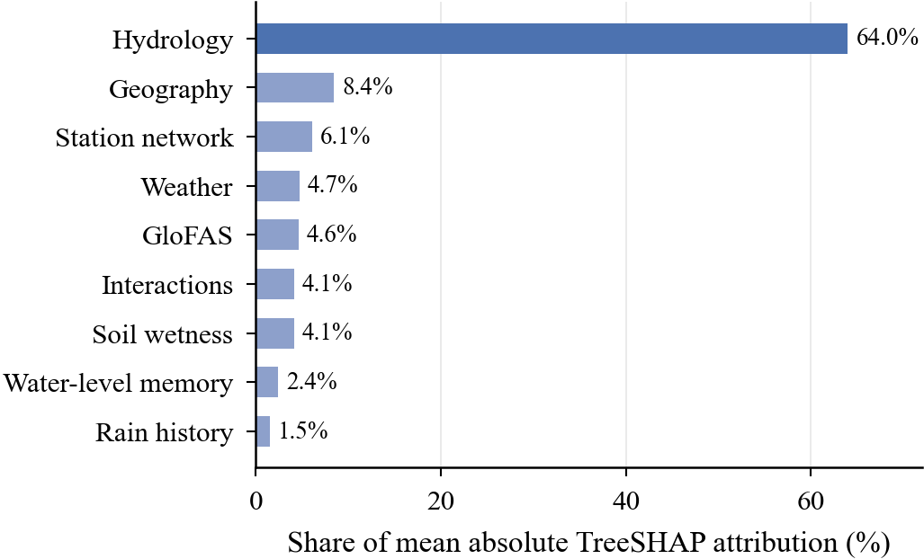
Fig. 4. Share of mean absolute TreeSHAP attribution by feature group at 24 h on val_2022. Hydrology dominates; network and rainfall-history groups are small once local stage is known.
Feature-group explanations are stable across models (Spearman ρ=0.755–0.878 between D16 and the earlier XGBoost incumbent). Permutation importance diverges at 24 h under collinearity, so group-level TreeSHAP is used for interpretation and individual feature ranks are not over-interpreted.
VI. Discussion and Limitations
A. Why Gradient Boosting Wins Here
The ML–DL result is task-specific. Danger-level exceedance is a tabular, autocorrelated rare-event problem with engineered lags; gradient-boosted trees exploit threshold structure and persistence efficiently. The fusion rematch narrows representation differences but remains 0.0206 below XGBoost. This does not imply that DL is unsuitable for flood forecasting; it shows that added complexity is not justified by predictive gain for this dataset and formulation.
Ablation reinforces this interpretation: local hydrology contributes the dominant incremental skill, while network features add little after local stage is known. For this setting, data quality, label definition, and hydrological feature design matter more than a larger architecture.
B. What the Protocol Audit Changes
The P2/P3 defect is a validation leak, not a feature leak. Per-cell refitting lowers near-saturated development means by about 0.02 but leaves the champion and frozen-test result unchanged because val_2022 was always out-of-sample. The lesson is that automated leakage checks must test evaluation masks as well as features.
The test ledger provides a related caution: the programme opened the frozen period before D16 was finalised. Although D16's pre-registered read was reproduced exactly, the test was not pristine. Benchmark studies should therefore report every test opening, model version, and whether the result influenced selection.
C. Operational Interpretation
The results support decision support, not replacement of operational forecasting. At 24 h, D16 beats persistence but precision at the 10:1 threshold is 0.55; at 72 h, ranking is weaker and the earlier XGBoost model is marginally higher. Because no future rainfall/NWP is used, the system is primarily a hydrological nowcast driven by observed stage, upstream propagation, and recent rainfall. Forecast rainfall is the clearest route to longer-lead skill.
Cost-sensitive thresholds make the miss/false-alarm trade-off explicit, but the 5:1–20:1 ratios and four risk bands are research assumptions. Any operational pilot should re-estimate thresholds with stakeholder costs and monitor calibration by season.
D. Limitations
Limitations include a non-pristine programme-level test history; absence of future rainfall/NWP; the missing 2018 archive and partial 2026 record; changing station coverage and administrative danger levels; neighbour/upstream covariates that are not fully isolated across spatial folds; a matched DL rematch completed only for fusion; reuse of val_2022 for selection; different strict-development and permissive-test event definitions; and associational SHAP explanations. These constraints support interpreting D16 as a strong benchmark and candidate for prospective piloting, not a deployed warning system.

VII. Conclusion
We presented a leakage-aware probabilistic framework for 24/48/72 h FFWC danger-level forecasting in Bangladesh. D16 achieves mean PR-AUC 0.9574 on 2022 validation and 0.7708 on the frozen test versus 0.6675 for persistence, winning all 21 test cell–horizon comparisons. The best DL configuration reaches 0.9356 on validation, and a matched fusion rematch remains 0.0206 below XGBoost. Test calibration is strong, strict event recall improves over persistence at 48–72 h, and TreeSHAP attributes 64% of 24 h importance to local hydrology. A protocol audit corrected an intermediate in-sample scoring defect without changing the champion or frozen-test result. The central finding is methodological: credible flood AI requires leakage-aware evaluation, strong hydrological baselines, and transparent test discipline. Future work should incorporate forecast rainfall and prospective operational evaluation.
References
[1] J. Rentschler, M. Salhab, and B. A. Jafino, “Flood exposure and poverty in 188 countries,” Nature Communications, vol. 13, no. 1, Art. no. 3527, 2022, doi: 10.1038/s41467-022-30727-4.
[2] Flood Forecasting and Warning Centre, Bangladesh Water Development Board, “Annual flood report 2023,” Dhaka, Bangladesh, 2023. [Online]. Available: http://www.ffwc.gov.bd/
[3] M. Asif, M. M. Kuglitsch, I. Pelivan, and R. Albano, “Review and intercomparison of machine learning applications for short-term flood forecasting,” Water Resources Management, vol. 39, pp. 1971–1991, 2025, doi: 10.1007/s11269-025-04093-x.
[4] B. Kuhaneswaran, G. Sorwar, A. R. Alaei, and F. Tong, “Evolution of data-driven flood forecasting: Trends, technologies, and gaps—A systematic mapping study,” Water, vol. 17, no. 15, Art. no. 2281, 2025, doi: 10.3390/w17152281.
[5] A. H. Akinsoji, B. Adelodun, Q. Adeyi, R. A. Salau, G. Odey, and K. S. Choi, “Integrating machine learning models with comprehensive data strategies and optimization techniques to enhance flood prediction accuracy: A review,” Water Resources Management, vol. 38, no. 12, pp. 4735–4761, 2024, doi: 10.1007/s11269-024-03885-x.
[6] F. Noor, S. Haq, M. Rakib, T. Ahmed, Z. Jamal, Z. S. Siam, R. T. Hasan, M. S. G. Adnan, A. Dewan, and R. M. Rahman, “Water level forecasting using spatiotemporal attention-based long short-term memory network,” Water, vol. 14, no. 4, Art. no. 612, 2022, doi: 10.3390/w14040612.
[7] M. T. Islam, S. C. Roy, N. Jahan, A. A. Ferdaus, K. Fujisawa, and A. K. M. Adham, “Comparative evaluation of machine learning models for extreme river water level forecasting in Bangladesh: Implications for flood and drought resilience,” Progress in Disaster Science, vol. 27, Art. no. 100449, 2025, doi: 10.1016/j.pdisas.2025.100449.
[8] M. T. Islam, M. A. Al-Sufi Ridoy, N. Jahan, S. C. Roy, and A. K. M. Adham, “From short to long-term horizons: Comparative assessment of machine learning and deep learning for river stage prediction with spatial transferability analysis,” Results in Engineering, vol. 28, Art. no. 108194, 2025, doi: 10.1016/j.rineng.2025.108194.
[9] M. T. Islam, S. C. Roy, N. Jahan, N. Islam, and A. K. M. Adham, “From climate signals to smart predictions: Advanced machine learning and deep learning for hydrological modeling in data-scarce Bangladesh,” H2Open Journal, vol. 9, no. 2, pp. 81–109, 2026, doi: 10.2166/h2oj.2026.036.
[10] M. T. Islam, S. C. Roy, N. Jahan, M. S. I. Yousuf, and A. K. M. Adham, “Extending river discharge forecast lead times with machine and deep learning for proactive hydrological hazard management in Bangladesh,” H2Open Journal, vol. 9, no. 3, Art. no. 100013, 2026, doi: 10.2166/h2oj.2026.100013.
[11] K. N.-e.-A. Siddiquee, M. T. Sarker, M. Al Qwaid, N. Barua, K. S. Akter, S. Chowdhury, and M. S. Hossen, “Advanced machine learning techniques for daily streamflow forecasting: A case study of the Brahmaputra River,” Scientific Reports, 2026, doi: 10.1038/s41598-026-69747-1.
[12] A. Mosavi, P. Ozturk, and K.-W. Chau, “Flood prediction using machine learning models: Literature review,” Water, vol. 10, no. 11, Art. no. 1536, 2018, doi: 10.3390/w10111536.
[13] D. R. Roberts et al., “Cross-validation strategies for data with temporal, spatial, hierarchical, or phylogenetic structure,” Ecography, vol. 40, no. 8, pp. 913–929, 2017, doi: 10.1111/ecog.02881.
[14] S. Kaufman, S. Rosset, C. Perlich, and O. Stitelman, “Leakage in data mining: Formulation, detection, and avoidance,” ACM Transactions on Knowledge Discovery from Data, vol. 6, no. 4, Art. no. 15, pp. 1–21, 2012, doi: 10.1145/2382577.2382579.
[15] S. Kapoor and A. Narayanan, “Leakage and the reproducibility crisis in machine-learning-based science,” Patterns, vol. 4, no. 9, Art. no. 100804, 2023, doi: 10.1016/j.patter.2023.100804.
[16] T. Saito and M. Rehmsmeier, “The precision-recall plot is more informative than the ROC plot when evaluating binary classifiers on imbalanced datasets,” PLoS ONE, vol. 10, no. 3, Art. no. e0118432, 2015, doi: 10.1371/journal.pone.0118432.
[17] T. Chen and C. Guestrin, “XGBoost: A scalable tree boosting system,” in Proc. 22nd ACM SIGKDD Int. Conf. Knowledge Discovery and Data Mining, 2016, pp. 785–794, doi: 10.1145/2939672.2939785.
[18] G. Ke et al., “LightGBM: A highly efficient gradient boosting decision tree,” in Advances in Neural Information Processing Systems, vol. 30, 2017, pp. 3146–3154.
[19] L. Breiman, “Random forests,” Machine Learning, vol. 45, no. 1, pp. 5–32, 2001, doi: 10.1023/A:1010933404324.
[20] J. H. Friedman, “Greedy function approximation: A gradient boosting machine,” The Annals of Statistics, vol. 29, no. 5, pp. 1189–1232, 2001, doi: 10.1214/aos/1013203451.
[21] S. Hochreiter and J. Schmidhuber, “Long short-term memory,” Neural Computation, vol. 9, no. 8, pp. 1735–1780, 1997, doi: 10.1162/neco.1997.9.8.1735.
[22] K. Cho et al., “Learning phrase representations using RNN encoder–decoder for statistical machine translation,” in Proc. Conf. Empirical Methods in Natural Language Processing, 2014, pp. 1724–1734, doi: 10.3115/v1/D14-1179.
[23] S. Bai, J. Z. Kolter, and V. Koltun, “An empirical evaluation of generic convolutional and recurrent networks for sequence modeling,” arXiv:1803.01271, 2018.
[24] A. Vaswani et al., “Attention is all you need,” in Advances in Neural Information Processing Systems, vol. 30, 2017, pp. 5998–6008.
[25] T. N. Kipf and M. Welling, “Semi-supervised classification with graph convolutional networks,” in Proc. Int. Conf. Learning Representations, 2017.
[26] P. Veličković et al., “Graph attention networks,” in Proc. Int. Conf. Learning Representations, 2018.
[27] S. M. Lundberg and S.-I. Lee, “A unified approach to interpreting model predictions,” in Advances in Neural Information Processing Systems, vol. 30, 2017, pp. 4765–4774.
[28] S. M. Lundberg et al., “From local explanations to global understanding with explainable AI for trees,” Nature Machine Intelligence, vol. 2, no. 1, pp. 56–67, 2020, doi: 10.1038/s42256-019-0138-9.
[29] A. Niculescu-Mizil and R. Caruana, “Predicting good probabilities with supervised learning,” in Proc. 22nd Int. Conf. Machine Learning, 2005, pp. 625–632, doi: 10.1145/1102351.1102430.
[30] C. Guo, G. Pleiss, Y. Sun, and K. Q. Weinberger, “On calibration of modern neural networks,” in Proc. 34th Int. Conf. Machine Learning, 2017, pp. 1321–1330.
[31] G. W. Brier, “Verification of forecasts expressed in terms of probability,” Monthly Weather Review, vol. 78, no. 1, pp. 1–3, 1950, doi: 10.1175/1520-0493(1950)078<0001:VOFEIT>2.0.CO;2.
[32] C. A. T. Ferro and D. B. Stephenson, “Extremal dependence indices: Improved verification measures for deterministic forecasts of rare binary events,” Weather and Forecasting, vol. 26, no. 5, pp. 699–713, 2011, doi: 10.1175/WAF-D-10-05030.1.
[33] B. Efron and R. J. Tibshirani, An Introduction to the Bootstrap. New York, NY, USA: Chapman & Hall, 1993.
[34] J. Muñoz-Sabater et al., “ERA5-Land: A state-of-the-art global reanalysis dataset for land applications,” Earth System Science Data, vol. 13, no. 9, pp. 4349–4383, 2021, doi: 10.5194/essd-13-4349-2021.
[35] L. Alfieri et al., “GloFAS – global ensemble streamflow forecasting and flood early warning,” Hydrology and Earth System Sciences, vol. 17, no. 3, pp. 1161–1175, 2013, doi: 10.5194/hess-17-1161-2013.
[36] T. G. Farr et al., “The Shuttle Radar Topography Mission,” Reviews of Geophysics, vol. 45, no. 2, Art. no. RG2004, 2007, doi: 10.1029/2005RG000183.
[37] NASA Langley Research Center, “POWER project data sets,” 2024. [Online]. Available: https://power.larc.nasa.gov/
[38] F. Kratzert, D. Klotz, C. Brenner, K. Schulz, and M. Herrnegger, “Rainfall–runoff modelling using long short-term memory (LSTM) networks,” Hydrology and Earth System Sciences, vol. 22, no. 11, pp. 6005–6022, 2018, doi: 10.5194/hess-22-6005-2018.
[39] M. Reichstein et al., “Deep learning and process understanding for data-driven Earth system science,” Nature, vol. 566, pp. 195–204, 2019, doi: 10.1038/s41586-019-0912-1.
[40] M. Sit et al., “A comprehensive review of deep learning applications in hydrology and water resources,” Water Science and Technology, vol. 82, no. 12, pp. 2635–2670, 2020, doi: 10.2166/wst.2020.369.
[41] OpenStreetMap contributors, “Planet dump,” 2024. [Online]. Available: https://planet.openstreetmap.org/
[42] D. Runfola et al., “geoBoundaries: A global database of political administrative boundaries,” PLoS ONE, vol. 15, no. 4, Art. no. e0231866, 2020, doi: 10.1371/journal.pone.0231866.

