**Md. Tanvir Rahman** 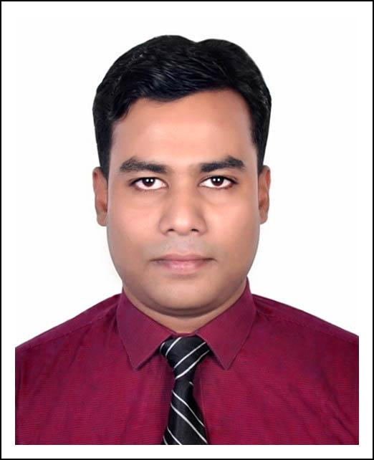

**Present and Mailing Address:**

House#38, Block#B, Road#1, Dhorengartek

Uttara, Dhaka-1230, Bangladesh.

Contact: **+880 1834 172219**

E-mail: **sajal.it.ju@gmail.com**

# **Job Experience(s):**

|  |  |  |
| --- | --- | --- |
| **Time Period** | **Duration** | **Designation & Institute** |
| 25 February, 2020 - Present | Ongoing | **Lecturer**, Department of ICT,  Mawlana Bhashani Science and Technology University, Tangail, Bangladesh |
| 01 July, 2018 -  24 February, 2020 | 1 Year  7 Months | **Senior Lecturer**, Department of CSE,  Daffodil International University, Dhaka, Bangladesh |
| 26 April, 2015 –  30 June, 2018 | 3 Years  2 Months | **Lecturer**, Department of CSE,  Daffodil International University, Dhaka, Bangladesh |
| 01 July, 2016 –  31 December, 2016 | 6 Months | **Lecturer (Part Time)**, Institute of Information Technology,  Jahangirnagar University, Savar, Dhaka, Bangladesh |
| 01 July, 2015 –  31 December, 2015 | 6 Months | **Lecturer (Part Time)**, Institute of Information Technology,  Jahangirnagar University, Dhaka, Bangladesh |

# **Career Objective:**

I want to build my career in an educational institute, employing and pertaining to utilize my technical skills and research knowledge. I also want to make a career rather than just a job and to face the challenges in all aspects.

# **Academic Qualification(s):**

|  |  |  |  |  |
| --- | --- | --- | --- | --- |
| **Title of the Degree** | **Institute** | **Passing Year** | **CGPA** | **Position** |
| M.Sc. in Information Technology | Jahangirnagar University, Bangladesh | 2015 | 3.80 (out of 4.00) | 1st Class 5th |
| B.Sc. (Hons) in Information Technology | Jahangirnagar University, Bangladesh | 2013 | 3.79 (out of 4.00) | 1st Class 2nd |
| H.S.C. (Science) | BCIC College, Bangladesh | 2009 | 5.00 (out of 5.00) | - |
| S.S.C. (Science) | Meherpur Govt. High School, Bangladesh | 2007 | 4.88 (out of 5.00) | - |

# **Academic Achievement(s):**

1. Champion in **4th CFICC** (Citi Financial IT Case Competition), 2012 with team name ‘***IIT-JU Thirsty Crows***’. The Competition was jointly organized by **CITI** Foundation and **DNET**.
2. Jahangirnagar University merit scholarships for academic performances from 2010 to 2014.
3. First grade scholarship in Primary Scholarship Examination, 2001 from Khulna Zone.
4. First grade scholarship in Junior Scholarship Examination, 2004 from Khulna Zone.

# **Publication(s):**

1. **Md. Tanvir Rahman**, Risala T. Khan, Muhammad R. A. Khandaker, Mathini Sellathurai, and Md. Sifat Ar Salan, “An Automated Contact Tracing Approach for Controlling Covid-19 Spread Based on Geolocation Data from Mobile Cellular Networks”, *IEEE Access*, vol.8, pp.213554-213565, 2020, doi: 10.1109/ACCESS.2020.3040198.
2. **Md. Tanvir Rahman**, Taslima Ferdaus Shuva, Risala Tasin Khan, Mostofa Kamal Nasir, “A Review of Contact Tracing Approaches for Controlling COVID-19 Pandemic”, *Global Journal of Computer Science and Technology*, [S.l.], feb. 2021. ISSN 0975-4172. doi: <https://doi.org/10.34257/GJCSTHVOL21IS1PG31>.
3. Md. Shams Sayied Haque, **Md. Tanvir Rahman**, Risala Tasin Khan, and Mohammad Shibli Kaysar, “Voice Assistant and Touch Screen Operated Intelligent Wheelchair for Physically Challenged People”, in *Proceedings of International Conference on Trends in Computational and Cognitive Engineering. Advances in Intelligent Systems and Computing* , vol. 1309, Springer, 2020. https://doi.org/10.1007/978-981-33-4673-4_32
4. Aminul Haque, **Md. Tanvir Rahman**, “An Agent-based Grouping Strategy for Federated Grid Computing”, *Global Journal of Computer Science and Technology: E Network, Web & Security*, [S.l.], apr. 2018. ISSN 0975-4172.
5. Toufik Ahmed Emon, **Md. Tanvir Rahman**, Uzzal Kumar Prodhan, Mohammed Zahidur Rahman, “Telemedicine and IoMT: Its importance regarding healthcare in Bangladesh”, *International Journal of Scientific & Engineering Research,* volume.9, issue. 2, February 2018.
6. **Md. Tanvir Rahman**, Md. Sifat Ar Salan, Taslima Ferdaus Shuva and Risala Tasin Khan, “Efficient Sensor-Cloud Communication using Data Classification and Compression”, *International Journal of Information Technology and Computer Science*, vol. 9, no. 6, pp. 9-17, 2017. doi: 10.5815/ijitcs.2017.06.02
7. **Md. Tanvir Rahman**, Taslima Ferdaus Shuva and K M Akkas Ali, “Trusted Device along with Trusted Location and Biometry based Authentication Method”, *International Journal of Computer Applications*, vol. 150, no. 4, pp.26-30, 2016. doi: 10.5120/ijca2016911490
8. Firoz Ahmed, Mehrin Anannya, **Md. Tanvir Rahman** and Risala Tasin Khan, “Automated CV Processing along with Psychometric Analysis in Job Recruiting Process”, *International Conference on Electrical Engineering and Information Communication Technology (ICEEICT)*, pp.1-5, 2015. doi: 10.1109/ICEEICT.2015.7307521
9. **Md. Tanvir Rahman** and Fahima Tabassum, “Implementation of a Multi-Environment Alumni Association with Geographical Location Identification”, *Jahangirnagar University Journal of Information Technology,* volume 3, pp.41-46, 2014.

# **Training Summary:**

|  |  |  |
| --- | --- | --- |
| **Title of the Training** | **Institute** | **Time Period** |
| Participatory Engagement Technique (PET) Training | Human Resource Development Institute (HRDI), Daffodil International University | May 02, 2015 - May 08, 2015 |
| Database Design & Implementation with WEB Application | Institute of Information Technology, Jahangirnagar University | February 16, 2013 (Day Long) |
| CCNA Part I | Cisco Local Academy, Institute of Information Technology, Jahangirnagar University | January 01, 2013 - April 30, 2013 |
| CCNA Part II | Cisco Local Academy, Institute of Information Technology, Jahangirnagar University | May 02, 2013 - August 31, 2013 |

# **Personal Details:**

|  |  |
| --- | --- |
| **Name** | Md. Tanvir Rahman |
| **Father’s Name** | Md. Moklesur Rahman |
| **Mother’s Name** | Nargis Tanzia |
| **Permanent Address** | Home#124, Road#1/A, Stadium Para, Meherpur-7100 |
| **Date of Birth** | 05 October 1992 |
| **Religion** | Islam |
| **Nationality** | Bangladeshi by birth |
| **National ID** | 6875982933 |
| **Marital Status** | Married |

# **References:**

|  |  |
| --- | --- |
| **Dr. Ruhul Amin Khandaker**  Assistant Professor  School of Engineering and Physical Sciences,  Heriot-Watt University, United Kingdom  Phone (Cell): +44 (0) 131 451 3349  Email: m.khandaker@hw.ac.uk  Relation: Academic. | **Dr. Risala Tasin Khan**  Professor  Institute of Information Technology,  Jahangirnagar University, Bangladesh.  Phone (Cell): +880 1715 108479  Email: risala@juniv.edu  Relation: Academic (M.Sc. Supervisor). |

# 

# **Declaration:**

I hereby declare that the information given above is true to the best of my knowledge.



-----------------------------

Md. Tanvir Rahman