# Uninformed Search Algorithms

**Uninformed search is a class of general-purpose search algorithms which operates in brute force-way. Uninformed search algorithms do not have additional information about state or search space other than how to traverse the tree, so it is also called blind search.**

**Following are the various types of uninformed search algorithms:**

1. **Breadth-first Search**
2. **Depth-limited Search**
3. **Iterative deepening search**
4. **Uniform cost search**
5. **Bidirectional Search**

## **Breadth-first Search:**

# Graph Traversal - BFS

Graph traversal is a technique used for searching a vertex in a graph. The graph traversal is also used to decide the order of vertices is visited in the search process. A graph traversal finds the edges to be used in the search process without creating loops. That means using graph traversal we visit all the vertices of the graph without getting into looping path.

There are two graph traversal techniques and they are as folloL

# BFS (Breadth First Search)

BFS traversal of a graph produces a **spanning tree** as final result. **Spanning Tree** is a graph without loops. We use **Queue data structure** with maximum size of total number of vertices in the graph to implement BFS traversal.

We use the following steps to implement BFS traversal...

* **Step 1 -** Define a Queue of size total number of vertices in the graph.
* **Step 2 -** Select any vertex as **starting point** for traversal. Visit that vertex and insert it into the Queue.
* **Step 3 -** Visit all the non-visited **adjacent** vertices of the vertex which is at front of the Queue and insert them into the Queue.
* **Step 4 -** When there is no new vertex to be visited from the vertex which is at front of the Queue then delete that vertex.
* **Step 5 -** Repeat steps 3 and 4 until queue becomes empty.
* **Step 6 -** When queue becomes empty, then produce final spanning tree by removing unused edges from the graph

# Example

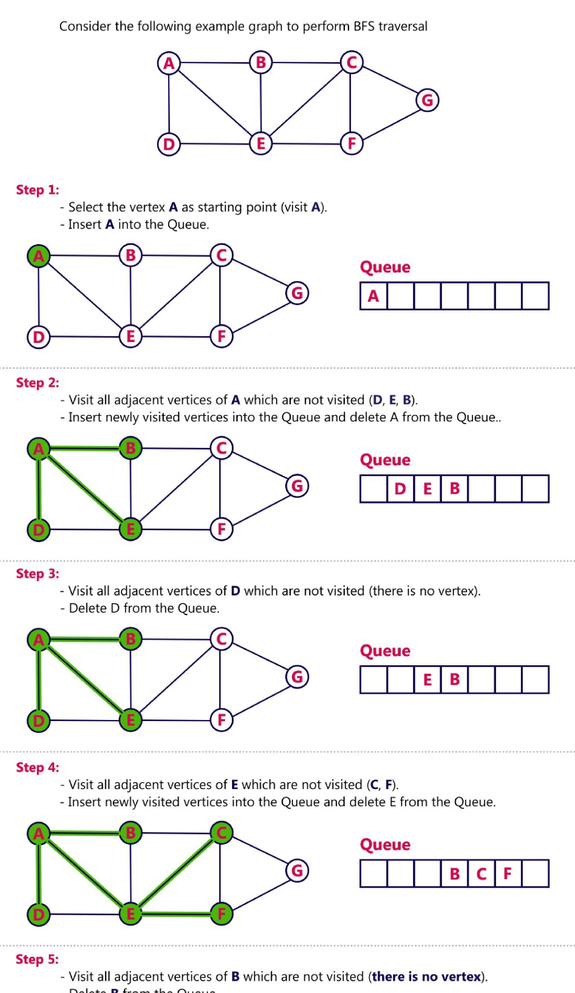

## **2. Iterative deepeningdepth-first Search:**

The iterative deepening algorithm is a combination of DFS and BFS algorithms. This search algorithm finds out the best depth limit and does it by gradually increasing the limit until a goal is found.

This algorithm performs depth-first search up to a certain "depth limit", and it keeps increasing the depth limit after each iteration until the goal node is found.

This Search algorithm combines the benefits of Breadth-first search's fast search and depth-first search's memory efficiency.

The iterative search algorithm is useful uninformed search when search space is large, and depth of goal node is unknown.

*What is iterative deepening algorithm in artificial intelligence?*

Iterative deepening A* (IDA*) is a graph traversal and path search algorithm that can find the shortest path between a designated start node and any member of a set of goal nodes in a weighted graph.

**Advantages:**

* Itcombines the benefits of BFS and DFS search algorithm in terms of fast search and memory efficiency.

**Disadvantages:**

* The main drawback of IDDFS is that it repeats all the work of the previous phase.

### **Example:**

Following tree structure is showing the iterative deepening depth-first search. IDDFS algorithm performs various iterations until it does not find the goal node. The iteration performed by the algorithm is given as:

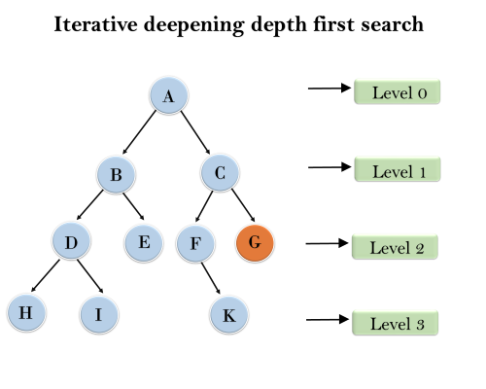

1'st Iteration-----> A  
2'nd Iteration----> A, B, C  
3'rd Iteration------>A, B, D, E, C, F, G  
4'th Iteration------>A, B, D, H, I, E, C, F, K, G  
In the fourth iteration, the algorithm will find the goal node.

**Completeness:**

This algorithm is complete is ifthe branching factor is finite.

**Time Complexity:**

Let's suppose b is the branching factor and depth is d then the worst-case time complexity is **O(bd)**.

**Space Complexity:**

The space complexity of IDDFS will be **O(bd)**.

**Optimal:**

IDDFS algorithm is optimal if path cost is a non- decreasing function of the depth of the node.

## **3.Bidirectional Search Algorithm:**

**Bidirectional search algorithm runs two simultaneous searches, one form initial state called as forward-search and other from goal node called as backward-search, to find the goal node. Bidirectional search replaces one single search graph with two small subgraphs in which one starts the search from an initial vertex and other starts from goal vertex. The search stops when these two graphs intersect each other.**

**Bidirectional search can use search techniques such as BFS, DFS, DLS, etc.**

**Advantages:**

* Bidirectional search is fast.
* Bidirectional search requires less memory

**Disadvantages:**

* Implementation of the bidirectional search tree is difficult.
* **In bidirectional search, one should know the goal state in advance.**

### **Example:**

In the below search tree, bidirectional search algorithm is applied. This algorithm divides one graph/tree into two sub-graphs. It starts traversing from node 1 in the forward direction and starts from goal node 16 in the backward direction.

The algorithm terminates at node 9 where two searches meet.

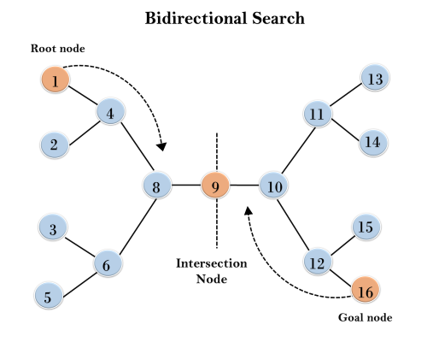**Completeness:** Bidirectional Search is complete if we use BFS in both searches.

**Time Complexity:** Time complexity of bidirectional search using BFS is **O(bd)**.

**Space Complexity:** Space complexity of bidirectional search is **O(bd)**.

**Optimal:** Bidirectional search is Optimal.

## **4. Uniform-cost Search Algorithm:**

Uniform-cost search is a searching algorithm used for traversing a weighted tree or graph. This algorithm comes into play when a different cost is available for each edge. The primary goal of the uniform-cost search is to find a path to the goal node which has the lowest cumulative cost. Uniform-cost search expands nodes according to their path costs form the root node. It can be used to solve any graph/tree where the optimal cost is in demand. A uniform-cost search algorithm is implemented by the priority queue. It gives maximum priority to the lowest cumulative cost. Uniform cost search is equivalent to BFS algorithm if the path cost of all edges is the same.

**Advantages:**

* Uniform cost search is optimal because at every state the path with the least cost is chosen.

**Disadvantages:**

* It does not care about the number of steps involve in searching and only concerned about path cost. Due to which this algorithm may be stuck in an infinite loop.

### **Example:**

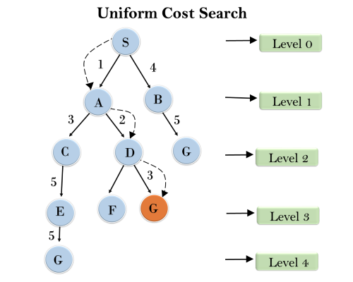

**Completeness:**

Uniform-cost search is complete, such as if there is a solution, UCS will find it.

**Time Complexity:**

Let C* **is Cost of the optimal solution**, and **ε** is each step to get closer to the goal node. Then the number of steps is = C*/ε+1. Here we have taken +1, as we start from state 0 and end to C*/ε.

Hence, the worst-case time complexity of Uniform-cost search is**O(b1 + [C*/ε])/**.

**Space Complexity:**

The same logic is for space complexity so, the worst-case space complexity of Uniform-cost search is **O(b1 + [C*/ε])**.

**Optimal:**

Uniform-cost search is always optimal as it only selects a path with the lowest path cost.

**class** Node(object):

"""This class represents a node in a graph."""

**def** __init__(self, label: str**=None**):

"""

Initialize a new node.

Args:

label: the string identifier for the node

"""

self**.**label **=** label

self**.**children **=** []

**def** __lt__(self,other):

"""

Perform the less than operation (self < other).

Args:

other: the other Node to compare to

"""

**return** (self**.**label **<** other**.**label)

**def** __gt__(self,other):

"""

Perform the greater than operation (self > other).

Args:

other: the other Node to compare to

"""

**return** (self**.**label **>** other**.**label)

**def** __repr__(self):

"""Return a string form of this node."""

**return** '{} -> {}'**.**format(self**.**label, self**.**children)

**def** add_child(self, node, cost**=**1):

"""

Add a child node to this node.

Args:

node: the node to add to the children

cost: the cost of the edge (default 1)

"""

edge **=** Edge(self, node, cost)

self**.**children**.**append(edge)

**class** Edge(object):

"""This class represents an edge in a graph."""

**def** __init__(self, source: Node, destination: Node, cost: int**=**1):

"""

Initialize a new edge.

Args:

source: the source of the edge

destination: the destination of the edge

cost: the cost of the edge (default 1)

"""

self**.**source **=** source

self**.**destination **=** destination

self**.**cost **=** cost

**def** __repr__(self):

"""Return a string form of this edge."""

**return** '{}: {}'**.**format(self**.**cost, self**.**destination**.**label)

create all the nodes

In [28]:

S **=** Node('S')

A **=** Node('A')

B **=** Node('B')

C **=** Node('C')

D **=** Node('D')

G **=** Node('G')

create all the edges

In [29]:

S**.**add_child(A, 1)

S**.**add_child(G, 12)

A**.**add_child(B, 3)

A**.**add_child(C, 1)

B**.**add_child(D, 3)

C**.**add_child(D, 1)

C**.**add_child(G, 2)

D**.**add_child(G, 3)

take a look

In [26]:

_ **=** [print(node) **for** node **in** [S, A, B, C, D, G]]

S -> [1: A, 3: G]

A -> [3: B, 1: C]

B -> [3: D]

C -> [1: D, 2: G]

D -> [3: G]

G -> []

UCS(root):

Insert the root into the queue

While the queue is not empty

Dequeue the maximum priority element from the queue

(If priorities are same, alphabetically smaller path is chosen)

If the path is ending in the goal state, print the path and exit

Else

Insert all the children of the dequeued element, with the cumulative costs as priority

In [22]:

**from** queue **import** PriorityQueue

**def** ucs(root, goal):

"""

Return the uniform cost search path from root to gaol.

Args:

root: the starting node for the search

goal: the goal node for the search

Returns: a list with the path from root to goal

Raises: ValueError if goal isn't in the graph

"""

*# create a priority queue of paths*

queue **=** PriorityQueue()

queue**.**put((0, [root]))

*# iterate over the items in the queue*

**while** **not** queue**.**empty():

*# get the highest priority item*

pair **=** queue**.**get()

current **=** pair[1][**-**1]

*# if it's the goal, return*

**if** current**.**label **==** goal:

**return** pair[1]

*# add all the edges to the priority queue*

**for** edge **in** current**.**children:

*# create a new path with the node from the edge*

new_path **=** list(pair[1])

new_path**.**append(edge**.**destination)

*# append the new path to the queue with the edges priority*

queue**.**put((pair[0] **+** edge**.**cost, new_path))

In [30]:

ucs(S, 'G')

Out[30]:

[S -> [1: A, 12: G], A -> [3: B, 1: C], C -> [1: D, 2: G], G -> []]

# 

## **5.Depth-Limited Search Algorithm:**

A depth-limited search algorithm is similar to depth-first search with a predetermined limit. Depth-limited search can solve the drawback of the infinite path in the Depth-first search. In this algorithm, the node at the depth limit will treat as it has no successor nodes further.

Depth-limited search can be terminated with two Conditions of failure:

* Standard failure value: It indicates that problem does not have any solution.
* Cutoff failure value: It defines no solution for the problem within a given depth limit.

**Advantages:**

Depth-limited search is Memory efficient.

**Disadvantages:**

* Depth-limited search also has a disadvantage of incompleteness.
* It may not be optimal if the problem has more than one solution.

### **Example:**

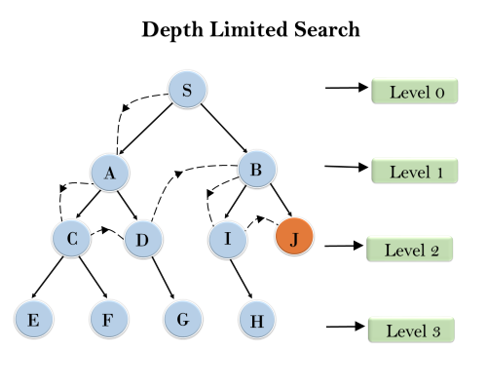

**Completeness:** DLS search algorithm is complete if the solution is above the depth-limit.

**Time Complexity:** Time complexity of DLS algorithm is **O(bℓ)**.

**Space Complexity:** Space complexity of DLS algorithm is O**(b×ℓ)**.

**Optimal:** Depth-limited search can be viewed as a special case of DFS, and it is also not optimal even if ℓ>d.