RIYA ELIZABATH VINOTH

2048049

1.Creating and Inserting:

create table Department(deptno int primary key,deptname varchar(20),location varchar(20));

insert into Department values(100,'Computer Science','Belaghavi');

insert into Department values(101,'Maths','BGL');

insert into Department values(102,'Basic Science','Belaghavi');

insert into Department values(103,'Maths','Banglore');

create table Employeee(empno int primary key,emp_fname varchar(20),emp_lname varchar(20),deptno numeric);

alter table Employeee

add foreign key(deptno) references Department(deptno);

insert into Employeee values(200,'Ria','Mathew',100);

insert into Employeee values(201,'Rohan','Philip',101);

insert into Employeee values(202,'Jia','Cherian',102);

insert into Employeee values(203,'Jake','Lukose',103);

create table Project(projno int primary key,projname varchar(20),budget int);

insert into Project values(300,'Appollo',60000);

insert into Project values(301,'Agri',80000);

insert into Project values(302,'Electric',40000);

insert into Project values(303,'Luna',75000);

create table Works_on(empno numeric,projno numeric,job varchar(20),enterdate date);

alter table Works_on

add foreign key(empno) references Employeee(empno);

alter table Works_on

add foreign key(projno) references Project(projno);

insert into Works_on values(200,300,'Advisor',date '2015-12-05');

insert into Works_on values(201,301,'CheifAdvisor',date '2010-08-08');

insert into Works_on values(202,302,'Staff',date '2014-09-05');

insert into Works_on values(203,303,'Advisor',date '2019-04-09');

3. select * from Project

where budget>50000;

|  |  |  |
| --- | --- | --- |
| **PROJNO** | **PROJNAME** | **BUDGET** |
| 300 | Appollo | 60000 |
| 301 | Agri | 80000 |
| 303 | Luna | 75000 |

4. select * from Employeee inner join Department on Employeee.deptno=Department.deptno and Department.location='BGL';

|  |  |  |  |  |  |  |
| --- | --- | --- | --- | --- | --- | --- |
| **EMPNO** | **EMP_FNAME** | **EMP_LNAME** | **DEPTNO** | **DEPTNO** | **DEPTNAME** | **LOCATION** |
| 201 | Rohan | Philip | 101 | 101 | Maths | BGL |

5. select count(empno) from Works_on inner join Project on Works_on.projno = Project.projno

|  |
| --- |
| **COUNT(EMPNO)** |
| 4 |

6.

SELECT Employeee.empno , Employeee.emp_fname ,Project.projname

FROM Employeee

INNER JOIN Works_on ON Employeee.empno=Works_on.empno

INNER JOIN Project ON Works_on.projno=Project.projno

and Project.projname='Appollo';

EMPNO EMP_FNAME PROJNAME

200 Ria Appollo

7

select min(budget) from Project;

|  |
| --- |
| **MIN(BUDGET)** |
| 40000 |

select max(budget) from Project;

|  |
| --- |
| **MAX(BUDGET)** |
| 80000 |
|  |

8.

SELECT Department.deptname ,Project.projname

FROM Department

INNER JOIN Employeee ON Employeee.deptno=Department.deptno

INNER JOIN Works_on ON Works_on.empno=Employeee.empno

INNER JOIN Project ON Project.projno=Works_on.projno

and Department.location='Belaghavi';

DEPTNAME PROJNAME

Basic Science Electric

Computer Science Appollo

9.

CREATE OR REPLACE PROCEDURE MY_PROCEDURE(VAR IN NUMBER)

AS

Bu Project.Budget%TYPE;

BEGIN

SELECT AVG(Budget) INTO Bu FROM Project WHERE projno=VAR;

DBMS_OUTPUT.PUT_LINE(Bu);

END;

Procedure created.

Execute MY_PROCEDURE(300);

Statement processed.  
60000

10.

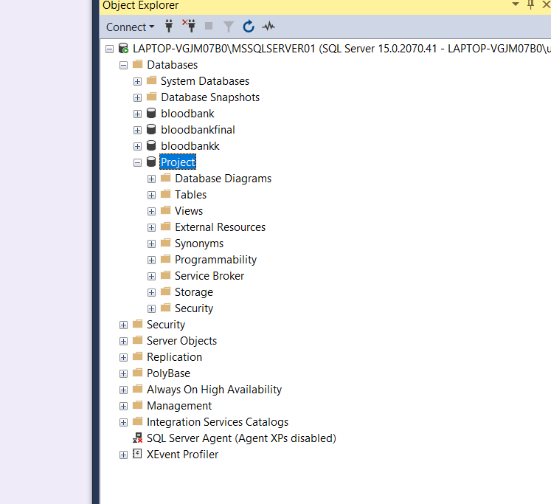Database Project is created.

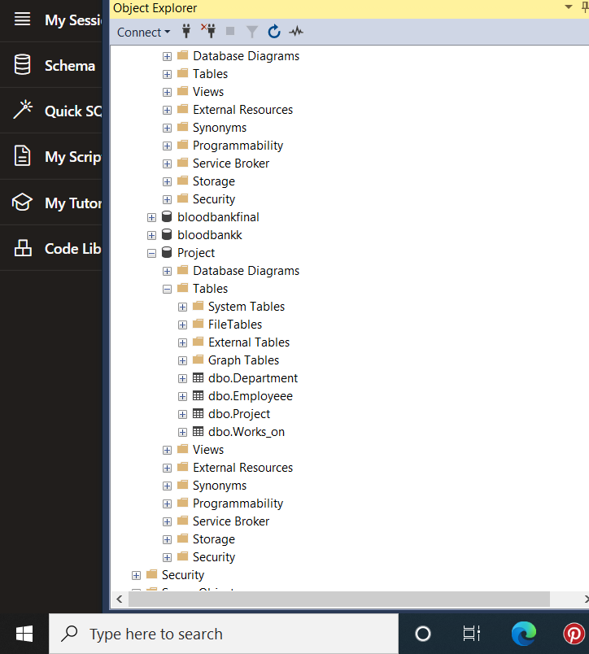 Tables are also created.

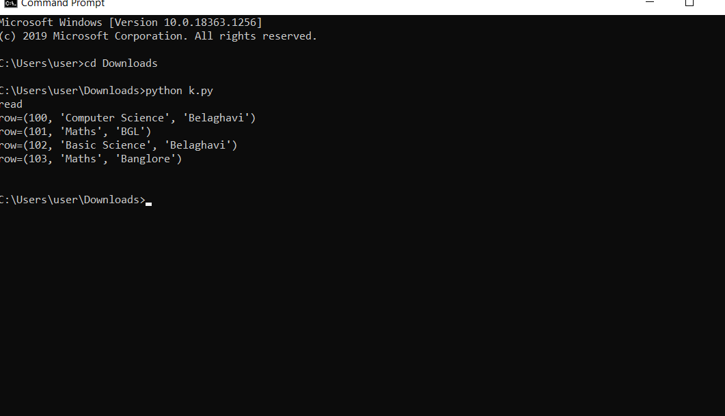Read Operation is done.

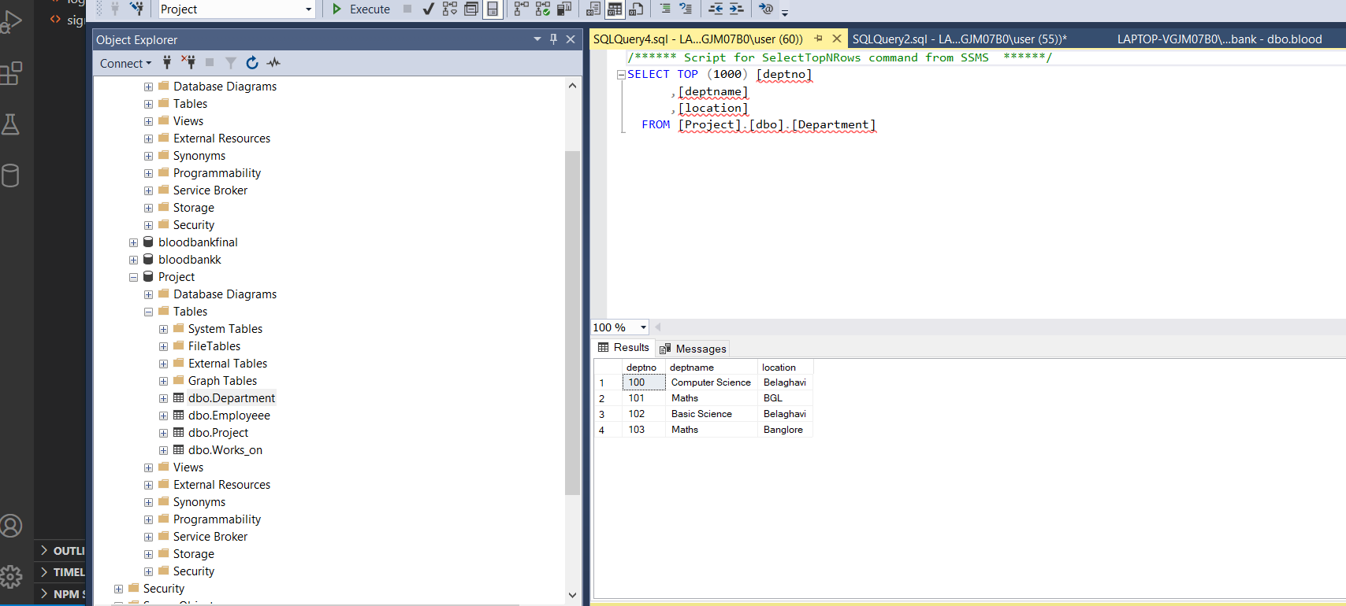Actual Database Records for table Department.

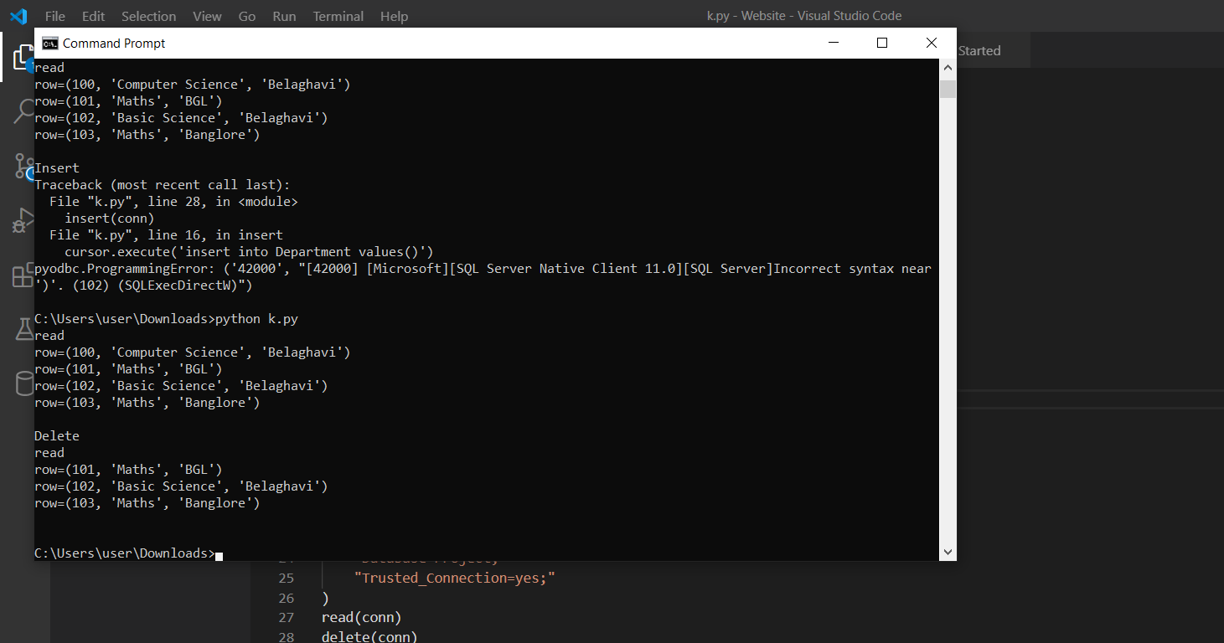Delete Operation is done for Dept No-100.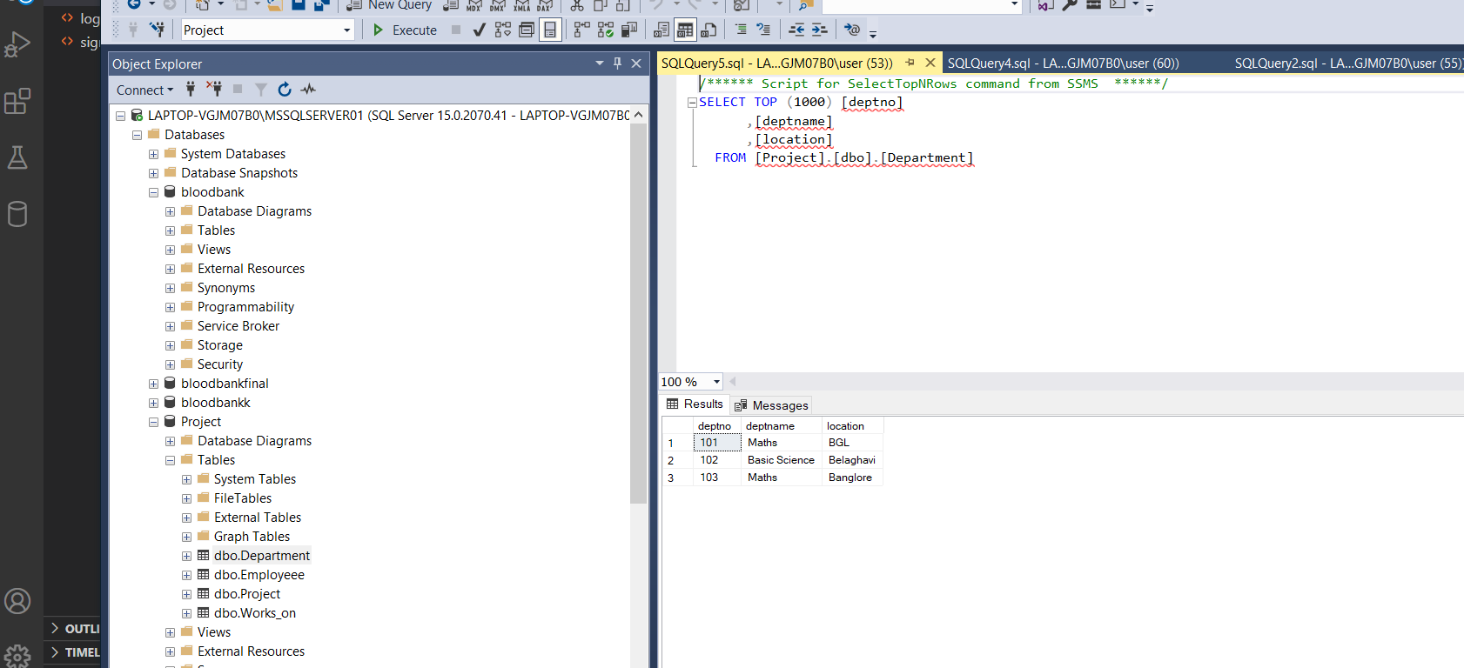Actual database is also modified.

Python Program  
import pyodbc

def read(conn):

    print("read")

    cursor = conn.cursor()

    cursor.execute("select * from Department")

    for row in cursor:

        print(f'row={row}')

    print()

def delete(conn):

    print("Delete")

    cursor = conn.cursor()

    cursor.execute('delete from Department where deptno = 100')

    conn.commit()

    read(conn)

def create(conn):

    print("Create")

    cursor = conn.cursor()

    cursor.execute(

        'insert into Department (deptno,deptname,location) values(?, ?); ')

    conn.commit()

    read(conn)

conn = pyodbc.connect(

    "Driver={SQL Server Native Client 11.0};"

    "Server=LAPTOP-VGJM07B0\MSSQLSERVER01;"

    "Database=Project;"

    "Trusted_Connection=yes;"

)

read(conn)

delete(conn)

create(conn)

conn.close()