LanChat Application - Demonstration Report
Submitted By: Technology Stack:
Riya Gupta C++, Qt 6, TCP Sockets, UDP Sockets, CMake
Project Overview
LAN Chat is a desktop-based chat application developed using C++ and the Qt Framework. The application demonstrates GUI development, TCP networking, UDP-based user discovery architecture, local file handling, and event-driven programming using Qt Signals and Slots.
The application allows users to send messages, maintain chat history, manage visibility status, and communicate through a simple graphical interface.

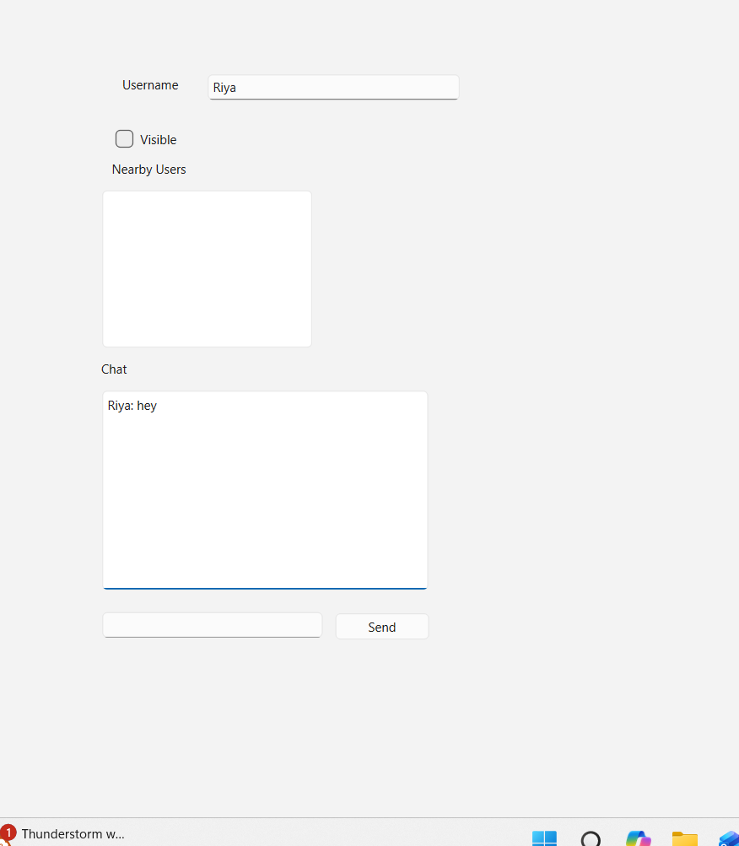
Figure 1: LAN Chat Application User Interface
The application provides a username field, visibility control, nearby users panel, chat display area, message input field, and send button. Users can enter messages and communicate through the chat interface.

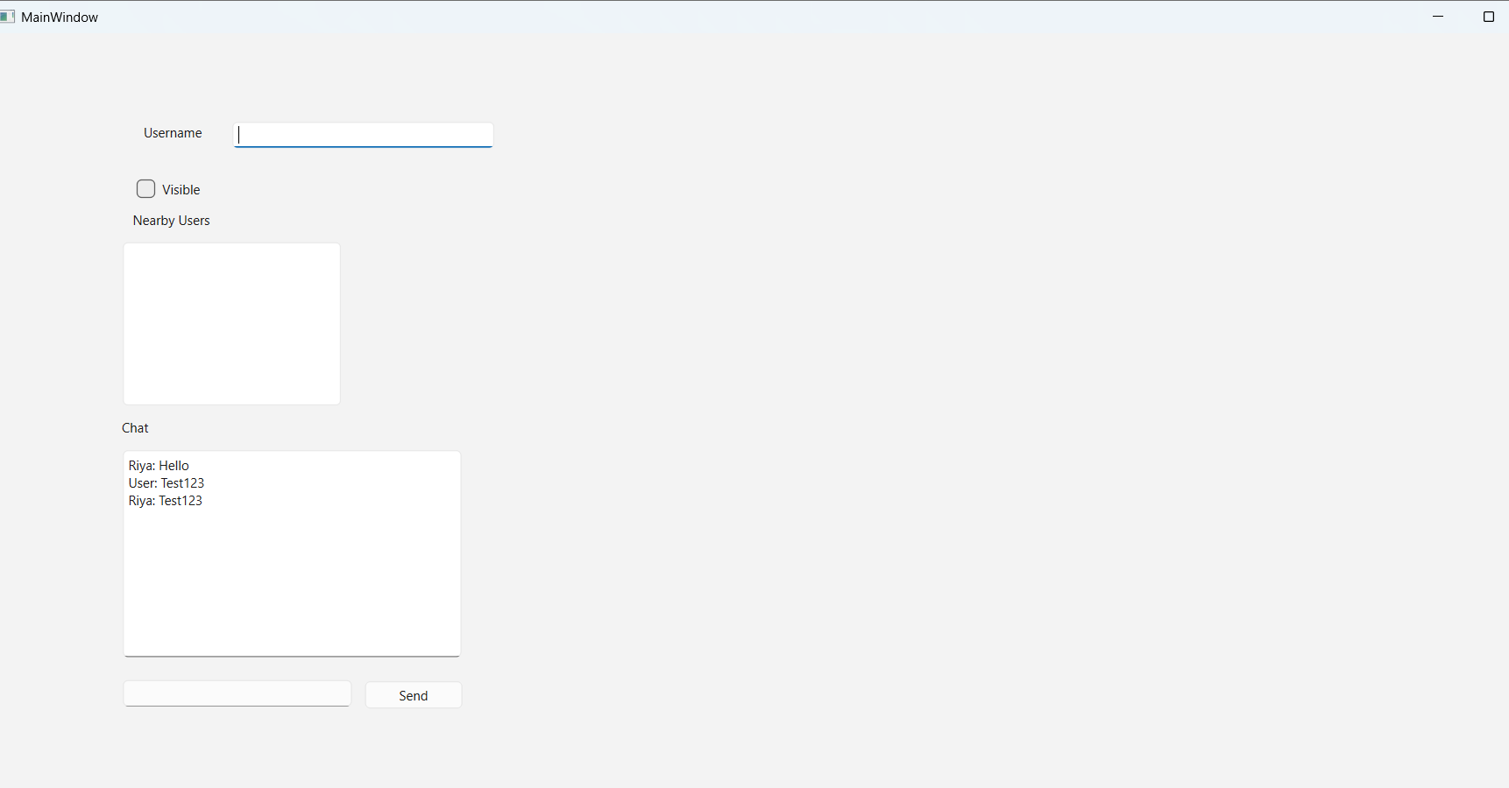

Figure 2: Application Startup Screen
The LAN Chat application startup interface displaying the username field, visibility toggle, nearby users panel, chat history area, message input box, and send button. Previously saved chat messages are automatically loaded from local storage during startup.
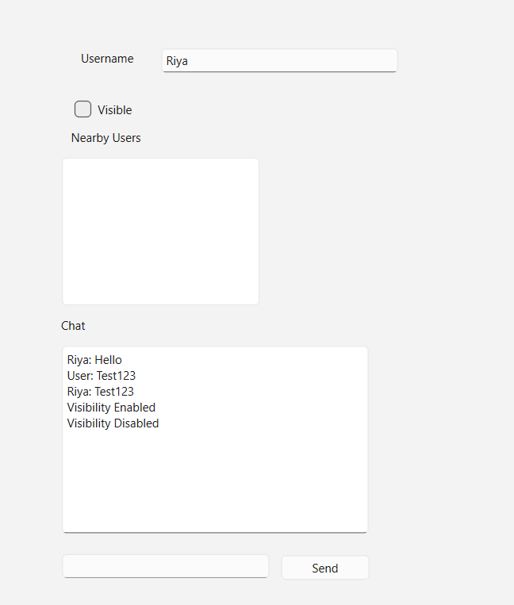
Figure 3: User Visibility Toggle
The application allows users to enable or disable their visibility status. When the checkbox is toggled, the action is recorded in the chat area, providing feedback regarding the user's visibility state.

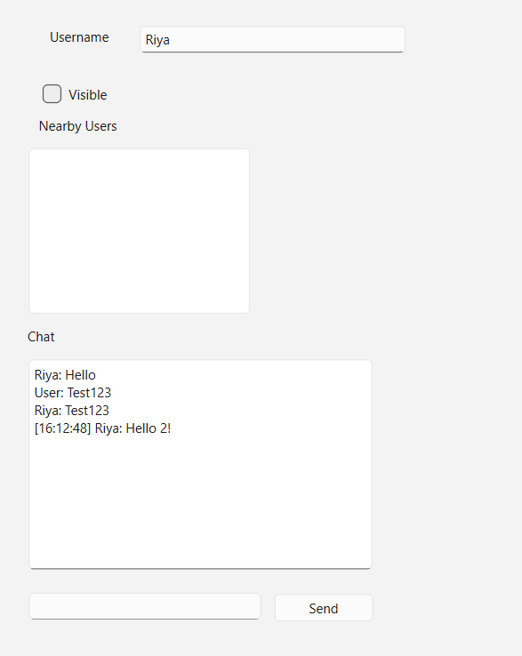
Figure 4: Timestamped Chat Messages
Messages sent through the application are automatically tagged with the current system time before being displayed. This helps users track the sequence and timing of conversations.

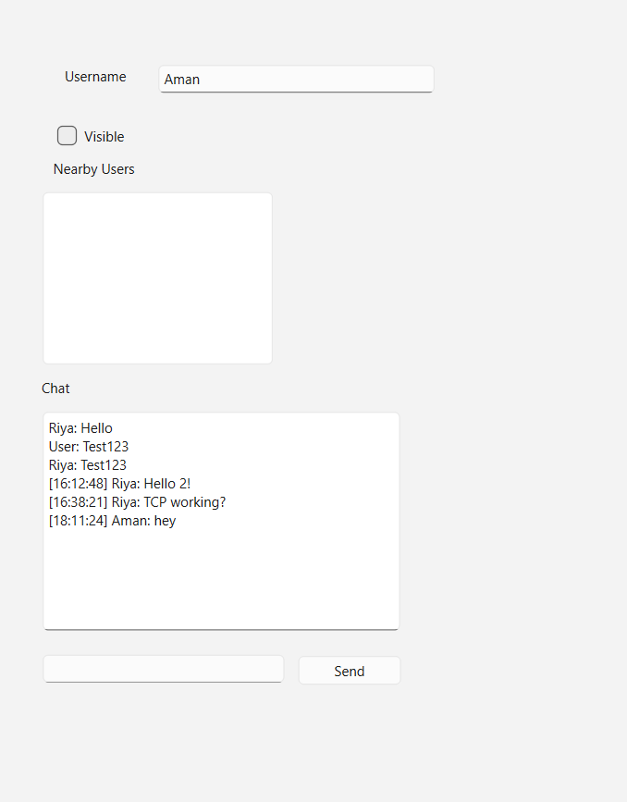
Figure 5: Message Transmission and Display
The user sends a message through the application. The message is received by the TCP server component, displayed in the chat area, and stored in the local chat history file. The chat window shows both previously saved messages and newly transmitted messages.

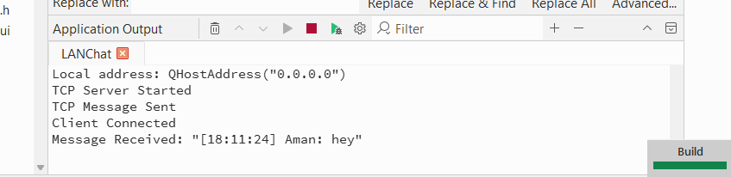
Figure 6: TCP Server and Client Communication
The Application Output window confirms successful TCP communication. The TCP server starts listening, a client connects successfully, the message is transmitted, and the server receives and processes the message.

Conclusion
The LAN Chat application prototype was successfully developed using C++ and Qt. Core functionalities including GUI implementation, TCP-based message communication, timestamp generation, chat history persistence, and visibility controls have been implemented and tested successfully.
UDP-based nearby user discovery has been implemented using QUdpSocket; however, complete validation across multiple devices and LAN environments remains an area for future enhancement.
The project demonstrates practical knowledge of networking, file handling, GUI design, and event-driven application development using the Qt Framework.

