TECHNICAL REPORT · NATURAL LANGUAGE PROCESSING · MACHINE LEARNING
Disaster Tweet Classification
Real-time disaster identification from social media using NLP and machine learning
PREPARED BY  Riya | DATE  15 October 2026 | FINAL MODEL  Logistic Regression | MODEL VERSION  DTM_20261013_020912 | DATASET  7,613 labelled tweets

1 Executive Summary
This report documents the design, evaluation and deployment of a machine-learning system that classifies tweets as genuine disaster reports or non-disaster content. The work follows a leakage-safe pipeline from data exploration through to a production-ready Flask API and Streamlit application. A Logistic Regression classifier trained on 32,136 combined text features achieved an F1 score of 0.747 and a ROC-AUC of 0.857 on a protected test set that remained untouched throughout development.
0.747 | 0.753 | 0.741 | 0.857 | 97.1% | 6,718
Test F1 | Recall | Precision | ROC-AUC | F1 under noise | Model-ready tweets

2 Objectives and Methodology
Social media is a rapid source of situational information during emergencies, but disaster vocabulary is frequently used figuratively. The objective of this project is therefore to build a reliable, explainable classifier that supports emergency monitoring and analyst triage. The methodology comprises eight stages, each designed so that test data never influences model development.
Stage | Activity | Key output
1 Exploration | Structure, quality, class balance, vocabulary | 7,613 tweets profiled
2 Preparation | Cleaning, tokenisation, lemmatisation, deduplication | 6,718 model-ready records
3 Features | Word, character, structural, sentiment, lexicon | 32,136 features
4 Modelling | Ablation, cross-validation, tuning | Logistic Regression locked
5 Evaluation | Protected test, ROC, errors, explainability | F1 0.747, AUC 0.857
6 Validation | Robustness, subgroups, confidence, review policy | 14/14 evidence items cleared
7–8 Deployment | Flask API and Streamlit interface | 14/14 HTTP and 39/39 UI tests

3 Dataset and Exploratory Analysis
The dataset contains 7,613 hand-labelled tweets and five variables: id, keyword, location, text and target. Overall completeness is 93.18%. Location is missing for 33.29% of tweets and keyword for 0.80%, while text and target are fully populated and labels are strictly binary. The target is moderately imbalanced, with 57.03% non-disaster and 42.97% disaster tweets (ratio 1.33:1), which motivated stratified sampling and the use of F1, precision and recall in preference to accuracy alone.
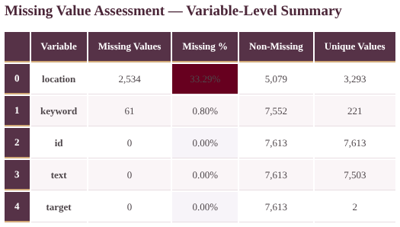  Figure 1. Missing-value summary | 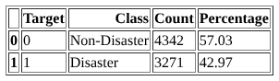  Figure 2. Class distribution

Keyword analysis shows that disaster tweets favour event and consequence terms (fire, suicide, police, killed, hiroshima), whereas non-disaster tweets contain conversational terms (like, love, get, now). Substantial vocabulary overlap, and recurring phrases such as “suicide bomber detonated” against “liked youtube video”, indicate that context and phrase-level features are required in addition to single keywords.
4 Data Preparation
A reproducible cleaning workflow preserved the original text while producing a normalised, model-ready representation. A noise audit identified URLs in 52.2% of tweets, mentions in 26.4% and hashtags in 22.9%, together with HTML entities in 4.7%.
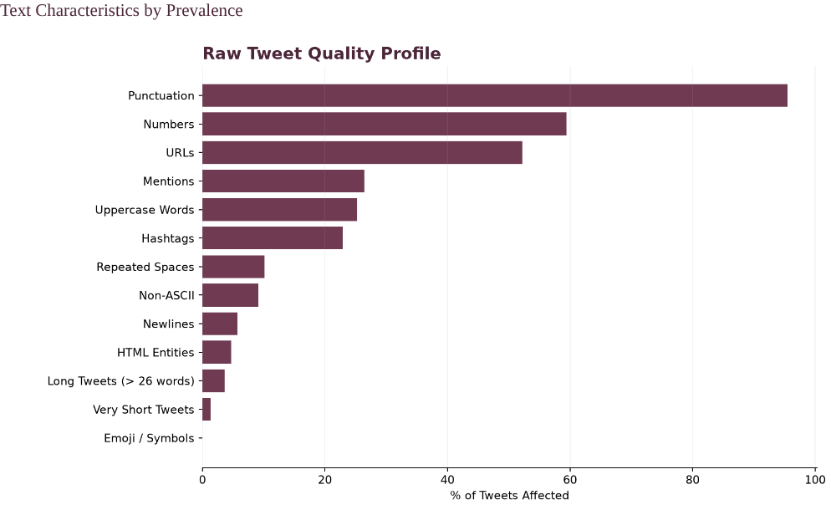  Figure 3. Raw tweet quality profile (% of tweets affected) | 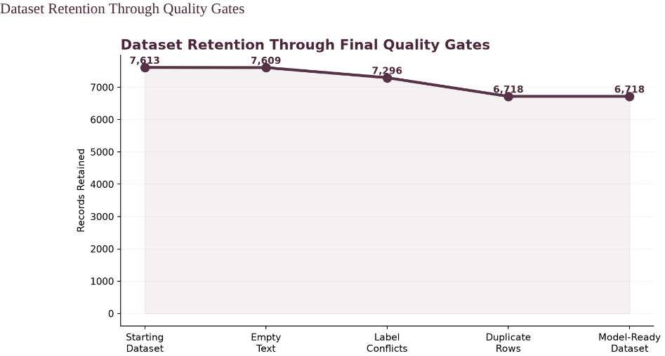  Figure 4. Dataset retention through quality gates

▪ Normalisation: HTML decoded, text lower-cased, URLs and mentions removed, hashtag words retained; 98.8% of tweets were normalised.
▪ Tokenisation and stopwords: 105,703 tokens processed; 36.9% stopwords removed while 681 negations (no, not, never) were preserved to protect meaning.
▪ Lemmatisation: vocabulary reduced by 13.2% (14,698 to 12,761 terms).
▪ Quality gates: 1,161 exact-duplicate records and 126 label conflicts were addressed, leaving 6,718 model-ready records (88.24% retention).
▪ Stratified split: 5,374 training and 1,344 test tweets, with zero text overlap and a class-proportion gap of only 0.034%. All vectorisers were fitted on training data only.
KEY INSIGHT Cleaning removes noise while preserving meaning: negations and hashtag words are kept, and all learning is confined to the training partition.

5 Feature Engineering and Model Selection
Five complementary feature blocks were combined to give the classifier lexical, sub-word, stylistic, emotional and domain evidence.
Feature block | Features | Purpose / observation
Word TF-IDF (1–2 grams) | 7,112 | Vocabulary and phrases (kill, flood, storm, fire, bomb)
Character TF-IDF (3–5 grams) | 25,000 | Spelling variants, slang and word stems
Structural | 12 | URLs 1.6x and digits 1.7x more frequent in disaster tweets
Sentiment (VADER) | 4 | Disaster tweets more negative (compound −0.25 vs −0.05)
Domain lexicon | 8 | Disaster terms 3.8x more frequent in disaster tweets

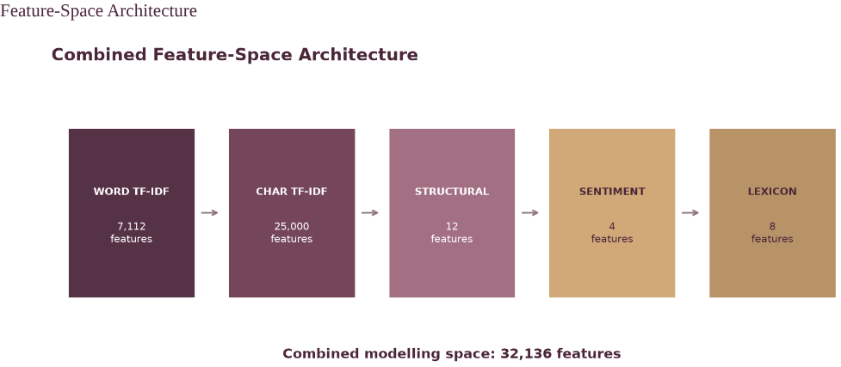
Figure 5. Combined feature space (32,136 features)

Feature set | Features | Accuracy | Precision | Recall | F1
All features | 30,834 | 0.795 | 0.794 | 0.670 | 0.727
Word + character | 30,810 | 0.785 | 0.788 | 0.645 | 0.709
Character TF-IDF | 25,000 | 0.788 | 0.814 | 0.620 | 0.704
Word TF-IDF | 5,810 | 0.788 | 0.820 | 0.613 | 0.702
Engineered only | 24 | 0.692 | 0.671 | 0.476 | 0.557

Table 1. Feature-set ablation on development data (protected test set not used)
Note: Feature counts in the ablation table reflect the development-split vocabulary; the final training pipeline expands to 32,136 features.
Model | Dev. F1 | CV mean F1 | CV std | Recall | Train time
Logistic Regression | 0.727 | 0.728 | 0.032 | 0.670 | 3.6 s
Linear SVM | 0.715 | 0.713 | 0.028 | 0.696 | 4.2 s
Random Forest | 0.704 | 0.714 | 0.020 | 0.650 | 5.1 s
SGD Classifier | 0.702 | n/a | n/a | 0.670 | 0.3 s

Table 2. Baseline and five-fold cross-validation comparison
Logistic Regression led both the baselines and the five-fold stratified cross-validation (mean F1 0.728). Hyperparameter tuning (C = 1.0, balanced class weights, sublinear TF) lifted cross-validated F1 to 0.734 with recall of 0.732, outperforming a tuned Random Forest (F1 0.723). The configuration was then locked before the protected test set was opened.
KEY INSIGHT Every feature block adds value, and a simple linear model outperforms more complex alternatives on this sparse text representation.

6 Model Evaluation and Validation
On the 1,344 unseen test tweets the model detected 411 of 546 disaster tweets and correctly rejected 654 of 798 non-disaster tweets. Ranking quality is strong: ROC-AUC reached 0.857 and average precision 0.836, roughly twice the 0.406 chance baseline. The default threshold of 0.50 was retained; a test-derived alternative (0.476) was examined for diagnostic purposes only.
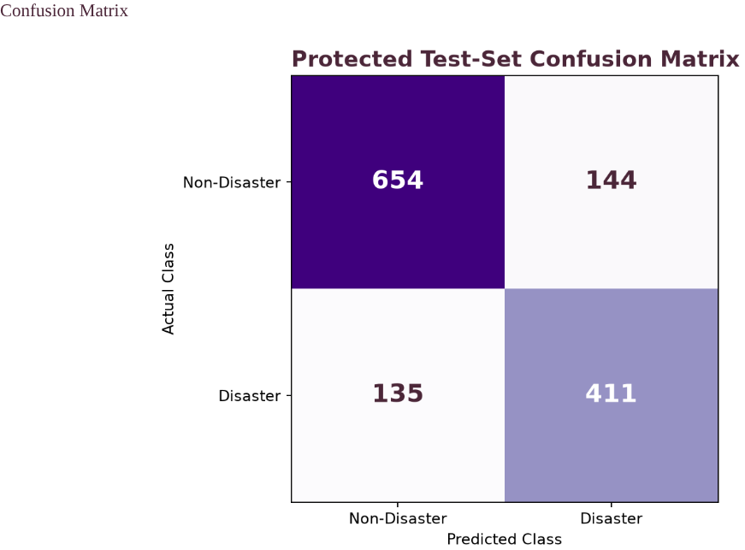  Figure 6. Confusion matrix (protected test set) | 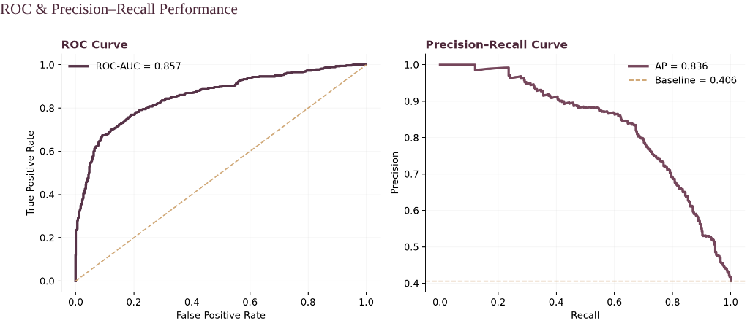  Figure 7. ROC and precision–recall curves

Evaluation stage | F1 | Comment
Training | 0.878 | Fit on training data (gap to test monitored)
Cross-validation | 0.728 | 5 folds, standard deviation 0.032
Validation | 0.743 | Development hold-out
Protected test | 0.747 | Final estimate on unseen tweets

Explainability analysis of the linear coefficients shows that disaster predictions are driven by terms such as train, building, hiroshima, forest and typhoon, while non-disaster predictions are associated with terms such as new, job, nowplaying and book. Of the 279 errors (20.76%), 144 were false positives and 135 false negatives; most arose from figurative or ambiguous wording and fell close to the decision boundary.
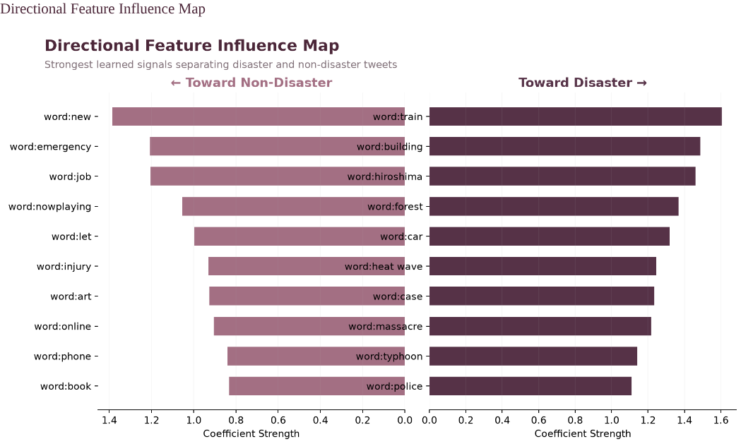  Figure 8. Strongest learned features by direction | 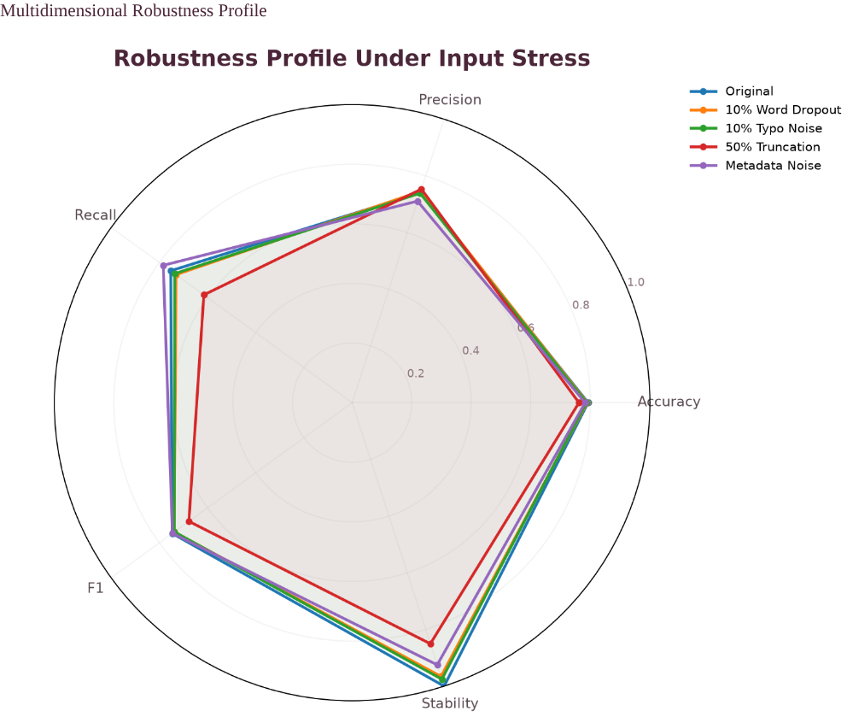  Figure 9. Robustness profile under input stress

Stress testing showed that the classifier retains an average of 97.07% of its F1 under word dropout, typographical noise and metadata noise. Slice F1 ranged from 0.591 to 0.823 across nine tweet formats. Prediction certainty separates correct from incorrect outputs (median 0.632 versus 0.311), so routing predictions with certainty of 0.60 or below to analysts would capture 77.1% of errors while automating 47.6% of volume.
Certainty cut-off | Tweets reviewed | Automated accuracy | Errors captured | Missed disasters captured
≤ 0.20 | 15.6% | 83.6% | 33.3% | 25.2%
≤ 0.40 | 33.9% | 87.5% | 60.2% | 51.9%
≤ 0.60 | 52.4% | 90.0% | 77.1% | 73.3%
≤ 0.80 | 78.9% | 94.4% | 94.3% | 91.9%

7 Deployment
The locked pipeline was serialised (1.89 MB, SHA-256 fingerprinted) and reloaded with identical predictions on 32/32 smoke tests. A Flask service exposes health and prediction endpoints, and the Streamlit interface provides plain-language results, input validation, a responsible-use statement and accessible controls.
Component | Description | Verification
Production package | Cloudpickle bundle, version DTM_20261013_020912 | 32/32 reload parity checks
Flask API | GET /, GET /health, POST /predict | 14/14 HTTP tests; 100% prediction parity
Streamlit UI | Analyse Tweet, Performance, Reliability, About | 39/39 acceptance tests
Reproducibility | Fixed seed 42, model card, README, manifest | 6/6 checks; 102/102 SHA-256 verified

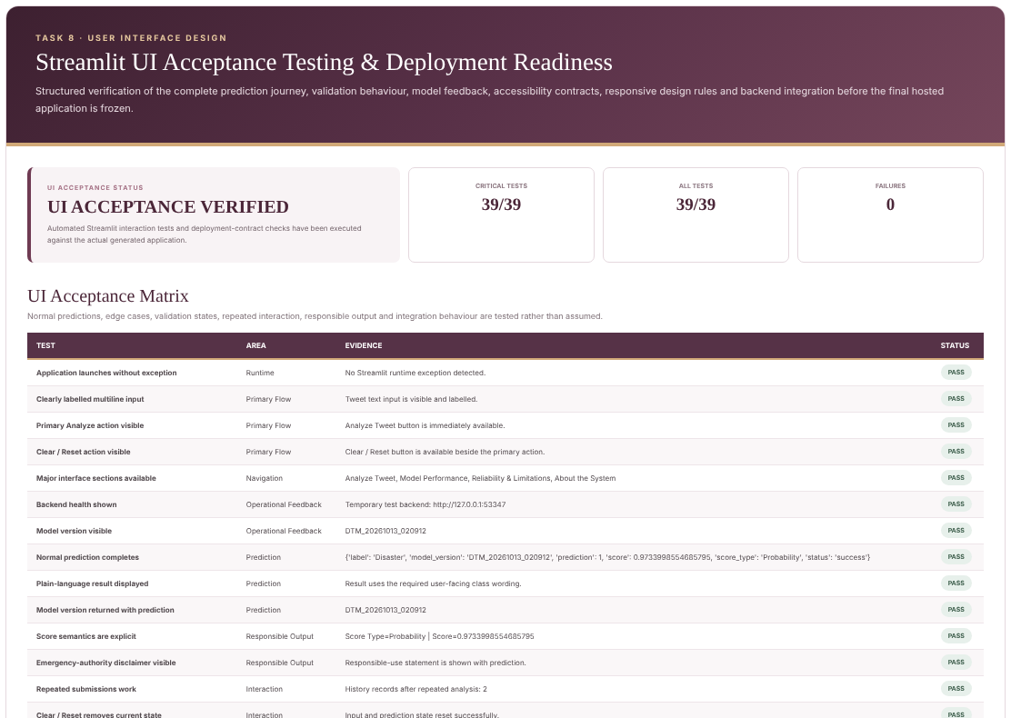
Figure 10. Streamlit UI acceptance testing

8 Conclusion and Recommendations
The project delivers an interpretable, reproducible and rigorously validated disaster-tweet classifier supported by a tested API and user interface. Held-out estimates are consistent across cross-validation, validation and test (F1 0.728, 0.743 and 0.747), and the model is robust to realistic text noise. It is well suited to decision support for emergency monitoring.
Key finding | Evidence
Strong generalisation | F1 0.728 (CV), 0.743 (validation), 0.747 (test)
Reliable ranking | ROC-AUC 0.857; average precision 0.836 against a 0.406 baseline
Resilience to noisy text | 97.07% average F1 retention under stress tests
Production readiness | 14/14 HTTP tests, 39/39 UI tests, 100% API prediction parity
Governance | Locked model, leakage sign-off, model card and verified package

▪ Retain human review for low-certainty predictions to reduce missed events.
▪ Monitor recall, alert volume and prediction confidence after release.
▪ Retrain periodically on newly labelled tweets and re-validate before redeployment.

