- TITLE PAGE
AMAZON SALES DATA ANALYSIS

Internship Project Report
Project ID: 78G0OL
Analyze and Provide Insights on Amazon Sales Report

Submitted by:
RIYA GUPTA
Computer Science and Engineering
HERITAGE INSTITUTE OF TECHNOLOGY

Internship Duration:
10 August 2026 – 10 September 2026

- INTRODUCTION
E-commerce generates large volumes of transactional data that can provide valuable insights into sales performance, customer preferences, product demand, fulfillment operations, and geographical distribution. Proper analysis of such data can help organizations make informed decisions regarding inventory, sales strategies, logistics, and customer service.
This project focuses on analyzing an Amazon sales dataset to identify meaningful patterns and trends in the available transaction data. The analysis covers sales performance, product categories and sizes, fulfillment methods, courier status, B2B transactions, geographical distribution, and order-value behavior.
Python-based data analysis and visualization techniques were used to clean, explore, summarize, and visualize the dataset. The findings were then converted into actionable business insights and recommendations.

- PROBLEM STATEMENT
The Amazon sales dataset contains transaction-level information such as order details, dates, order status, fulfilment method, product category, size, quantity, sales amount, and shipping location. However, raw transactional data does not directly provide clear business insights.
Therefore, the objective of this project is to analyse the available data systematically and identify patterns in sales, products, fulfilment, geographical distribution, and order behaviour. These insights can be used to support better inventory planning, sales decisions, operational monitoring, and customer service strategies.

- OBJECTIVES
- To analyse sales trends and patterns over time.
- To identify popular product categories, sizes, and quantities.
- To evaluate different fulfilment methods.
- To analyse customer/order behaviour based on the information available in the dataset.
- To study sales distribution across geographical regions.
- To provide actionable business insights and recommendations for growth.

- DATASET DESCRIPTION
The dataset used for this project is the Amazon Sale Report dataset. It contains transaction-level information related to Amazon sales orders.
The dataset includes fields related to order identification, date, order status, fulfilment method, sales channel, product category, size, quantity, amount, and shipping information.
After data cleaning and preprocessing, the working dataset contained 128,808 records and 19 columns.
Parameter | Value
Cleaned records | 128,808
Columns | 19
Unique orders | 120,229
Date range in source data | 05-Apr-2022 to 30-Apr-2022
Currency | INR

- TOOLS AND TECHNOLOGIES
The following tools and technologies were used for the analysis:
- Python – programming language used for data analysis.
- Pandas – used for data loading, cleaning, transformation, and aggregation.
- NumPy – used for numerical operations.
- Matplotlib – used for creating visualizations.
- Seaborn – used for statistical and graphical visualization.
- Google Colab – used as the development and execution environment.

- DATA CLEANING
Before performing exploratory data analysis, the dataset was examined for missing values, duplicate records, empty columns, invalid values, and incorrect data types.
Completely empty columns were identified and removed. Duplicate records were also checked and removed to prevent repeated transactions from affecting the analysis. Numerical fields were examined for invalid negative values.
Missing values were investigated before deciding how they should be handled. Missing values in the Amount field were retained where appropriate because replacing them without sufficient information could introduce artificial values.
Cleaning Step | Result
Empty columns removed | New, PendingS
Duplicate rows removed | 168
Final duplicate rows | 0
Missing Amount values | 2,568
Missing Amount percentage | 6.06%
Missing shipping-location records | 14
Negative Quantity values | 0
Negative Amount values | 0
Final dataset | 128,808 × 19
The cleaned dataset was subsequently used for all further analysis.

- SALES OVERVIEW
The monthly sales analysis shows that April 2022 recorded the available monthly sales amount of INR 17,529,523.99. The daily analysis identified 14-Apr-2022 as the highest recorded sales day, with sales of INR 1,106,541.52. Since the available source dates are concentrated in April 2022, the monthly comparison should be interpreted accordingly.
Table:
Sales Metric | Value
Total records | 128,808
Unique orders | 120,229
Total recorded sales | INR 78,496,786.39
Average recorded sales | INR 648.63
Minimum amount | INR 0
Maximum amount | INR 5,584

Graph 1:
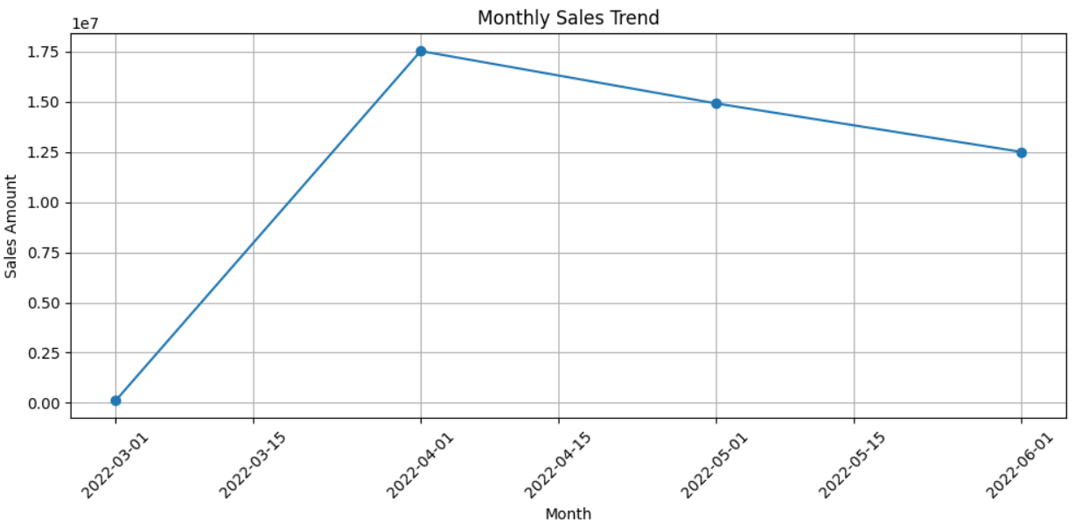
Figure 1: Monthly Sales Trend
The monthly sales analysis shows that April 2022 recorded the available monthly sales amount of INR 17,529,523.99. The daily analysis identified 14-Apr-2022 as the highest recorded sales day, with sales of INR 1,106,541.52. Since the available source dates are concentrated in April 2022, the monthly comparison should be interpreted accordingly.

- PRODUCT ANALYSIS
Product analysis was performed to identify the categories contributing most to order volume and recorded sales.
The analysis showed that T-shirt and Shirt were the dominant product categories. T-shirts recorded the highest sales and quantity among all product categories.

Table:
Category | Order Records | Quantity | Recorded Sales
T-shirt | 50,219 | 45,228 | INR 39,154,132.17
Shirt | 49,804 | 44,978 | INR 21,269,768.70
Blazer | 15,489 | 13,934 | INR 11,208,506.12
Trousers | 10,607 | 9,889 | INR 5,341,305.30
Perfume | 1,157 | 1,051 | INR 789,419.66
Wallet | 926 | 863 | INR 458,408.18
Socks | 439 | 398 | INR 150,397.50
Shoes | 164 | 152 | INR 123,933.76

Graph 2:
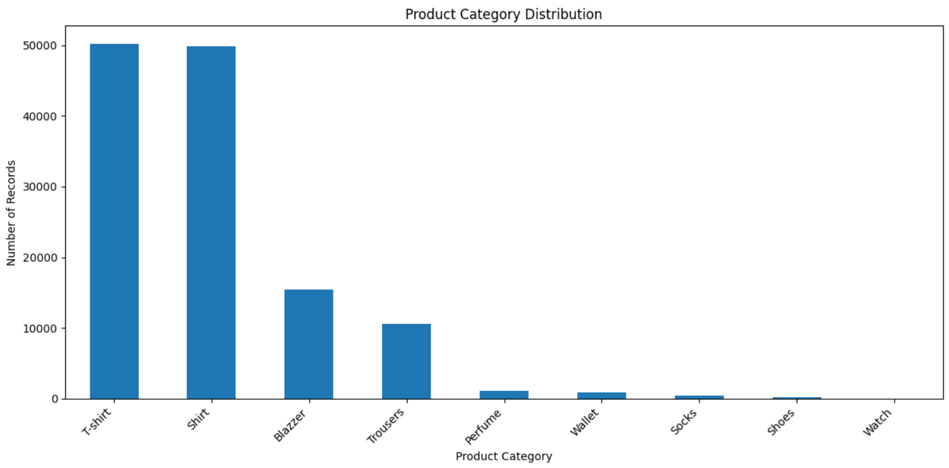
Figure 2: Recorded Sales by Product Category
T-shirts generated the highest recorded sales at INR 39,154,132.17 and also recorded the highest order volume and quantity. Shirts were the second-largest category by order volume and recorded sales.

- SIZE ANALYSIS
Product size analysis was performed to understand the distribution of demand across different sizes.
Size M recorded the highest order volume and total quantity, while also generating the highest recorded sales amount.
Table:
Size | Order Records | Quantity | Recorded Sales
M | 22,350 | 20,116 | INR 13,678,295.13
L | 21,777 | 19,680 | INR 13,023,938.84
XL | 20,520 | 18,609 | INR 12,240,095.38
XXL | 17,783 | 16,226 | INR 10,452,621.64
S | 16,754 | 15,022 | INR 10,414,943.18
3XL | 14,626 | 13,346 | INR 9,026,104.92
XS | 11,033 | 9,829 | INR 6,952,253.10
Free | 2,250 | 2,069 | INR 1,372,676.60
6XL | 738 | 688 | INR 576,249.33
5XL | 550 | 513 | INR 425,156.63
4XL | 427 | 398 | INR 334,451.64

Graph 3:
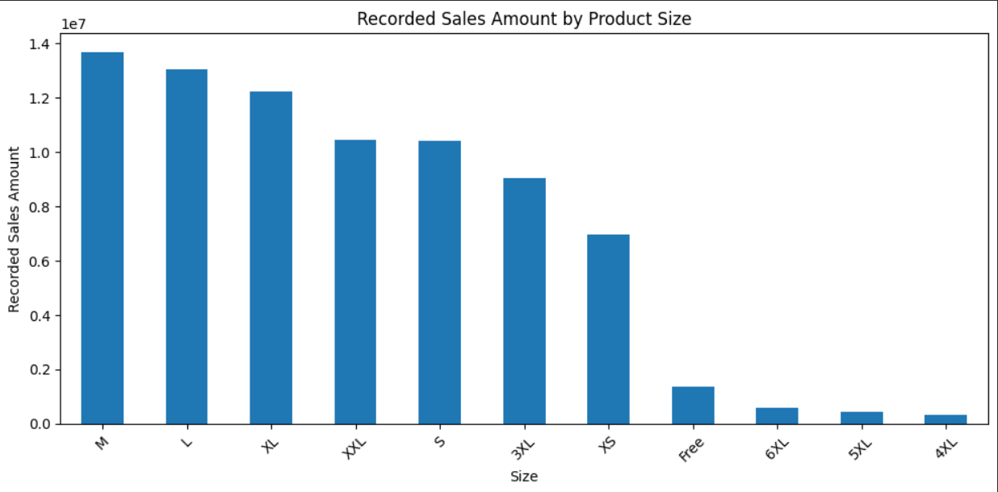
Figure 3: Recorded Sales by Product Size
Size M recorded the highest order volume and total quantity, while also generating the highest recorded sales amount. M recorded 22,350 order records, 20,116 units, and INR 13,678,295.13 in recorded sales.

- FULFILMENT ANALYSIS
Amazon fulfilment accounted for 89,595 records (69.56%), while Merchant fulfilment accounted for 39,213 records (30.44%). Amazon fulfilment generated INR 54,262,165.00 in recorded sales, compared with INR 24,234,621.39 for Merchant fulfilment. The average recorded sales amount was INR 649.52 for Amazon fulfilment and INR 646.65 for Merchant fulfilment.
Table:
Fulfilment | Records | Share | Recorded Sales | Average Recorded Sales
Amazon | 89,595 | 69.56% | INR 54,262,165.00 | INR 649.52
Merchant | 39,213 | 30.44% | INR 24,234,621.39 | INR 646.65
Merchant fulfilment recorded a higher cancellation rate than Amazon fulfilment, indicating a need for closer monitoring of merchant-side order processing and cancellation patterns.
Graph 4:
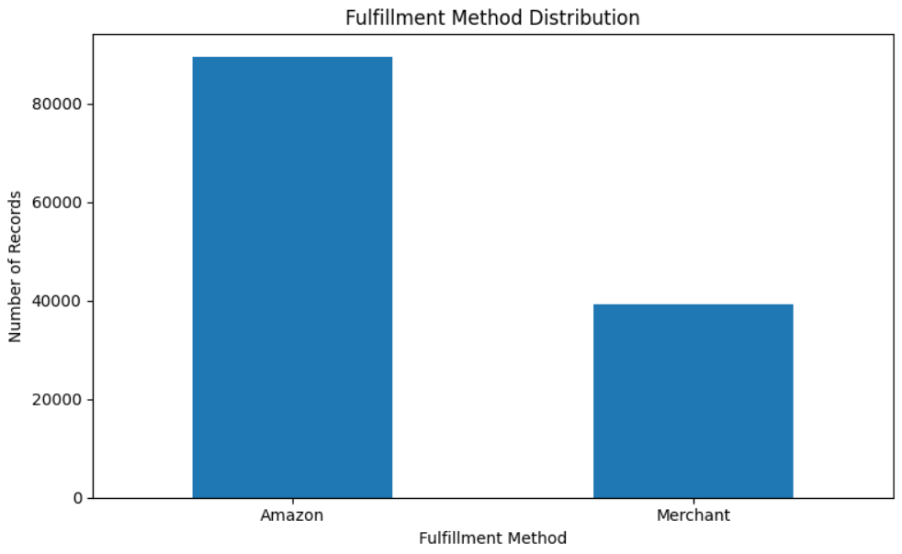
Figure 4: Fulfilment Method Distribution
Amazon fulfilment handled the majority of transactions and recorded sales. Amazon also had a slightly higher average recorded sales amount, while the detailed fulfilment analysis showed a higher cancellation rate for Merchant fulfilment.

- COURIER STATUS
The Shipped status was dominant, accounting for 109,341 records (84.89%). Orders marked as On the Way, Unshipped, and Cancelled represented smaller proportions of the dataset.
Table:
Courier Status | Records | Percentage
Shipped | 109,341 | 84.89%
On the Way | 6,863 | 5.33%
Unshipped | 6,675 | 5.18%
Cancelled | 5,929 | 4.60%
Graph 5:
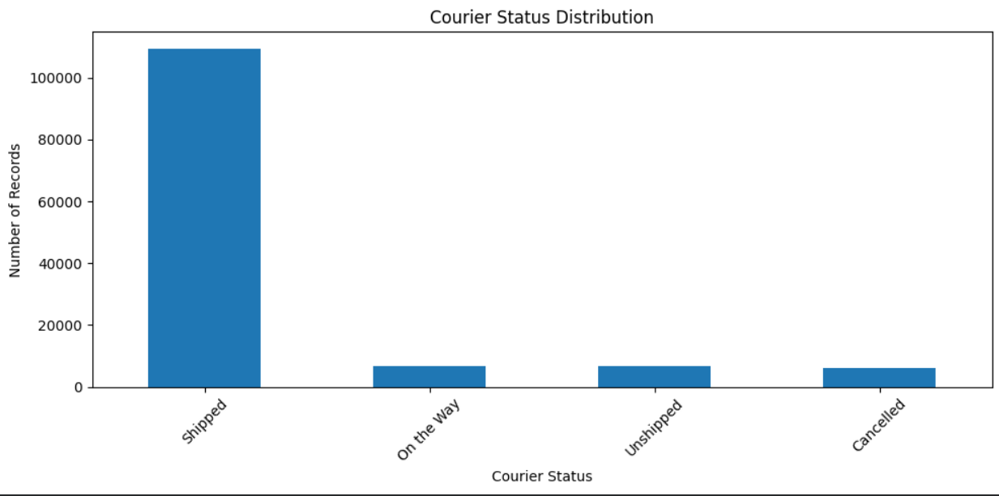
Figure 5: Courier Status Distribution

- B2B ANALYSIS
B2B transactions represented a small proportion of the dataset. There were 871 B2B records, representing 0.68% of the cleaned dataset, compared with 127,937 non-B2B records (99.32%). B2B transactions generated INR 591,220.79 in recorded sales, while non-B2B transactions generated INR 77,905,565.60. Although B2B transactions represented a small proportion of records, their average recorded sales amount of INR 701.33 was higher than the INR 648.26 average for non-B2B transactions.

Graph 6:
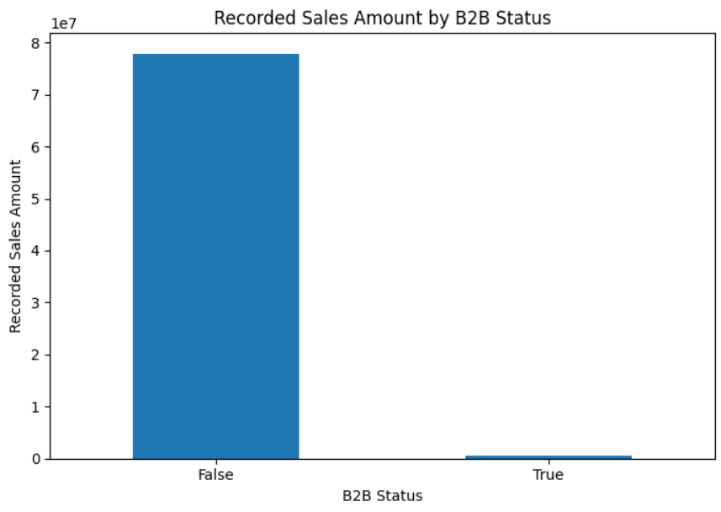
Figure 6: Recorded Sales Comparison Between B2B and Non-B2B Transactions

- GEOGRAPHICAL ANALYSIS
Geographical analysis was performed using shipping location information to identify major states and cities contributing to order activity and recorded sales.
Maharashtra was the leading state by order records, quantity, and recorded sales. Bengaluru was the leading city by order records and recorded sales.

Table:
Measure | Leading Region | Result
State by order records | Maharashtra | 22,234
State by recorded sales | Maharashtra | INR 13,318,966.38
State by quantity | Maharashtra | 20,304
City by order records | Bengaluru | 11,191
City by recorded sales | Bengaluru | INR 6,836,614.65

Graph 7:
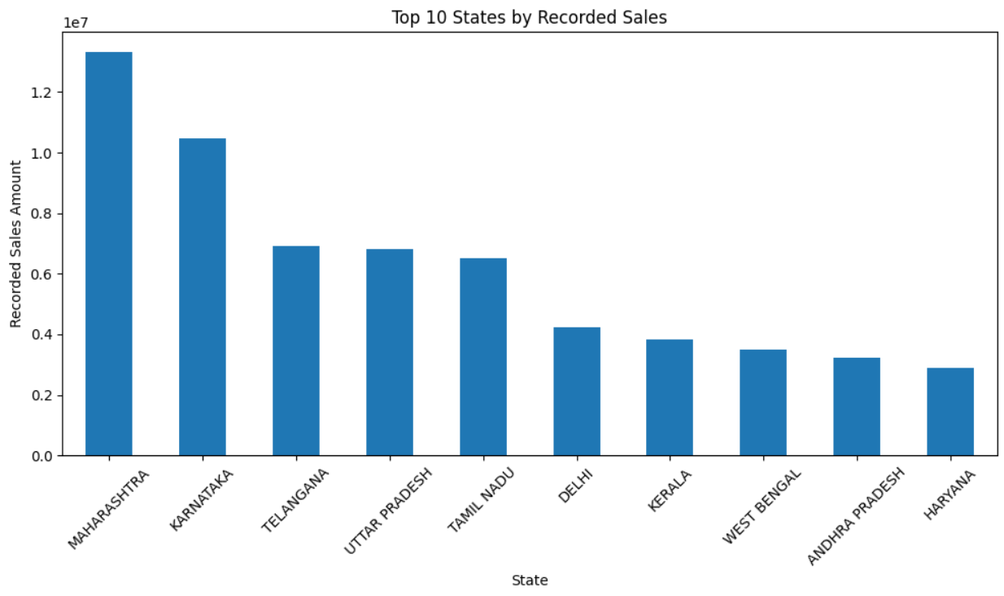
Figure 7: Top 10 States by Recorded Sales
Maharashtra recorded the highest sales among the analysed states, with INR 13,318,966.38, followed by Karnataka and Telangana. Bengaluru was the leading city by both order records and recorded sales, with 11,191 order records and INR 6,836,614.65 in recorded sales.

- CUSTOMER/ORDER BEHAVIOR
The dataset does not contain a dedicated Customer ID, customer name, email address, or phone number. Therefore, individual customer histories cannot be uniquely reconstructed from the available data.
For behavioural analysis, Order ID was used as the transaction-level identifier. Each unique order was analysed using its recorded sales value, total quantity purchased, and number of product records associated with the order.
Orders were classified into Low Value, Medium Value, and High Value segments based on their recorded order value. Quantity-based behavioural segments were also created to distinguish orders with relatively low, medium, and high purchasing quantities.
The resulting behavioural segments were further examined using shipping-state information to identify the geographical distribution of high-value orders.

15.1 Order-Value Behaviour
There were 120,229 unique orders in the cleaned dataset. The order-value segmentation produced three groups: Low Value, Medium Value, and High Value.

Segment | Orders | Share | Average Recorded Sales
Low Value | 40,301 | 33.52% | INR 300.14
Medium Value | 39,865 | 33.16% | INR 611.09
High Value | 40,063 | 33.32% | INR 1,049.34

Graph 8:
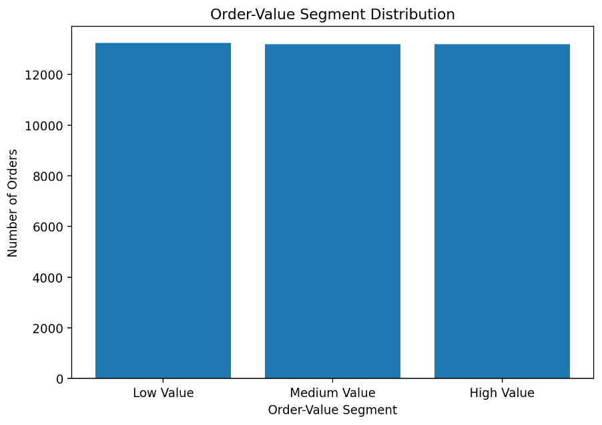
Figure 8: Order-Value Segment Distribution
The three segments contain approximately equal numbers of orders because quantile-based segmentation was used. However, the average recorded sales value differs substantially across the segments. High-value orders had an average recorded sales value of INR 1,049.34, compared with INR 611.09 for medium-value orders and INR 300.14 for low-value orders.

15.2 Quantity-Based Behaviour
Orders were additionally classified into Low Quantity, Medium Quantity, and High Quantity groups according to total quantity purchased. This provides an additional measure of purchasing intensity alongside order value and helps distinguish orders involving relatively smaller or larger quantities of products.
Quantity Segment | Number of Orders
Low Quantity | 40,076
Medium Quantity | 40,076
High Quantity | 40,077
The quantity-based segmentation produced three groups with nearly equal numbers of orders. This provides an additional view of purchasing intensity alongside the order-value segmentation.

15.3 Geographical Distribution of High-Value Orders
The value-based order segments were combined with shipping-state information to examine the geographical distribution of high-value transactions. This analysis identifies the states contributing the greatest number of high-value orders and provides a regional view of higher-value purchasing activity.
Maharashtra recorded the highest number of high-value orders, with 6,476 high-value orders. This indicates that Maharashtra represents an important geographical market within the high-value order segment.

Graph 9:
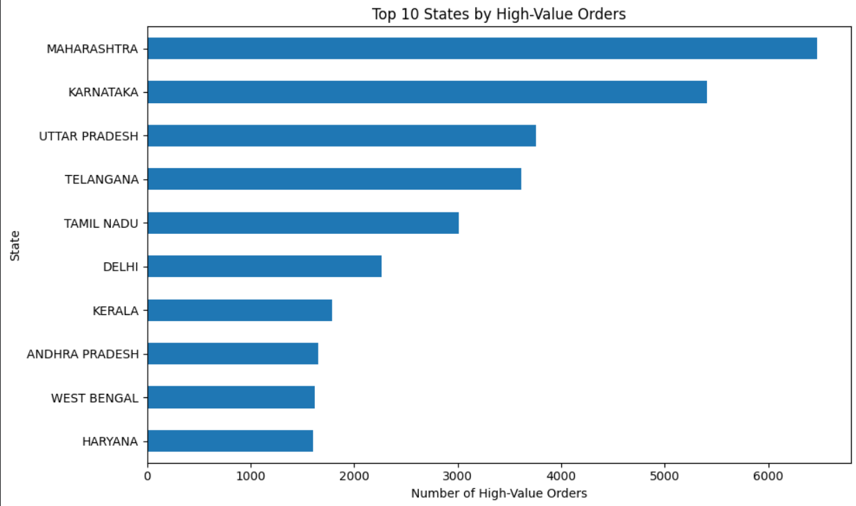
Figure 9: Top 10 States by High-Value Orders
The geographical distribution of high-value orders shows that Maharashtra recorded the highest number of high-value orders (6,476), followed by Karnataka and Uttar Pradesh. Telangana and Tamil Nadu also recorded substantial numbers of high-value orders. The analysis indicates that high-value purchasing activity is concentrated in a limited number of states, which can help support regional sales planning and inventory allocation.

16. KEY FINDINGS
1. Product demand
T-shirts were the strongest product category in terms of both quantity and recorded sales. T-shirts recorded 45,228 units and INR 39,154,132.17 in recorded sales.
2. Size preference
Size M recorded the highest order volume and quantity and also generated the highest recorded sales among sizes, with 22,350 order records, 20,116 units, and INR 13,678,295.13 in recorded sales.
3. Fulfilment
Amazon fulfilment handled the majority of transactions, accounting for 89,595 records (69.56%), and generated the highest recorded sales.
4. Courier operations
Shipped orders were the dominant courier status, accounting for 109,341 records (84.89%).
5. Geography
Maharashtra was the leading state by order records, quantity, and recorded sales, while Bengaluru was the leading city by order records and recorded sales.
6. Order-value behaviour
High-value orders had a substantially higher average recorded value (INR 1,049.34) than medium-value orders (INR 611.09) and low-value orders (INR 300.14).
7. B2B
B2B transactions represented 0.68% of records but had a higher average recorded sales value (INR 701.33) than non-B2B transactions (INR 648.26).
8. Customer/Order Behaviour
Order-level behavioural segmentation showed clear differences between low-, medium-, and high-value transactions. Quantity-based segmentation provided an additional measure of purchasing intensity, while the geographical analysis identified Maharashtra as the leading state for high-value orders, with 6,476 high-value orders.

17. RECOMMENDATIONS
Recommendation 1 — Inventory
Inventory planning should prioritize high-volume product categories, particularly T-shirts and Shirts, and should give appropriate attention to high-demand sizes such as L and M.
Recommendation 2 — Regional inventory
Regional demand patterns should be considered when allocating inventory, with particular attention to Maharashtra and other high-performing states.
Recommendation 3 — Fulfillment
Merchant fulfilment should be monitored closely because its observed cancellation rate was higher than that of Amazon fulfilment.
Recommendation 4 — Courier operations
Cancelled and unshipped orders should be monitored regularly to identify operational issues and improve delivery performance.
Recommendation 5 — High-Value Order Strategy
High-value order segments can be used to identify higher-value purchasing patterns and support targeted sales promotions, inventory planning, and regional sales strategies. States with stronger concentrations of high-value orders can also be prioritized when planning regional initiatives.
Recommendation 6 — B2B
B2B transactions can be monitored separately because their average recorded sales value was higher than non-B2B transactions.
Recommendation 7 — Future Customer Data Collection
A dedicated Customer ID should be included in future datasets. This would enable accurate analysis of repeat purchases, customer segmentation, customer retention, customer lifetime value, and individual customer behaviour.

18. LIMITATIONS
The analysis has several limitations based on the available dataset:
- The dataset does not contain a dedicated Customer ID. Therefore, the analysis uses Order ID as a transaction-level identifier and focuses on order-level purchasing behaviour rather than individual customer histories.
- A significant number of date values were missing, which limits the completeness of time-based analysis.
- Some Amount values were missing and were retained after investigation.
- The dataset contains sales transaction values but does not provide complete cost, profit, or margin information.
- The geographical data is predominantly India-based, limiting international comparison.

19. CONCLUSION
The Amazon sales data analysis provided a comprehensive examination of sales performance, product demand, fulfilment methods, courier status, B2B transactions, geographical distribution, and order-value behaviour.
The analysis identified T-shirts as the leading product category, M as the highest-volume and highest-sales size, Amazon as the dominant fulfilment method, Maharashtra as the leading state, and Bengaluru as the leading city.
The findings provide useful information for inventory planning, regional sales strategies, fulfilment monitoring, courier operations, and business decision-making.
The order-level behavioural analysis demonstrated clear differences across low-, medium-, and high-value transactions. Quantity-based segmentation provided an additional measure of purchasing intensity, while the geographical analysis identified the distribution of high-value orders across shipping states. Because the dataset does not contain a dedicated Customer ID, the analysis appropriately focuses on transaction-level behaviour rather than individual customer histories.
Overall, the analysis converts the raw Amazon sales data into actionable business insights and recommendations that can support improved sales planning, inventory management, fulfilment operations, and customer service.

