St. Francis Institute of Technology, Mumbai-400 103

**Department Of Information Technology**

A.Y. 2024-2025

Class: TE-ITA/B, Semester: VI

Subject: **Business Intelligence Lab**

**Experiment – 8: To implement Apriori Association mining algorithm using open source tool WEKA and ORANGE**

1. **Aim:** Implementation of Association in Data Mining (Apriori,FPM) in WEKA & Orange
2. **Objectives:** After study of this experiment, the students will be able to implement Apriori Algorithm in WEKA/Orange
3. **Outcomes:** After study of this experiment, the students will be able to

**CO 5:** Design and Implement various frequent data mining techniques and formulate association rules   on large data sets

1. **Prerequisite:** Introduction to algorithms of Associativity
2. **Requirements:** Personal Computer, Windows XP operating system/Windows 7, Internet Connection, Microsoft Word, WEKA tool, Orange tool.
3. **Theory:**
4. Introduction to FPM

Frequent Pattern Mining (FPM) is a core technique in data mining that focuses on discovering patterns, associations, or correlations among a set of items in large datasets. It is commonly used in market basket analysis to find products that frequently co-occur in transactions. FPM helps in understanding customer behavior, improving product placement, and enhancing recommendation systems. The main goal is to identify itemsets that appear together frequently based on a defined support threshold.

1. Introduction to Apriori Algorithm

The Apriori algorithm is a classic and widely-used algorithm for mining frequent itemsets and generating association rules in FPM. It works on the principle that all subsets of a frequent itemset must also be frequent. The algorithm uses a bottom-up approach where frequent subsets are extended one item at a time (candidate generation), and groups of candidates are tested against the data. It is efficient for discovering useful patterns, such as "if a customer buys bread, they are likely to buy butter," which can be used for targeted marketing and inventory management.

1. **Laboratory Exercise:** Implementation of Association Algorithm in WEKA & Orange and take printout of implementation along with coding and snapshot.
2. **Post-Experiments Exercise**
3. **Questions:**
   * Solve numerical for Apriori algorithm
   * Simple CLI execution of Apriori algorithm in WEKA using the following command:

**java weka.associations.Apriori -N 100 -T 1 -C 1.5 -D 0.05 -U 1.0 -M 0.1 -S -1.0 -I -t directory-path\bank-data-final.arff**

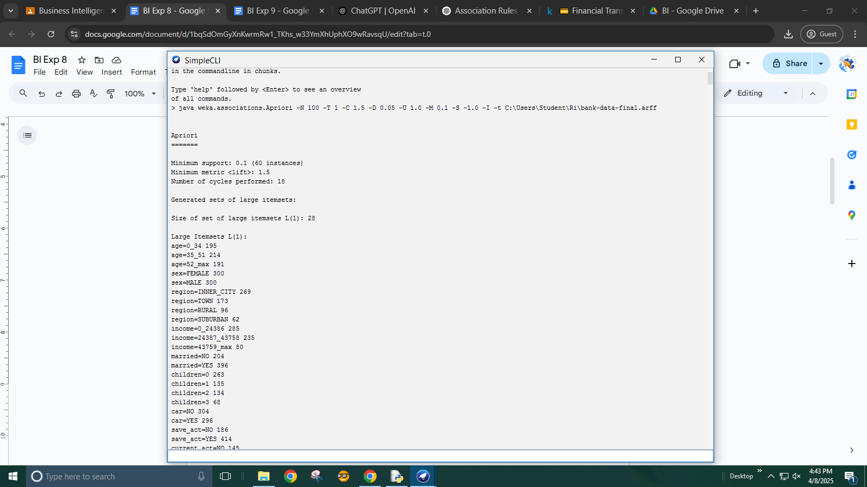

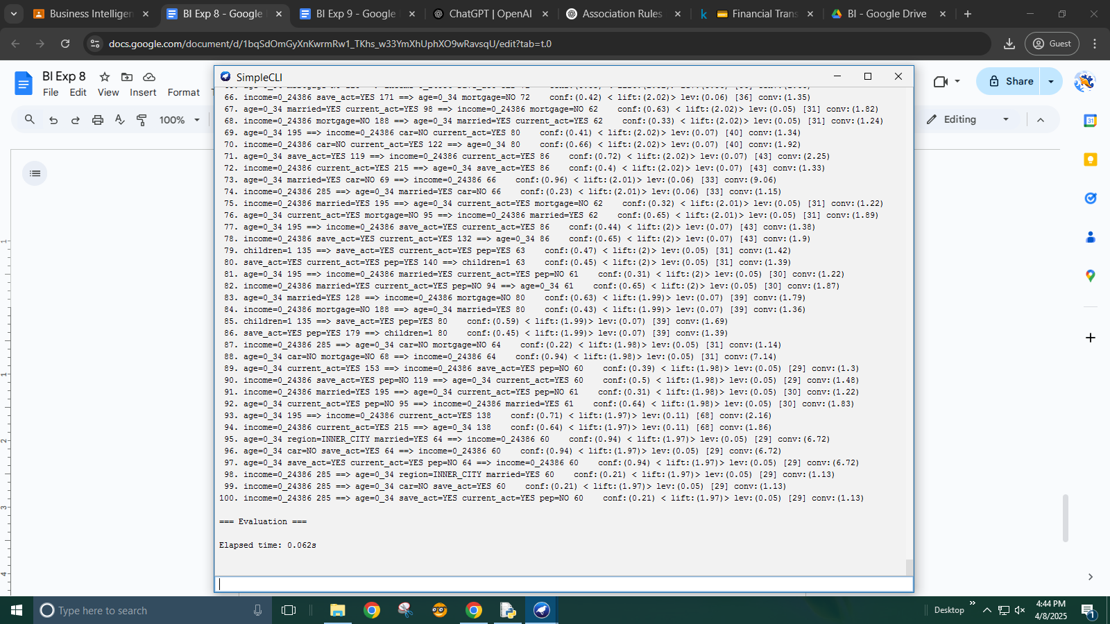

1. **Conclusion:**
   * Summary of Experiment
   * Importance of Experiment
   * Application of Experiment
2. **Reference:** Data Mining: Concept & Techniques, 3rd Edition, Jiawei Han, Micheline  Kamber, Jian Pei, Elsevier.

Loading the dataset in WEKA

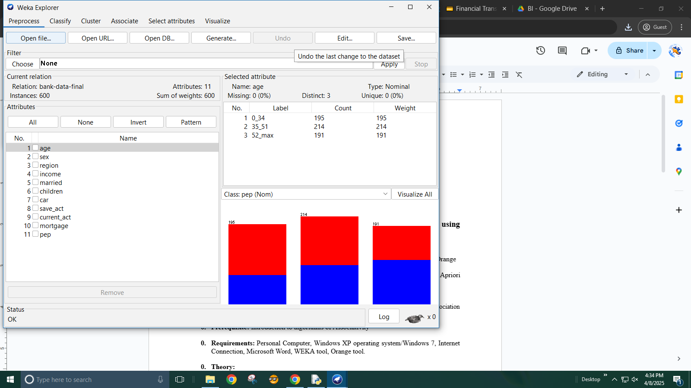

Applying apriori algorithm with number of rules set to 10

\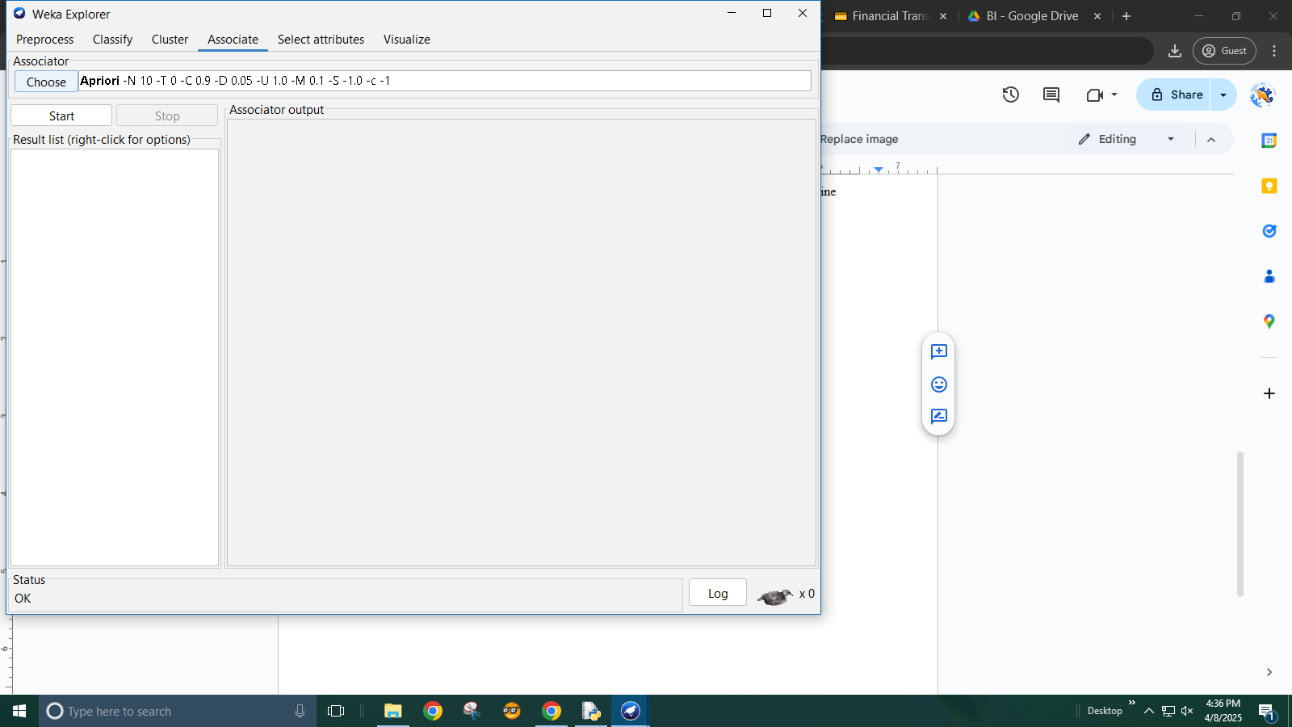

Result of apriori algorithm with 10 rules

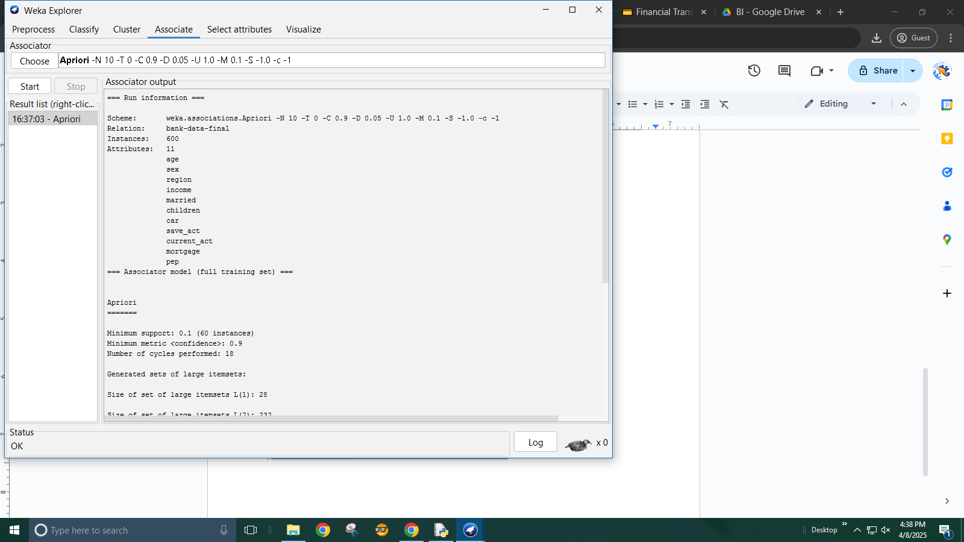

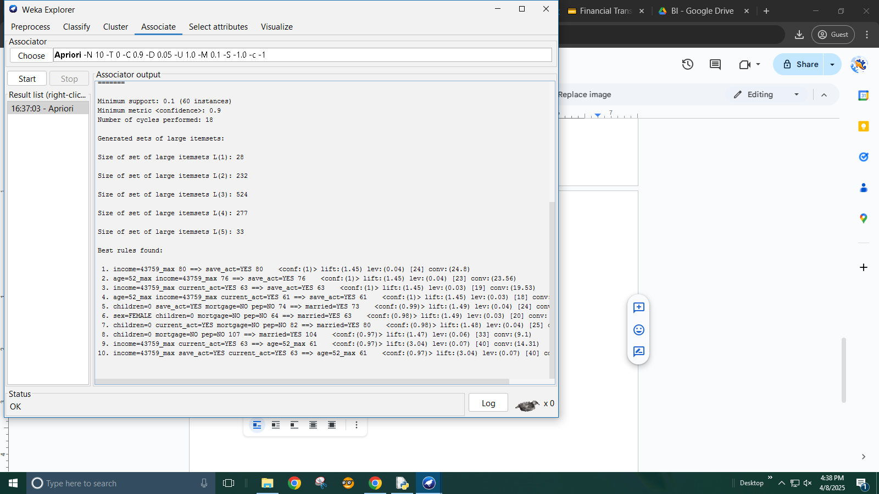

setting number of rules as 100 Result of apriori algorithm with 100 rules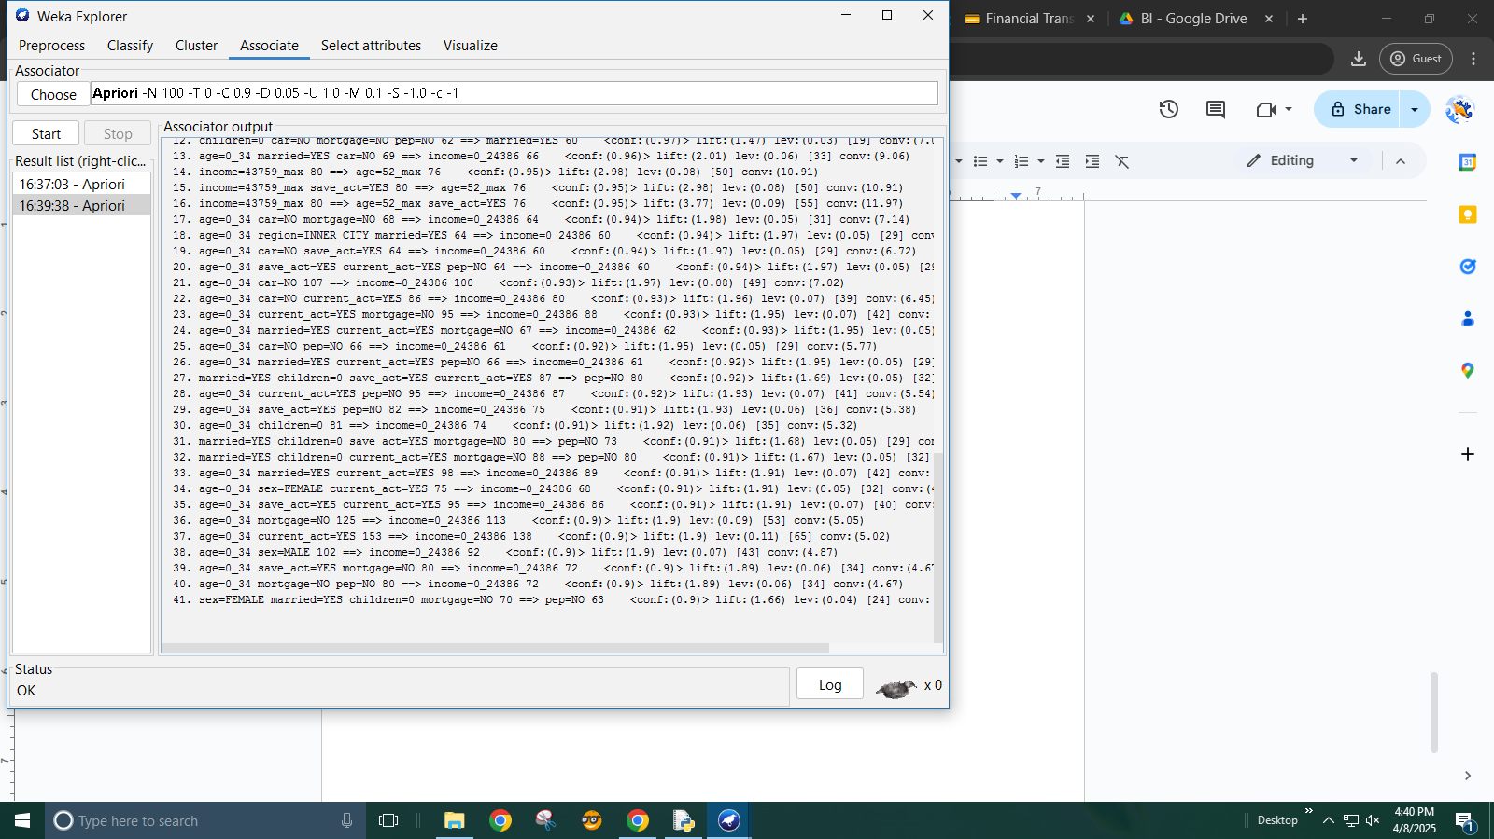

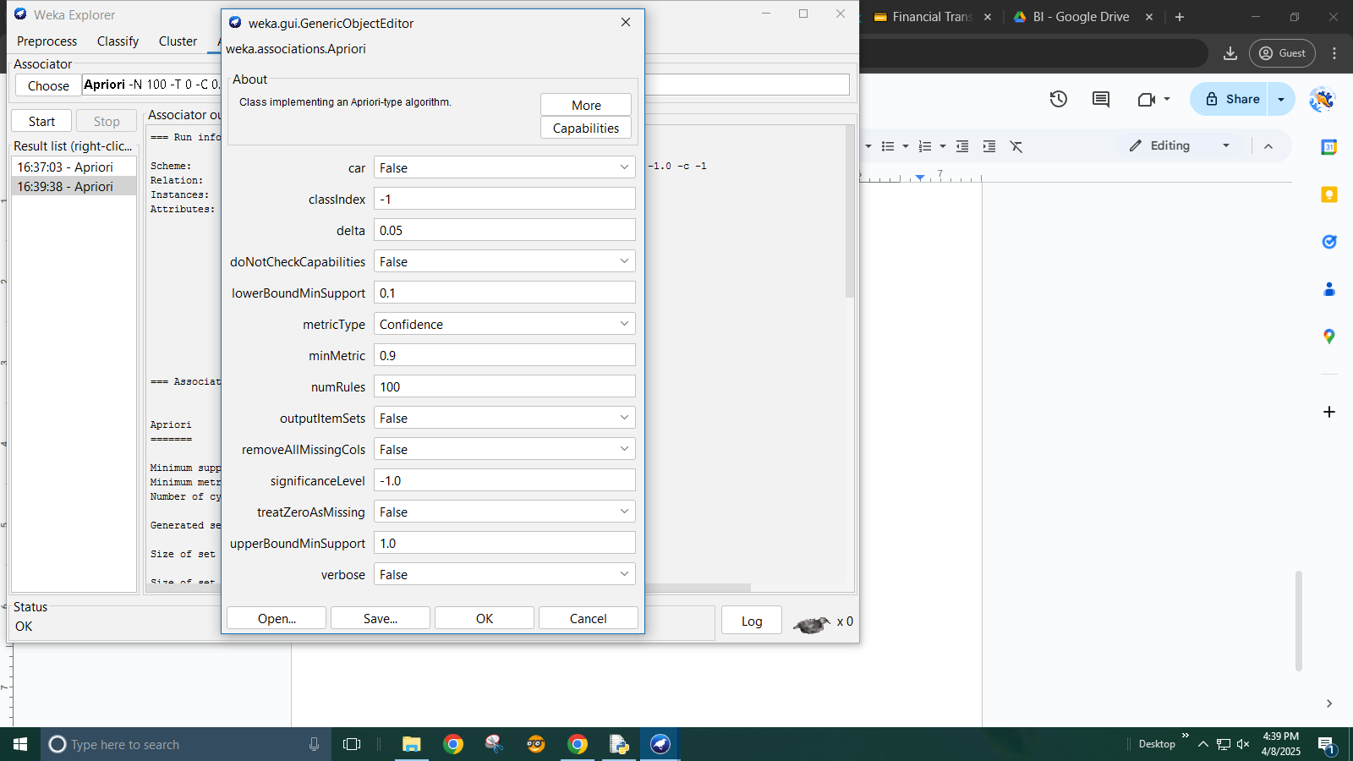

Applying association in orange

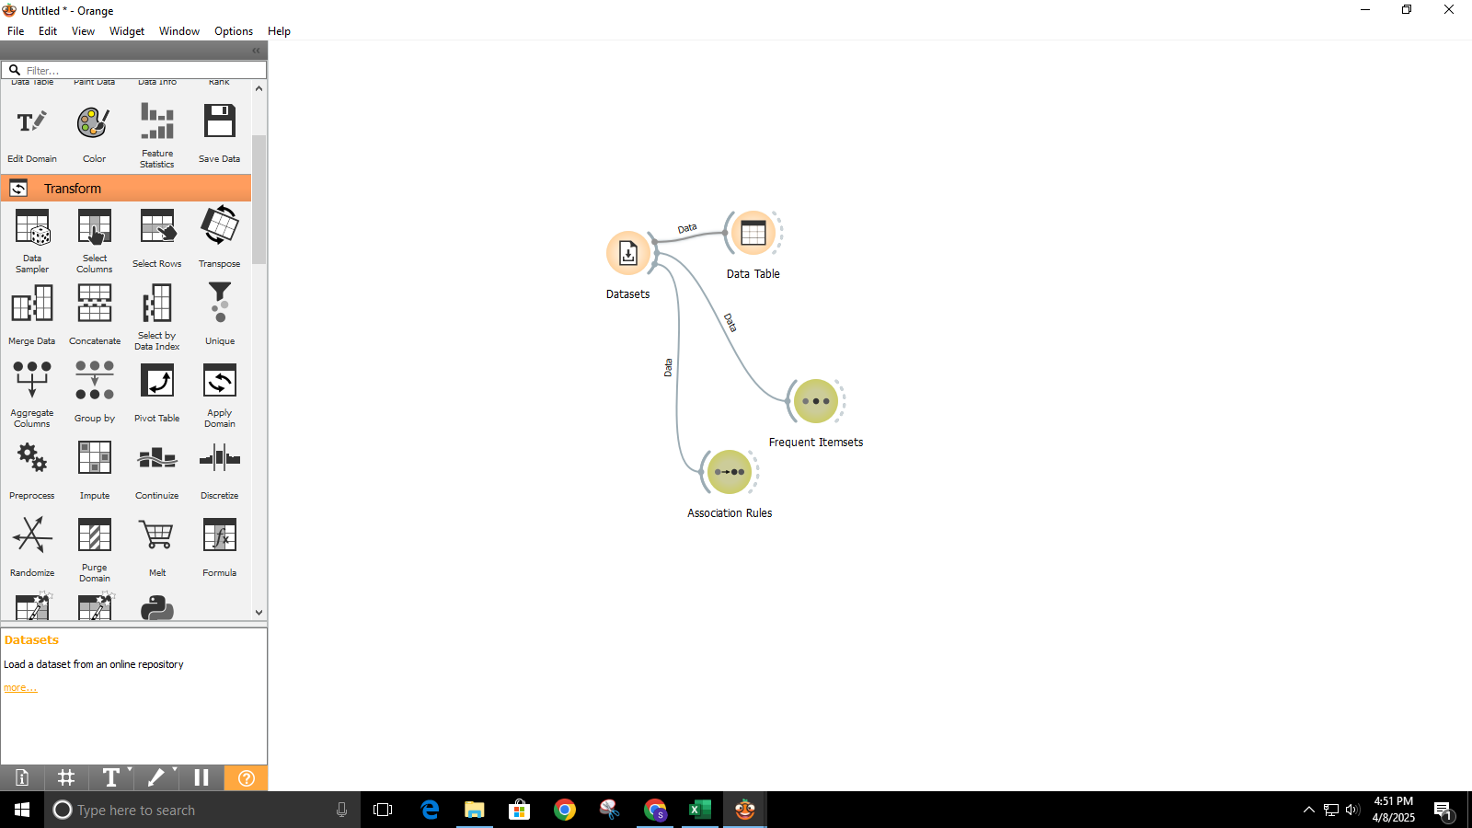

loading the foodamrt dataset in orange  
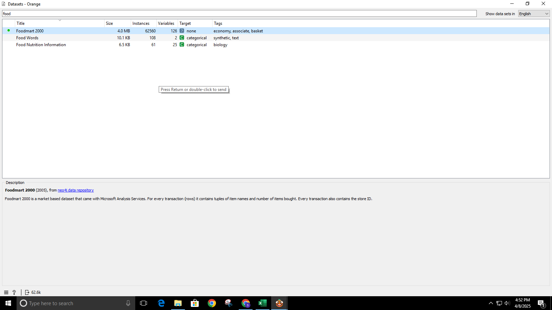

viewing the dataset in the datatable widget  
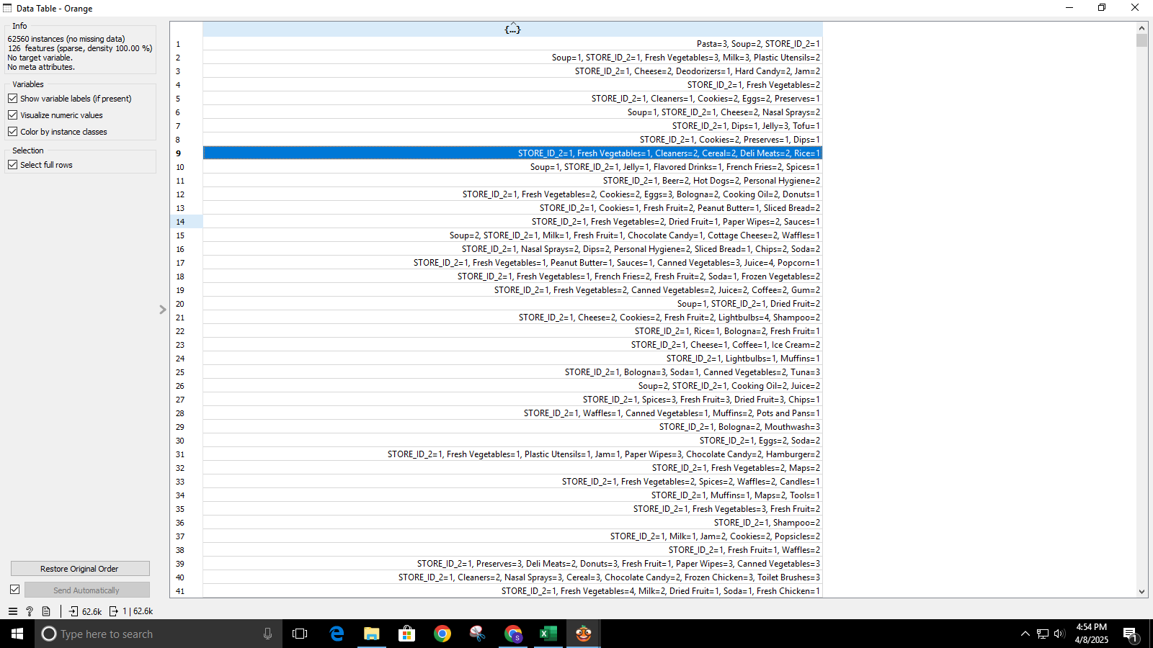

finding frequent itemset with support=0.1

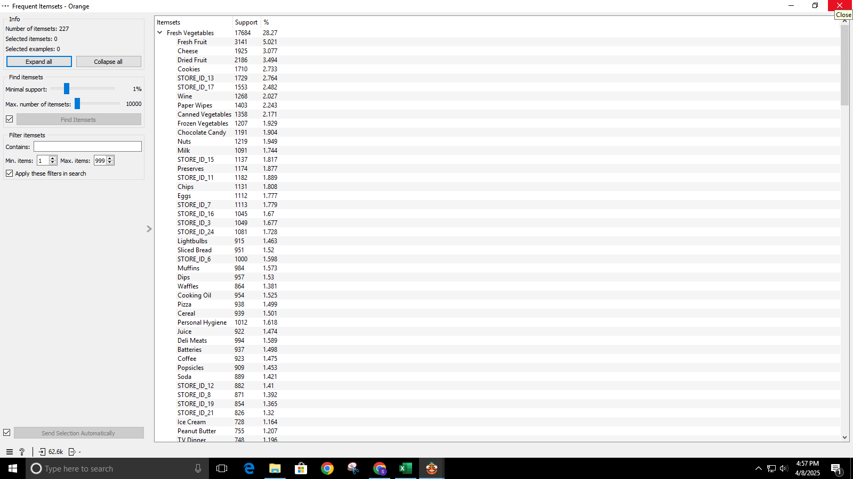

generating association rule based on the confident percent 20%

