Ecommerce Shipment
Performance Analysis
SQL portfolio project | Riya Jain

1 Title
Ecommerce Shipment Performance Analysis Using MySQL

2 Objective
I chose this project to understand where delivery operations can lose time and money. The analysis looks at delivery success, courier delays, warehouse dispatch capacity and shipping margin.

3 Business Scenario
This practice case assumes an ecommerce business uses several warehouses and courier partners. Its operations team needs a regular report to see which shipments arrive late, where dispatch is slow and whether shipping fees cover shipping costs. The questions are based on the supplied SQL exercise; this is not a completed client engagement.

4 Business Requirements
- Track monthly shipment volume and delivery success, alongside on-time delivery performance.
- Compare couriers, destination regions and warehouse–courier combinations on delivery delays.
- Compare warehouse dispatch times, cancellations and daily capacity usage.
- Review shipping margin, the largest shipment-level losses and monthly margin movement.
- Compare Standard and Express services on delivery time, cost and on-time performance.

5 SQL Concepts Covered
SELECT, WHERE, JOIN, GROUP BY, ORDER BY, LIMIT, DISTINCT, aggregate functions, subqueries and date functions appear in the submitted work. The code uses COUNT, SUM, AVG, MAX, MONTH, DAY, DATE, DATEDIFF and TIMESTAMPDIFF.

6 Database Design
The design uses three tables. Each shipment links to one courier and one warehouse. A courier or warehouse can be linked to many shipments. Keeping their details separate avoids repeating names and capacity values in every shipment record.
Proposed keys: shipments.shipment_id, carriers.carrier_id and warehouses.warehouse_id are primary keys. The carrier_id and warehouse_id fields in shipments are foreign keys. These relationships must be checked against the actual database.

7 Table Structure
The fields below are referenced in the submitted SQL. Data types and key constraints were not supplied, so this is a working data dictionary rather than a verified database definition.

shipments
shipment_id: shipment identifier
carrier_id and warehouse_id: links to the lookup tables
order_at: order creation time
dispatch_at: dispatch time
delivered_at: actual delivery time
promised_delivery_at: promised delivery deadline
status: shipment status
shipping_fee: fee charged
shipping_cost: delivery cost

carriers
carrier_id: courier identifier
carrier_name: courier name
service_type: Standard or Express, as used in the supplied query

warehouses
warehouse_id: warehouse identifier
daily_dispatch_capacity: maximum planned dispatches per day

Scope of the available schema
The SQL includes a region comparison, but the exact region field and table definition are not supplied. The service comparison references service_type in carriers. These details are documented as written in the submitted file.

About the source file
This report describes the submitted SQL file. Each business question is followed by an image of its original SQL code. These code images were rendered from the supplied file; they are not query-result screenshots.

8 SQL Implementation Step by Step

1. How many shipments do we receive each month, and what percentage are successfully delivered?
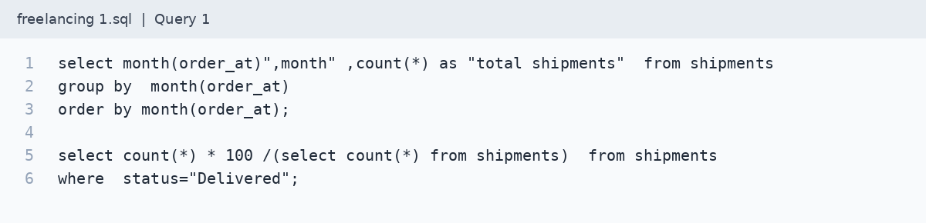

2. Of the shipments delivered, what percentage reach customers within the promised delivery time?
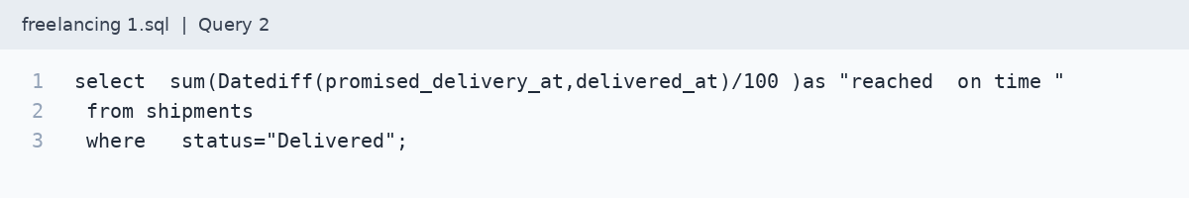

3. Which warehouses take the longest to dispatch orders? Please compare average and maximum order-to-dispatch time in hours, excluding cancelled shipments.
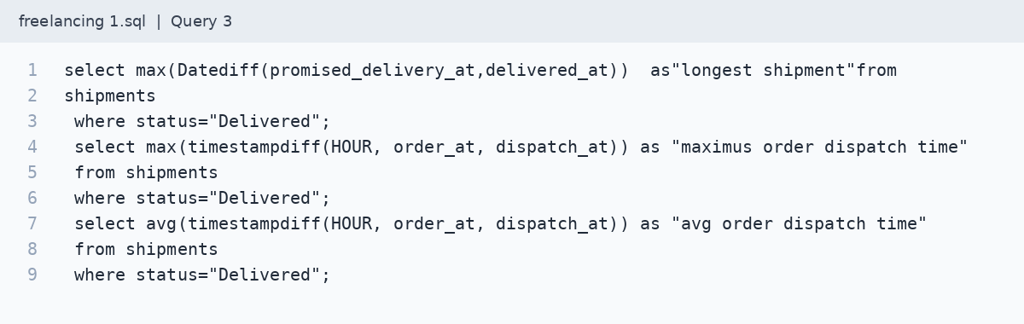

4. How do our courier partners compare on average delivery time, measured from dispatch to delivery?
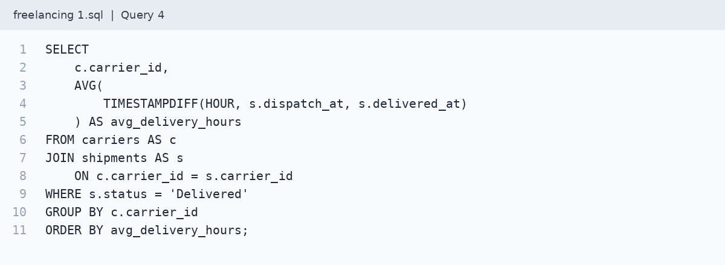

5. Which courier partners have the highest late-delivery rates? Please include only partners with at least 30 delivered shipments.
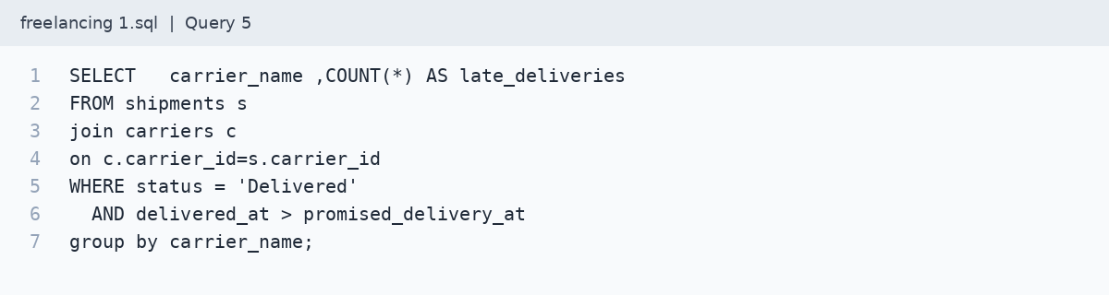

6. Which destination regions have the highest percentage of late deliveries?
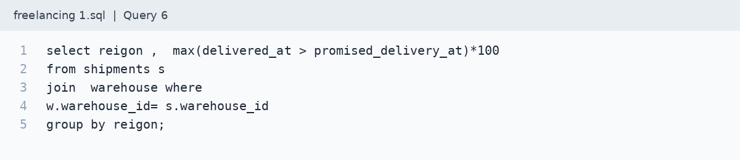

7. How much shipping margin does each courier partner generate? Use shipping fee minus shipping cost for delivered shipments.
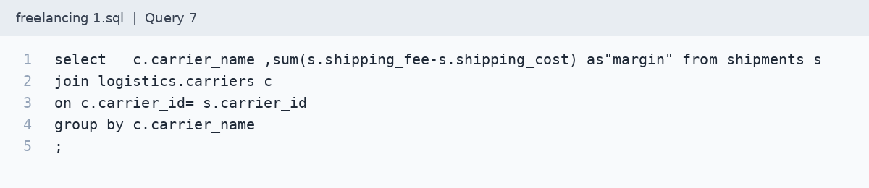

8. Please identify the 10 delivered shipments where shipping costs exceeded shipping fees by the largest amount.
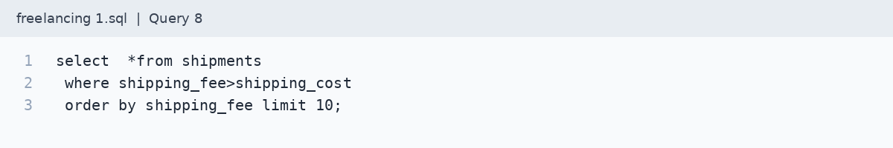

9. Were there any days when a warehouse dispatched more shipments than its daily capacity? Please show the warehouse, date and excess volume.
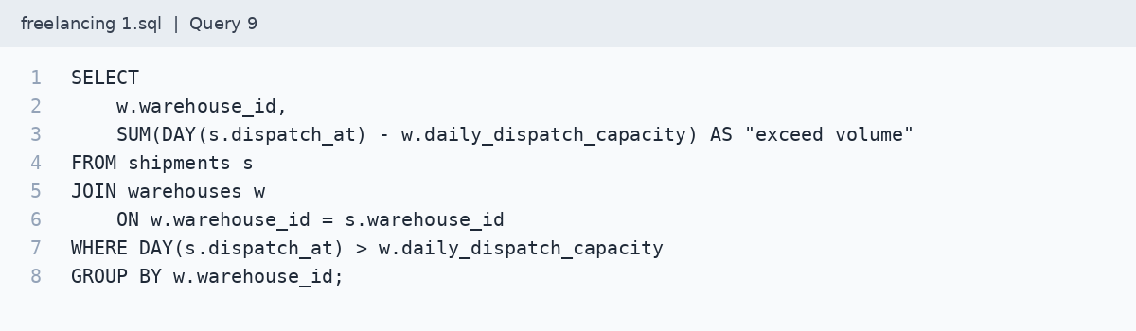

10. How has our shipping margin changed month over month, based on the delivery date?
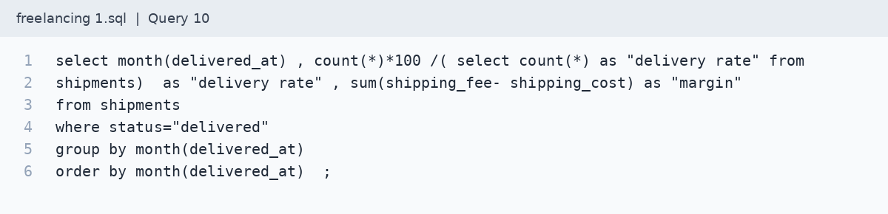

11. Which warehouses have the highest cancellation rates? Please include total shipments and cancelled shipments for context.
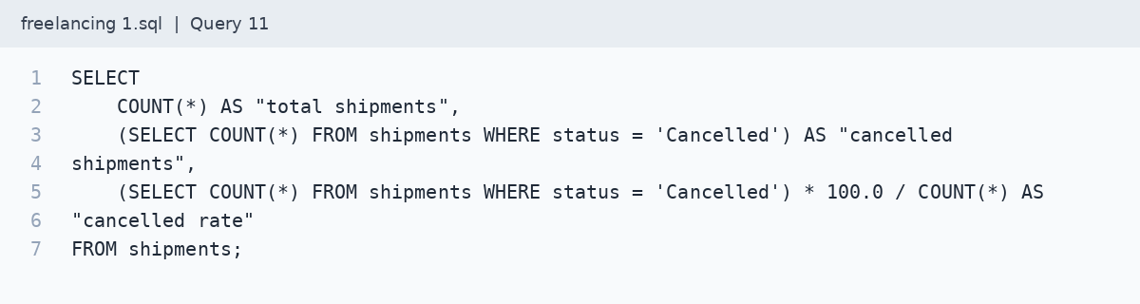

12. For late deliveries, how many hours late do shipments arrive on average, and which courier partner has the highest average delay?
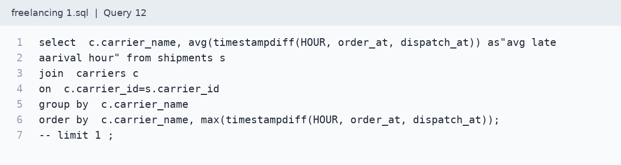

13. Which warehouse-and-courier combinations have the highest on-time delivery rates? Please include only combinations with at least 30 delivered shipments.
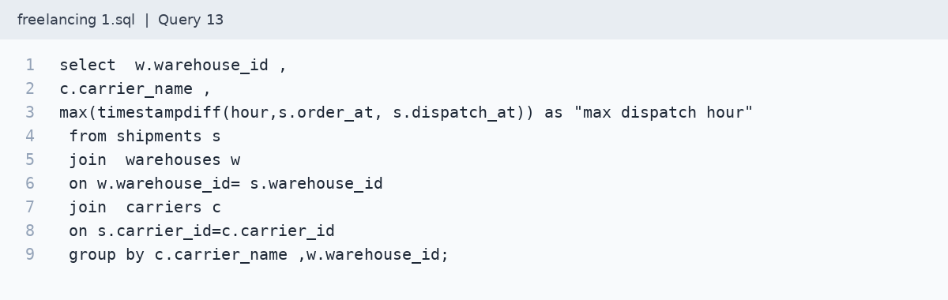

14. How do Standard and Express services compare on average delivery time, on-time delivery rate and average shipping cost per delivered shipment?
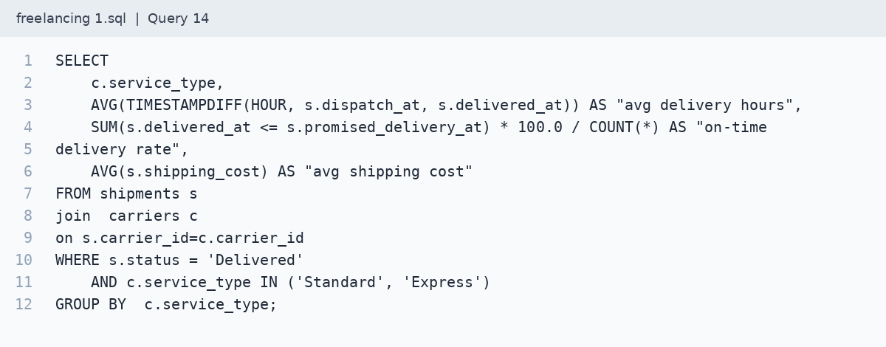

9 Output
The attachment contains SQL statements, not executed result tables. The intended outputs are monthly summaries, courier and warehouse comparisons, capacity exceptions and shipment-level margin details. Results have not been invented for this report.
Actual output tables or screenshots can be added after the SQL is run. No numerical results are included here because they were not supplied with the code.

10 Business Justification
The report can help an operations team decide where to investigate first. A courier with a high late-delivery rate may need a service review. Long order-to-dispatch times point to a warehouse process that needs checking. Repeated capacity exceptions may justify changes to staffing or order allocation. Negative shipping margin can prompt a review of pricing and courier charges. These are possible actions, not findings from the current file.

11 Interview Questions

Why use a rate instead of only counting late shipments?
A courier handling more orders may have more late deliveries even if its performance is better. A rate makes the comparison more useful, while the shipment count shows how much evidence supports it.

Why combine shipment records with courier details?
Shipments contain the delivery records, while carriers provide courier details. Joining them makes it possible to review the shipment records by courier.

What does the warehouse capacity question aim to identify?
It aims to identify dates when a warehouse dispatched more shipments than its stated daily capacity.

Does shipping margin represent net profit?
No. It only subtracts shipping cost from shipping fees. It does not account for the business’s other expenses.

12 Learning Outcomes
The main learning is to define a metric before writing SQL. Each question needs the right starting point, time period and denominator. Joining tables also requires checking that lookup keys are unique, otherwise shipment counts and financial totals can be inflated.

13 Real World Applications
This analysis could support a weekly logistics review, a courier service meeting or a basic Power BI dashboard. The operations team could use it to follow delivery performance, while the finance team reviews shipping margin and loss-making shipments.
For a first dashboard, use cards for shipment count, delivery success and shipping margin. Add a monthly shipment chart, a courier late-delivery comparison and a warehouse capacity exception table. Prepare percentage summaries in SQL so the initial dashboard can stay simple.

14 Key Takeaways
A useful delivery report needs more than shipment counts. It should show whether orders arrive on time, where delays begin and whether delivery charges cover their cost. The most important checks in this project are the percentage denominator, the correct timestamp pair and the number of records behind each comparison.
The SQL file brings the business questions and query attempts together in one place. This report provides context for that work while keeping the original implementation unchanged. It does not claim that the queries have been validated or that business improvements have already been achieved.

15 Assignment and Challenge for Students
Extend the project into a short weekly operations review using the actual dataset.
- Run the submitted SQL against the project database and capture the output or any errors for review.
- Choose one courier for further review. Support the choice with delivery count, late-delivery rate and average delay.
- Find a warehouse that repeatedly exceeds capacity. Check whether dispatch time also increases on those dates.
- Compare the monthly margin outputs and explain any visible change using the available data.
- Write three recommendations using actual results. State what the data supports and what needs further investigation.

Project status
Documentation is prepared from the supplied SQL. The code is reproduced as provided. Executed outputs and business findings were not included in the source material.

