POST-MORTEM REPORT — INC0001234

Incident: INC0001234 — P1 APAC BGP Outage
Date: 14 January 2025 | 03:47–06:22 UTC
Duration: 2 hours 35 minutes (SLA BREACH by 35 minutes)
Author: James Wu (CTO) | Reviewed: Angela Brooks (IT Director)
Status: Post-mortem complete — all corrective actions tracked

1. Executive Summary
A Priority 1 BGP routing outage affecting all APAC network connections began at 03:47 UTC on 14 January 2025. The outage was caused by Ansible Tower automation job AT-4421 applying a Disaster Recovery BGP community filter to production routers due to a CI/CD approval gate defect. 847 users across Singapore, Sydney, and Tokyo were unable to access corporate systems for 2 hours 35 minutes, resulting in a total business impact of USD 142,000.
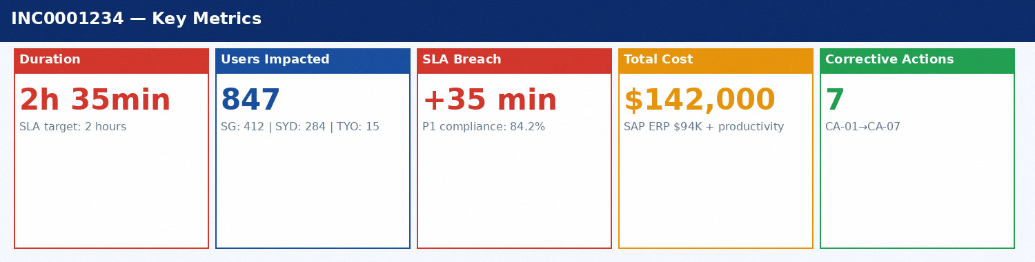
Figure 1: INC0001234 Key Performance Metrics

2. Impact Analysis
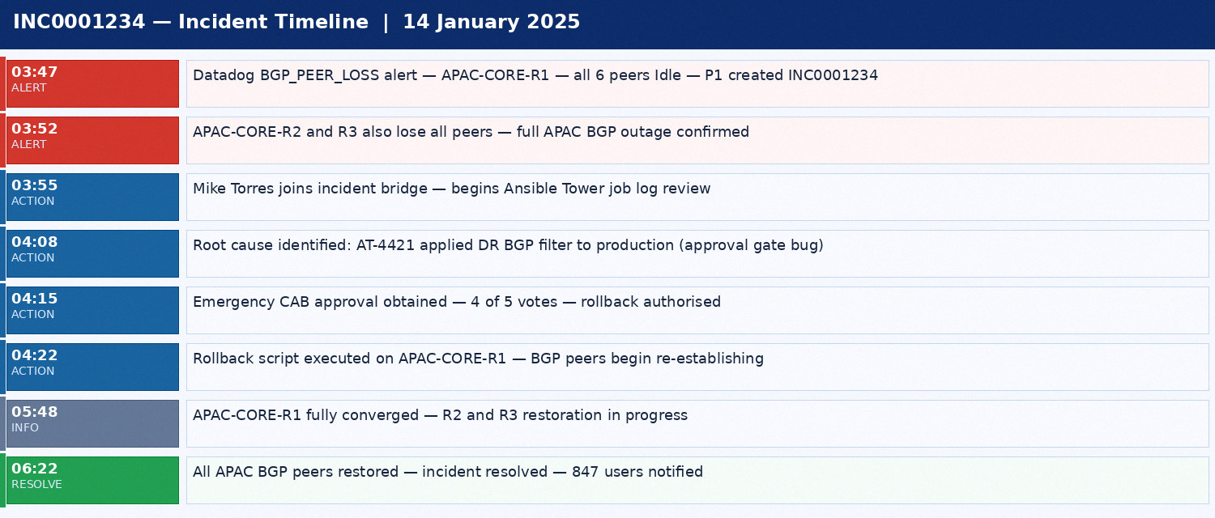
Figure 2: INC0001234 Incident Timeline

2.1 Financial Impact Breakdown
Impact Category | Systems Affected | Duration | Cost (USD)
SAP ERP — EDI Transactions | APAC app servers — logistics EDI | 2h 35min | $94,000
Staff Productivity | 847 APAC users — all corporate apps | 2h 35min | $48,000
Salesforce CRM | Sales team unable to update opportunities | 2h 35min | $28,000
Customer SLA Credits | Acme Global, Pacific Logistics, SG Financial | N/A | $12,000
Incident Response Overtime | NOC, Network, DevOps after-hours | 3.5 hours | $2,040
TOTAL |  |  | USD 142,000

3. Root Cause and Contributing Factors
The primary root cause was a defect in the Jenkinsfile CI/CD pipeline approval gate. The gate evaluated the condition 'build.state != Cancelled' — meaning any job not explicitly cancelled would pass, regardless of approval status. This allowed Ansible Tower job AT-4421 to execute against production APAC core routers (R1, R2, R3) without Network CAB review.
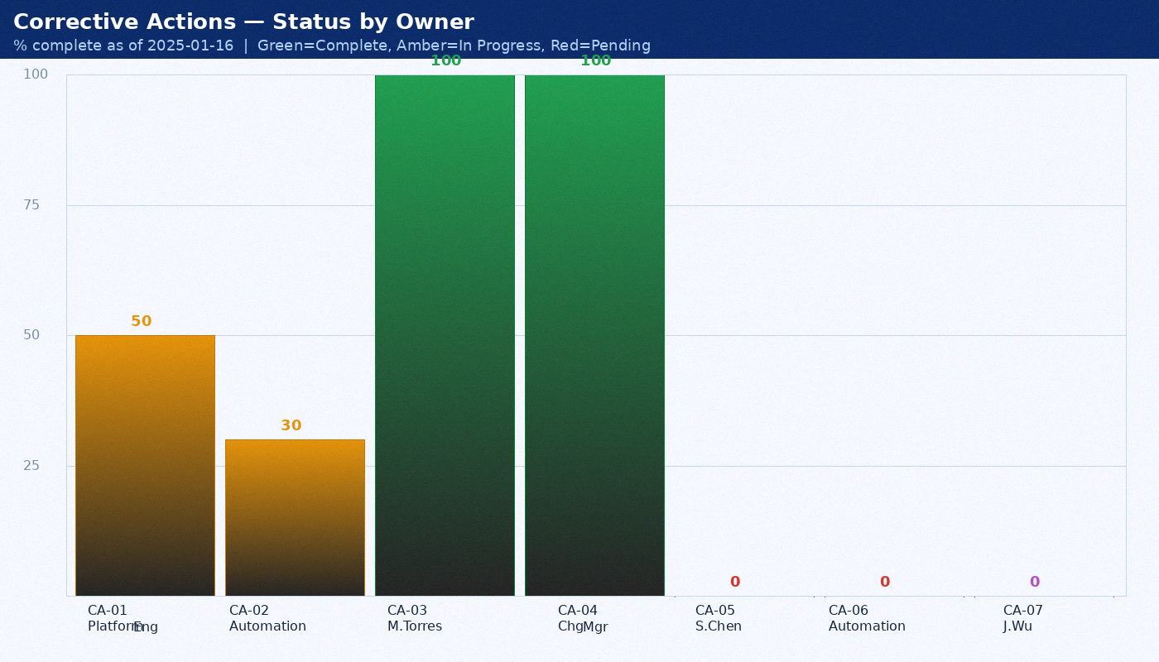
Figure 3: Corrective Action Completion Status

3.1 Contributing Factors
Factor | Description | Control Gap
CI/CD gate defect | Jenkinsfile: state != Cancelled instead of state == Approved | Code review did not test boolean logic edge cases
Shared inventory tag | DR and production APAC routers both tagged 'APAC' in Ansible | No environment segregation in Ansible Tower inventory
No pre-flight diff | Ansible playbook lacked dry-run step before executing | Validation step not included in playbook design
Automation not a Change | AT-4421 exempt from CAB — classified as routine automation | Automated network jobs not subject to change management

4. SLA Context
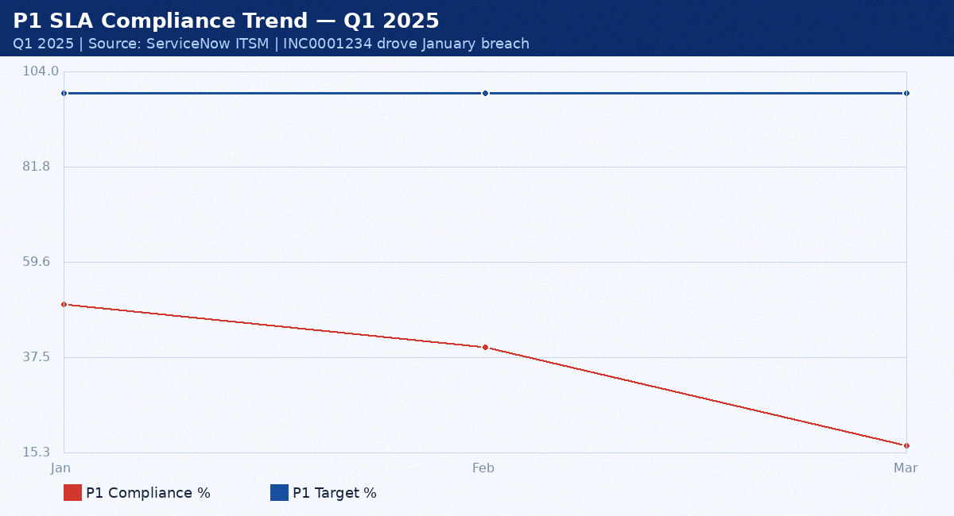
Figure 4: P1 SLA Compliance — Q1 2025 vs Target

The January 2025 P1 SLA compliance of 50.0% represents a severe breach of the 99.0% target. INC0001234 alone caused 2 of 4 P1 incidents in January to breach SLA. The Q1 trend shows continued deterioration in February (40.0%) before partial recovery in March.
Table 4: P1 SLA Compliance Context — Q1 2025
Metric | Jan 2025 | Feb 2025 | Mar 2025 | Q1 2025 | Target | Status
P1 SLA % | 50.0% | 91.7% | 94.0% | 84.2% | 99.0% | BREACH
P2 SLA % | 89.0% | 91.0% | 95.0% | 91.7% | 95.0% | BREACH
P3 SLA % | 93.0% | 94.0% | 95.0% | 94.0% | 90.0% | MET
Availability | 99.68% | 99.70% | 99.75% | 99.71% | 99.90% | BREACH
MTTR (P1) | 95min | 88min | 82min | 88min | 60min | BREACH

5. Corrective Actions
ID | Action | Owner | Due | Status
CA-01 | Fix Jenkinsfile gate: state == Approved with Allow-list | Platform Engineering | 2025-01-21 | In Progress
CA-02 | Add pre-flight BGP diff check — abort if > 5-line diff | Automation Team | 2025-01-28 | In Progress
CA-03 | Separate DR and production Ansible inventory by env prefix | Mike Torres | 2025-01-24 | Complete ✓
CA-04 | Classify automated network jobs as Changes requiring CAB | Change Manager | 2025-01-21 | Complete ✓
CA-05 | Ansible Tower runbook: add BGP peer count validation step | Sarah Chen | 2025-01-24 | Pending
CA-06 | Audit all 47 Ansible templates for gate logic defects | Automation Team | 2025-02-07 | Pending
CA-07 | Full post-mortem with all stakeholders — CTO chaired | James Wu | 2025-01-16 | Complete ✓

