INFRASTRUCTURE CAPACITY PLANNING REPORT — H1 2025

Owner: Infrastructure Architecture | Angela Brooks
Date: 12 January 2025
Scope: All production infrastructure — 9 critical systems assessed
Critical Decisions: 2 required by end of January (GPU-Farm and VMware-02 APAC)

1. Infrastructure Overview
This report assesses current infrastructure utilisation and projects capacity requirements through H2 2025. Two systems are at CRITICAL risk and require immediate investment decisions. The GPU Farm is at 98.1% peak utilisation; without expansion by 24 January, ML training job ML-TRAIN-0047 scheduled for February will evict production inference pods. The PROD-VMware-02 APAC cluster is at 94.7% CPU, with Q2 APAC workload growth projecting full contention by March.
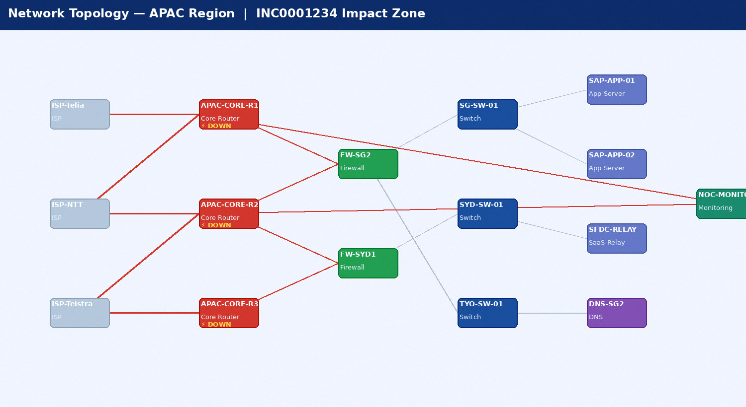
Figure 1: APAC Network Topology — Impact Zone of INC0001234 (DOWN nodes shown in red)

2. Capacity Risk Summary
System | Type | Current Util | Risk | Months to Full | Action Required | Cost (USD) | Decision Date
GPU-Farm-01 A100 | Platform | 98.1% | CRITICAL | N/A | Add 4x p3.8xl reserved | $220,000/yr | 2025-01-24
PROD-VMware-02 APAC | Compute | 94.7% | CRITICAL | N/A | Order 2x HPE BL460c | $84,000 | 2025-01-31
SAN Primary FA-400C | Storage | 70.6% | HIGH | 9.3 mo | Order 300TB expansion | $310,000 | 2025-03-15
Backup Target ME5 | Storage | 81.2% | HIGH | 6.3 mo | Add Azure Blob overflow | $43,200/yr | 2025-02-28
APAC Internet 5G | Network | 91.0% | HIGH | N/A | Upgrade to 10G | $48,000/yr | 2025-02-15
K8s-Prod-02 APAC | Platform | 73.1% | MEDIUM | N/A | Add 8 nodes | $25,200 | 2025-02-01
PROD-VMware-01 EMEA | Compute | 68.2% | LOW | N/A | No action | — | N/A
SAN Secondary AFF | Storage | 64.0% | LOW | 13.1 mo | No action | — | N/A

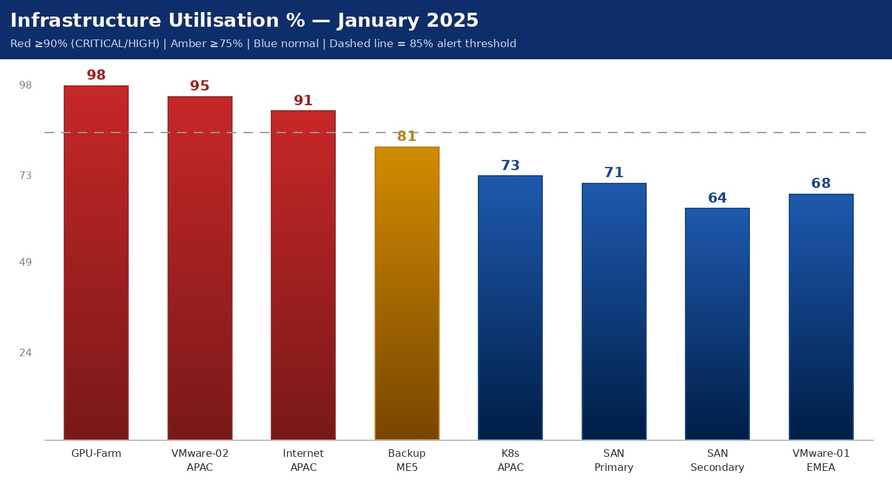
Figure 2: Current Infrastructure Utilisation — January 2025

3. Growth Trend Analysis
The following charts show 12-month utilisation growth for the three highest-risk systems. GPU-Farm growth is driven by ML model training demand increasing 40% QoQ. VMware-02 APAC growth reflects the Q1 2025 application migration from Rackspace (8 workloads). SAN Primary growth is linear at ~13TB/week.
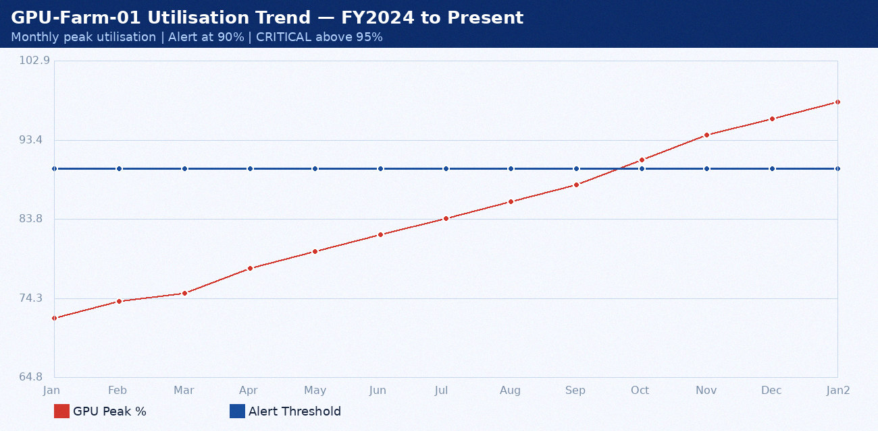
Figure 3: GPU-Farm-01 Peak Utilisation Growth — 13-Month Trend

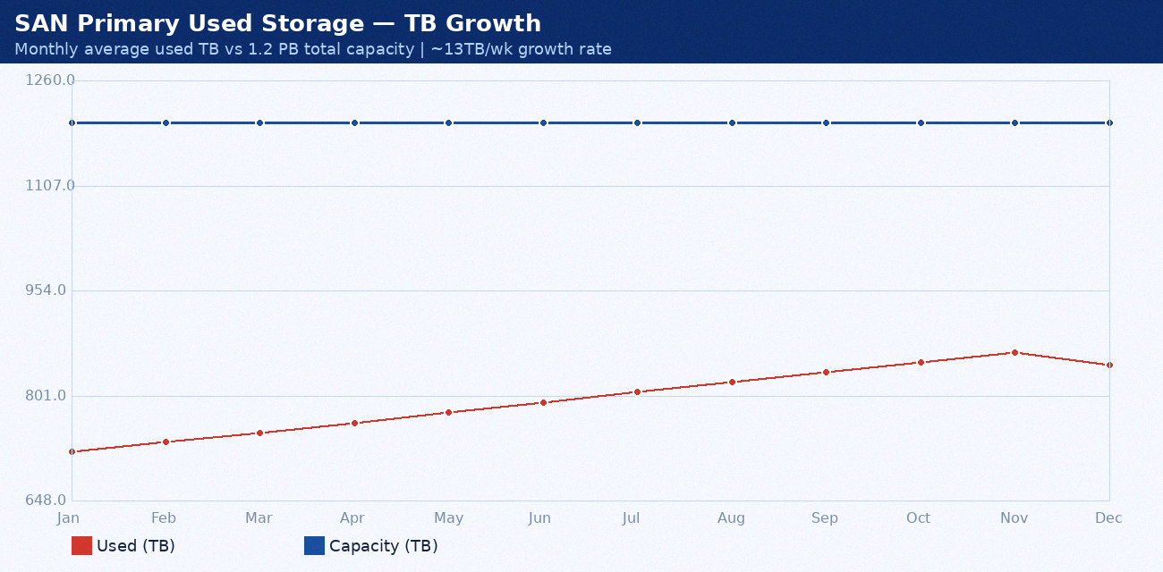
Figure 4: SAN Primary Storage Growth — January through December 2024

4. Investment Summary
Investment Item | Type | FY2025 Capex | Annual Opex | Priority | ROI Justification
GPU Farm p3.8xl (4 instances) | Platform | — | $220,000 | CRITICAL | Prevents $180K/mo inference revenue loss
VMware APAC (2x HPE BL460c) | Compute | $84,000 | — | CRITICAL | Prevents Q2 APAC app contention
SAN Primary 300TB expansion | Storage | $310,000 | — | HIGH | 9.3-month runway without action
Azure Blob backup overflow | Storage | — | $43,200 | HIGH | Avoids $600K emergency purchase
APAC Internet 10G upgrade | Network | — | $48,000 | HIGH | Eliminates customer-facing congestion
K8s APAC 8-node expansion | Platform | — | $25,200 | MEDIUM | Memory headroom for new services

