VENDOR PERFORMANCE PACK — Q1 2025

Owner: Angela Brooks (IT Director)
Period: Q1 2025 — January through March
Total Providers: 23 third-party IT vendors — total spend: USD 4.3M/yr

1. Scorecard Summary
This pack summarises performance across all major IT service providers for Q1 2025. Two vendors require immediate management action: Wipro MSP (Performance Improvement Notice issued) and Rackspace (contract non-renewal recommendation for July 2025). NetGuard Systems achieved the highest score at 94/100.
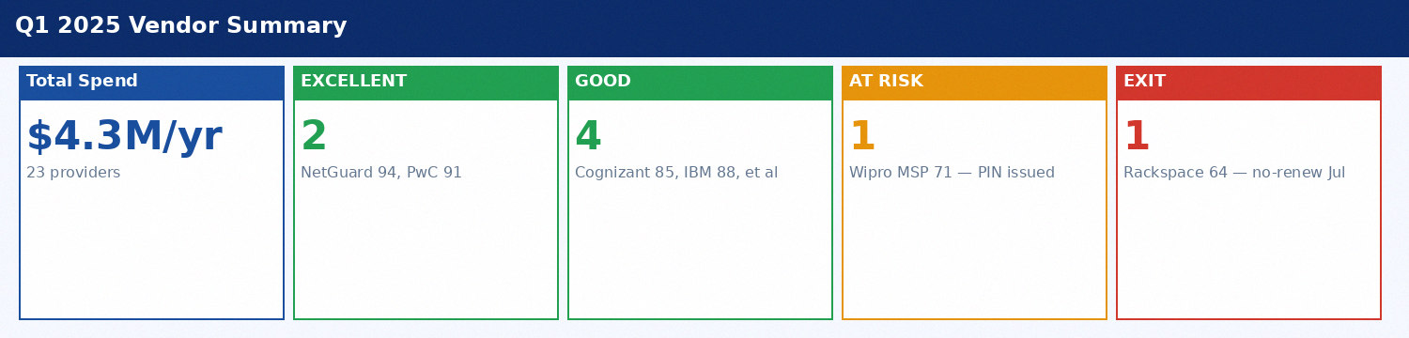
Figure 1: Q1 2025 Vendor Portfolio Overview

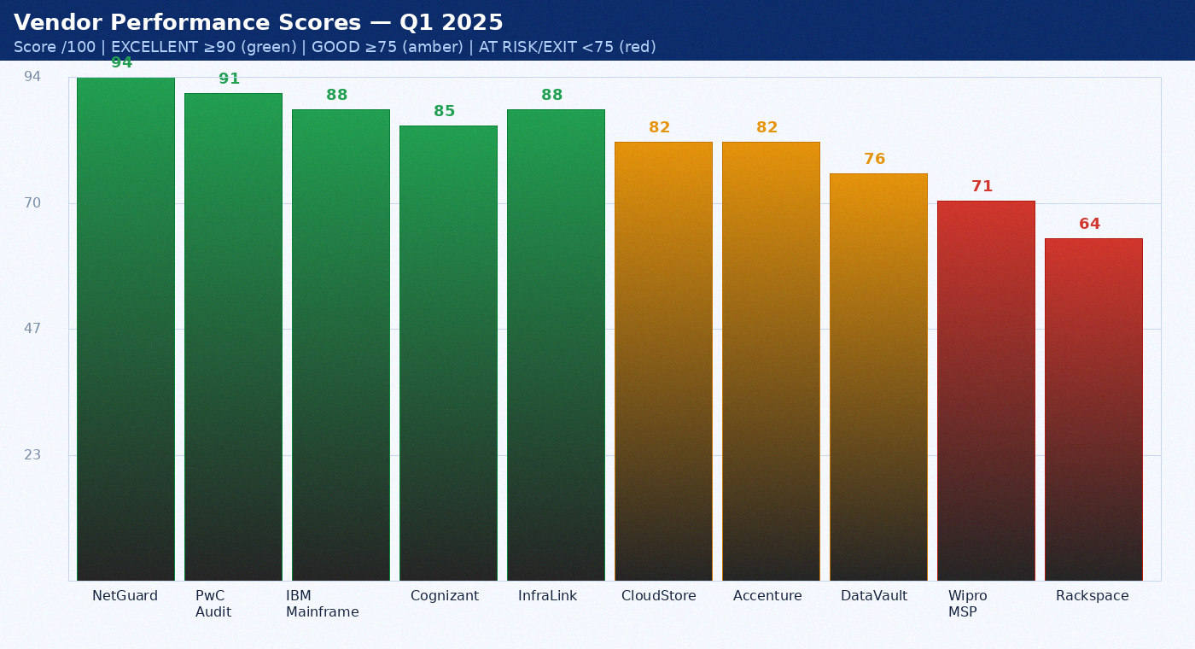
Figure 2: Q1 2025 Vendor Scores — All Providers

1.1 Vendor Scorecard Table
Provider | Annual Spend | Q1 Score | SLA Breaches | Trend | Recommendation
Accenture — ITSM Programme | $340,000 | 82/100 | 0 | ↑ stable | Continue — negotiate fixed-fee
Wipro — Infrastructure MSP | $1,200,000 | 71/100 | 3 | ↓ -8pp | Issue PIN by Feb 2025
DataVault Inc. — Archival | $284,000 | 76/100 | 2 | ↓ -4pp | Add SLA penalty clause
Cognizant — App Support | $780,000 | 85/100 | 0 | ↑ +2pp | Extend 2yr + 5% rate cut
Rackspace — Legacy Hosting | $240,000 | 64/100 | 3 | ↓ -12pp | DO NOT RENEW Jul 2025
IBM — Mainframe Operations | $420,000 | 88/100 | 0 | → steady | Retain — renegotiate fee
NetGuard Systems | $95,000 | 94/100 | 0 | ↑ +3pp | EXCELLENT — expand scope
PwC — IT Audit | $95,000 | 91/100 | 0 | ↑ +2pp | Expand FY2026 scope

2. Wipro MSP — Performance Improvement Notice
Wipro Infrastructure MSP's SLA compliance has declined from 97% to 89% over the past six months — a drop of 8 percentage points. Three P1-equivalent SLA breaches were recorded in Q1 2025. Staff turnover on our account reached 4 lead engineers replaced in 12 months. A formal Performance Improvement Notice will be issued by 28 February 2025 with a 90-day improvement window. KPIs: NOC SLA must return to 95%, account staff turnover below 25%.
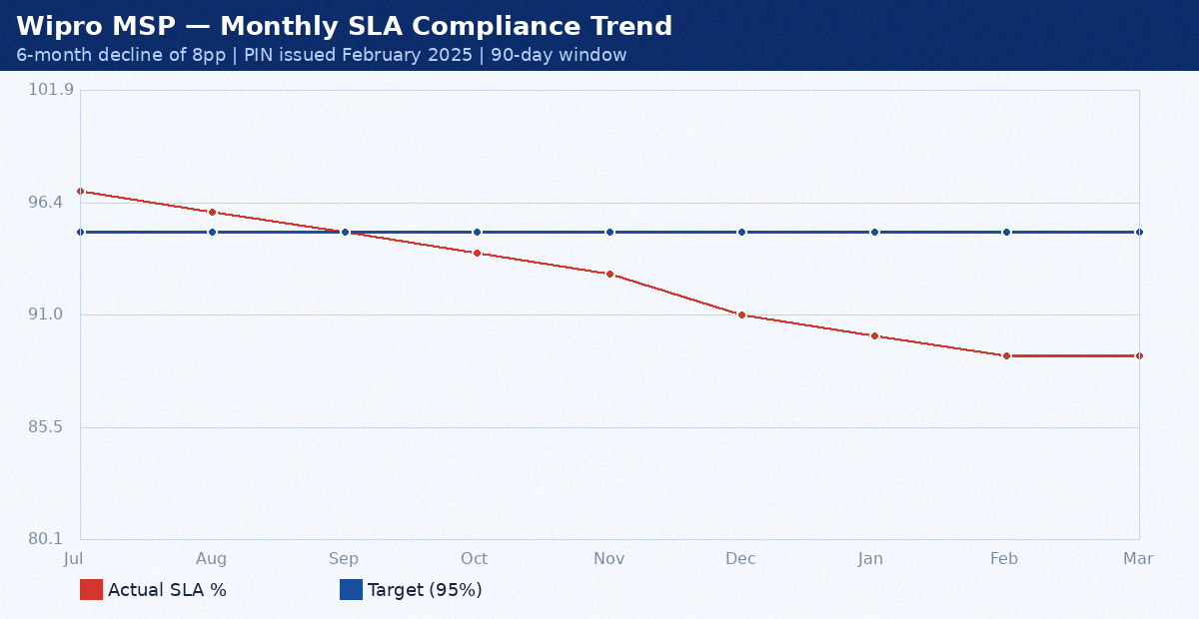
Figure 3: Wipro MSP SLA Compliance — Declining Trend (Jul 2024–Mar 2025)

3. Rackspace — Contract Exit Plan
Rackspace Legacy Hosting is recommended for non-renewal at its July 2025 contract expiry. Three infrastructure incidents in Q4 2024 were directly attributed to Rackspace: a 7-day patching delay on CVE-2024-38112 (vs our 72-hour policy), a firewall misconfiguration that exposed a legacy app to the internet for 4 hours, and an unplanned 2-hour maintenance outage without advance notification. Net annual saving from non-renewal: $240,000.
Workload | Current Host | Migration Target | Target Date | Owner | Status
Legacy HRMS | Rackspace | AWS EC2 ap-southeast-1 | 2025-05-31 | Ravi Patel | Planning
Legacy Finance App | Rackspace | AWS RDS + EC2 | 2025-04-30 | Sarah Chen | Planning
Test/Dev Environment | Rackspace | AWS Dev Account | 2025-03-31 | Ravi Patel | In Progress
Archive Web Server | Rackspace | S3 + CloudFront | 2025-04-15 | Ravi Patel | Not Started
Legacy CRM API | Rackspace | AWS Lambda + API GW | 2025-05-15 | Ravi Patel | Not Started
Batch Processing | Rackspace | AWS Batch | 2025-05-31 | Sarah Chen | Not Started
Legacy Reporting | Rackspace | AWS QuickSight | 2025-06-15 | Angela Brooks | Not Started
DR Relay Server | Rackspace | AWS Transit Gateway | 2025-06-30 | Mike Torres | Not Started

