IT ARCHITECTURE OVERVIEW — v3.1

Owners: Mike Torres (Network) & Ravi Patel (DevOps)
Version: 3.1 — Updated 12 January 2025
Scope: All production and DR infrastructure — EMEA, APAC, AMER regions
Classification: CONFIDENTIAL — IT Leadership and Architecture Review Board

1. Network Architecture
The production network is anchored at Equinix LD6 London (DC-PRIMARY-LD6) with a hot standby at Equinix AM6 Amsterdam (DC-SECONDARY-AM6). The disaster recovery site is at Digital Realty FRA11 Frankfurt (DC-DR2-FRA11). APAC connectivity is provided via three core routers (APAC-CORE-R1, R2, R3) with dual ISP connections per router. The BGP outage on 14 January 2025 (INC0001234) affected all three APAC core routers.
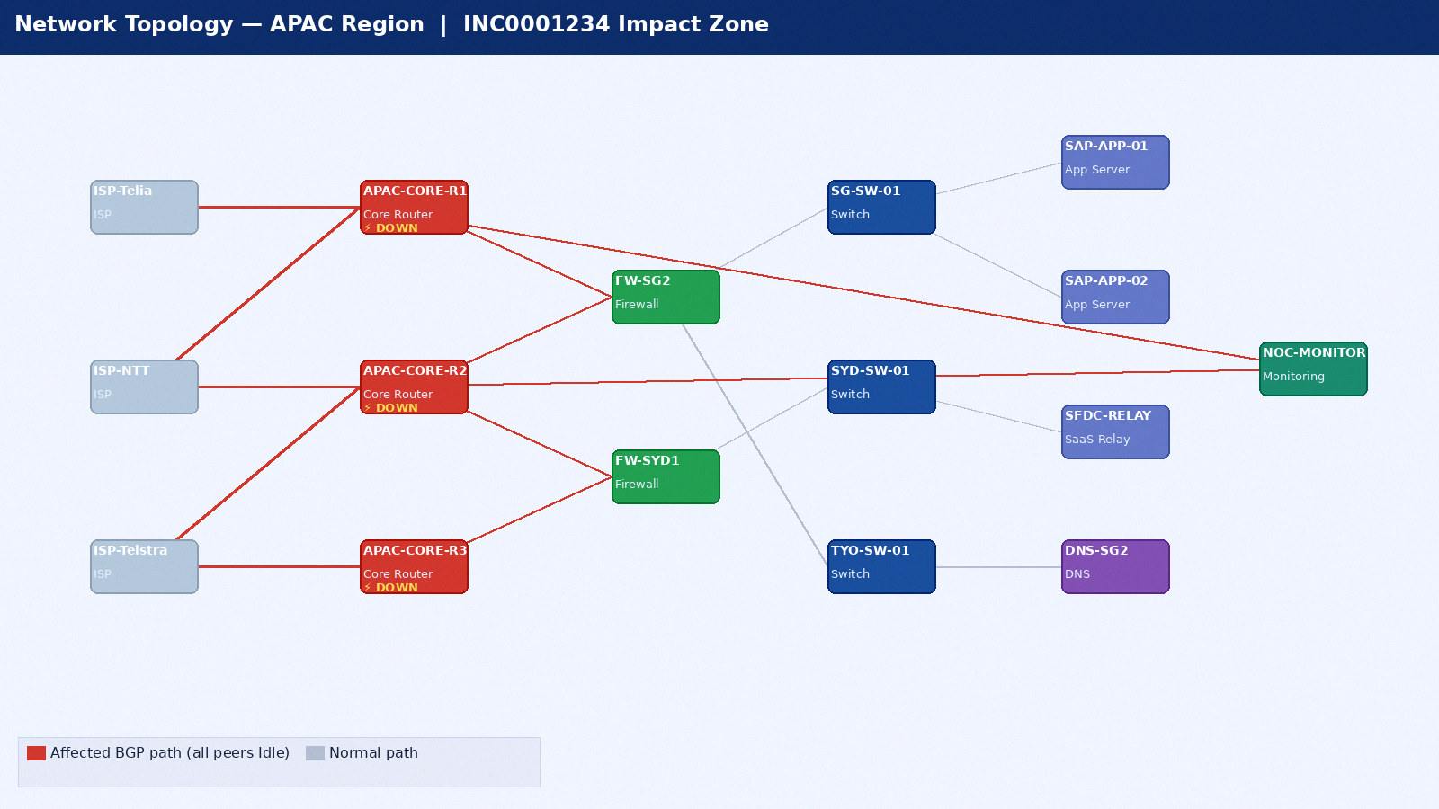
Figure 1: APAC Network Topology — INC0001234 Impact (red = DOWN)

1.1 BGP Configuration
Router | Site | Peer Count | Local AS | Peer ISPs | Status (Jan 14 2025)
APAC-CORE-R1 | DC-PRIMARY-LD6 | 6 | AS65001 | Telia AS1299, NTT AS2914, ISP×4 | DOWN — INC0001234
APAC-CORE-R2 | DC-PRIMARY-LD6 | 6 | AS65001 | Telstra AS4637, Singtel AS7473, ISP×4 | DOWN — INC0001234
APAC-CORE-R3 | DC-DR2-FRA11 | 6 | AS65001 | Lumen AS3356, Tata AS6453, ISP×4 | DOWN — INC0001234
EMEA-CORE-R1 | DC-PRIMARY-LD6 | 8 | AS65001 | Telia AS1299, Lumen AS3356, ISP×6 | UP — Nominal
AMER-CORE-R1 | DC-AMER-NY9 | 6 | AS65001 | ATT AS7018, Cogent AS174, ISP×4 | UP — Nominal

2. Compute Infrastructure
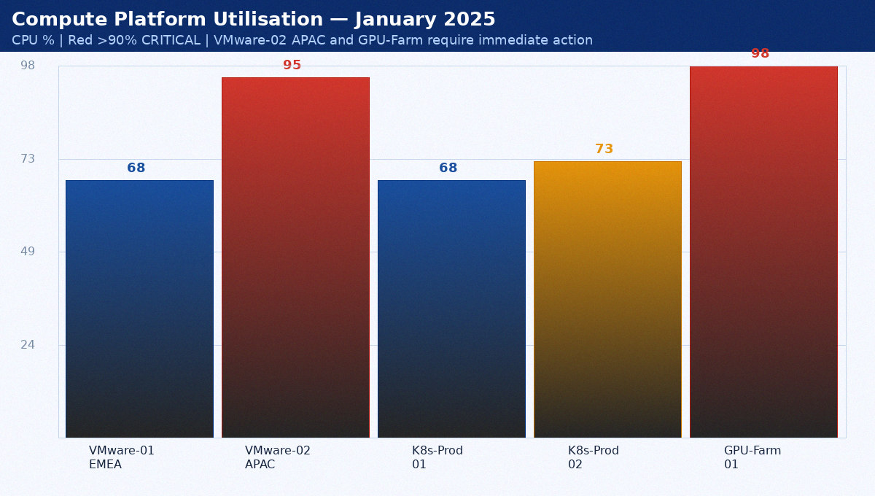
Figure 2: Compute Platform Utilisation — January 2025

System | Type | Capacity | Utilisation | Node Count | Risk | Decision Required
PROD-VMware-02 APAC | vSphere 8 | 960 vCPU / 3.8TB RAM | 94.7% | 48 hosts | CRITICAL | Order 2x HPE BL460c by Jan 31
GPU-Farm-01 A100 | NVIDIA DGX | 64 A100 GPUs | 98.1% | 8 DGX nodes | CRITICAL | Add 4x p3.8xl by Jan 24
K8s-Prod-01 EMEA | AWS EKS 1.29 | 32 r6i.2xlarge | 68.2% | 32 nodes | LOW | No action
K8s-Prod-02 APAC | AWS EKS 1.29 | 32 r6i.2xlarge | 73.1% | 32 nodes | MEDIUM | Add 8 nodes by Feb 1
PROD-VMware-01 EMEA | vSphere 8 | 1,280 vCPU / 5.1TB | 68.2% | 64 hosts | LOW | No action

4. Identity and Security — Appendix 1
This appendix covers Active Directory, Okta, MFA coverage in the context of the FY2024/2025 infrastructure review. Data is current as of January 2025.
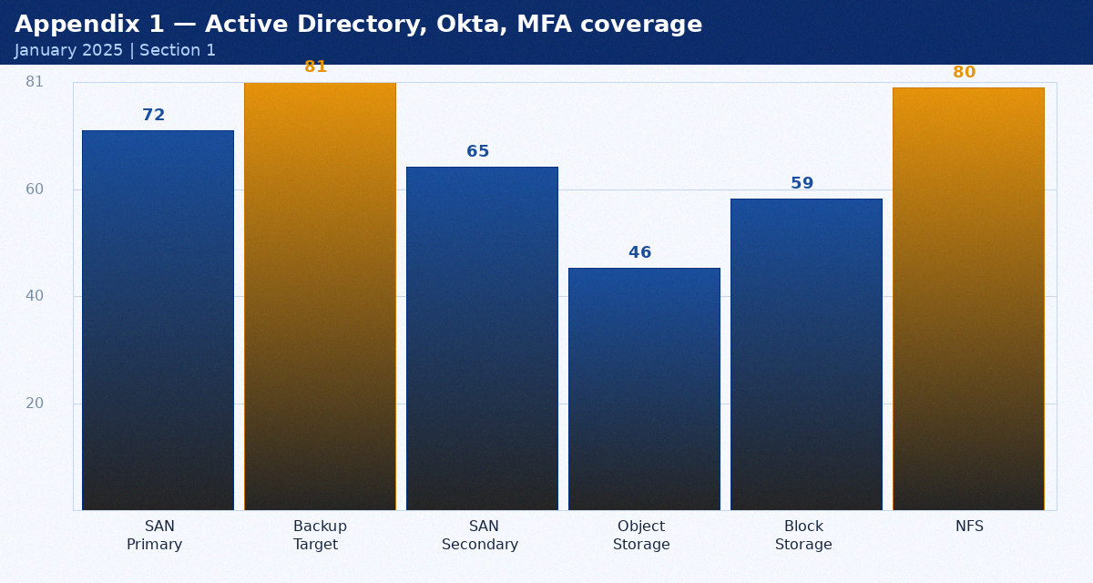
Figure 6: Active Directory, Okta, MFA coverage metrics

Component | Status | Last Tested | Next Action | Owner
1A | Operational | 2024-02-15 | Q2 review | Mike Torres
1B | Operational | 2024-02-20 | Q2 review | Sarah Chen
2A | Maintenance due | 2024-02-25 | Schedule review | Ravi Patel

5. Application Stack — Appendix 2
This appendix covers SAP ERP, Salesforce CRM, ServiceNow in the context of the FY2024/2025 infrastructure review. Data is current as of January 2025.
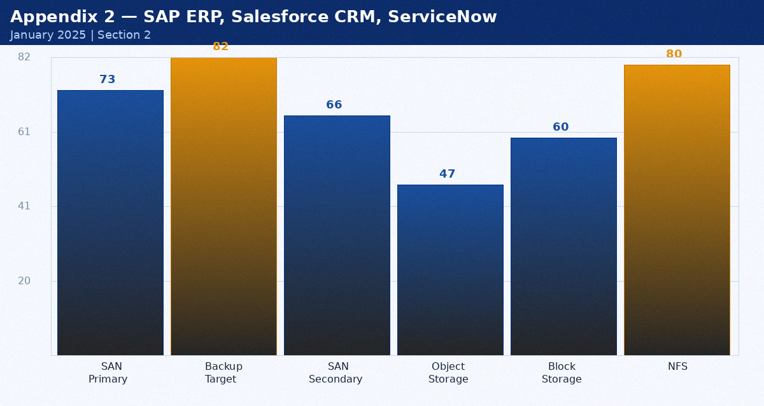
Figure 7: SAP ERP, Salesforce CRM, ServiceNow metrics

Component | Status | Last Tested | Next Action | Owner
3A | Operational | 2024-03-15 | Q2 review | Mike Torres
3B | Operational | 2024-03-20 | Q2 review | Sarah Chen
4A | Maintenance due | 2024-03-25 | Schedule review | Ravi Patel

6. Monitoring and Operations — Appendix 3
This appendix covers Datadog, PagerDuty, Ansible Tower in the context of the FY2024/2025 infrastructure review. Data is current as of January 2025.
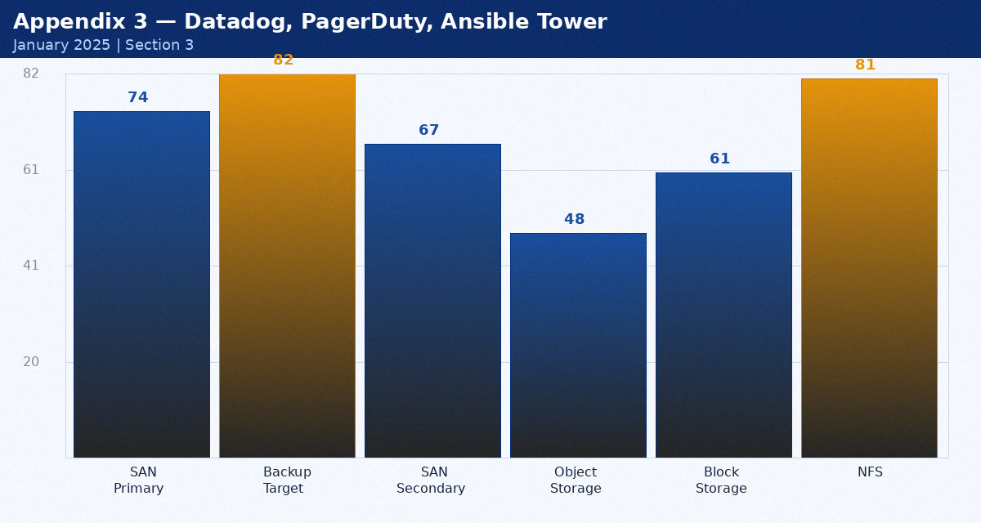
Figure 8: Datadog, PagerDuty, Ansible Tower metrics

Component | Status | Last Tested | Next Action | Owner
5A | Operational | 2024-04-15 | Q2 review | Mike Torres
5B | Operational | 2024-04-20 | Q2 review | Sarah Chen
6A | Maintenance due | 2024-04-25 | Schedule review | Ravi Patel

7. Disaster Recovery — Appendix 4
This appendix covers DC-DR2-FRA11, RPO/RTO targets, test results in the context of the FY2024/2025 infrastructure review. Data is current as of January 2025.
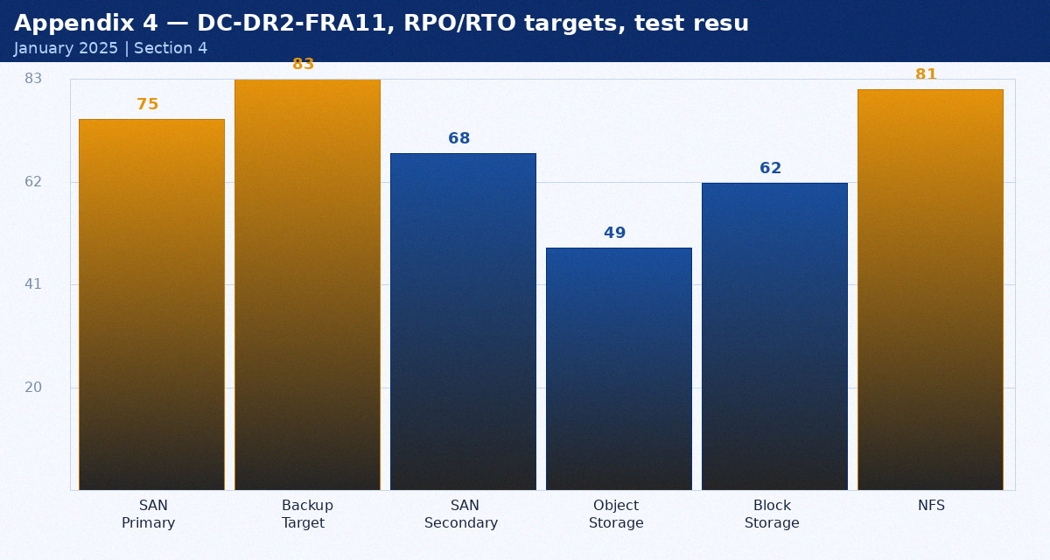
Figure 9: DC-DR2-FRA11, RPO/RTO targets, test results metrics

Component | Status | Last Tested | Next Action | Owner
7A | Operational | 2024-05-15 | Q2 review | Mike Torres
7B | Operational | 2024-05-20 | Q2 review | Sarah Chen
8A | Maintenance due | 2024-05-25 | Schedule review | Ravi Patel

8. Cloud Strategy — Appendix 5
This appendix covers AWS, Azure, multi-cloud governance in the context of the FY2024/2025 infrastructure review. Data is current as of January 2025.
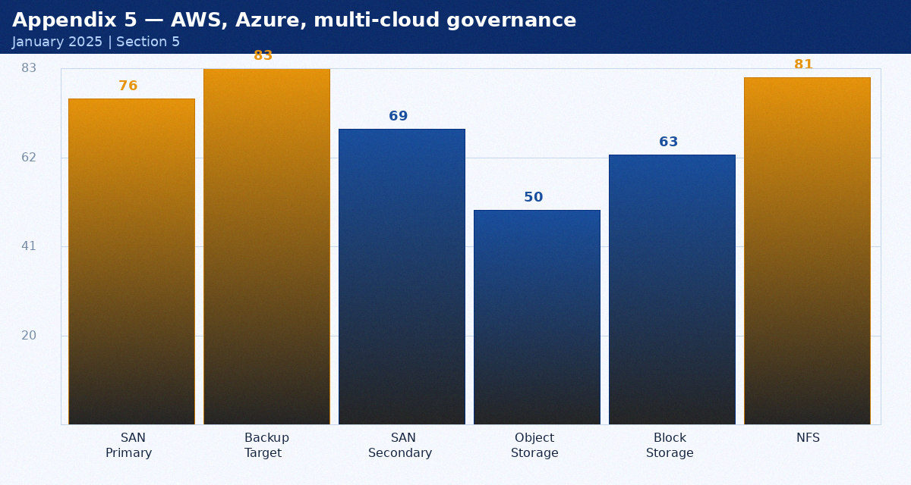
Figure 10: AWS, Azure, multi-cloud governance metrics

Component | Status | Last Tested | Next Action | Owner
9A | Operational | 2024-06-15 | Q2 review | Mike Torres
9B | Operational | 2024-06-20 | Q2 review | Sarah Chen
10A | Maintenance due | 2024-06-25 | Schedule review | Ravi Patel

9. Network Security — Appendix 6
This appendix covers PA-5280 firewalls, ZTNA, DDoS in the context of the FY2024/2025 infrastructure review. Data is current as of January 2025.
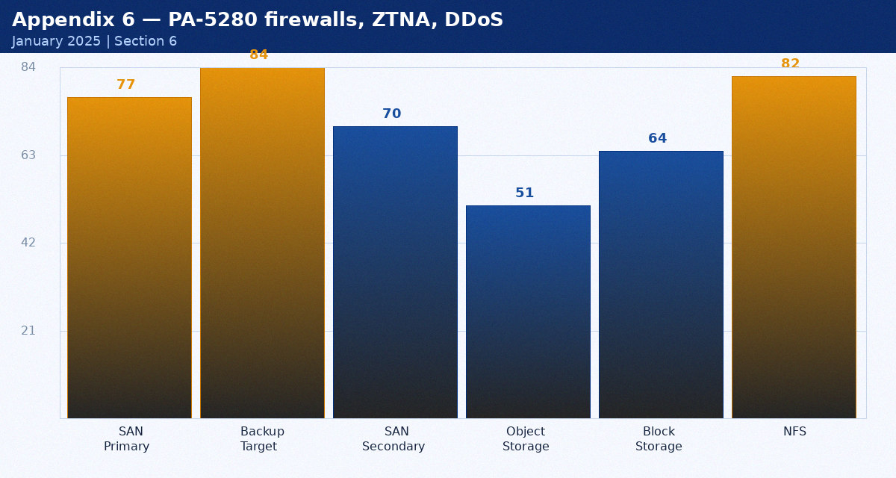
Figure 11: PA-5280 firewalls, ZTNA, DDoS metrics

Component | Status | Last Tested | Next Action | Owner
11A | Operational | 2024-07-15 | Q2 review | Mike Torres
11B | Operational | 2024-07-20 | Q2 review | Sarah Chen
12A | Maintenance due | 2024-07-25 | Schedule review | Ravi Patel

10. DevOps Platform — Appendix 7
This appendix covers Jenkins, Ansible Tower, Terraform, GitHub in the context of the FY2024/2025 infrastructure review. Data is current as of January 2025.
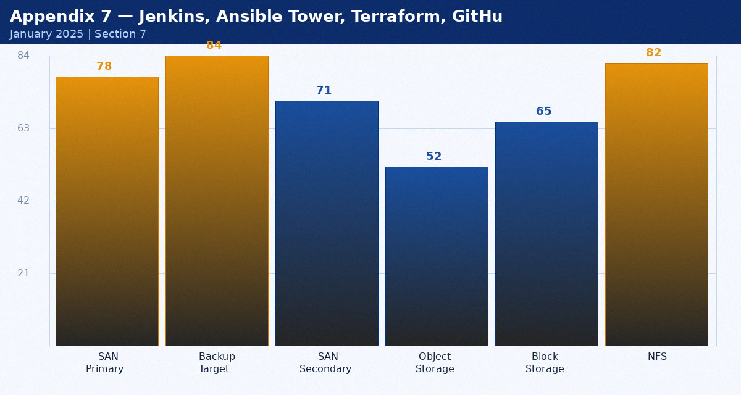
Figure 12: Jenkins, Ansible Tower, Terraform, GitHub metrics

Component | Status | Last Tested | Next Action | Owner
13A | Operational | 2024-08-15 | Q2 review | Mike Torres
13B | Operational | 2024-08-20 | Q2 review | Sarah Chen
14A | Maintenance due | 2024-08-25 | Schedule review | Ravi Patel

3. Storage Architecture — Appendix 8
This appendix covers Storage systems and growth projections in the context of the FY2024/2025 infrastructure review. Data is current as of January 2025.
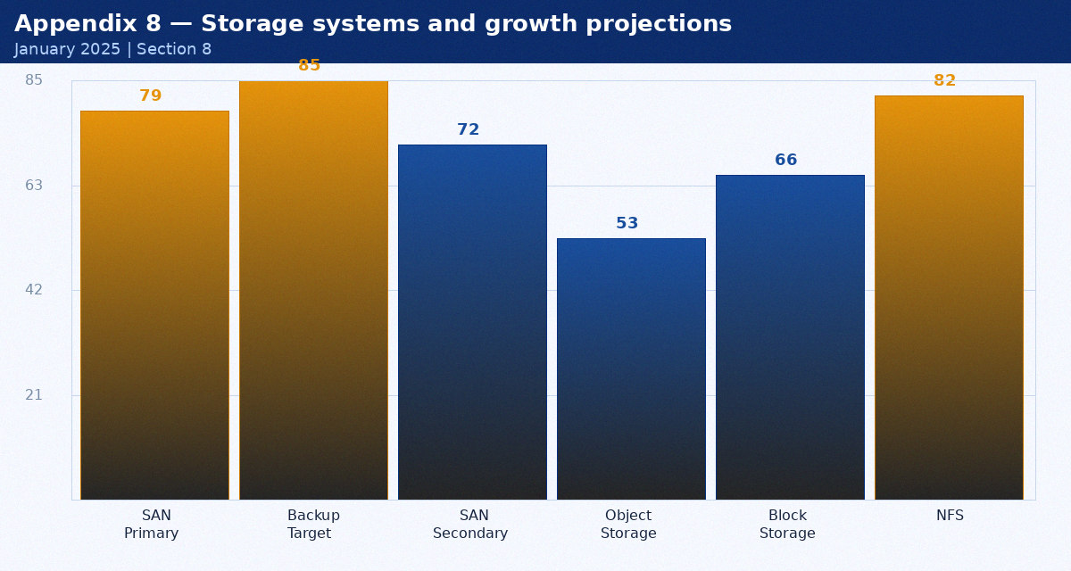
Figure 13: Storage systems and growth projections metrics

Component | Status | Last Tested | Next Action | Owner
15A | Operational | 2024-09-15 | Q2 review | Mike Torres
15B | Operational | 2024-09-20 | Q2 review | Sarah Chen
16A | Maintenance due | 2024-09-25 | Schedule review | Ravi Patel

4. Identity and Security — Appendix 9
This appendix covers Active Directory, Okta, MFA coverage in the context of the FY2024/2025 infrastructure review. Data is current as of January 2025.
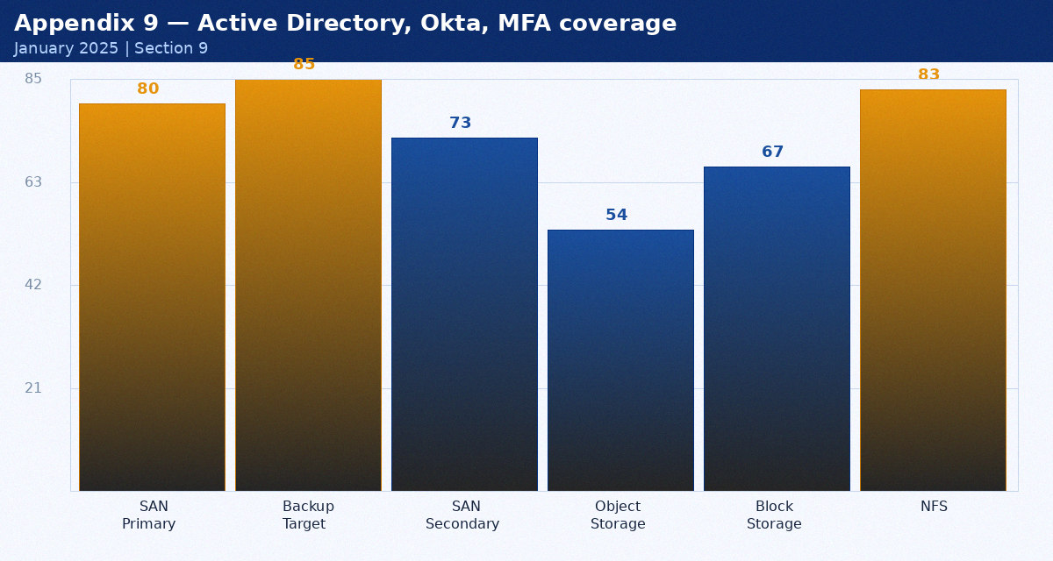
Figure 14: Active Directory, Okta, MFA coverage metrics

Component | Status | Last Tested | Next Action | Owner
17A | Operational | 2024-10-15 | Q2 review | Mike Torres
17B | Operational | 2024-10-20 | Q2 review | Sarah Chen
18A | Maintenance due | 2024-10-25 | Schedule review | Ravi Patel

5. Application Stack — Appendix 10
This appendix covers SAP ERP, Salesforce CRM, ServiceNow in the context of the FY2024/2025 infrastructure review. Data is current as of January 2025.
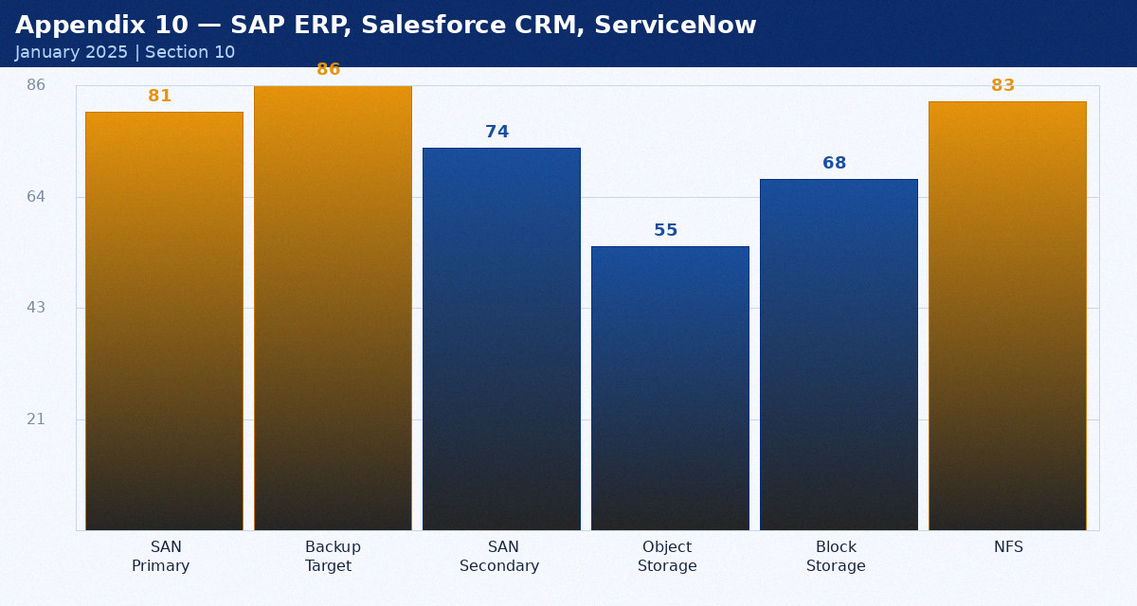
Figure 15: SAP ERP, Salesforce CRM, ServiceNow metrics

Component | Status | Last Tested | Next Action | Owner
19A | Operational | 2024-11-15 | Q2 review | Mike Torres
19B | Operational | 2024-11-20 | Q2 review | Sarah Chen
20A | Maintenance due | 2024-11-25 | Schedule review | Ravi Patel

6. Monitoring and Operations — Appendix 11
This appendix covers Datadog, PagerDuty, Ansible Tower in the context of the FY2024/2025 infrastructure review. Data is current as of January 2025.
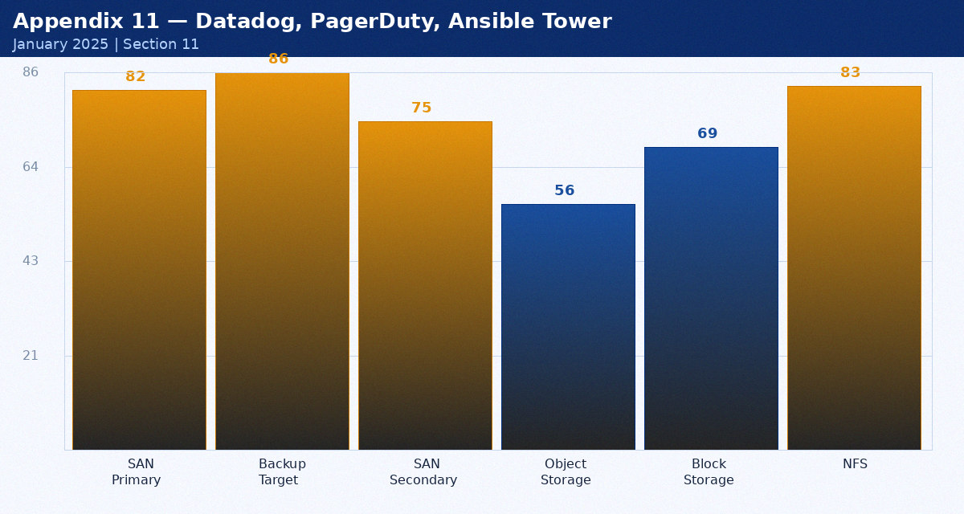
Figure 16: Datadog, PagerDuty, Ansible Tower metrics

Component | Status | Last Tested | Next Action | Owner
21A | Operational | 2024-12-15 | Q2 review | Mike Torres
21B | Operational | 2024-12-20 | Q2 review | Sarah Chen
22A | Maintenance due | 2024-12-25 | Schedule review | Ravi Patel

7. Disaster Recovery — Appendix 12
This appendix covers DC-DR2-FRA11, RPO/RTO targets, test results in the context of the FY2024/2025 infrastructure review. Data is current as of January 2025.
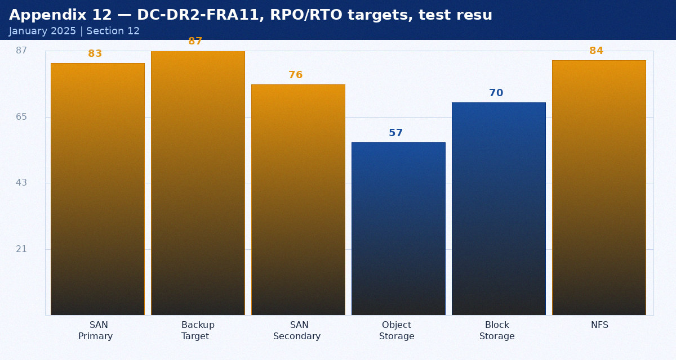
Figure 17: DC-DR2-FRA11, RPO/RTO targets, test results metrics

Component | Status | Last Tested | Next Action | Owner
23A | Operational | 2024-01-15 | Q2 review | Mike Torres
23B | Operational | 2024-01-20 | Q2 review | Sarah Chen
24A | Maintenance due | 2024-01-25 | Schedule review | Ravi Patel

8. Cloud Strategy — Appendix 13
This appendix covers AWS, Azure, multi-cloud governance in the context of the FY2024/2025 infrastructure review. Data is current as of January 2025.
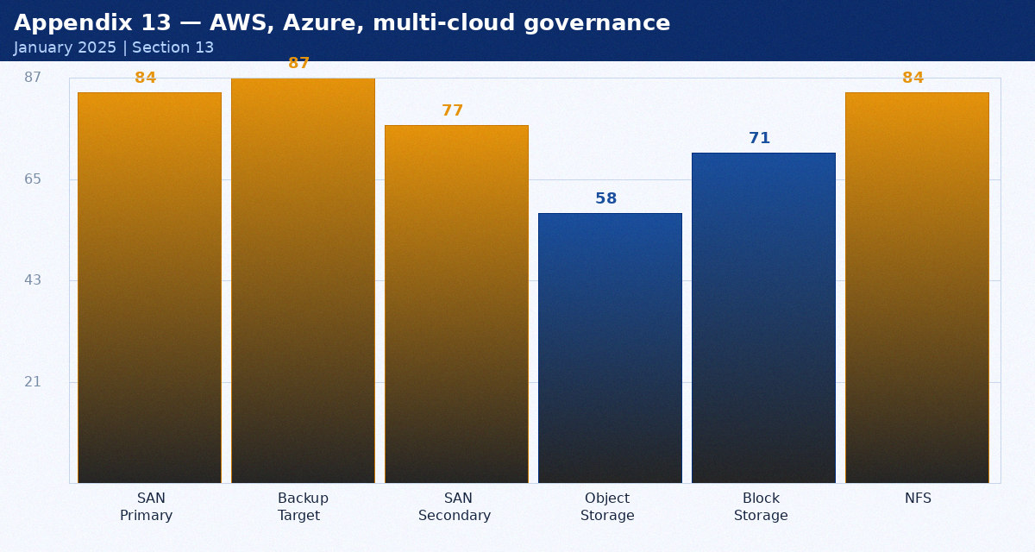
Figure 18: AWS, Azure, multi-cloud governance metrics

Component | Status | Last Tested | Next Action | Owner
25A | Operational | 2024-02-15 | Q2 review | Mike Torres
25B | Operational | 2024-02-20 | Q2 review | Sarah Chen
26A | Maintenance due | 2024-02-25 | Schedule review | Ravi Patel

9. Network Security — Appendix 14
This appendix covers PA-5280 firewalls, ZTNA, DDoS in the context of the FY2024/2025 infrastructure review. Data is current as of January 2025.
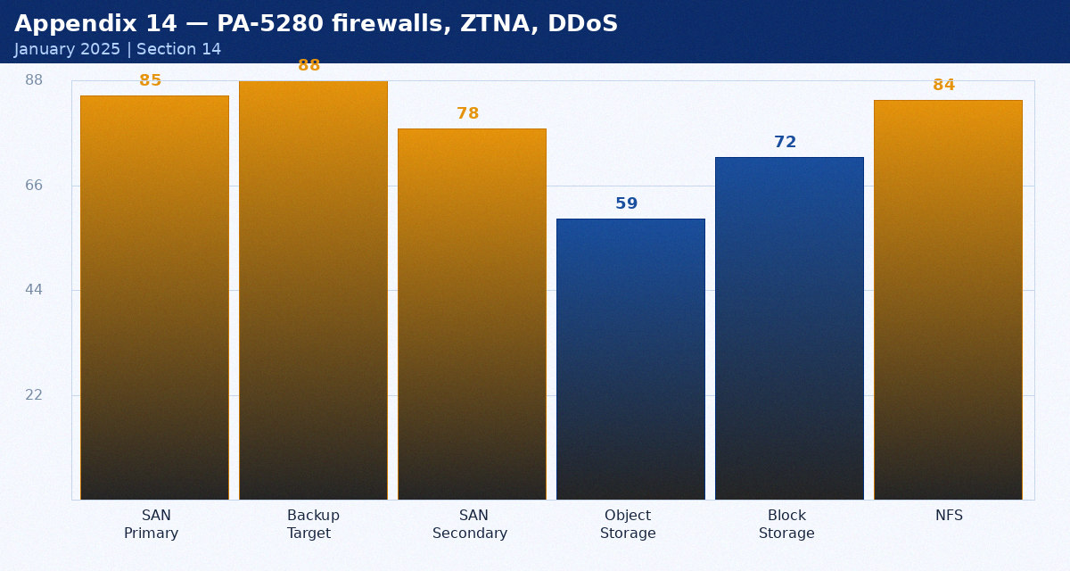
Figure 19: PA-5280 firewalls, ZTNA, DDoS metrics

Component | Status | Last Tested | Next Action | Owner
27A | Operational | 2024-03-15 | Q2 review | Mike Torres
27B | Operational | 2024-03-20 | Q2 review | Sarah Chen
28A | Maintenance due | 2024-03-25 | Schedule review | Ravi Patel

10. DevOps Platform — Appendix 15
This appendix covers Jenkins, Ansible Tower, Terraform, GitHub in the context of the FY2024/2025 infrastructure review. Data is current as of January 2025.
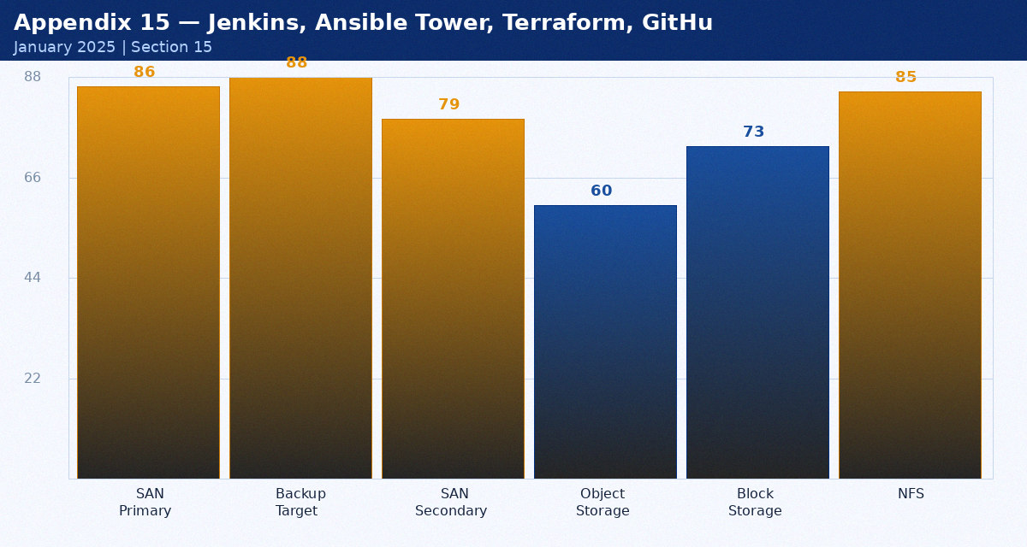
Figure 20: Jenkins, Ansible Tower, Terraform, GitHub metrics

Component | Status | Last Tested | Next Action | Owner
29A | Operational | 2024-04-15 | Q2 review | Mike Torres
29B | Operational | 2024-04-20 | Q2 review | Sarah Chen
30A | Maintenance due | 2024-04-25 | Schedule review | Ravi Patel

3. Storage Architecture — Appendix 16
This appendix covers Storage systems and growth projections in the context of the FY2024/2025 infrastructure review. Data is current as of January 2025.
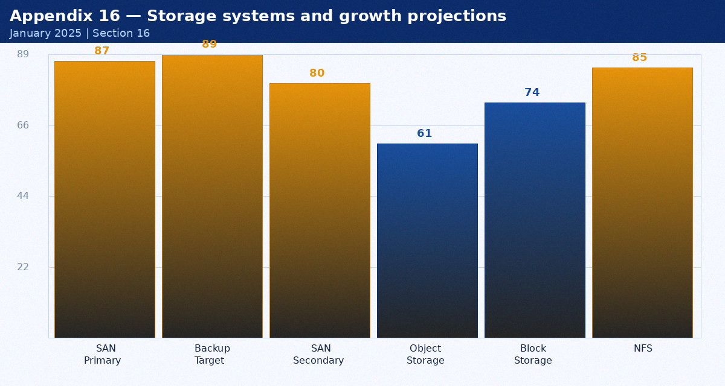
Figure 21: Storage systems and growth projections metrics

Component | Status | Last Tested | Next Action | Owner
31A | Operational | 2024-05-15 | Q2 review | Mike Torres
31B | Operational | 2024-05-20 | Q2 review | Sarah Chen
32A | Maintenance due | 2024-05-25 | Schedule review | Ravi Patel

4. Identity and Security — Appendix 17
This appendix covers Active Directory, Okta, MFA coverage in the context of the FY2024/2025 infrastructure review. Data is current as of January 2025.
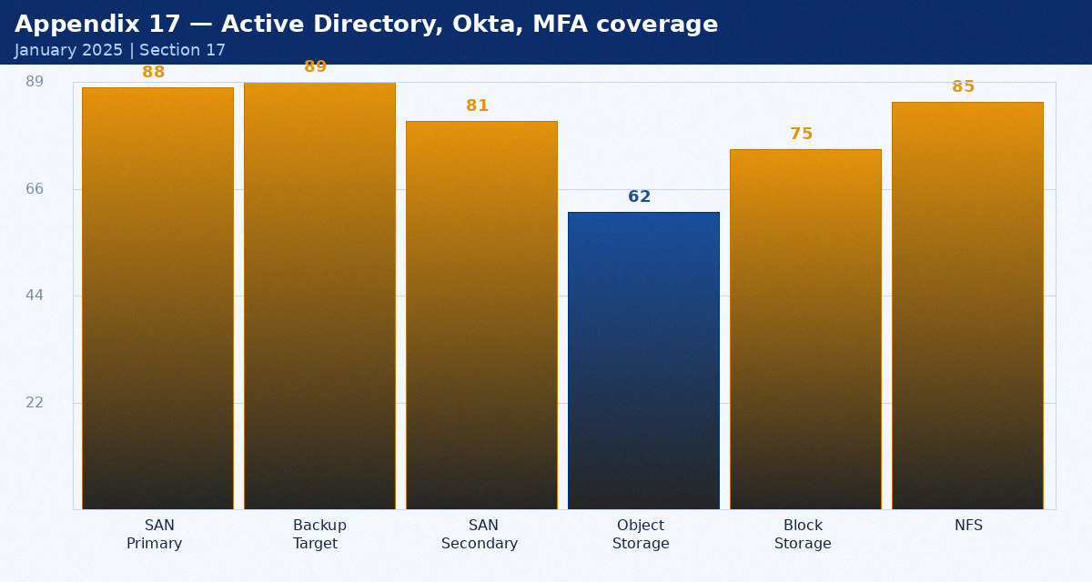
Figure 22: Active Directory, Okta, MFA coverage metrics

Component | Status | Last Tested | Next Action | Owner
33A | Operational | 2024-06-15 | Q2 review | Mike Torres
33B | Operational | 2024-06-20 | Q2 review | Sarah Chen
34A | Maintenance due | 2024-06-25 | Schedule review | Ravi Patel

5. Application Stack — Appendix 18
This appendix covers SAP ERP, Salesforce CRM, ServiceNow in the context of the FY2024/2025 infrastructure review. Data is current as of January 2025.
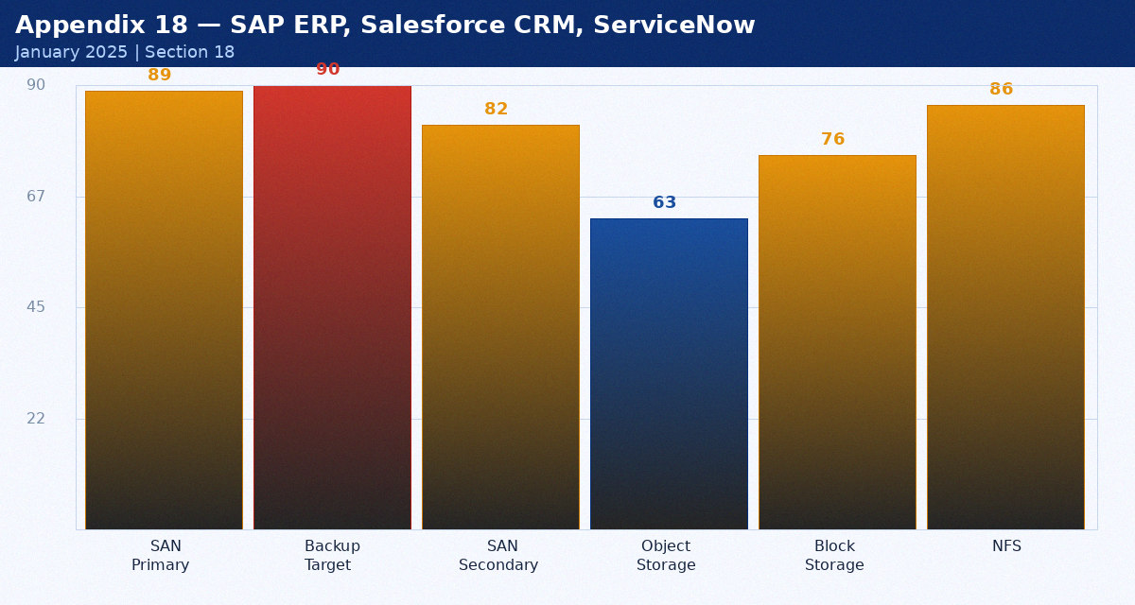
Figure 23: SAP ERP, Salesforce CRM, ServiceNow metrics

Component | Status | Last Tested | Next Action | Owner
35A | Operational | 2024-07-15 | Q2 review | Mike Torres
35B | Operational | 2024-07-20 | Q2 review | Sarah Chen
36A | Maintenance due | 2024-07-25 | Schedule review | Ravi Patel

6. Monitoring and Operations — Appendix 19
This appendix covers Datadog, PagerDuty, Ansible Tower in the context of the FY2024/2025 infrastructure review. Data is current as of January 2025.
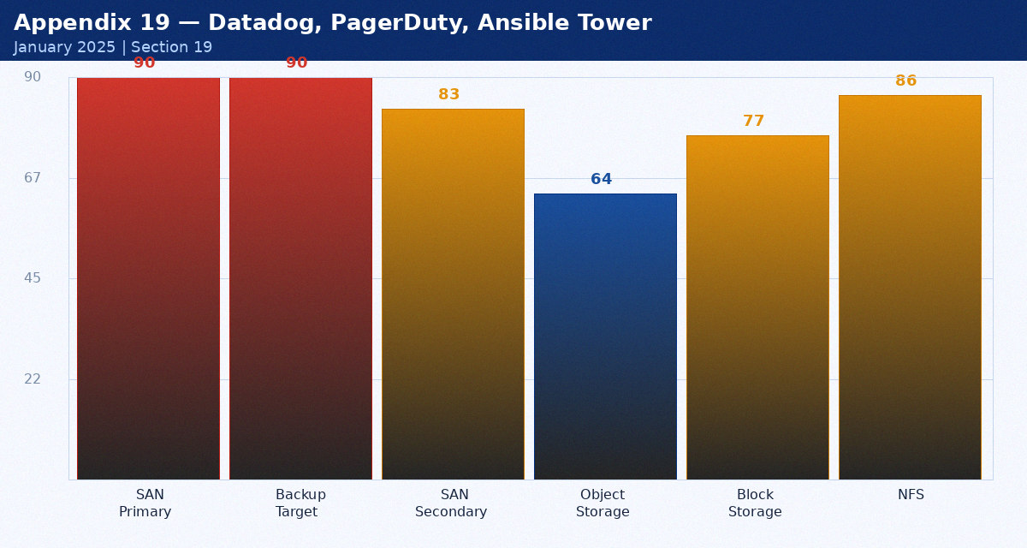
Figure 24: Datadog, PagerDuty, Ansible Tower metrics

Component | Status | Last Tested | Next Action | Owner
37A | Operational | 2024-08-15 | Q2 review | Mike Torres
37B | Operational | 2024-08-20 | Q2 review | Sarah Chen
38A | Maintenance due | 2024-08-25 | Schedule review | Ravi Patel

7. Disaster Recovery — Appendix 20
This appendix covers DC-DR2-FRA11, RPO/RTO targets, test results in the context of the FY2024/2025 infrastructure review. Data is current as of January 2025.
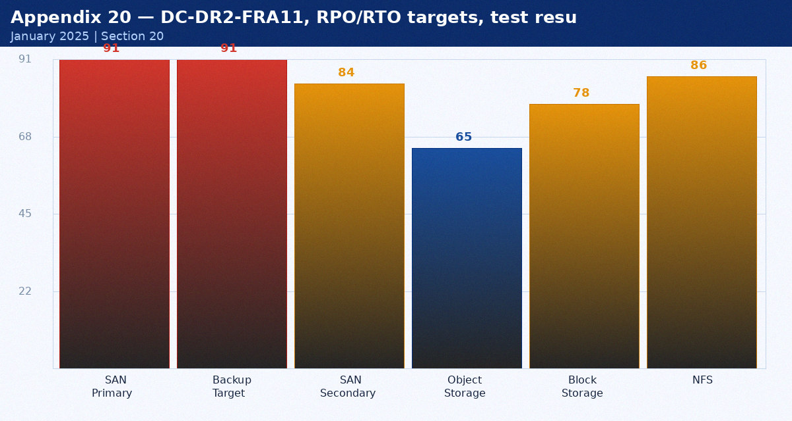
Figure 25: DC-DR2-FRA11, RPO/RTO targets, test results metrics

Component | Status | Last Tested | Next Action | Owner
39A | Operational | 2024-09-15 | Q2 review | Mike Torres
39B | Operational | 2024-09-20 | Q2 review | Sarah Chen
40A | Maintenance due | 2024-09-25 | Schedule review | Ravi Patel

8. Cloud Strategy — Appendix 21
This appendix covers AWS, Azure, multi-cloud governance in the context of the FY2024/2025 infrastructure review. Data is current as of January 2025.
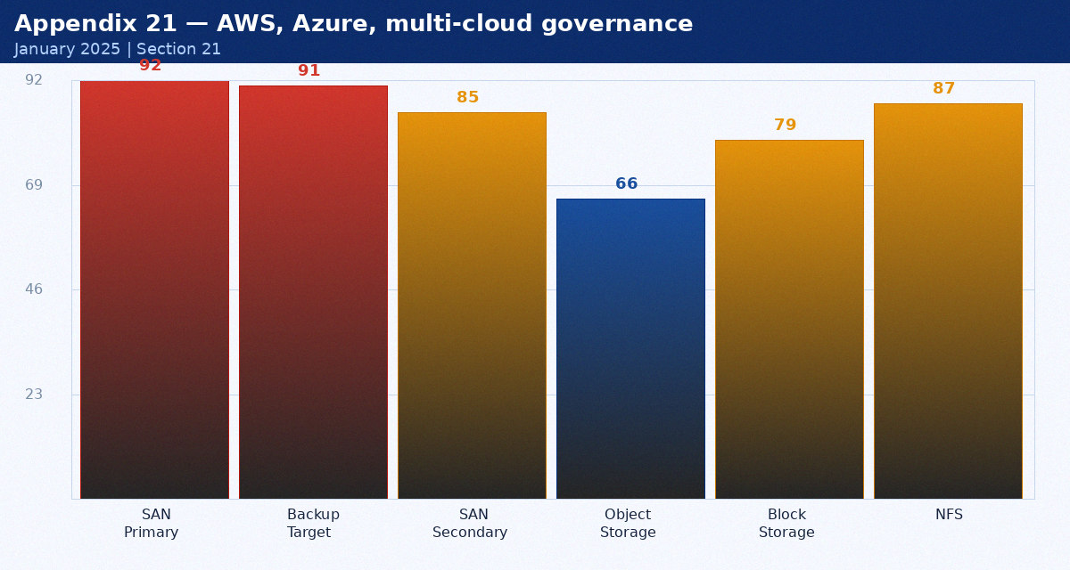
Figure 26: AWS, Azure, multi-cloud governance metrics

Component | Status | Last Tested | Next Action | Owner
41A | Operational | 2024-10-15 | Q2 review | Mike Torres
41B | Operational | 2024-10-20 | Q2 review | Sarah Chen
42A | Maintenance due | 2024-10-25 | Schedule review | Ravi Patel

9. Network Security — Appendix 22
This appendix covers PA-5280 firewalls, ZTNA, DDoS in the context of the FY2024/2025 infrastructure review. Data is current as of January 2025.
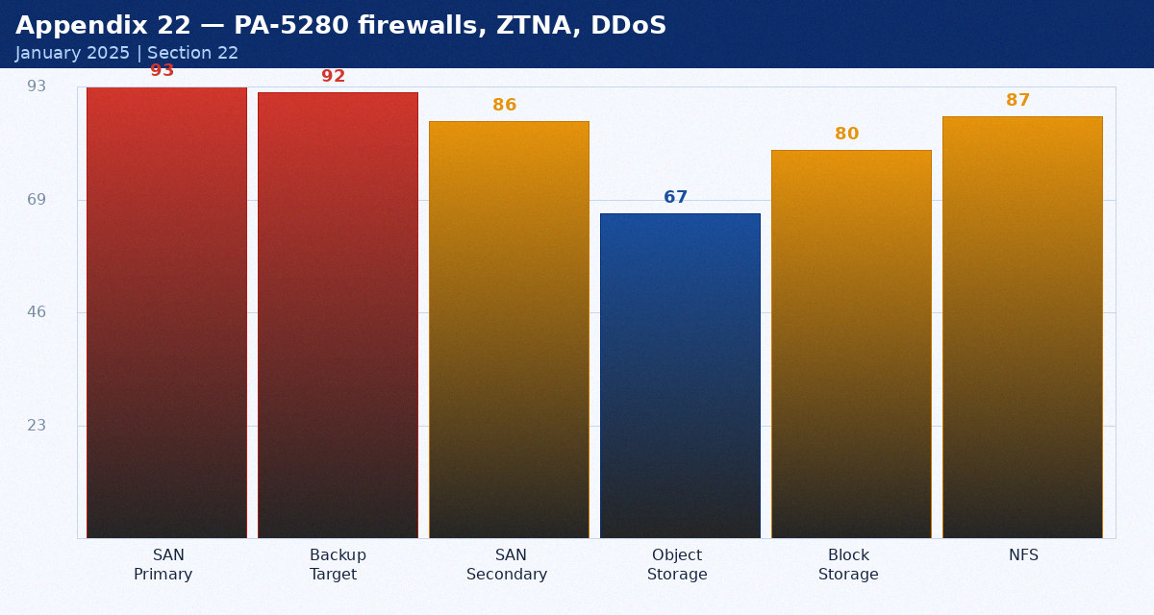
Figure 27: PA-5280 firewalls, ZTNA, DDoS metrics

Component | Status | Last Tested | Next Action | Owner
43A | Operational | 2024-11-15 | Q2 review | Mike Torres
43B | Operational | 2024-11-20 | Q2 review | Sarah Chen
44A | Maintenance due | 2024-11-25 | Schedule review | Ravi Patel

10. DevOps Platform — Appendix 23
This appendix covers Jenkins, Ansible Tower, Terraform, GitHub in the context of the FY2024/2025 infrastructure review. Data is current as of January 2025.
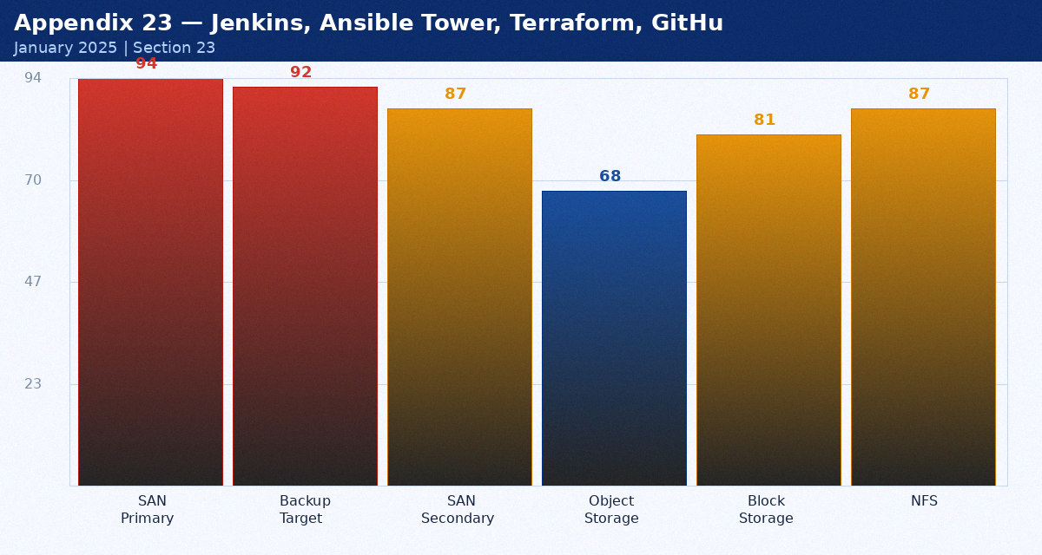
Figure 28: Jenkins, Ansible Tower, Terraform, GitHub metrics

Component | Status | Last Tested | Next Action | Owner
45A | Operational | 2024-12-15 | Q2 review | Mike Torres
45B | Operational | 2024-12-20 | Q2 review | Sarah Chen
46A | Maintenance due | 2024-12-25 | Schedule review | Ravi Patel

3. Storage Architecture — Appendix 24
This appendix covers Storage systems and growth projections in the context of the FY2024/2025 infrastructure review. Data is current as of January 2025.
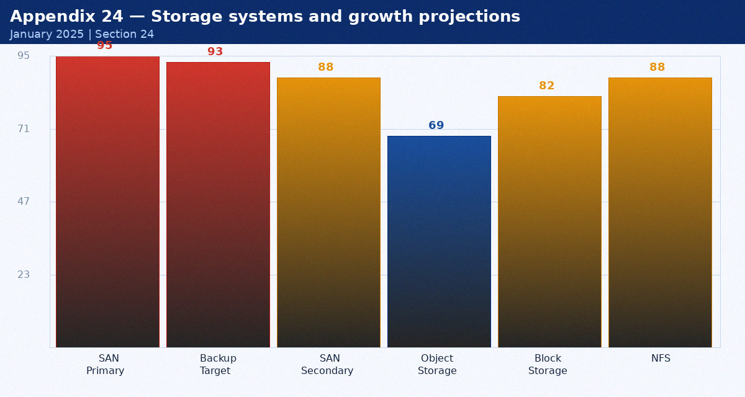
Figure 29: Storage systems and growth projections metrics

Component | Status | Last Tested | Next Action | Owner
47A | Operational | 2024-01-15 | Q2 review | Mike Torres
47B | Operational | 2024-01-20 | Q2 review | Sarah Chen
48A | Maintenance due | 2024-01-25 | Schedule review | Ravi Patel

