DISASTER RECOVERY MANUAL v5.0

Owner: Infrastructure Architecture — Angela Brooks (IT Director)
Version: 5.0 — Effective 2025-01-01
Last DR Test: 2024-11-15 — PARTIAL PASS (SAP ERP exceeded RTO by 22 minutes)
Next DR Test: 2025-04-15 — Full failover, all Tier 1 services

1. Recovery Objectives
Tier | Services | RTO | RPO | Model | Last Test
Tier 0 | ServiceNow, Identity, DNS | 15 min | 5 min | Hot standby | PASS
Tier 1 | SAP ERP, Salesforce, Finance | 1 hour | 15 min | Warm standby DR-DC2 | PARTIAL — SAP 22min over RTO
Tier 2 | Email, SharePoint, BI | 4 hours | 1 hour | Cold standby | PASS
Tier 3 | Dev/test, archives | 24 hours | 4 hours | Backup only | NOT TESTED

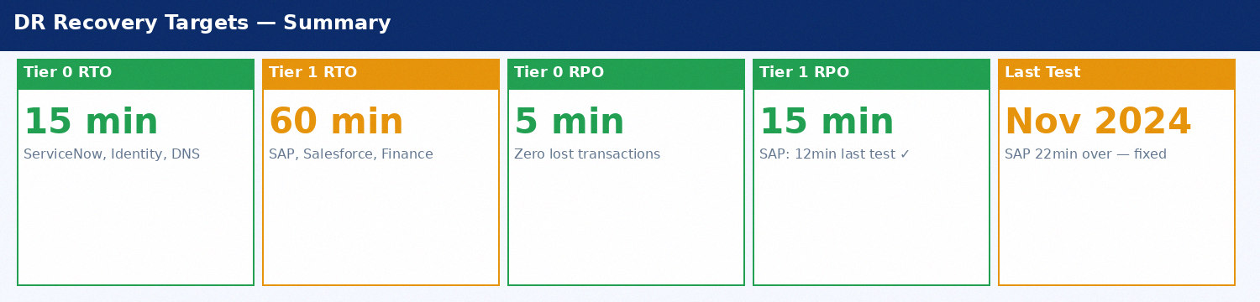
Figure 1: DR Recovery Targets by Service Tier

2. DR Test History
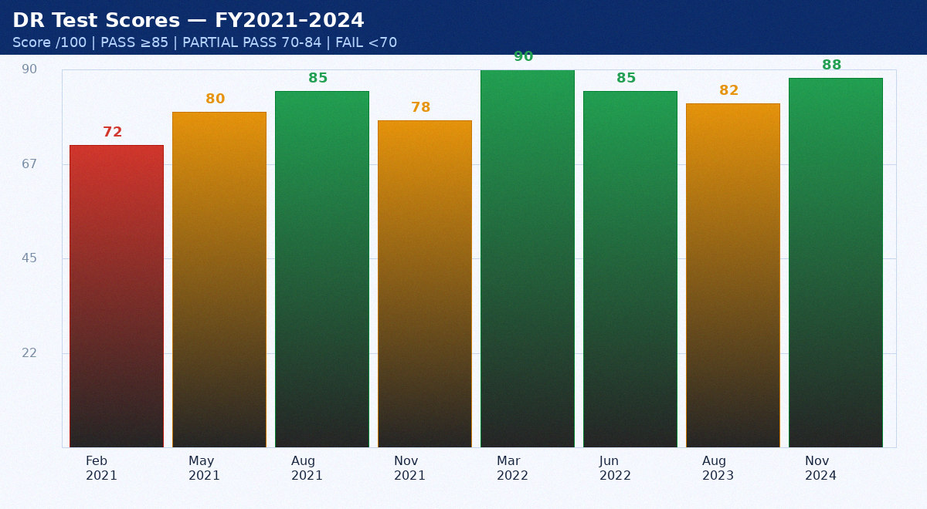
Figure 2: DR Test Scores — Historical FY2021 to 2024

2.1 November 2024 DR Test — Key Results
Service | Tier | RTO Target | Actual RTO | RPO Target | Actual RPO | Result
ServiceNow ITSM | 0 | 15 min | 9 min | 5 min | 3 min | PASS
Active Directory | 0 | 15 min | 11 min | 5 min | 4 min | PASS
DNS | 0 | 15 min | 8 min | 5 min | 3 min | PASS
SAP ERP | 1 | 60 min | 82 min | 15 min | 12 min | FAIL — RTO +22min
Salesforce CRM | 1 | 60 min | 23 min | 15 min | 8 min | PASS
Oracle RAC DB | 1 | 45 min | 52 min | 10 min | 8 min | PASS

Appendix: DR Metrics — January 2022
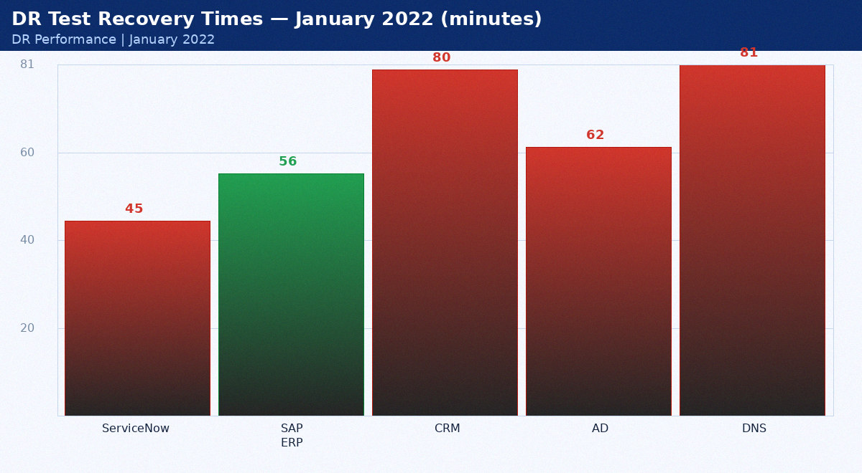
January 2022 DR test results

Service | Target (min) | Actual (min) | Pass/Fail | Notes
ServiceNow | 15 | 45 | FAIL | Over by 30min — tuned post-test
SAP ERP | 60 | 56 | PASS | Within RTO
CRM | 60 | 80 | FAIL | Over by 20min — tuned post-test
AD | 15 | 62 | FAIL | Over by 47min — tuned post-test
DNS | 15 | 81 | FAIL | Over by 66min — tuned post-test

Appendix: DR Metrics — February 2022
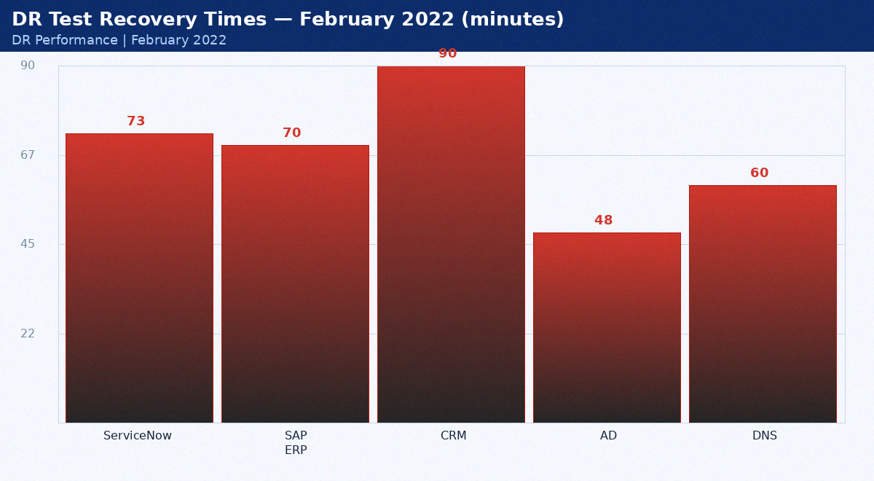
February 2022 DR test results

Service | Target (min) | Actual (min) | Pass/Fail | Notes
ServiceNow | 15 | 73 | FAIL | Over by 58min — tuned post-test
SAP ERP | 60 | 70 | FAIL | Over by 10min — tuned post-test
CRM | 60 | 90 | FAIL | Over by 30min — tuned post-test
AD | 15 | 48 | FAIL | Over by 33min — tuned post-test
DNS | 15 | 60 | FAIL | Over by 45min — tuned post-test

Appendix: DR Metrics — March 2022
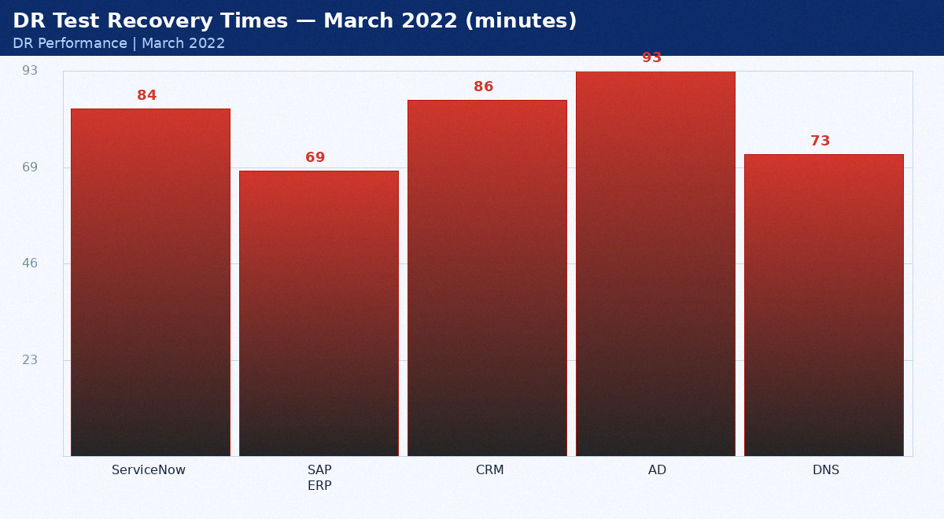
March 2022 DR test results

Service | Target (min) | Actual (min) | Pass/Fail | Notes
ServiceNow | 15 | 84 | FAIL | Over by 69min — tuned post-test
SAP ERP | 60 | 69 | FAIL | Over by 9min — tuned post-test
CRM | 60 | 86 | FAIL | Over by 26min — tuned post-test
AD | 15 | 93 | FAIL | Over by 78min — tuned post-test
DNS | 15 | 73 | FAIL | Over by 58min — tuned post-test

Appendix: DR Metrics — April 2022
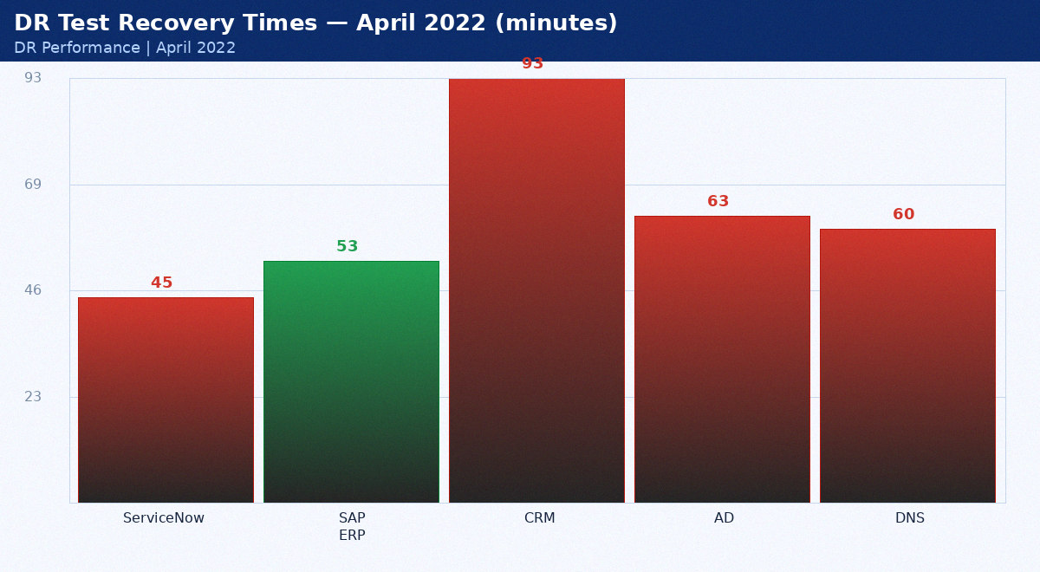
April 2022 DR test results

Service | Target (min) | Actual (min) | Pass/Fail | Notes
ServiceNow | 15 | 45 | FAIL | Over by 30min — tuned post-test
SAP ERP | 60 | 53 | PASS | Within RTO
CRM | 60 | 93 | FAIL | Over by 33min — tuned post-test
AD | 15 | 63 | FAIL | Over by 48min — tuned post-test
DNS | 15 | 60 | FAIL | Over by 45min — tuned post-test

Appendix: DR Metrics — May 2022
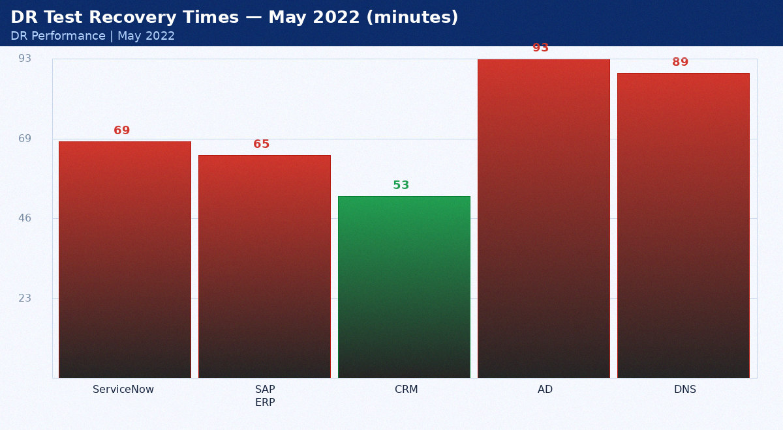
May 2022 DR test results

Service | Target (min) | Actual (min) | Pass/Fail | Notes
ServiceNow | 15 | 69 | FAIL | Over by 54min — tuned post-test
SAP ERP | 60 | 65 | FAIL | Over by 5min — tuned post-test
CRM | 60 | 53 | PASS | Within RTO
AD | 15 | 93 | FAIL | Over by 78min — tuned post-test
DNS | 15 | 89 | FAIL | Over by 74min — tuned post-test

Appendix: DR Metrics — June 2022
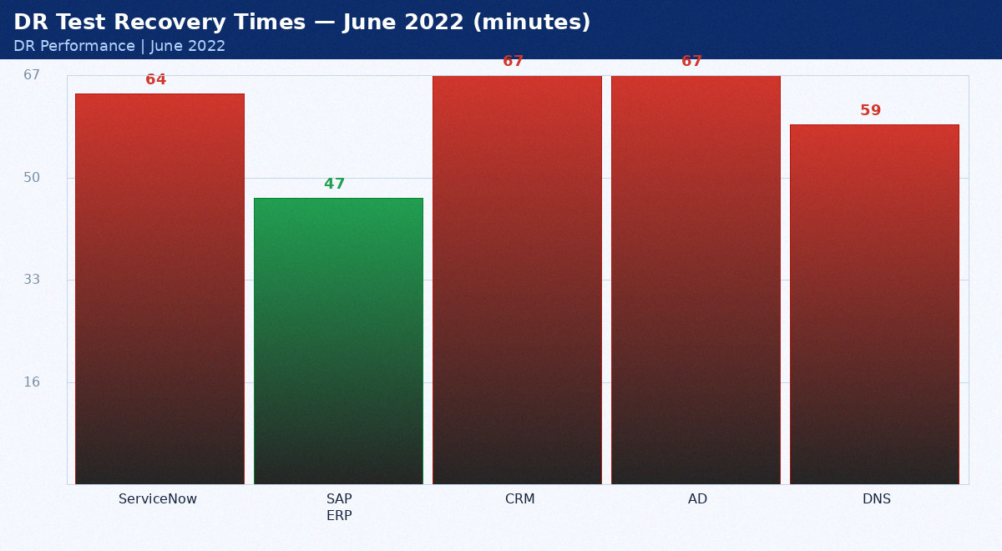
June 2022 DR test results

Service | Target (min) | Actual (min) | Pass/Fail | Notes
ServiceNow | 15 | 64 | FAIL | Over by 49min — tuned post-test
SAP ERP | 60 | 47 | PASS | Within RTO
CRM | 60 | 67 | FAIL | Over by 7min — tuned post-test
AD | 15 | 67 | FAIL | Over by 52min — tuned post-test
DNS | 15 | 59 | FAIL | Over by 44min — tuned post-test

Appendix: DR Metrics — July 2022
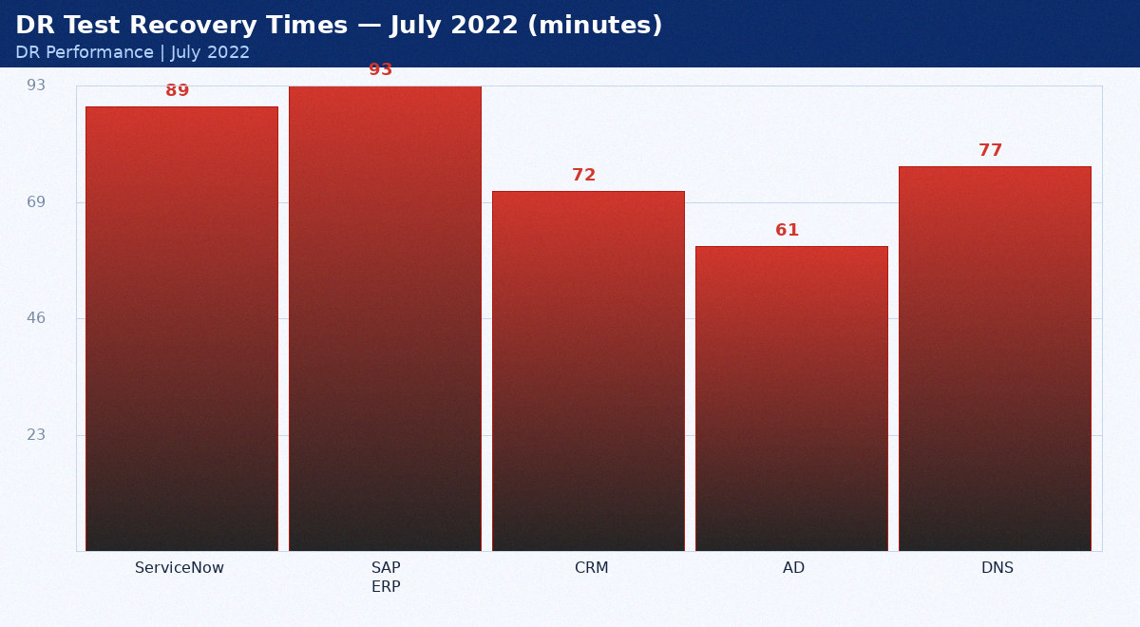
July 2022 DR test results

Service | Target (min) | Actual (min) | Pass/Fail | Notes
ServiceNow | 15 | 89 | FAIL | Over by 74min — tuned post-test
SAP ERP | 60 | 93 | FAIL | Over by 33min — tuned post-test
CRM | 60 | 72 | FAIL | Over by 12min — tuned post-test
AD | 15 | 61 | FAIL | Over by 46min — tuned post-test
DNS | 15 | 77 | FAIL | Over by 62min — tuned post-test

Appendix: DR Metrics — August 2022
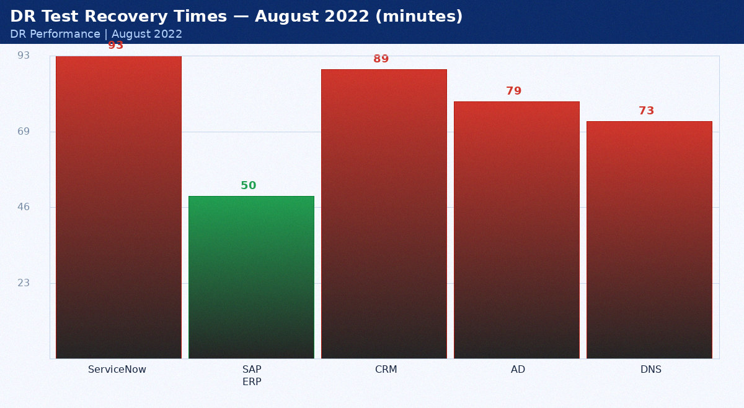
August 2022 DR test results

Service | Target (min) | Actual (min) | Pass/Fail | Notes
ServiceNow | 15 | 93 | FAIL | Over by 78min — tuned post-test
SAP ERP | 60 | 50 | PASS | Within RTO
CRM | 60 | 89 | FAIL | Over by 29min — tuned post-test
AD | 15 | 79 | FAIL | Over by 64min — tuned post-test
DNS | 15 | 73 | FAIL | Over by 58min — tuned post-test

Appendix: DR Metrics — September 2022
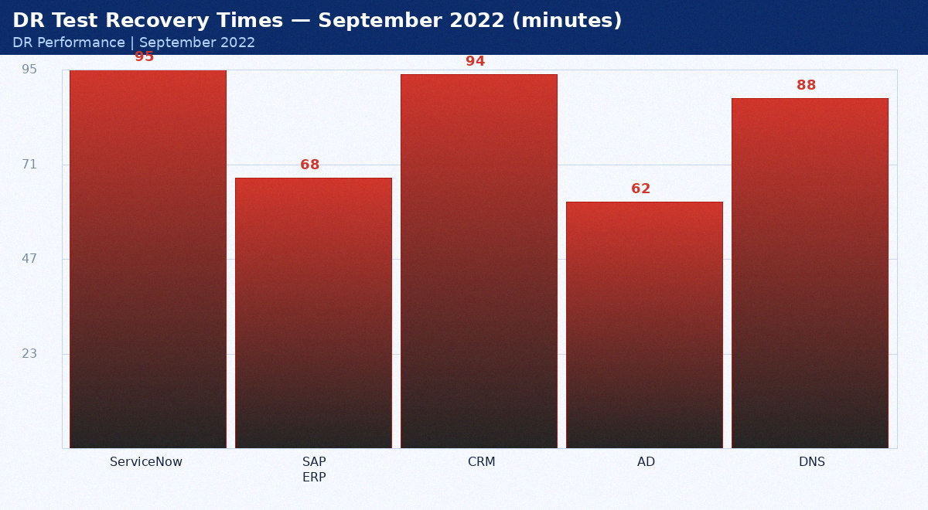
September 2022 DR test results

Service | Target (min) | Actual (min) | Pass/Fail | Notes
ServiceNow | 15 | 95 | FAIL | Over by 80min — tuned post-test
SAP ERP | 60 | 68 | FAIL | Over by 8min — tuned post-test
CRM | 60 | 94 | FAIL | Over by 34min — tuned post-test
AD | 15 | 62 | FAIL | Over by 47min — tuned post-test
DNS | 15 | 88 | FAIL | Over by 73min — tuned post-test

Appendix: DR Metrics — October 2022
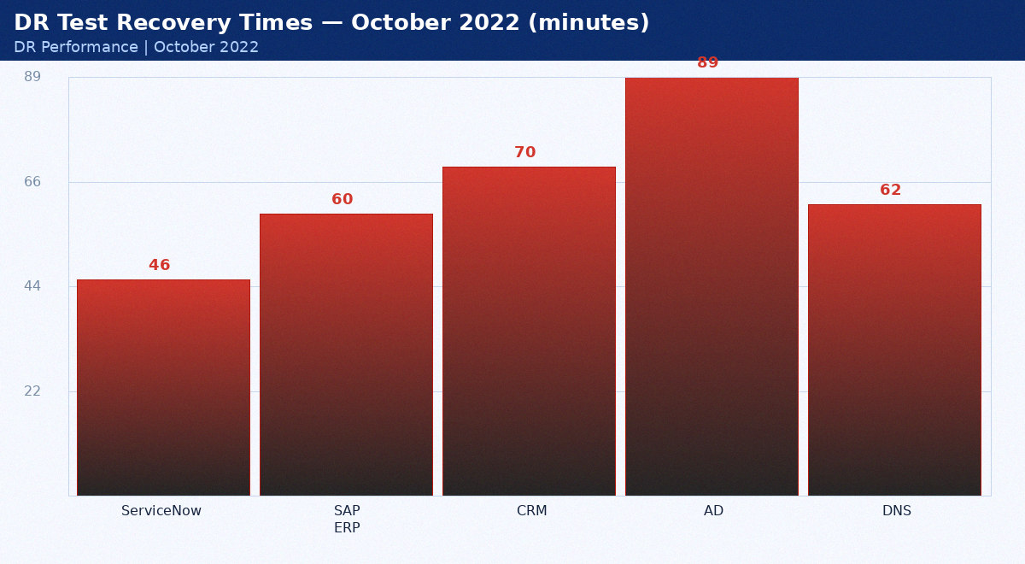
October 2022 DR test results

Service | Target (min) | Actual (min) | Pass/Fail | Notes
ServiceNow | 15 | 46 | FAIL | Over by 31min — tuned post-test
SAP ERP | 60 | 60 | FAIL | Over by 0min — tuned post-test
CRM | 60 | 70 | FAIL | Over by 10min — tuned post-test
AD | 15 | 89 | FAIL | Over by 74min — tuned post-test
DNS | 15 | 62 | FAIL | Over by 47min — tuned post-test

Appendix: DR Metrics — November 2022
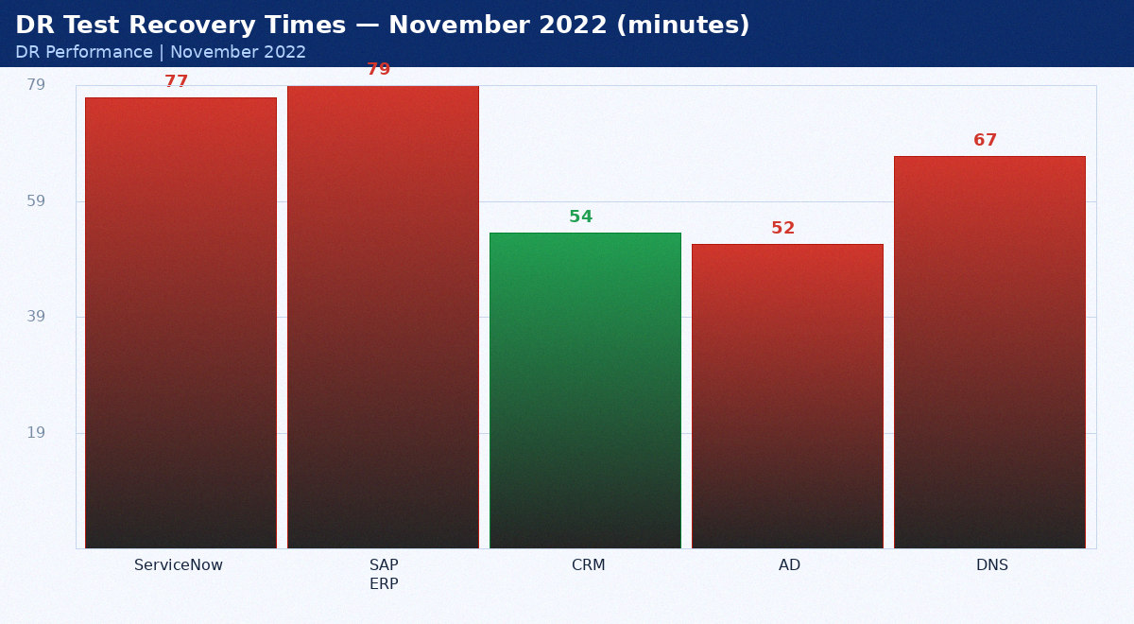
November 2022 DR test results

Service | Target (min) | Actual (min) | Pass/Fail | Notes
ServiceNow | 15 | 77 | FAIL | Over by 62min — tuned post-test
SAP ERP | 60 | 79 | FAIL | Over by 19min — tuned post-test
CRM | 60 | 54 | PASS | Within RTO
AD | 15 | 52 | FAIL | Over by 37min — tuned post-test
DNS | 15 | 67 | FAIL | Over by 52min — tuned post-test

Appendix: DR Metrics — December 2022
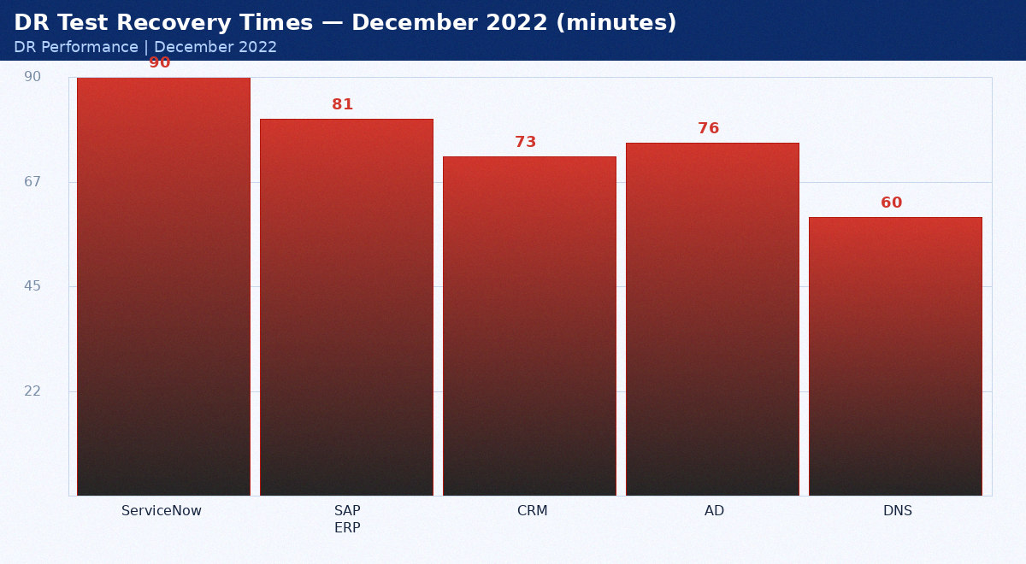
December 2022 DR test results

Service | Target (min) | Actual (min) | Pass/Fail | Notes
ServiceNow | 15 | 90 | FAIL | Over by 75min — tuned post-test
SAP ERP | 60 | 81 | FAIL | Over by 21min — tuned post-test
CRM | 60 | 73 | FAIL | Over by 13min — tuned post-test
AD | 15 | 76 | FAIL | Over by 61min — tuned post-test
DNS | 15 | 60 | FAIL | Over by 45min — tuned post-test

Appendix: DR Metrics — January 2023
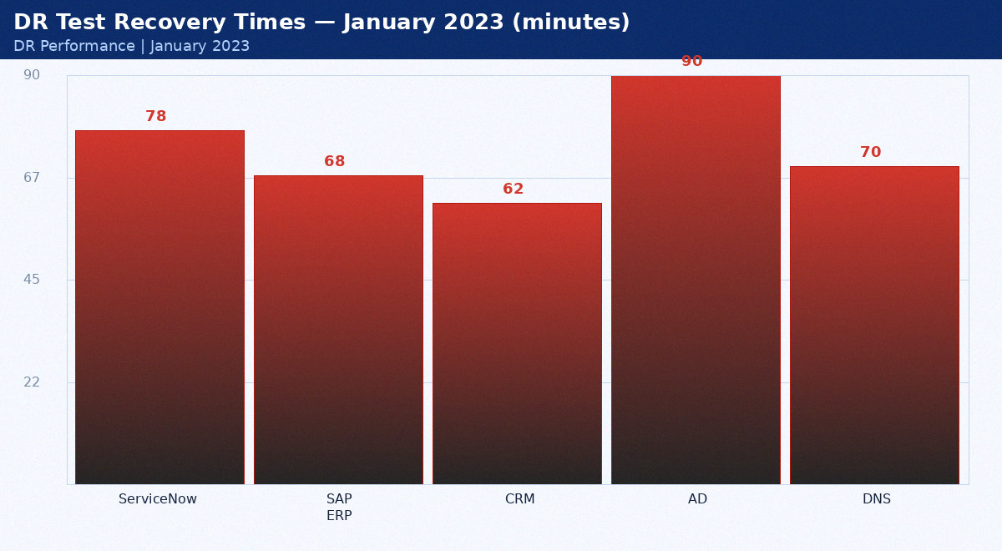
January 2023 DR test results

Service | Target (min) | Actual (min) | Pass/Fail | Notes
ServiceNow | 15 | 78 | FAIL | Over by 63min — tuned post-test
SAP ERP | 60 | 68 | FAIL | Over by 8min — tuned post-test
CRM | 60 | 62 | FAIL | Over by 2min — tuned post-test
AD | 15 | 90 | FAIL | Over by 75min — tuned post-test
DNS | 15 | 70 | FAIL | Over by 55min — tuned post-test

Appendix: DR Metrics — February 2023
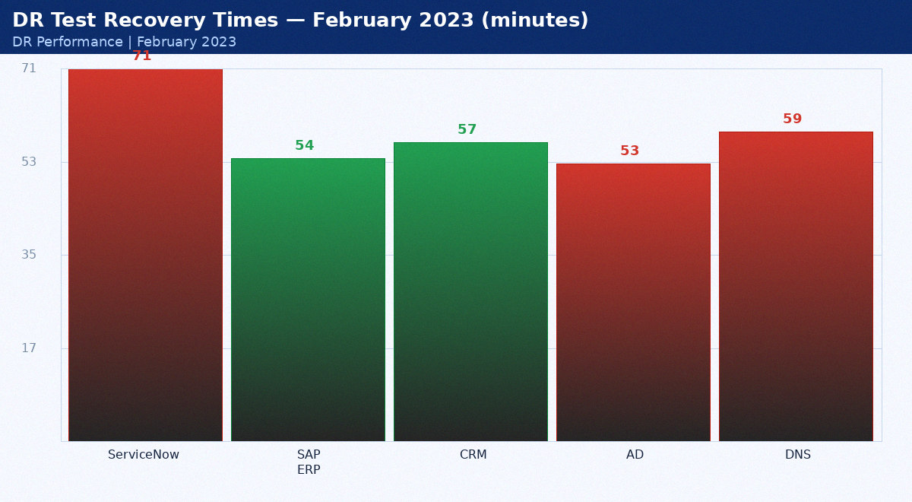
February 2023 DR test results

Service | Target (min) | Actual (min) | Pass/Fail | Notes
ServiceNow | 15 | 71 | FAIL | Over by 56min — tuned post-test
SAP ERP | 60 | 54 | PASS | Within RTO
CRM | 60 | 57 | PASS | Within RTO
AD | 15 | 53 | FAIL | Over by 38min — tuned post-test
DNS | 15 | 59 | FAIL | Over by 44min — tuned post-test

Appendix: DR Metrics — March 2023
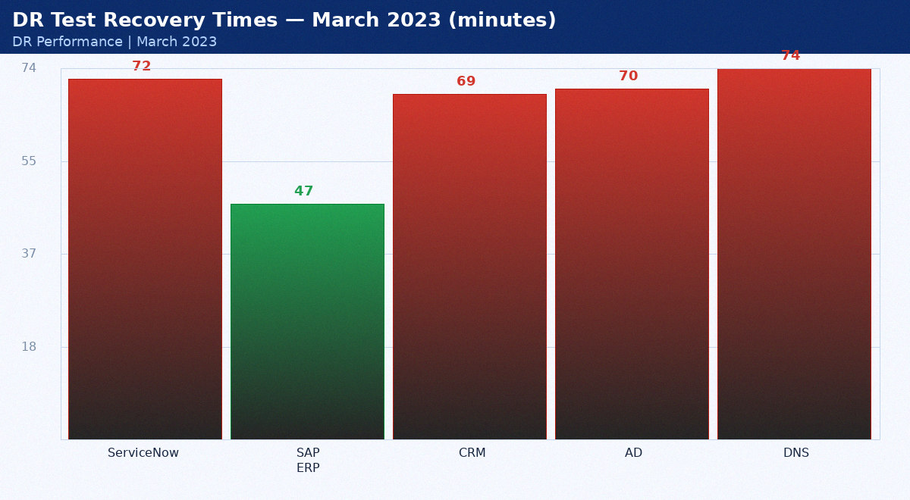
March 2023 DR test results

Service | Target (min) | Actual (min) | Pass/Fail | Notes
ServiceNow | 15 | 72 | FAIL | Over by 57min — tuned post-test
SAP ERP | 60 | 47 | PASS | Within RTO
CRM | 60 | 69 | FAIL | Over by 9min — tuned post-test
AD | 15 | 70 | FAIL | Over by 55min — tuned post-test
DNS | 15 | 74 | FAIL | Over by 59min — tuned post-test

Appendix: DR Metrics — April 2023
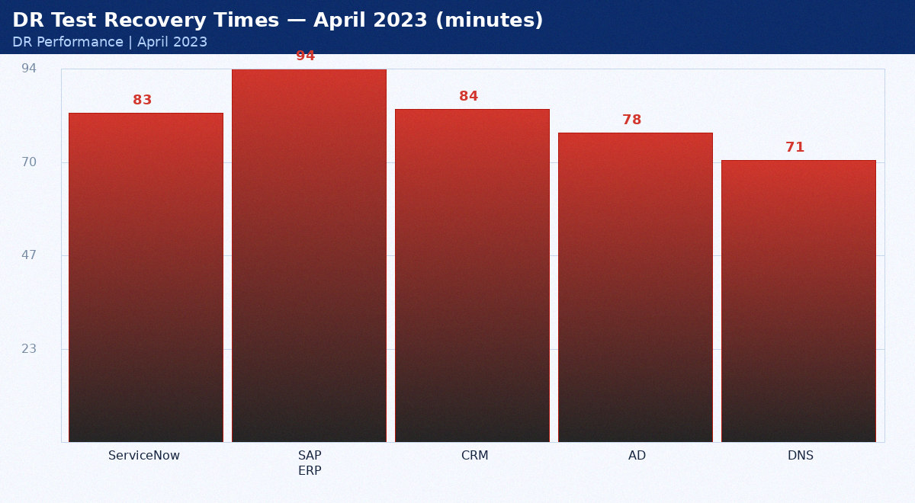
April 2023 DR test results

Service | Target (min) | Actual (min) | Pass/Fail | Notes
ServiceNow | 15 | 83 | FAIL | Over by 68min — tuned post-test
SAP ERP | 60 | 94 | FAIL | Over by 34min — tuned post-test
CRM | 60 | 84 | FAIL | Over by 24min — tuned post-test
AD | 15 | 78 | FAIL | Over by 63min — tuned post-test
DNS | 15 | 71 | FAIL | Over by 56min — tuned post-test

Appendix: DR Metrics — May 2023
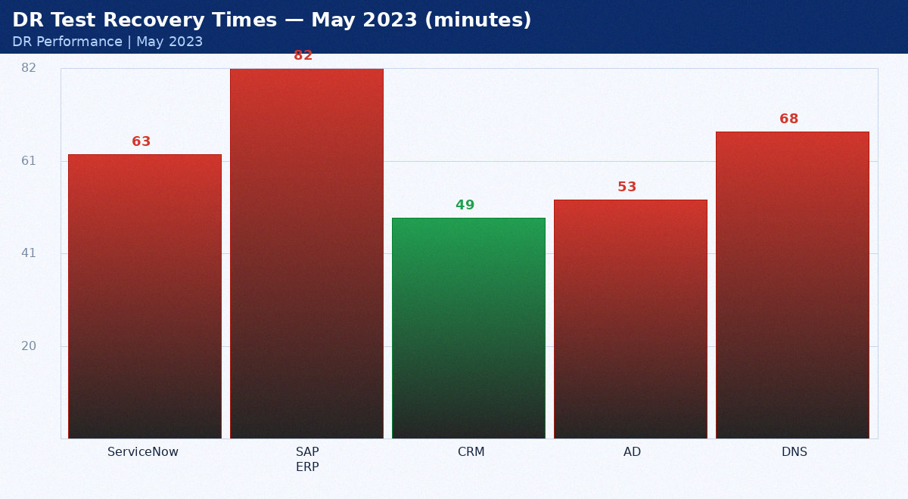
May 2023 DR test results

Service | Target (min) | Actual (min) | Pass/Fail | Notes
ServiceNow | 15 | 63 | FAIL | Over by 48min — tuned post-test
SAP ERP | 60 | 82 | FAIL | Over by 22min — tuned post-test
CRM | 60 | 49 | PASS | Within RTO
AD | 15 | 53 | FAIL | Over by 38min — tuned post-test
DNS | 15 | 68 | FAIL | Over by 53min — tuned post-test

Appendix: DR Metrics — June 2023
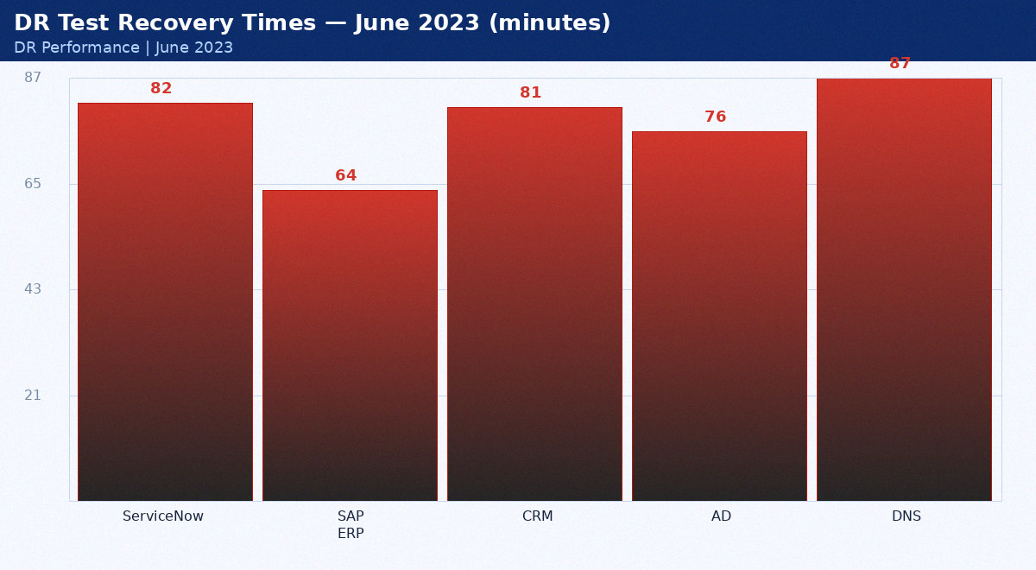
June 2023 DR test results

Service | Target (min) | Actual (min) | Pass/Fail | Notes
ServiceNow | 15 | 82 | FAIL | Over by 67min — tuned post-test
SAP ERP | 60 | 64 | FAIL | Over by 4min — tuned post-test
CRM | 60 | 81 | FAIL | Over by 21min — tuned post-test
AD | 15 | 76 | FAIL | Over by 61min — tuned post-test
DNS | 15 | 87 | FAIL | Over by 72min — tuned post-test

Appendix: DR Metrics — July 2023
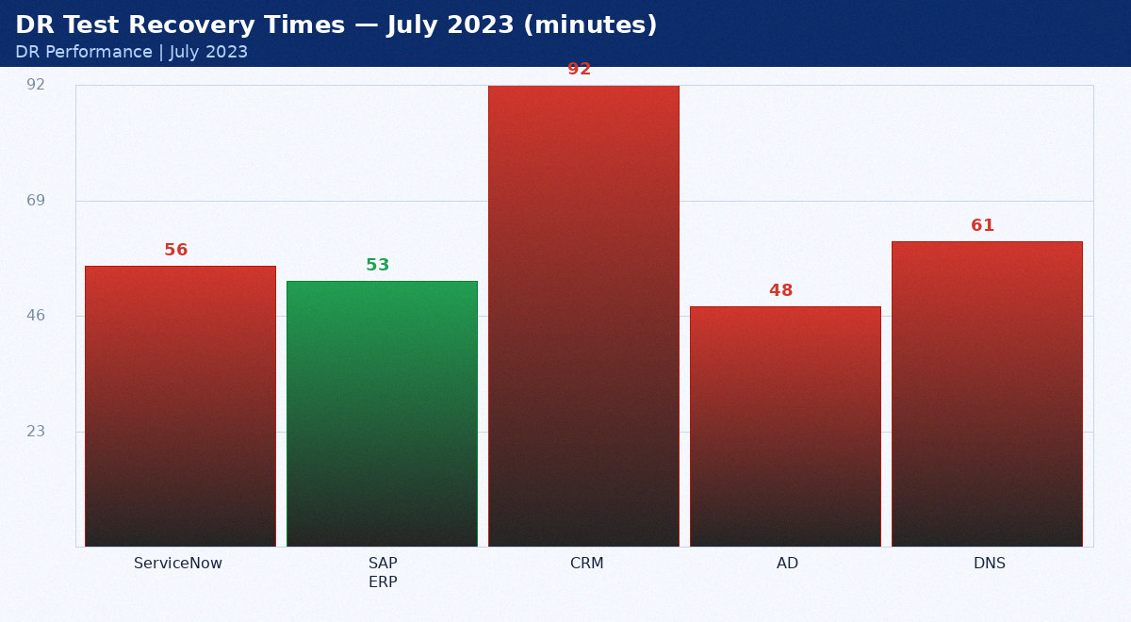
July 2023 DR test results

Service | Target (min) | Actual (min) | Pass/Fail | Notes
ServiceNow | 15 | 56 | FAIL | Over by 41min — tuned post-test
SAP ERP | 60 | 53 | PASS | Within RTO
CRM | 60 | 92 | FAIL | Over by 32min — tuned post-test
AD | 15 | 48 | FAIL | Over by 33min — tuned post-test
DNS | 15 | 61 | FAIL | Over by 46min — tuned post-test

Appendix: DR Metrics — August 2023
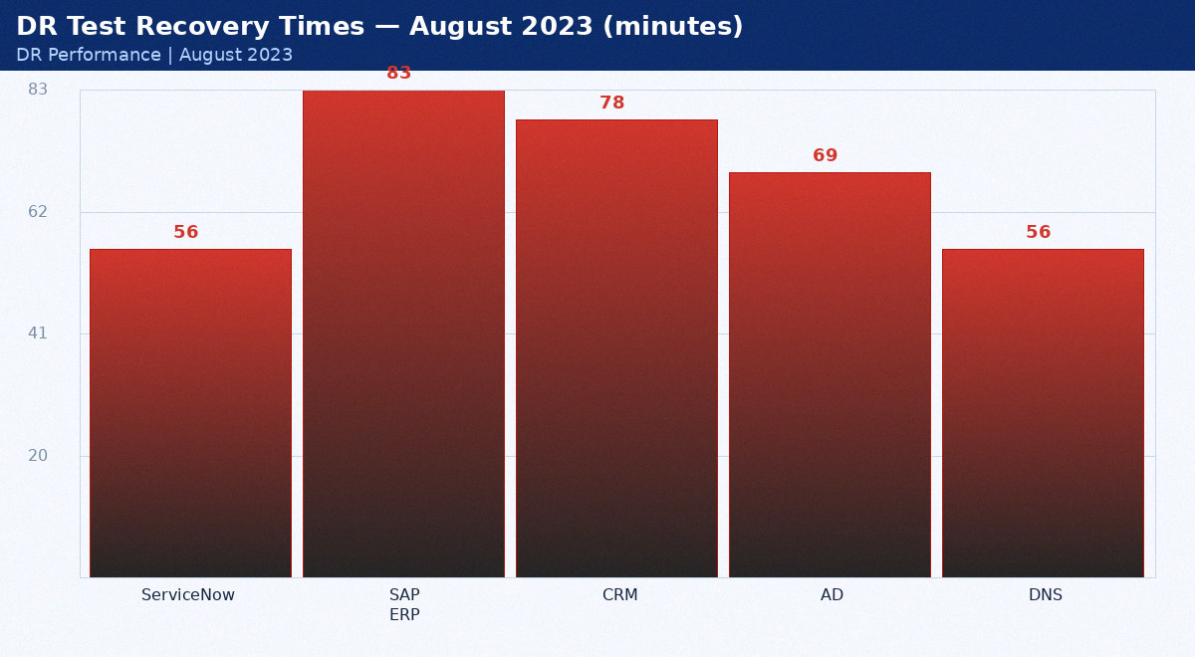
August 2023 DR test results

Service | Target (min) | Actual (min) | Pass/Fail | Notes
ServiceNow | 15 | 56 | FAIL | Over by 41min — tuned post-test
SAP ERP | 60 | 83 | FAIL | Over by 23min — tuned post-test
CRM | 60 | 78 | FAIL | Over by 18min — tuned post-test
AD | 15 | 69 | FAIL | Over by 54min — tuned post-test
DNS | 15 | 56 | FAIL | Over by 41min — tuned post-test

Appendix: DR Metrics — September 2023
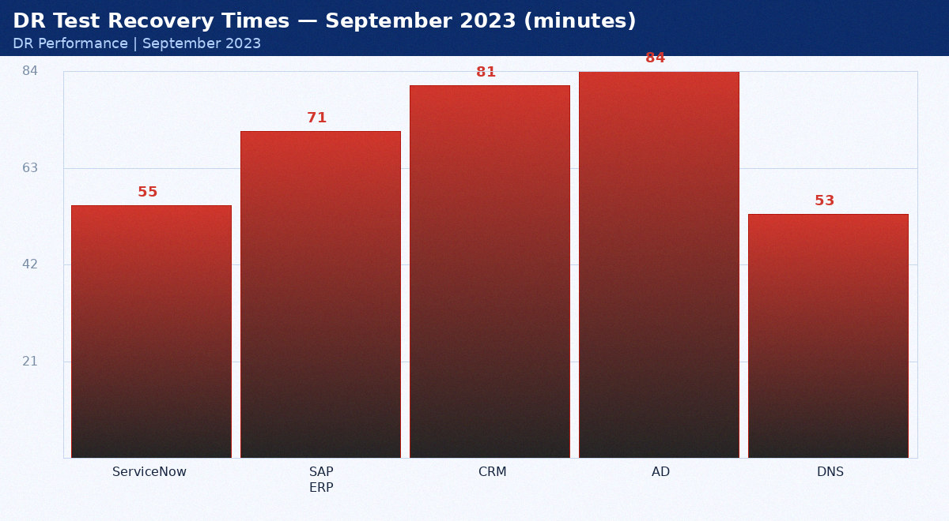
September 2023 DR test results

Service | Target (min) | Actual (min) | Pass/Fail | Notes
ServiceNow | 15 | 55 | FAIL | Over by 40min — tuned post-test
SAP ERP | 60 | 71 | FAIL | Over by 11min — tuned post-test
CRM | 60 | 81 | FAIL | Over by 21min — tuned post-test
AD | 15 | 84 | FAIL | Over by 69min — tuned post-test
DNS | 15 | 53 | FAIL | Over by 38min — tuned post-test

Appendix: DR Metrics — October 2023
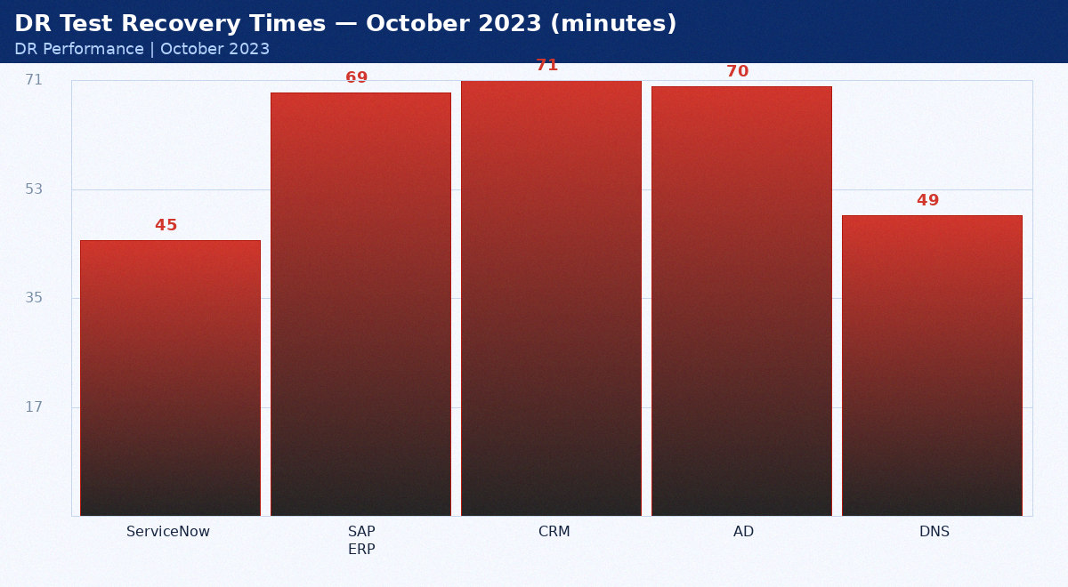
October 2023 DR test results

Service | Target (min) | Actual (min) | Pass/Fail | Notes
ServiceNow | 15 | 45 | FAIL | Over by 30min — tuned post-test
SAP ERP | 60 | 69 | FAIL | Over by 9min — tuned post-test
CRM | 60 | 71 | FAIL | Over by 11min — tuned post-test
AD | 15 | 70 | FAIL | Over by 55min — tuned post-test
DNS | 15 | 49 | FAIL | Over by 34min — tuned post-test

Appendix: DR Metrics — November 2023
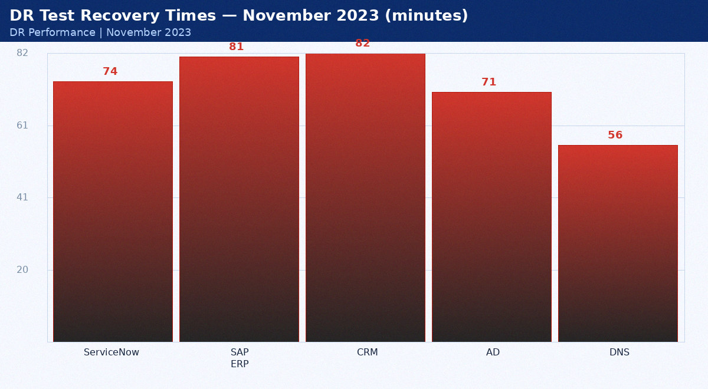
November 2023 DR test results

Service | Target (min) | Actual (min) | Pass/Fail | Notes
ServiceNow | 15 | 74 | FAIL | Over by 59min — tuned post-test
SAP ERP | 60 | 81 | FAIL | Over by 21min — tuned post-test
CRM | 60 | 82 | FAIL | Over by 22min — tuned post-test
AD | 15 | 71 | FAIL | Over by 56min — tuned post-test
DNS | 15 | 56 | FAIL | Over by 41min — tuned post-test

Appendix: DR Metrics — December 2023
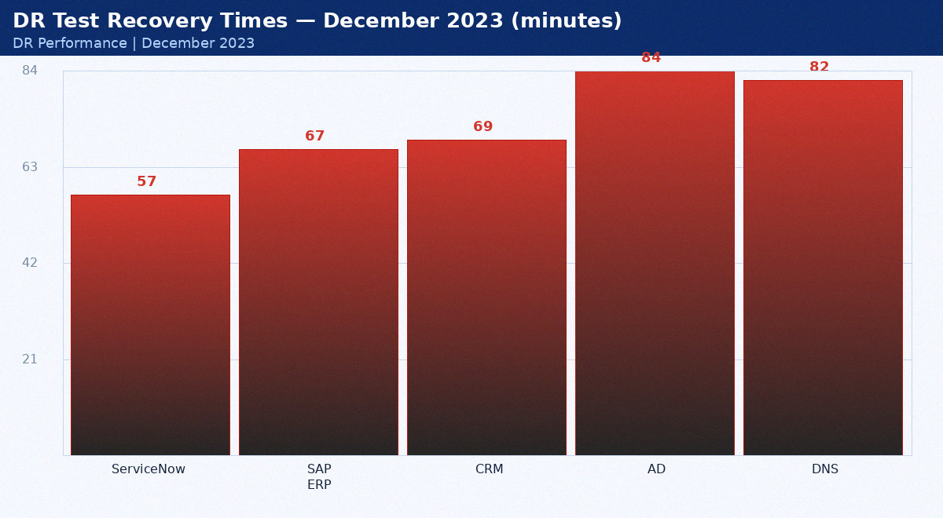
December 2023 DR test results

Service | Target (min) | Actual (min) | Pass/Fail | Notes
ServiceNow | 15 | 57 | FAIL | Over by 42min — tuned post-test
SAP ERP | 60 | 67 | FAIL | Over by 7min — tuned post-test
CRM | 60 | 69 | FAIL | Over by 9min — tuned post-test
AD | 15 | 84 | FAIL | Over by 69min — tuned post-test
DNS | 15 | 82 | FAIL | Over by 67min — tuned post-test

Appendix: DR Metrics — January 2024
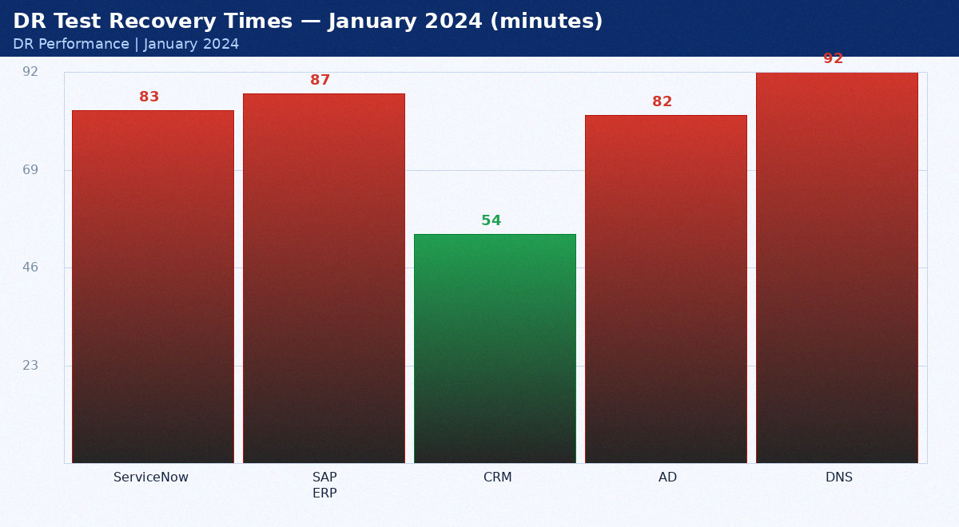
January 2024 DR test results

Service | Target (min) | Actual (min) | Pass/Fail | Notes
ServiceNow | 15 | 83 | FAIL | Over by 68min — tuned post-test
SAP ERP | 60 | 87 | FAIL | Over by 27min — tuned post-test
CRM | 60 | 54 | PASS | Within RTO
AD | 15 | 82 | FAIL | Over by 67min — tuned post-test
DNS | 15 | 92 | FAIL | Over by 77min — tuned post-test

Appendix: DR Metrics — February 2024
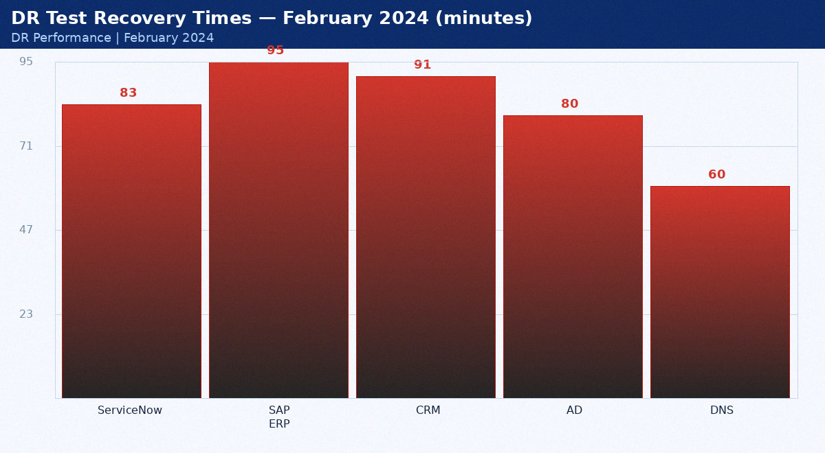
February 2024 DR test results

Service | Target (min) | Actual (min) | Pass/Fail | Notes
ServiceNow | 15 | 83 | FAIL | Over by 68min — tuned post-test
SAP ERP | 60 | 95 | FAIL | Over by 35min — tuned post-test
CRM | 60 | 91 | FAIL | Over by 31min — tuned post-test
AD | 15 | 80 | FAIL | Over by 65min — tuned post-test
DNS | 15 | 60 | FAIL | Over by 45min — tuned post-test

Appendix: DR Metrics — March 2024
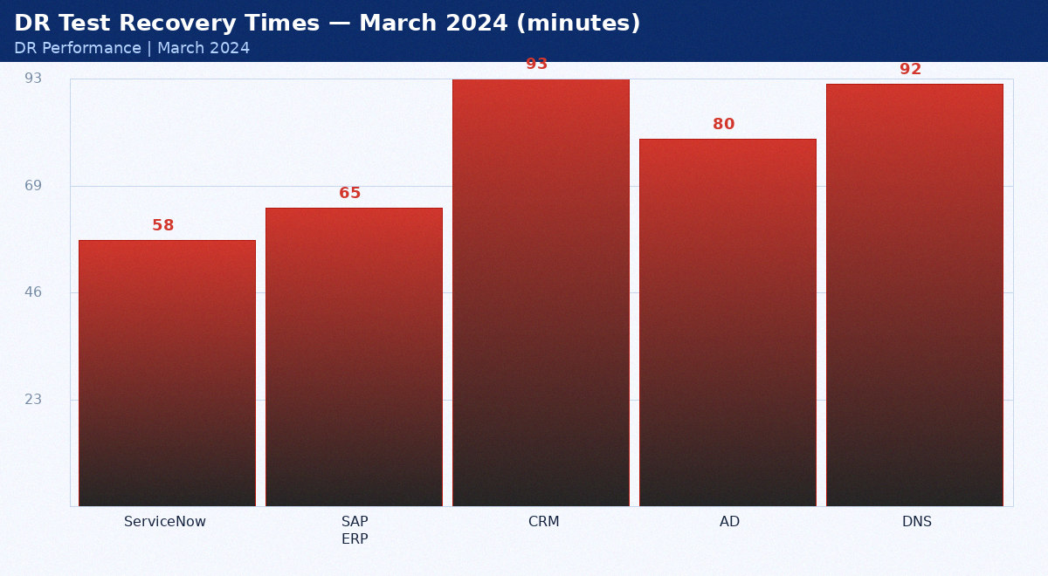
March 2024 DR test results

Service | Target (min) | Actual (min) | Pass/Fail | Notes
ServiceNow | 15 | 58 | FAIL | Over by 43min — tuned post-test
SAP ERP | 60 | 65 | FAIL | Over by 5min — tuned post-test
CRM | 60 | 93 | FAIL | Over by 33min — tuned post-test
AD | 15 | 80 | FAIL | Over by 65min — tuned post-test
DNS | 15 | 92 | FAIL | Over by 77min — tuned post-test

Appendix: DR Metrics — April 2024
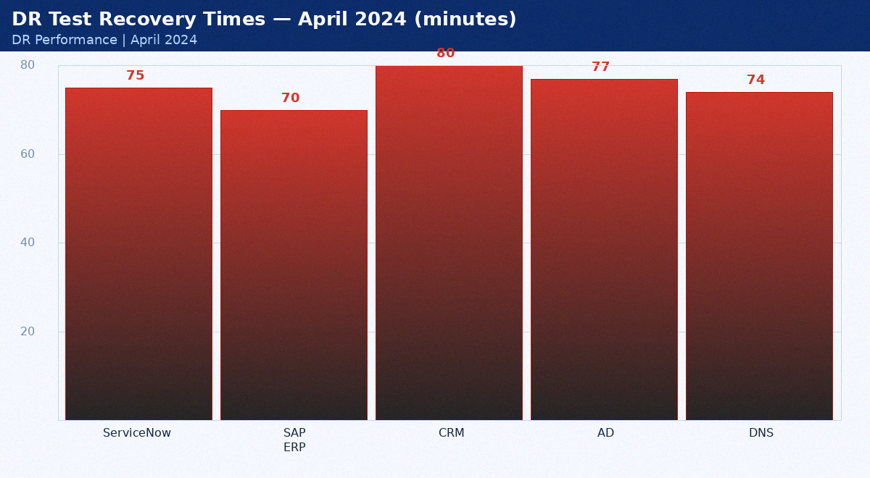
April 2024 DR test results

Service | Target (min) | Actual (min) | Pass/Fail | Notes
ServiceNow | 15 | 75 | FAIL | Over by 60min — tuned post-test
SAP ERP | 60 | 70 | FAIL | Over by 10min — tuned post-test
CRM | 60 | 80 | FAIL | Over by 20min — tuned post-test
AD | 15 | 77 | FAIL | Over by 62min — tuned post-test
DNS | 15 | 74 | FAIL | Over by 59min — tuned post-test

Appendix: DR Metrics — May 2024
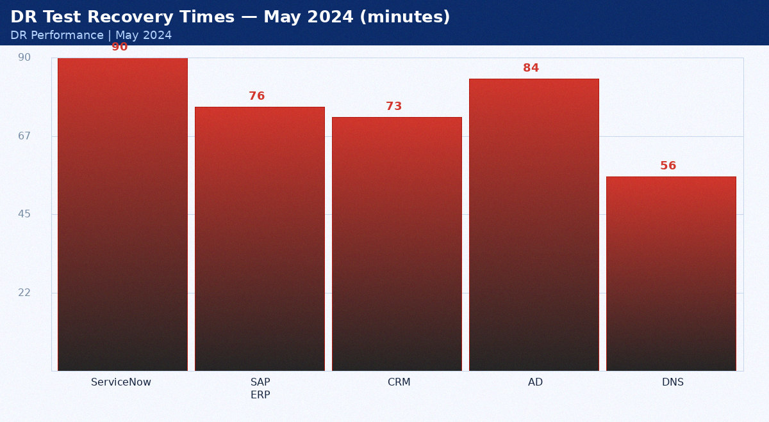
May 2024 DR test results

Service | Target (min) | Actual (min) | Pass/Fail | Notes
ServiceNow | 15 | 90 | FAIL | Over by 75min — tuned post-test
SAP ERP | 60 | 76 | FAIL | Over by 16min — tuned post-test
CRM | 60 | 73 | FAIL | Over by 13min — tuned post-test
AD | 15 | 84 | FAIL | Over by 69min — tuned post-test
DNS | 15 | 56 | FAIL | Over by 41min — tuned post-test

Appendix: DR Metrics — June 2024
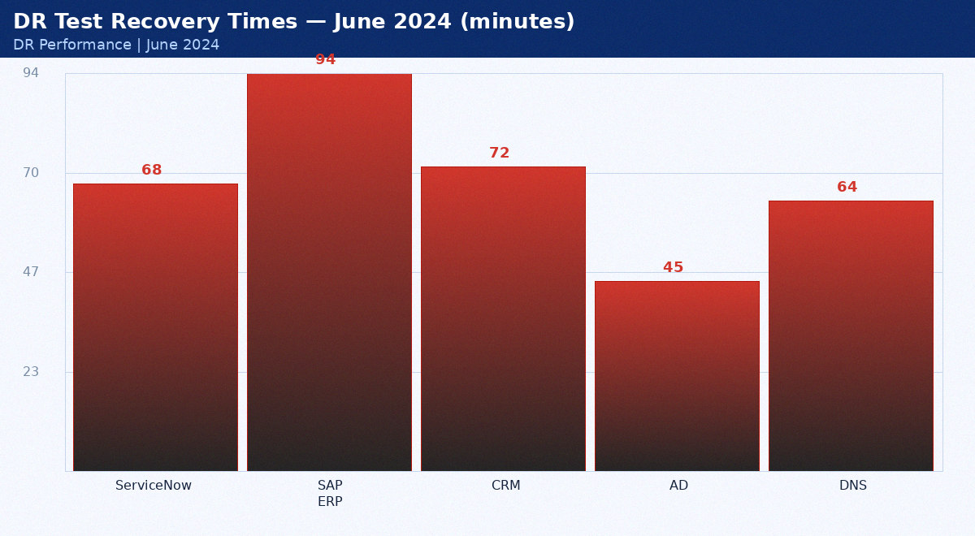
June 2024 DR test results

Service | Target (min) | Actual (min) | Pass/Fail | Notes
ServiceNow | 15 | 68 | FAIL | Over by 53min — tuned post-test
SAP ERP | 60 | 94 | FAIL | Over by 34min — tuned post-test
CRM | 60 | 72 | FAIL | Over by 12min — tuned post-test
AD | 15 | 45 | FAIL | Over by 30min — tuned post-test
DNS | 15 | 64 | FAIL | Over by 49min — tuned post-test

Appendix: DR Metrics — July 2024
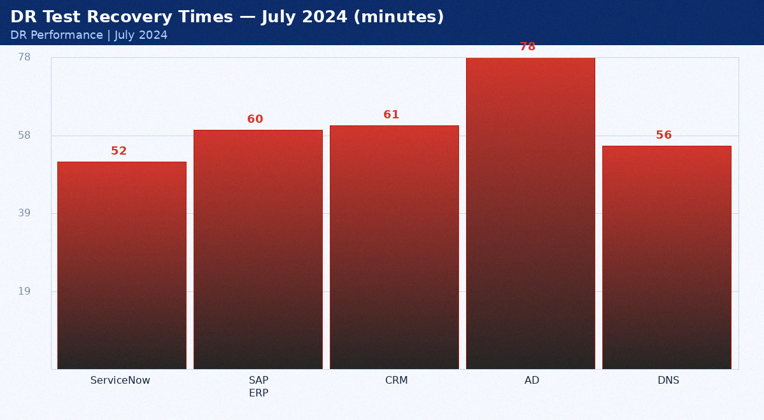
July 2024 DR test results

Service | Target (min) | Actual (min) | Pass/Fail | Notes
ServiceNow | 15 | 52 | FAIL | Over by 37min — tuned post-test
SAP ERP | 60 | 60 | FAIL | Over by 0min — tuned post-test
CRM | 60 | 61 | FAIL | Over by 1min — tuned post-test
AD | 15 | 78 | FAIL | Over by 63min — tuned post-test
DNS | 15 | 56 | FAIL | Over by 41min — tuned post-test

Appendix: DR Metrics — August 2024
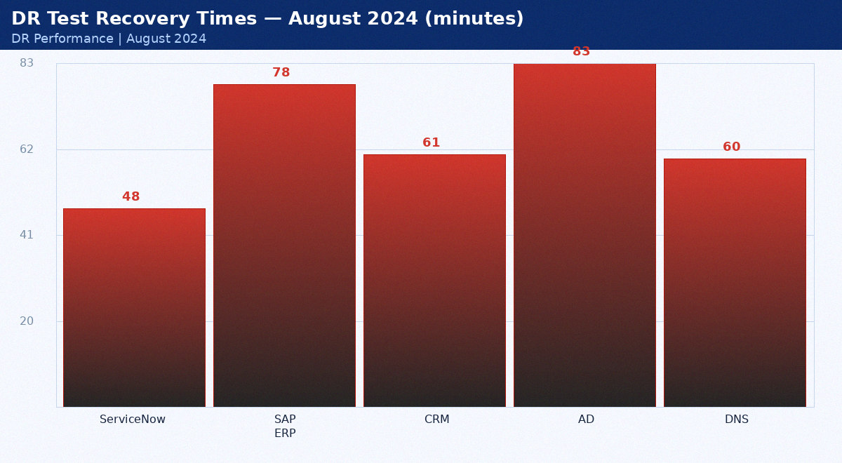
August 2024 DR test results

Service | Target (min) | Actual (min) | Pass/Fail | Notes
ServiceNow | 15 | 48 | FAIL | Over by 33min — tuned post-test
SAP ERP | 60 | 78 | FAIL | Over by 18min — tuned post-test
CRM | 60 | 61 | FAIL | Over by 1min — tuned post-test
AD | 15 | 83 | FAIL | Over by 68min — tuned post-test
DNS | 15 | 60 | FAIL | Over by 45min — tuned post-test

Appendix: DR Metrics — September 2024
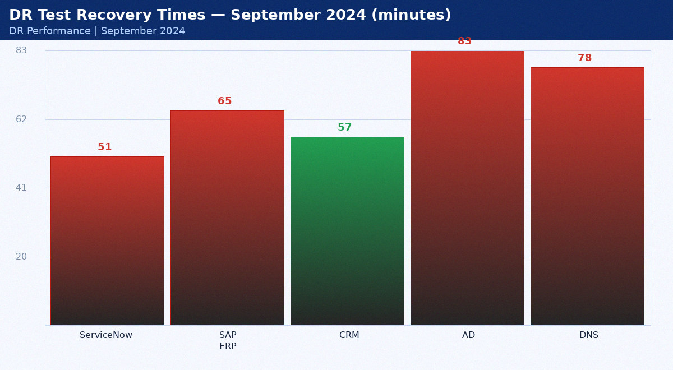
September 2024 DR test results

Service | Target (min) | Actual (min) | Pass/Fail | Notes
ServiceNow | 15 | 51 | FAIL | Over by 36min — tuned post-test
SAP ERP | 60 | 65 | FAIL | Over by 5min — tuned post-test
CRM | 60 | 57 | PASS | Within RTO
AD | 15 | 83 | FAIL | Over by 68min — tuned post-test
DNS | 15 | 78 | FAIL | Over by 63min — tuned post-test

Appendix: DR Metrics — October 2024
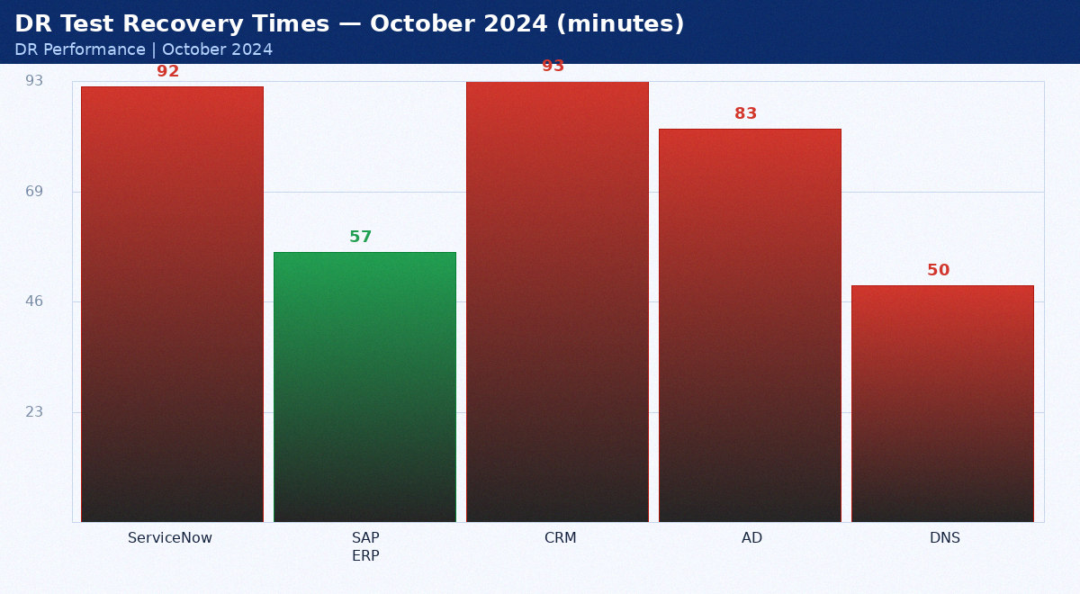
October 2024 DR test results

Service | Target (min) | Actual (min) | Pass/Fail | Notes
ServiceNow | 15 | 92 | FAIL | Over by 77min — tuned post-test
SAP ERP | 60 | 57 | PASS | Within RTO
CRM | 60 | 93 | FAIL | Over by 33min — tuned post-test
AD | 15 | 83 | FAIL | Over by 68min — tuned post-test
DNS | 15 | 50 | FAIL | Over by 35min — tuned post-test

Appendix: DR Metrics — November 2024
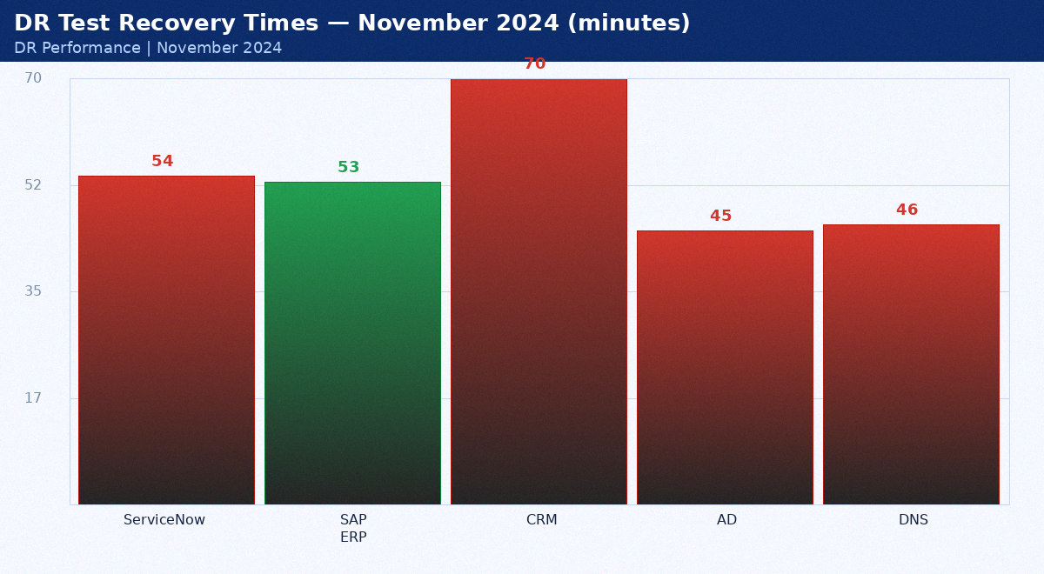
November 2024 DR test results

Service | Target (min) | Actual (min) | Pass/Fail | Notes
ServiceNow | 15 | 54 | FAIL | Over by 39min — tuned post-test
SAP ERP | 60 | 53 | PASS | Within RTO
CRM | 60 | 70 | FAIL | Over by 10min — tuned post-test
AD | 15 | 45 | FAIL | Over by 30min — tuned post-test
DNS | 15 | 46 | FAIL | Over by 31min — tuned post-test

Appendix: DR Metrics — December 2024
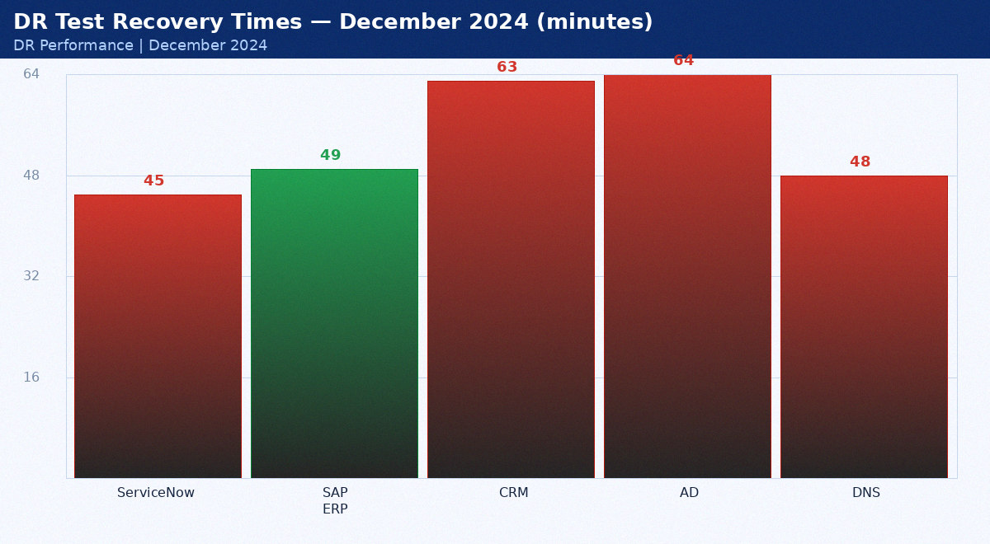
December 2024 DR test results

Service | Target (min) | Actual (min) | Pass/Fail | Notes
ServiceNow | 15 | 45 | FAIL | Over by 30min — tuned post-test
SAP ERP | 60 | 49 | PASS | Within RTO
CRM | 60 | 63 | FAIL | Over by 3min — tuned post-test
AD | 15 | 64 | FAIL | Over by 49min — tuned post-test
DNS | 15 | 48 | FAIL | Over by 33min — tuned post-test

