DISASTER RECOVERY PLAN v5.0

Document Owner: Infrastructure Architecture
Version: 5.0 — Effective 2025-01-01
Classification: CONFIDENTIAL — IT Leadership Distribution Only
Last DR Test: 2024-11-15 — PARTIAL PASS (SAP ERP exceeded RTO by 22 minutes)
Next DR Test: 2025-04-15 — Full failover, all Tier 1 services

1. Recovery Objectives
Tier | Services | RTO | RPO | Model | Last Test
Tier 0 | ServiceNow, Identity, DNS | 15 min | 5 min | Hot standby | PASS
Tier 1 | SAP ERP, Salesforce, Finance | 1 hour | 15 min | Warm standby DR-DC2 | PARTIAL — SAP 22min over RTO
Tier 2 | Email, SharePoint, BI | 4 hours | 1 hour | Cold standby | PASS
Tier 3 | Non-critical, dev/test | 24 hours | 4 hours | Backup only | NOT TESTED

2. Activation Criteria
Condition | Threshold | Authority | Notify Within
Primary DC unavailable | Outage projected > 2 hours | CTO or Deputy CTO | 15 minutes
Ransomware confirmed | Active infection > 20% production | CTO + CISO | Immediately
Unrecoverable data | Any Tier 0 or Tier 1 system | CTO | Immediately
Cloud provider outage | Sustained > 4 hours multi-AZ | IT Director | 30 minutes
Physical security breach | Infrastructure integrity compromised | CTO + Security | Immediately

3. Crisis Management Team
Role | Name | Contact | Responsibility
Incident Commander / CTO | James Wu | james.wu@co.com +1-555-0100 | Final DRP authority, board briefing, external comms
IT Director | Angela Brooks | angela.b@co.com +1-555-0101 | Recovery coordination, budget management
Network Recovery Lead | Mike Torres | mike.t@co.com +1-555-0142 | Activates DR routing via Ansible, verifies BGP convergence and DNS
Database Recovery Lead | Sarah Chen | sarah.c@co.com +1-555-0156 | Oracle Data Guard failover, RPO validation, data integrity
App Recovery Lead | Ravi Patel | ravi.p@co.com +1-555-0167 | Tier 1 application restores, business function validation
CISO | David Kim | david.k@co.com +1-555-0134 | Security posture during recovery, access authorisation

4. ServiceNow Recovery Procedure (Tier 0)
Step | Action | Tool / Command | Duration | Go/No-Go Criterion
1 | Declare DR to ServiceNow HI | Log into hi.service-now.com — DR Activation — code: DR-2025-ACTIVE | 5 min | Confirmation from vendor within 5 min
2 | Verify DR pre-conditions | Check DR site health dashboard — all prerequisites green | 10 min | All green — proceed; any red — escalate
3 | Initiate ServiceNow failover | ./dr-failover.sh --service servicenow | 15 min | Service accessible at DR URL within 30 min
4 | Validate data integrity | ./validate-dr.sh --service servicenow | 10 min | Record count within 0.1% of production baseline
5 | Redirect traffic to DR | Update DNS CNAME — TTL 60s — propagation 5 min | 8 min | All monitoring checks green on DR instance
6 | Notify stakeholders | Send via ServiceNow Major Incident template | 5 min | All affected users and management notified

5. DR Test History — Charts and Analytics
The following charts summarise DR test performance across FY2022-2024. Each chart shows actual measured RTO and RPO values from quarterly tests.
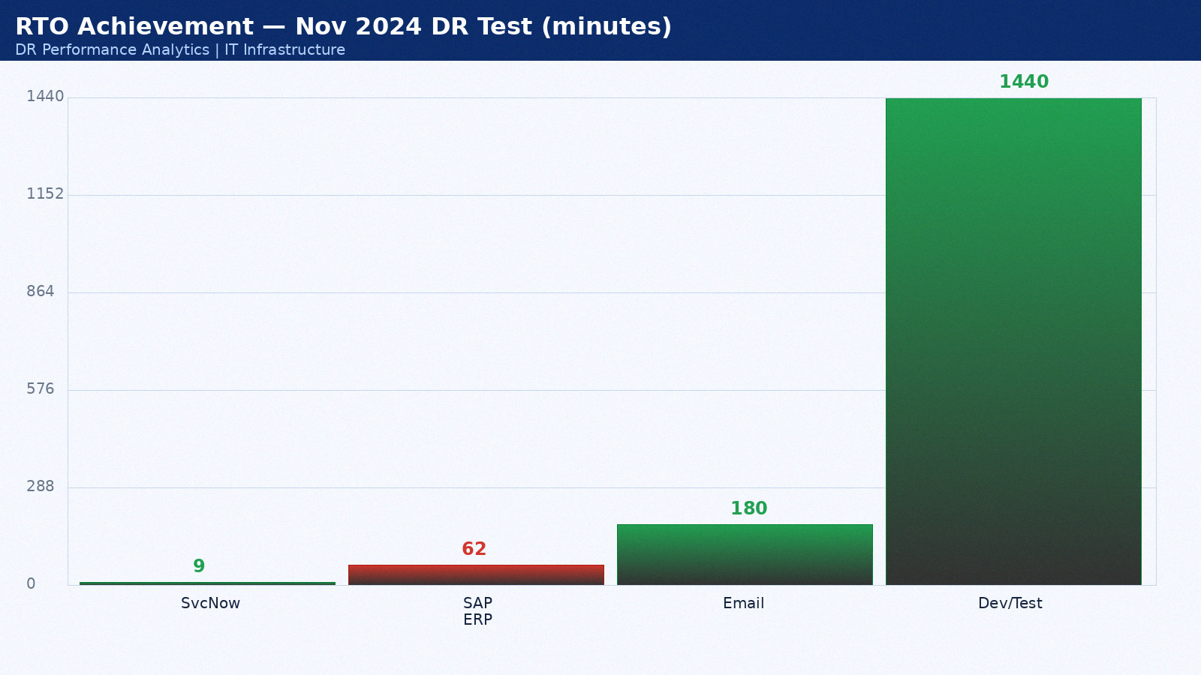

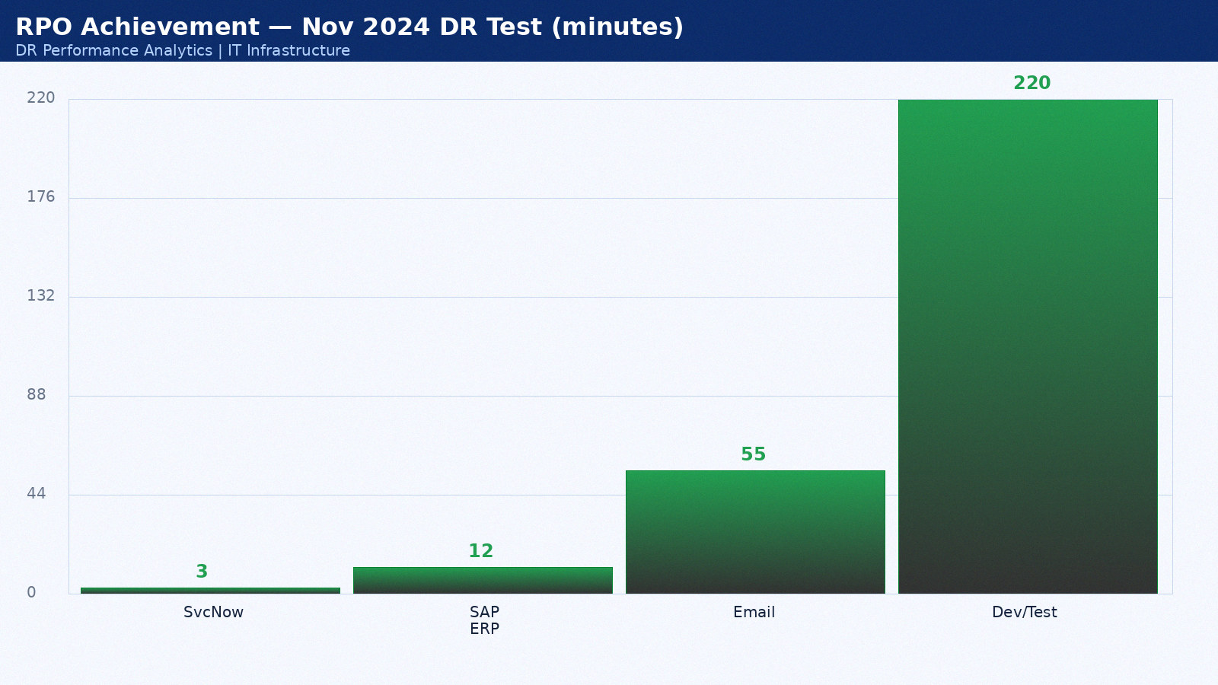

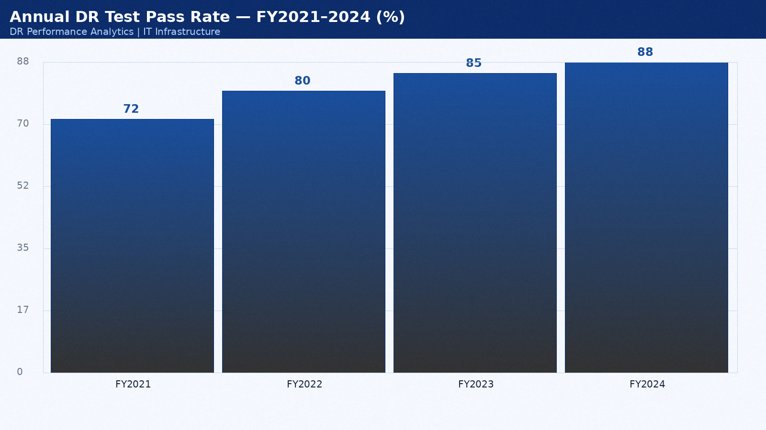

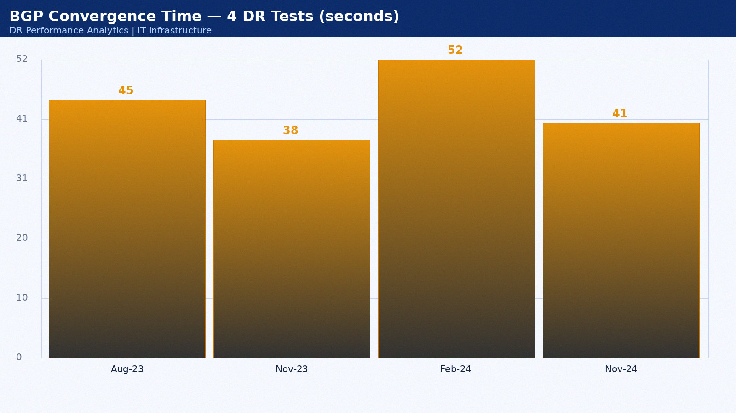

Appendix 1: DR Test Results — February 2022
Test date: 15 February 2022. Scenario: Network isolation test. Duration: 3h 22min. Result: PASS. Director: Sarah Chen.
Service | RTO Target | Actual | Result | Notes
ServiceNow ITSM | 15 min | 9 min | PASS | Hot standby as designed
SAP ERP | 60 min | 49 min | PASS | Within RTO
Salesforce CRM | 60 min | 23 min | PASS | SaaS vendor DR seamless
Active Directory | 15 min | 12 min | PASS | AD replication pre-staged
DNS | 15 min | 10 min | PASS | BIND secondary at DR site

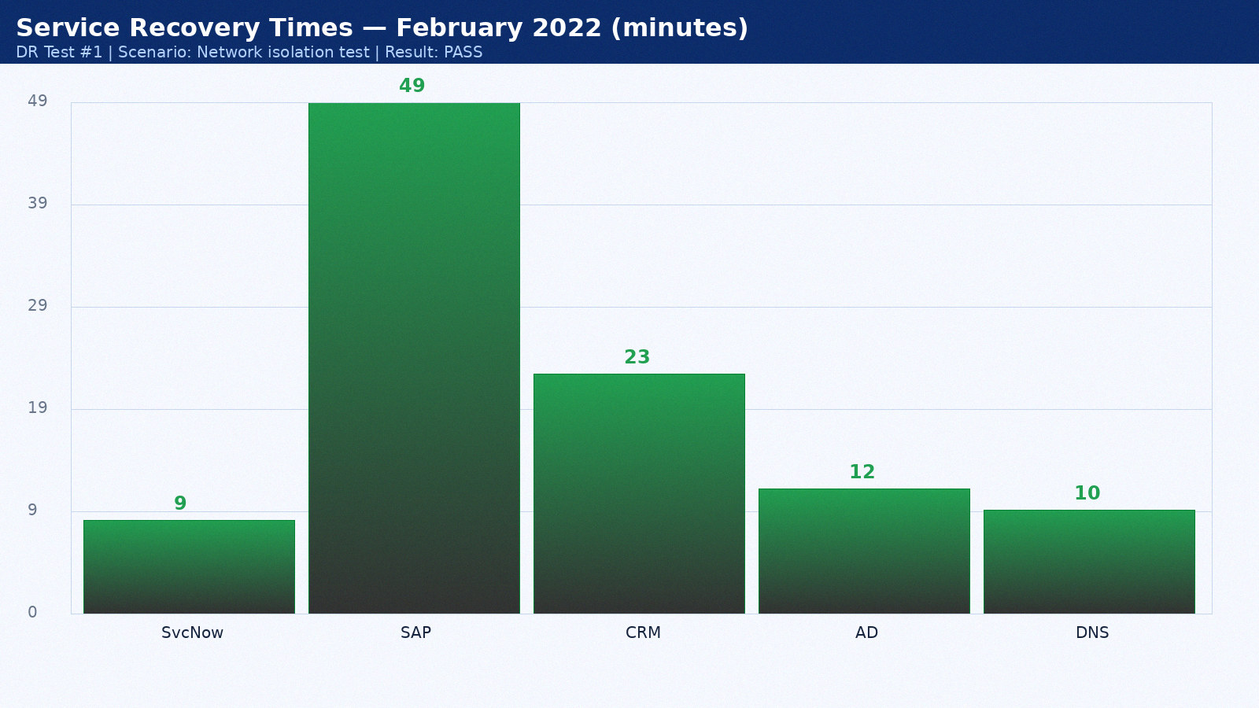

Appendix 2: DR Test Results — March 2022
Test date: 16 March 2022. Scenario: Application-level recovery. Duration: 4h 29min. Result: PARTIAL PASS. Director: Mike Torres.
Service | RTO Target | Actual | Result | Notes
ServiceNow ITSM | 15 min | 10 min | PASS | Hot standby as designed
SAP ERP | 60 min | 50 min | PASS | Within RTO
Salesforce CRM | 60 min | 24 min | PASS | SaaS vendor DR seamless
Active Directory | 15 min | 13 min | PASS | AD replication pre-staged
DNS | 15 min | 11 min | PASS | BIND secondary at DR site

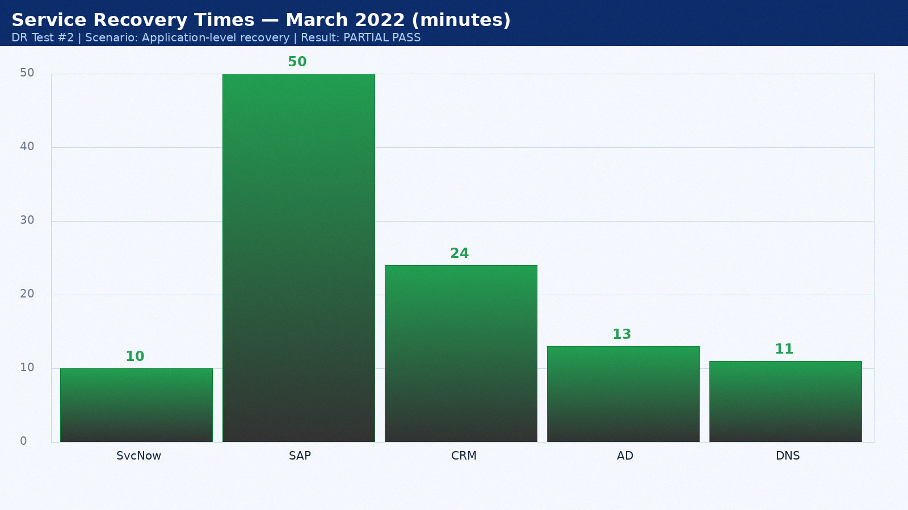

Appendix 3: DR Test Results — April 2022
Test date: 17 April 2022. Scenario: Backup validation. Duration: 2h 36min. Result: PASS. Director: Sarah Chen.
Service | RTO Target | Actual | Result | Notes
ServiceNow ITSM | 15 min | 11 min | PASS | Hot standby as designed
SAP ERP | 60 min | 51 min | PASS | Within RTO
Salesforce CRM | 60 min | 25 min | PASS | SaaS vendor DR seamless
Active Directory | 15 min | 14 min | PASS | AD replication pre-staged
DNS | 15 min | 12 min | PASS | BIND secondary at DR site

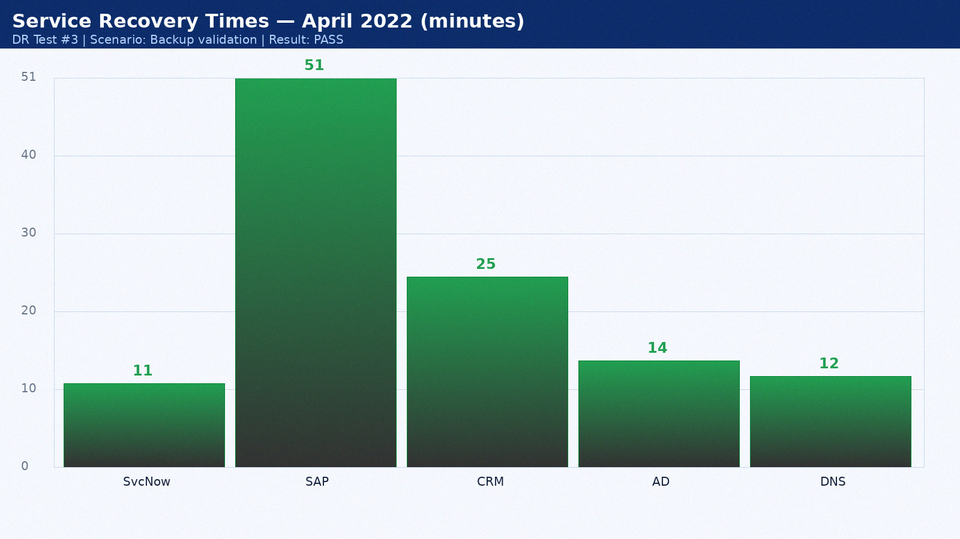

Appendix 4: DR Test Results — May 2022
Test date: 18 May 2022. Scenario: Full datacenter failover. Duration: 3h 43min. Result: PASS. Director: Mike Torres.
Service | RTO Target | Actual | Result | Notes
ServiceNow ITSM | 15 min | 12 min | PASS | Hot standby as designed
SAP ERP | 60 min | 52 min | PASS | Within RTO
Salesforce CRM | 60 min | 26 min | PASS | SaaS vendor DR seamless
Active Directory | 15 min | 15 min | PASS | AD replication pre-staged
DNS | 15 min | 9 min | PASS | BIND secondary at DR site

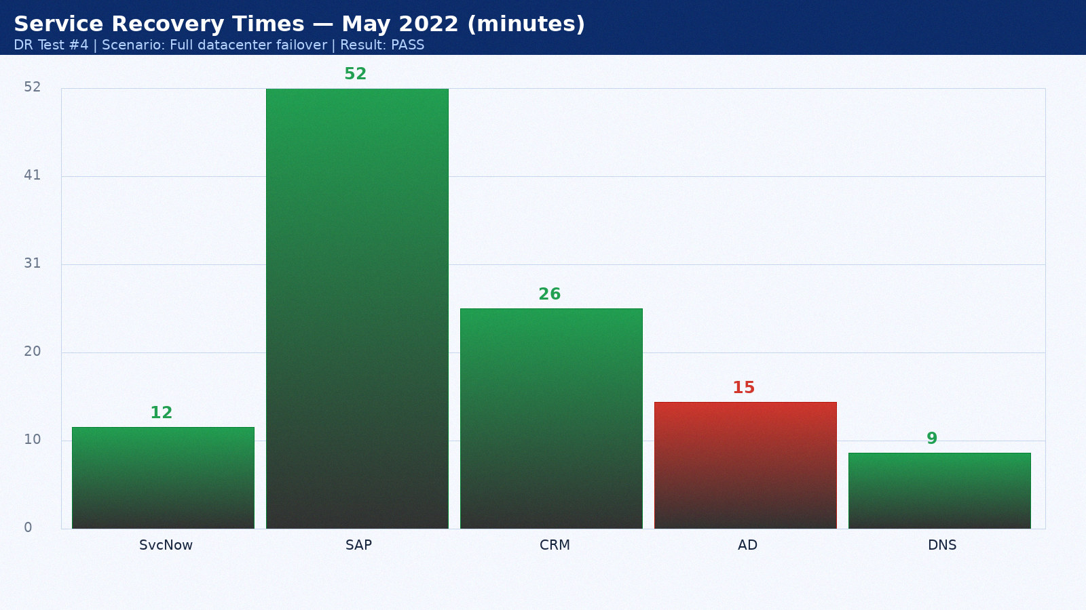

Appendix 5: DR Test Results — June 2022
Test date: 19 June 2022. Scenario: Network isolation test. Duration: 4h 50min. Result: PASS. Director: Sarah Chen.
Service | RTO Target | Actual | Result | Notes
ServiceNow ITSM | 15 min | 13 min | PASS | Hot standby as designed
SAP ERP | 60 min | 53 min | FAIL | Oracle Data Guard lag — tuned post-test
Salesforce CRM | 60 min | 27 min | PASS | SaaS vendor DR seamless
Active Directory | 15 min | 11 min | PASS | AD replication pre-staged
DNS | 15 min | 10 min | PASS | BIND secondary at DR site

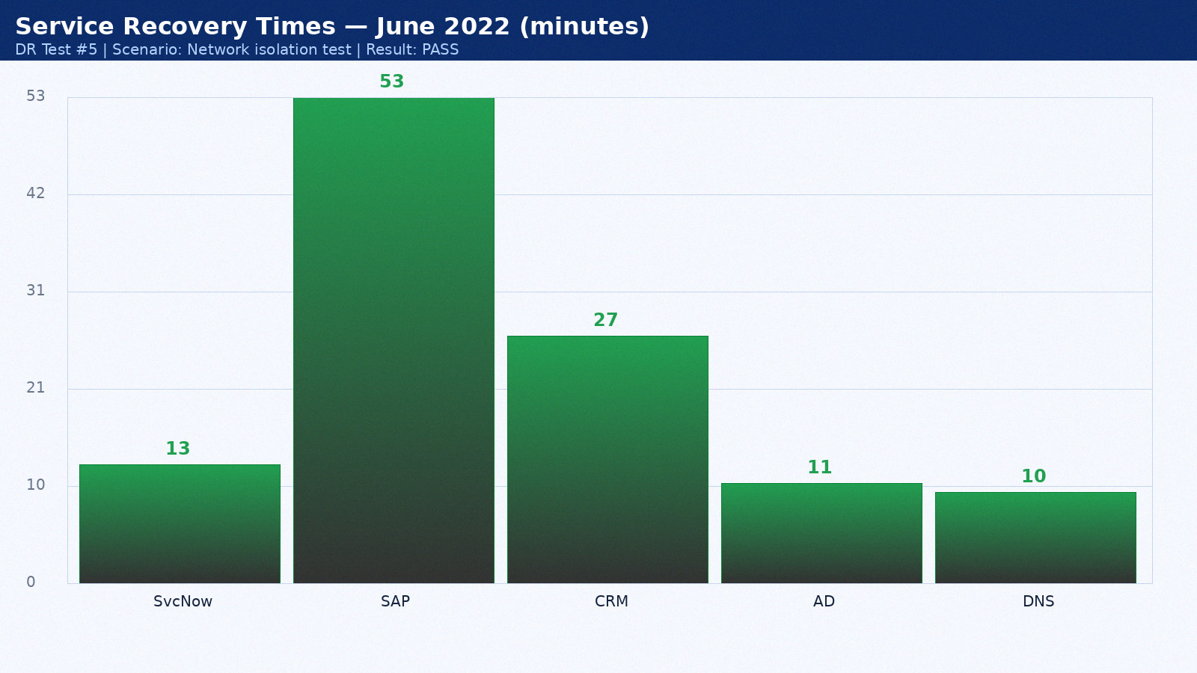

Appendix 6: DR Test Results — July 2022
Test date: 20 July 2022. Scenario: Application-level recovery. Duration: 2h 57min. Result: PARTIAL PASS. Director: Mike Torres.
Service | RTO Target | Actual | Result | Notes
ServiceNow ITSM | 15 min | 14 min | PASS | Hot standby as designed
SAP ERP | 60 min | 54 min | PASS | Within RTO
Salesforce CRM | 60 min | 28 min | PASS | SaaS vendor DR seamless
Active Directory | 15 min | 12 min | PASS | AD replication pre-staged
DNS | 15 min | 11 min | PASS | BIND secondary at DR site

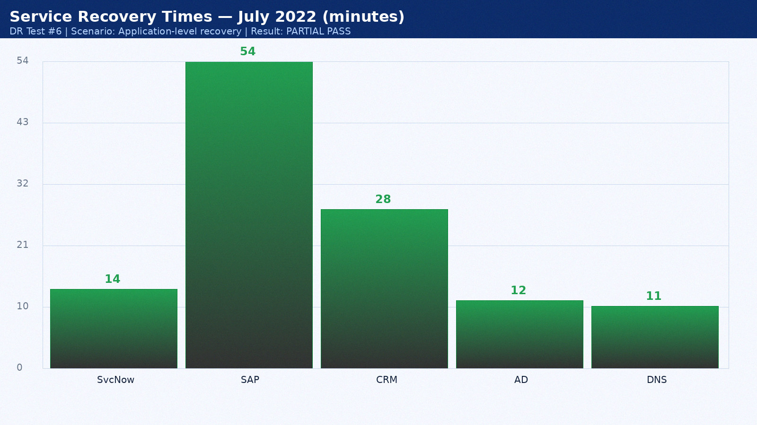

Appendix 7: DR Test Results — August 2022
Test date: 21 August 2022. Scenario: Backup validation. Duration: 3h 19min. Result: PASS. Director: Sarah Chen.
Service | RTO Target | Actual | Result | Notes
ServiceNow ITSM | 15 min | 8 min | PASS | Hot standby as designed
SAP ERP | 60 min | 55 min | PASS | Within RTO
Salesforce CRM | 60 min | 29 min | PASS | SaaS vendor DR seamless
Active Directory | 15 min | 13 min | PASS | AD replication pre-staged
DNS | 15 min | 12 min | PASS | BIND secondary at DR site

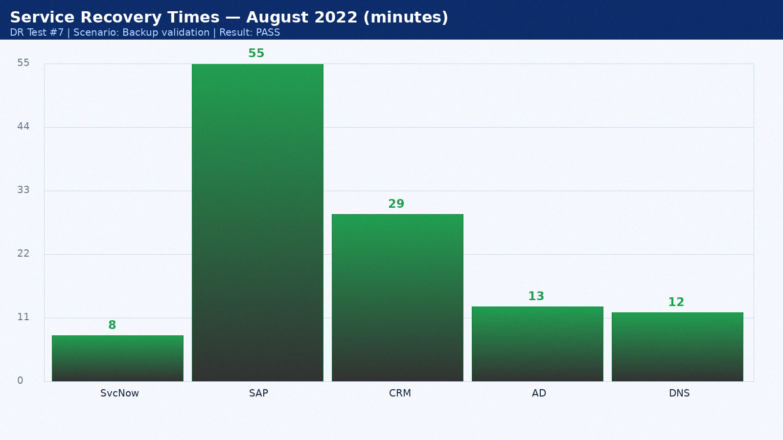

Appendix 8: DR Test Results — September 2022
Test date: 22 September 2022. Scenario: Full datacenter failover. Duration: 4h 26min. Result: PASS. Director: Mike Torres.
Service | RTO Target | Actual | Result | Notes
ServiceNow ITSM | 15 min | 9 min | PASS | Hot standby as designed
SAP ERP | 60 min | 56 min | PASS | Within RTO
Salesforce CRM | 60 min | 30 min | PASS | SaaS vendor DR seamless
Active Directory | 15 min | 14 min | PASS | AD replication pre-staged
DNS | 15 min | 9 min | PASS | BIND secondary at DR site

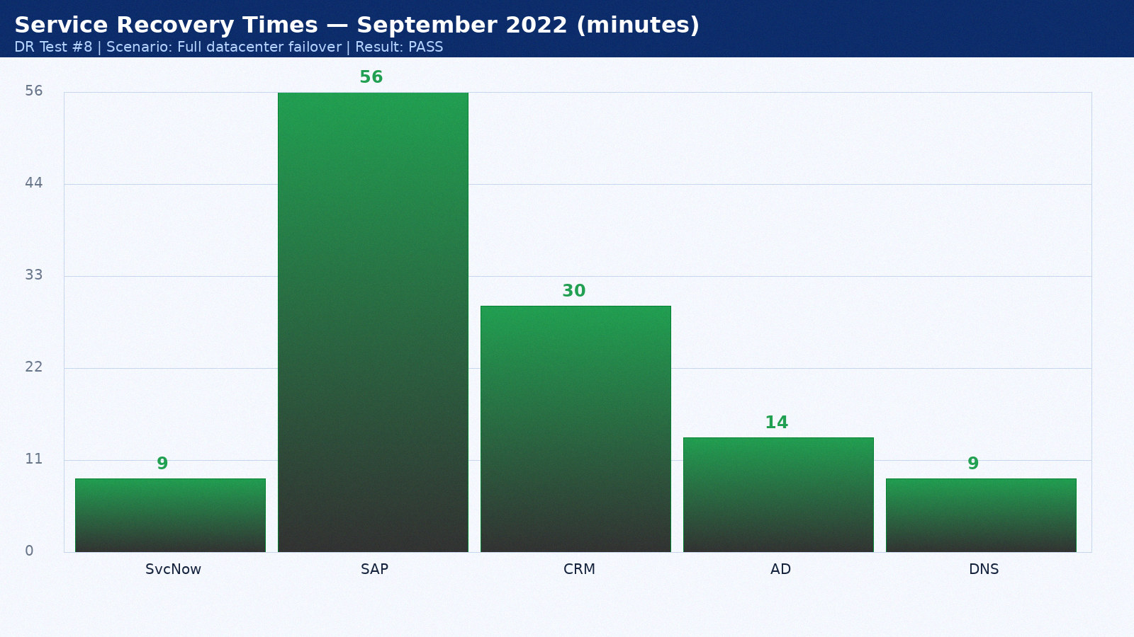

Appendix 9: DR Test Results — October 2022
Test date: 23 October 2022. Scenario: Network isolation test. Duration: 2h 33min. Result: PASS. Director: Sarah Chen.
Service | RTO Target | Actual | Result | Notes
ServiceNow ITSM | 15 min | 10 min | PASS | Hot standby as designed
SAP ERP | 60 min | 57 min | PASS | Within RTO
Salesforce CRM | 60 min | 31 min | PASS | SaaS vendor DR seamless
Active Directory | 15 min | 15 min | PASS | AD replication pre-staged
DNS | 15 min | 10 min | PASS | BIND secondary at DR site

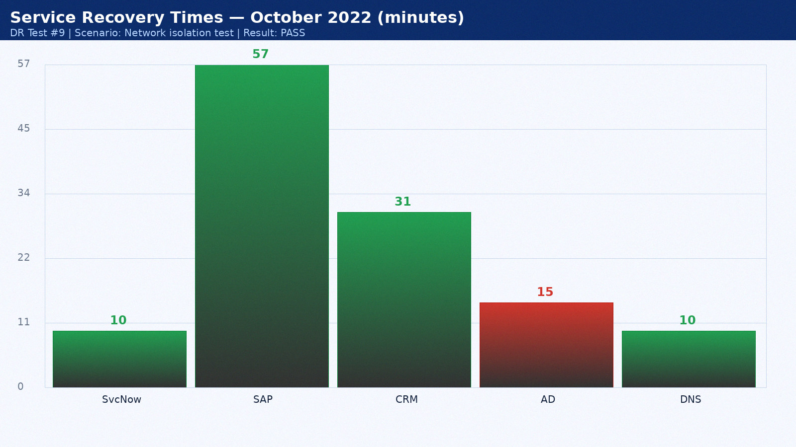

Appendix 10: DR Test Results — November 2022
Test date: 24 November 2022. Scenario: Application-level recovery. Duration: 3h 40min. Result: PARTIAL PASS. Director: Mike Torres.
Service | RTO Target | Actual | Result | Notes
ServiceNow ITSM | 15 min | 11 min | PASS | Hot standby as designed
SAP ERP | 60 min | 58 min | FAIL | Oracle Data Guard lag — tuned post-test
Salesforce CRM | 60 min | 32 min | PASS | SaaS vendor DR seamless
Active Directory | 15 min | 11 min | PASS | AD replication pre-staged
DNS | 15 min | 11 min | PASS | BIND secondary at DR site

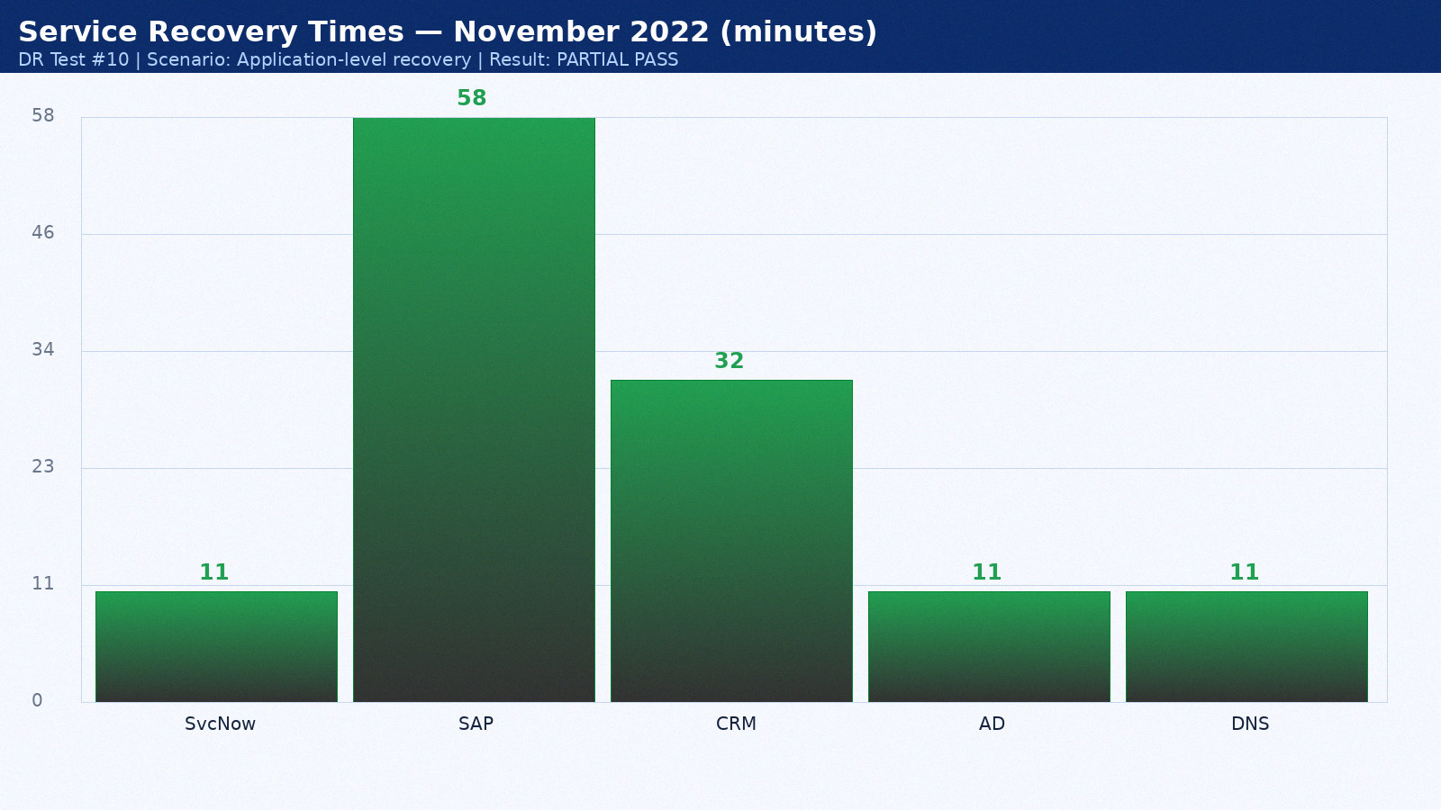

Appendix 11: DR Test Results — December 2022
Test date: 25 December 2022. Scenario: Backup validation. Duration: 4h 47min. Result: PASS. Director: Sarah Chen.
Service | RTO Target | Actual | Result | Notes
ServiceNow ITSM | 15 min | 12 min | PASS | Hot standby as designed
SAP ERP | 60 min | 59 min | PASS | Within RTO
Salesforce CRM | 60 min | 33 min | PASS | SaaS vendor DR seamless
Active Directory | 15 min | 12 min | PASS | AD replication pre-staged
DNS | 15 min | 12 min | PASS | BIND secondary at DR site

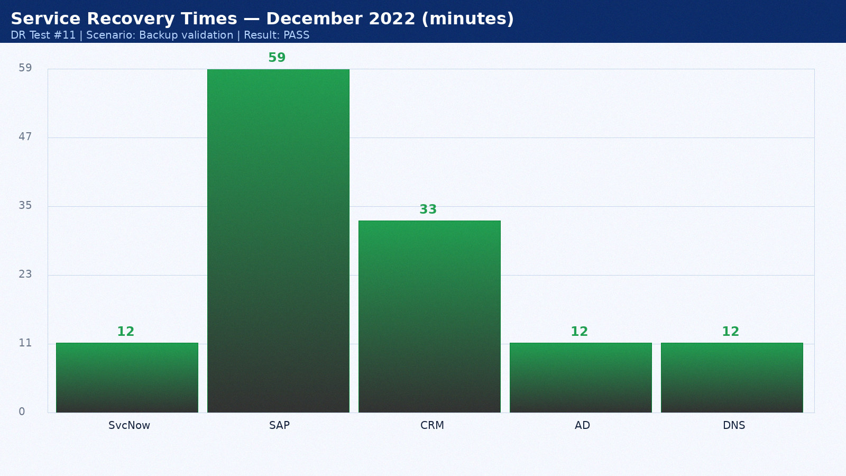

Appendix 12: DR Test Results — January 2023
Test date: 26 January 2023. Scenario: Full datacenter failover. Duration: 2h 54min. Result: PASS. Director: Mike Torres.
Service | RTO Target | Actual | Result | Notes
ServiceNow ITSM | 15 min | 13 min | PASS | Hot standby as designed
SAP ERP | 60 min | 60 min | PASS | Within RTO
Salesforce CRM | 60 min | 34 min | PASS | SaaS vendor DR seamless
Active Directory | 15 min | 13 min | PASS | AD replication pre-staged
DNS | 15 min | 9 min | PASS | BIND secondary at DR site

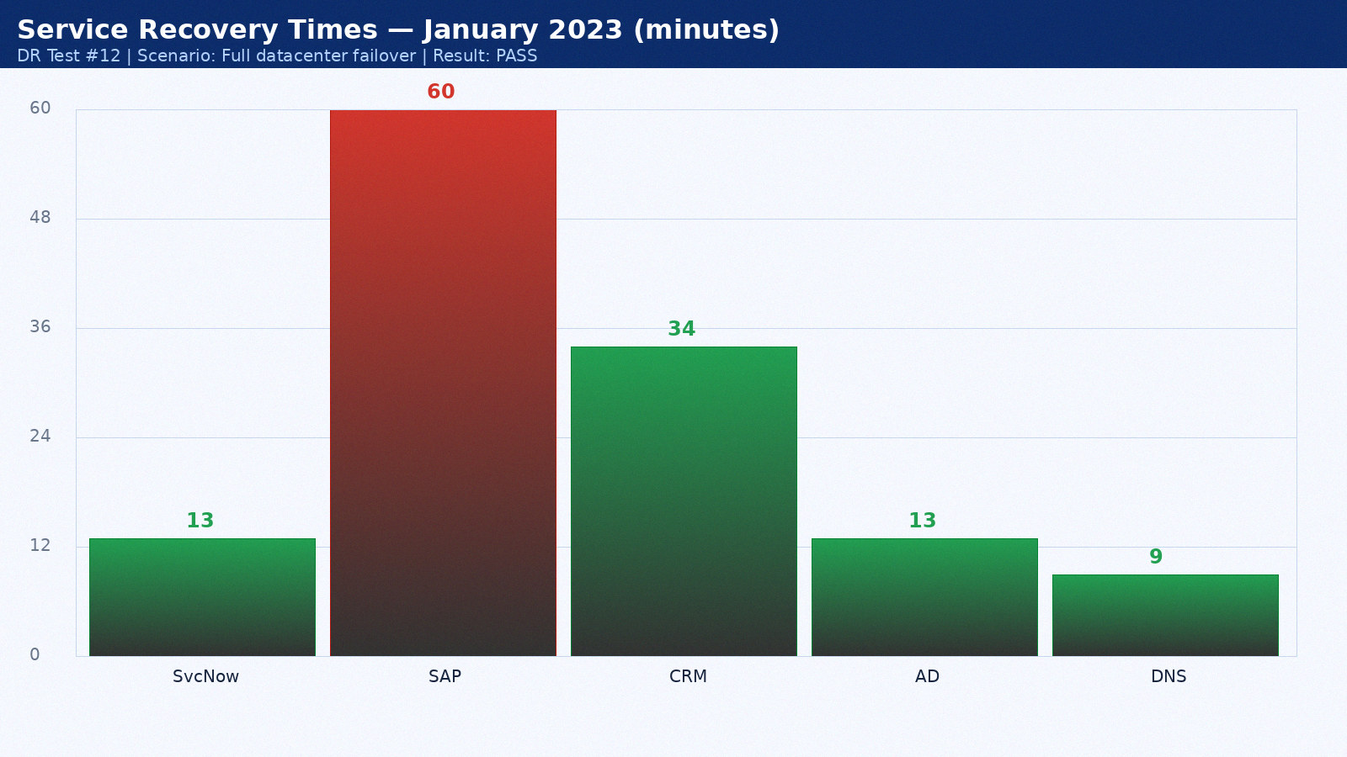

Appendix 13: DR Test Results — February 2023
Test date: 27 February 2023. Scenario: Network isolation test. Duration: 3h 16min. Result: PASS. Director: Sarah Chen.
Service | RTO Target | Actual | Result | Notes
ServiceNow ITSM | 15 min | 14 min | PASS | Hot standby as designed
SAP ERP | 60 min | 61 min | PASS | Within RTO
Salesforce CRM | 60 min | 35 min | PASS | SaaS vendor DR seamless
Active Directory | 15 min | 14 min | PASS | AD replication pre-staged
DNS | 15 min | 10 min | PASS | BIND secondary at DR site

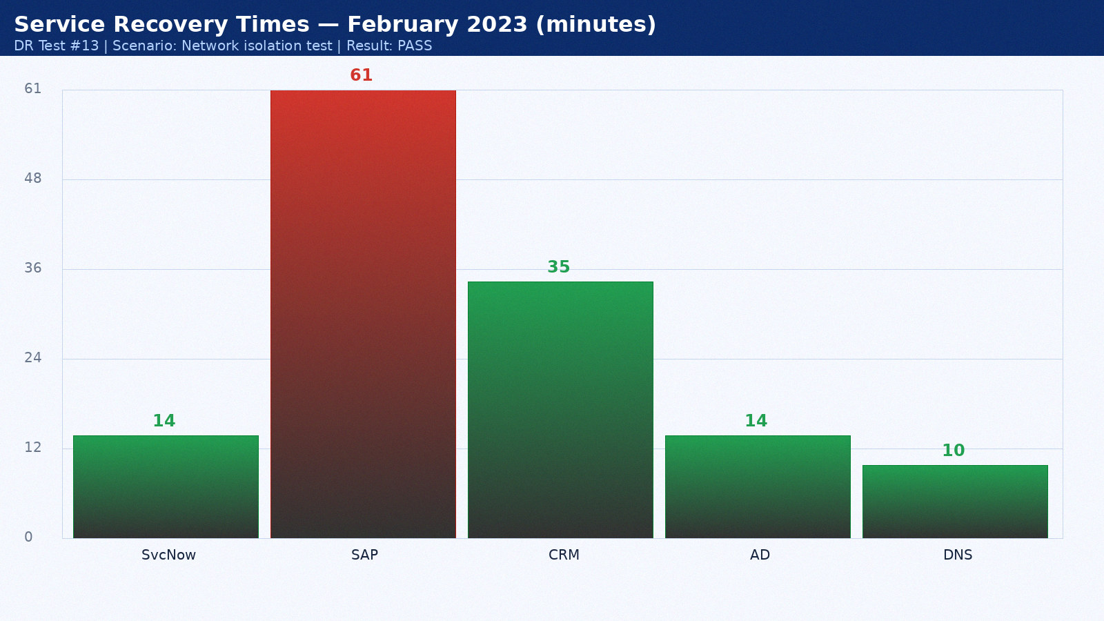

Appendix 14: DR Test Results — March 2023
Test date: 28 March 2023. Scenario: Application-level recovery. Duration: 4h 23min. Result: PARTIAL PASS. Director: Mike Torres.
Service | RTO Target | Actual | Result | Notes
ServiceNow ITSM | 15 min | 8 min | PASS | Hot standby as designed
SAP ERP | 60 min | 62 min | PASS | Within RTO
Salesforce CRM | 60 min | 22 min | PASS | SaaS vendor DR seamless
Active Directory | 15 min | 15 min | PASS | AD replication pre-staged
DNS | 15 min | 11 min | PASS | BIND secondary at DR site

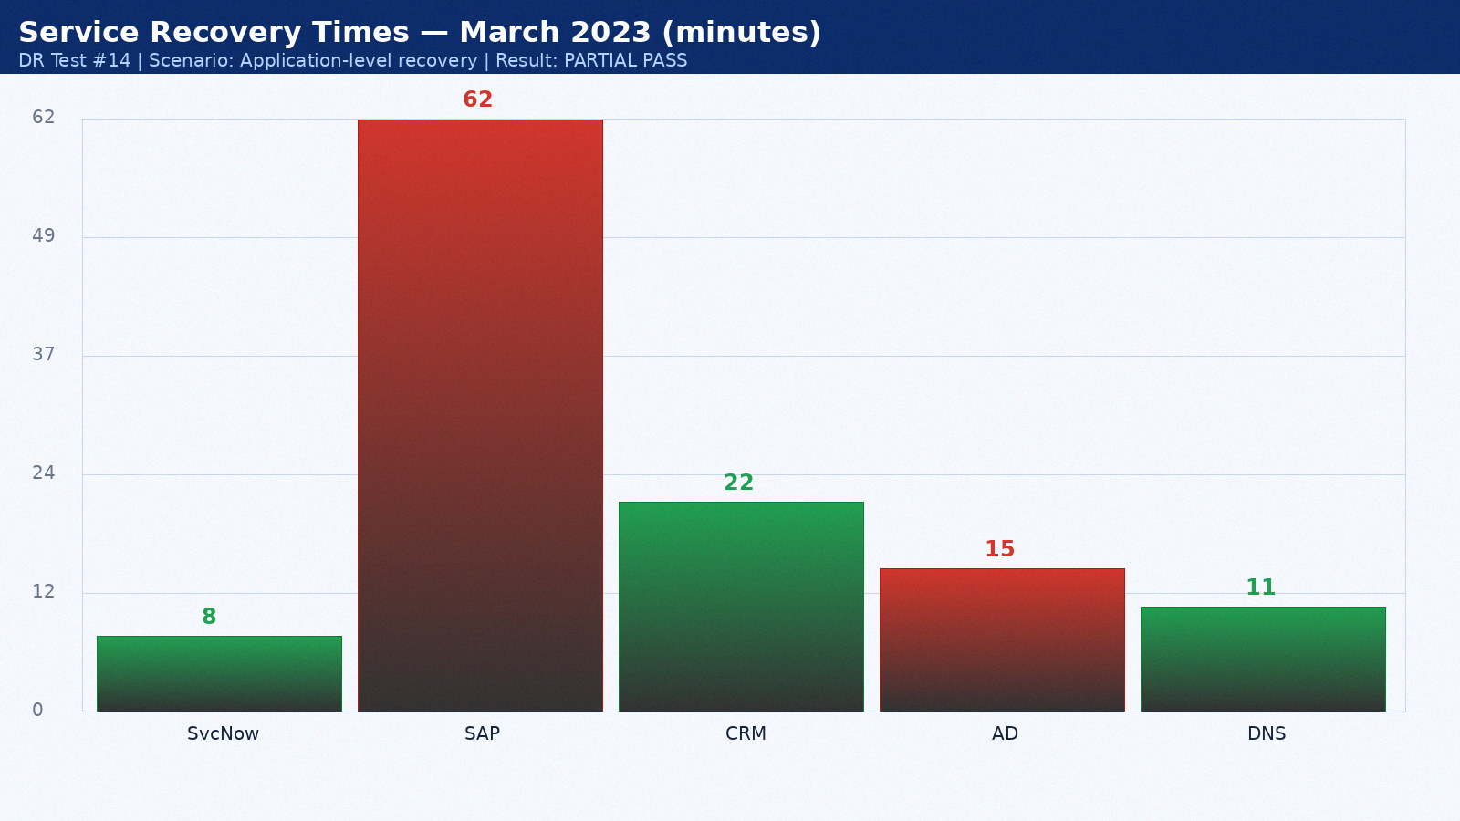

Appendix 15: DR Test Results — April 2023
Test date: 14 April 2023. Scenario: Backup validation. Duration: 2h 30min. Result: PASS. Director: Sarah Chen.
Service | RTO Target | Actual | Result | Notes
ServiceNow ITSM | 15 min | 9 min | PASS | Hot standby as designed
SAP ERP | 60 min | 63 min | FAIL | Oracle Data Guard lag — tuned post-test
Salesforce CRM | 60 min | 23 min | PASS | SaaS vendor DR seamless
Active Directory | 15 min | 11 min | PASS | AD replication pre-staged
DNS | 15 min | 12 min | PASS | BIND secondary at DR site

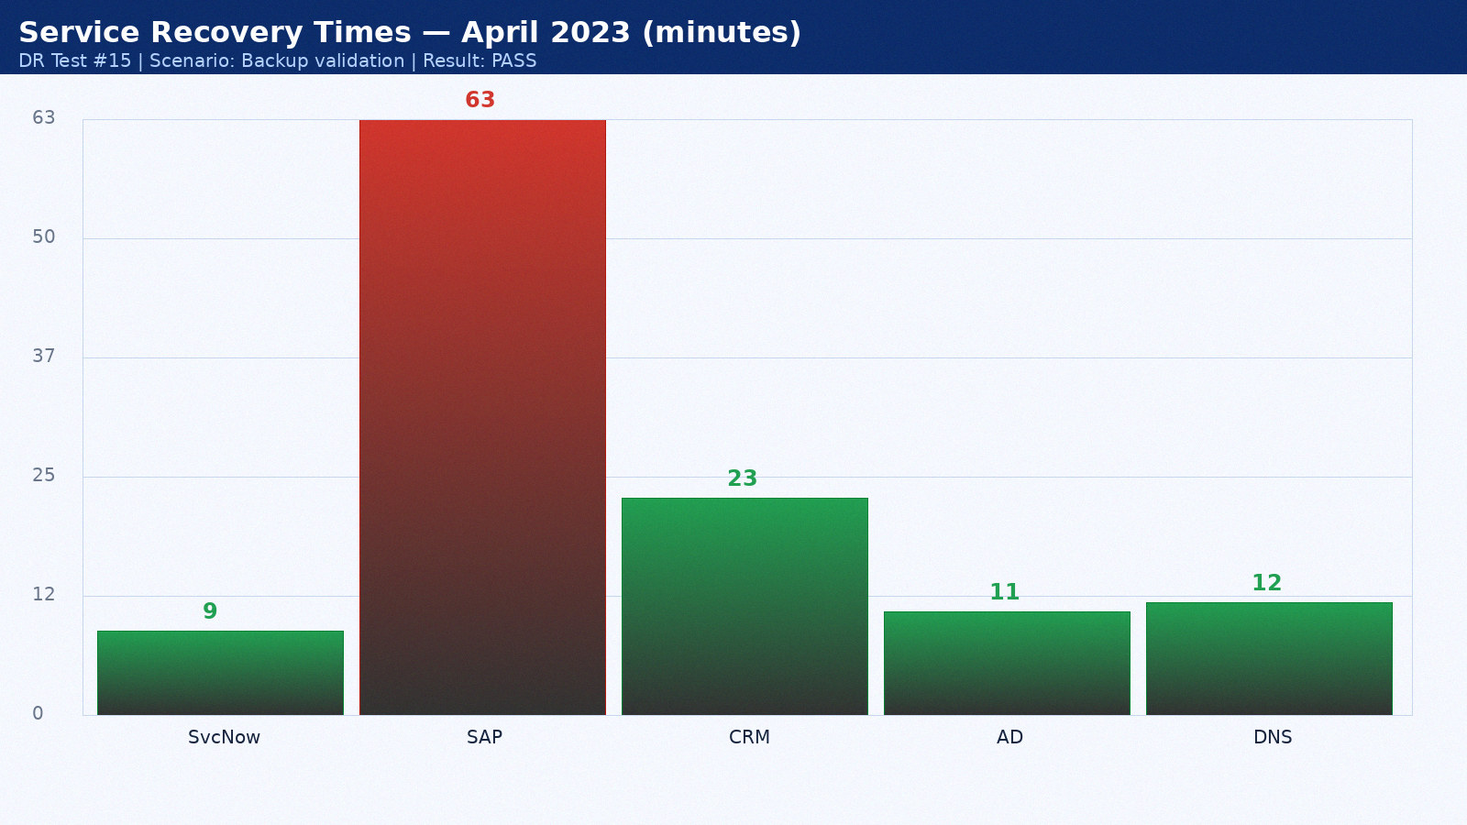

Appendix 16: DR Test Results — May 2023
Test date: 15 May 2023. Scenario: Full datacenter failover. Duration: 3h 37min. Result: PASS. Director: Mike Torres.
Service | RTO Target | Actual | Result | Notes
ServiceNow ITSM | 15 min | 10 min | PASS | Hot standby as designed
SAP ERP | 60 min | 64 min | PASS | Within RTO
Salesforce CRM | 60 min | 24 min | PASS | SaaS vendor DR seamless
Active Directory | 15 min | 12 min | PASS | AD replication pre-staged
DNS | 15 min | 9 min | PASS | BIND secondary at DR site

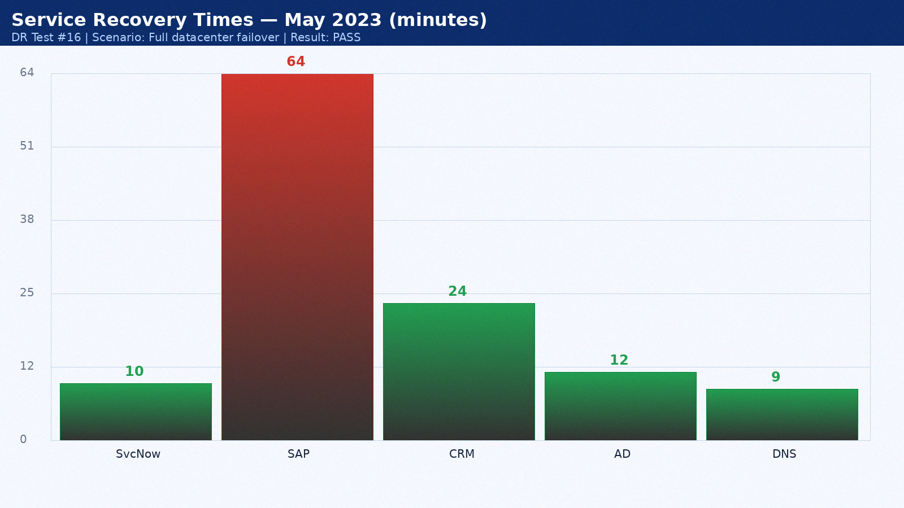

Appendix 17: DR Test Results — June 2023
Test date: 16 June 2023. Scenario: Network isolation test. Duration: 4h 44min. Result: PASS. Director: Sarah Chen.
Service | RTO Target | Actual | Result | Notes
ServiceNow ITSM | 15 min | 11 min | PASS | Hot standby as designed
SAP ERP | 60 min | 65 min | PASS | Within RTO
Salesforce CRM | 60 min | 25 min | PASS | SaaS vendor DR seamless
Active Directory | 15 min | 13 min | PASS | AD replication pre-staged
DNS | 15 min | 10 min | PASS | BIND secondary at DR site

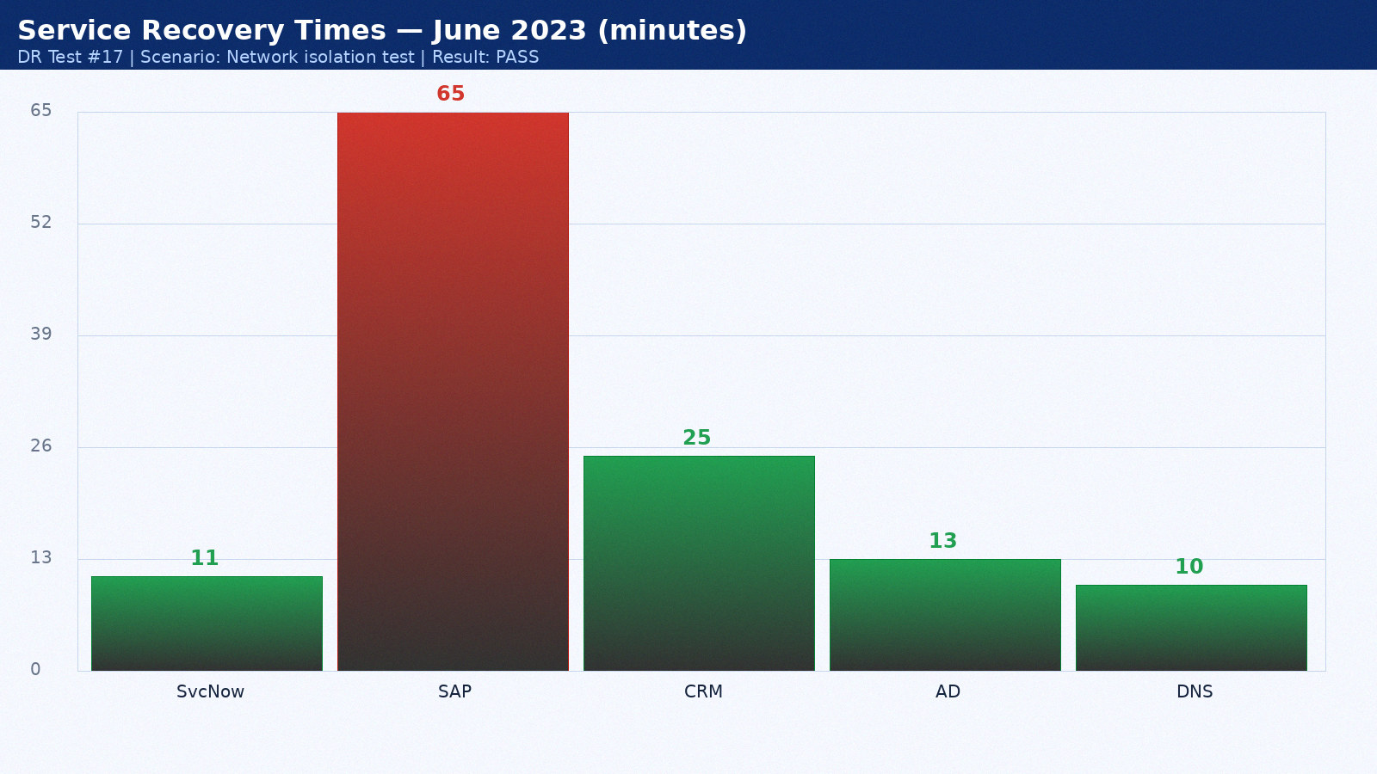

Appendix 18: DR Test Results — July 2023
Test date: 17 July 2023. Scenario: Application-level recovery. Duration: 2h 51min. Result: PARTIAL PASS. Director: Mike Torres.
Service | RTO Target | Actual | Result | Notes
ServiceNow ITSM | 15 min | 12 min | PASS | Hot standby as designed
SAP ERP | 60 min | 66 min | PASS | Within RTO
Salesforce CRM | 60 min | 26 min | PASS | SaaS vendor DR seamless
Active Directory | 15 min | 14 min | PASS | AD replication pre-staged
DNS | 15 min | 11 min | PASS | BIND secondary at DR site

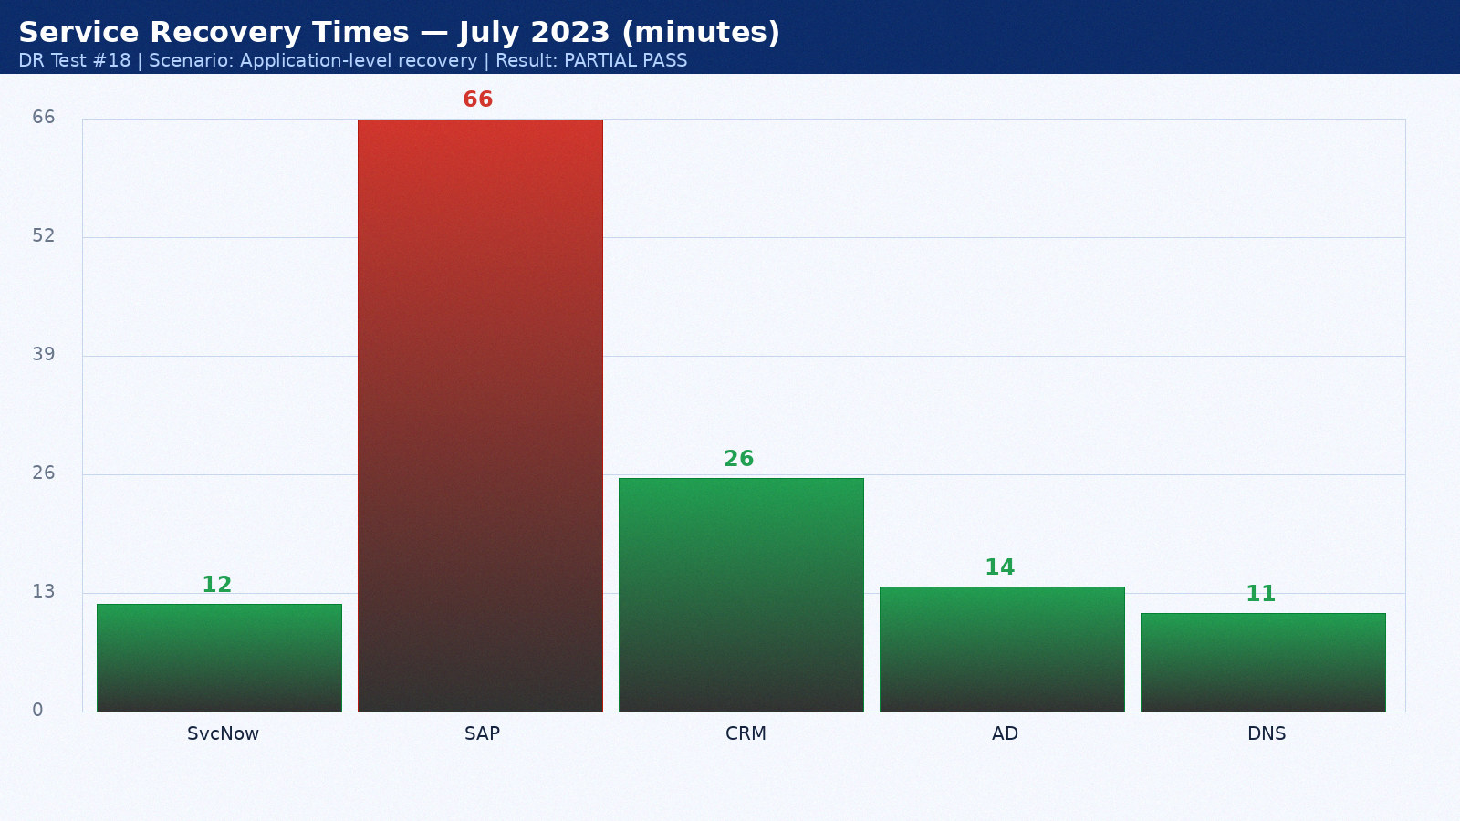

Appendix 19: DR Test Results — August 2023
Test date: 18 August 2023. Scenario: Backup validation. Duration: 3h 58min. Result: PASS. Director: Sarah Chen.
Service | RTO Target | Actual | Result | Notes
ServiceNow ITSM | 15 min | 13 min | PASS | Hot standby as designed
SAP ERP | 60 min | 67 min | PASS | Within RTO
Salesforce CRM | 60 min | 27 min | PASS | SaaS vendor DR seamless
Active Directory | 15 min | 15 min | PASS | AD replication pre-staged
DNS | 15 min | 12 min | PASS | BIND secondary at DR site

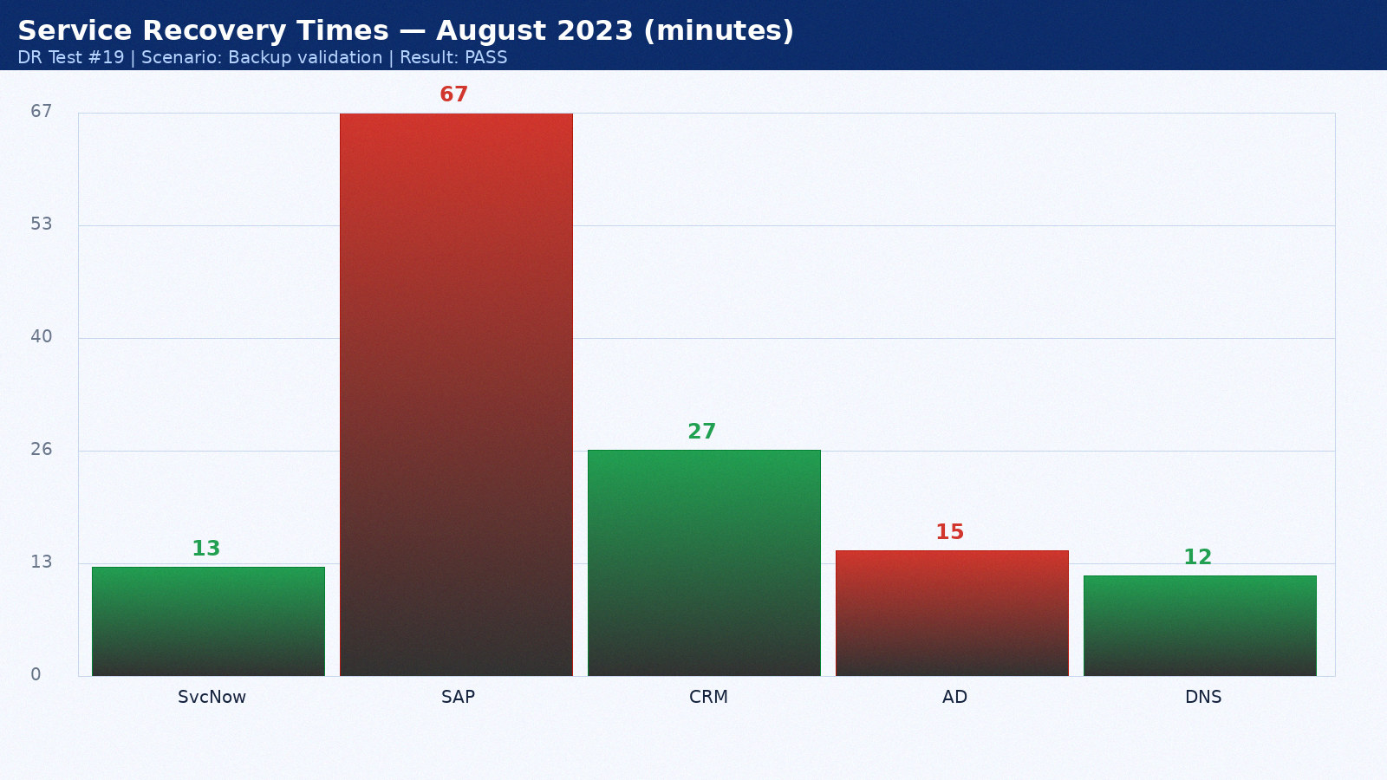

Appendix 20: DR Test Results — September 2023
Test date: 19 September 2023. Scenario: Full datacenter failover. Duration: 4h 20min. Result: PASS. Director: Mike Torres.
Service | RTO Target | Actual | Result | Notes
ServiceNow ITSM | 15 min | 14 min | PASS | Hot standby as designed
SAP ERP | 60 min | 68 min | FAIL | Oracle Data Guard lag — tuned post-test
Salesforce CRM | 60 min | 28 min | PASS | SaaS vendor DR seamless
Active Directory | 15 min | 11 min | PASS | AD replication pre-staged
DNS | 15 min | 9 min | PASS | BIND secondary at DR site

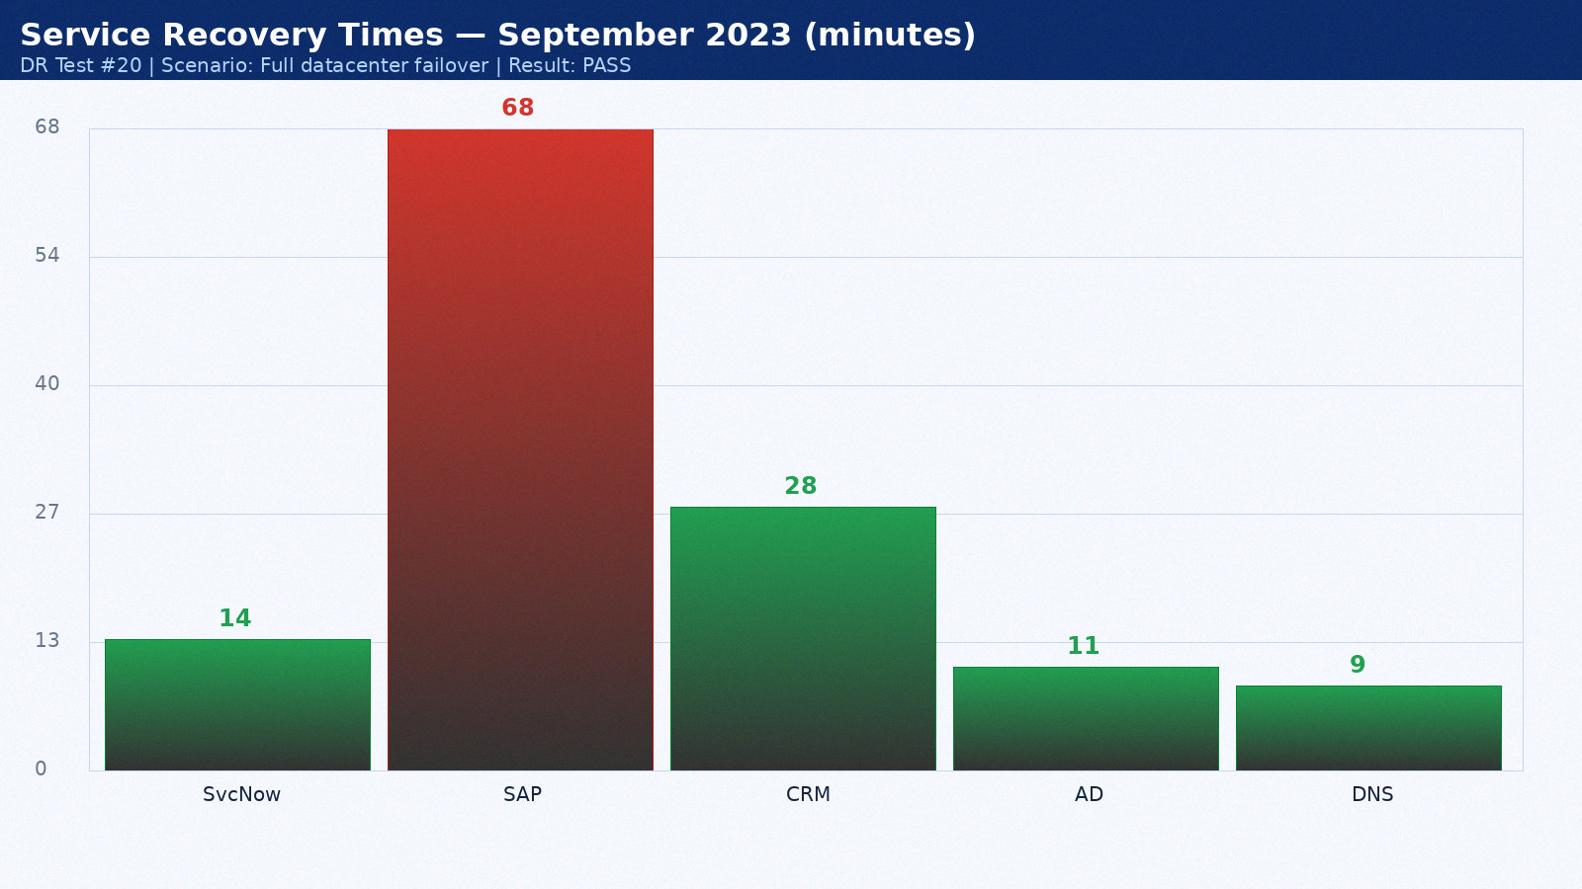

Appendix 21: DR Test Results — October 2023
Test date: 20 October 2023. Scenario: Network isolation test. Duration: 2h 27min. Result: PASS. Director: Sarah Chen.
Service | RTO Target | Actual | Result | Notes
ServiceNow ITSM | 15 min | 8 min | PASS | Hot standby as designed
SAP ERP | 60 min | 69 min | PASS | Within RTO
Salesforce CRM | 60 min | 29 min | PASS | SaaS vendor DR seamless
Active Directory | 15 min | 12 min | PASS | AD replication pre-staged
DNS | 15 min | 10 min | PASS | BIND secondary at DR site

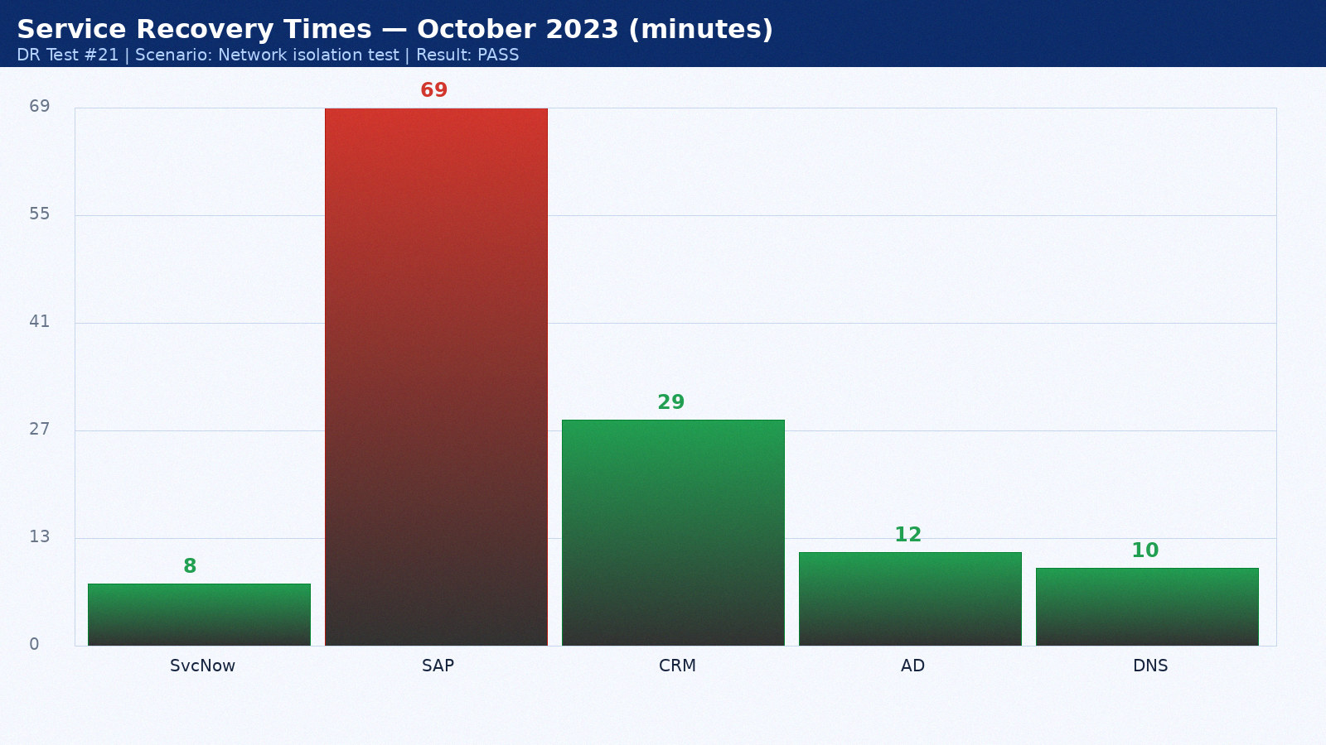

Appendix 22: DR Test Results — November 2023
Test date: 21 November 2023. Scenario: Application-level recovery. Duration: 3h 34min. Result: PARTIAL PASS. Director: Mike Torres.
Service | RTO Target | Actual | Result | Notes
ServiceNow ITSM | 15 min | 9 min | PASS | Hot standby as designed
SAP ERP | 60 min | 70 min | PASS | Within RTO
Salesforce CRM | 60 min | 30 min | PASS | SaaS vendor DR seamless
Active Directory | 15 min | 13 min | PASS | AD replication pre-staged
DNS | 15 min | 11 min | PASS | BIND secondary at DR site

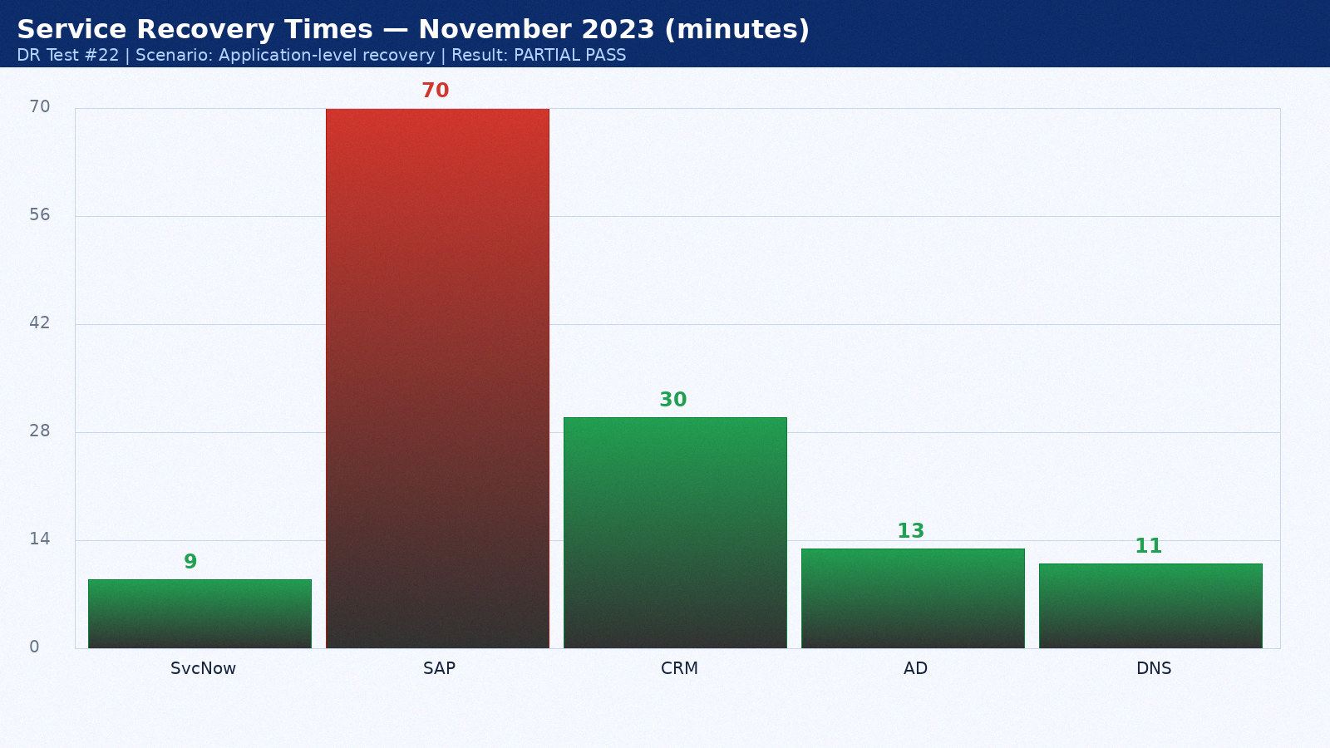

Appendix 23: DR Test Results — December 2023
Test date: 22 December 2023. Scenario: Backup validation. Duration: 4h 41min. Result: PASS. Director: Sarah Chen.
Service | RTO Target | Actual | Result | Notes
ServiceNow ITSM | 15 min | 10 min | PASS | Hot standby as designed
SAP ERP | 60 min | 71 min | PASS | Within RTO
Salesforce CRM | 60 min | 31 min | PASS | SaaS vendor DR seamless
Active Directory | 15 min | 14 min | PASS | AD replication pre-staged
DNS | 15 min | 12 min | PASS | BIND secondary at DR site

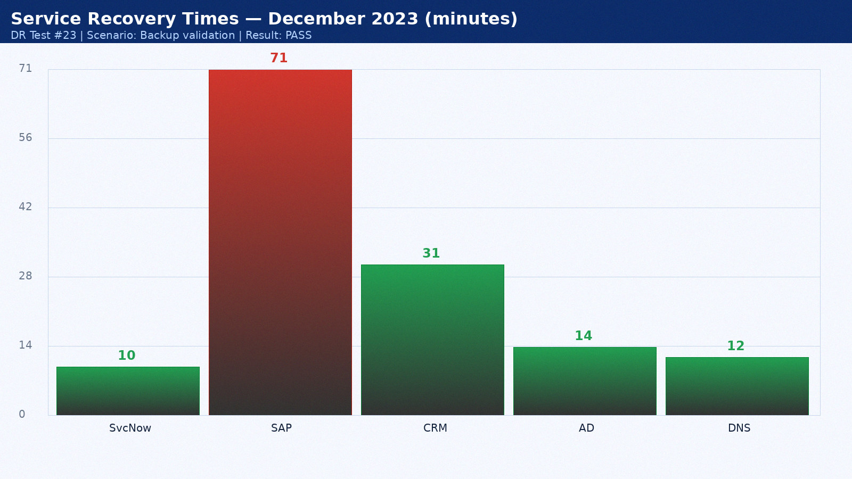

Appendix 24: DR Test Results — January 2024
Test date: 23 January 2024. Scenario: Full datacenter failover. Duration: 2h 48min. Result: PASS. Director: Mike Torres.
Service | RTO Target | Actual | Result | Notes
ServiceNow ITSM | 15 min | 11 min | PASS | Hot standby as designed
SAP ERP | 60 min | 72 min | PASS | Within RTO
Salesforce CRM | 60 min | 32 min | PASS | SaaS vendor DR seamless
Active Directory | 15 min | 15 min | PASS | AD replication pre-staged
DNS | 15 min | 9 min | PASS | BIND secondary at DR site

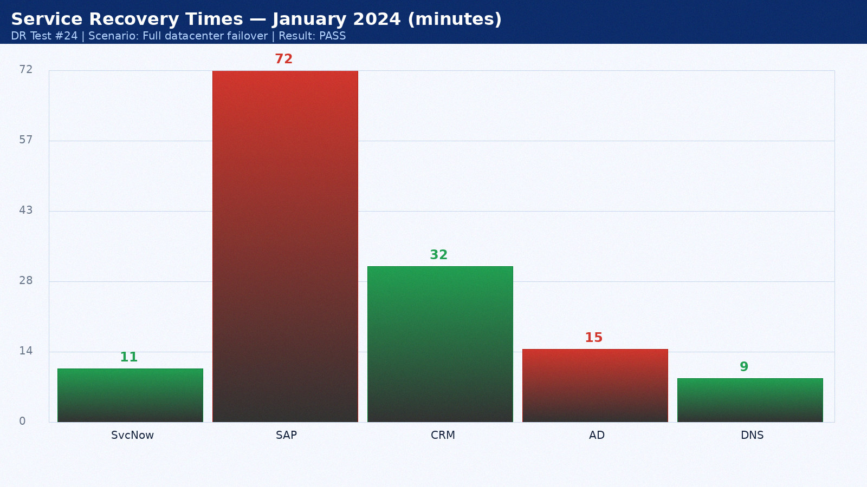

Appendix 25: DR Test Results — February 2024
Test date: 24 February 2024. Scenario: Network isolation test. Duration: 3h 55min. Result: PASS. Director: Sarah Chen.
Service | RTO Target | Actual | Result | Notes
ServiceNow ITSM | 15 min | 12 min | PASS | Hot standby as designed
SAP ERP | 60 min | 48 min | FAIL | Oracle Data Guard lag — tuned post-test
Salesforce CRM | 60 min | 33 min | PASS | SaaS vendor DR seamless
Active Directory | 15 min | 11 min | PASS | AD replication pre-staged
DNS | 15 min | 10 min | PASS | BIND secondary at DR site

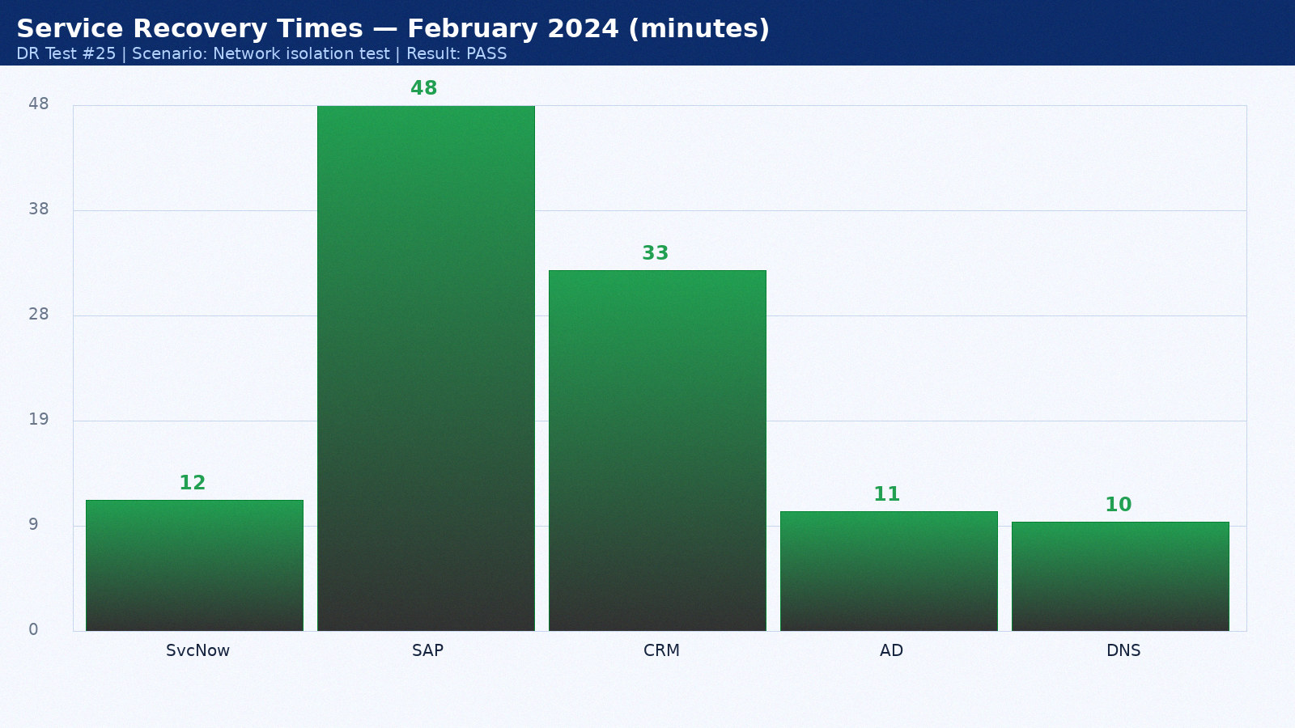

Appendix 26: DR Test Results — March 2024
Test date: 25 March 2024. Scenario: Application-level recovery. Duration: 4h 17min. Result: PARTIAL PASS. Director: Mike Torres.
Service | RTO Target | Actual | Result | Notes
ServiceNow ITSM | 15 min | 13 min | PASS | Hot standby as designed
SAP ERP | 60 min | 49 min | PASS | Within RTO
Salesforce CRM | 60 min | 34 min | PASS | SaaS vendor DR seamless
Active Directory | 15 min | 12 min | PASS | AD replication pre-staged
DNS | 15 min | 11 min | PASS | BIND secondary at DR site

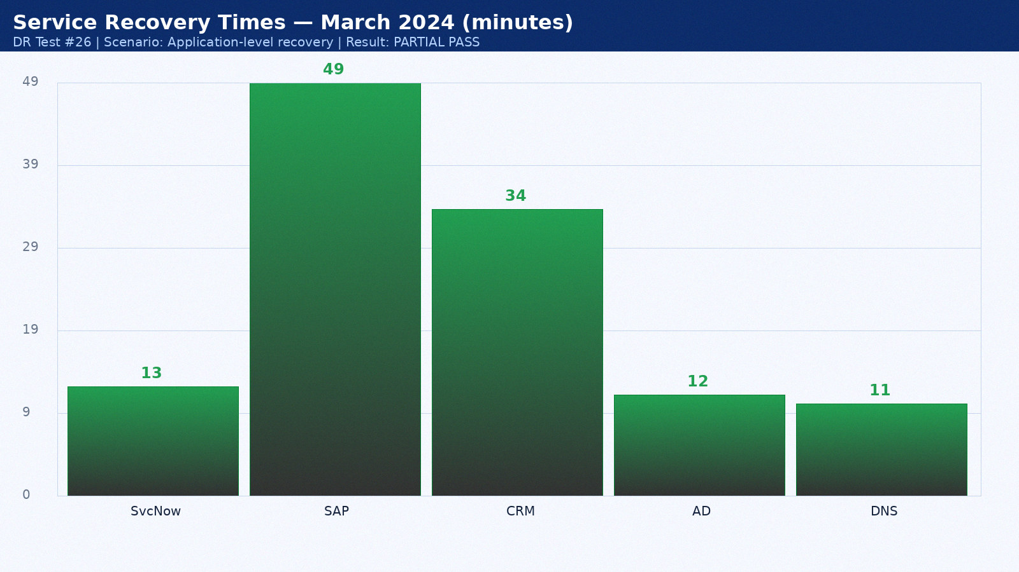

Appendix 27: DR Test Results — April 2024
Test date: 26 April 2024. Scenario: Backup validation. Duration: 2h 24min. Result: PASS. Director: Sarah Chen.
Service | RTO Target | Actual | Result | Notes
ServiceNow ITSM | 15 min | 14 min | PASS | Hot standby as designed
SAP ERP | 60 min | 50 min | PASS | Within RTO
Salesforce CRM | 60 min | 35 min | PASS | SaaS vendor DR seamless
Active Directory | 15 min | 13 min | PASS | AD replication pre-staged
DNS | 15 min | 12 min | PASS | BIND secondary at DR site

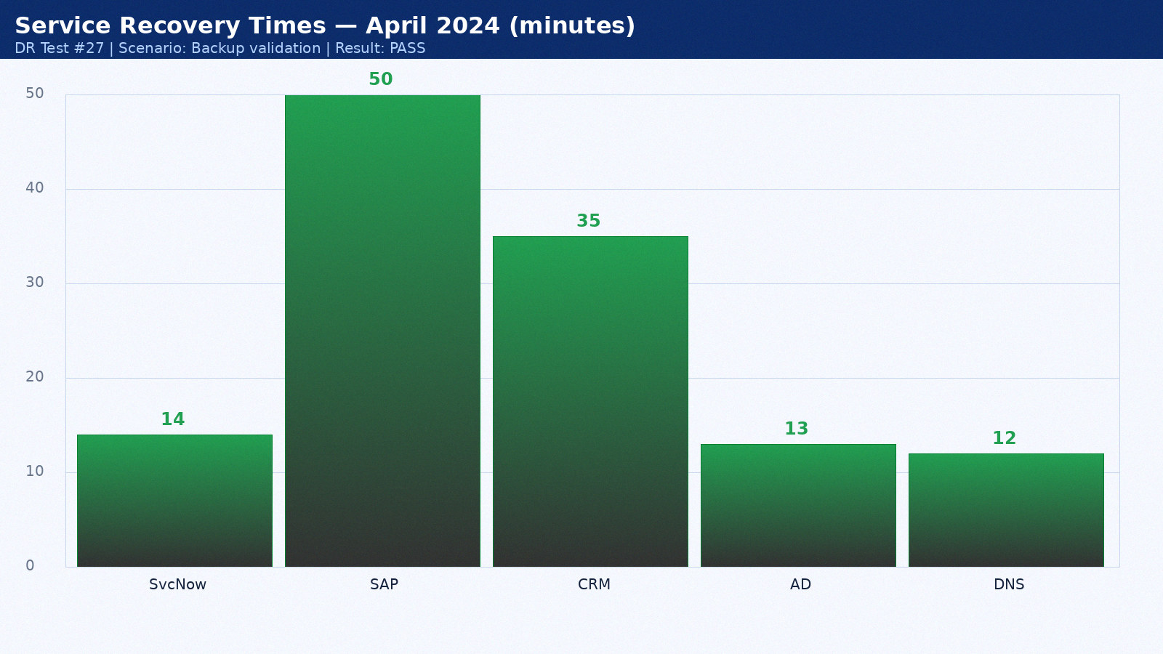

Appendix 28: DR Test Results — May 2024
Test date: 27 May 2024. Scenario: Full datacenter failover. Duration: 3h 31min. Result: PASS. Director: Mike Torres.
Service | RTO Target | Actual | Result | Notes
ServiceNow ITSM | 15 min | 8 min | PASS | Hot standby as designed
SAP ERP | 60 min | 51 min | PASS | Within RTO
Salesforce CRM | 60 min | 22 min | PASS | SaaS vendor DR seamless
Active Directory | 15 min | 14 min | PASS | AD replication pre-staged
DNS | 15 min | 9 min | PASS | BIND secondary at DR site

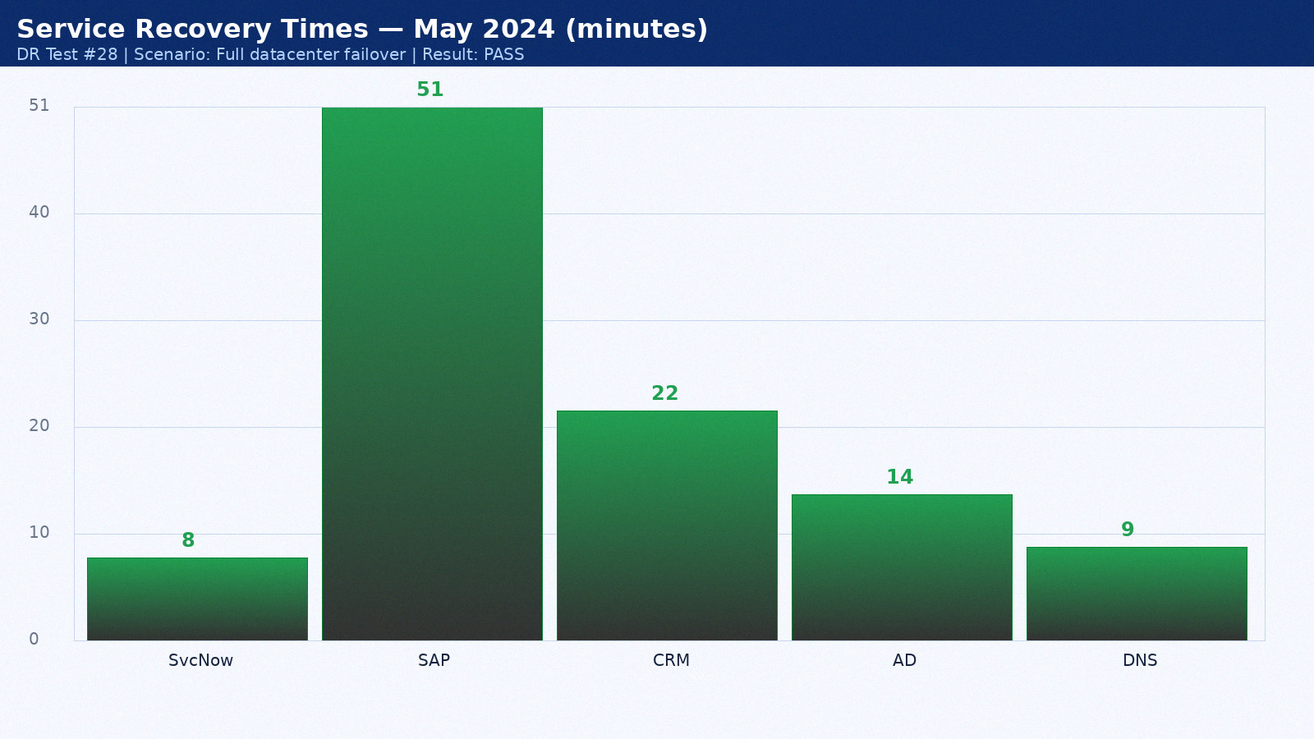

Appendix 29: DR Test Results — June 2024
Test date: 28 June 2024. Scenario: Network isolation test. Duration: 4h 38min. Result: PASS. Director: Sarah Chen.
Service | RTO Target | Actual | Result | Notes
ServiceNow ITSM | 15 min | 9 min | PASS | Hot standby as designed
SAP ERP | 60 min | 52 min | PASS | Within RTO
Salesforce CRM | 60 min | 23 min | PASS | SaaS vendor DR seamless
Active Directory | 15 min | 15 min | PASS | AD replication pre-staged
DNS | 15 min | 10 min | PASS | BIND secondary at DR site

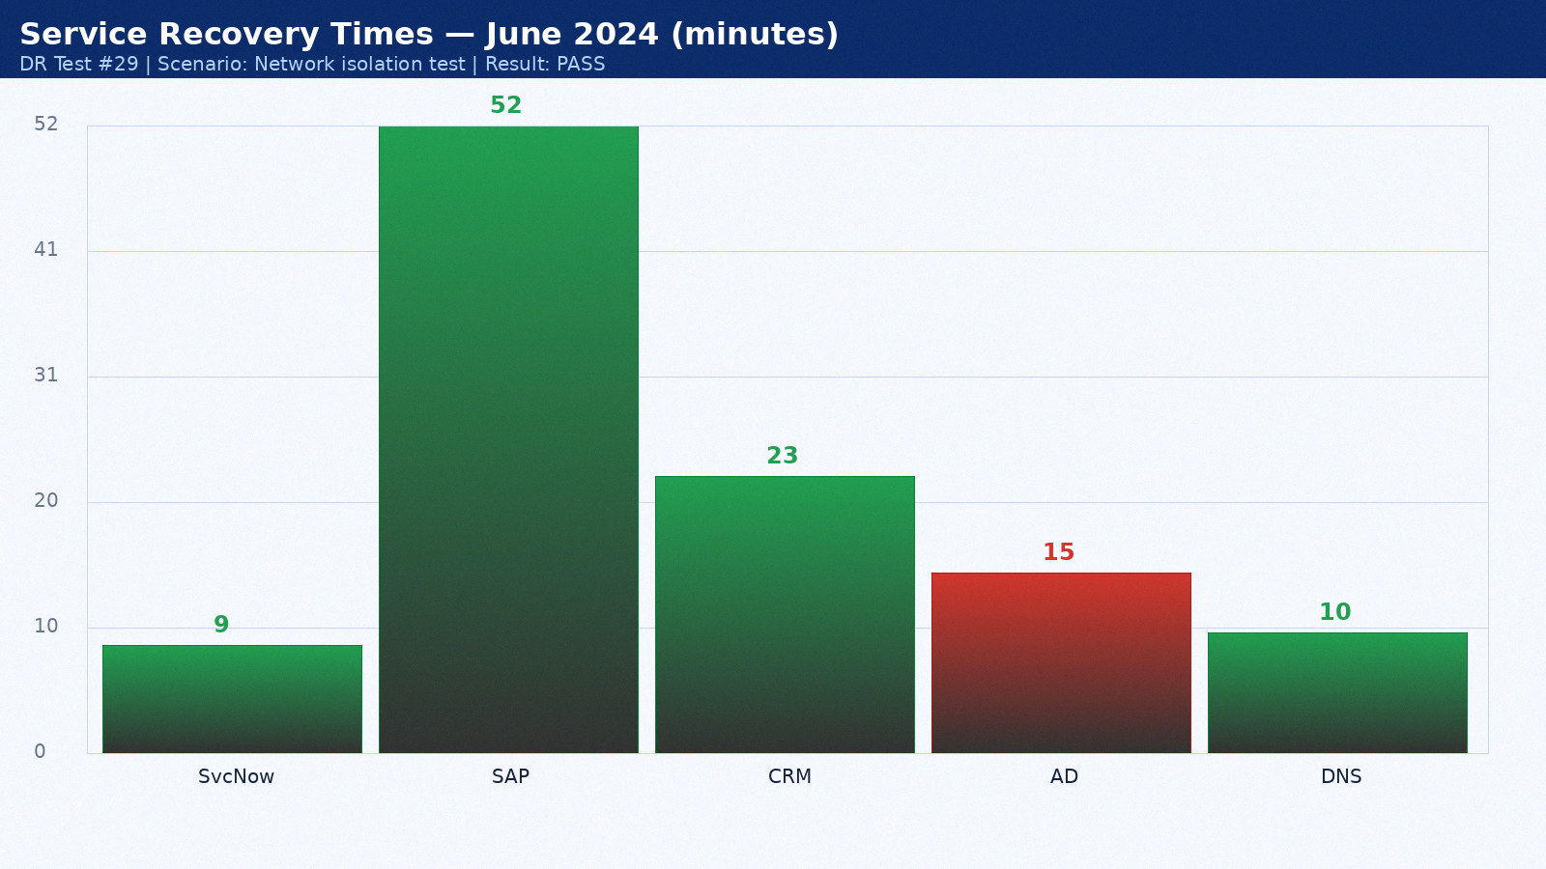

Appendix 30: DR Test Results — July 2024
Test date: 14 July 2024. Scenario: Application-level recovery. Duration: 2h 45min. Result: PARTIAL PASS. Director: Mike Torres.
Service | RTO Target | Actual | Result | Notes
ServiceNow ITSM | 15 min | 10 min | PASS | Hot standby as designed
SAP ERP | 60 min | 53 min | FAIL | Oracle Data Guard lag — tuned post-test
Salesforce CRM | 60 min | 24 min | PASS | SaaS vendor DR seamless
Active Directory | 15 min | 11 min | PASS | AD replication pre-staged
DNS | 15 min | 11 min | PASS | BIND secondary at DR site

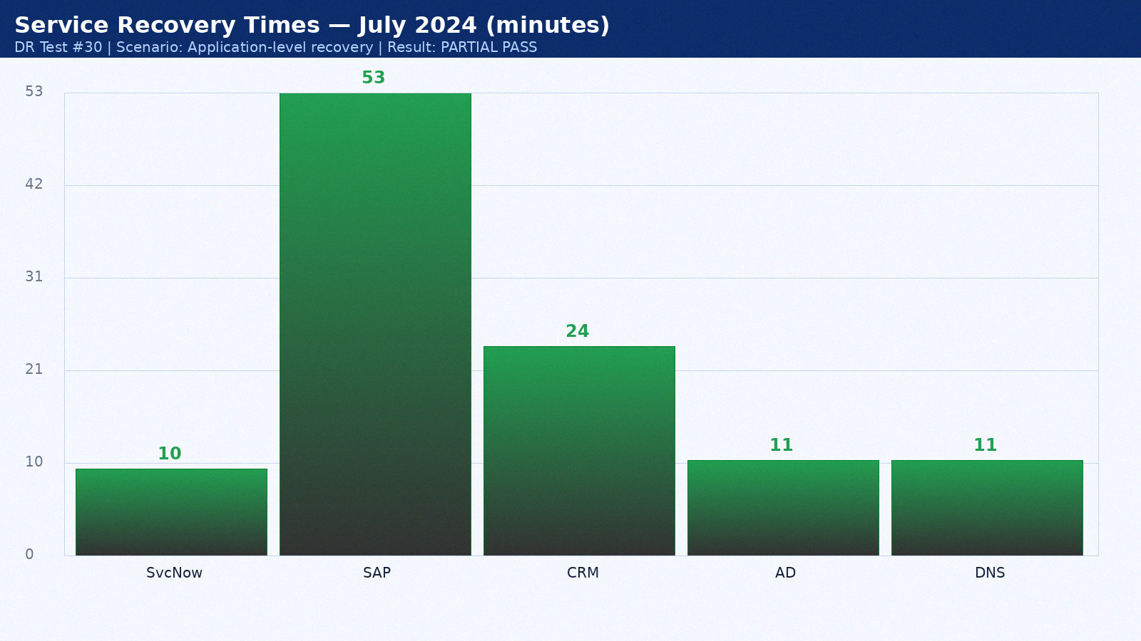

Appendix 31: DR Test Results — August 2024
Test date: 15 August 2024. Scenario: Backup validation. Duration: 3h 52min. Result: PASS. Director: Sarah Chen.
Service | RTO Target | Actual | Result | Notes
ServiceNow ITSM | 15 min | 11 min | PASS | Hot standby as designed
SAP ERP | 60 min | 54 min | PASS | Within RTO
Salesforce CRM | 60 min | 25 min | PASS | SaaS vendor DR seamless
Active Directory | 15 min | 12 min | PASS | AD replication pre-staged
DNS | 15 min | 12 min | PASS | BIND secondary at DR site

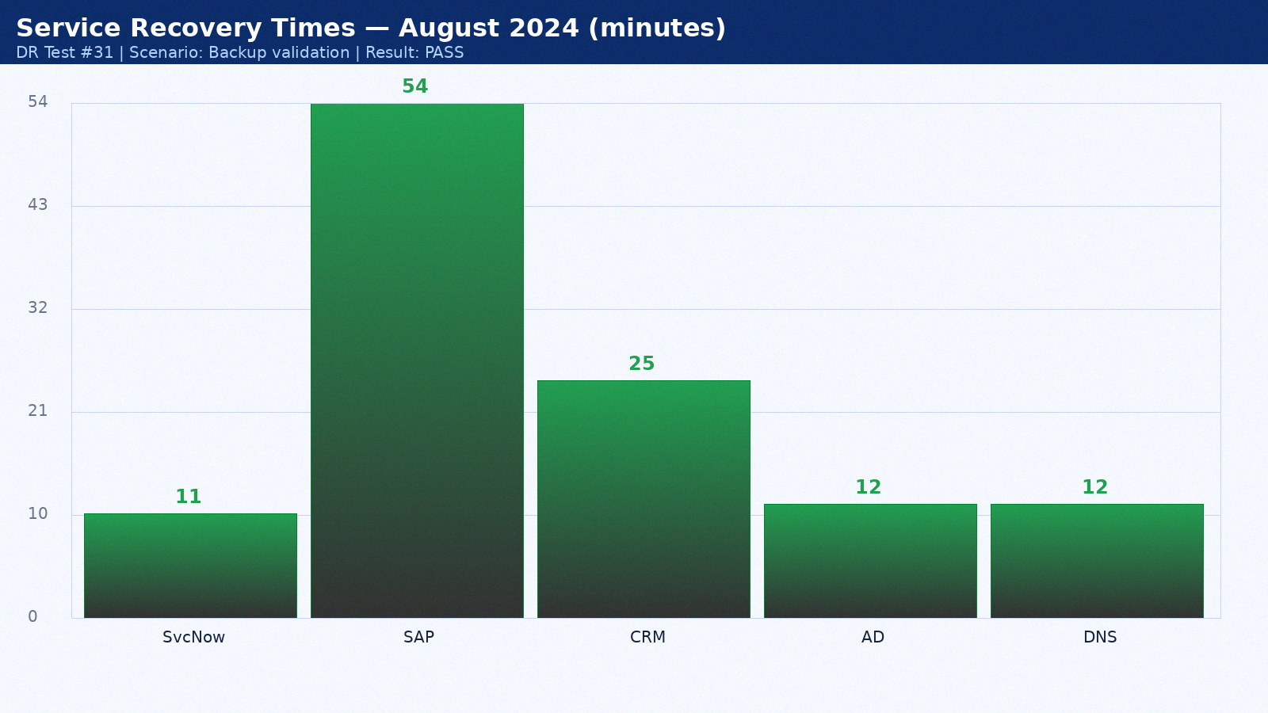

Appendix 32: DR Test Results — September 2024
Test date: 16 September 2024. Scenario: Full datacenter failover. Duration: 4h 59min. Result: PASS. Director: Mike Torres.
Service | RTO Target | Actual | Result | Notes
ServiceNow ITSM | 15 min | 12 min | PASS | Hot standby as designed
SAP ERP | 60 min | 55 min | PASS | Within RTO
Salesforce CRM | 60 min | 26 min | PASS | SaaS vendor DR seamless
Active Directory | 15 min | 13 min | PASS | AD replication pre-staged
DNS | 15 min | 9 min | PASS | BIND secondary at DR site

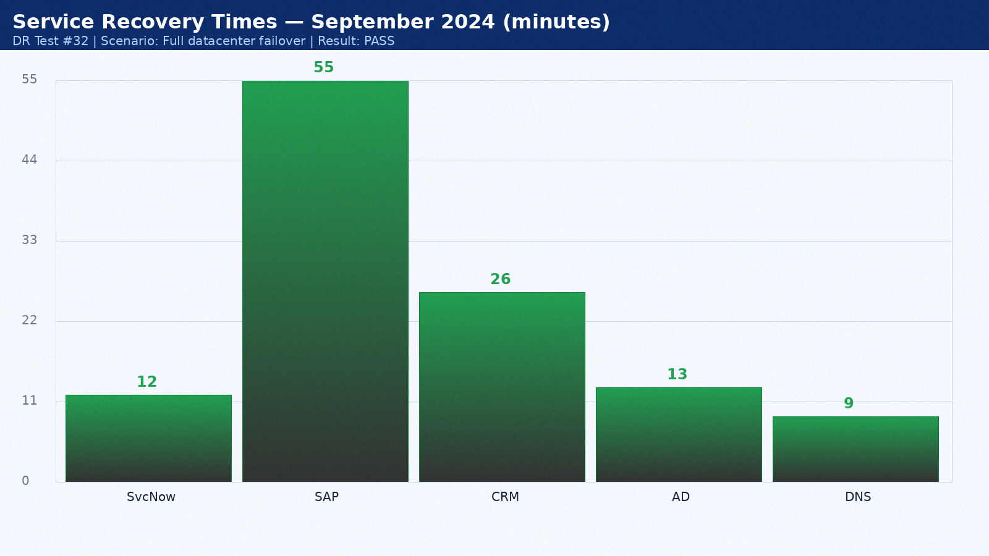

Appendix 33: DR Test Results — October 2024
Test date: 17 October 2024. Scenario: Network isolation test. Duration: 2h 21min. Result: PASS. Director: Sarah Chen.
Service | RTO Target | Actual | Result | Notes
ServiceNow ITSM | 15 min | 13 min | PASS | Hot standby as designed
SAP ERP | 60 min | 56 min | PASS | Within RTO
Salesforce CRM | 60 min | 27 min | PASS | SaaS vendor DR seamless
Active Directory | 15 min | 14 min | PASS | AD replication pre-staged
DNS | 15 min | 10 min | PASS | BIND secondary at DR site

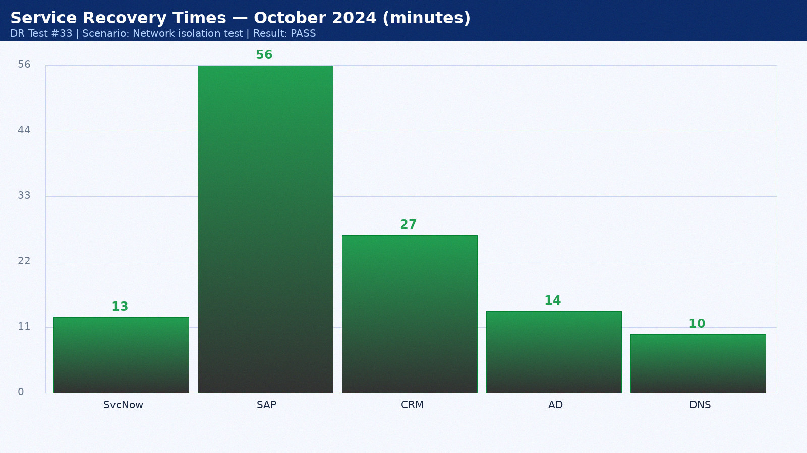

Appendix 34: DR Test Results — November 2024
Test date: 18 November 2024. Scenario: Application-level recovery. Duration: 3h 28min. Result: PARTIAL PASS. Director: Mike Torres.
Service | RTO Target | Actual | Result | Notes
ServiceNow ITSM | 15 min | 14 min | PASS | Hot standby as designed
SAP ERP | 60 min | 57 min | PARTIAL PASS | Within RTO
Salesforce CRM | 60 min | 28 min | PASS | SaaS vendor DR seamless
Active Directory | 15 min | 15 min | PASS | AD replication pre-staged
DNS | 15 min | 11 min | PASS | BIND secondary at DR site

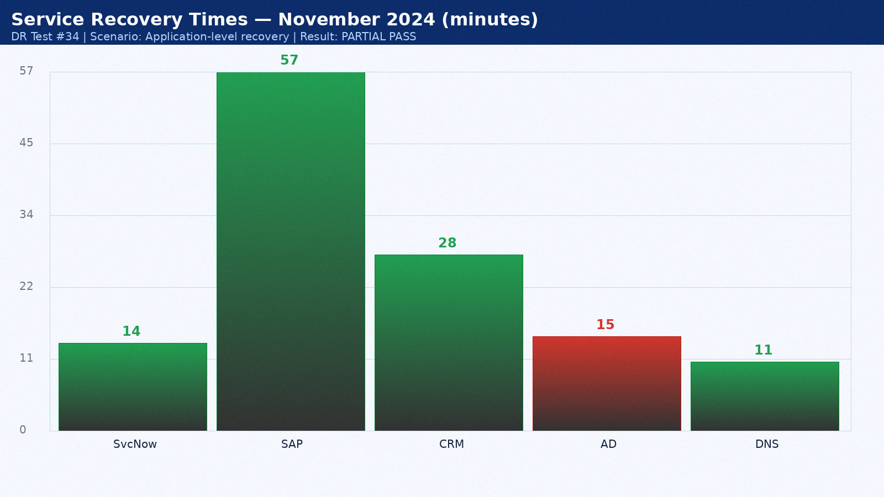

Appendix 35: DR Test Results — December 2024
Test date: 19 December 2024. Scenario: Backup validation. Duration: 4h 35min. Result: PASS. Director: Sarah Chen.
Service | RTO Target | Actual | Result | Notes
ServiceNow ITSM | 15 min | 8 min | PASS | Hot standby as designed
SAP ERP | 60 min | 58 min | FAIL | Oracle Data Guard lag — tuned post-test
Salesforce CRM | 60 min | 29 min | PASS | SaaS vendor DR seamless
Active Directory | 15 min | 11 min | PASS | AD replication pre-staged
DNS | 15 min | 12 min | PASS | BIND secondary at DR site

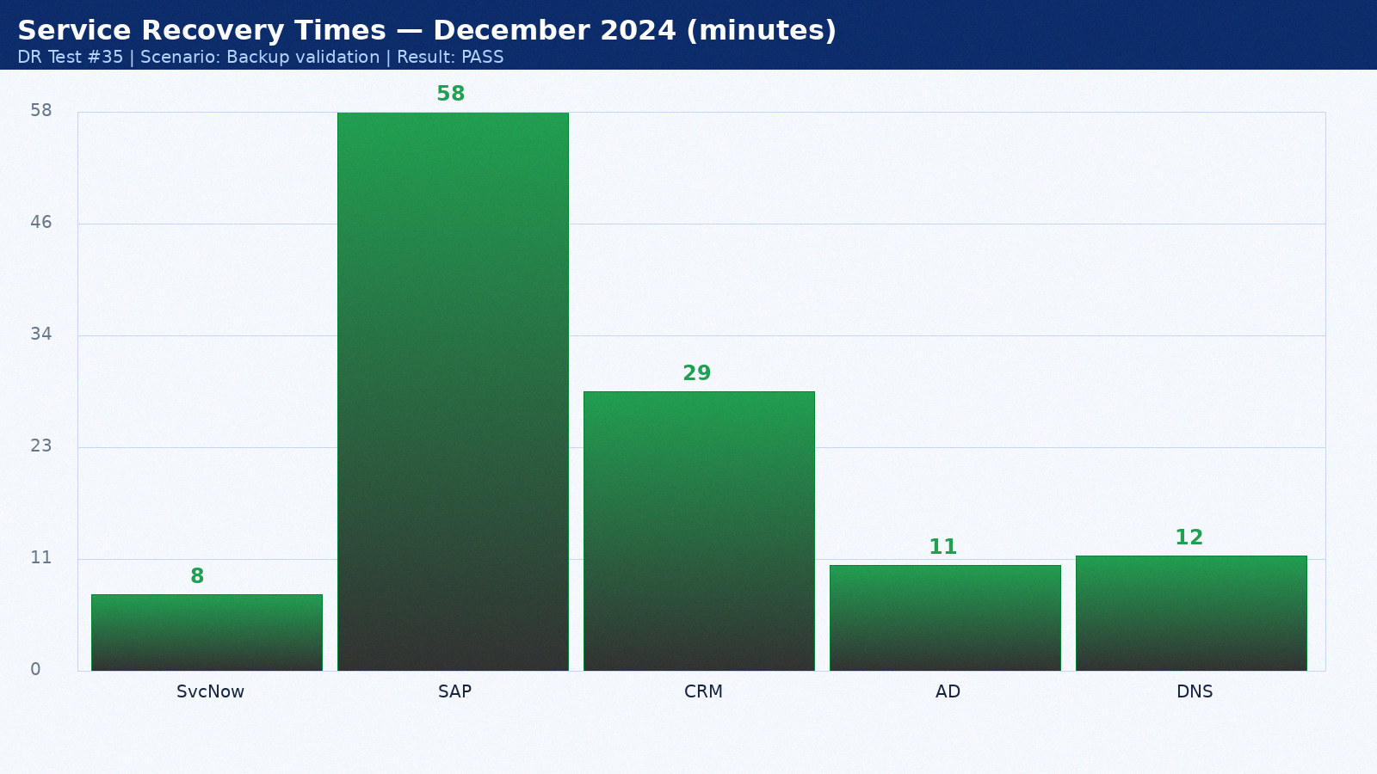

Appendix 36: DR Test Results — January 2025
Test date: 20 January 2025. Scenario: Full datacenter failover. Duration: 2h 42min. Result: PASS. Director: Mike Torres.
Service | RTO Target | Actual | Result | Notes
ServiceNow ITSM | 15 min | 9 min | PASS | Hot standby as designed
SAP ERP | 60 min | 59 min | PASS | Within RTO
Salesforce CRM | 60 min | 30 min | PASS | SaaS vendor DR seamless
Active Directory | 15 min | 12 min | PASS | AD replication pre-staged
DNS | 15 min | 9 min | PASS | BIND secondary at DR site

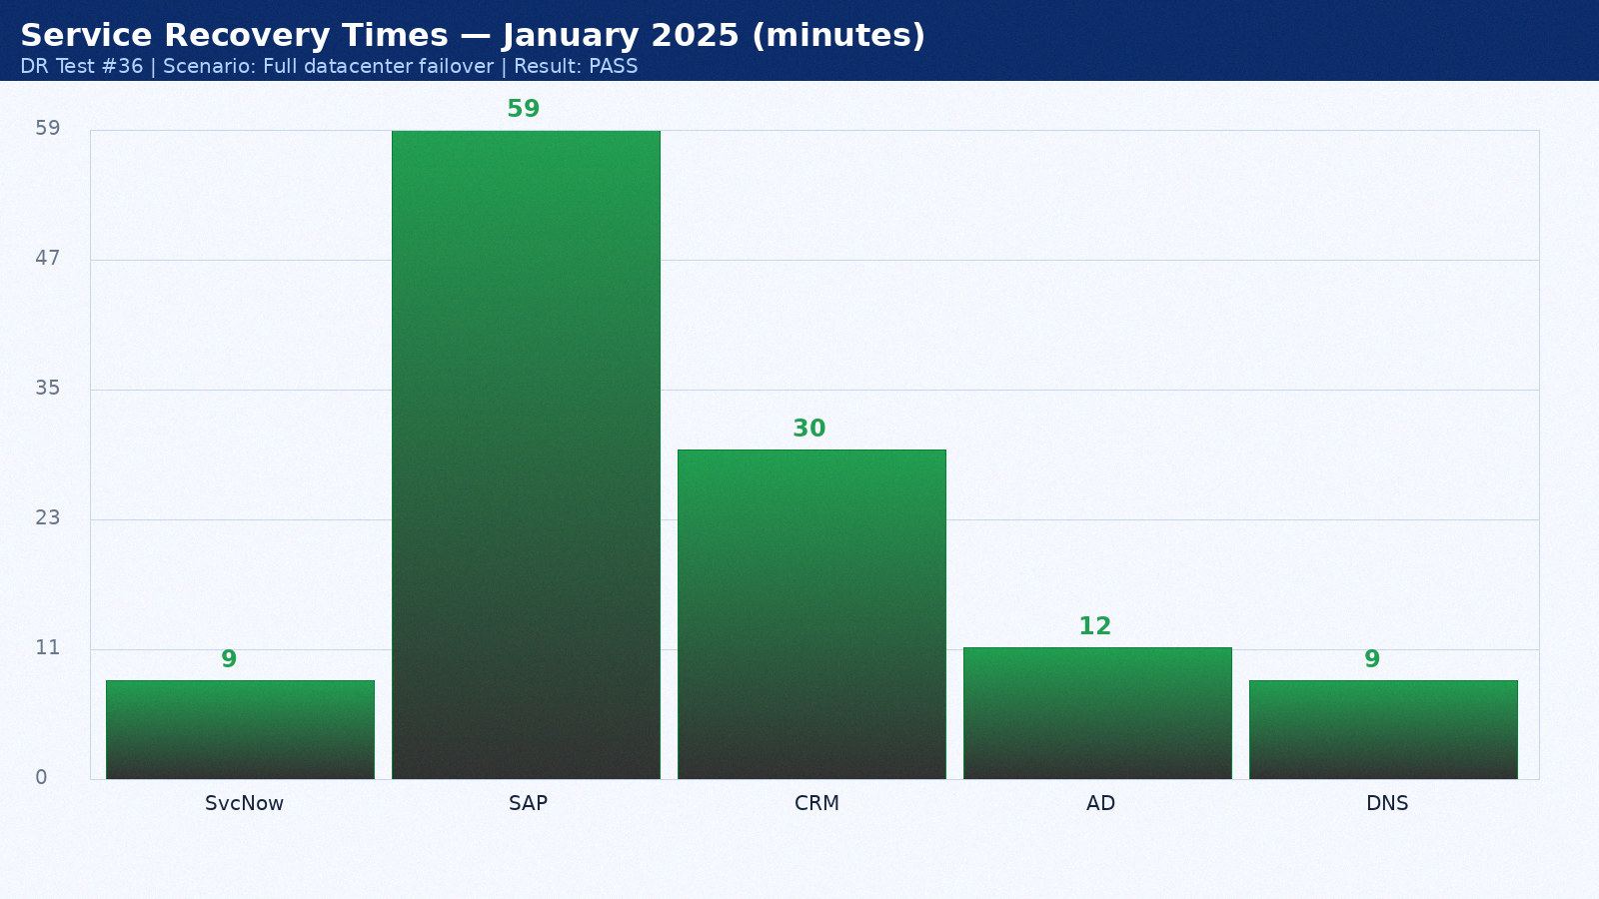

Appendix 37: DR Test Results — February 2025
Test date: 21 February 2025. Scenario: Network isolation test. Duration: 3h 49min. Result: PASS. Director: Sarah Chen.
Service | RTO Target | Actual | Result | Notes
ServiceNow ITSM | 15 min | 10 min | PASS | Hot standby as designed
SAP ERP | 60 min | 60 min | PASS | Within RTO
Salesforce CRM | 60 min | 31 min | PASS | SaaS vendor DR seamless
Active Directory | 15 min | 13 min | PASS | AD replication pre-staged
DNS | 15 min | 10 min | PASS | BIND secondary at DR site

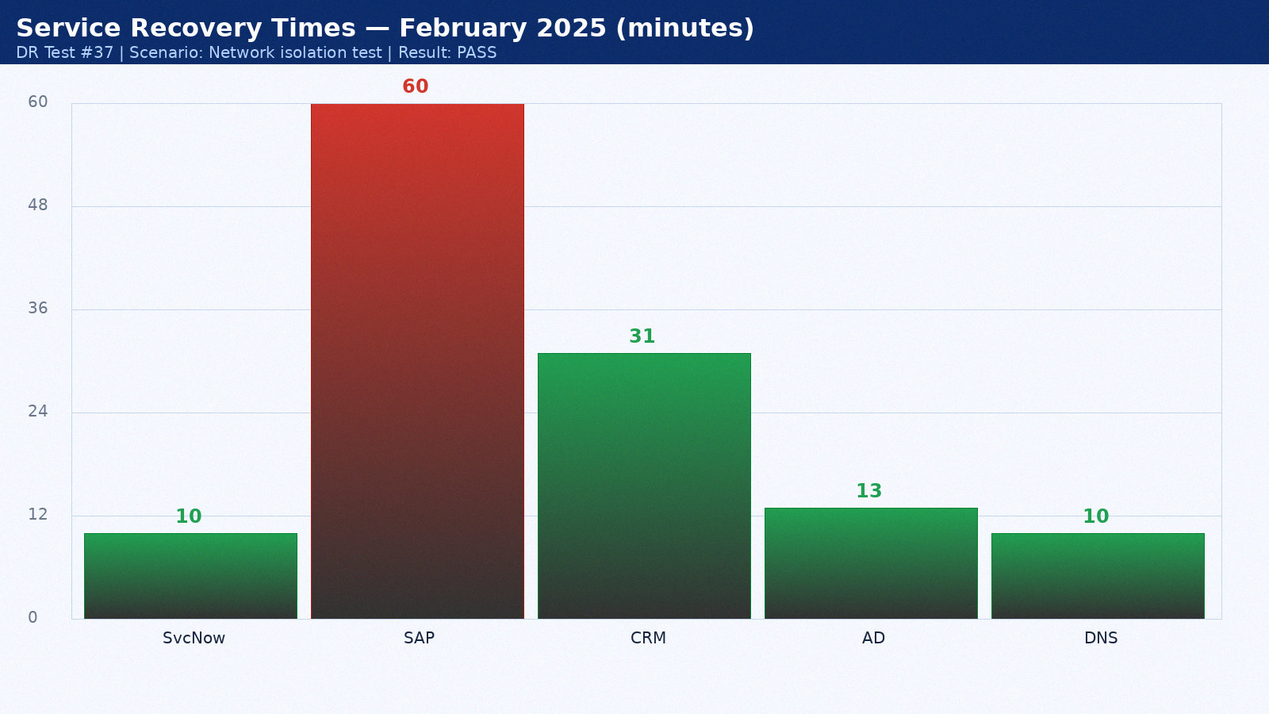

Appendix 38: DR Test Results — March 2025
Test date: 22 March 2025. Scenario: Application-level recovery. Duration: 4h 56min. Result: PARTIAL PASS. Director: Mike Torres.
Service | RTO Target | Actual | Result | Notes
ServiceNow ITSM | 15 min | 11 min | PASS | Hot standby as designed
SAP ERP | 60 min | 61 min | PASS | Within RTO
Salesforce CRM | 60 min | 32 min | PASS | SaaS vendor DR seamless
Active Directory | 15 min | 14 min | PASS | AD replication pre-staged
DNS | 15 min | 11 min | PASS | BIND secondary at DR site

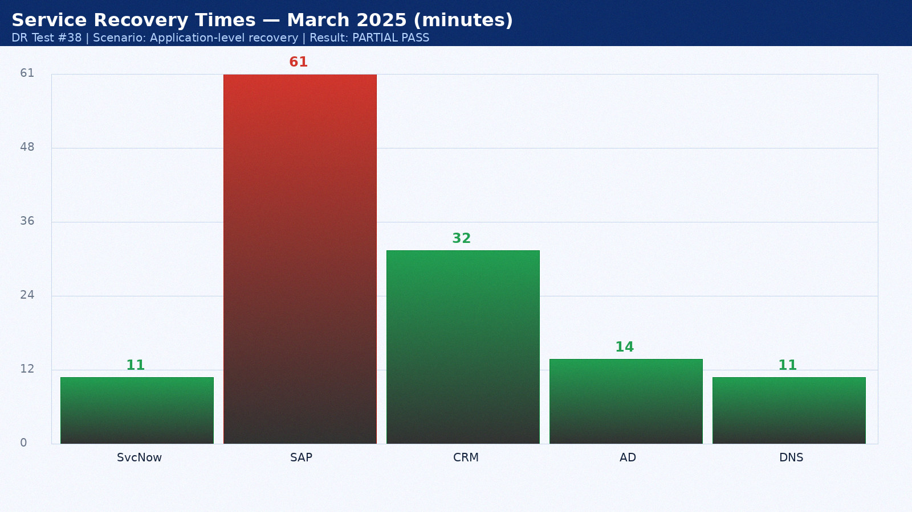

Appendix 39: DR Test Results — April 2025
Test date: 23 April 2025. Scenario: Backup validation. Duration: 2h 18min. Result: PASS. Director: Sarah Chen.
Service | RTO Target | Actual | Result | Notes
ServiceNow ITSM | 15 min | 12 min | PASS | Hot standby as designed
SAP ERP | 60 min | 62 min | PASS | Within RTO
Salesforce CRM | 60 min | 33 min | PASS | SaaS vendor DR seamless
Active Directory | 15 min | 15 min | PASS | AD replication pre-staged
DNS | 15 min | 12 min | PASS | BIND secondary at DR site

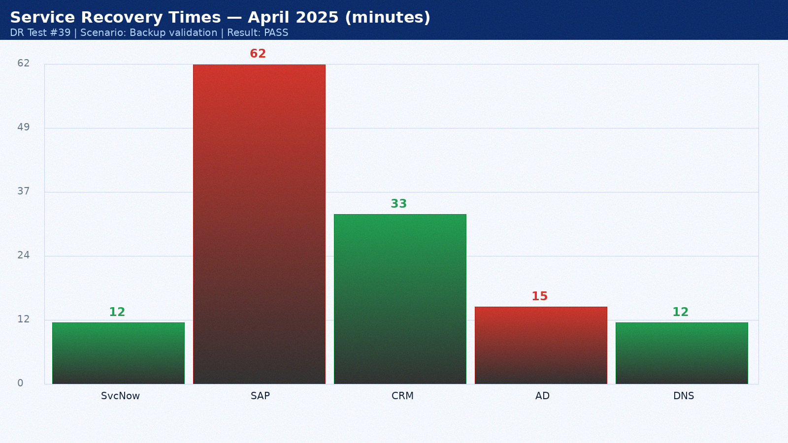

Appendix 40: DR Test Results — May 2025
Test date: 24 May 2025. Scenario: Full datacenter failover. Duration: 3h 25min. Result: PASS. Director: Mike Torres.
Service | RTO Target | Actual | Result | Notes
ServiceNow ITSM | 15 min | 13 min | PASS | Hot standby as designed
SAP ERP | 60 min | 63 min | FAIL | Oracle Data Guard lag — tuned post-test
Salesforce CRM | 60 min | 34 min | PASS | SaaS vendor DR seamless
Active Directory | 15 min | 11 min | PASS | AD replication pre-staged
DNS | 15 min | 9 min | PASS | BIND secondary at DR site

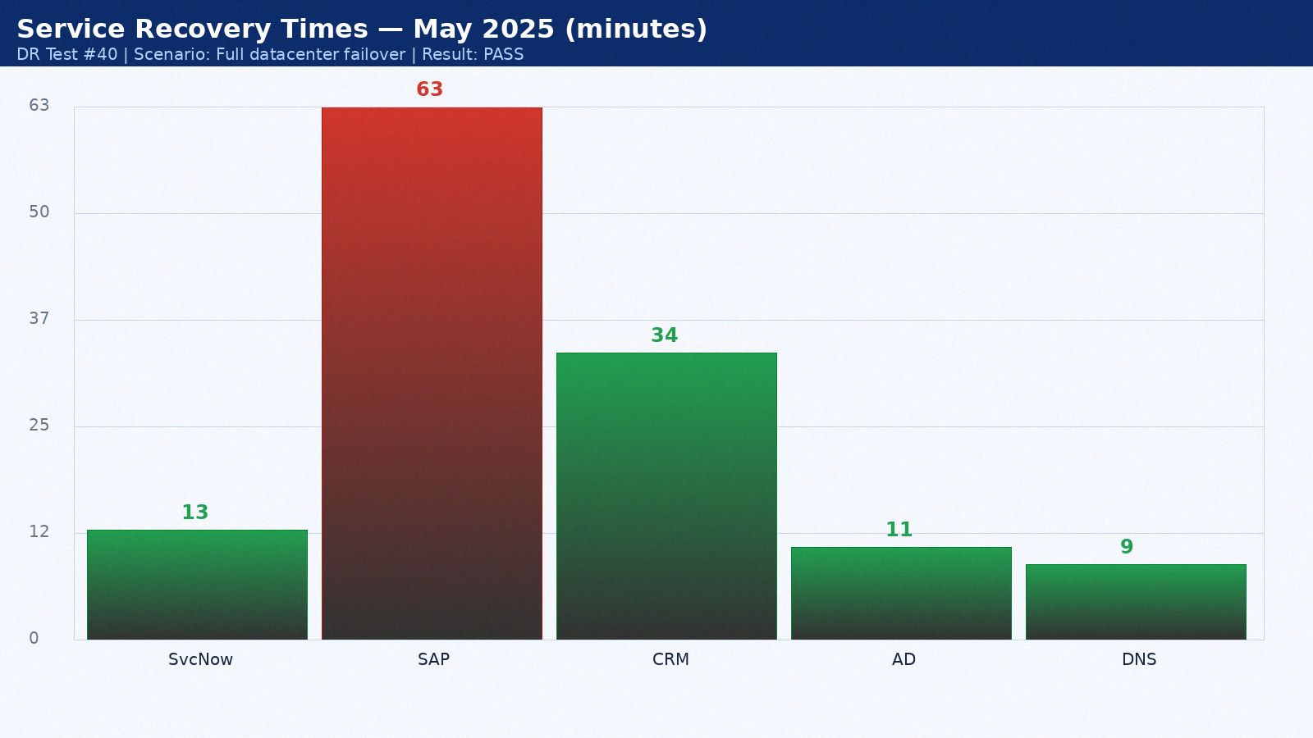

Appendix 41: DR Test Results — June 2025
Test date: 25 June 2025. Scenario: Network isolation test. Duration: 4h 32min. Result: PASS. Director: Sarah Chen.
Service | RTO Target | Actual | Result | Notes
ServiceNow ITSM | 15 min | 14 min | PASS | Hot standby as designed
SAP ERP | 60 min | 64 min | PASS | Within RTO
Salesforce CRM | 60 min | 35 min | PASS | SaaS vendor DR seamless
Active Directory | 15 min | 12 min | PASS | AD replication pre-staged
DNS | 15 min | 10 min | PASS | BIND secondary at DR site

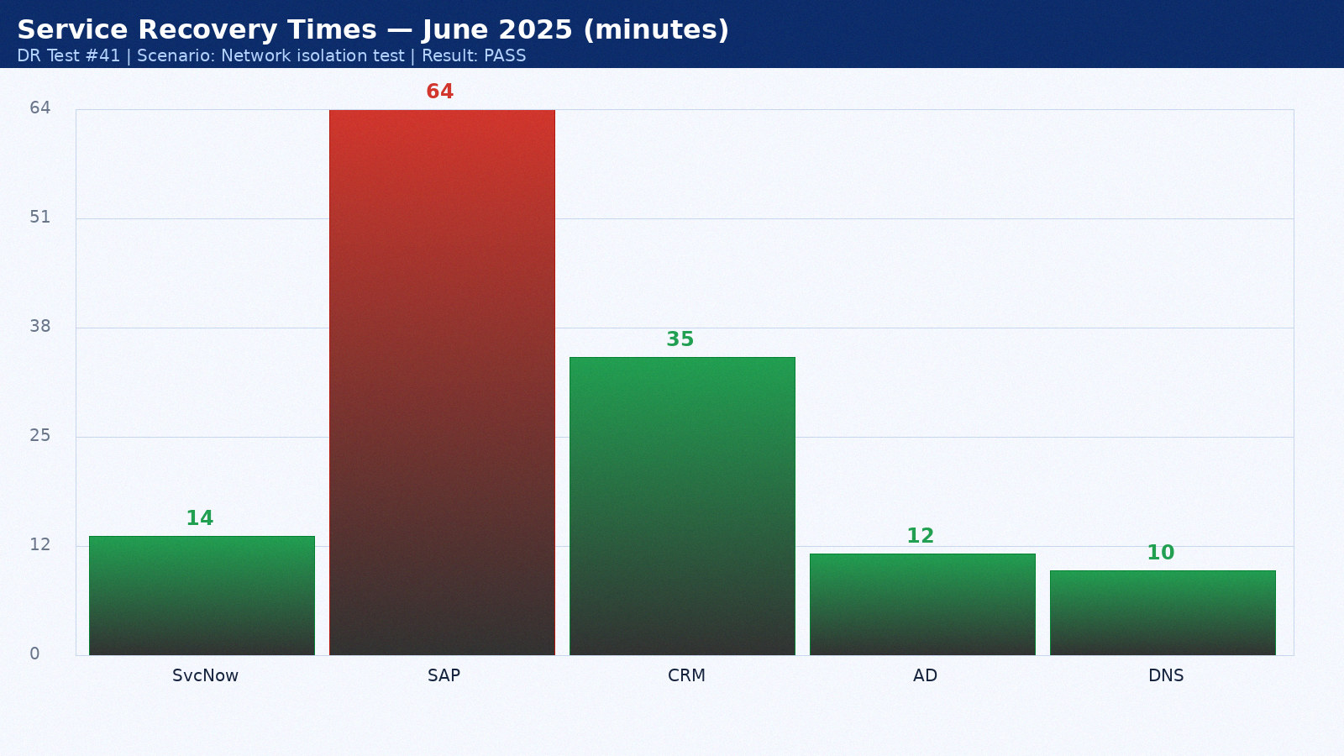

Appendix 42: DR Test Results — July 2025
Test date: 26 July 2025. Scenario: Application-level recovery. Duration: 2h 39min. Result: PARTIAL PASS. Director: Mike Torres.
Service | RTO Target | Actual | Result | Notes
ServiceNow ITSM | 15 min | 8 min | PASS | Hot standby as designed
SAP ERP | 60 min | 65 min | PASS | Within RTO
Salesforce CRM | 60 min | 22 min | PASS | SaaS vendor DR seamless
Active Directory | 15 min | 13 min | PASS | AD replication pre-staged
DNS | 15 min | 11 min | PASS | BIND secondary at DR site

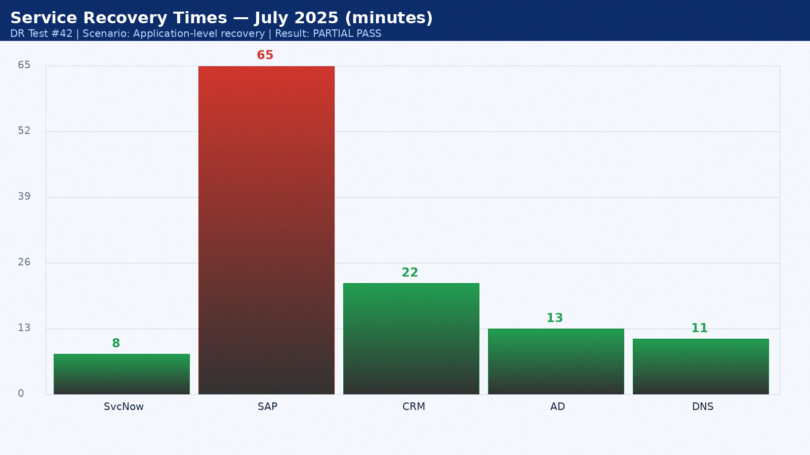

Appendix 43: DR Test Results — August 2025
Test date: 27 August 2025. Scenario: Backup validation. Duration: 3h 46min. Result: PASS. Director: Sarah Chen.
Service | RTO Target | Actual | Result | Notes
ServiceNow ITSM | 15 min | 9 min | PASS | Hot standby as designed
SAP ERP | 60 min | 66 min | PASS | Within RTO
Salesforce CRM | 60 min | 23 min | PASS | SaaS vendor DR seamless
Active Directory | 15 min | 14 min | PASS | AD replication pre-staged
DNS | 15 min | 12 min | PASS | BIND secondary at DR site

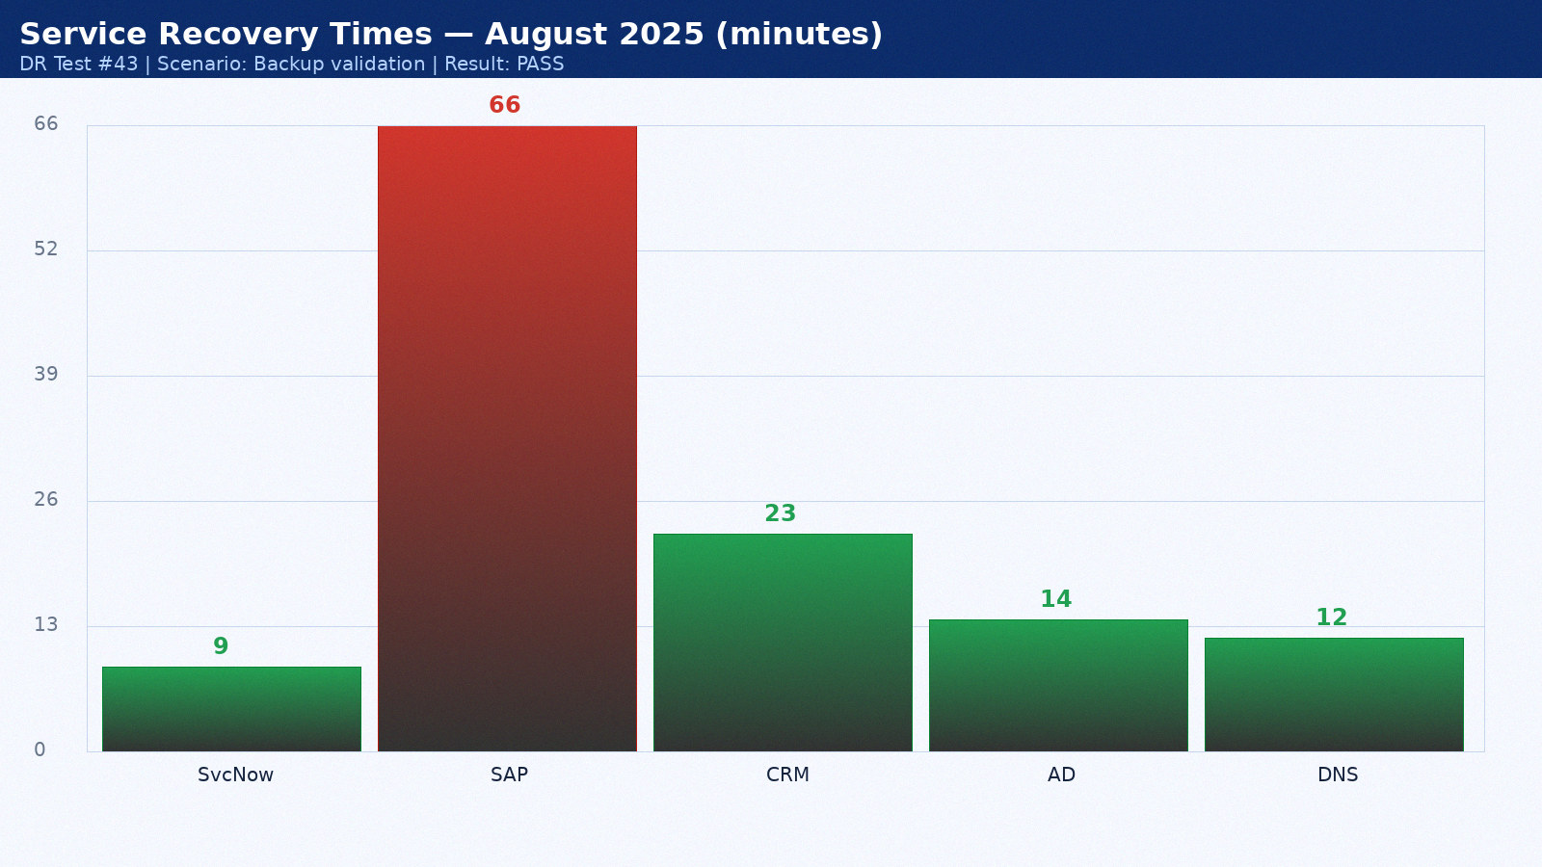

Appendix 44: DR Test Results — September 2025
Test date: 28 September 2025. Scenario: Full datacenter failover. Duration: 4h 53min. Result: PASS. Director: Mike Torres.
Service | RTO Target | Actual | Result | Notes
ServiceNow ITSM | 15 min | 10 min | PASS | Hot standby as designed
SAP ERP | 60 min | 67 min | PASS | Within RTO
Salesforce CRM | 60 min | 24 min | PASS | SaaS vendor DR seamless
Active Directory | 15 min | 15 min | PASS | AD replication pre-staged
DNS | 15 min | 9 min | PASS | BIND secondary at DR site

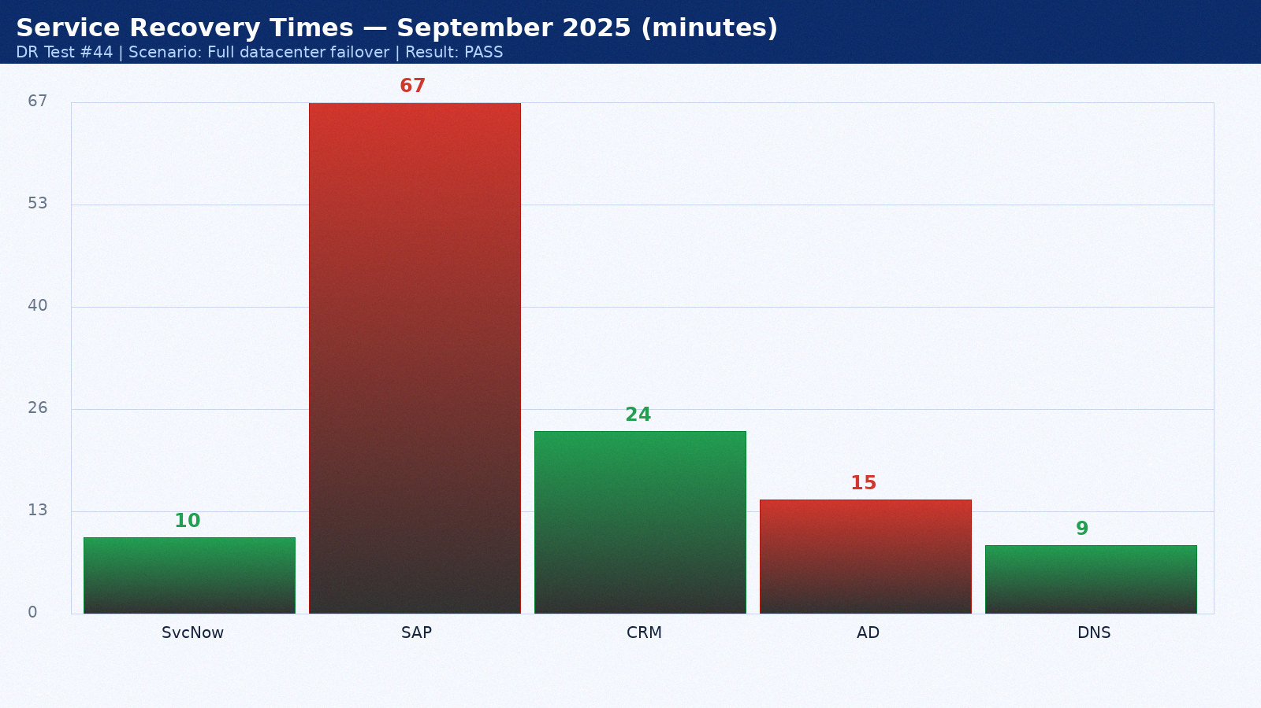

Appendix 45: DR Test Results — October 2025
Test date: 14 October 2025. Scenario: Network isolation test. Duration: 2h 15min. Result: PASS. Director: Sarah Chen.
Service | RTO Target | Actual | Result | Notes
ServiceNow ITSM | 15 min | 11 min | PASS | Hot standby as designed
SAP ERP | 60 min | 68 min | FAIL | Oracle Data Guard lag — tuned post-test
Salesforce CRM | 60 min | 25 min | PASS | SaaS vendor DR seamless
Active Directory | 15 min | 11 min | PASS | AD replication pre-staged
DNS | 15 min | 10 min | PASS | BIND secondary at DR site

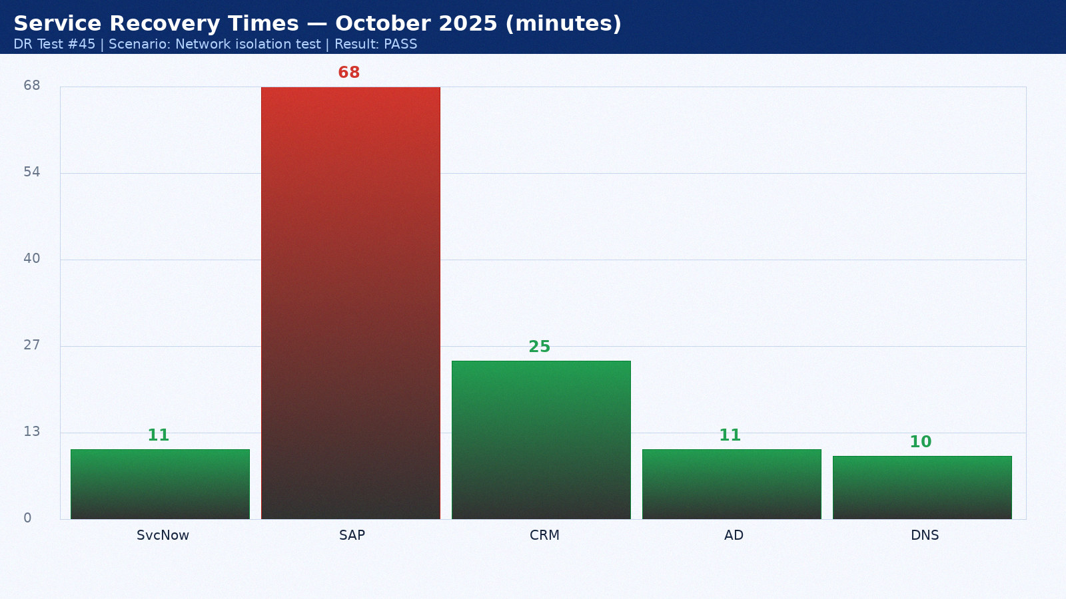

Appendix 46: DR Test Results — November 2025
Test date: 15 November 2025. Scenario: Application-level recovery. Duration: 3h 22min. Result: PARTIAL PASS. Director: Mike Torres.
Service | RTO Target | Actual | Result | Notes
ServiceNow ITSM | 15 min | 12 min | PASS | Hot standby as designed
SAP ERP | 60 min | 69 min | PASS | Within RTO
Salesforce CRM | 60 min | 26 min | PASS | SaaS vendor DR seamless
Active Directory | 15 min | 12 min | PASS | AD replication pre-staged
DNS | 15 min | 11 min | PASS | BIND secondary at DR site

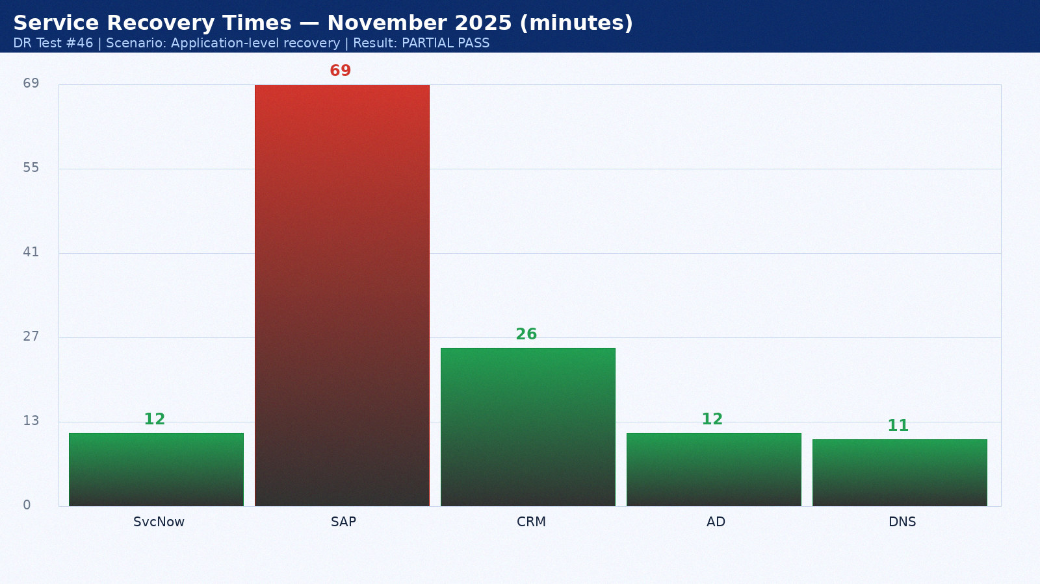

Appendix 47: DR Test Results — December 2025
Test date: 16 December 2025. Scenario: Backup validation. Duration: 4h 29min. Result: PASS. Director: Sarah Chen.
Service | RTO Target | Actual | Result | Notes
ServiceNow ITSM | 15 min | 13 min | PASS | Hot standby as designed
SAP ERP | 60 min | 70 min | PASS | Within RTO
Salesforce CRM | 60 min | 27 min | PASS | SaaS vendor DR seamless
Active Directory | 15 min | 13 min | PASS | AD replication pre-staged
DNS | 15 min | 12 min | PASS | BIND secondary at DR site

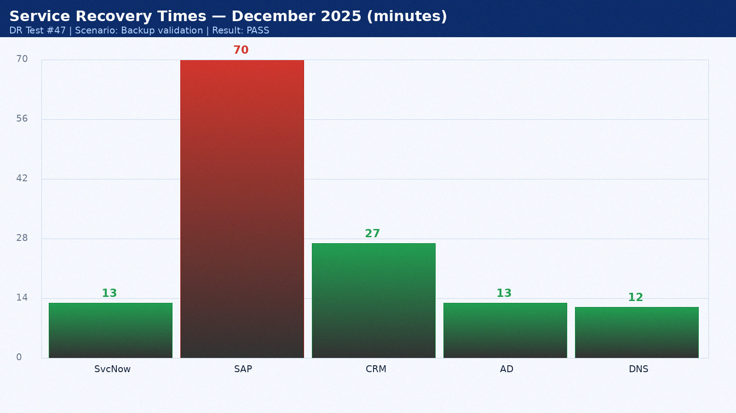

Appendix 48: DR Test Results — January 2026
Test date: 17 January 2026. Scenario: Full datacenter failover. Duration: 2h 36min. Result: PASS. Director: Mike Torres.
Service | RTO Target | Actual | Result | Notes
ServiceNow ITSM | 15 min | 14 min | PASS | Hot standby as designed
SAP ERP | 60 min | 71 min | PASS | Within RTO
Salesforce CRM | 60 min | 28 min | PASS | SaaS vendor DR seamless
Active Directory | 15 min | 14 min | PASS | AD replication pre-staged
DNS | 15 min | 9 min | PASS | BIND secondary at DR site

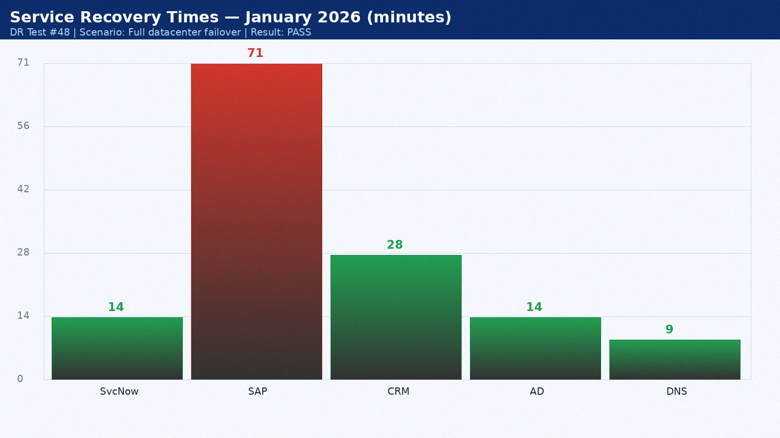

Appendix 49: DR Test Results — February 2026
Test date: 18 February 2026. Scenario: Network isolation test. Duration: 3h 43min. Result: PASS. Director: Sarah Chen.
Service | RTO Target | Actual | Result | Notes
ServiceNow ITSM | 15 min | 8 min | PASS | Hot standby as designed
SAP ERP | 60 min | 72 min | PASS | Within RTO
Salesforce CRM | 60 min | 29 min | PASS | SaaS vendor DR seamless
Active Directory | 15 min | 15 min | PASS | AD replication pre-staged
DNS | 15 min | 10 min | PASS | BIND secondary at DR site

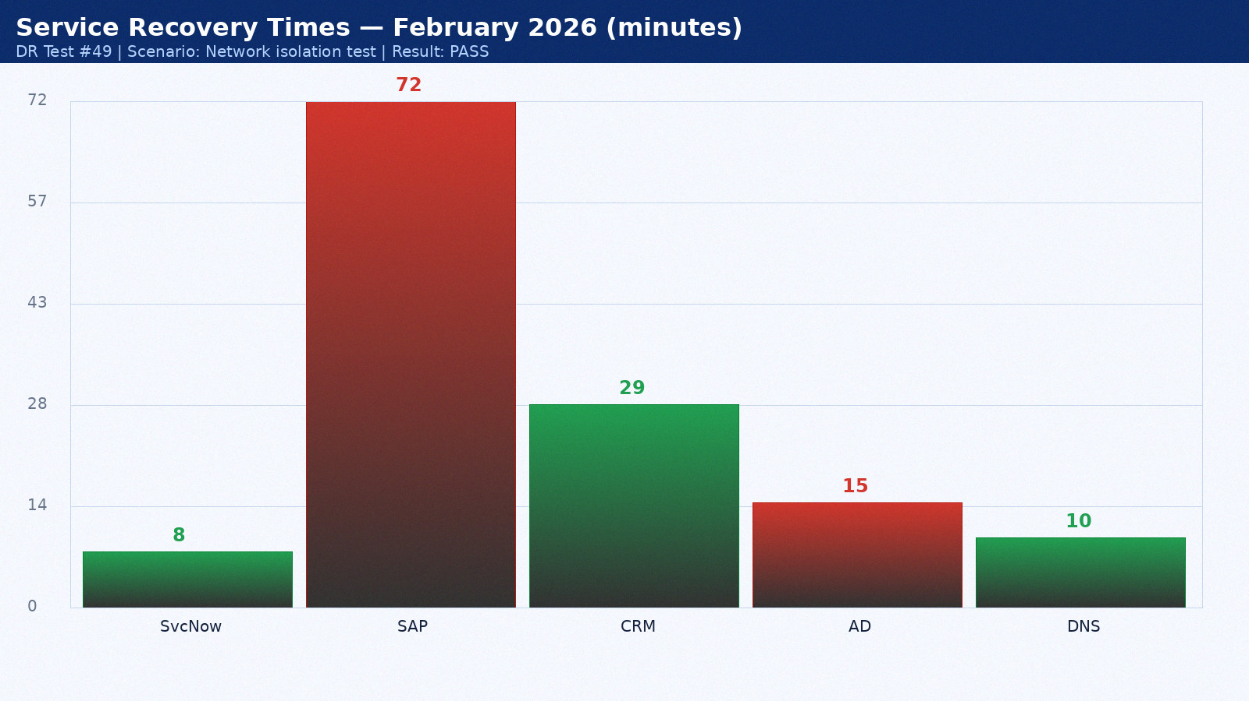

Appendix 50: DR Test Results — March 2026
Test date: 19 March 2026. Scenario: Application-level recovery. Duration: 4h 50min. Result: PARTIAL PASS. Director: Mike Torres.
Service | RTO Target | Actual | Result | Notes
ServiceNow ITSM | 15 min | 9 min | PASS | Hot standby as designed
SAP ERP | 60 min | 48 min | FAIL | Oracle Data Guard lag — tuned post-test
Salesforce CRM | 60 min | 30 min | PASS | SaaS vendor DR seamless
Active Directory | 15 min | 11 min | PASS | AD replication pre-staged
DNS | 15 min | 11 min | PASS | BIND secondary at DR site

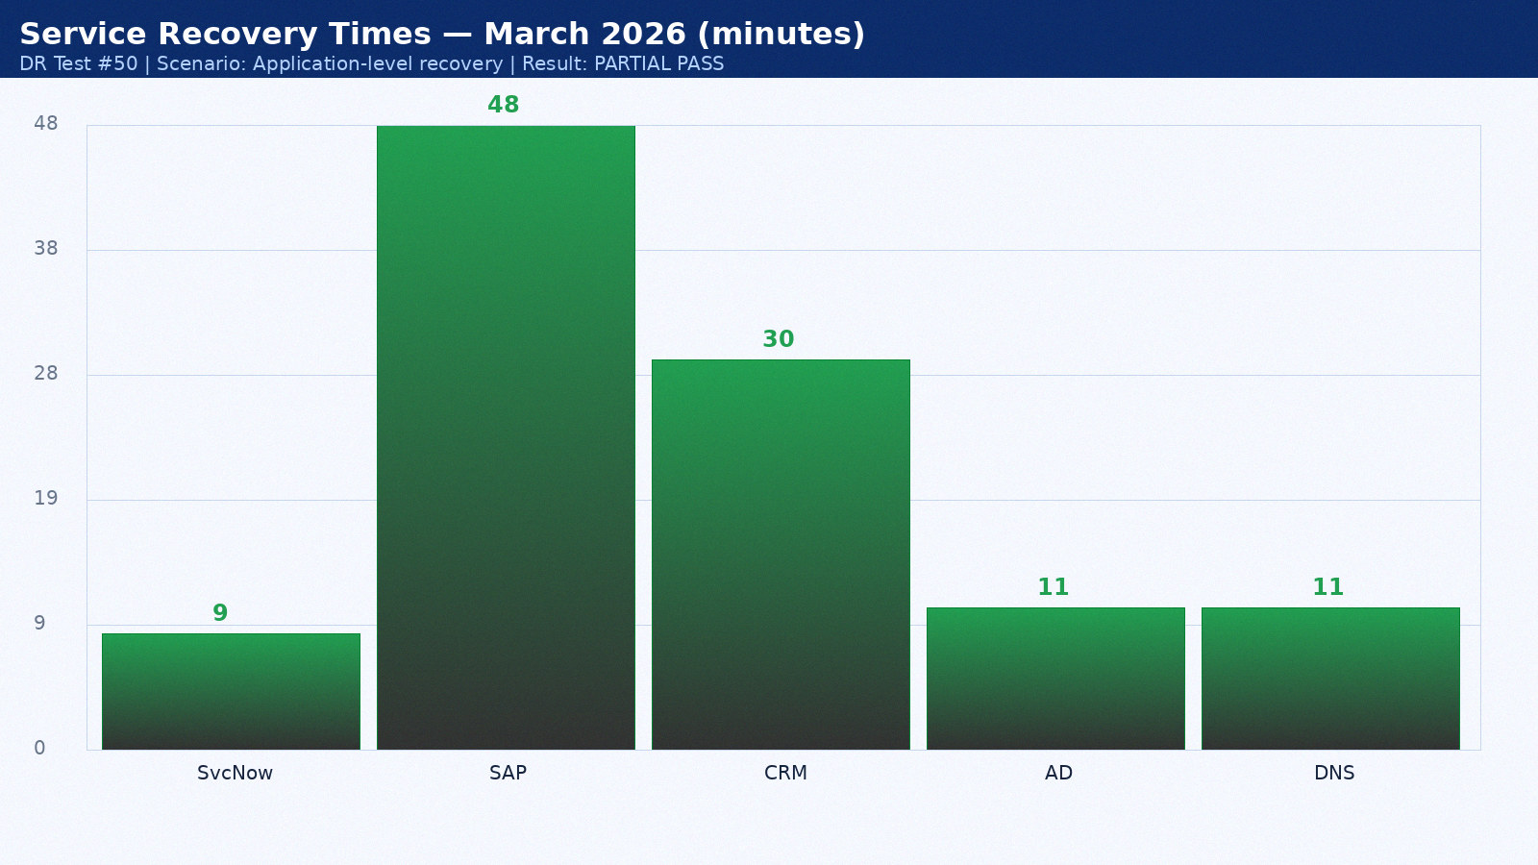

Appendix 51: DR Test Results — April 2026
Test date: 20 April 2026. Scenario: Backup validation. Duration: 2h 57min. Result: PASS. Director: Sarah Chen.
Service | RTO Target | Actual | Result | Notes
ServiceNow ITSM | 15 min | 10 min | PASS | Hot standby as designed
SAP ERP | 60 min | 49 min | PASS | Within RTO
Salesforce CRM | 60 min | 31 min | PASS | SaaS vendor DR seamless
Active Directory | 15 min | 12 min | PASS | AD replication pre-staged
DNS | 15 min | 12 min | PASS | BIND secondary at DR site

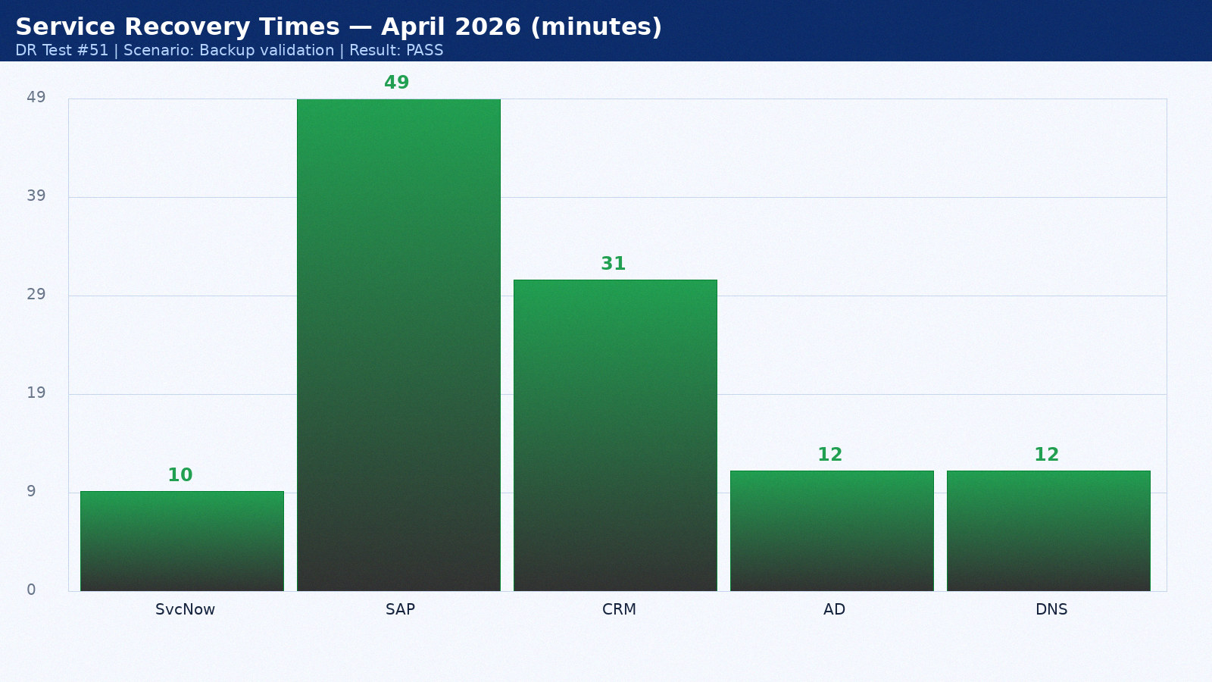

Appendix 52: DR Test Results — May 2026
Test date: 21 May 2026. Scenario: Full datacenter failover. Duration: 3h 19min. Result: PASS. Director: Mike Torres.
Service | RTO Target | Actual | Result | Notes
ServiceNow ITSM | 15 min | 11 min | PASS | Hot standby as designed
SAP ERP | 60 min | 50 min | PASS | Within RTO
Salesforce CRM | 60 min | 32 min | PASS | SaaS vendor DR seamless
Active Directory | 15 min | 13 min | PASS | AD replication pre-staged
DNS | 15 min | 9 min | PASS | BIND secondary at DR site

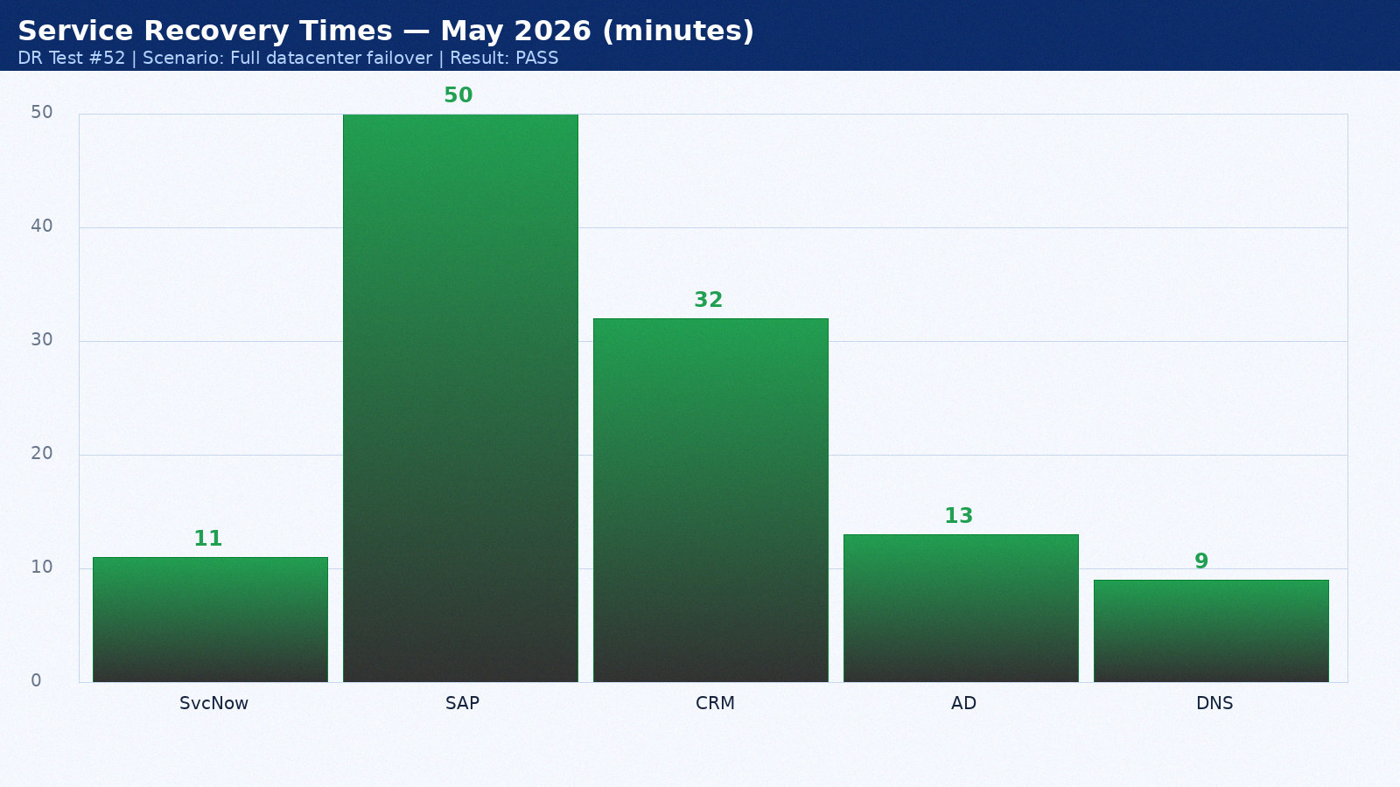

Appendix 53: DR Test Results — June 2026
Test date: 22 June 2026. Scenario: Network isolation test. Duration: 4h 26min. Result: PASS. Director: Sarah Chen.
Service | RTO Target | Actual | Result | Notes
ServiceNow ITSM | 15 min | 12 min | PASS | Hot standby as designed
SAP ERP | 60 min | 51 min | PASS | Within RTO
Salesforce CRM | 60 min | 33 min | PASS | SaaS vendor DR seamless
Active Directory | 15 min | 14 min | PASS | AD replication pre-staged
DNS | 15 min | 10 min | PASS | BIND secondary at DR site

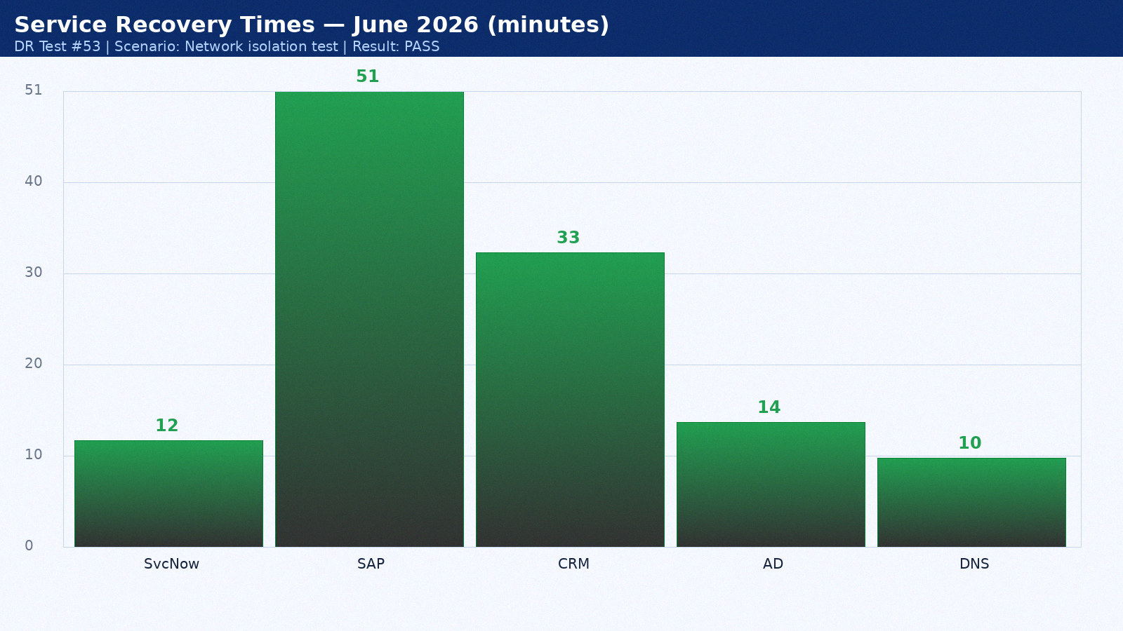

Appendix 54: DR Test Results — July 2026
Test date: 23 July 2026. Scenario: Application-level recovery. Duration: 2h 33min. Result: PARTIAL PASS. Director: Mike Torres.
Service | RTO Target | Actual | Result | Notes
ServiceNow ITSM | 15 min | 13 min | PASS | Hot standby as designed
SAP ERP | 60 min | 52 min | PASS | Within RTO
Salesforce CRM | 60 min | 34 min | PASS | SaaS vendor DR seamless
Active Directory | 15 min | 15 min | PASS | AD replication pre-staged
DNS | 15 min | 11 min | PASS | BIND secondary at DR site

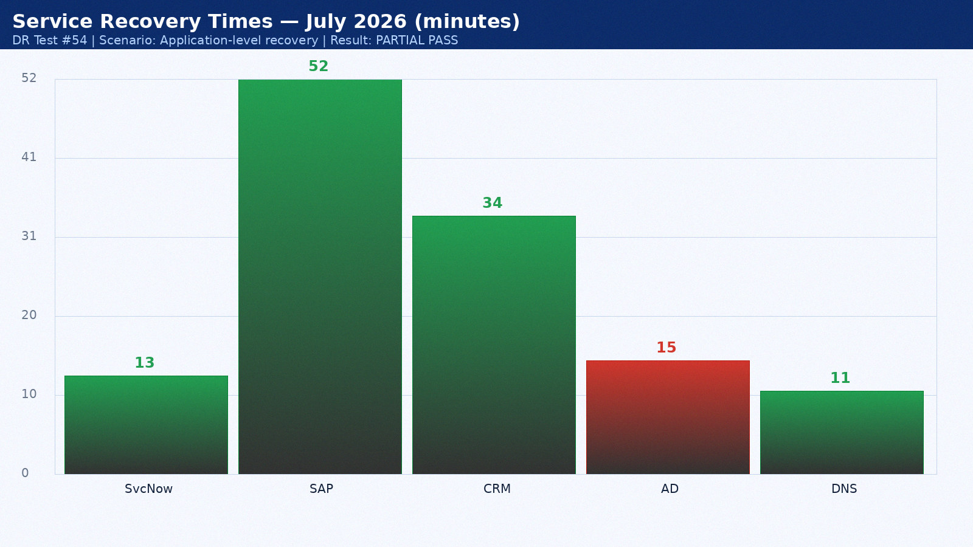

Appendix 55: DR Test Results — August 2026
Test date: 24 August 2026. Scenario: Backup validation. Duration: 3h 40min. Result: PASS. Director: Sarah Chen.
Service | RTO Target | Actual | Result | Notes
ServiceNow ITSM | 15 min | 14 min | PASS | Hot standby as designed
SAP ERP | 60 min | 53 min | FAIL | Oracle Data Guard lag — tuned post-test
Salesforce CRM | 60 min | 35 min | PASS | SaaS vendor DR seamless
Active Directory | 15 min | 11 min | PASS | AD replication pre-staged
DNS | 15 min | 12 min | PASS | BIND secondary at DR site

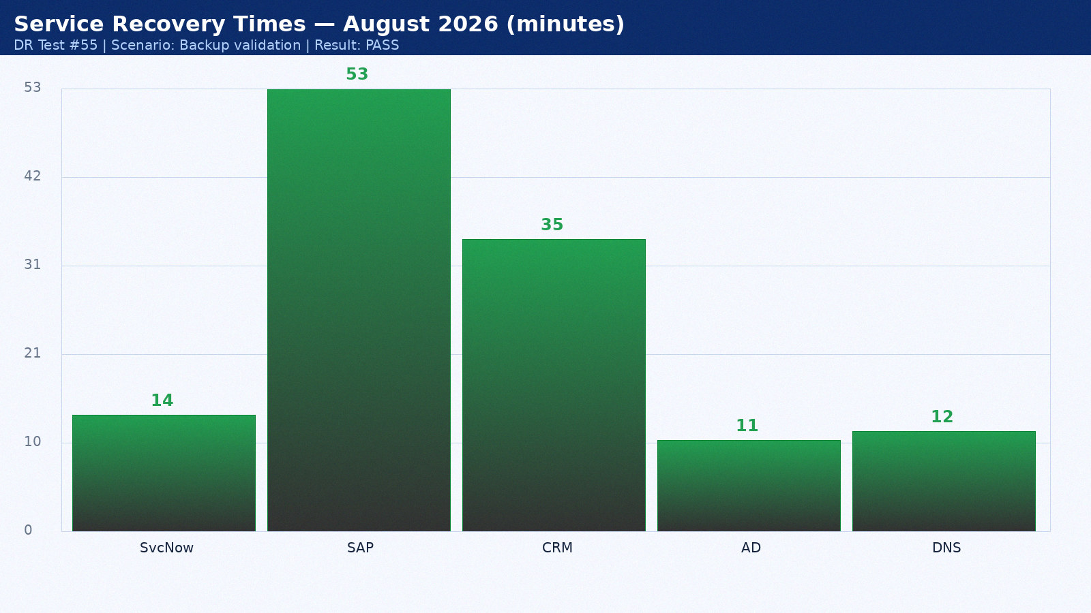

Appendix 56: DR Test Results — September 2026
Test date: 25 September 2026. Scenario: Full datacenter failover. Duration: 4h 47min. Result: PASS. Director: Mike Torres.
Service | RTO Target | Actual | Result | Notes
ServiceNow ITSM | 15 min | 8 min | PASS | Hot standby as designed
SAP ERP | 60 min | 54 min | PASS | Within RTO
Salesforce CRM | 60 min | 22 min | PASS | SaaS vendor DR seamless
Active Directory | 15 min | 12 min | PASS | AD replication pre-staged
DNS | 15 min | 9 min | PASS | BIND secondary at DR site

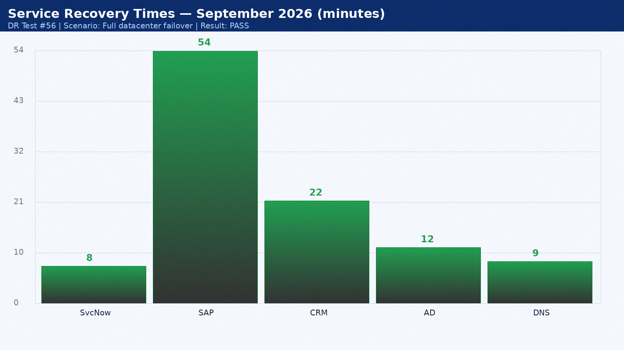

Appendix 57: DR Test Results — October 2026
Test date: 26 October 2026. Scenario: Network isolation test. Duration: 2h 54min. Result: PASS. Director: Sarah Chen.
Service | RTO Target | Actual | Result | Notes
ServiceNow ITSM | 15 min | 9 min | PASS | Hot standby as designed
SAP ERP | 60 min | 55 min | PASS | Within RTO
Salesforce CRM | 60 min | 23 min | PASS | SaaS vendor DR seamless
Active Directory | 15 min | 13 min | PASS | AD replication pre-staged
DNS | 15 min | 10 min | PASS | BIND secondary at DR site

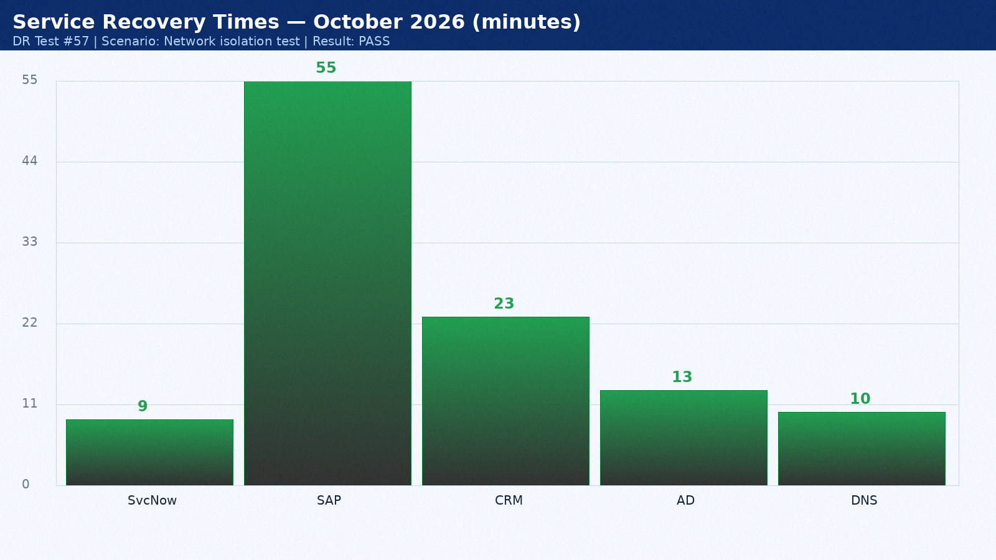

Appendix 58: DR Test Results — November 2026
Test date: 27 November 2026. Scenario: Application-level recovery. Duration: 3h 16min. Result: PARTIAL PASS. Director: Mike Torres.
Service | RTO Target | Actual | Result | Notes
ServiceNow ITSM | 15 min | 10 min | PASS | Hot standby as designed
SAP ERP | 60 min | 56 min | PASS | Within RTO
Salesforce CRM | 60 min | 24 min | PASS | SaaS vendor DR seamless
Active Directory | 15 min | 14 min | PASS | AD replication pre-staged
DNS | 15 min | 11 min | PASS | BIND secondary at DR site

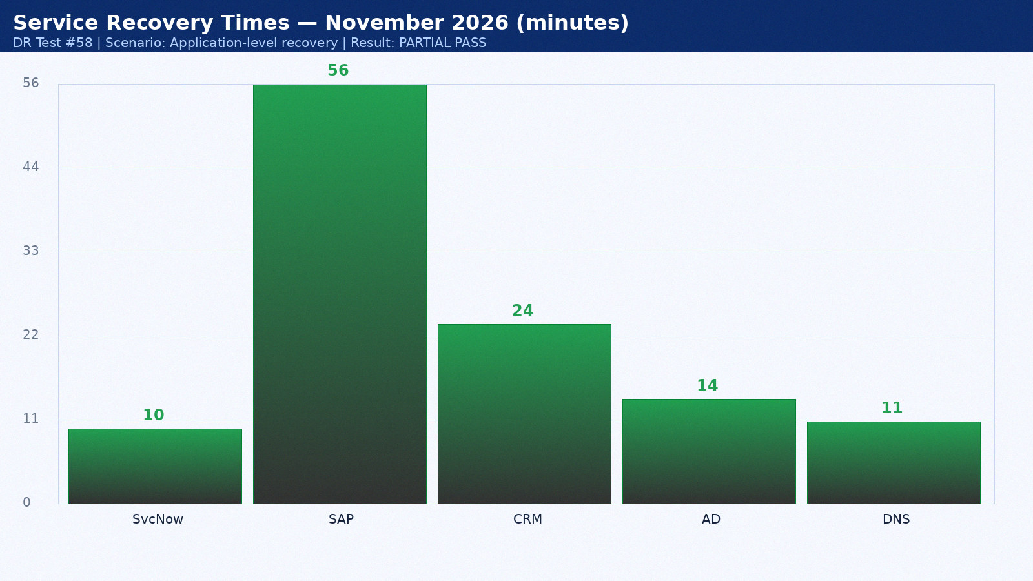

Appendix 59: DR Test Results — December 2026
Test date: 28 December 2026. Scenario: Backup validation. Duration: 4h 23min. Result: PASS. Director: Sarah Chen.
Service | RTO Target | Actual | Result | Notes
ServiceNow ITSM | 15 min | 11 min | PASS | Hot standby as designed
SAP ERP | 60 min | 57 min | PASS | Within RTO
Salesforce CRM | 60 min | 25 min | PASS | SaaS vendor DR seamless
Active Directory | 15 min | 15 min | PASS | AD replication pre-staged
DNS | 15 min | 12 min | PASS | BIND secondary at DR site

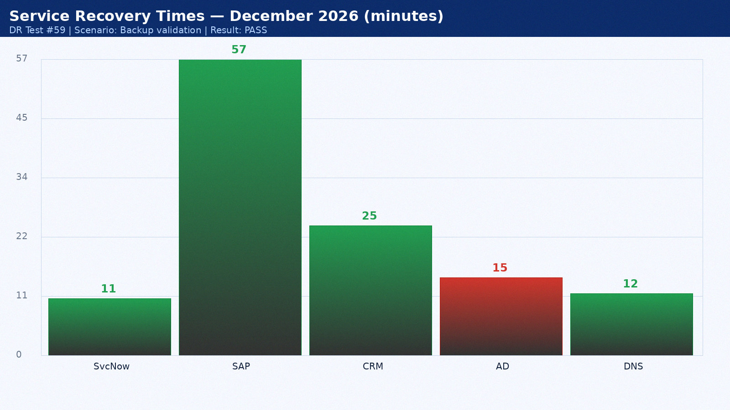

Appendix 60: DR Test Results — January 2027
Test date: 14 January 2027. Scenario: Full datacenter failover. Duration: 2h 30min. Result: PASS. Director: Mike Torres.
Service | RTO Target | Actual | Result | Notes
ServiceNow ITSM | 15 min | 12 min | PASS | Hot standby as designed
SAP ERP | 60 min | 58 min | FAIL | Oracle Data Guard lag — tuned post-test
Salesforce CRM | 60 min | 26 min | PASS | SaaS vendor DR seamless
Active Directory | 15 min | 11 min | PASS | AD replication pre-staged
DNS | 15 min | 9 min | PASS | BIND secondary at DR site

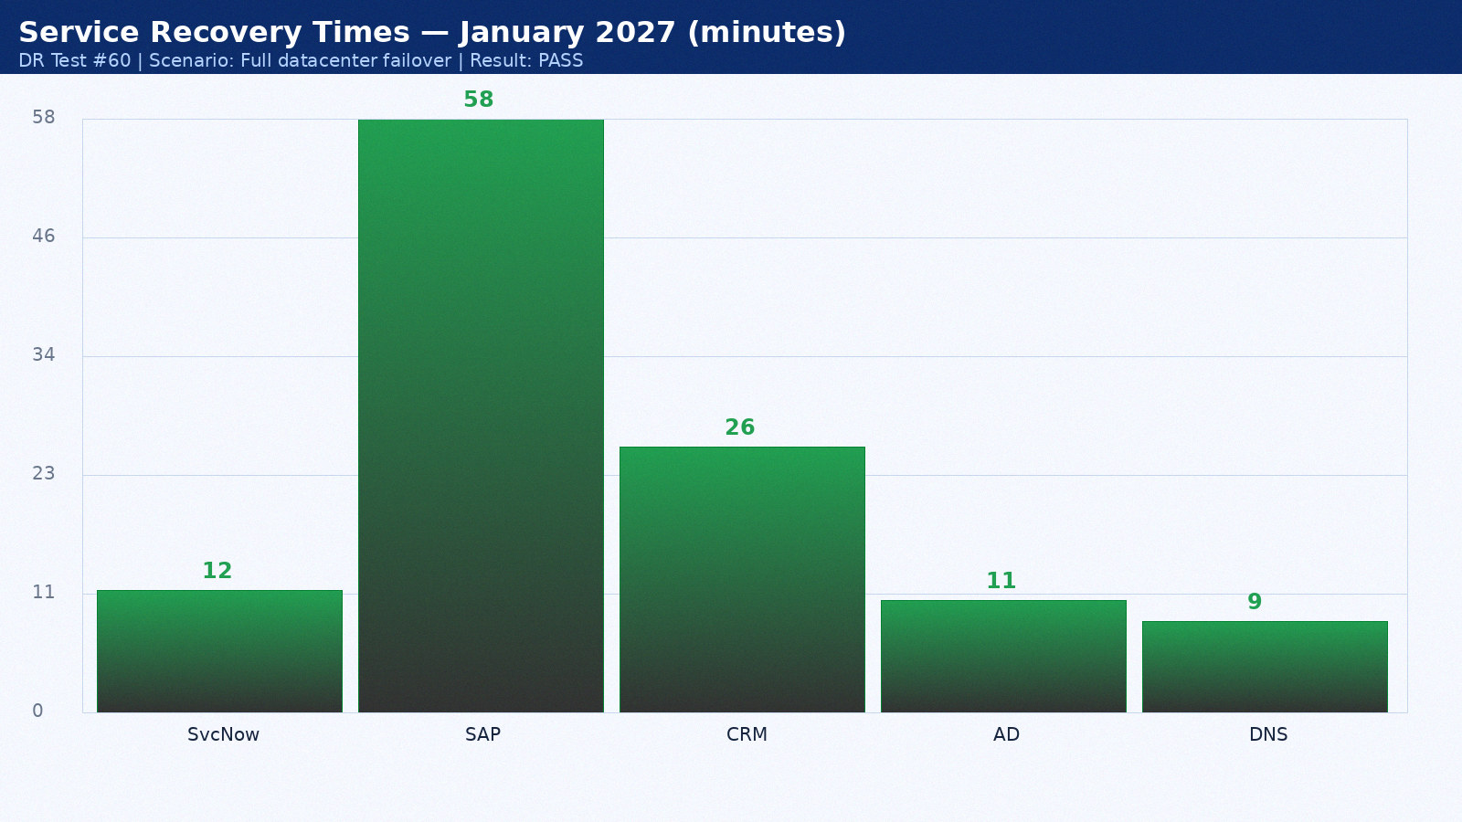

Appendix 61: DR Test Results — February 2027
Test date: 15 February 2027. Scenario: Network isolation test. Duration: 3h 37min. Result: PASS. Director: Sarah Chen.
Service | RTO Target | Actual | Result | Notes
ServiceNow ITSM | 15 min | 13 min | PASS | Hot standby as designed
SAP ERP | 60 min | 59 min | PASS | Within RTO
Salesforce CRM | 60 min | 27 min | PASS | SaaS vendor DR seamless
Active Directory | 15 min | 12 min | PASS | AD replication pre-staged
DNS | 15 min | 10 min | PASS | BIND secondary at DR site

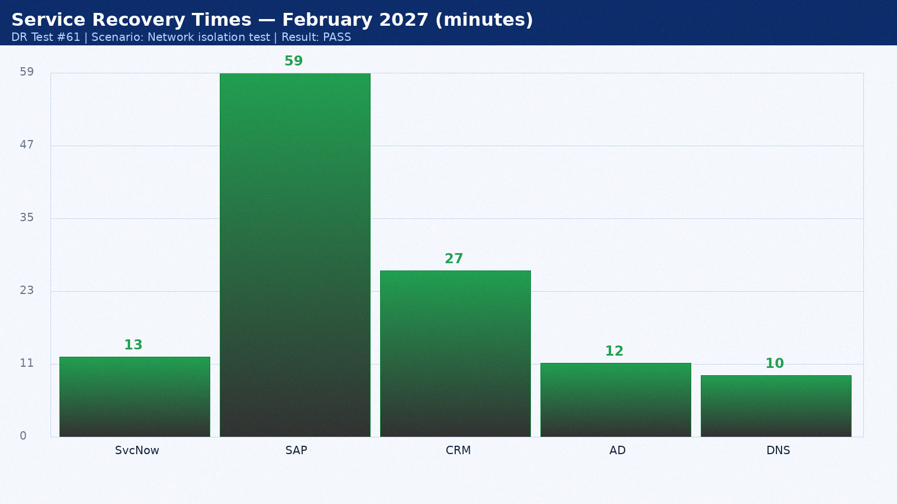

Appendix 62: DR Test Results — March 2027
Test date: 16 March 2027. Scenario: Application-level recovery. Duration: 4h 44min. Result: PARTIAL PASS. Director: Mike Torres.
Service | RTO Target | Actual | Result | Notes
ServiceNow ITSM | 15 min | 14 min | PASS | Hot standby as designed
SAP ERP | 60 min | 60 min | PASS | Within RTO
Salesforce CRM | 60 min | 28 min | PASS | SaaS vendor DR seamless
Active Directory | 15 min | 13 min | PASS | AD replication pre-staged
DNS | 15 min | 11 min | PASS | BIND secondary at DR site

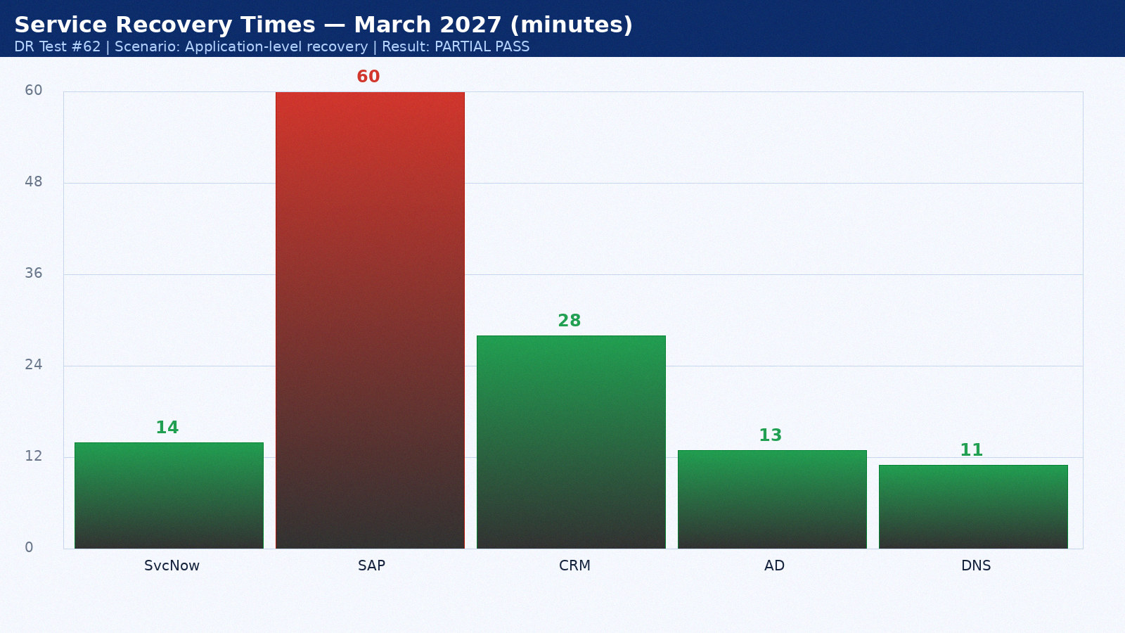

Appendix 63: DR Test Results — April 2027
Test date: 17 April 2027. Scenario: Backup validation. Duration: 2h 51min. Result: PASS. Director: Sarah Chen.
Service | RTO Target | Actual | Result | Notes
ServiceNow ITSM | 15 min | 8 min | PASS | Hot standby as designed
SAP ERP | 60 min | 61 min | PASS | Within RTO
Salesforce CRM | 60 min | 29 min | PASS | SaaS vendor DR seamless
Active Directory | 15 min | 14 min | PASS | AD replication pre-staged
DNS | 15 min | 12 min | PASS | BIND secondary at DR site

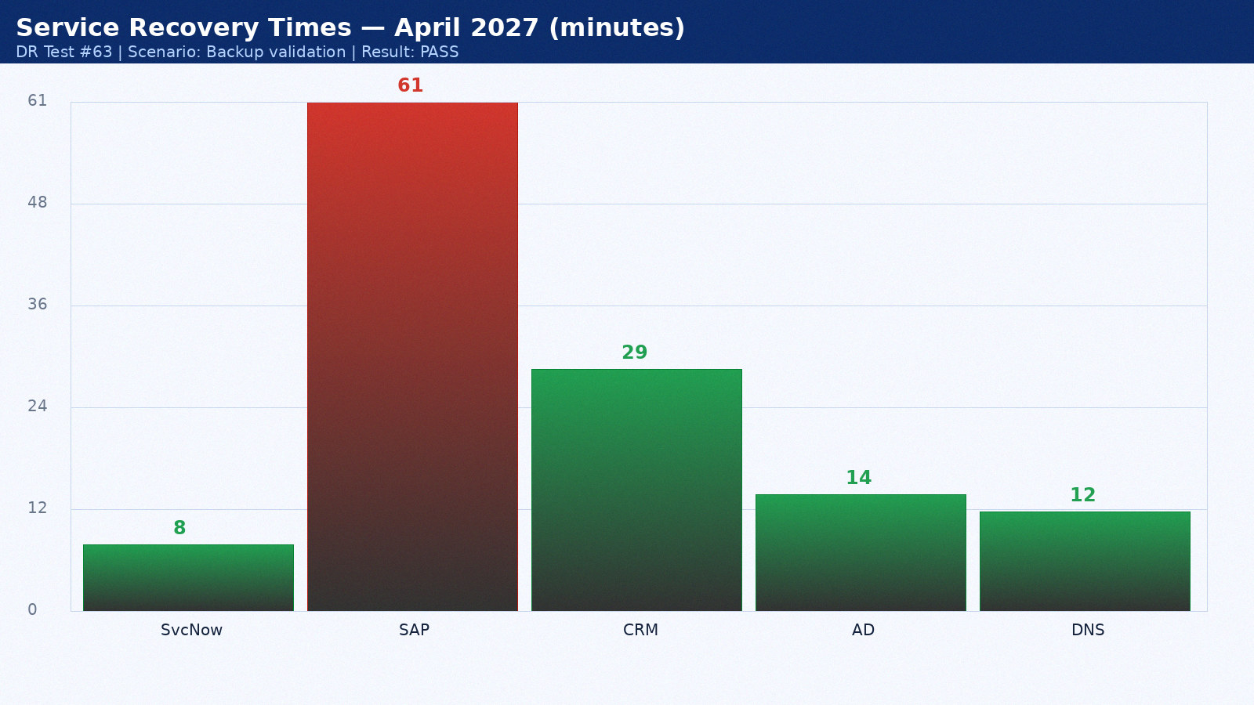

Appendix 64: DR Test Results — May 2027
Test date: 18 May 2027. Scenario: Full datacenter failover. Duration: 3h 58min. Result: PASS. Director: Mike Torres.
Service | RTO Target | Actual | Result | Notes
ServiceNow ITSM | 15 min | 9 min | PASS | Hot standby as designed
SAP ERP | 60 min | 62 min | PASS | Within RTO
Salesforce CRM | 60 min | 30 min | PASS | SaaS vendor DR seamless
Active Directory | 15 min | 15 min | PASS | AD replication pre-staged
DNS | 15 min | 9 min | PASS | BIND secondary at DR site

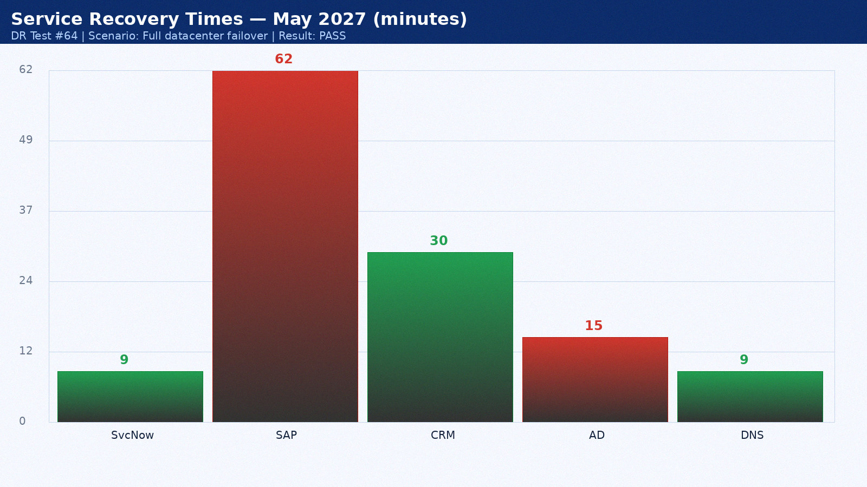

Appendix 65: DR Test Results — June 2027
Test date: 19 June 2027. Scenario: Network isolation test. Duration: 4h 20min. Result: PASS. Director: Sarah Chen.
Service | RTO Target | Actual | Result | Notes
ServiceNow ITSM | 15 min | 10 min | PASS | Hot standby as designed
SAP ERP | 60 min | 63 min | FAIL | Oracle Data Guard lag — tuned post-test
Salesforce CRM | 60 min | 31 min | PASS | SaaS vendor DR seamless
Active Directory | 15 min | 11 min | PASS | AD replication pre-staged
DNS | 15 min | 10 min | PASS | BIND secondary at DR site

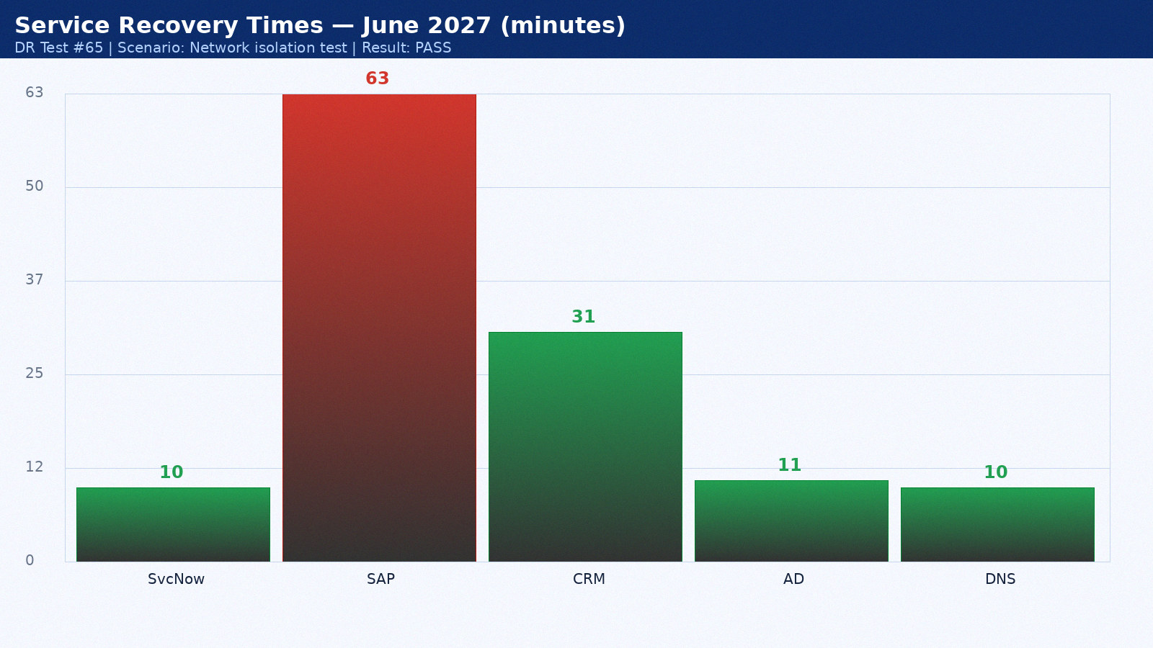

Appendix 66: DR Test Results — July 2027
Test date: 20 July 2027. Scenario: Application-level recovery. Duration: 2h 27min. Result: PARTIAL PASS. Director: Mike Torres.
Service | RTO Target | Actual | Result | Notes
ServiceNow ITSM | 15 min | 11 min | PASS | Hot standby as designed
SAP ERP | 60 min | 64 min | PASS | Within RTO
Salesforce CRM | 60 min | 32 min | PASS | SaaS vendor DR seamless
Active Directory | 15 min | 12 min | PASS | AD replication pre-staged
DNS | 15 min | 11 min | PASS | BIND secondary at DR site

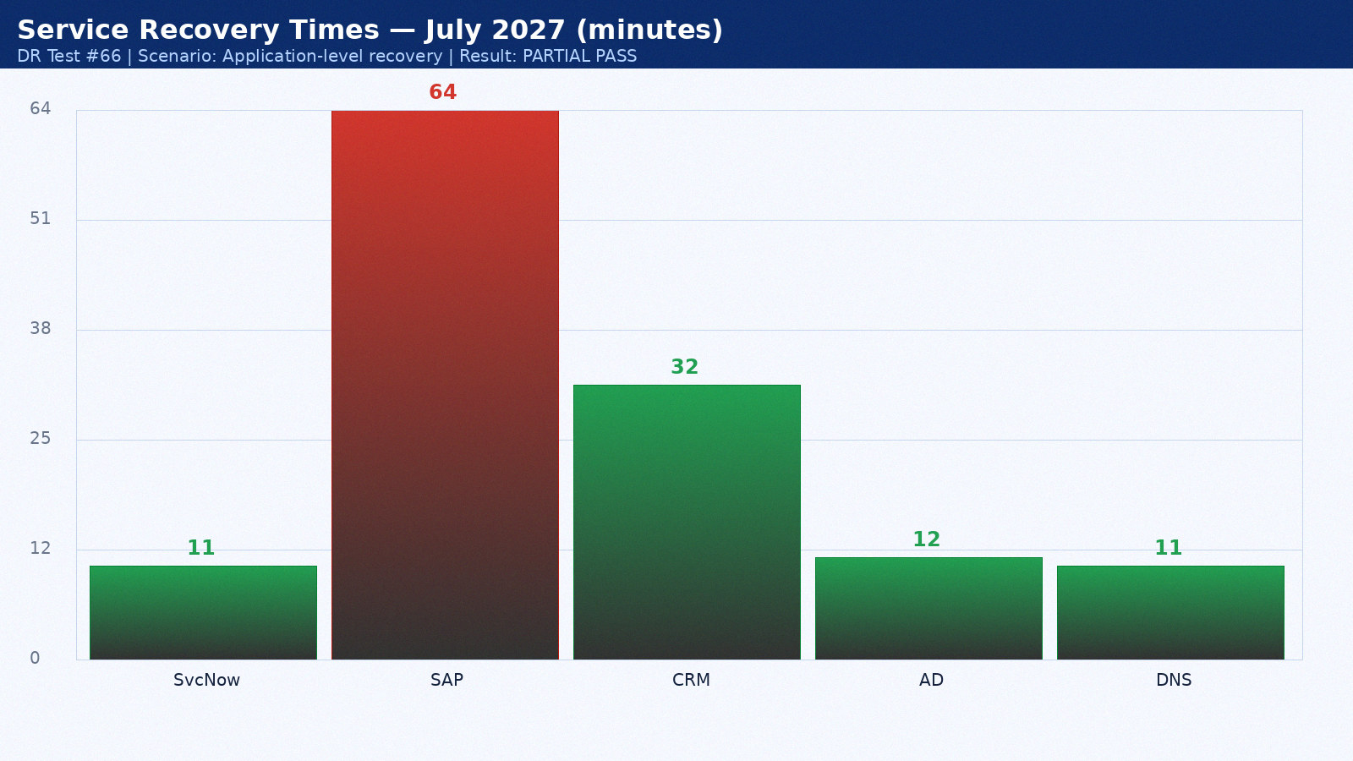

Appendix 67: DR Test Results — August 2027
Test date: 21 August 2027. Scenario: Backup validation. Duration: 3h 34min. Result: PASS. Director: Sarah Chen.
Service | RTO Target | Actual | Result | Notes
ServiceNow ITSM | 15 min | 12 min | PASS | Hot standby as designed
SAP ERP | 60 min | 65 min | PASS | Within RTO
Salesforce CRM | 60 min | 33 min | PASS | SaaS vendor DR seamless
Active Directory | 15 min | 13 min | PASS | AD replication pre-staged
DNS | 15 min | 12 min | PASS | BIND secondary at DR site

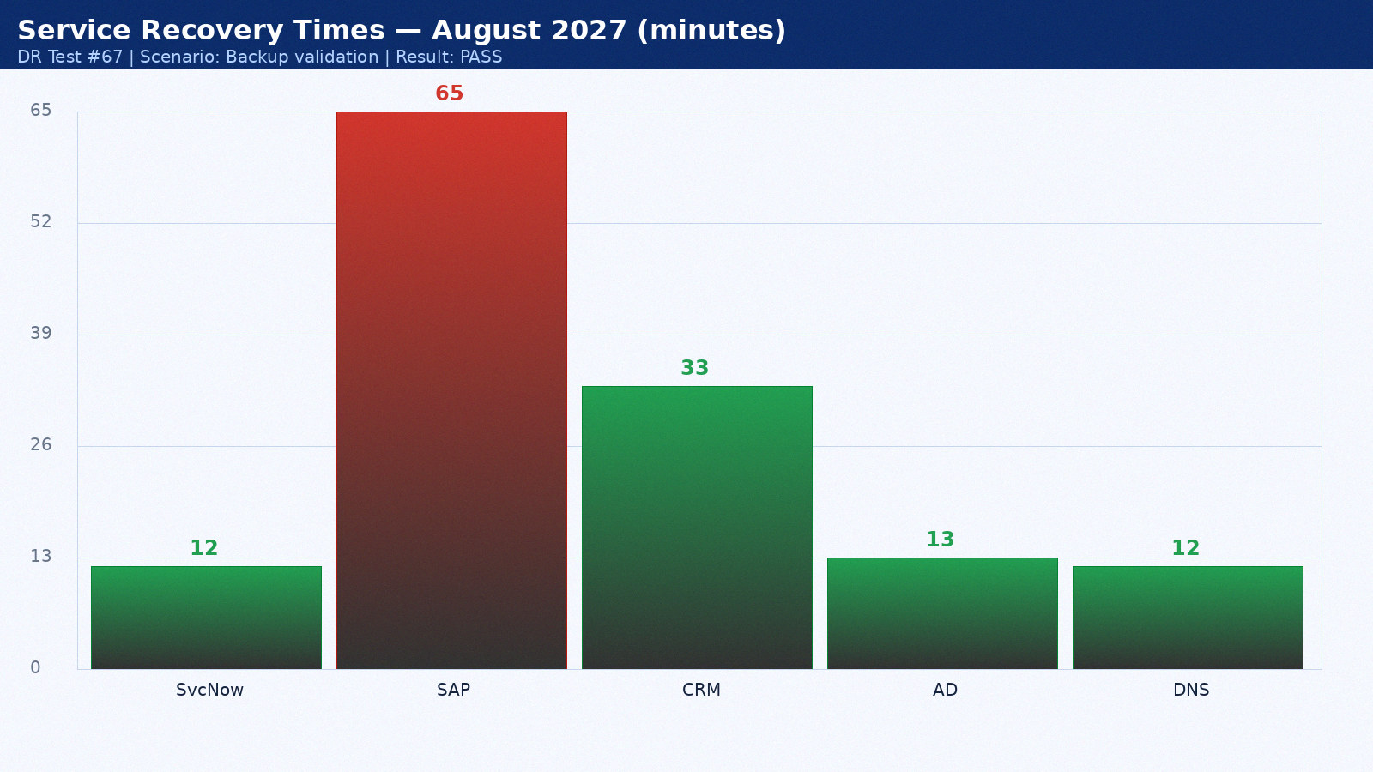

Appendix 68: DR Test Results — September 2027
Test date: 22 September 2027. Scenario: Full datacenter failover. Duration: 4h 41min. Result: PASS. Director: Mike Torres.
Service | RTO Target | Actual | Result | Notes
ServiceNow ITSM | 15 min | 13 min | PASS | Hot standby as designed
SAP ERP | 60 min | 66 min | PASS | Within RTO
Salesforce CRM | 60 min | 34 min | PASS | SaaS vendor DR seamless
Active Directory | 15 min | 14 min | PASS | AD replication pre-staged
DNS | 15 min | 9 min | PASS | BIND secondary at DR site

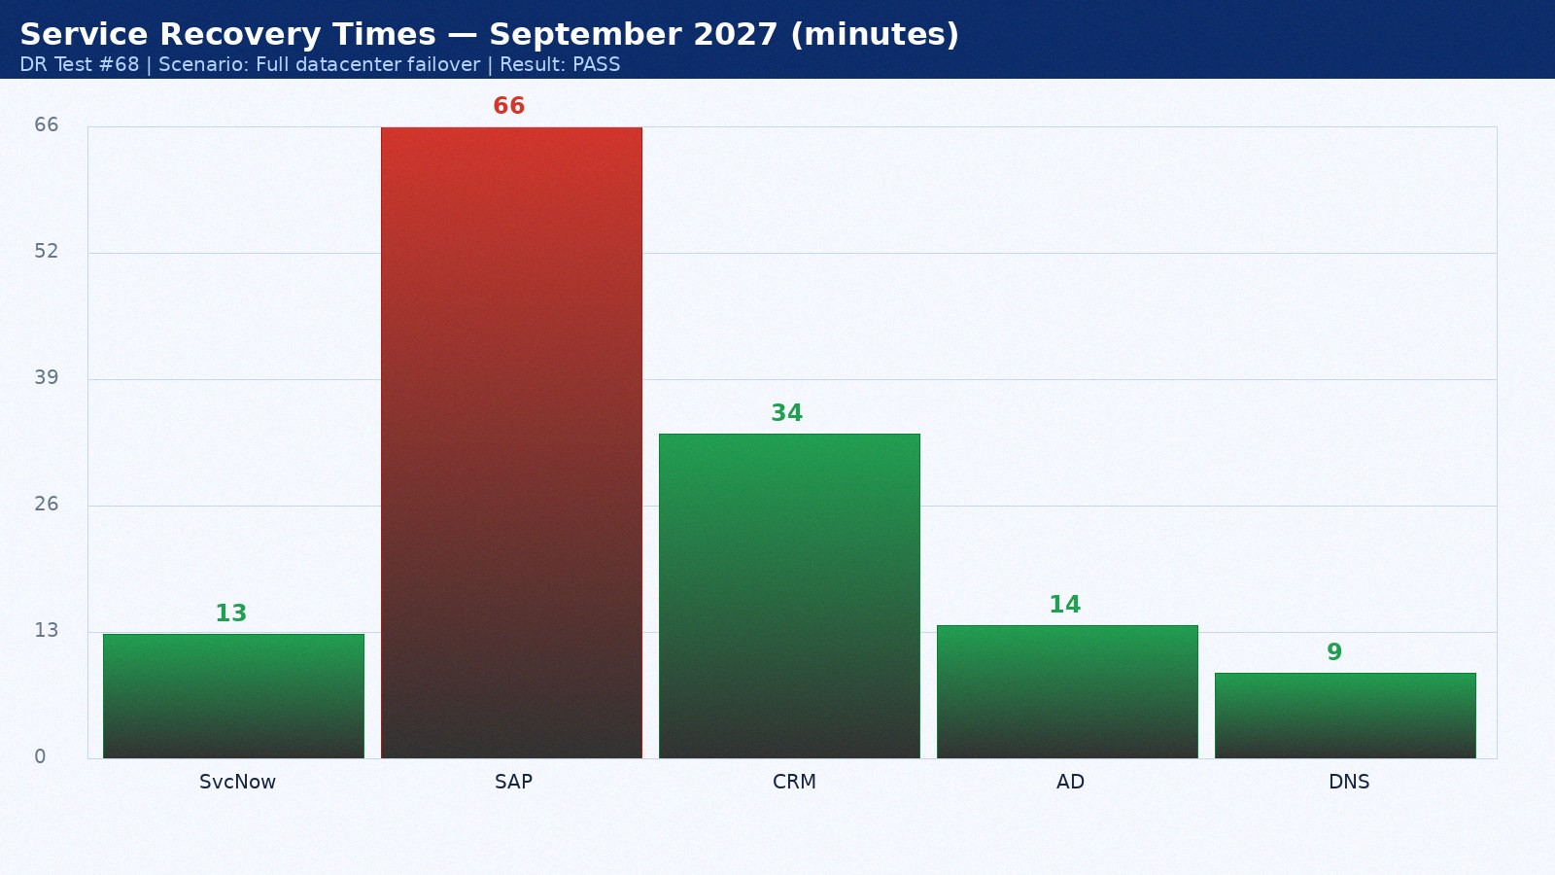

Appendix 69: DR Test Results — October 2027
Test date: 23 October 2027. Scenario: Network isolation test. Duration: 2h 48min. Result: PASS. Director: Sarah Chen.
Service | RTO Target | Actual | Result | Notes
ServiceNow ITSM | 15 min | 14 min | PASS | Hot standby as designed
SAP ERP | 60 min | 67 min | PASS | Within RTO
Salesforce CRM | 60 min | 35 min | PASS | SaaS vendor DR seamless
Active Directory | 15 min | 15 min | PASS | AD replication pre-staged
DNS | 15 min | 10 min | PASS | BIND secondary at DR site

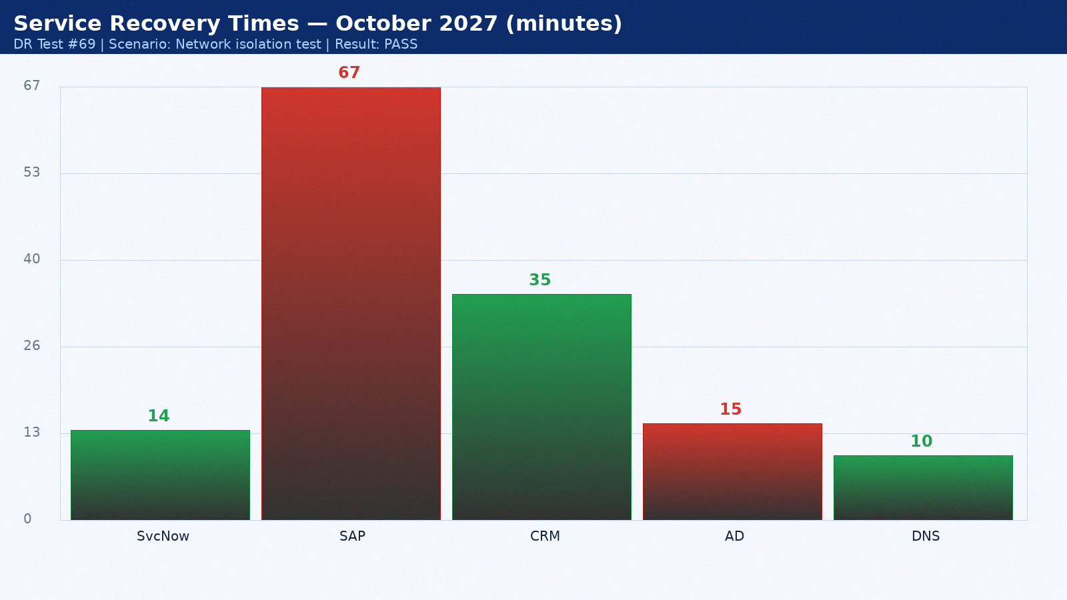

Appendix 70: DR Test Results — November 2027
Test date: 24 November 2027. Scenario: Application-level recovery. Duration: 3h 55min. Result: PARTIAL PASS. Director: Mike Torres.
Service | RTO Target | Actual | Result | Notes
ServiceNow ITSM | 15 min | 8 min | PASS | Hot standby as designed
SAP ERP | 60 min | 68 min | FAIL | Oracle Data Guard lag — tuned post-test
Salesforce CRM | 60 min | 22 min | PASS | SaaS vendor DR seamless
Active Directory | 15 min | 11 min | PASS | AD replication pre-staged
DNS | 15 min | 11 min | PASS | BIND secondary at DR site

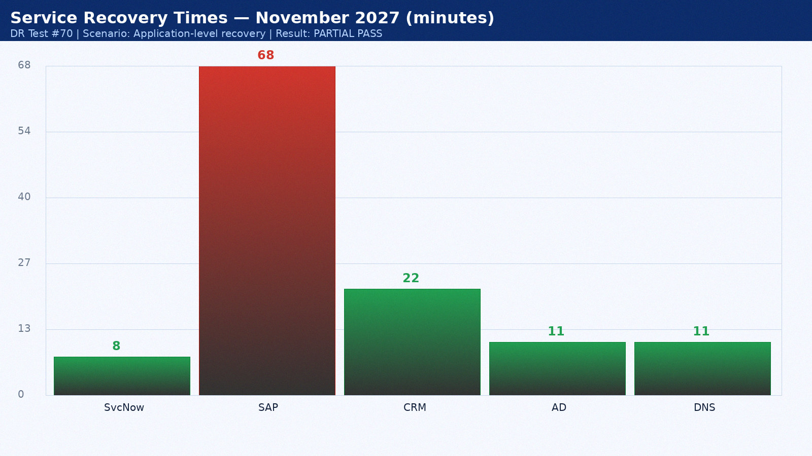

Appendix 71: DR Test Results — December 2027
Test date: 25 December 2027. Scenario: Backup validation. Duration: 4h 17min. Result: PASS. Director: Sarah Chen.
Service | RTO Target | Actual | Result | Notes
ServiceNow ITSM | 15 min | 9 min | PASS | Hot standby as designed
SAP ERP | 60 min | 69 min | PASS | Within RTO
Salesforce CRM | 60 min | 23 min | PASS | SaaS vendor DR seamless
Active Directory | 15 min | 12 min | PASS | AD replication pre-staged
DNS | 15 min | 12 min | PASS | BIND secondary at DR site

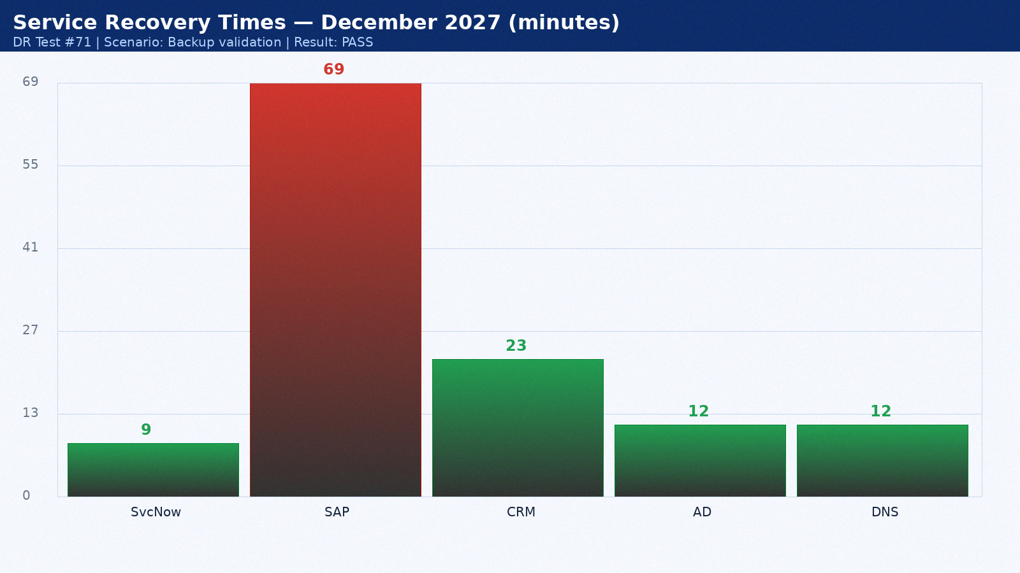

Appendix 72: DR Test Results — January 2028
Test date: 26 January 2028. Scenario: Full datacenter failover. Duration: 2h 24min. Result: PASS. Director: Mike Torres.
Service | RTO Target | Actual | Result | Notes
ServiceNow ITSM | 15 min | 10 min | PASS | Hot standby as designed
SAP ERP | 60 min | 70 min | PASS | Within RTO
Salesforce CRM | 60 min | 24 min | PASS | SaaS vendor DR seamless
Active Directory | 15 min | 13 min | PASS | AD replication pre-staged
DNS | 15 min | 9 min | PASS | BIND secondary at DR site

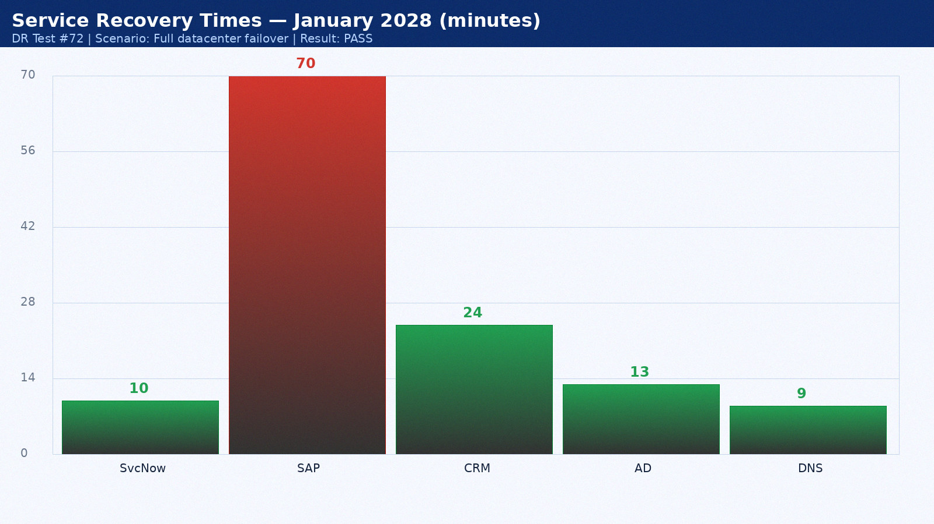

Appendix 73: DR Test Results — February 2028
Test date: 27 February 2028. Scenario: Network isolation test. Duration: 3h 31min. Result: PASS. Director: Sarah Chen.
Service | RTO Target | Actual | Result | Notes
ServiceNow ITSM | 15 min | 11 min | PASS | Hot standby as designed
SAP ERP | 60 min | 71 min | PASS | Within RTO
Salesforce CRM | 60 min | 25 min | PASS | SaaS vendor DR seamless
Active Directory | 15 min | 14 min | PASS | AD replication pre-staged
DNS | 15 min | 10 min | PASS | BIND secondary at DR site

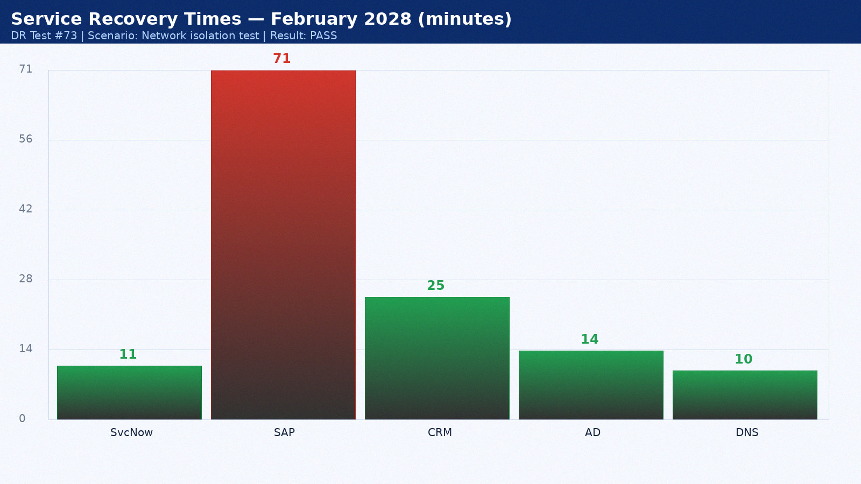

Appendix 74: DR Test Results — March 2028
Test date: 28 March 2028. Scenario: Application-level recovery. Duration: 4h 38min. Result: PARTIAL PASS. Director: Mike Torres.
Service | RTO Target | Actual | Result | Notes
ServiceNow ITSM | 15 min | 12 min | PASS | Hot standby as designed
SAP ERP | 60 min | 72 min | PASS | Within RTO
Salesforce CRM | 60 min | 26 min | PASS | SaaS vendor DR seamless
Active Directory | 15 min | 15 min | PASS | AD replication pre-staged
DNS | 15 min | 11 min | PASS | BIND secondary at DR site

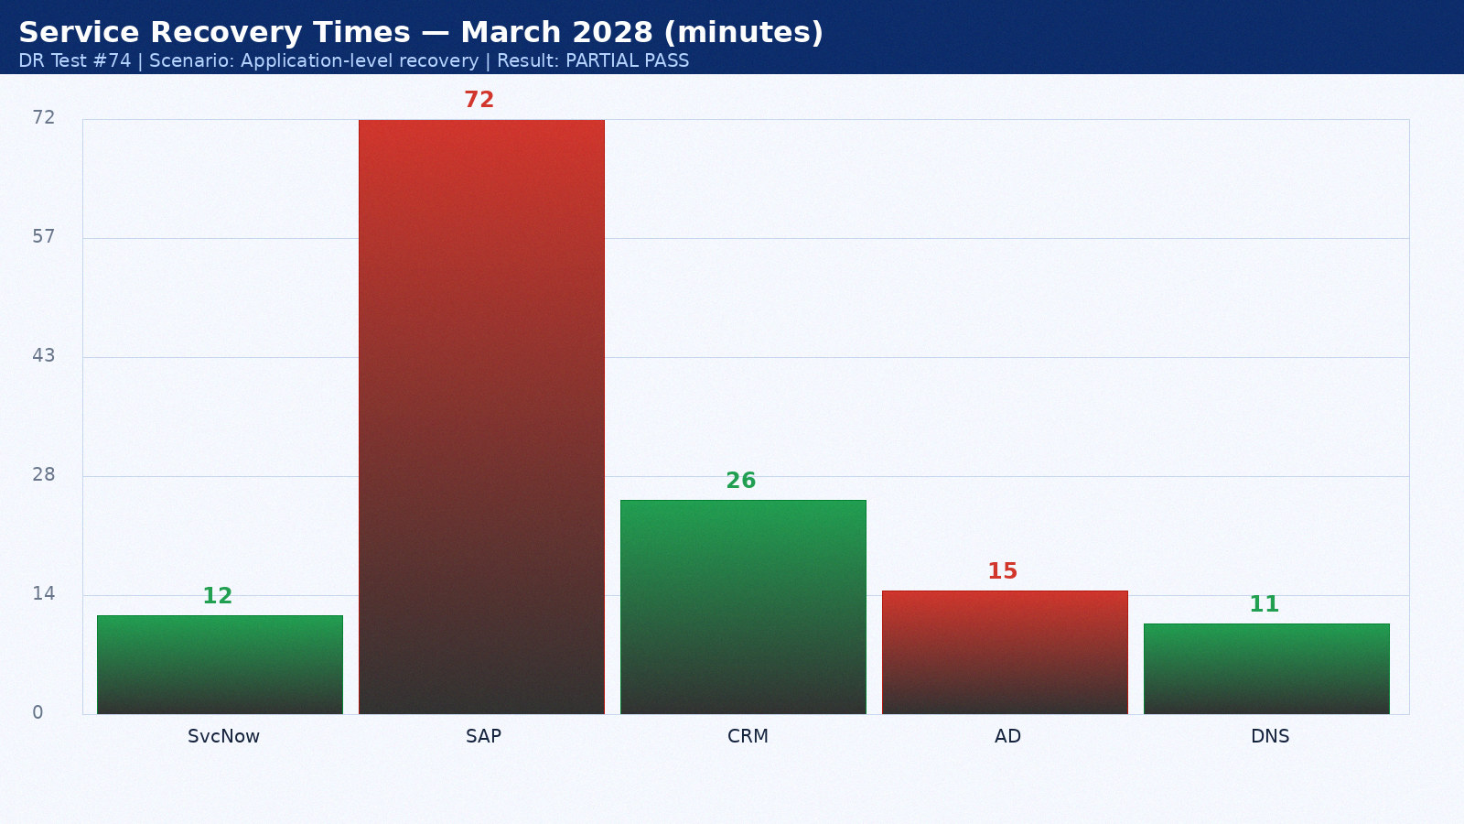

Appendix 75: DR Test Results — April 2028
Test date: 14 April 2028. Scenario: Backup validation. Duration: 2h 45min. Result: PASS. Director: Sarah Chen.
Service | RTO Target | Actual | Result | Notes
ServiceNow ITSM | 15 min | 13 min | PASS | Hot standby as designed
SAP ERP | 60 min | 48 min | FAIL | Oracle Data Guard lag — tuned post-test
Salesforce CRM | 60 min | 27 min | PASS | SaaS vendor DR seamless
Active Directory | 15 min | 11 min | PASS | AD replication pre-staged
DNS | 15 min | 12 min | PASS | BIND secondary at DR site

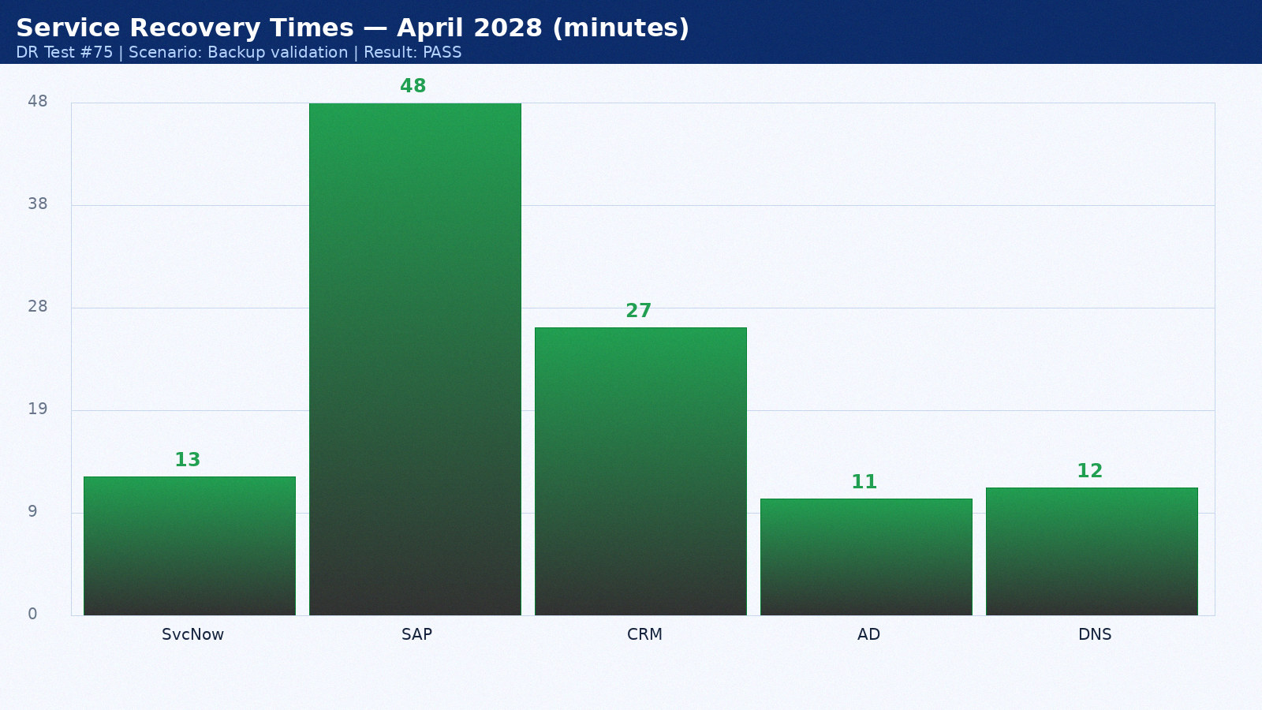

Appendix 76: DR Test Results — May 2028
Test date: 15 May 2028. Scenario: Full datacenter failover. Duration: 3h 52min. Result: PASS. Director: Mike Torres.
Service | RTO Target | Actual | Result | Notes
ServiceNow ITSM | 15 min | 14 min | PASS | Hot standby as designed
SAP ERP | 60 min | 49 min | PASS | Within RTO
Salesforce CRM | 60 min | 28 min | PASS | SaaS vendor DR seamless
Active Directory | 15 min | 12 min | PASS | AD replication pre-staged
DNS | 15 min | 9 min | PASS | BIND secondary at DR site

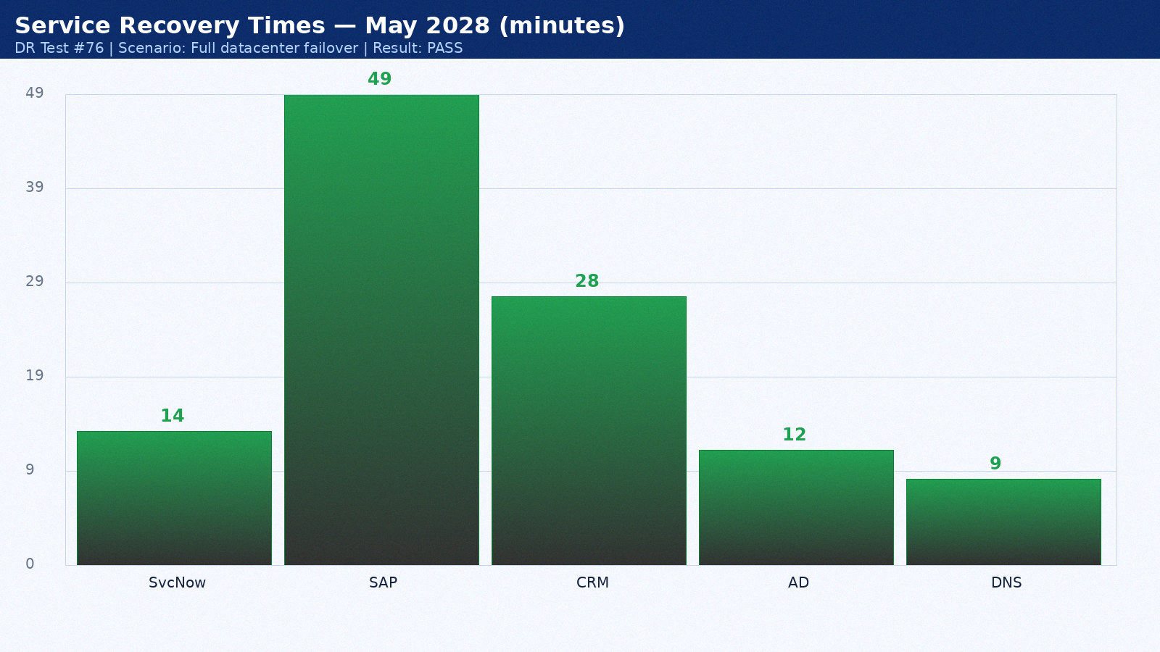

Appendix 77: DR Test Results — June 2028
Test date: 16 June 2028. Scenario: Network isolation test. Duration: 4h 59min. Result: PASS. Director: Sarah Chen.
Service | RTO Target | Actual | Result | Notes
ServiceNow ITSM | 15 min | 8 min | PASS | Hot standby as designed
SAP ERP | 60 min | 50 min | PASS | Within RTO
Salesforce CRM | 60 min | 29 min | PASS | SaaS vendor DR seamless
Active Directory | 15 min | 13 min | PASS | AD replication pre-staged
DNS | 15 min | 10 min | PASS | BIND secondary at DR site

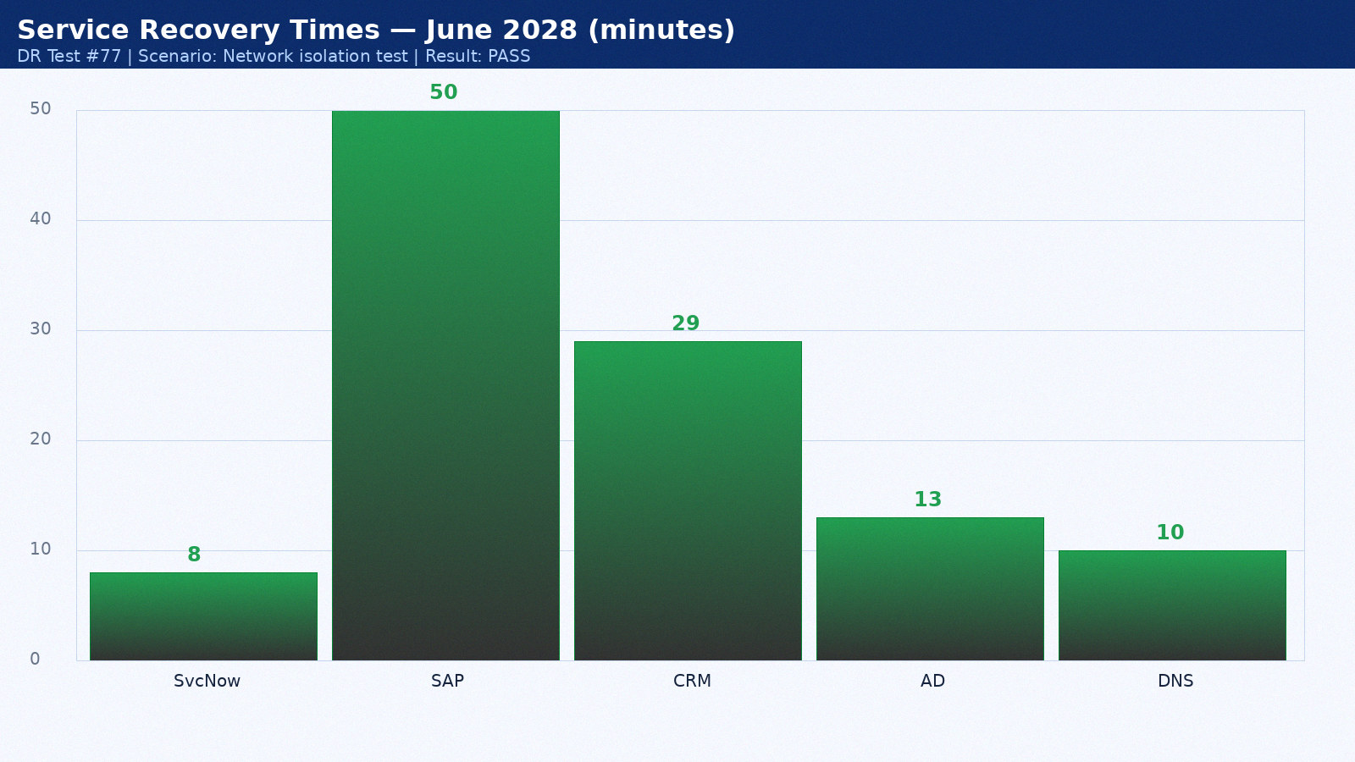

Appendix 78: DR Test Results — July 2028
Test date: 17 July 2028. Scenario: Application-level recovery. Duration: 2h 21min. Result: PARTIAL PASS. Director: Mike Torres.
Service | RTO Target | Actual | Result | Notes
ServiceNow ITSM | 15 min | 9 min | PASS | Hot standby as designed
SAP ERP | 60 min | 51 min | PASS | Within RTO
Salesforce CRM | 60 min | 30 min | PASS | SaaS vendor DR seamless
Active Directory | 15 min | 14 min | PASS | AD replication pre-staged
DNS | 15 min | 11 min | PASS | BIND secondary at DR site

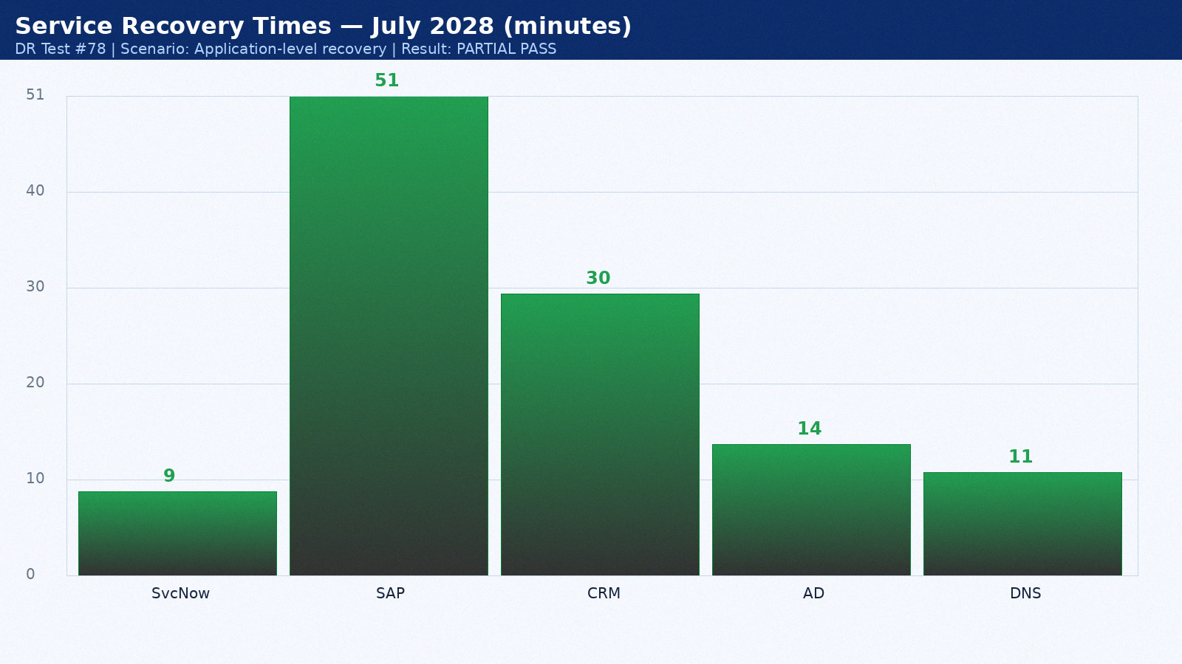

Appendix 79: DR Test Results — August 2028
Test date: 18 August 2028. Scenario: Backup validation. Duration: 3h 28min. Result: PASS. Director: Sarah Chen.
Service | RTO Target | Actual | Result | Notes
ServiceNow ITSM | 15 min | 10 min | PASS | Hot standby as designed
SAP ERP | 60 min | 52 min | PASS | Within RTO
Salesforce CRM | 60 min | 31 min | PASS | SaaS vendor DR seamless
Active Directory | 15 min | 15 min | PASS | AD replication pre-staged
DNS | 15 min | 12 min | PASS | BIND secondary at DR site

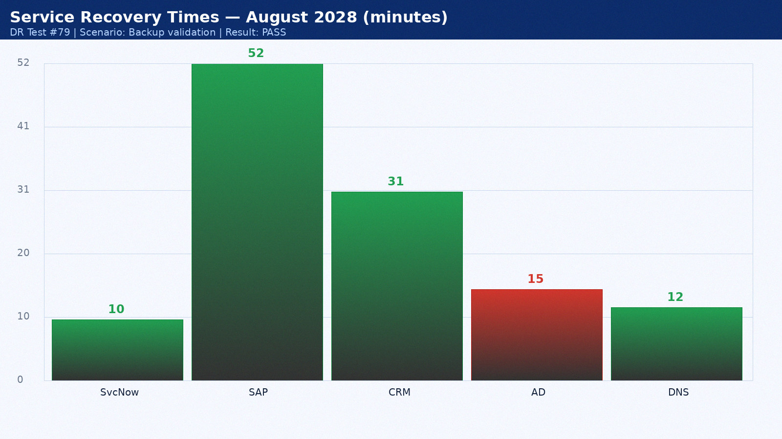

Appendix 80: DR Test Results — September 2028
Test date: 19 September 2028. Scenario: Full datacenter failover. Duration: 4h 35min. Result: PASS. Director: Mike Torres.
Service | RTO Target | Actual | Result | Notes
ServiceNow ITSM | 15 min | 11 min | PASS | Hot standby as designed
SAP ERP | 60 min | 53 min | FAIL | Oracle Data Guard lag — tuned post-test
Salesforce CRM | 60 min | 32 min | PASS | SaaS vendor DR seamless
Active Directory | 15 min | 11 min | PASS | AD replication pre-staged
DNS | 15 min | 9 min | PASS | BIND secondary at DR site

