IT OUTSOURCING STRATEGY REVIEW 2025

Owner: Angela Brooks (IT Director)
Date: 12 January 2025
Scope: 23 third-party IT providers — total annual spend: USD 4.3 million
Classification: CONFIDENTIAL — IT Leadership and Procurement only

1. Executive Summary
This annual outsourcing strategy review assesses all 23 third-party IT service providers against the organisation's strategic objectives for FY2025. Key findings: Wipro MSP performance has declined — SLA compliance dropped 97%→89% in six months — a Performance Improvement Notice will be issued by February 2025. Rackspace should not be renewed at its July 2025 expiry. Cognizant is the strongest performer (85/100) — recommended for 2-year extension with 5% rate reduction. NetGuard Systems and PricewaterhouseCoopers both achieved EXCELLENT ratings and scope should expand in FY2026.

2. Provider Scorecard
Provider | Annual Spend | Q1 Score | SLA Breaches | Trend | Recommendation
Accenture — ITSM | $340,000 | 82/100 | 0 | ↑ stable | Continue — negotiate fixed-fee remaining 3 phases
Wipro — Infra MSP | $1,200,000 | 71/100 | 3 | ↓ -8pp | Issue PIN Feb 2025 — SLA 97%→89%
DataVault — Archive | $284,000 | 76/100 | 2 | ↓ -4pp | Add penalty clause — concentration risk 6.2 PB
Cognizant — App Supp | $780,000 | 85/100 | 0 | ↑ +2pp | Extend 2yr + 5% rate reduction + cloud scope
Rackspace — Hosting | $240,000 | 64/100 | 3 | ↓ -12pp | DO NOT RENEW Jul 2025 — 3 Q4 incidents
IBM — Mainframe Ops | $420,000 | 88/100 | 0 | → steady | Retain mainframe lifespan — renegotiate fee
NetGuard Systems | $95,000 | 94/100 | 0 | ↑ +3pp | EXCELLENT — expand to managed monitoring H2
PwC — IT Audit | $95,000 | 91/100 | 0 | ↑ +2pp | EXCELLENT — expand FY2026: cloud security + TPRM

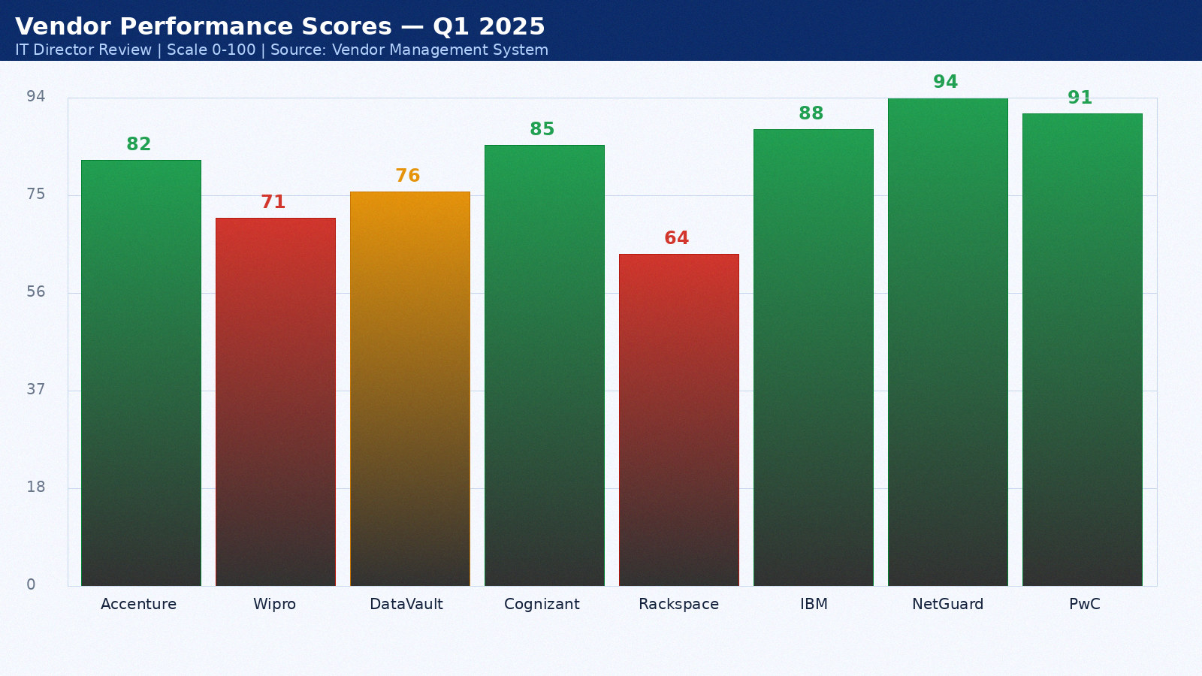

Appendix 1: Wipro MSP — Monthly SLA Data February 2022
Provider: Wipro MSP. Period: February 2022. Total tickets: 13. P1: 1. P2: 4. P3: 9. SLA compliance: 89%. Breaches: 1. Average MTTR: 36 minutes. CSAT: 3.6/5.0.
Month | SLA Target | Actual SLA | Breach? | Tickets | MTTR (min) | CSAT
Jan 2022 | 99.5% | 92.0% | Yes | 3 | 35 | 4.0
Feb 2022 | 99.5% | 93.0% | Yes | 4 | 36 | 4.1
Mar 2022 | 99.5% | 94.0% | Yes | 5 | 37 | 4.2
Apr 2022 | 99.5% | 95.0% | Yes | 6 | 38 | 4.3
May 2022 | 99.5% | 96.0% | Yes | 7 | 39 | 4.4
Jun 2022 | 99.5% | 97.0% | Yes | 8 | 40 | 4.5
Jul 2022 | 99.5% | 98.0% | Yes | 9 | 41 | 4.6
Aug 2022 | 99.5% | 92.0% | Yes | 10 | 42 | 4.7
Sep 2022 | 99.5% | 93.0% | Yes | 3 | 43 | 4.8
Oct 2022 | 99.5% | 94.0% | Yes | 4 | 44 | 4.9
Nov 2022 | 99.5% | 95.0% | Yes | 5 | 45 | 4.0
Dec 2022 | 99.5% | 96.0% | Yes | 6 | 46 | 4.1

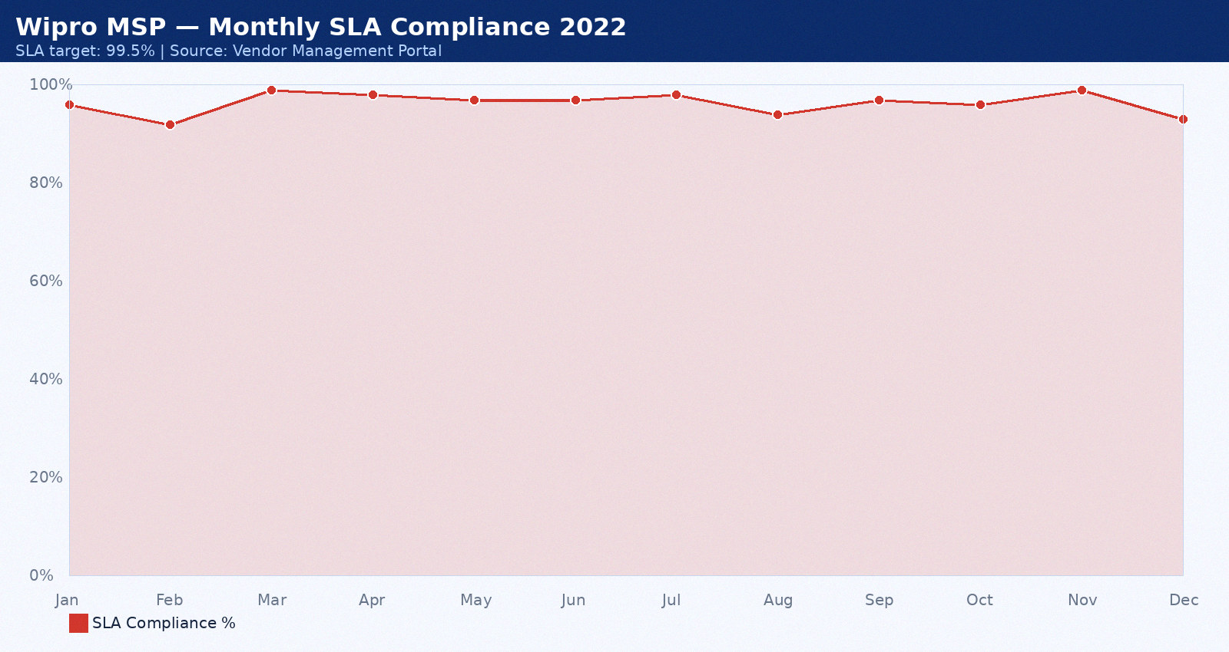

Appendix 2: DataVault — Monthly SLA Data March 2022
Provider: DataVault. Period: March 2022. Total tickets: 14. P1: 2. P2: 5. P3: 10. SLA compliance: 90%. Breaches: 2. Average MTTR: 37 minutes. CSAT: 3.7/5.0.
Month | SLA Target | Actual SLA | Breach? | Tickets | MTTR (min) | CSAT
Jan 2022 | 99.5% | 92.0% | Yes | 3 | 35 | 4.0
Feb 2022 | 99.5% | 93.0% | Yes | 4 | 36 | 4.1
Mar 2022 | 99.5% | 94.0% | Yes | 5 | 37 | 4.2
Apr 2022 | 99.5% | 95.0% | Yes | 6 | 38 | 4.3
May 2022 | 99.5% | 96.0% | Yes | 7 | 39 | 4.4
Jun 2022 | 99.5% | 97.0% | Yes | 8 | 40 | 4.5
Jul 2022 | 99.5% | 98.0% | Yes | 9 | 41 | 4.6
Aug 2022 | 99.5% | 92.0% | Yes | 10 | 42 | 4.7
Sep 2022 | 99.5% | 93.0% | Yes | 3 | 43 | 4.8
Oct 2022 | 99.5% | 94.0% | Yes | 4 | 44 | 4.9
Nov 2022 | 99.5% | 95.0% | Yes | 5 | 45 | 4.0
Dec 2022 | 99.5% | 96.0% | Yes | 6 | 46 | 4.1

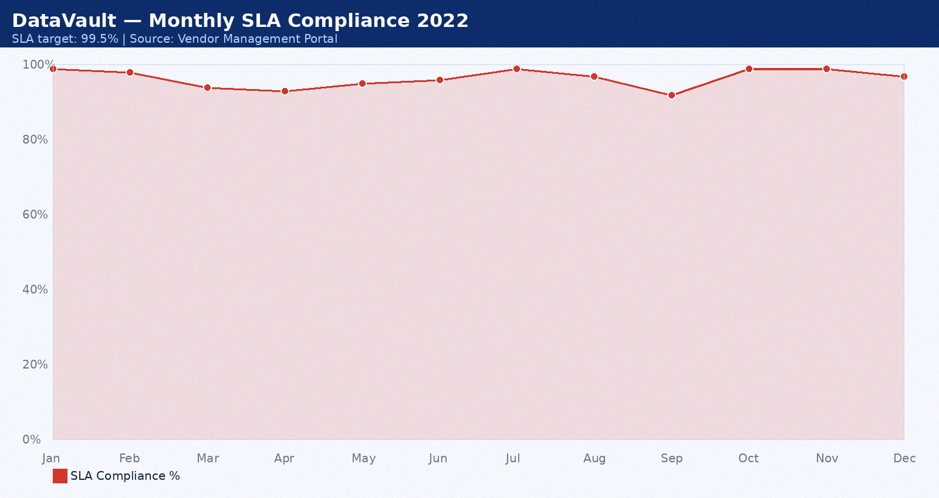

Appendix 3: Cognizant — Monthly SLA Data April 2022
Provider: Cognizant. Period: April 2022. Total tickets: 15. P1: 0. P2: 6. P3: 11. SLA compliance: 91%. Breaches: 0. Average MTTR: 38 minutes. CSAT: 3.8/5.0.
Month | SLA Target | Actual SLA | Breach? | Tickets | MTTR (min) | CSAT
Jan 2022 | 99.5% | 92.0% | Yes | 3 | 35 | 4.0
Feb 2022 | 99.5% | 93.0% | Yes | 4 | 36 | 4.1
Mar 2022 | 99.5% | 94.0% | Yes | 5 | 37 | 4.2
Apr 2022 | 99.5% | 95.0% | Yes | 6 | 38 | 4.3
May 2022 | 99.5% | 96.0% | Yes | 7 | 39 | 4.4
Jun 2022 | 99.5% | 97.0% | Yes | 8 | 40 | 4.5
Jul 2022 | 99.5% | 98.0% | Yes | 9 | 41 | 4.6
Aug 2022 | 99.5% | 92.0% | Yes | 10 | 42 | 4.7
Sep 2022 | 99.5% | 93.0% | Yes | 3 | 43 | 4.8
Oct 2022 | 99.5% | 94.0% | Yes | 4 | 44 | 4.9
Nov 2022 | 99.5% | 95.0% | Yes | 5 | 45 | 4.0
Dec 2022 | 99.5% | 96.0% | Yes | 6 | 46 | 4.1

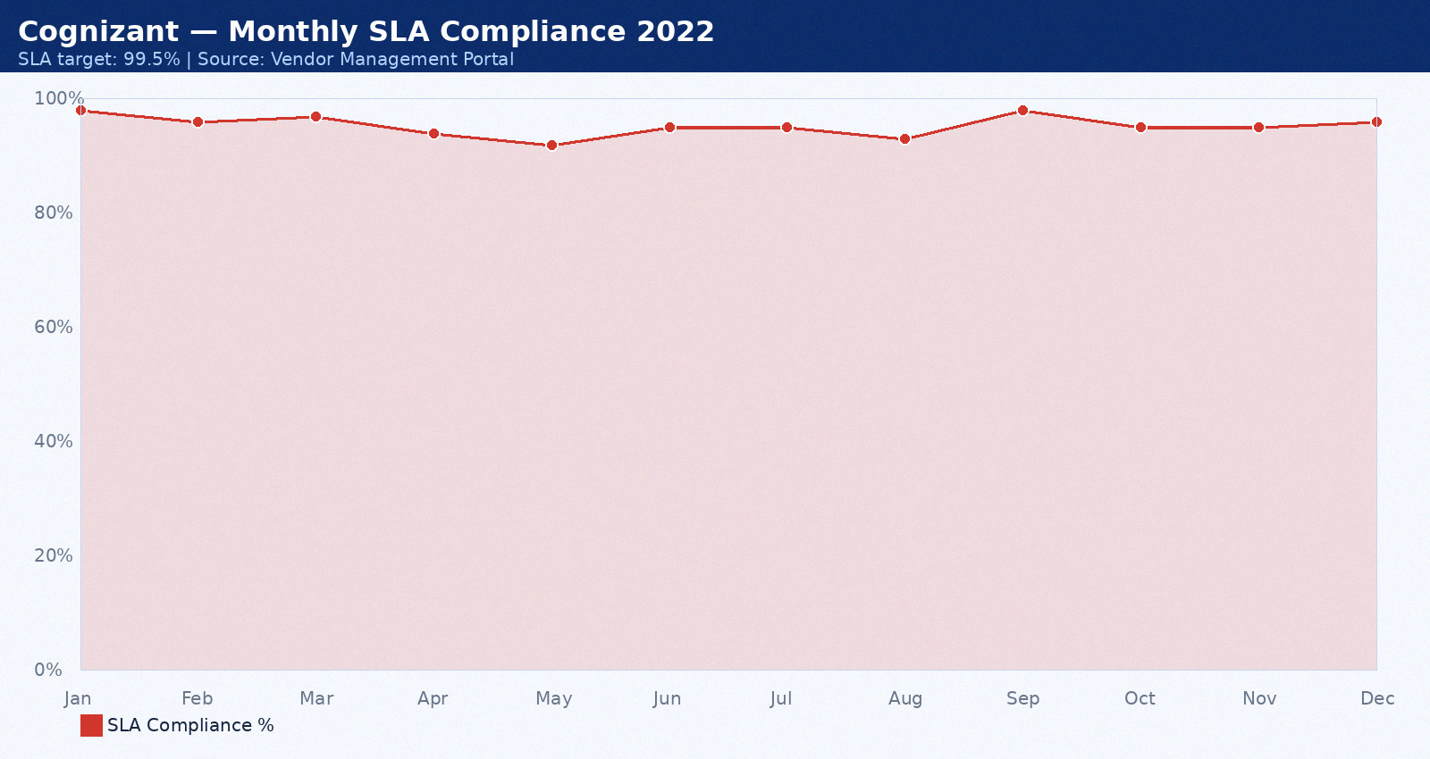

Appendix 4: Rackspace — Monthly SLA Data May 2022
Provider: Rackspace. Period: May 2022. Total tickets: 16. P1: 1. P2: 7. P3: 12. SLA compliance: 92%. Breaches: 1. Average MTTR: 39 minutes. CSAT: 3.9/5.0.
Month | SLA Target | Actual SLA | Breach? | Tickets | MTTR (min) | CSAT
Jan 2022 | 99.5% | 92.0% | Yes | 3 | 35 | 4.0
Feb 2022 | 99.5% | 93.0% | Yes | 4 | 36 | 4.1
Mar 2022 | 99.5% | 94.0% | Yes | 5 | 37 | 4.2
Apr 2022 | 99.5% | 95.0% | Yes | 6 | 38 | 4.3
May 2022 | 99.5% | 96.0% | Yes | 7 | 39 | 4.4
Jun 2022 | 99.5% | 97.0% | Yes | 8 | 40 | 4.5
Jul 2022 | 99.5% | 98.0% | Yes | 9 | 41 | 4.6
Aug 2022 | 99.5% | 92.0% | Yes | 10 | 42 | 4.7
Sep 2022 | 99.5% | 93.0% | Yes | 3 | 43 | 4.8
Oct 2022 | 99.5% | 94.0% | Yes | 4 | 44 | 4.9
Nov 2022 | 99.5% | 95.0% | Yes | 5 | 45 | 4.0
Dec 2022 | 99.5% | 96.0% | Yes | 6 | 46 | 4.1

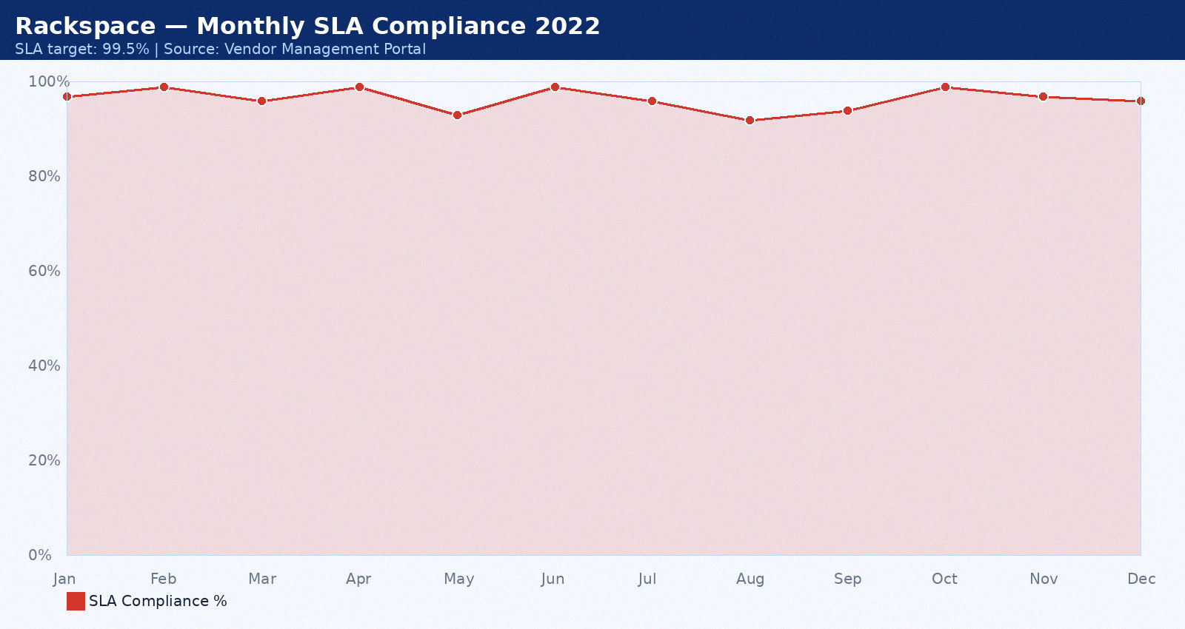

Appendix 5: IBM — Monthly SLA Data June 2022
Provider: IBM. Period: June 2022. Total tickets: 17. P1: 2. P2: 3. P3: 13. SLA compliance: 93%. Breaches: 2. Average MTTR: 40 minutes. CSAT: 4.0/5.0.
Month | SLA Target | Actual SLA | Breach? | Tickets | MTTR (min) | CSAT
Jan 2022 | 99.5% | 92.0% | Yes | 3 | 35 | 4.0
Feb 2022 | 99.5% | 93.0% | Yes | 4 | 36 | 4.1
Mar 2022 | 99.5% | 94.0% | Yes | 5 | 37 | 4.2
Apr 2022 | 99.5% | 95.0% | Yes | 6 | 38 | 4.3
May 2022 | 99.5% | 96.0% | Yes | 7 | 39 | 4.4
Jun 2022 | 99.5% | 97.0% | Yes | 8 | 40 | 4.5
Jul 2022 | 99.5% | 98.0% | Yes | 9 | 41 | 4.6
Aug 2022 | 99.5% | 92.0% | Yes | 10 | 42 | 4.7
Sep 2022 | 99.5% | 93.0% | Yes | 3 | 43 | 4.8
Oct 2022 | 99.5% | 94.0% | Yes | 4 | 44 | 4.9
Nov 2022 | 99.5% | 95.0% | Yes | 5 | 45 | 4.0
Dec 2022 | 99.5% | 96.0% | Yes | 6 | 46 | 4.1

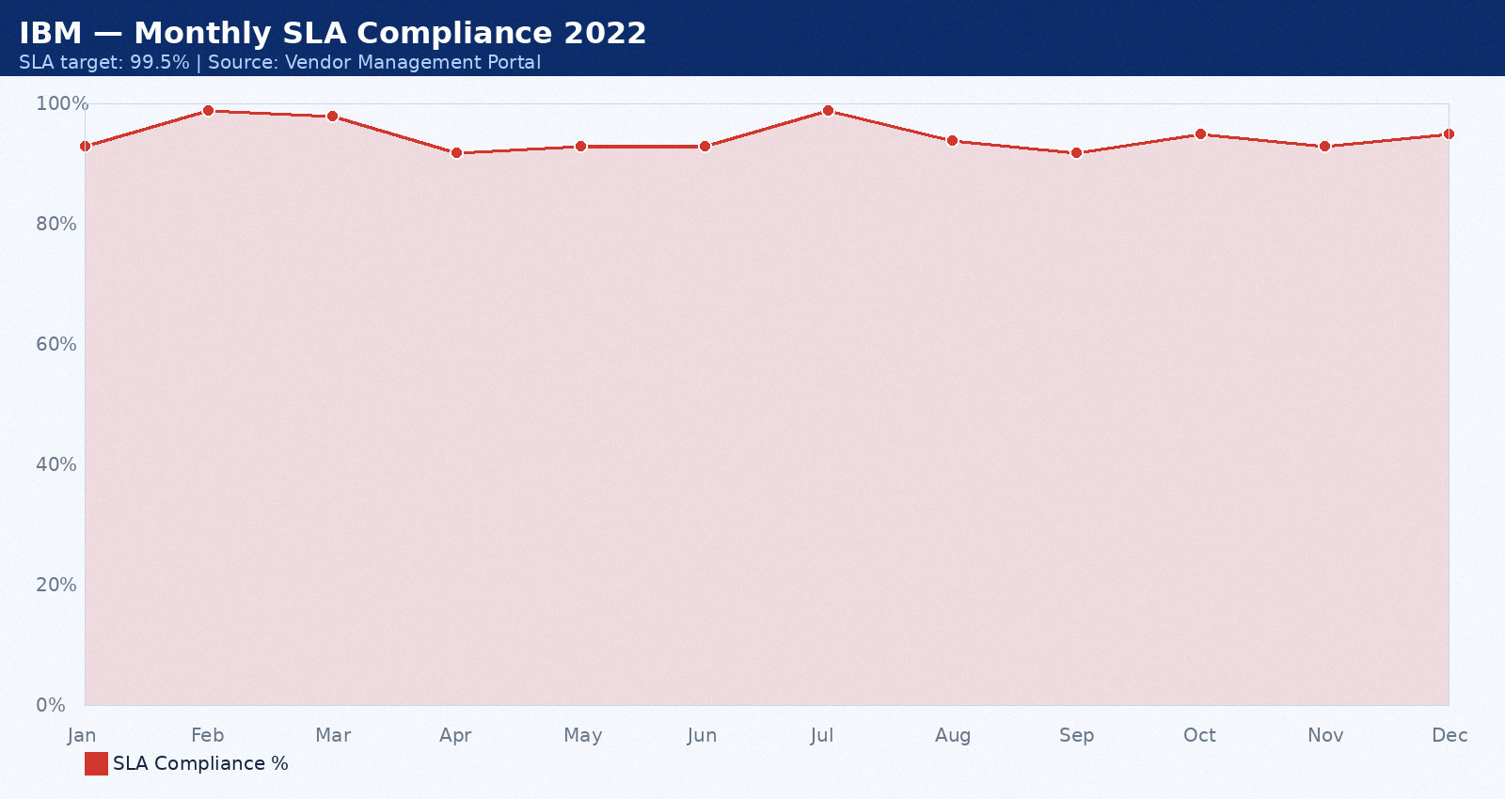

Appendix 6: NetGuard — Monthly SLA Data July 2022
Provider: NetGuard. Period: July 2022. Total tickets: 18. P1: 0. P2: 4. P3: 8. SLA compliance: 94%. Breaches: 0. Average MTTR: 41 minutes. CSAT: 4.1/5.0.
Month | SLA Target | Actual SLA | Breach? | Tickets | MTTR (min) | CSAT
Jan 2022 | 99.5% | 92.0% | Yes | 3 | 35 | 4.0
Feb 2022 | 99.5% | 93.0% | Yes | 4 | 36 | 4.1
Mar 2022 | 99.5% | 94.0% | Yes | 5 | 37 | 4.2
Apr 2022 | 99.5% | 95.0% | Yes | 6 | 38 | 4.3
May 2022 | 99.5% | 96.0% | Yes | 7 | 39 | 4.4
Jun 2022 | 99.5% | 97.0% | Yes | 8 | 40 | 4.5
Jul 2022 | 99.5% | 98.0% | Yes | 9 | 41 | 4.6
Aug 2022 | 99.5% | 92.0% | Yes | 10 | 42 | 4.7
Sep 2022 | 99.5% | 93.0% | Yes | 3 | 43 | 4.8
Oct 2022 | 99.5% | 94.0% | Yes | 4 | 44 | 4.9
Nov 2022 | 99.5% | 95.0% | Yes | 5 | 45 | 4.0
Dec 2022 | 99.5% | 96.0% | Yes | 6 | 46 | 4.1

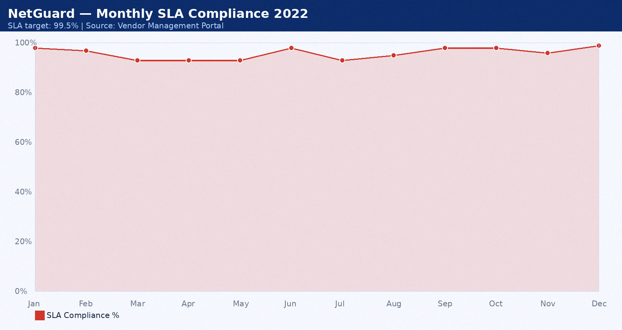

Appendix 7: PwC — Monthly SLA Data August 2022
Provider: PwC. Period: August 2022. Total tickets: 19. P1: 1. P2: 5. P3: 9. SLA compliance: 95%. Breaches: 1. Average MTTR: 42 minutes. CSAT: 4.2/5.0.
Month | SLA Target | Actual SLA | Breach? | Tickets | MTTR (min) | CSAT
Jan 2022 | 99.5% | 92.0% | Yes | 3 | 35 | 4.0
Feb 2022 | 99.5% | 93.0% | Yes | 4 | 36 | 4.1
Mar 2022 | 99.5% | 94.0% | Yes | 5 | 37 | 4.2
Apr 2022 | 99.5% | 95.0% | Yes | 6 | 38 | 4.3
May 2022 | 99.5% | 96.0% | Yes | 7 | 39 | 4.4
Jun 2022 | 99.5% | 97.0% | Yes | 8 | 40 | 4.5
Jul 2022 | 99.5% | 98.0% | Yes | 9 | 41 | 4.6
Aug 2022 | 99.5% | 92.0% | Yes | 10 | 42 | 4.7
Sep 2022 | 99.5% | 93.0% | Yes | 3 | 43 | 4.8
Oct 2022 | 99.5% | 94.0% | Yes | 4 | 44 | 4.9
Nov 2022 | 99.5% | 95.0% | Yes | 5 | 45 | 4.0
Dec 2022 | 99.5% | 96.0% | Yes | 6 | 46 | 4.1

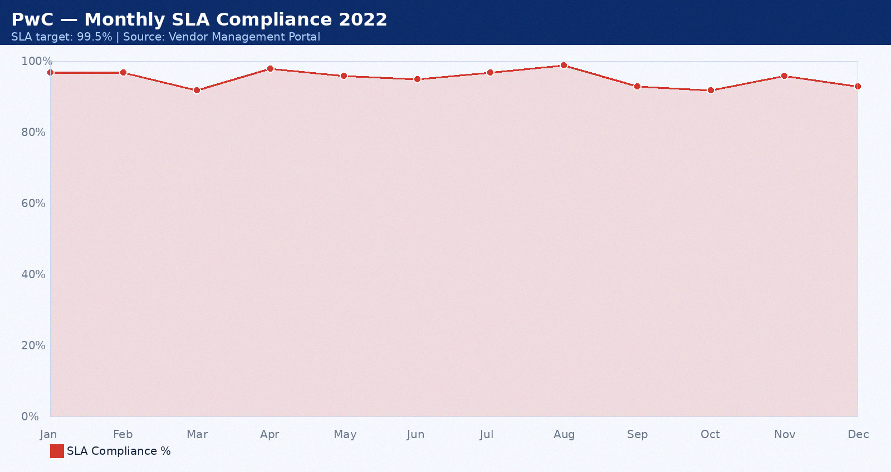

Appendix 8: Accenture — Monthly SLA Data September 2022
Provider: Accenture. Period: September 2022. Total tickets: 20. P1: 2. P2: 6. P3: 10. SLA compliance: 96%. Breaches: 2. Average MTTR: 43 minutes. CSAT: 4.3/5.0.
Month | SLA Target | Actual SLA | Breach? | Tickets | MTTR (min) | CSAT
Jan 2022 | 99.5% | 92.0% | Yes | 3 | 35 | 4.0
Feb 2022 | 99.5% | 93.0% | Yes | 4 | 36 | 4.1
Mar 2022 | 99.5% | 94.0% | Yes | 5 | 37 | 4.2
Apr 2022 | 99.5% | 95.0% | Yes | 6 | 38 | 4.3
May 2022 | 99.5% | 96.0% | Yes | 7 | 39 | 4.4
Jun 2022 | 99.5% | 97.0% | Yes | 8 | 40 | 4.5
Jul 2022 | 99.5% | 98.0% | Yes | 9 | 41 | 4.6
Aug 2022 | 99.5% | 92.0% | Yes | 10 | 42 | 4.7
Sep 2022 | 99.5% | 93.0% | Yes | 3 | 43 | 4.8
Oct 2022 | 99.5% | 94.0% | Yes | 4 | 44 | 4.9
Nov 2022 | 99.5% | 95.0% | Yes | 5 | 45 | 4.0
Dec 2022 | 99.5% | 96.0% | Yes | 6 | 46 | 4.1

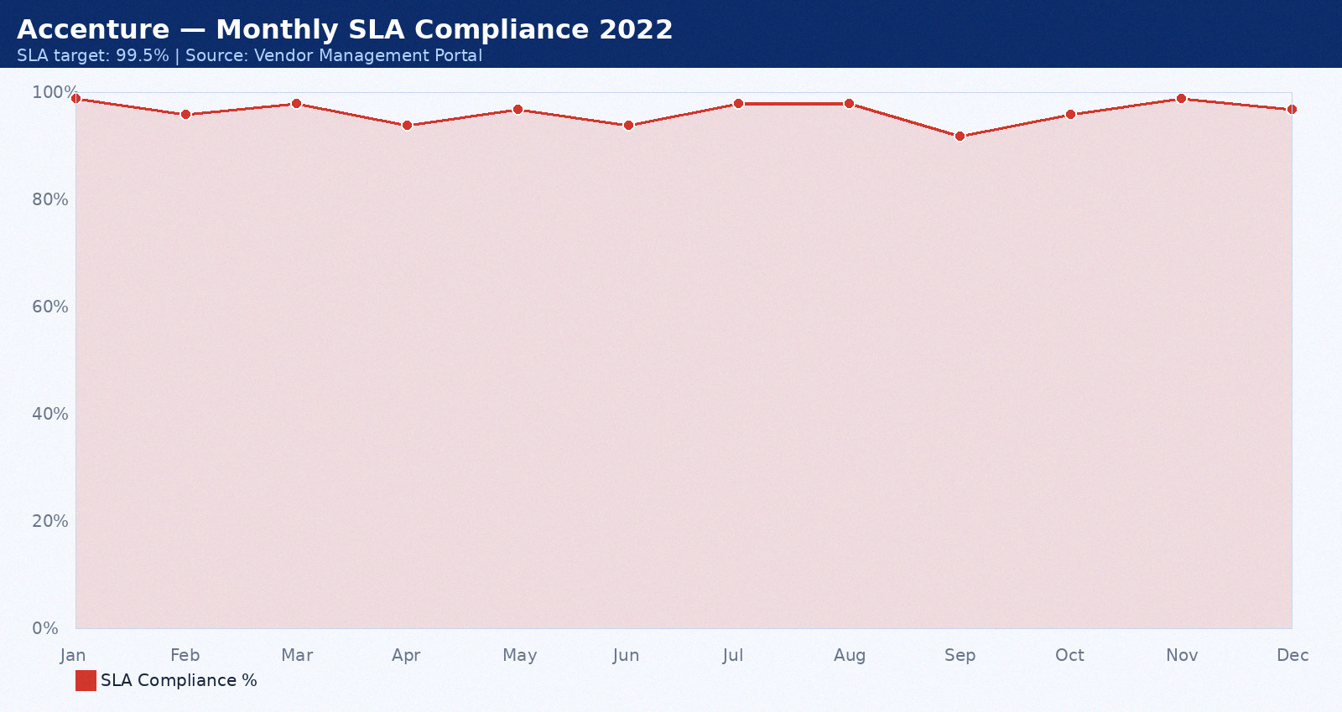

Appendix 9: Wipro MSP — Monthly SLA Data October 2022
Provider: Wipro MSP. Period: October 2022. Total tickets: 21. P1: 0. P2: 7. P3: 11. SLA compliance: 97%. Breaches: 0. Average MTTR: 44 minutes. CSAT: 4.4/5.0.
Month | SLA Target | Actual SLA | Breach? | Tickets | MTTR (min) | CSAT
Jan 2022 | 99.5% | 92.0% | Yes | 3 | 35 | 4.0
Feb 2022 | 99.5% | 93.0% | Yes | 4 | 36 | 4.1
Mar 2022 | 99.5% | 94.0% | Yes | 5 | 37 | 4.2
Apr 2022 | 99.5% | 95.0% | Yes | 6 | 38 | 4.3
May 2022 | 99.5% | 96.0% | Yes | 7 | 39 | 4.4
Jun 2022 | 99.5% | 97.0% | Yes | 8 | 40 | 4.5
Jul 2022 | 99.5% | 98.0% | Yes | 9 | 41 | 4.6
Aug 2022 | 99.5% | 92.0% | Yes | 10 | 42 | 4.7
Sep 2022 | 99.5% | 93.0% | Yes | 3 | 43 | 4.8
Oct 2022 | 99.5% | 94.0% | Yes | 4 | 44 | 4.9
Nov 2022 | 99.5% | 95.0% | Yes | 5 | 45 | 4.0
Dec 2022 | 99.5% | 96.0% | Yes | 6 | 46 | 4.1

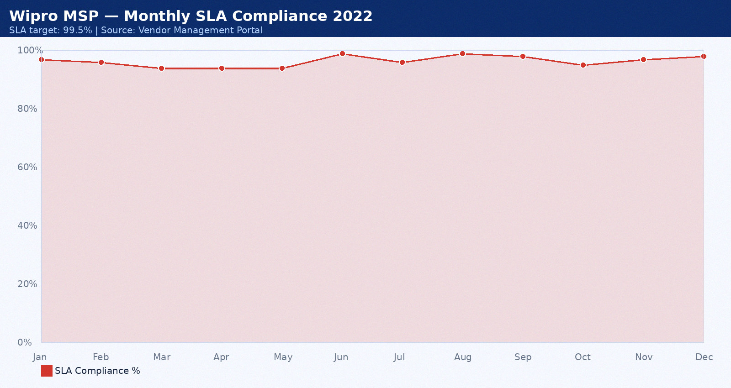

Appendix 10: DataVault — Monthly SLA Data November 2022
Provider: DataVault. Period: November 2022. Total tickets: 22. P1: 1. P2: 3. P3: 12. SLA compliance: 98%. Breaches: 1. Average MTTR: 45 minutes. CSAT: 4.5/5.0.
Month | SLA Target | Actual SLA | Breach? | Tickets | MTTR (min) | CSAT
Jan 2022 | 99.5% | 92.0% | Yes | 3 | 35 | 4.0
Feb 2022 | 99.5% | 93.0% | Yes | 4 | 36 | 4.1
Mar 2022 | 99.5% | 94.0% | Yes | 5 | 37 | 4.2
Apr 2022 | 99.5% | 95.0% | Yes | 6 | 38 | 4.3
May 2022 | 99.5% | 96.0% | Yes | 7 | 39 | 4.4
Jun 2022 | 99.5% | 97.0% | Yes | 8 | 40 | 4.5
Jul 2022 | 99.5% | 98.0% | Yes | 9 | 41 | 4.6
Aug 2022 | 99.5% | 92.0% | Yes | 10 | 42 | 4.7
Sep 2022 | 99.5% | 93.0% | Yes | 3 | 43 | 4.8
Oct 2022 | 99.5% | 94.0% | Yes | 4 | 44 | 4.9
Nov 2022 | 99.5% | 95.0% | Yes | 5 | 45 | 4.0
Dec 2022 | 99.5% | 96.0% | Yes | 6 | 46 | 4.1

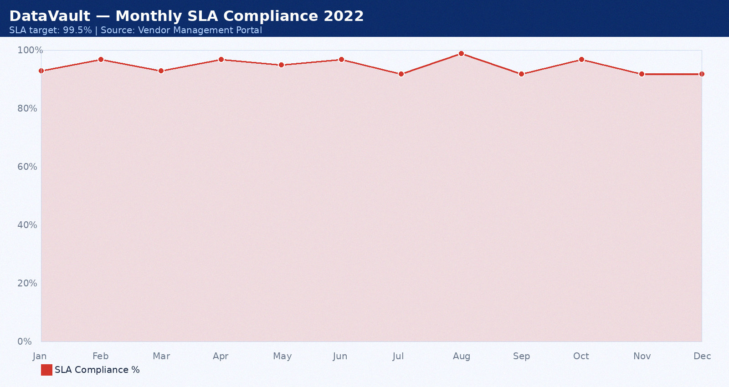

Appendix 11: Cognizant — Monthly SLA Data December 2022
Provider: Cognizant. Period: December 2022. Total tickets: 23. P1: 2. P2: 4. P3: 13. SLA compliance: 99%. Breaches: 2. Average MTTR: 46 minutes. CSAT: 4.6/5.0.
Month | SLA Target | Actual SLA | Breach? | Tickets | MTTR (min) | CSAT
Jan 2022 | 99.5% | 92.0% | Yes | 3 | 35 | 4.0
Feb 2022 | 99.5% | 93.0% | Yes | 4 | 36 | 4.1
Mar 2022 | 99.5% | 94.0% | Yes | 5 | 37 | 4.2
Apr 2022 | 99.5% | 95.0% | Yes | 6 | 38 | 4.3
May 2022 | 99.5% | 96.0% | Yes | 7 | 39 | 4.4
Jun 2022 | 99.5% | 97.0% | Yes | 8 | 40 | 4.5
Jul 2022 | 99.5% | 98.0% | Yes | 9 | 41 | 4.6
Aug 2022 | 99.5% | 92.0% | Yes | 10 | 42 | 4.7
Sep 2022 | 99.5% | 93.0% | Yes | 3 | 43 | 4.8
Oct 2022 | 99.5% | 94.0% | Yes | 4 | 44 | 4.9
Nov 2022 | 99.5% | 95.0% | Yes | 5 | 45 | 4.0
Dec 2022 | 99.5% | 96.0% | Yes | 6 | 46 | 4.1

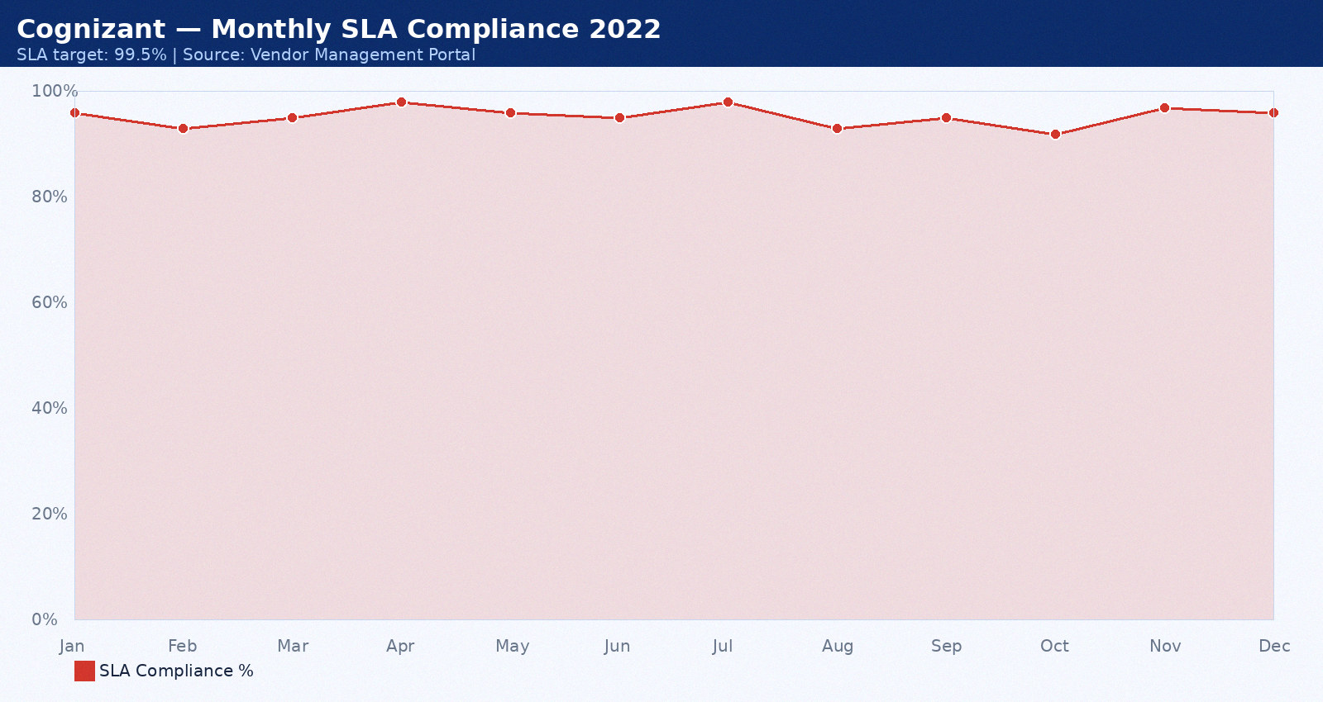

Appendix 12: Rackspace — Monthly SLA Data January 2023
Provider: Rackspace. Period: January 2023. Total tickets: 24. P1: 0. P2: 5. P3: 8. SLA compliance: 88%. Breaches: 0. Average MTTR: 47 minutes. CSAT: 4.7/5.0.
Month | SLA Target | Actual SLA | Breach? | Tickets | MTTR (min) | CSAT
Jan 2023 | 99.5% | 92.0% | Yes | 3 | 35 | 4.0
Feb 2023 | 99.5% | 93.0% | Yes | 4 | 36 | 4.1
Mar 2023 | 99.5% | 94.0% | Yes | 5 | 37 | 4.2
Apr 2023 | 99.5% | 95.0% | Yes | 6 | 38 | 4.3
May 2023 | 99.5% | 96.0% | Yes | 7 | 39 | 4.4
Jun 2023 | 99.5% | 97.0% | Yes | 8 | 40 | 4.5
Jul 2023 | 99.5% | 98.0% | Yes | 9 | 41 | 4.6
Aug 2023 | 99.5% | 92.0% | Yes | 10 | 42 | 4.7
Sep 2023 | 99.5% | 93.0% | Yes | 3 | 43 | 4.8
Oct 2023 | 99.5% | 94.0% | Yes | 4 | 44 | 4.9
Nov 2023 | 99.5% | 95.0% | Yes | 5 | 45 | 4.0
Dec 2023 | 99.5% | 96.0% | Yes | 6 | 46 | 4.1

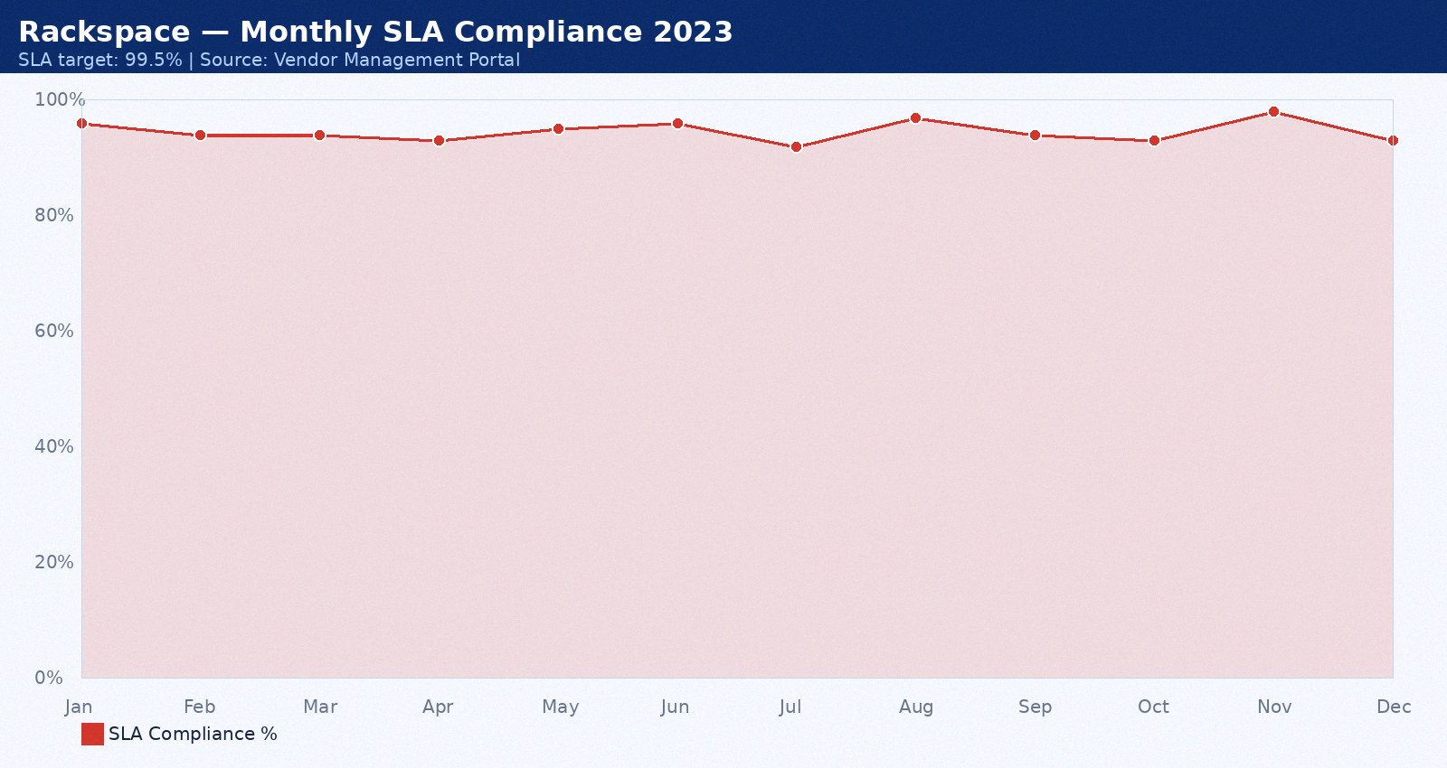

Appendix 13: IBM — Monthly SLA Data February 2023
Provider: IBM. Period: February 2023. Total tickets: 25. P1: 1. P2: 6. P3: 9. SLA compliance: 89%. Breaches: 1. Average MTTR: 48 minutes. CSAT: 4.8/5.0.
Month | SLA Target | Actual SLA | Breach? | Tickets | MTTR (min) | CSAT
Jan 2023 | 99.5% | 92.0% | Yes | 3 | 35 | 4.0
Feb 2023 | 99.5% | 93.0% | Yes | 4 | 36 | 4.1
Mar 2023 | 99.5% | 94.0% | Yes | 5 | 37 | 4.2
Apr 2023 | 99.5% | 95.0% | Yes | 6 | 38 | 4.3
May 2023 | 99.5% | 96.0% | Yes | 7 | 39 | 4.4
Jun 2023 | 99.5% | 97.0% | Yes | 8 | 40 | 4.5
Jul 2023 | 99.5% | 98.0% | Yes | 9 | 41 | 4.6
Aug 2023 | 99.5% | 92.0% | Yes | 10 | 42 | 4.7
Sep 2023 | 99.5% | 93.0% | Yes | 3 | 43 | 4.8
Oct 2023 | 99.5% | 94.0% | Yes | 4 | 44 | 4.9
Nov 2023 | 99.5% | 95.0% | Yes | 5 | 45 | 4.0
Dec 2023 | 99.5% | 96.0% | Yes | 6 | 46 | 4.1

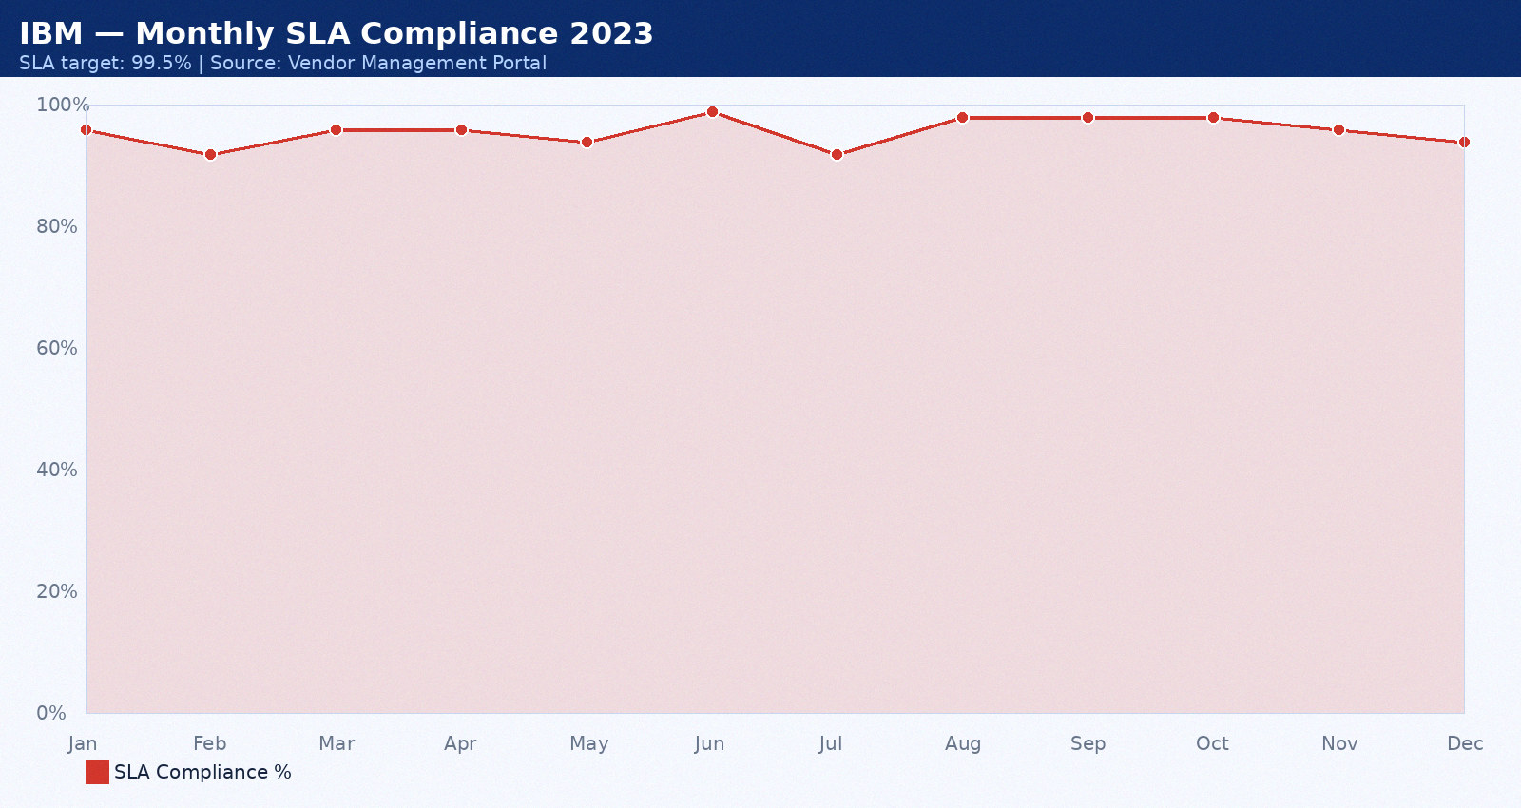

Appendix 14: NetGuard — Monthly SLA Data March 2023
Provider: NetGuard. Period: March 2023. Total tickets: 26. P1: 2. P2: 7. P3: 10. SLA compliance: 90%. Breaches: 2. Average MTTR: 49 minutes. CSAT: 4.9/5.0.
Month | SLA Target | Actual SLA | Breach? | Tickets | MTTR (min) | CSAT
Jan 2023 | 99.5% | 92.0% | Yes | 3 | 35 | 4.0
Feb 2023 | 99.5% | 93.0% | Yes | 4 | 36 | 4.1
Mar 2023 | 99.5% | 94.0% | Yes | 5 | 37 | 4.2
Apr 2023 | 99.5% | 95.0% | Yes | 6 | 38 | 4.3
May 2023 | 99.5% | 96.0% | Yes | 7 | 39 | 4.4
Jun 2023 | 99.5% | 97.0% | Yes | 8 | 40 | 4.5
Jul 2023 | 99.5% | 98.0% | Yes | 9 | 41 | 4.6
Aug 2023 | 99.5% | 92.0% | Yes | 10 | 42 | 4.7
Sep 2023 | 99.5% | 93.0% | Yes | 3 | 43 | 4.8
Oct 2023 | 99.5% | 94.0% | Yes | 4 | 44 | 4.9
Nov 2023 | 99.5% | 95.0% | Yes | 5 | 45 | 4.0
Dec 2023 | 99.5% | 96.0% | Yes | 6 | 46 | 4.1

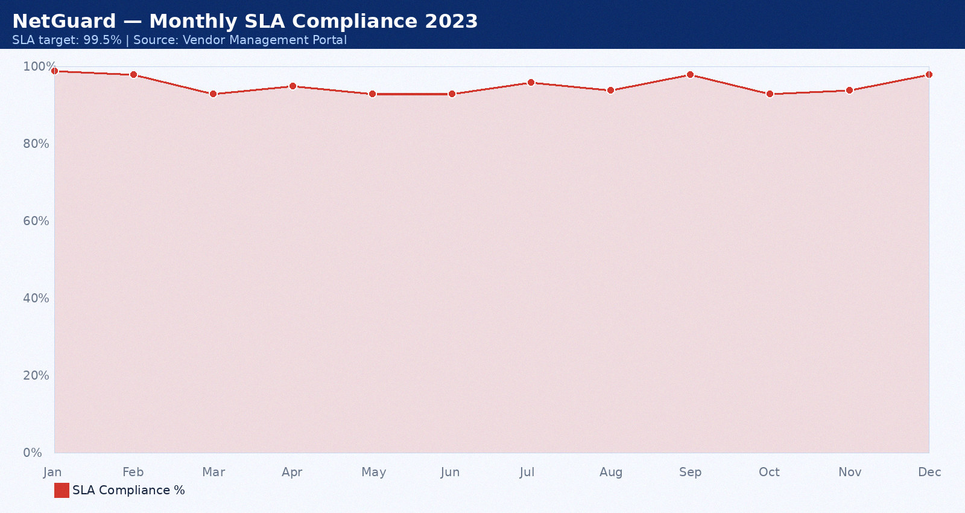

Appendix 15: PwC — Monthly SLA Data April 2023
Provider: PwC. Period: April 2023. Total tickets: 12. P1: 0. P2: 3. P3: 11. SLA compliance: 91%. Breaches: 0. Average MTTR: 50 minutes. CSAT: 3.5/5.0.
Month | SLA Target | Actual SLA | Breach? | Tickets | MTTR (min) | CSAT
Jan 2023 | 99.5% | 92.0% | Yes | 3 | 35 | 4.0
Feb 2023 | 99.5% | 93.0% | Yes | 4 | 36 | 4.1
Mar 2023 | 99.5% | 94.0% | Yes | 5 | 37 | 4.2
Apr 2023 | 99.5% | 95.0% | Yes | 6 | 38 | 4.3
May 2023 | 99.5% | 96.0% | Yes | 7 | 39 | 4.4
Jun 2023 | 99.5% | 97.0% | Yes | 8 | 40 | 4.5
Jul 2023 | 99.5% | 98.0% | Yes | 9 | 41 | 4.6
Aug 2023 | 99.5% | 92.0% | Yes | 10 | 42 | 4.7
Sep 2023 | 99.5% | 93.0% | Yes | 3 | 43 | 4.8
Oct 2023 | 99.5% | 94.0% | Yes | 4 | 44 | 4.9
Nov 2023 | 99.5% | 95.0% | Yes | 5 | 45 | 4.0
Dec 2023 | 99.5% | 96.0% | Yes | 6 | 46 | 4.1

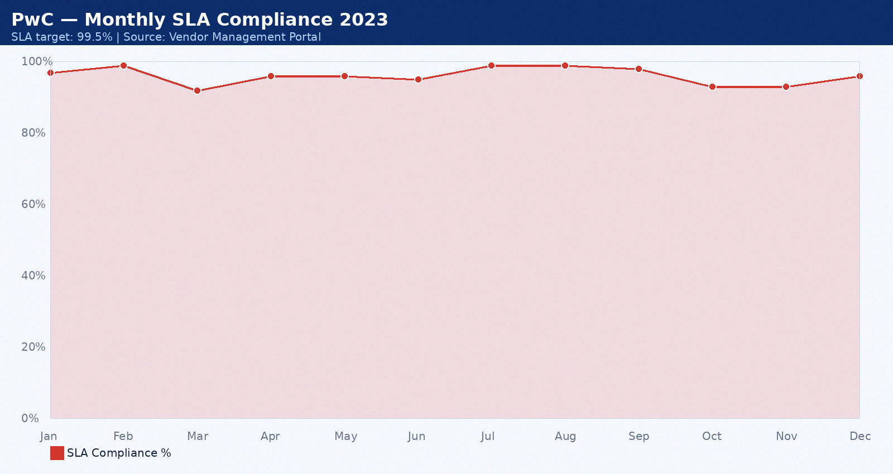

Appendix 16: Accenture — Monthly SLA Data May 2023
Provider: Accenture. Period: May 2023. Total tickets: 13. P1: 1. P2: 4. P3: 12. SLA compliance: 92%. Breaches: 1. Average MTTR: 51 minutes. CSAT: 3.6/5.0.
Month | SLA Target | Actual SLA | Breach? | Tickets | MTTR (min) | CSAT
Jan 2023 | 99.5% | 92.0% | Yes | 3 | 35 | 4.0
Feb 2023 | 99.5% | 93.0% | Yes | 4 | 36 | 4.1
Mar 2023 | 99.5% | 94.0% | Yes | 5 | 37 | 4.2
Apr 2023 | 99.5% | 95.0% | Yes | 6 | 38 | 4.3
May 2023 | 99.5% | 96.0% | Yes | 7 | 39 | 4.4
Jun 2023 | 99.5% | 97.0% | Yes | 8 | 40 | 4.5
Jul 2023 | 99.5% | 98.0% | Yes | 9 | 41 | 4.6
Aug 2023 | 99.5% | 92.0% | Yes | 10 | 42 | 4.7
Sep 2023 | 99.5% | 93.0% | Yes | 3 | 43 | 4.8
Oct 2023 | 99.5% | 94.0% | Yes | 4 | 44 | 4.9
Nov 2023 | 99.5% | 95.0% | Yes | 5 | 45 | 4.0
Dec 2023 | 99.5% | 96.0% | Yes | 6 | 46 | 4.1

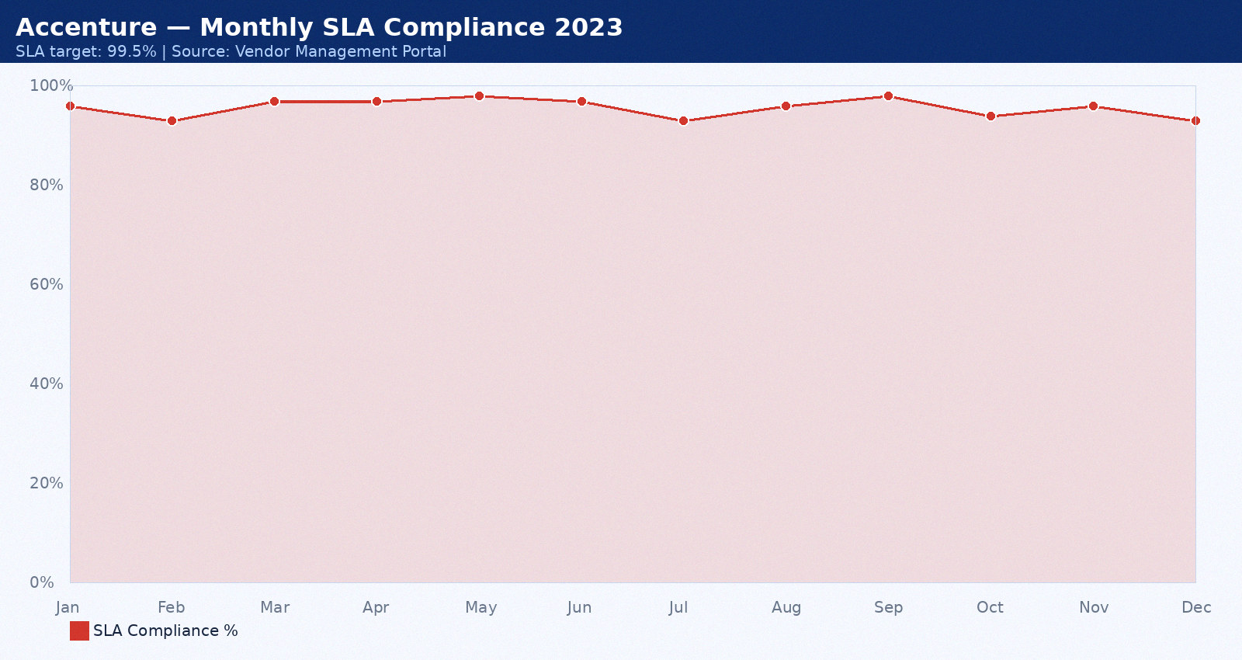

Appendix 17: Wipro MSP — Monthly SLA Data June 2023
Provider: Wipro MSP. Period: June 2023. Total tickets: 14. P1: 2. P2: 5. P3: 13. SLA compliance: 93%. Breaches: 2. Average MTTR: 52 minutes. CSAT: 3.7/5.0.
Month | SLA Target | Actual SLA | Breach? | Tickets | MTTR (min) | CSAT
Jan 2023 | 99.5% | 92.0% | Yes | 3 | 35 | 4.0
Feb 2023 | 99.5% | 93.0% | Yes | 4 | 36 | 4.1
Mar 2023 | 99.5% | 94.0% | Yes | 5 | 37 | 4.2
Apr 2023 | 99.5% | 95.0% | Yes | 6 | 38 | 4.3
May 2023 | 99.5% | 96.0% | Yes | 7 | 39 | 4.4
Jun 2023 | 99.5% | 97.0% | Yes | 8 | 40 | 4.5
Jul 2023 | 99.5% | 98.0% | Yes | 9 | 41 | 4.6
Aug 2023 | 99.5% | 92.0% | Yes | 10 | 42 | 4.7
Sep 2023 | 99.5% | 93.0% | Yes | 3 | 43 | 4.8
Oct 2023 | 99.5% | 94.0% | Yes | 4 | 44 | 4.9
Nov 2023 | 99.5% | 95.0% | Yes | 5 | 45 | 4.0
Dec 2023 | 99.5% | 96.0% | Yes | 6 | 46 | 4.1

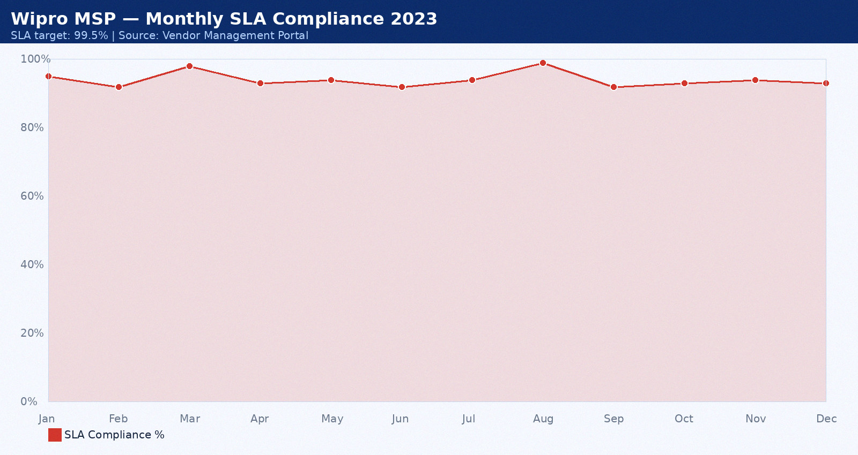

Appendix 18: DataVault — Monthly SLA Data July 2023
Provider: DataVault. Period: July 2023. Total tickets: 15. P1: 0. P2: 6. P3: 8. SLA compliance: 94%. Breaches: 0. Average MTTR: 53 minutes. CSAT: 3.8/5.0.
Month | SLA Target | Actual SLA | Breach? | Tickets | MTTR (min) | CSAT
Jan 2023 | 99.5% | 92.0% | Yes | 3 | 35 | 4.0
Feb 2023 | 99.5% | 93.0% | Yes | 4 | 36 | 4.1
Mar 2023 | 99.5% | 94.0% | Yes | 5 | 37 | 4.2
Apr 2023 | 99.5% | 95.0% | Yes | 6 | 38 | 4.3
May 2023 | 99.5% | 96.0% | Yes | 7 | 39 | 4.4
Jun 2023 | 99.5% | 97.0% | Yes | 8 | 40 | 4.5
Jul 2023 | 99.5% | 98.0% | Yes | 9 | 41 | 4.6
Aug 2023 | 99.5% | 92.0% | Yes | 10 | 42 | 4.7
Sep 2023 | 99.5% | 93.0% | Yes | 3 | 43 | 4.8
Oct 2023 | 99.5% | 94.0% | Yes | 4 | 44 | 4.9
Nov 2023 | 99.5% | 95.0% | Yes | 5 | 45 | 4.0
Dec 2023 | 99.5% | 96.0% | Yes | 6 | 46 | 4.1

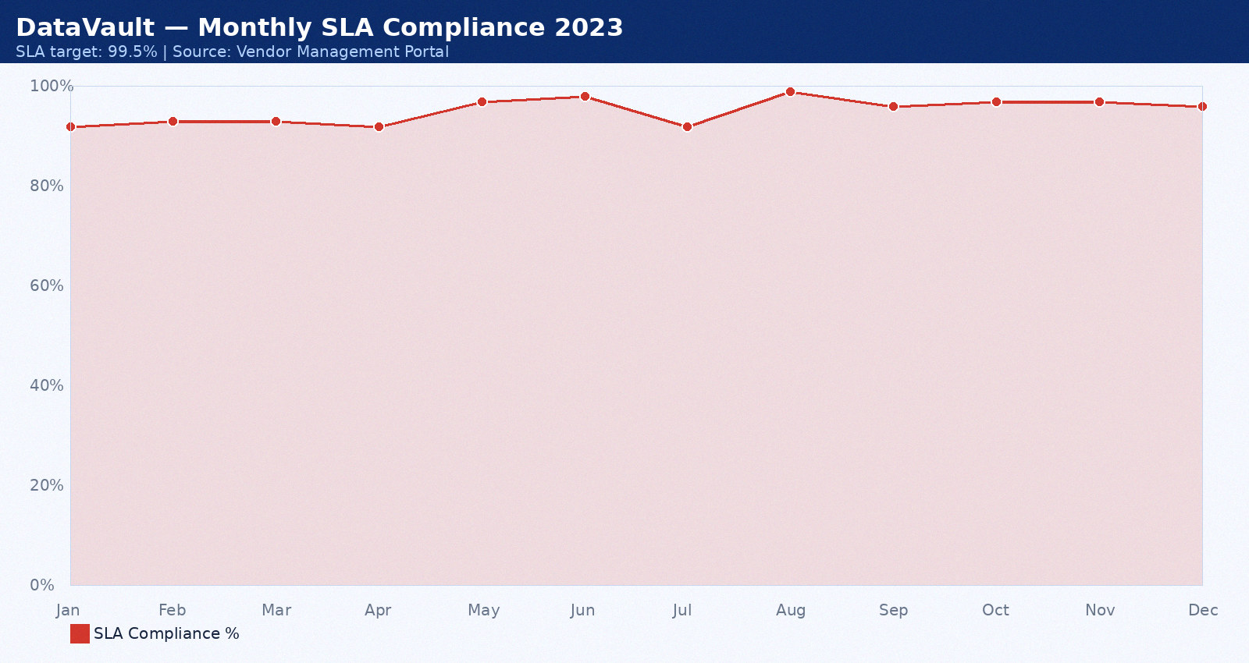

Appendix 19: Cognizant — Monthly SLA Data August 2023
Provider: Cognizant. Period: August 2023. Total tickets: 16. P1: 1. P2: 7. P3: 9. SLA compliance: 95%. Breaches: 1. Average MTTR: 54 minutes. CSAT: 3.9/5.0.
Month | SLA Target | Actual SLA | Breach? | Tickets | MTTR (min) | CSAT
Jan 2023 | 99.5% | 92.0% | Yes | 3 | 35 | 4.0
Feb 2023 | 99.5% | 93.0% | Yes | 4 | 36 | 4.1
Mar 2023 | 99.5% | 94.0% | Yes | 5 | 37 | 4.2
Apr 2023 | 99.5% | 95.0% | Yes | 6 | 38 | 4.3
May 2023 | 99.5% | 96.0% | Yes | 7 | 39 | 4.4
Jun 2023 | 99.5% | 97.0% | Yes | 8 | 40 | 4.5
Jul 2023 | 99.5% | 98.0% | Yes | 9 | 41 | 4.6
Aug 2023 | 99.5% | 92.0% | Yes | 10 | 42 | 4.7
Sep 2023 | 99.5% | 93.0% | Yes | 3 | 43 | 4.8
Oct 2023 | 99.5% | 94.0% | Yes | 4 | 44 | 4.9
Nov 2023 | 99.5% | 95.0% | Yes | 5 | 45 | 4.0
Dec 2023 | 99.5% | 96.0% | Yes | 6 | 46 | 4.1

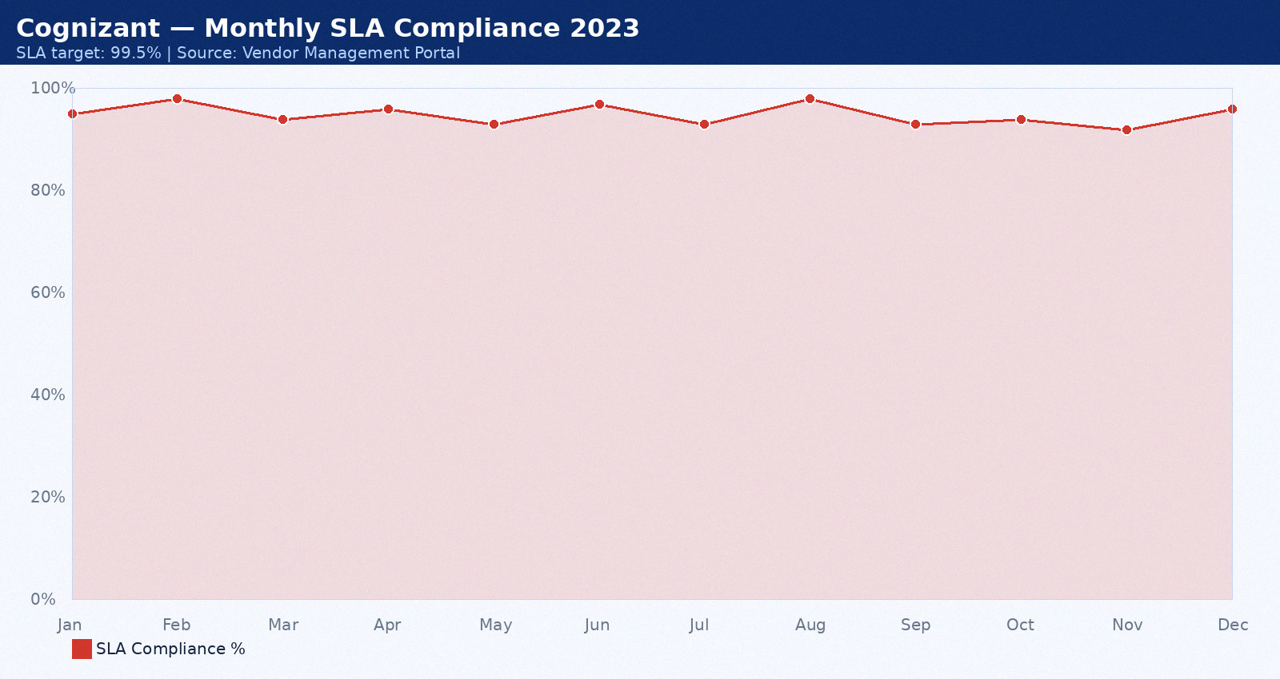

Appendix 20: Rackspace — Monthly SLA Data September 2023
Provider: Rackspace. Period: September 2023. Total tickets: 17. P1: 2. P2: 3. P3: 10. SLA compliance: 96%. Breaches: 2. Average MTTR: 55 minutes. CSAT: 4.0/5.0.
Month | SLA Target | Actual SLA | Breach? | Tickets | MTTR (min) | CSAT
Jan 2023 | 99.5% | 92.0% | Yes | 3 | 35 | 4.0
Feb 2023 | 99.5% | 93.0% | Yes | 4 | 36 | 4.1
Mar 2023 | 99.5% | 94.0% | Yes | 5 | 37 | 4.2
Apr 2023 | 99.5% | 95.0% | Yes | 6 | 38 | 4.3
May 2023 | 99.5% | 96.0% | Yes | 7 | 39 | 4.4
Jun 2023 | 99.5% | 97.0% | Yes | 8 | 40 | 4.5
Jul 2023 | 99.5% | 98.0% | Yes | 9 | 41 | 4.6
Aug 2023 | 99.5% | 92.0% | Yes | 10 | 42 | 4.7
Sep 2023 | 99.5% | 93.0% | Yes | 3 | 43 | 4.8
Oct 2023 | 99.5% | 94.0% | Yes | 4 | 44 | 4.9
Nov 2023 | 99.5% | 95.0% | Yes | 5 | 45 | 4.0
Dec 2023 | 99.5% | 96.0% | Yes | 6 | 46 | 4.1

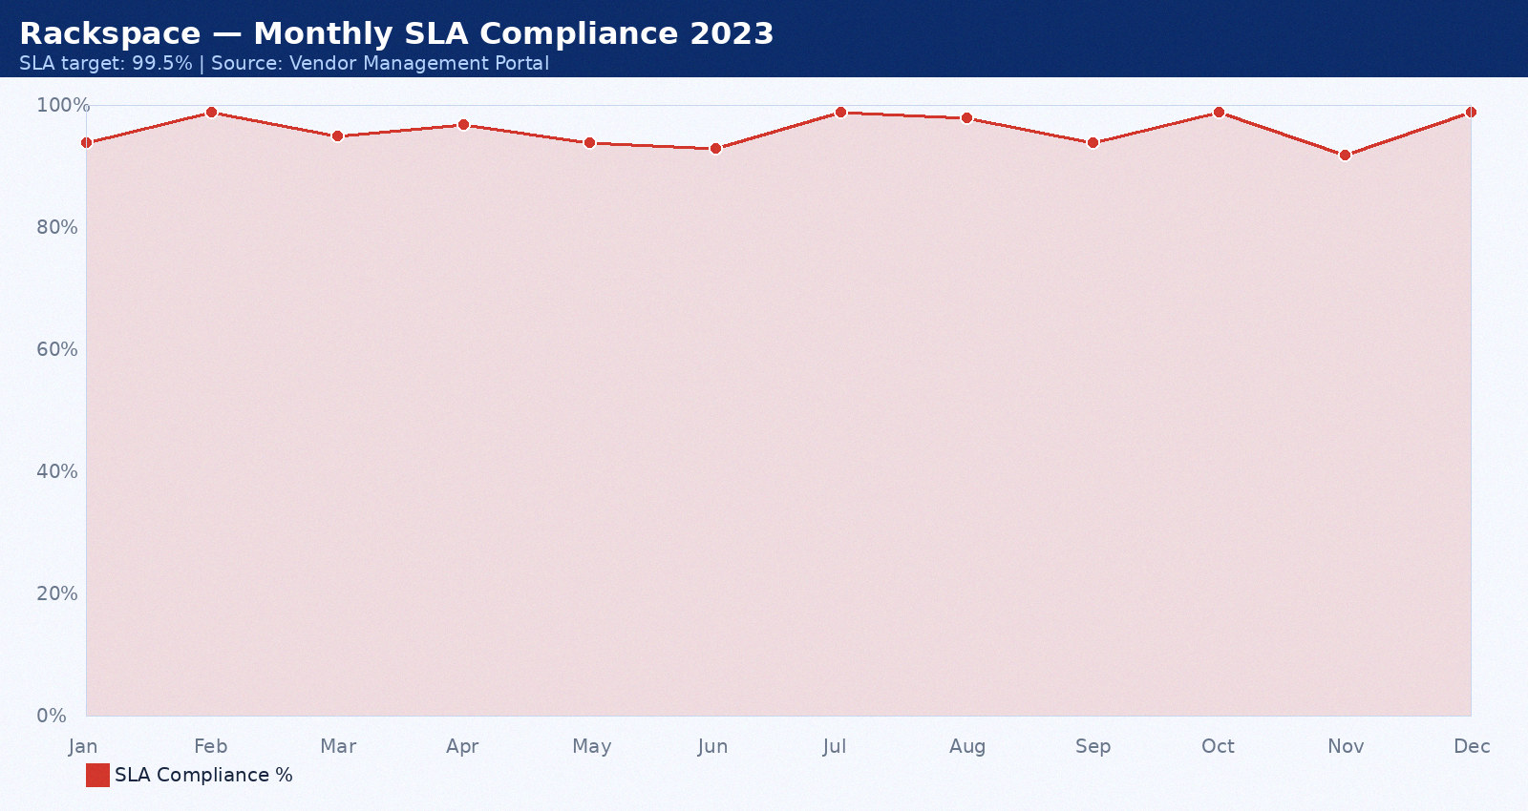

Appendix 21: IBM — Monthly SLA Data October 2023
Provider: IBM. Period: October 2023. Total tickets: 18. P1: 0. P2: 4. P3: 11. SLA compliance: 97%. Breaches: 0. Average MTTR: 56 minutes. CSAT: 4.1/5.0.
Month | SLA Target | Actual SLA | Breach? | Tickets | MTTR (min) | CSAT
Jan 2023 | 99.5% | 92.0% | Yes | 3 | 35 | 4.0
Feb 2023 | 99.5% | 93.0% | Yes | 4 | 36 | 4.1
Mar 2023 | 99.5% | 94.0% | Yes | 5 | 37 | 4.2
Apr 2023 | 99.5% | 95.0% | Yes | 6 | 38 | 4.3
May 2023 | 99.5% | 96.0% | Yes | 7 | 39 | 4.4
Jun 2023 | 99.5% | 97.0% | Yes | 8 | 40 | 4.5
Jul 2023 | 99.5% | 98.0% | Yes | 9 | 41 | 4.6
Aug 2023 | 99.5% | 92.0% | Yes | 10 | 42 | 4.7
Sep 2023 | 99.5% | 93.0% | Yes | 3 | 43 | 4.8
Oct 2023 | 99.5% | 94.0% | Yes | 4 | 44 | 4.9
Nov 2023 | 99.5% | 95.0% | Yes | 5 | 45 | 4.0
Dec 2023 | 99.5% | 96.0% | Yes | 6 | 46 | 4.1

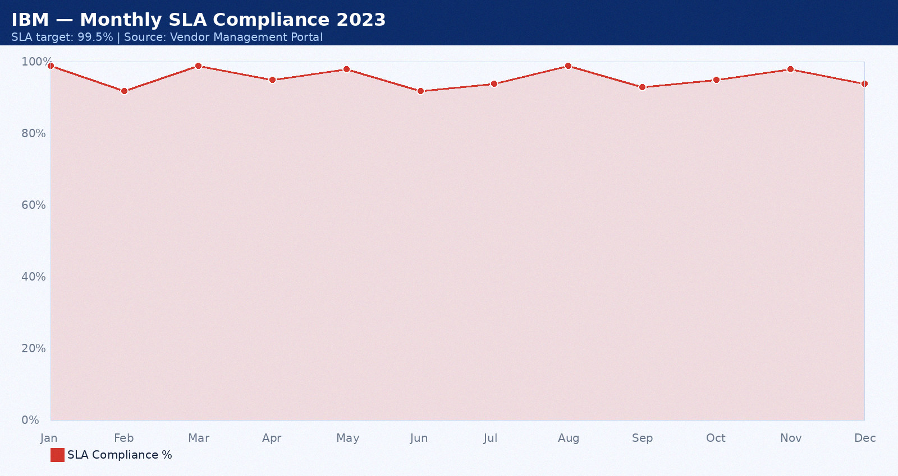

Appendix 22: NetGuard — Monthly SLA Data November 2023
Provider: NetGuard. Period: November 2023. Total tickets: 19. P1: 1. P2: 5. P3: 12. SLA compliance: 98%. Breaches: 1. Average MTTR: 57 minutes. CSAT: 4.2/5.0.
Month | SLA Target | Actual SLA | Breach? | Tickets | MTTR (min) | CSAT
Jan 2023 | 99.5% | 92.0% | Yes | 3 | 35 | 4.0
Feb 2023 | 99.5% | 93.0% | Yes | 4 | 36 | 4.1
Mar 2023 | 99.5% | 94.0% | Yes | 5 | 37 | 4.2
Apr 2023 | 99.5% | 95.0% | Yes | 6 | 38 | 4.3
May 2023 | 99.5% | 96.0% | Yes | 7 | 39 | 4.4
Jun 2023 | 99.5% | 97.0% | Yes | 8 | 40 | 4.5
Jul 2023 | 99.5% | 98.0% | Yes | 9 | 41 | 4.6
Aug 2023 | 99.5% | 92.0% | Yes | 10 | 42 | 4.7
Sep 2023 | 99.5% | 93.0% | Yes | 3 | 43 | 4.8
Oct 2023 | 99.5% | 94.0% | Yes | 4 | 44 | 4.9
Nov 2023 | 99.5% | 95.0% | Yes | 5 | 45 | 4.0
Dec 2023 | 99.5% | 96.0% | Yes | 6 | 46 | 4.1

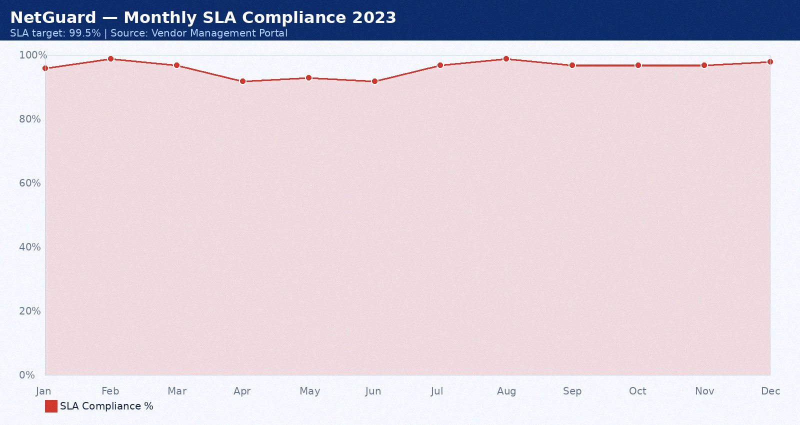

Appendix 23: PwC — Monthly SLA Data December 2023
Provider: PwC. Period: December 2023. Total tickets: 20. P1: 2. P2: 6. P3: 13. SLA compliance: 99%. Breaches: 2. Average MTTR: 58 minutes. CSAT: 4.3/5.0.
Month | SLA Target | Actual SLA | Breach? | Tickets | MTTR (min) | CSAT
Jan 2023 | 99.5% | 92.0% | Yes | 3 | 35 | 4.0
Feb 2023 | 99.5% | 93.0% | Yes | 4 | 36 | 4.1
Mar 2023 | 99.5% | 94.0% | Yes | 5 | 37 | 4.2
Apr 2023 | 99.5% | 95.0% | Yes | 6 | 38 | 4.3
May 2023 | 99.5% | 96.0% | Yes | 7 | 39 | 4.4
Jun 2023 | 99.5% | 97.0% | Yes | 8 | 40 | 4.5
Jul 2023 | 99.5% | 98.0% | Yes | 9 | 41 | 4.6
Aug 2023 | 99.5% | 92.0% | Yes | 10 | 42 | 4.7
Sep 2023 | 99.5% | 93.0% | Yes | 3 | 43 | 4.8
Oct 2023 | 99.5% | 94.0% | Yes | 4 | 44 | 4.9
Nov 2023 | 99.5% | 95.0% | Yes | 5 | 45 | 4.0
Dec 2023 | 99.5% | 96.0% | Yes | 6 | 46 | 4.1

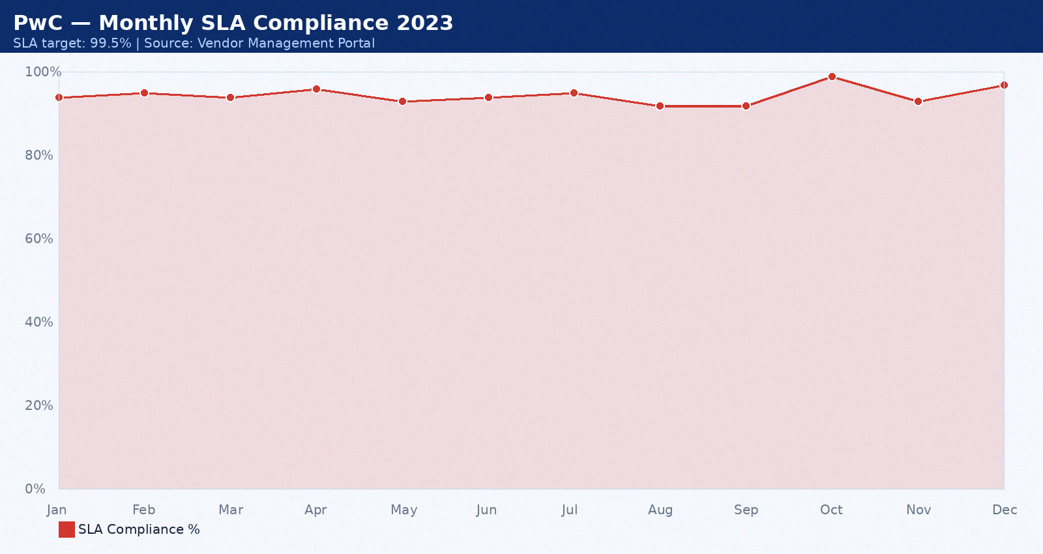

Appendix 24: Accenture — Monthly SLA Data January 2024
Provider: Accenture. Period: January 2024. Total tickets: 21. P1: 0. P2: 7. P3: 8. SLA compliance: 88%. Breaches: 0. Average MTTR: 59 minutes. CSAT: 4.4/5.0.
Month | SLA Target | Actual SLA | Breach? | Tickets | MTTR (min) | CSAT
Jan 2024 | 99.5% | 92.0% | Yes | 3 | 35 | 4.0
Feb 2024 | 99.5% | 93.0% | Yes | 4 | 36 | 4.1
Mar 2024 | 99.5% | 94.0% | Yes | 5 | 37 | 4.2
Apr 2024 | 99.5% | 95.0% | Yes | 6 | 38 | 4.3
May 2024 | 99.5% | 96.0% | Yes | 7 | 39 | 4.4
Jun 2024 | 99.5% | 97.0% | Yes | 8 | 40 | 4.5
Jul 2024 | 99.5% | 98.0% | Yes | 9 | 41 | 4.6
Aug 2024 | 99.5% | 92.0% | Yes | 10 | 42 | 4.7
Sep 2024 | 99.5% | 93.0% | Yes | 3 | 43 | 4.8
Oct 2024 | 99.5% | 94.0% | Yes | 4 | 44 | 4.9
Nov 2024 | 99.5% | 95.0% | Yes | 5 | 45 | 4.0
Dec 2024 | 99.5% | 96.0% | Yes | 6 | 46 | 4.1

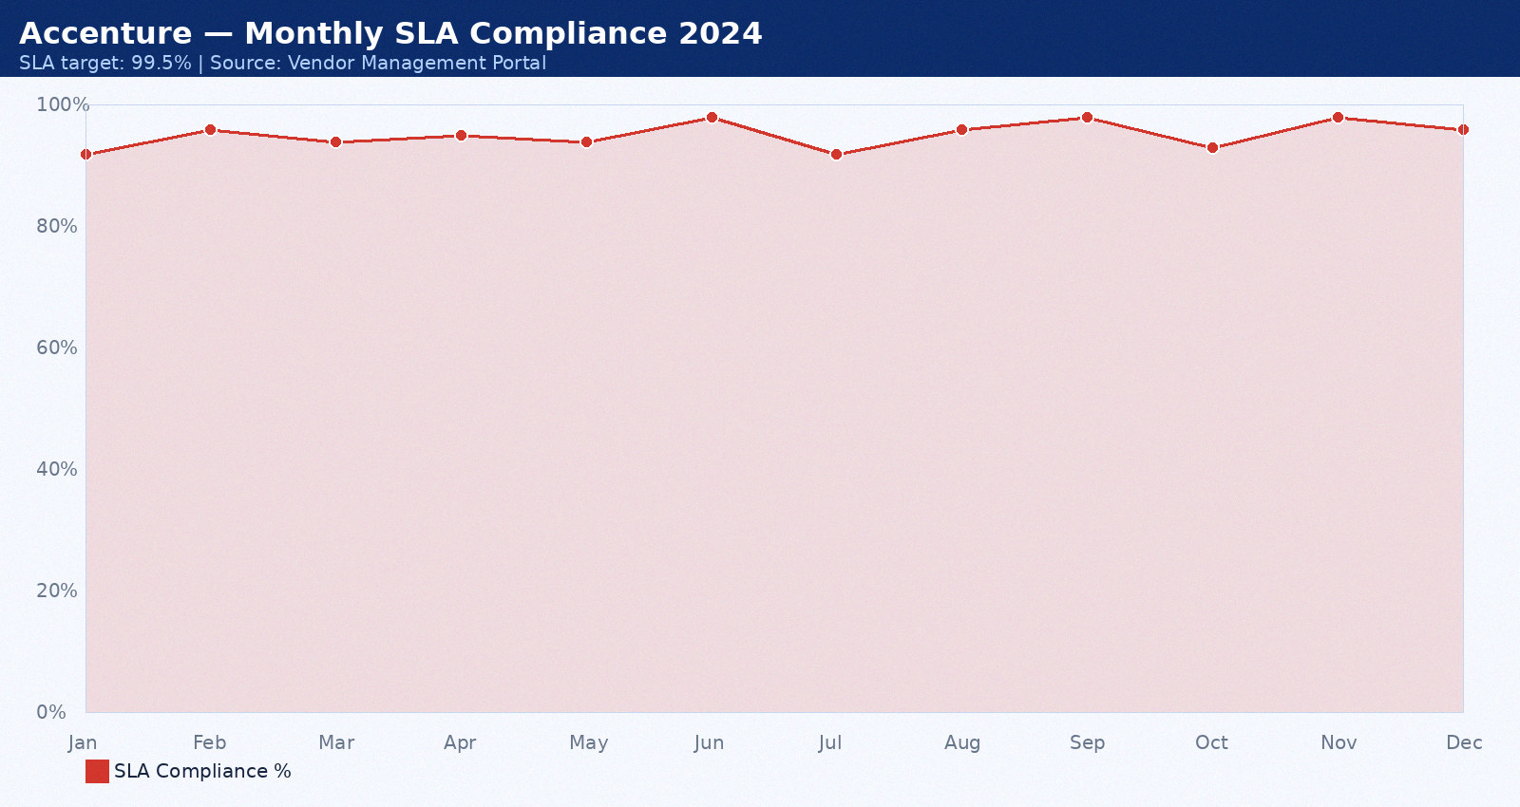

Appendix 25: Wipro MSP — Monthly SLA Data February 2024
Provider: Wipro MSP. Period: February 2024. Total tickets: 22. P1: 1. P2: 3. P3: 9. SLA compliance: 89%. Breaches: 1. Average MTTR: 35 minutes. CSAT: 4.5/5.0.
Month | SLA Target | Actual SLA | Breach? | Tickets | MTTR (min) | CSAT
Jan 2024 | 99.5% | 92.0% | Yes | 3 | 35 | 4.0
Feb 2024 | 99.5% | 93.0% | Yes | 4 | 36 | 4.1
Mar 2024 | 99.5% | 94.0% | Yes | 5 | 37 | 4.2
Apr 2024 | 99.5% | 95.0% | Yes | 6 | 38 | 4.3
May 2024 | 99.5% | 96.0% | Yes | 7 | 39 | 4.4
Jun 2024 | 99.5% | 97.0% | Yes | 8 | 40 | 4.5
Jul 2024 | 99.5% | 98.0% | Yes | 9 | 41 | 4.6
Aug 2024 | 99.5% | 92.0% | Yes | 10 | 42 | 4.7
Sep 2024 | 99.5% | 93.0% | Yes | 3 | 43 | 4.8
Oct 2024 | 99.5% | 94.0% | Yes | 4 | 44 | 4.9
Nov 2024 | 99.5% | 95.0% | Yes | 5 | 45 | 4.0
Dec 2024 | 99.5% | 96.0% | Yes | 6 | 46 | 4.1

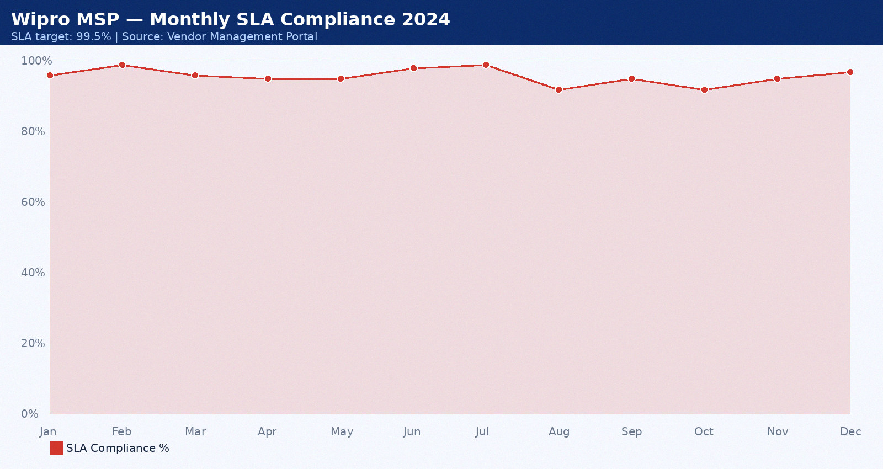

Appendix 26: DataVault — Monthly SLA Data March 2024
Provider: DataVault. Period: March 2024. Total tickets: 23. P1: 2. P2: 4. P3: 10. SLA compliance: 90%. Breaches: 2. Average MTTR: 36 minutes. CSAT: 4.6/5.0.
Month | SLA Target | Actual SLA | Breach? | Tickets | MTTR (min) | CSAT
Jan 2024 | 99.5% | 92.0% | Yes | 3 | 35 | 4.0
Feb 2024 | 99.5% | 93.0% | Yes | 4 | 36 | 4.1
Mar 2024 | 99.5% | 94.0% | Yes | 5 | 37 | 4.2
Apr 2024 | 99.5% | 95.0% | Yes | 6 | 38 | 4.3
May 2024 | 99.5% | 96.0% | Yes | 7 | 39 | 4.4
Jun 2024 | 99.5% | 97.0% | Yes | 8 | 40 | 4.5
Jul 2024 | 99.5% | 98.0% | Yes | 9 | 41 | 4.6
Aug 2024 | 99.5% | 92.0% | Yes | 10 | 42 | 4.7
Sep 2024 | 99.5% | 93.0% | Yes | 3 | 43 | 4.8
Oct 2024 | 99.5% | 94.0% | Yes | 4 | 44 | 4.9
Nov 2024 | 99.5% | 95.0% | Yes | 5 | 45 | 4.0
Dec 2024 | 99.5% | 96.0% | Yes | 6 | 46 | 4.1

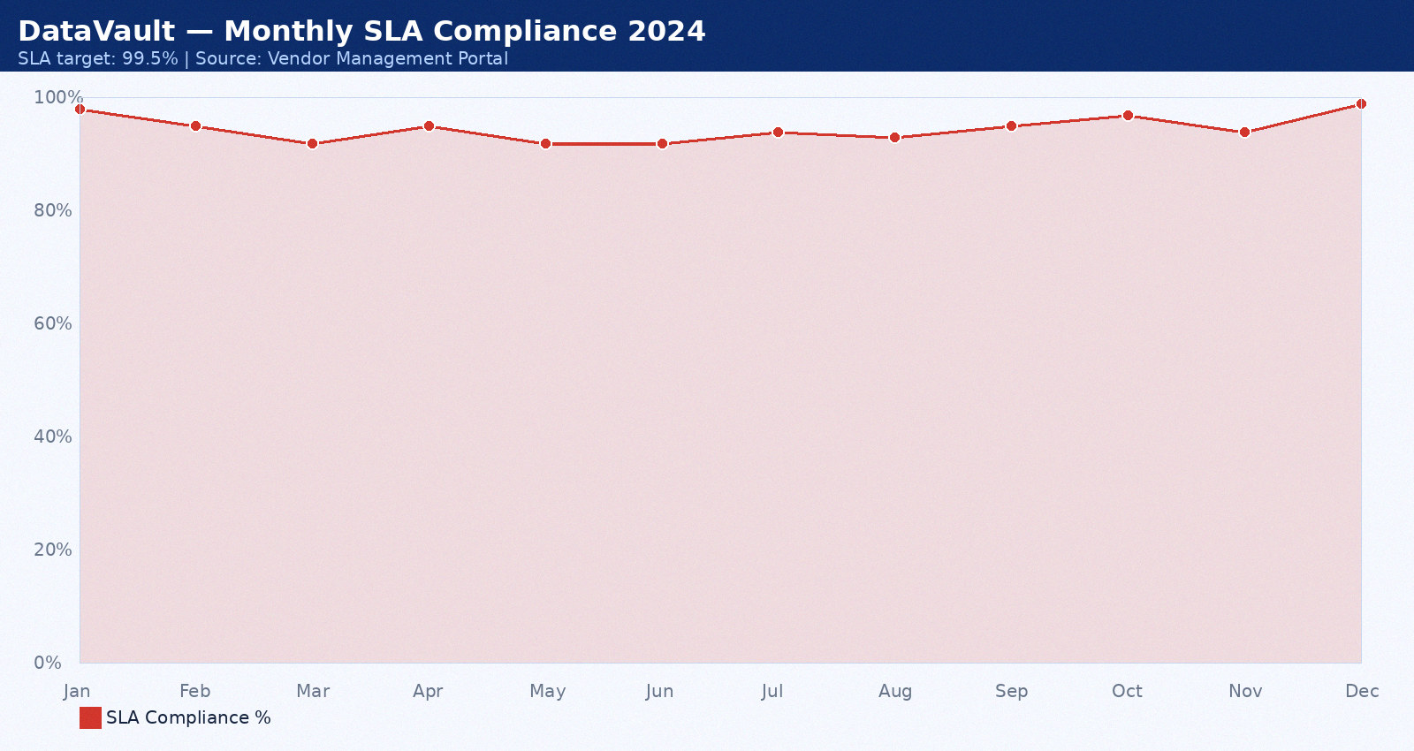

Appendix 27: Cognizant — Monthly SLA Data April 2024
Provider: Cognizant. Period: April 2024. Total tickets: 24. P1: 0. P2: 5. P3: 11. SLA compliance: 91%. Breaches: 0. Average MTTR: 37 minutes. CSAT: 4.7/5.0.
Month | SLA Target | Actual SLA | Breach? | Tickets | MTTR (min) | CSAT
Jan 2024 | 99.5% | 92.0% | Yes | 3 | 35 | 4.0
Feb 2024 | 99.5% | 93.0% | Yes | 4 | 36 | 4.1
Mar 2024 | 99.5% | 94.0% | Yes | 5 | 37 | 4.2
Apr 2024 | 99.5% | 95.0% | Yes | 6 | 38 | 4.3
May 2024 | 99.5% | 96.0% | Yes | 7 | 39 | 4.4
Jun 2024 | 99.5% | 97.0% | Yes | 8 | 40 | 4.5
Jul 2024 | 99.5% | 98.0% | Yes | 9 | 41 | 4.6
Aug 2024 | 99.5% | 92.0% | Yes | 10 | 42 | 4.7
Sep 2024 | 99.5% | 93.0% | Yes | 3 | 43 | 4.8
Oct 2024 | 99.5% | 94.0% | Yes | 4 | 44 | 4.9
Nov 2024 | 99.5% | 95.0% | Yes | 5 | 45 | 4.0
Dec 2024 | 99.5% | 96.0% | Yes | 6 | 46 | 4.1

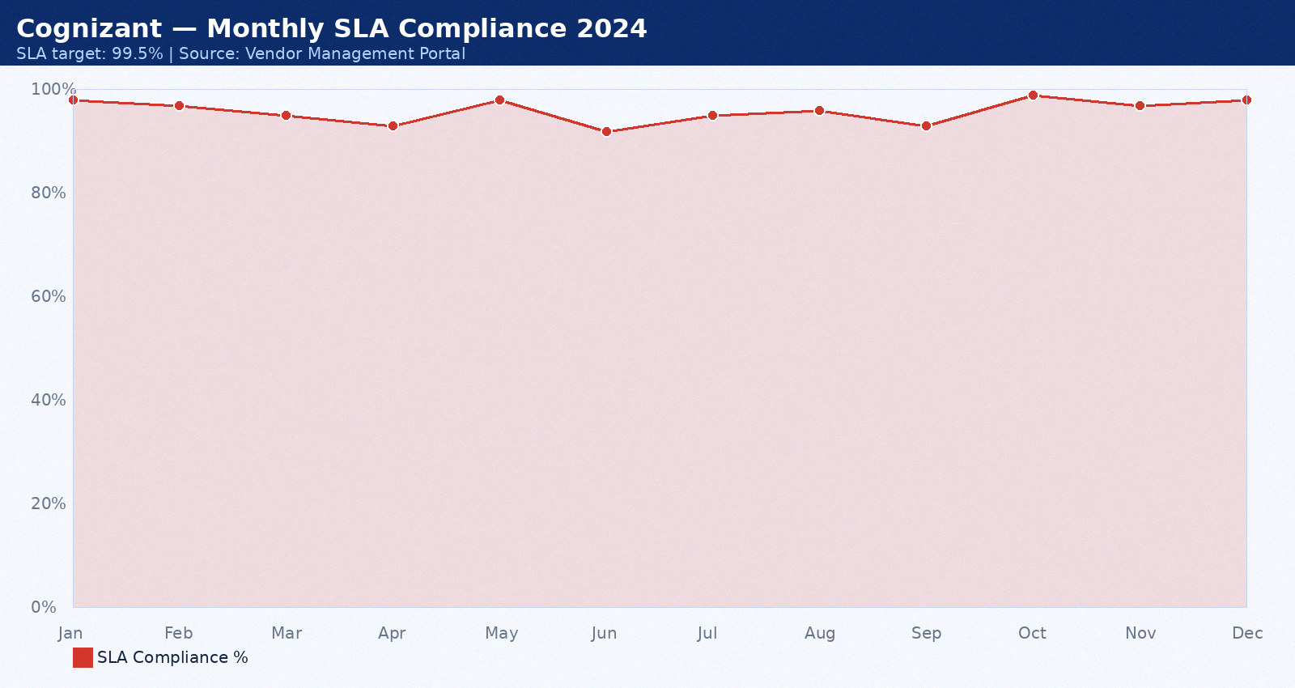

Appendix 28: Rackspace — Monthly SLA Data May 2024
Provider: Rackspace. Period: May 2024. Total tickets: 25. P1: 1. P2: 6. P3: 12. SLA compliance: 92%. Breaches: 1. Average MTTR: 38 minutes. CSAT: 4.8/5.0.
Month | SLA Target | Actual SLA | Breach? | Tickets | MTTR (min) | CSAT
Jan 2024 | 99.5% | 92.0% | Yes | 3 | 35 | 4.0
Feb 2024 | 99.5% | 93.0% | Yes | 4 | 36 | 4.1
Mar 2024 | 99.5% | 94.0% | Yes | 5 | 37 | 4.2
Apr 2024 | 99.5% | 95.0% | Yes | 6 | 38 | 4.3
May 2024 | 99.5% | 96.0% | Yes | 7 | 39 | 4.4
Jun 2024 | 99.5% | 97.0% | Yes | 8 | 40 | 4.5
Jul 2024 | 99.5% | 98.0% | Yes | 9 | 41 | 4.6
Aug 2024 | 99.5% | 92.0% | Yes | 10 | 42 | 4.7
Sep 2024 | 99.5% | 93.0% | Yes | 3 | 43 | 4.8
Oct 2024 | 99.5% | 94.0% | Yes | 4 | 44 | 4.9
Nov 2024 | 99.5% | 95.0% | Yes | 5 | 45 | 4.0
Dec 2024 | 99.5% | 96.0% | Yes | 6 | 46 | 4.1

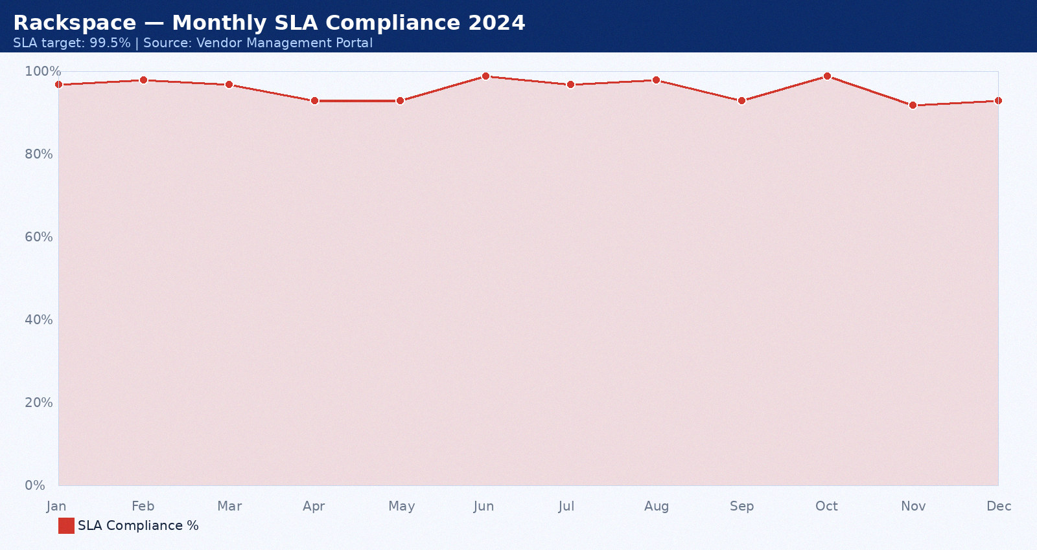

Appendix 29: IBM — Monthly SLA Data June 2024
Provider: IBM. Period: June 2024. Total tickets: 26. P1: 2. P2: 7. P3: 13. SLA compliance: 93%. Breaches: 2. Average MTTR: 39 minutes. CSAT: 4.9/5.0.
Month | SLA Target | Actual SLA | Breach? | Tickets | MTTR (min) | CSAT
Jan 2024 | 99.5% | 92.0% | Yes | 3 | 35 | 4.0
Feb 2024 | 99.5% | 93.0% | Yes | 4 | 36 | 4.1
Mar 2024 | 99.5% | 94.0% | Yes | 5 | 37 | 4.2
Apr 2024 | 99.5% | 95.0% | Yes | 6 | 38 | 4.3
May 2024 | 99.5% | 96.0% | Yes | 7 | 39 | 4.4
Jun 2024 | 99.5% | 97.0% | Yes | 8 | 40 | 4.5
Jul 2024 | 99.5% | 98.0% | Yes | 9 | 41 | 4.6
Aug 2024 | 99.5% | 92.0% | Yes | 10 | 42 | 4.7
Sep 2024 | 99.5% | 93.0% | Yes | 3 | 43 | 4.8
Oct 2024 | 99.5% | 94.0% | Yes | 4 | 44 | 4.9
Nov 2024 | 99.5% | 95.0% | Yes | 5 | 45 | 4.0
Dec 2024 | 99.5% | 96.0% | Yes | 6 | 46 | 4.1

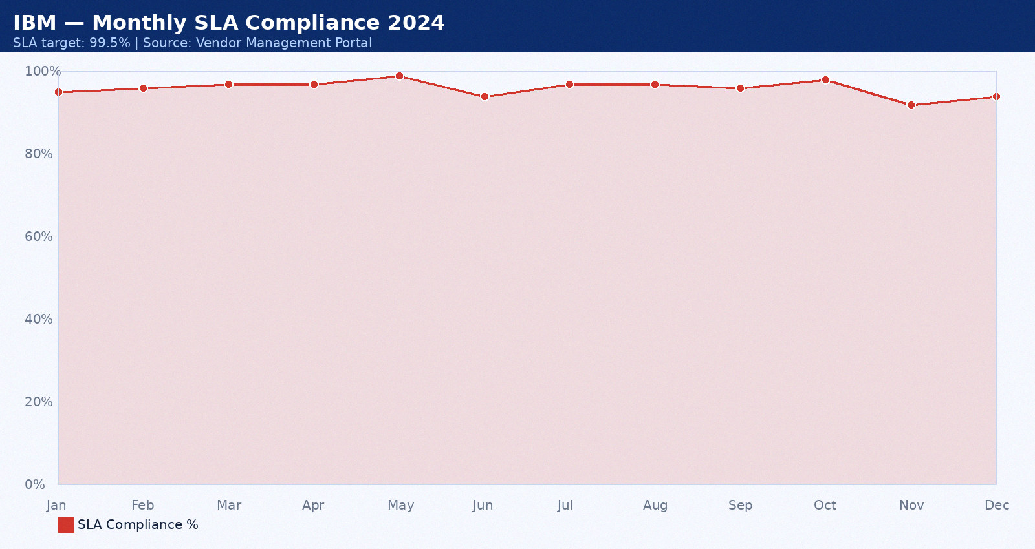

Appendix 30: NetGuard — Monthly SLA Data July 2024
Provider: NetGuard. Period: July 2024. Total tickets: 12. P1: 0. P2: 3. P3: 8. SLA compliance: 94%. Breaches: 0. Average MTTR: 40 minutes. CSAT: 3.5/5.0.
Month | SLA Target | Actual SLA | Breach? | Tickets | MTTR (min) | CSAT
Jan 2024 | 99.5% | 92.0% | Yes | 3 | 35 | 4.0
Feb 2024 | 99.5% | 93.0% | Yes | 4 | 36 | 4.1
Mar 2024 | 99.5% | 94.0% | Yes | 5 | 37 | 4.2
Apr 2024 | 99.5% | 95.0% | Yes | 6 | 38 | 4.3
May 2024 | 99.5% | 96.0% | Yes | 7 | 39 | 4.4
Jun 2024 | 99.5% | 97.0% | Yes | 8 | 40 | 4.5
Jul 2024 | 99.5% | 98.0% | Yes | 9 | 41 | 4.6
Aug 2024 | 99.5% | 92.0% | Yes | 10 | 42 | 4.7
Sep 2024 | 99.5% | 93.0% | Yes | 3 | 43 | 4.8
Oct 2024 | 99.5% | 94.0% | Yes | 4 | 44 | 4.9
Nov 2024 | 99.5% | 95.0% | Yes | 5 | 45 | 4.0
Dec 2024 | 99.5% | 96.0% | Yes | 6 | 46 | 4.1

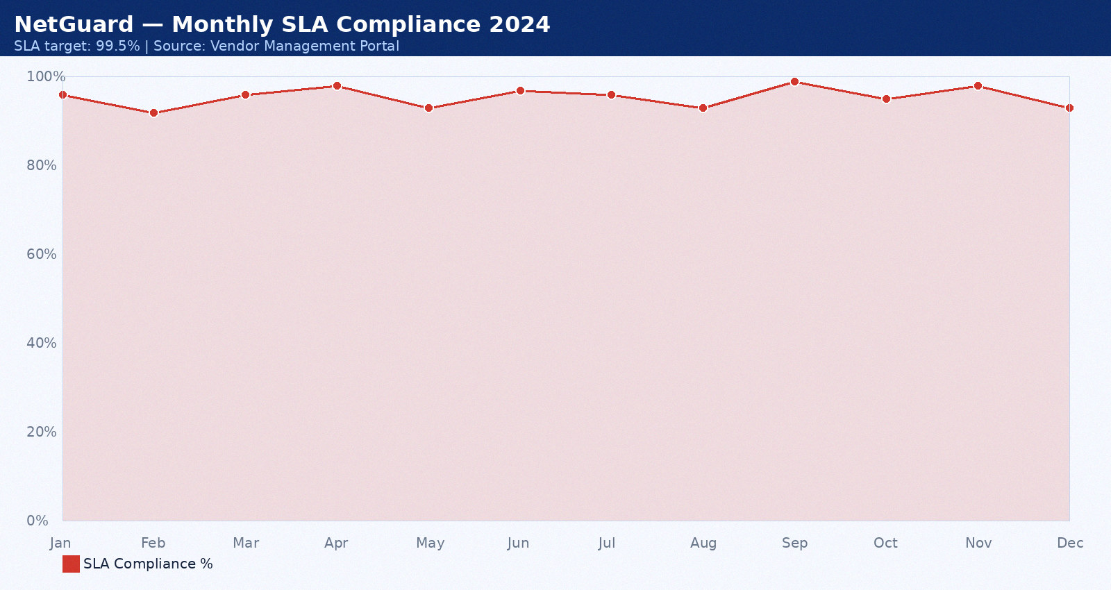

Appendix 31: PwC — Monthly SLA Data August 2024
Provider: PwC. Period: August 2024. Total tickets: 13. P1: 1. P2: 4. P3: 9. SLA compliance: 95%. Breaches: 1. Average MTTR: 41 minutes. CSAT: 3.6/5.0.
Month | SLA Target | Actual SLA | Breach? | Tickets | MTTR (min) | CSAT
Jan 2024 | 99.5% | 92.0% | Yes | 3 | 35 | 4.0
Feb 2024 | 99.5% | 93.0% | Yes | 4 | 36 | 4.1
Mar 2024 | 99.5% | 94.0% | Yes | 5 | 37 | 4.2
Apr 2024 | 99.5% | 95.0% | Yes | 6 | 38 | 4.3
May 2024 | 99.5% | 96.0% | Yes | 7 | 39 | 4.4
Jun 2024 | 99.5% | 97.0% | Yes | 8 | 40 | 4.5
Jul 2024 | 99.5% | 98.0% | Yes | 9 | 41 | 4.6
Aug 2024 | 99.5% | 92.0% | Yes | 10 | 42 | 4.7
Sep 2024 | 99.5% | 93.0% | Yes | 3 | 43 | 4.8
Oct 2024 | 99.5% | 94.0% | Yes | 4 | 44 | 4.9
Nov 2024 | 99.5% | 95.0% | Yes | 5 | 45 | 4.0
Dec 2024 | 99.5% | 96.0% | Yes | 6 | 46 | 4.1

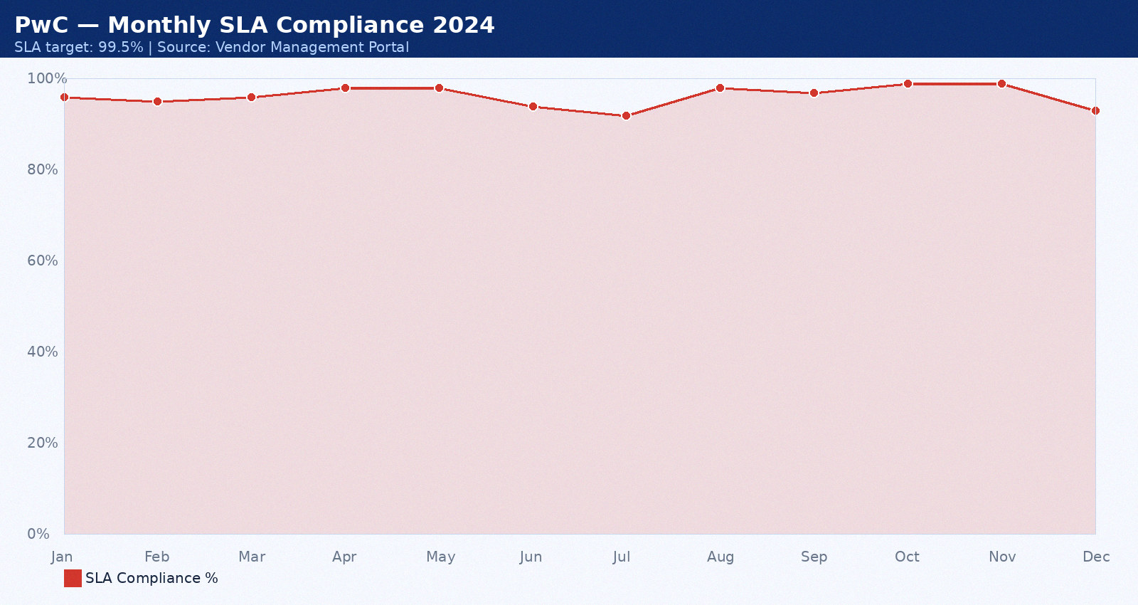

Appendix 32: Accenture — Monthly SLA Data September 2024
Provider: Accenture. Period: September 2024. Total tickets: 14. P1: 2. P2: 5. P3: 10. SLA compliance: 96%. Breaches: 2. Average MTTR: 42 minutes. CSAT: 3.7/5.0.
Month | SLA Target | Actual SLA | Breach? | Tickets | MTTR (min) | CSAT
Jan 2024 | 99.5% | 92.0% | Yes | 3 | 35 | 4.0
Feb 2024 | 99.5% | 93.0% | Yes | 4 | 36 | 4.1
Mar 2024 | 99.5% | 94.0% | Yes | 5 | 37 | 4.2
Apr 2024 | 99.5% | 95.0% | Yes | 6 | 38 | 4.3
May 2024 | 99.5% | 96.0% | Yes | 7 | 39 | 4.4
Jun 2024 | 99.5% | 97.0% | Yes | 8 | 40 | 4.5
Jul 2024 | 99.5% | 98.0% | Yes | 9 | 41 | 4.6
Aug 2024 | 99.5% | 92.0% | Yes | 10 | 42 | 4.7
Sep 2024 | 99.5% | 93.0% | Yes | 3 | 43 | 4.8
Oct 2024 | 99.5% | 94.0% | Yes | 4 | 44 | 4.9
Nov 2024 | 99.5% | 95.0% | Yes | 5 | 45 | 4.0
Dec 2024 | 99.5% | 96.0% | Yes | 6 | 46 | 4.1

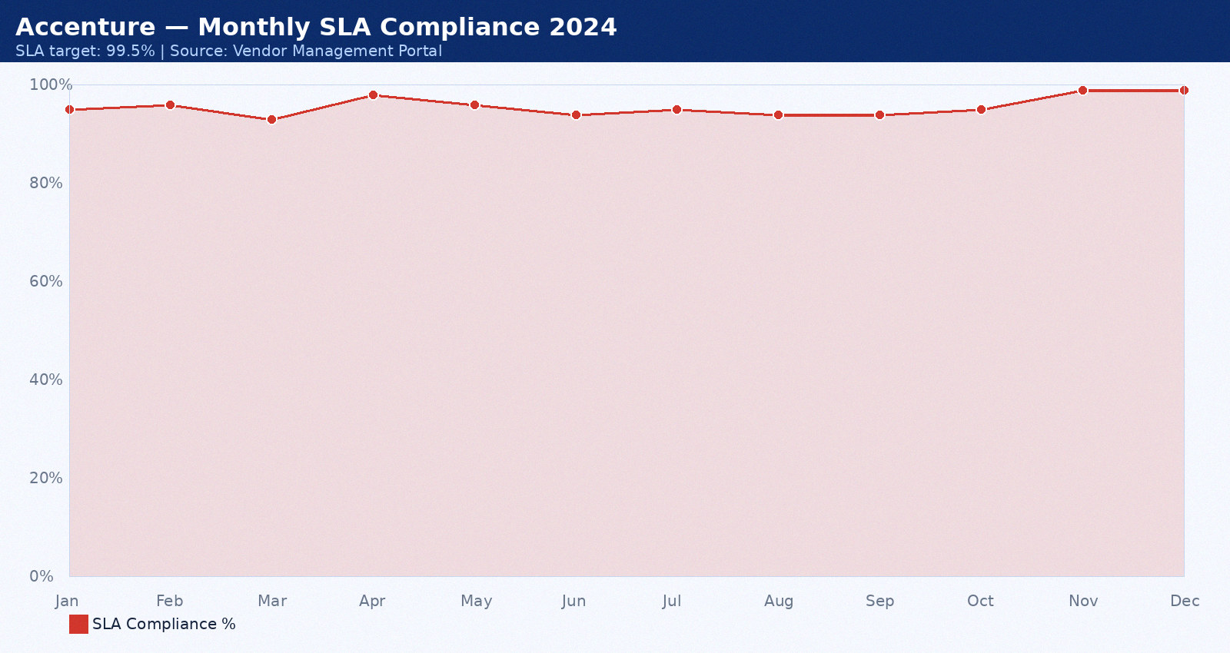

Appendix 33: Wipro MSP — Monthly SLA Data October 2024
Provider: Wipro MSP. Period: October 2024. Total tickets: 15. P1: 0. P2: 6. P3: 11. SLA compliance: 97%. Breaches: 0. Average MTTR: 43 minutes. CSAT: 3.8/5.0.
Month | SLA Target | Actual SLA | Breach? | Tickets | MTTR (min) | CSAT
Jan 2024 | 99.5% | 92.0% | Yes | 3 | 35 | 4.0
Feb 2024 | 99.5% | 93.0% | Yes | 4 | 36 | 4.1
Mar 2024 | 99.5% | 94.0% | Yes | 5 | 37 | 4.2
Apr 2024 | 99.5% | 95.0% | Yes | 6 | 38 | 4.3
May 2024 | 99.5% | 96.0% | Yes | 7 | 39 | 4.4
Jun 2024 | 99.5% | 97.0% | Yes | 8 | 40 | 4.5
Jul 2024 | 99.5% | 98.0% | Yes | 9 | 41 | 4.6
Aug 2024 | 99.5% | 92.0% | Yes | 10 | 42 | 4.7
Sep 2024 | 99.5% | 93.0% | Yes | 3 | 43 | 4.8
Oct 2024 | 99.5% | 94.0% | Yes | 4 | 44 | 4.9
Nov 2024 | 99.5% | 95.0% | Yes | 5 | 45 | 4.0
Dec 2024 | 99.5% | 96.0% | Yes | 6 | 46 | 4.1

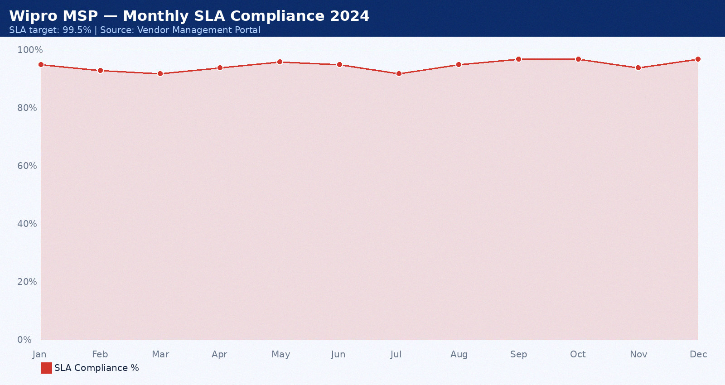

Appendix 34: DataVault — Monthly SLA Data November 2024
Provider: DataVault. Period: November 2024. Total tickets: 16. P1: 1. P2: 7. P3: 12. SLA compliance: 98%. Breaches: 1. Average MTTR: 44 minutes. CSAT: 3.9/5.0.
Month | SLA Target | Actual SLA | Breach? | Tickets | MTTR (min) | CSAT
Jan 2024 | 99.5% | 92.0% | Yes | 3 | 35 | 4.0
Feb 2024 | 99.5% | 93.0% | Yes | 4 | 36 | 4.1
Mar 2024 | 99.5% | 94.0% | Yes | 5 | 37 | 4.2
Apr 2024 | 99.5% | 95.0% | Yes | 6 | 38 | 4.3
May 2024 | 99.5% | 96.0% | Yes | 7 | 39 | 4.4
Jun 2024 | 99.5% | 97.0% | Yes | 8 | 40 | 4.5
Jul 2024 | 99.5% | 98.0% | Yes | 9 | 41 | 4.6
Aug 2024 | 99.5% | 92.0% | Yes | 10 | 42 | 4.7
Sep 2024 | 99.5% | 93.0% | Yes | 3 | 43 | 4.8
Oct 2024 | 99.5% | 94.0% | Yes | 4 | 44 | 4.9
Nov 2024 | 99.5% | 95.0% | Yes | 5 | 45 | 4.0
Dec 2024 | 99.5% | 96.0% | Yes | 6 | 46 | 4.1

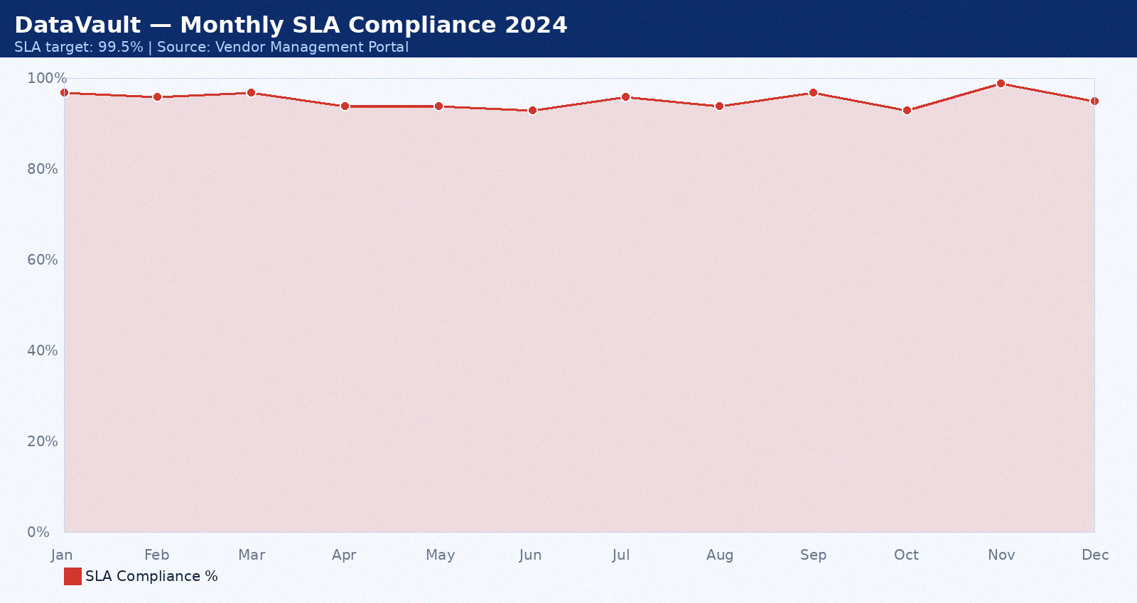

Appendix 35: Cognizant — Monthly SLA Data December 2024
Provider: Cognizant. Period: December 2024. Total tickets: 17. P1: 2. P2: 3. P3: 13. SLA compliance: 99%. Breaches: 2. Average MTTR: 45 minutes. CSAT: 4.0/5.0.
Month | SLA Target | Actual SLA | Breach? | Tickets | MTTR (min) | CSAT
Jan 2024 | 99.5% | 92.0% | Yes | 3 | 35 | 4.0
Feb 2024 | 99.5% | 93.0% | Yes | 4 | 36 | 4.1
Mar 2024 | 99.5% | 94.0% | Yes | 5 | 37 | 4.2
Apr 2024 | 99.5% | 95.0% | Yes | 6 | 38 | 4.3
May 2024 | 99.5% | 96.0% | Yes | 7 | 39 | 4.4
Jun 2024 | 99.5% | 97.0% | Yes | 8 | 40 | 4.5
Jul 2024 | 99.5% | 98.0% | Yes | 9 | 41 | 4.6
Aug 2024 | 99.5% | 92.0% | Yes | 10 | 42 | 4.7
Sep 2024 | 99.5% | 93.0% | Yes | 3 | 43 | 4.8
Oct 2024 | 99.5% | 94.0% | Yes | 4 | 44 | 4.9
Nov 2024 | 99.5% | 95.0% | Yes | 5 | 45 | 4.0
Dec 2024 | 99.5% | 96.0% | Yes | 6 | 46 | 4.1

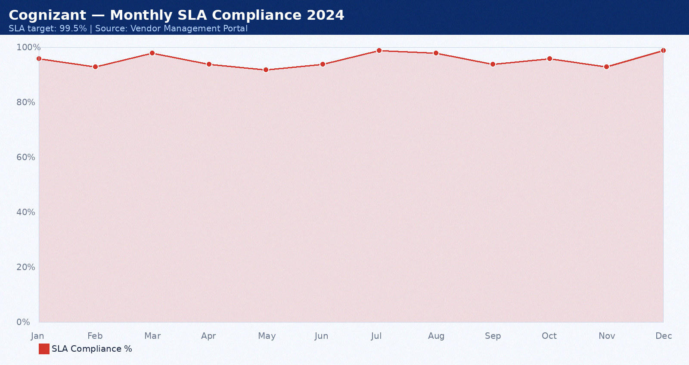

Appendix 36: Rackspace — Monthly SLA Data January 2025
Provider: Rackspace. Period: January 2025. Total tickets: 18. P1: 0. P2: 4. P3: 8. SLA compliance: 88%. Breaches: 0. Average MTTR: 46 minutes. CSAT: 4.1/5.0.
Month | SLA Target | Actual SLA | Breach? | Tickets | MTTR (min) | CSAT
Jan 2025 | 99.5% | 92.0% | Yes | 3 | 35 | 4.0
Feb 2025 | 99.5% | 93.0% | Yes | 4 | 36 | 4.1
Mar 2025 | 99.5% | 94.0% | Yes | 5 | 37 | 4.2
Apr 2025 | 99.5% | 95.0% | Yes | 6 | 38 | 4.3
May 2025 | 99.5% | 96.0% | Yes | 7 | 39 | 4.4
Jun 2025 | 99.5% | 97.0% | Yes | 8 | 40 | 4.5
Jul 2025 | 99.5% | 98.0% | Yes | 9 | 41 | 4.6
Aug 2025 | 99.5% | 92.0% | Yes | 10 | 42 | 4.7
Sep 2025 | 99.5% | 93.0% | Yes | 3 | 43 | 4.8
Oct 2025 | 99.5% | 94.0% | Yes | 4 | 44 | 4.9
Nov 2025 | 99.5% | 95.0% | Yes | 5 | 45 | 4.0
Dec 2025 | 99.5% | 96.0% | Yes | 6 | 46 | 4.1

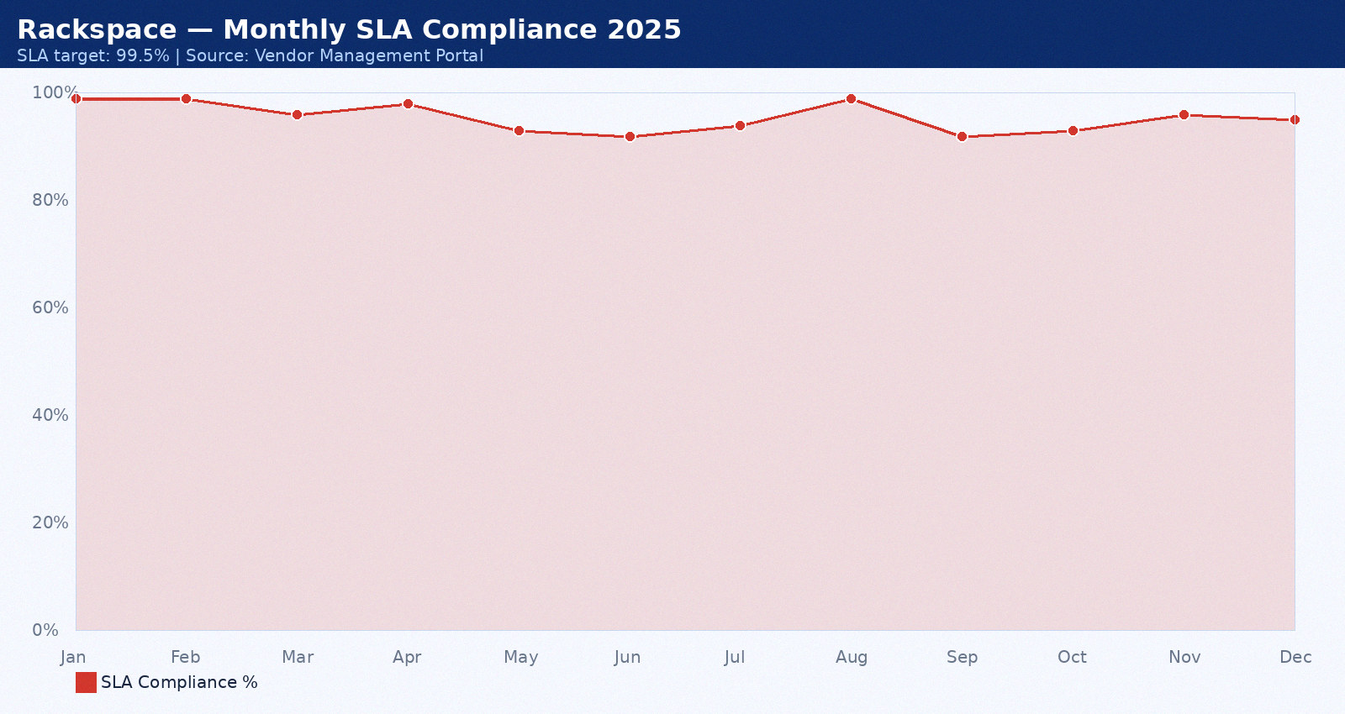

Appendix 37: IBM — Monthly SLA Data February 2025
Provider: IBM. Period: February 2025. Total tickets: 19. P1: 1. P2: 5. P3: 9. SLA compliance: 89%. Breaches: 1. Average MTTR: 47 minutes. CSAT: 4.2/5.0.
Month | SLA Target | Actual SLA | Breach? | Tickets | MTTR (min) | CSAT
Jan 2025 | 99.5% | 92.0% | Yes | 3 | 35 | 4.0
Feb 2025 | 99.5% | 93.0% | Yes | 4 | 36 | 4.1
Mar 2025 | 99.5% | 94.0% | Yes | 5 | 37 | 4.2
Apr 2025 | 99.5% | 95.0% | Yes | 6 | 38 | 4.3
May 2025 | 99.5% | 96.0% | Yes | 7 | 39 | 4.4
Jun 2025 | 99.5% | 97.0% | Yes | 8 | 40 | 4.5
Jul 2025 | 99.5% | 98.0% | Yes | 9 | 41 | 4.6
Aug 2025 | 99.5% | 92.0% | Yes | 10 | 42 | 4.7
Sep 2025 | 99.5% | 93.0% | Yes | 3 | 43 | 4.8
Oct 2025 | 99.5% | 94.0% | Yes | 4 | 44 | 4.9
Nov 2025 | 99.5% | 95.0% | Yes | 5 | 45 | 4.0
Dec 2025 | 99.5% | 96.0% | Yes | 6 | 46 | 4.1

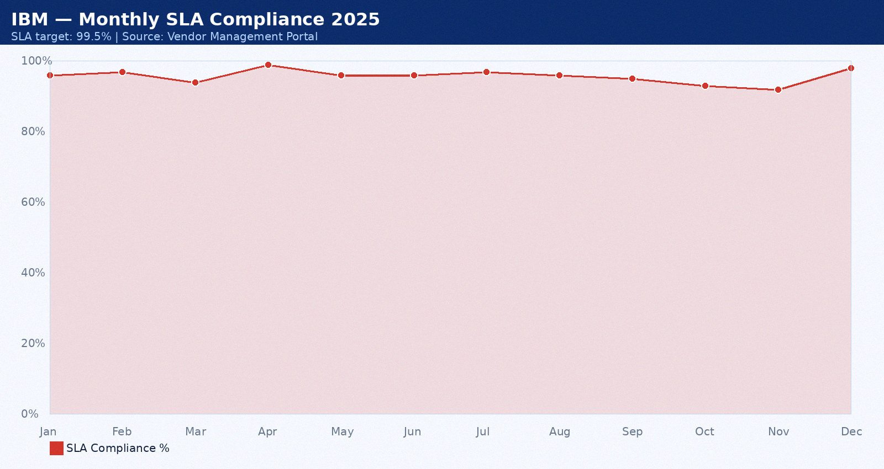

Appendix 38: NetGuard — Monthly SLA Data March 2025
Provider: NetGuard. Period: March 2025. Total tickets: 20. P1: 2. P2: 6. P3: 10. SLA compliance: 90%. Breaches: 2. Average MTTR: 48 minutes. CSAT: 4.3/5.0.
Month | SLA Target | Actual SLA | Breach? | Tickets | MTTR (min) | CSAT
Jan 2025 | 99.5% | 92.0% | Yes | 3 | 35 | 4.0
Feb 2025 | 99.5% | 93.0% | Yes | 4 | 36 | 4.1
Mar 2025 | 99.5% | 94.0% | Yes | 5 | 37 | 4.2
Apr 2025 | 99.5% | 95.0% | Yes | 6 | 38 | 4.3
May 2025 | 99.5% | 96.0% | Yes | 7 | 39 | 4.4
Jun 2025 | 99.5% | 97.0% | Yes | 8 | 40 | 4.5
Jul 2025 | 99.5% | 98.0% | Yes | 9 | 41 | 4.6
Aug 2025 | 99.5% | 92.0% | Yes | 10 | 42 | 4.7
Sep 2025 | 99.5% | 93.0% | Yes | 3 | 43 | 4.8
Oct 2025 | 99.5% | 94.0% | Yes | 4 | 44 | 4.9
Nov 2025 | 99.5% | 95.0% | Yes | 5 | 45 | 4.0
Dec 2025 | 99.5% | 96.0% | Yes | 6 | 46 | 4.1

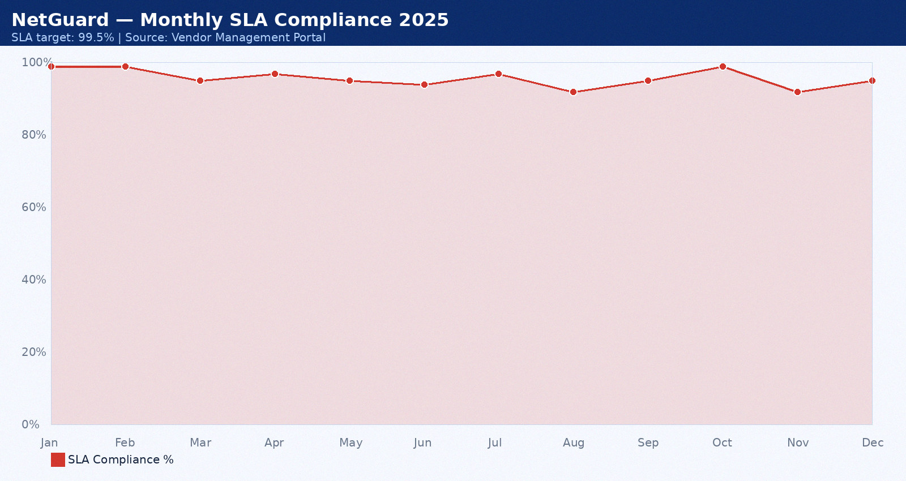

Appendix 39: PwC — Monthly SLA Data April 2025
Provider: PwC. Period: April 2025. Total tickets: 21. P1: 0. P2: 7. P3: 11. SLA compliance: 91%. Breaches: 0. Average MTTR: 49 minutes. CSAT: 4.4/5.0.
Month | SLA Target | Actual SLA | Breach? | Tickets | MTTR (min) | CSAT
Jan 2025 | 99.5% | 92.0% | Yes | 3 | 35 | 4.0
Feb 2025 | 99.5% | 93.0% | Yes | 4 | 36 | 4.1
Mar 2025 | 99.5% | 94.0% | Yes | 5 | 37 | 4.2
Apr 2025 | 99.5% | 95.0% | Yes | 6 | 38 | 4.3
May 2025 | 99.5% | 96.0% | Yes | 7 | 39 | 4.4
Jun 2025 | 99.5% | 97.0% | Yes | 8 | 40 | 4.5
Jul 2025 | 99.5% | 98.0% | Yes | 9 | 41 | 4.6
Aug 2025 | 99.5% | 92.0% | Yes | 10 | 42 | 4.7
Sep 2025 | 99.5% | 93.0% | Yes | 3 | 43 | 4.8
Oct 2025 | 99.5% | 94.0% | Yes | 4 | 44 | 4.9
Nov 2025 | 99.5% | 95.0% | Yes | 5 | 45 | 4.0
Dec 2025 | 99.5% | 96.0% | Yes | 6 | 46 | 4.1

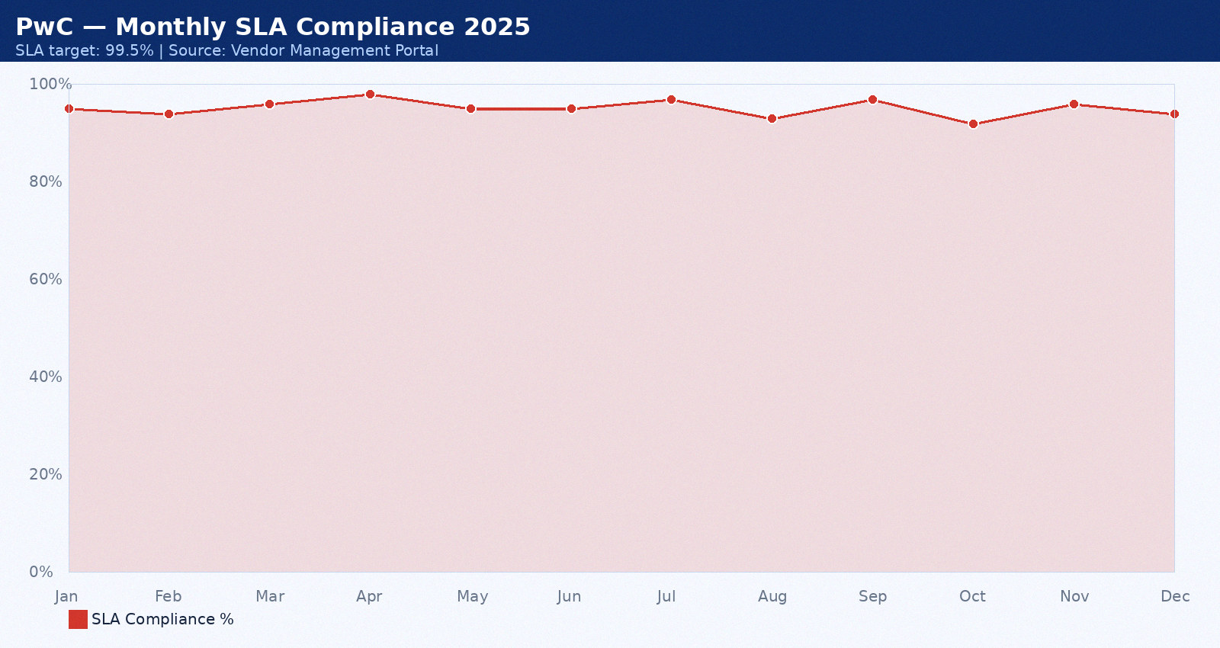

Appendix 40: Accenture — Monthly SLA Data May 2025
Provider: Accenture. Period: May 2025. Total tickets: 22. P1: 1. P2: 3. P3: 12. SLA compliance: 92%. Breaches: 1. Average MTTR: 50 minutes. CSAT: 4.5/5.0.
Month | SLA Target | Actual SLA | Breach? | Tickets | MTTR (min) | CSAT
Jan 2025 | 99.5% | 92.0% | Yes | 3 | 35 | 4.0
Feb 2025 | 99.5% | 93.0% | Yes | 4 | 36 | 4.1
Mar 2025 | 99.5% | 94.0% | Yes | 5 | 37 | 4.2
Apr 2025 | 99.5% | 95.0% | Yes | 6 | 38 | 4.3
May 2025 | 99.5% | 96.0% | Yes | 7 | 39 | 4.4
Jun 2025 | 99.5% | 97.0% | Yes | 8 | 40 | 4.5
Jul 2025 | 99.5% | 98.0% | Yes | 9 | 41 | 4.6
Aug 2025 | 99.5% | 92.0% | Yes | 10 | 42 | 4.7
Sep 2025 | 99.5% | 93.0% | Yes | 3 | 43 | 4.8
Oct 2025 | 99.5% | 94.0% | Yes | 4 | 44 | 4.9
Nov 2025 | 99.5% | 95.0% | Yes | 5 | 45 | 4.0
Dec 2025 | 99.5% | 96.0% | Yes | 6 | 46 | 4.1

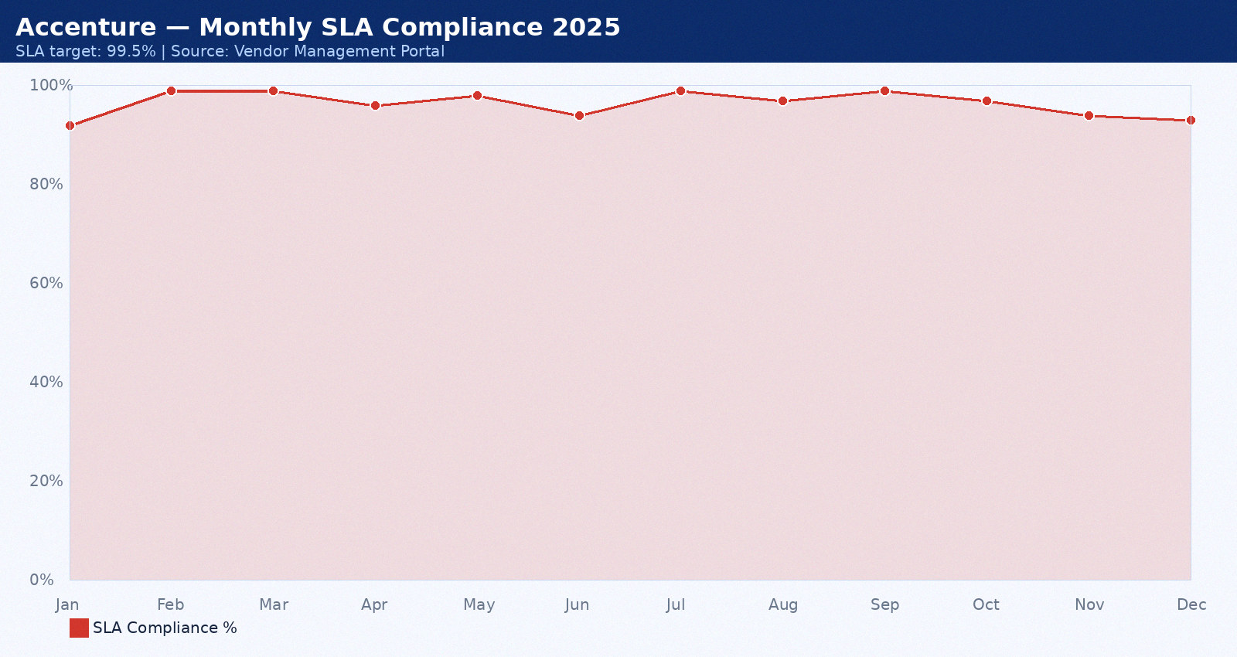

Appendix 41: Wipro MSP — Monthly SLA Data June 2025
Provider: Wipro MSP. Period: June 2025. Total tickets: 23. P1: 2. P2: 4. P3: 13. SLA compliance: 93%. Breaches: 2. Average MTTR: 51 minutes. CSAT: 4.6/5.0.
Month | SLA Target | Actual SLA | Breach? | Tickets | MTTR (min) | CSAT
Jan 2025 | 99.5% | 92.0% | Yes | 3 | 35 | 4.0
Feb 2025 | 99.5% | 93.0% | Yes | 4 | 36 | 4.1
Mar 2025 | 99.5% | 94.0% | Yes | 5 | 37 | 4.2
Apr 2025 | 99.5% | 95.0% | Yes | 6 | 38 | 4.3
May 2025 | 99.5% | 96.0% | Yes | 7 | 39 | 4.4
Jun 2025 | 99.5% | 97.0% | Yes | 8 | 40 | 4.5
Jul 2025 | 99.5% | 98.0% | Yes | 9 | 41 | 4.6
Aug 2025 | 99.5% | 92.0% | Yes | 10 | 42 | 4.7
Sep 2025 | 99.5% | 93.0% | Yes | 3 | 43 | 4.8
Oct 2025 | 99.5% | 94.0% | Yes | 4 | 44 | 4.9
Nov 2025 | 99.5% | 95.0% | Yes | 5 | 45 | 4.0
Dec 2025 | 99.5% | 96.0% | Yes | 6 | 46 | 4.1

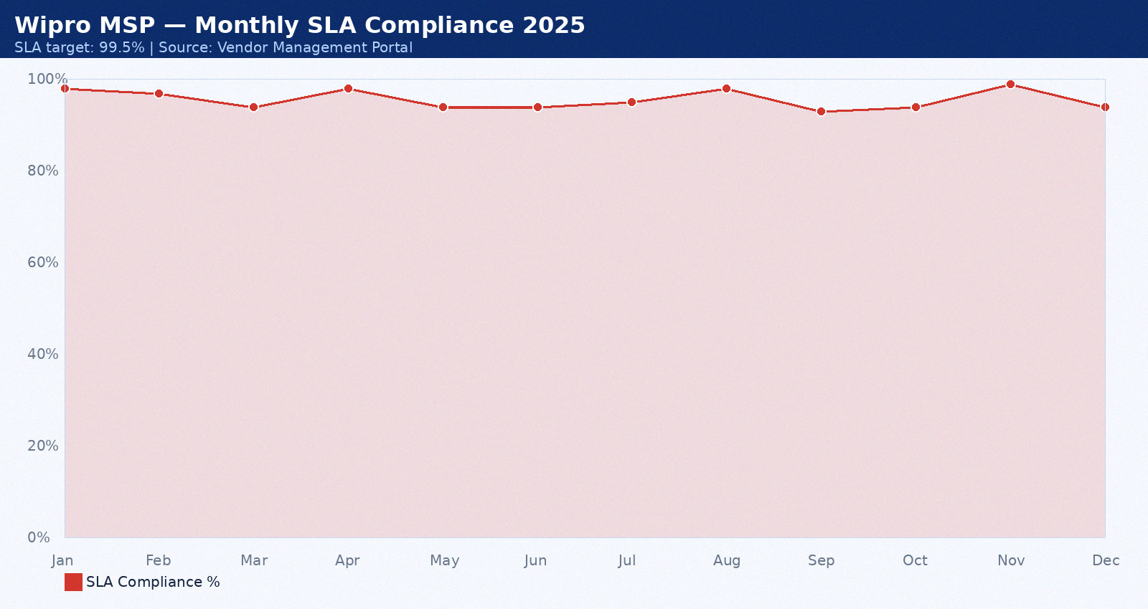

Appendix 42: DataVault — Monthly SLA Data July 2025
Provider: DataVault. Period: July 2025. Total tickets: 24. P1: 0. P2: 5. P3: 8. SLA compliance: 94%. Breaches: 0. Average MTTR: 52 minutes. CSAT: 4.7/5.0.
Month | SLA Target | Actual SLA | Breach? | Tickets | MTTR (min) | CSAT
Jan 2025 | 99.5% | 92.0% | Yes | 3 | 35 | 4.0
Feb 2025 | 99.5% | 93.0% | Yes | 4 | 36 | 4.1
Mar 2025 | 99.5% | 94.0% | Yes | 5 | 37 | 4.2
Apr 2025 | 99.5% | 95.0% | Yes | 6 | 38 | 4.3
May 2025 | 99.5% | 96.0% | Yes | 7 | 39 | 4.4
Jun 2025 | 99.5% | 97.0% | Yes | 8 | 40 | 4.5
Jul 2025 | 99.5% | 98.0% | Yes | 9 | 41 | 4.6
Aug 2025 | 99.5% | 92.0% | Yes | 10 | 42 | 4.7
Sep 2025 | 99.5% | 93.0% | Yes | 3 | 43 | 4.8
Oct 2025 | 99.5% | 94.0% | Yes | 4 | 44 | 4.9
Nov 2025 | 99.5% | 95.0% | Yes | 5 | 45 | 4.0
Dec 2025 | 99.5% | 96.0% | Yes | 6 | 46 | 4.1

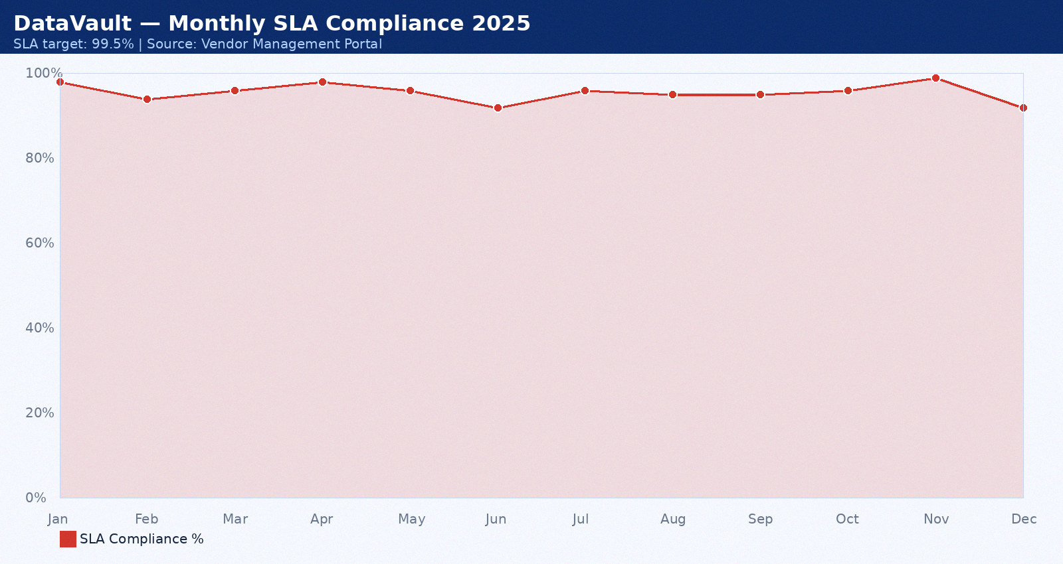

Appendix 43: Cognizant — Monthly SLA Data August 2025
Provider: Cognizant. Period: August 2025. Total tickets: 25. P1: 1. P2: 6. P3: 9. SLA compliance: 95%. Breaches: 1. Average MTTR: 53 minutes. CSAT: 4.8/5.0.
Month | SLA Target | Actual SLA | Breach? | Tickets | MTTR (min) | CSAT
Jan 2025 | 99.5% | 92.0% | Yes | 3 | 35 | 4.0
Feb 2025 | 99.5% | 93.0% | Yes | 4 | 36 | 4.1
Mar 2025 | 99.5% | 94.0% | Yes | 5 | 37 | 4.2
Apr 2025 | 99.5% | 95.0% | Yes | 6 | 38 | 4.3
May 2025 | 99.5% | 96.0% | Yes | 7 | 39 | 4.4
Jun 2025 | 99.5% | 97.0% | Yes | 8 | 40 | 4.5
Jul 2025 | 99.5% | 98.0% | Yes | 9 | 41 | 4.6
Aug 2025 | 99.5% | 92.0% | Yes | 10 | 42 | 4.7
Sep 2025 | 99.5% | 93.0% | Yes | 3 | 43 | 4.8
Oct 2025 | 99.5% | 94.0% | Yes | 4 | 44 | 4.9
Nov 2025 | 99.5% | 95.0% | Yes | 5 | 45 | 4.0
Dec 2025 | 99.5% | 96.0% | Yes | 6 | 46 | 4.1

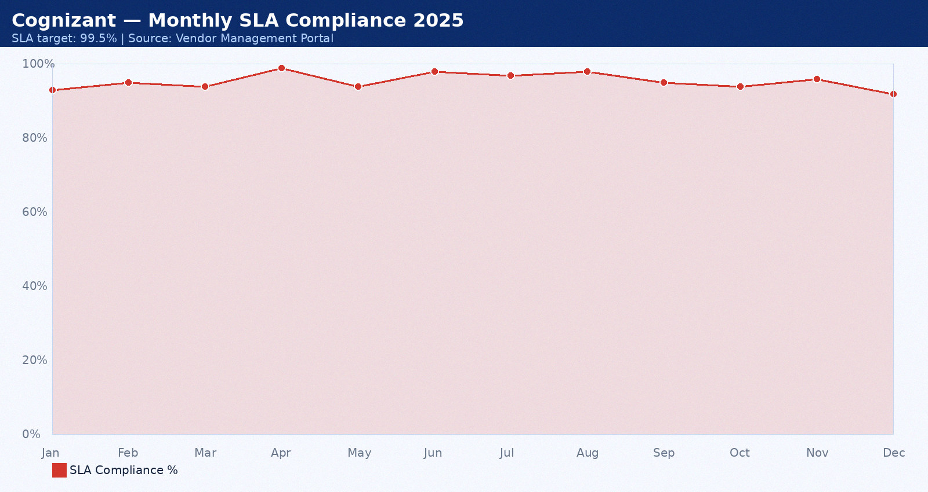

Appendix 44: Rackspace — Monthly SLA Data September 2025
Provider: Rackspace. Period: September 2025. Total tickets: 26. P1: 2. P2: 7. P3: 10. SLA compliance: 96%. Breaches: 2. Average MTTR: 54 minutes. CSAT: 4.9/5.0.
Month | SLA Target | Actual SLA | Breach? | Tickets | MTTR (min) | CSAT
Jan 2025 | 99.5% | 92.0% | Yes | 3 | 35 | 4.0
Feb 2025 | 99.5% | 93.0% | Yes | 4 | 36 | 4.1
Mar 2025 | 99.5% | 94.0% | Yes | 5 | 37 | 4.2
Apr 2025 | 99.5% | 95.0% | Yes | 6 | 38 | 4.3
May 2025 | 99.5% | 96.0% | Yes | 7 | 39 | 4.4
Jun 2025 | 99.5% | 97.0% | Yes | 8 | 40 | 4.5
Jul 2025 | 99.5% | 98.0% | Yes | 9 | 41 | 4.6
Aug 2025 | 99.5% | 92.0% | Yes | 10 | 42 | 4.7
Sep 2025 | 99.5% | 93.0% | Yes | 3 | 43 | 4.8
Oct 2025 | 99.5% | 94.0% | Yes | 4 | 44 | 4.9
Nov 2025 | 99.5% | 95.0% | Yes | 5 | 45 | 4.0
Dec 2025 | 99.5% | 96.0% | Yes | 6 | 46 | 4.1

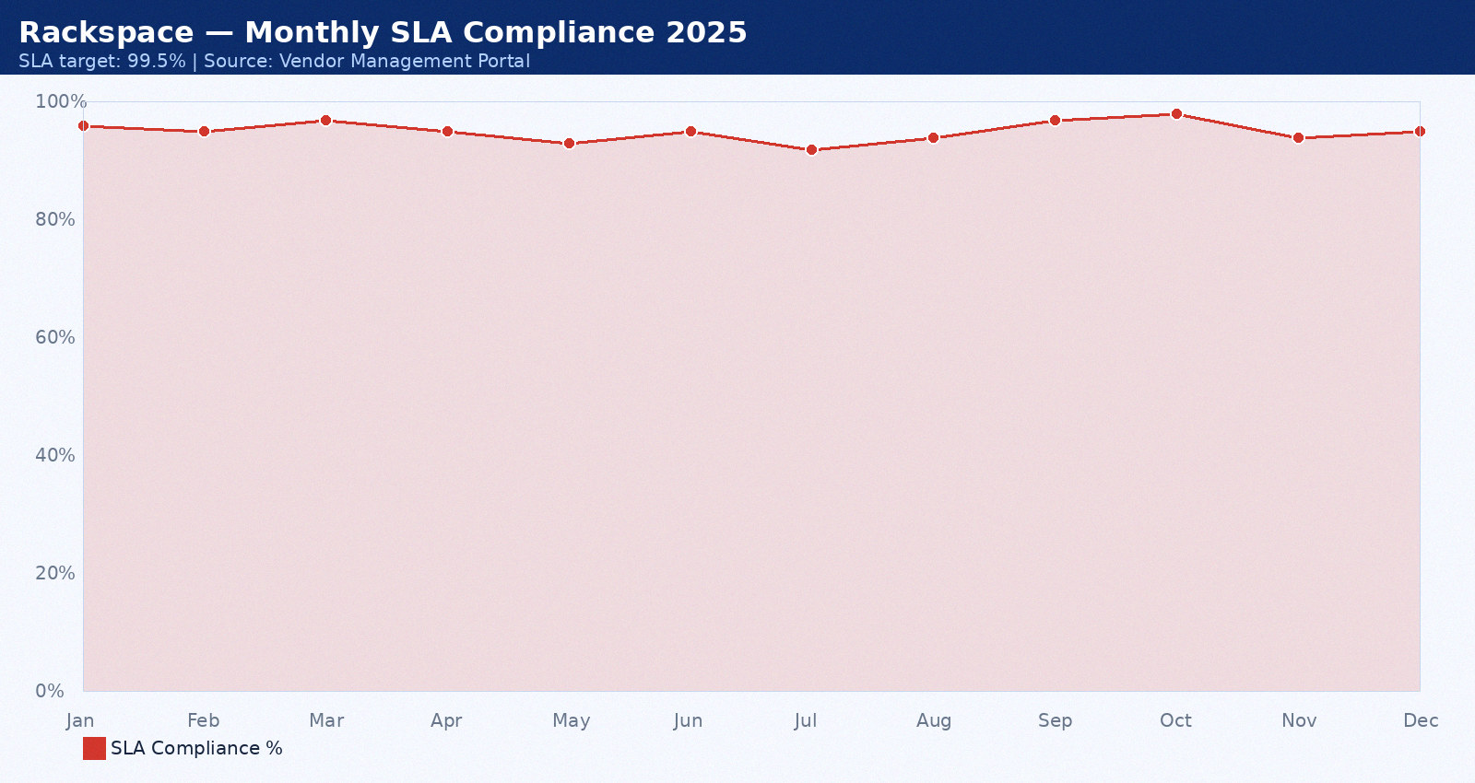

Appendix 45: IBM — Monthly SLA Data October 2025
Provider: IBM. Period: October 2025. Total tickets: 12. P1: 0. P2: 3. P3: 11. SLA compliance: 97%. Breaches: 0. Average MTTR: 55 minutes. CSAT: 3.5/5.0.
Month | SLA Target | Actual SLA | Breach? | Tickets | MTTR (min) | CSAT
Jan 2025 | 99.5% | 92.0% | Yes | 3 | 35 | 4.0
Feb 2025 | 99.5% | 93.0% | Yes | 4 | 36 | 4.1
Mar 2025 | 99.5% | 94.0% | Yes | 5 | 37 | 4.2
Apr 2025 | 99.5% | 95.0% | Yes | 6 | 38 | 4.3
May 2025 | 99.5% | 96.0% | Yes | 7 | 39 | 4.4
Jun 2025 | 99.5% | 97.0% | Yes | 8 | 40 | 4.5
Jul 2025 | 99.5% | 98.0% | Yes | 9 | 41 | 4.6
Aug 2025 | 99.5% | 92.0% | Yes | 10 | 42 | 4.7
Sep 2025 | 99.5% | 93.0% | Yes | 3 | 43 | 4.8
Oct 2025 | 99.5% | 94.0% | Yes | 4 | 44 | 4.9
Nov 2025 | 99.5% | 95.0% | Yes | 5 | 45 | 4.0
Dec 2025 | 99.5% | 96.0% | Yes | 6 | 46 | 4.1

