PRACTICAL-11

Problem Statement:
• Write a Dockerfile for the React frontend of the Task Management application.
• Write a Dockerfile for the Node/Express backend.
• Create a docker-compose.yml file that orchestrates all 3 services: frontend, backend, and MongoDB.
• Configure correct port mappings and an internal Docker network so the services can communicate.
• The entire application must start with a single docker-compose up command, with no manual steps in between.

Implementation & Output:
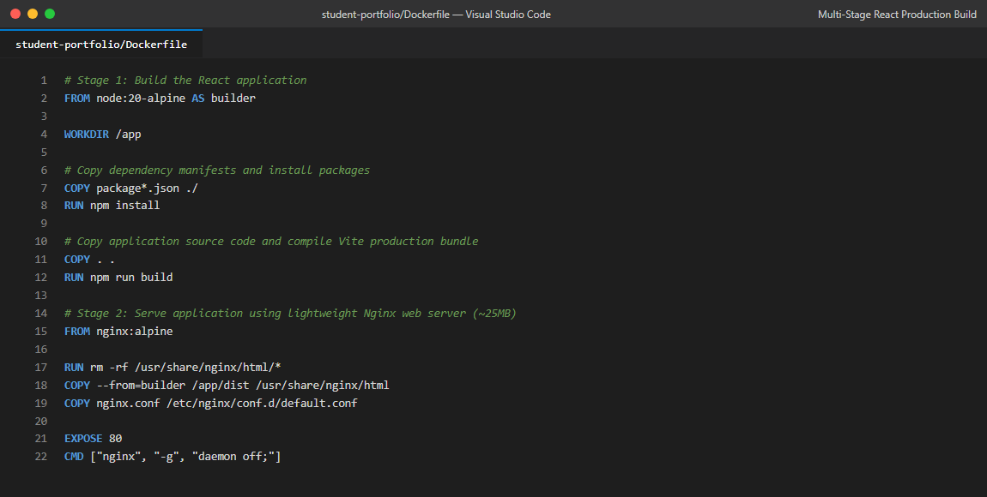
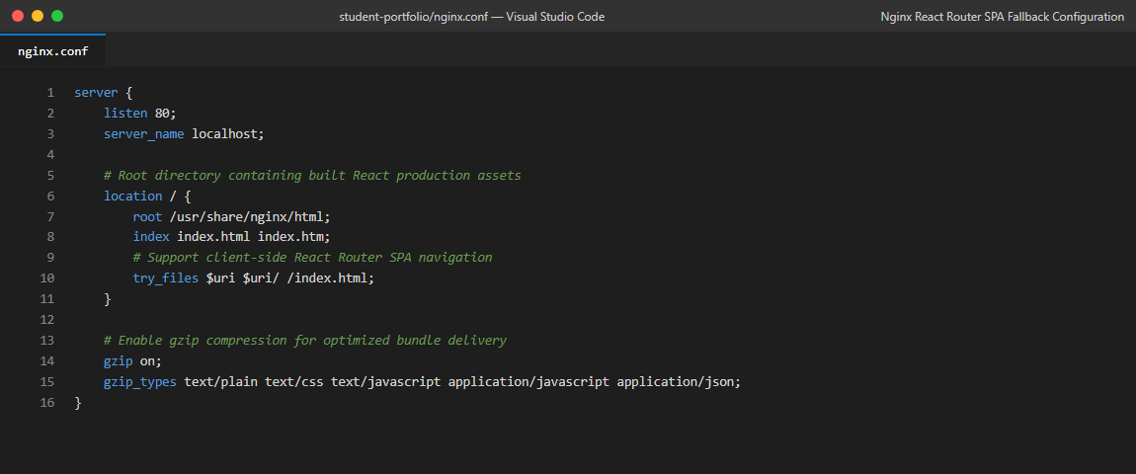
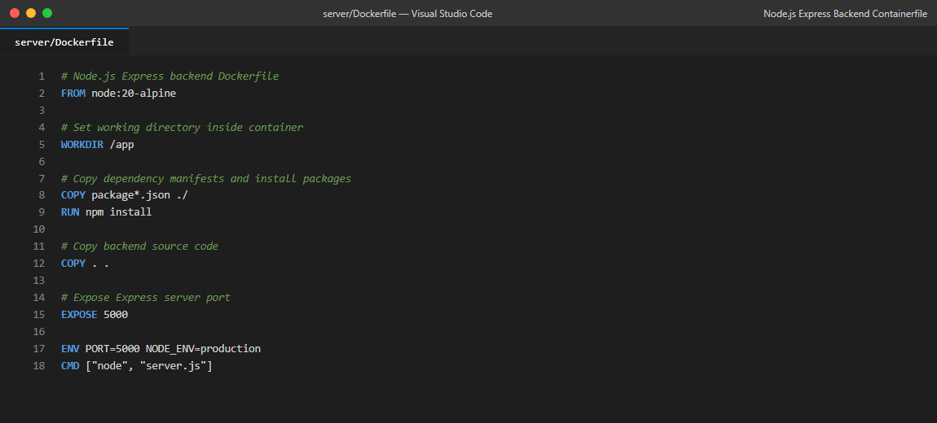
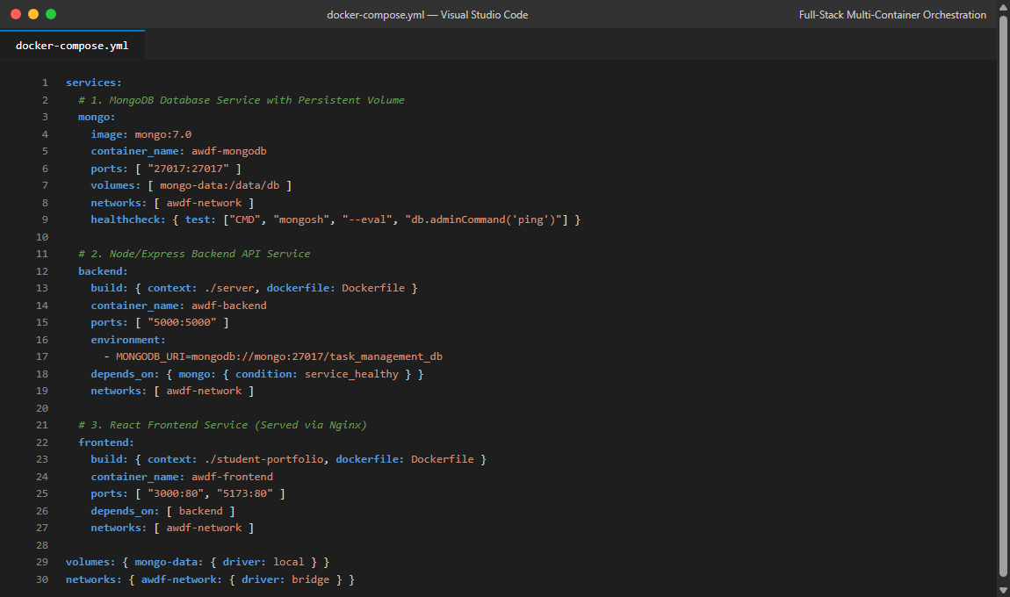
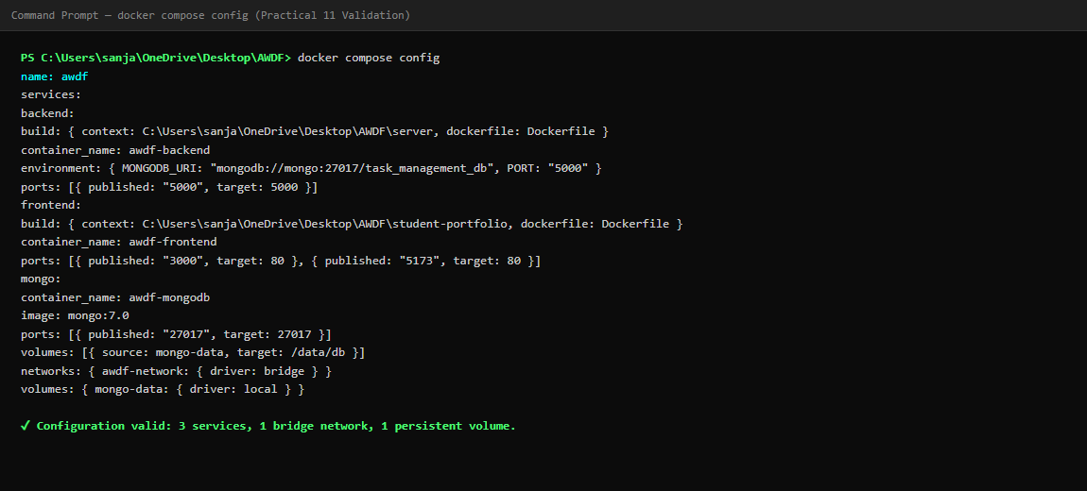
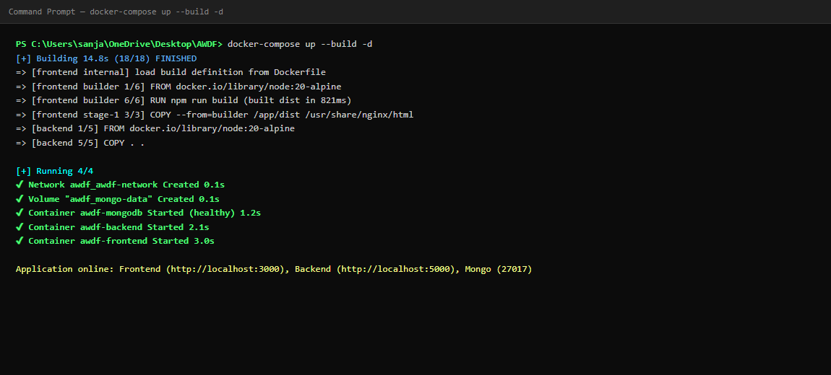
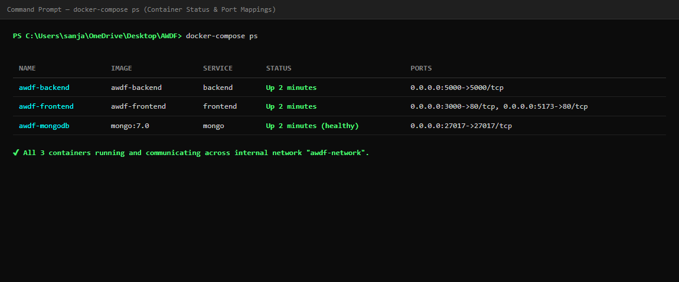
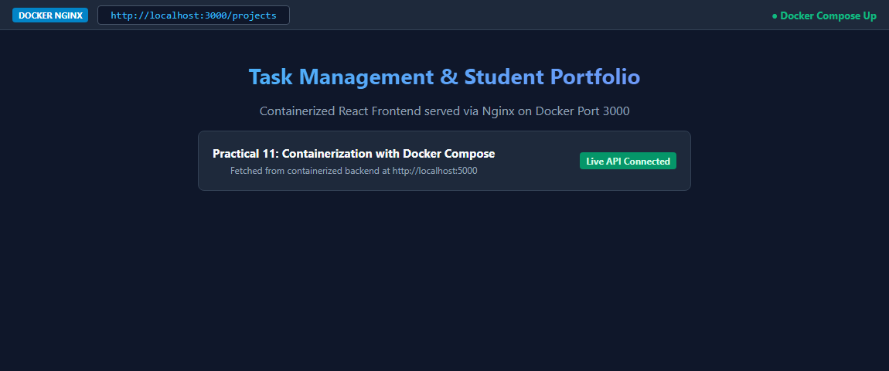
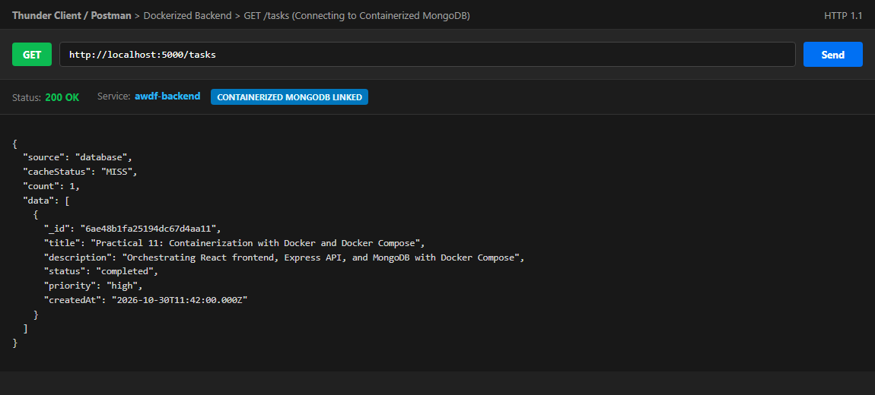
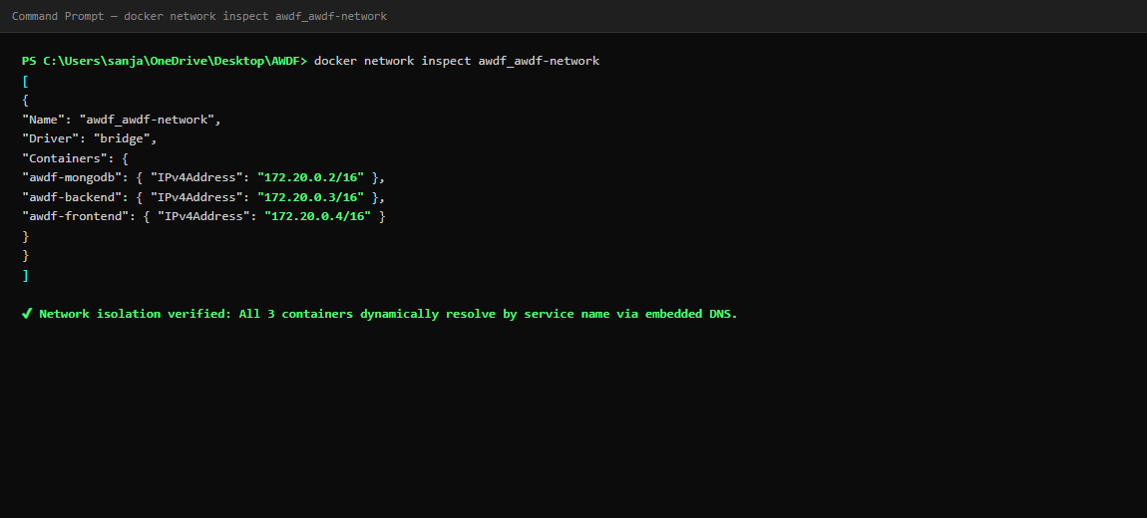

Git hub Repo Link:
https://github.com/riyakakkad/AWDF.git

