PRACTICAL-3

Problem Statement:
• Integrate a public REST API (e.g., GitHub API) into the portfolio
application to fetch and display a list of repositories dynamically.
• Use the Projects page built in Practical 2 as the integration point.
• Implement a loading spinner component shown while the request is in
progress.
• Implement an error message component shown if the API call fails.
• Render at least the repository name and URL for each item returned.

Implementation & Output:
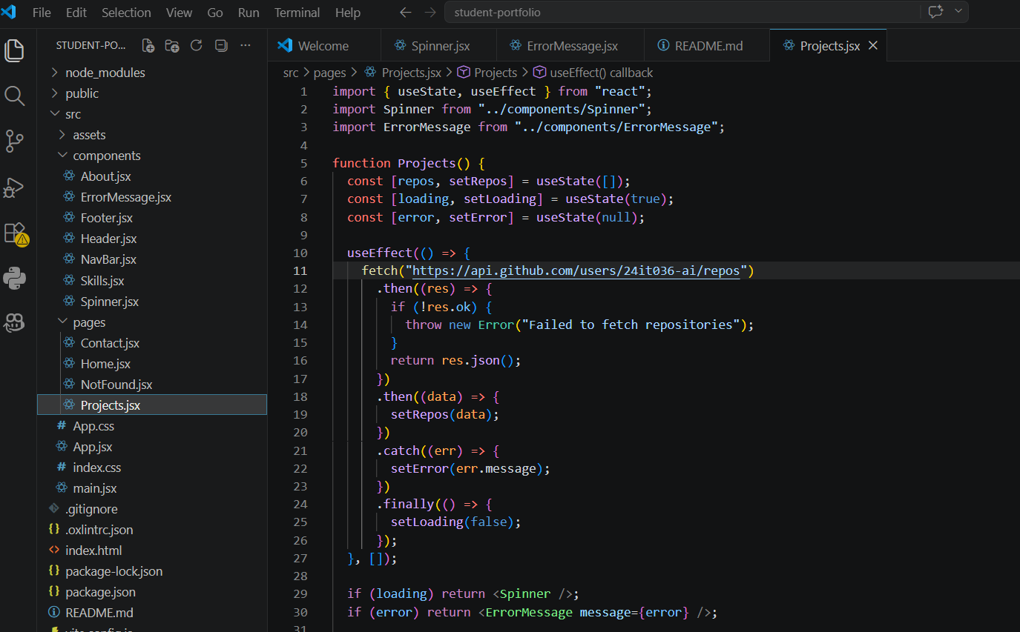

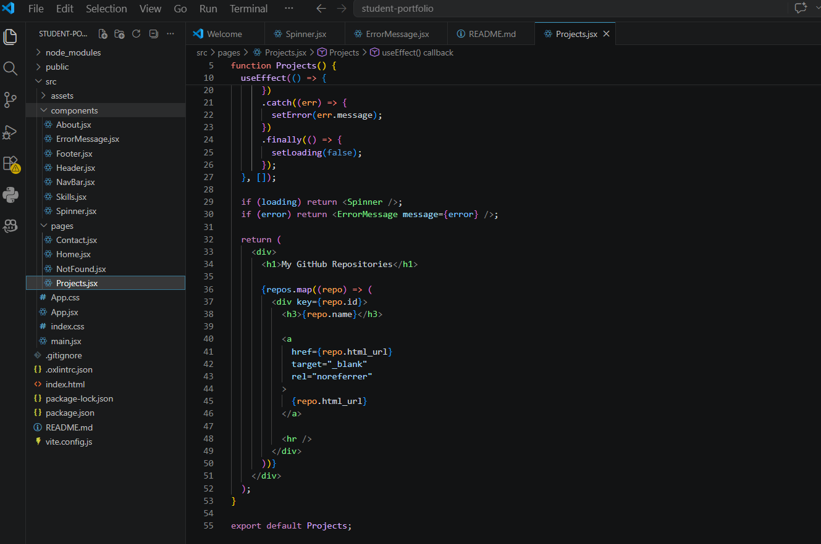
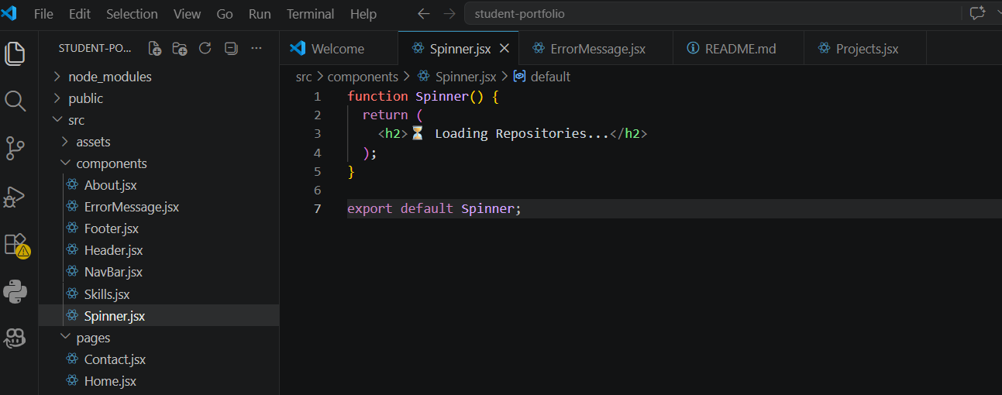

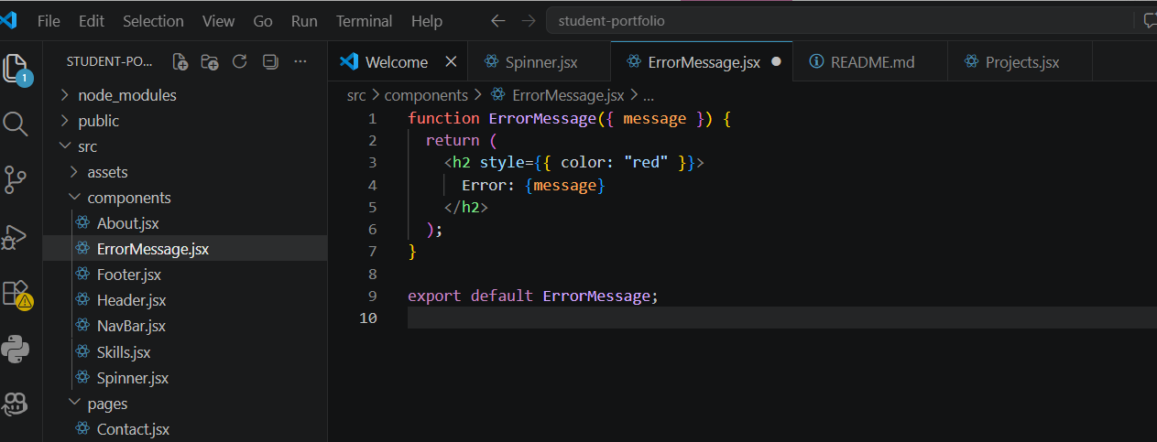

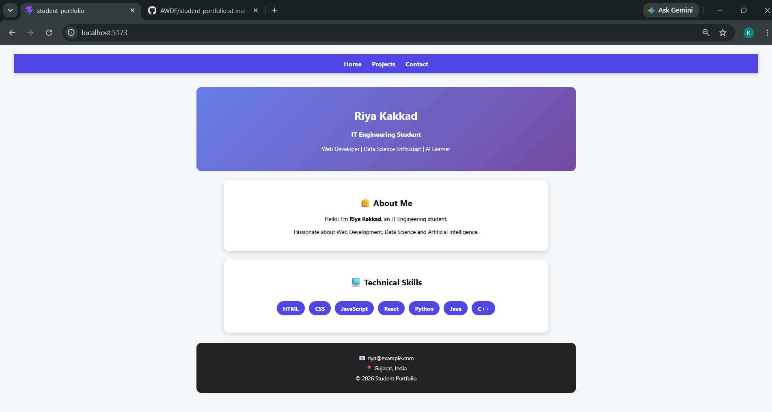

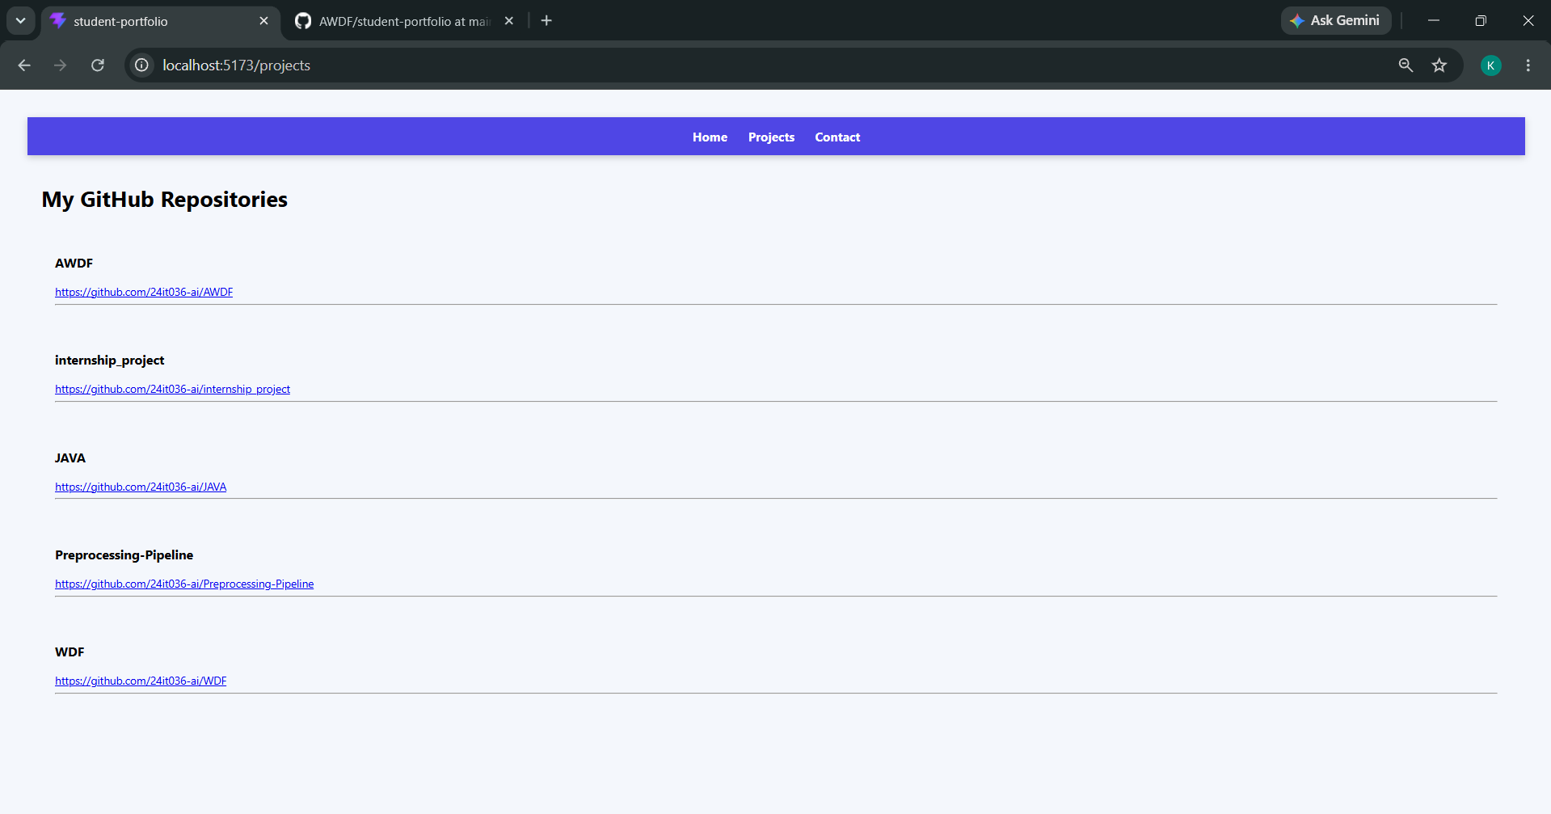

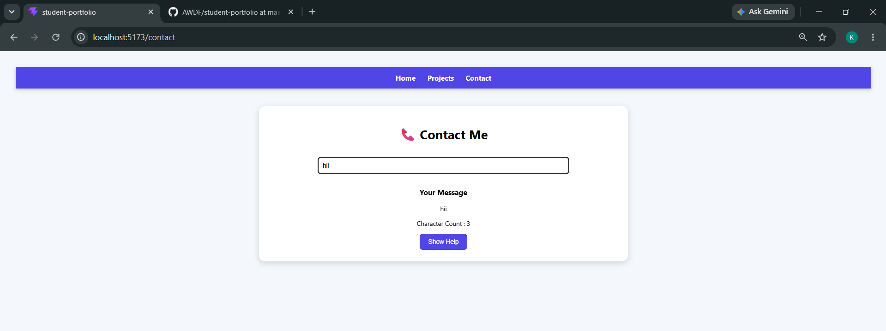

- Git hub Repo Link:
https://github.com/24it036-ai/AWDF

