PRACTICAL-4

Problem Statement:
• Build a Node/Express backend for a Task Management system.
• Implement REST endpoints for creating, reading, updating, and deleting tasks (in-memory array, no database yet).
• Apply a request logging middleware that logs method, URL, and timestamp for every incoming request.
• Apply a global error handling middleware as the last middleware in the pipeline.
• Use correct HTTP status codes (200, 201, 404, 500) for each response.

Implementation & Output:
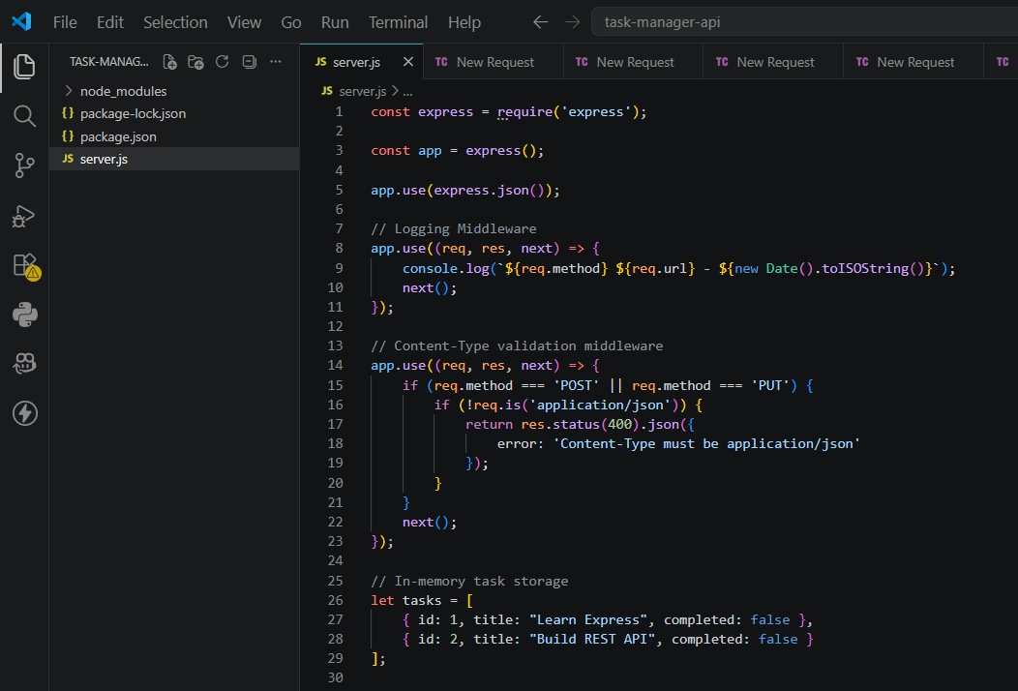
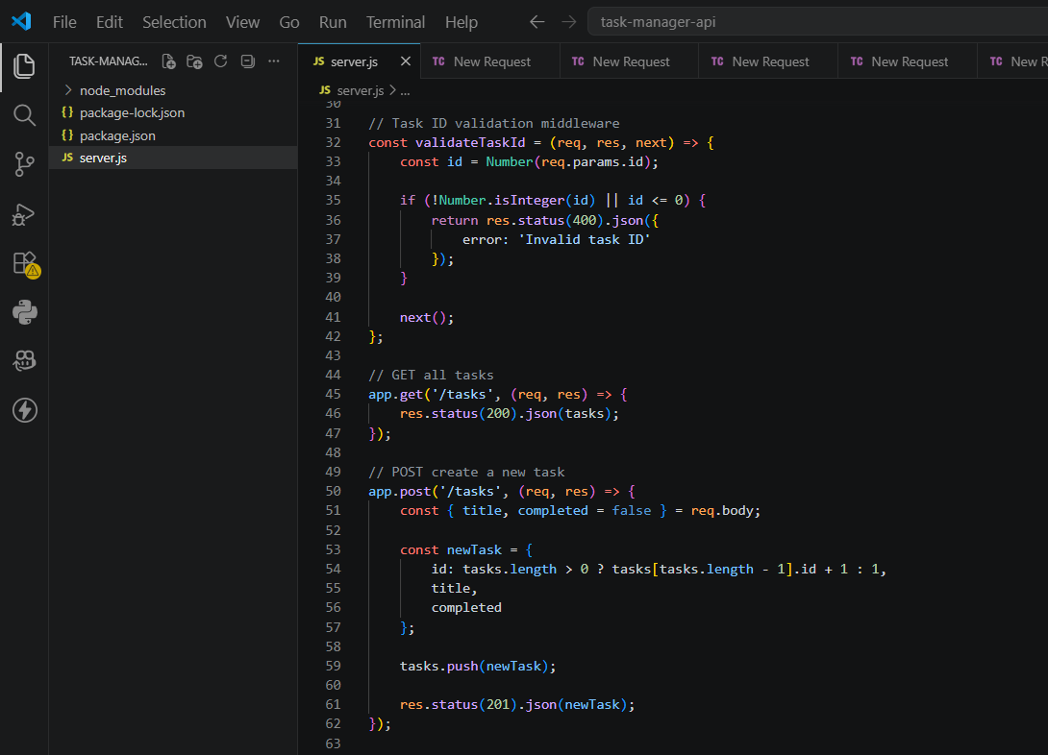
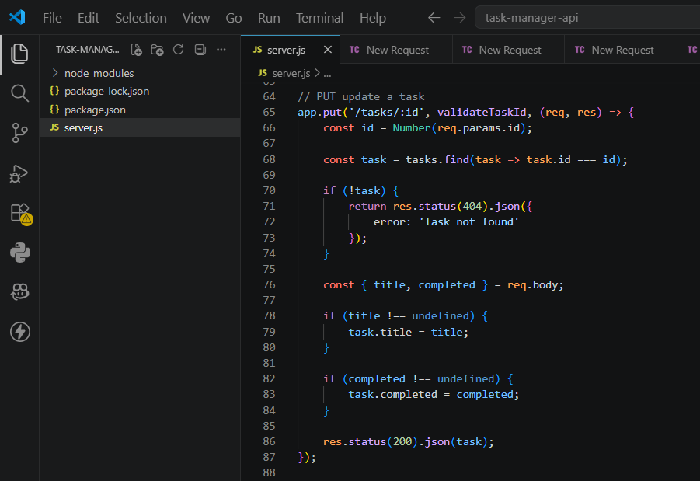
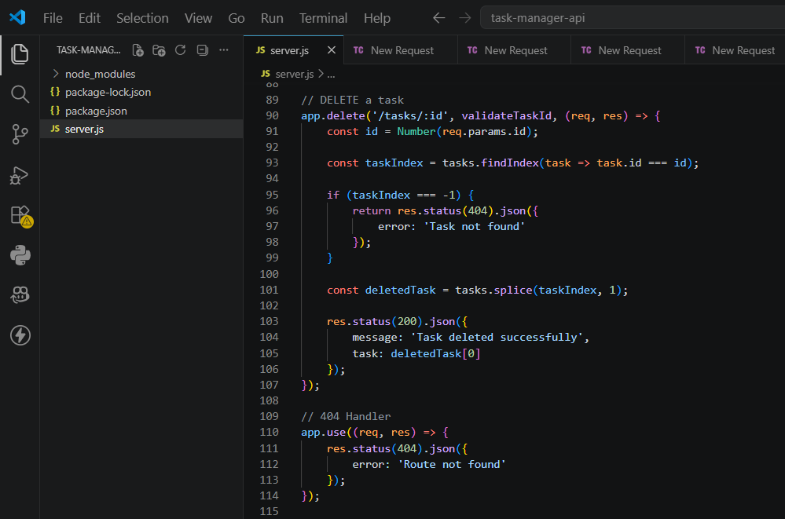
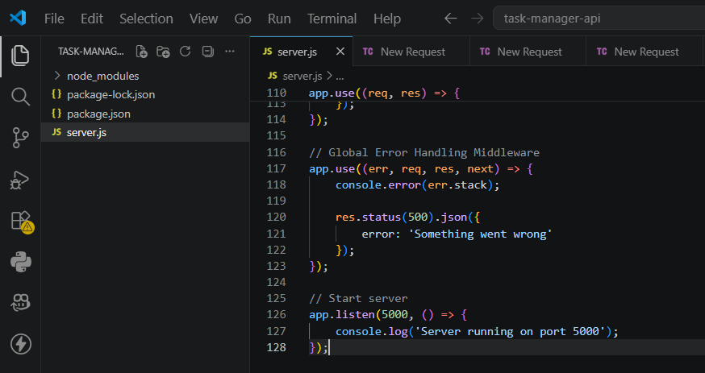
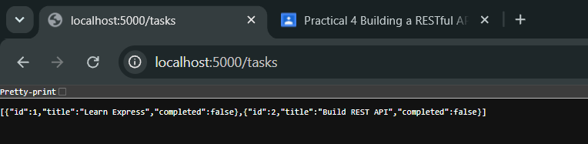
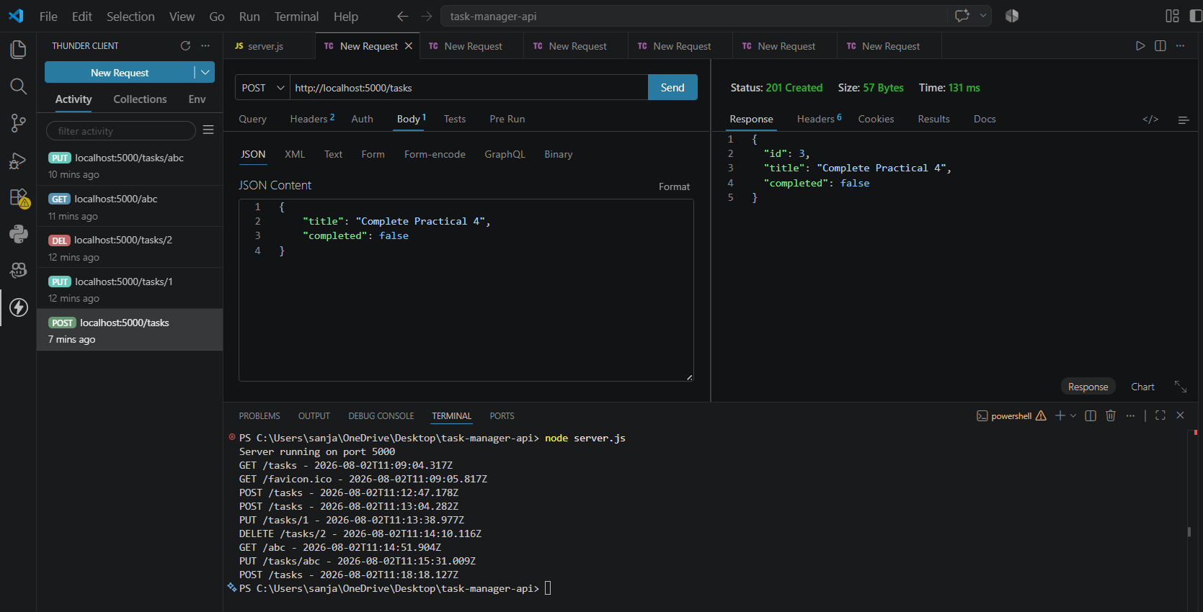
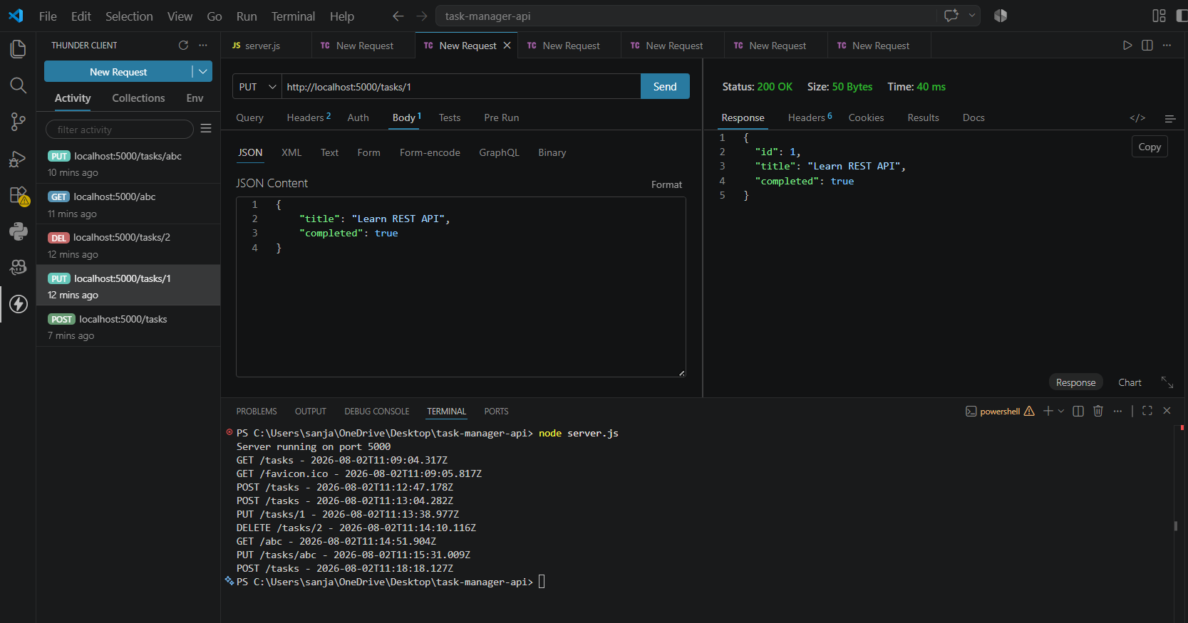
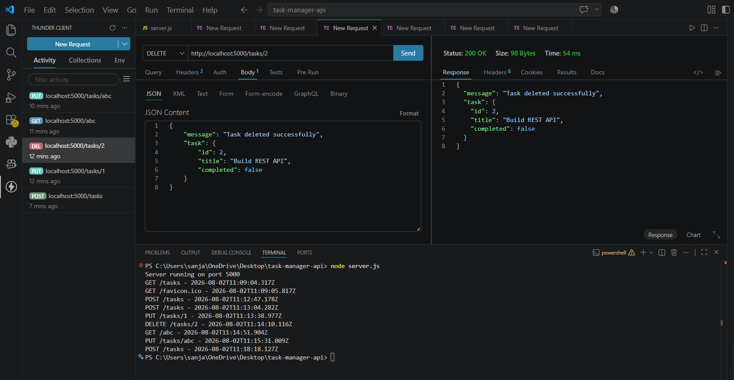
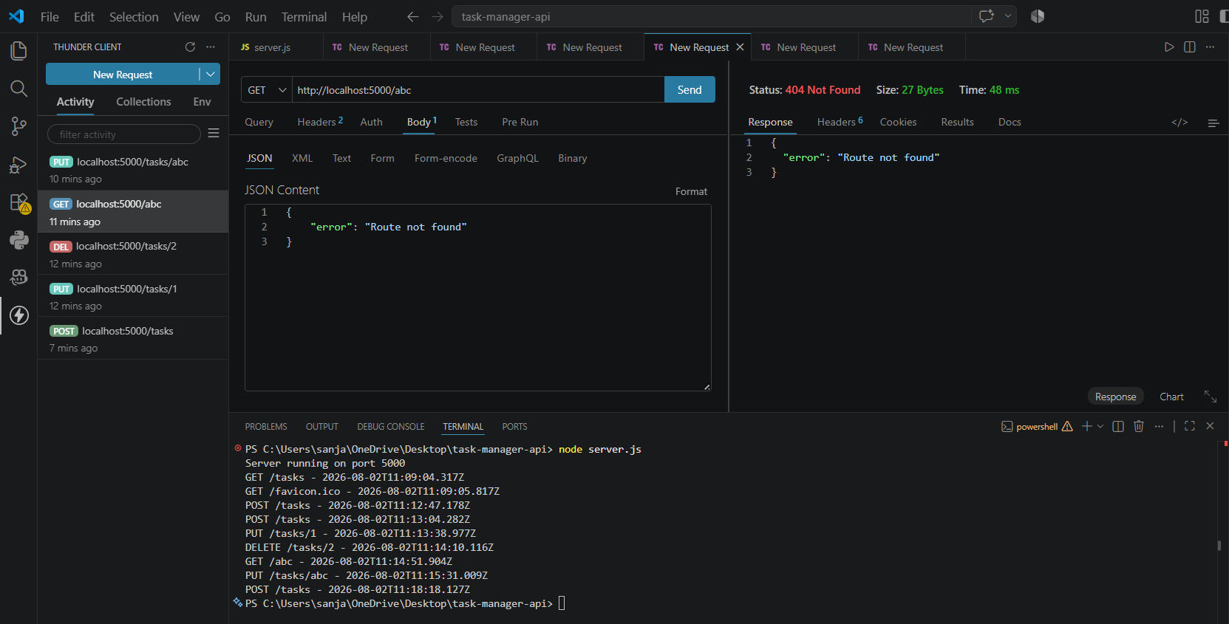
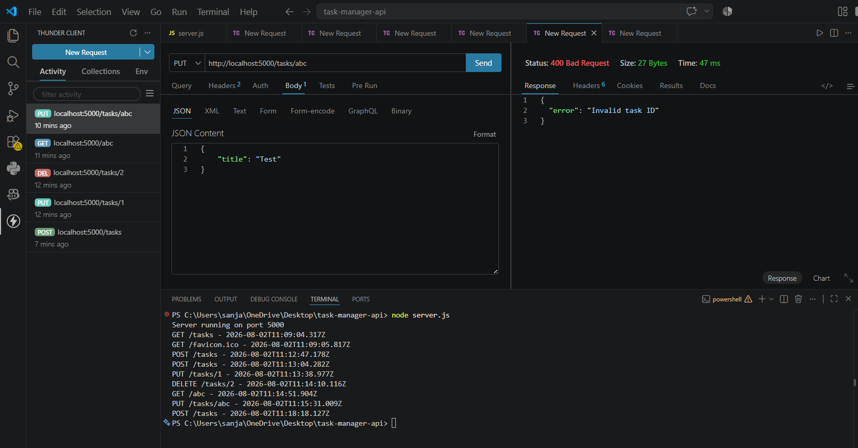
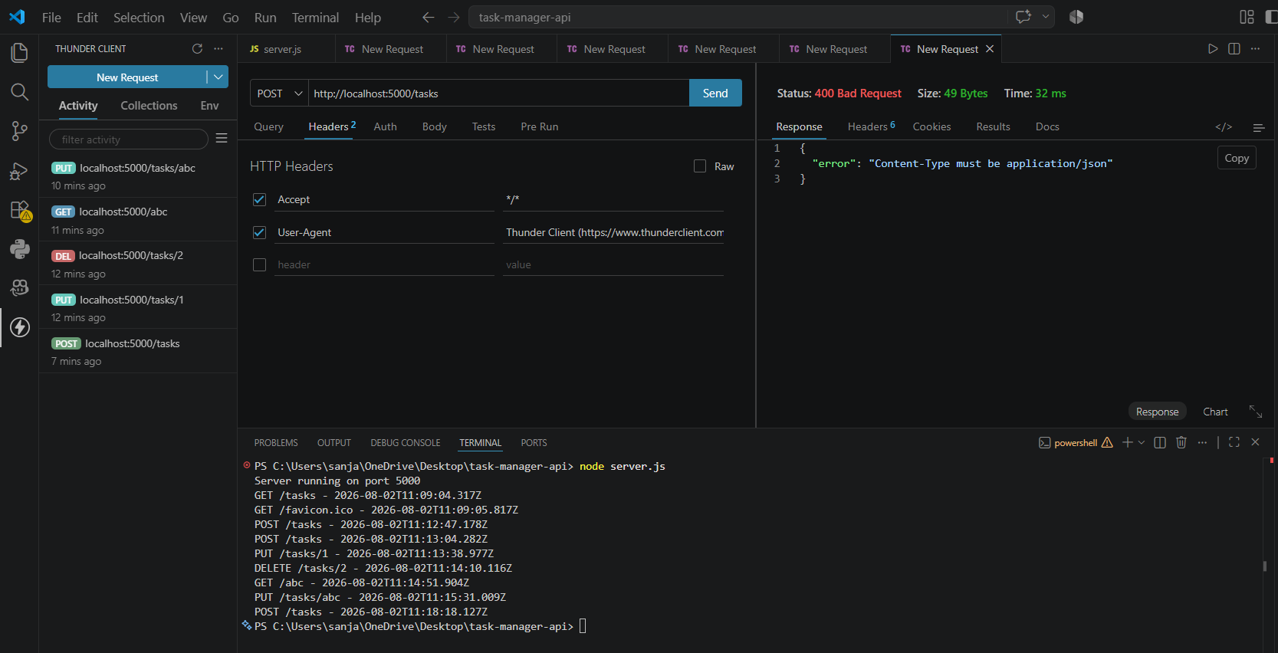

- Git hub Repo Link:
https://github.com/24it036-ai/task-manager-api-24it036.git

