PRACTICAL-5
Problem Statement:
• Extend the Task Management backend from Practical 4 by connecting
MongoDB using Mongoose.
• Define a Task schema with at least 4 fields: title (String, required),
description (String), completed (Boolean, default false), createdAt (Date,
default Date.now).
• Replace the in-memory array from Practical 4 with real Mongoose
model operations.
• Test all CRUD operations against the live database using Postman.
• Ensure validation errors are returned as structured JSON, not raw
Mongoose error objects.

Implementation & Output:
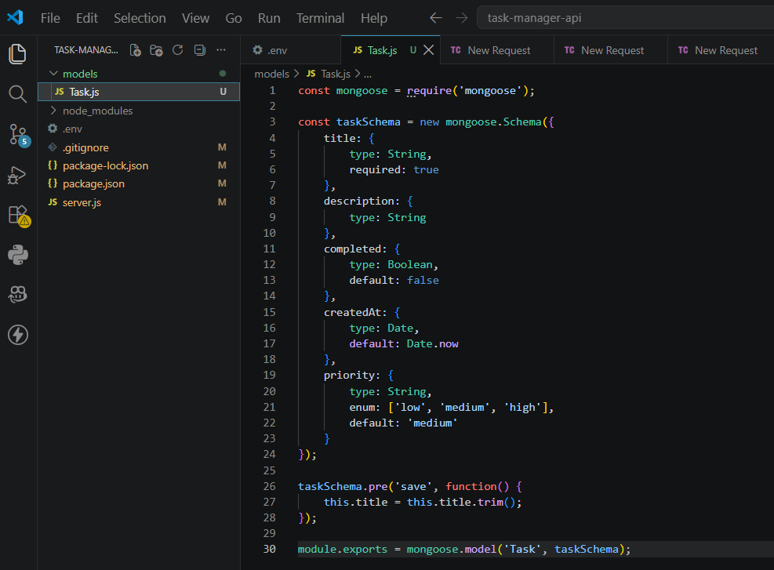
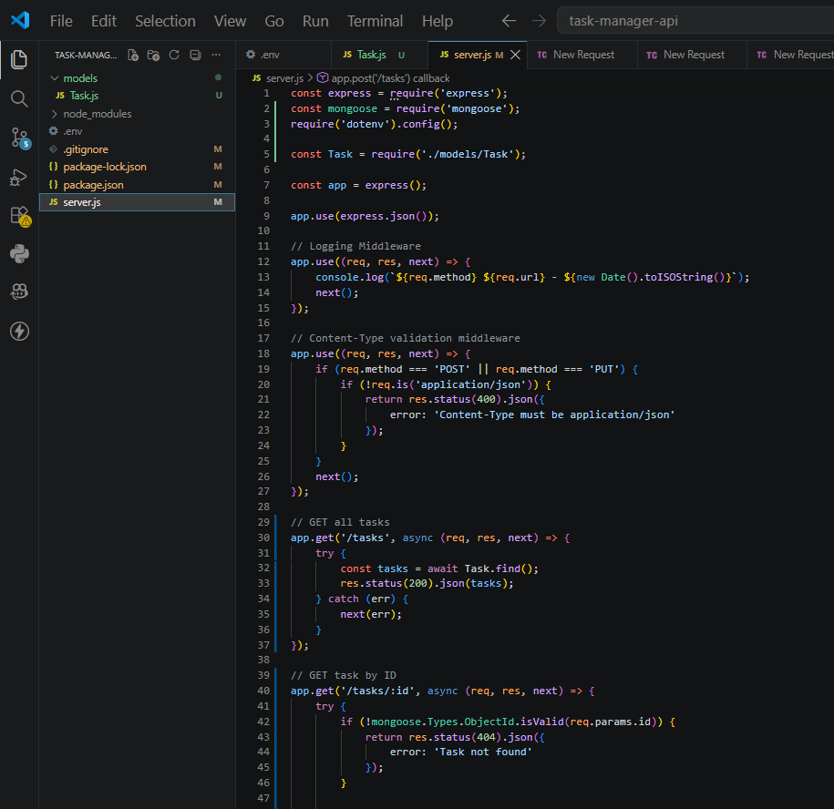
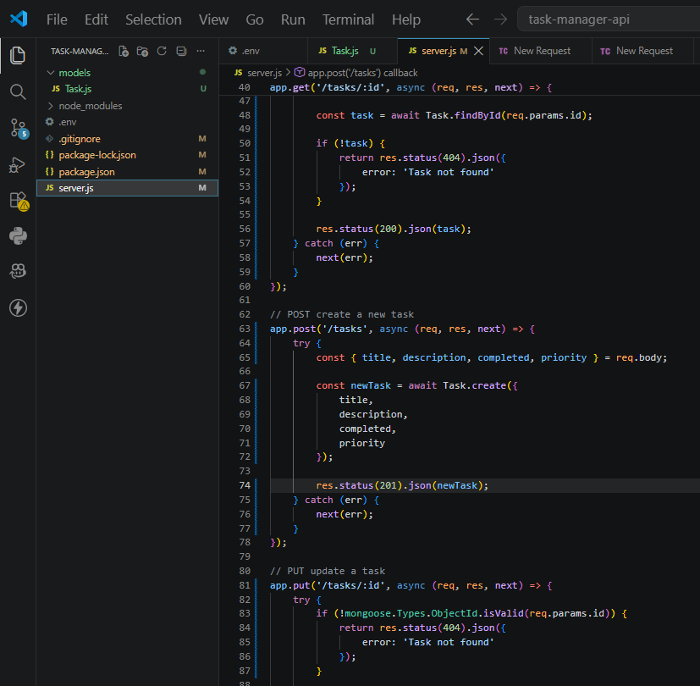
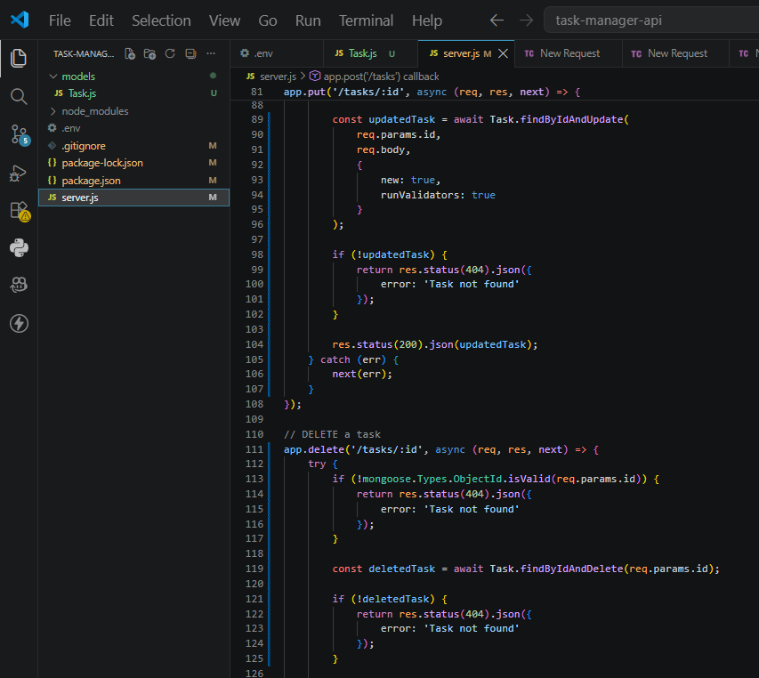
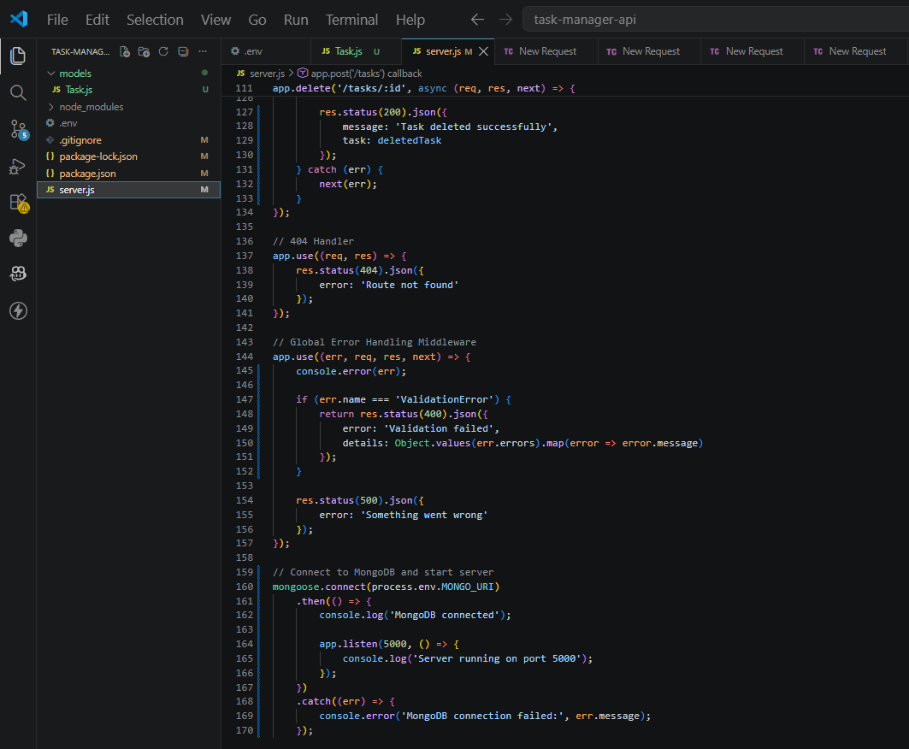
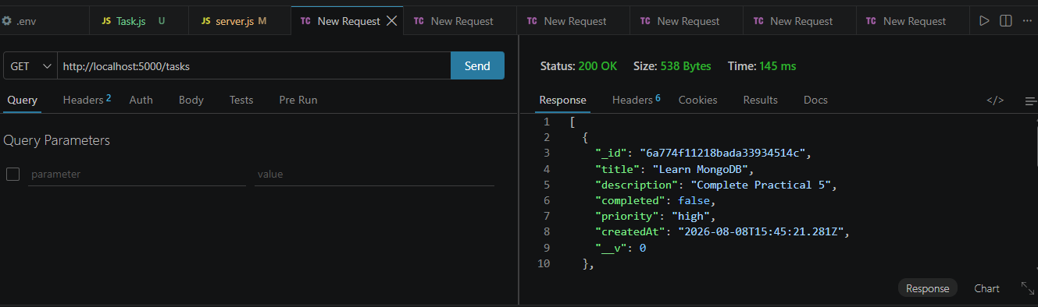
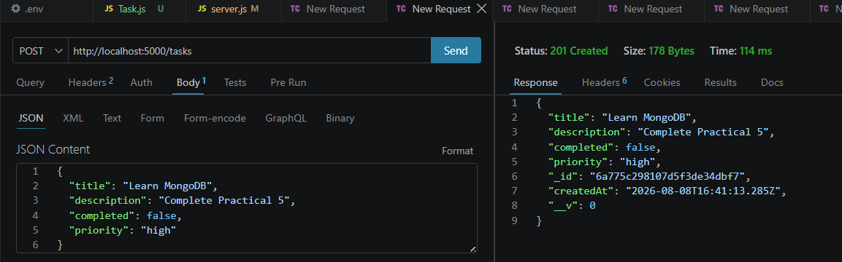
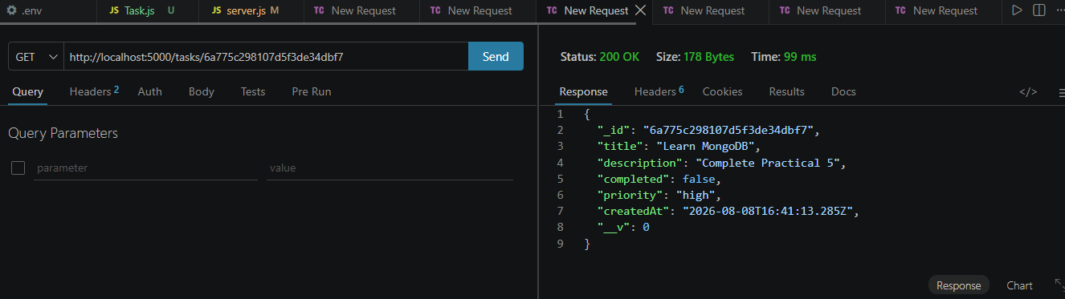
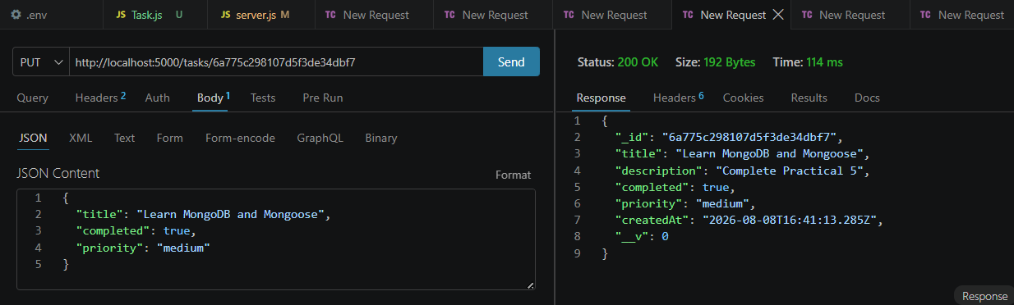
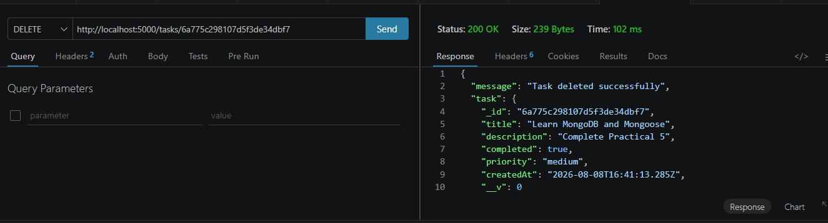
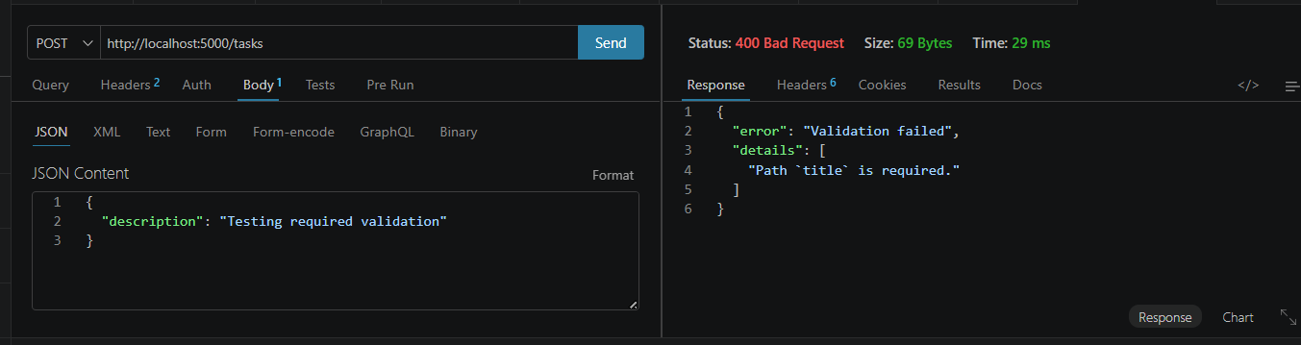
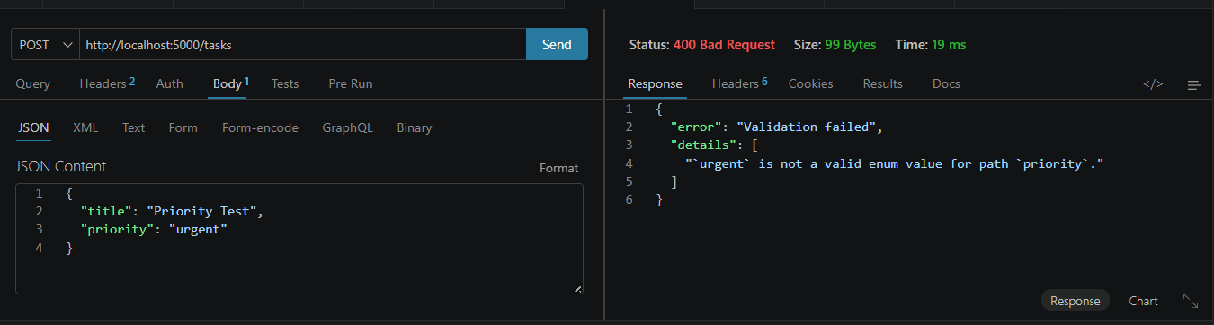
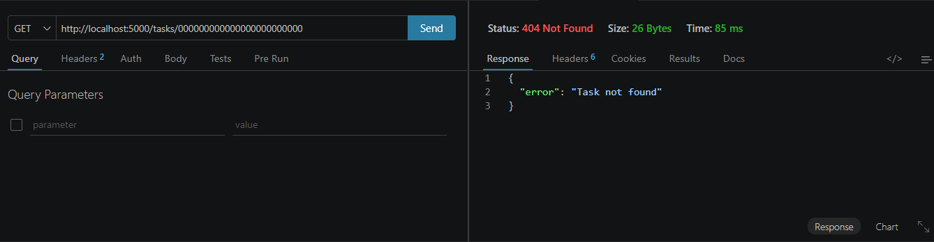
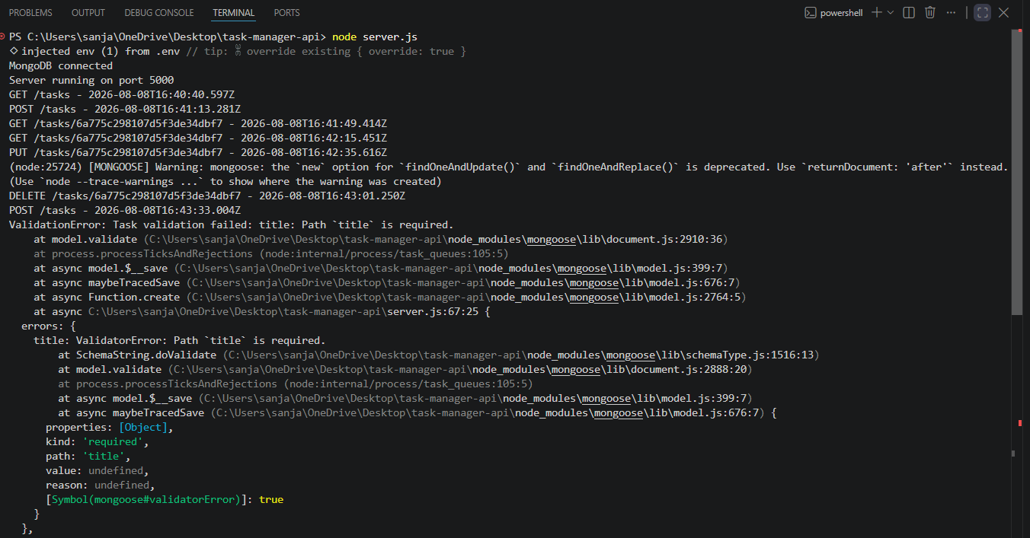
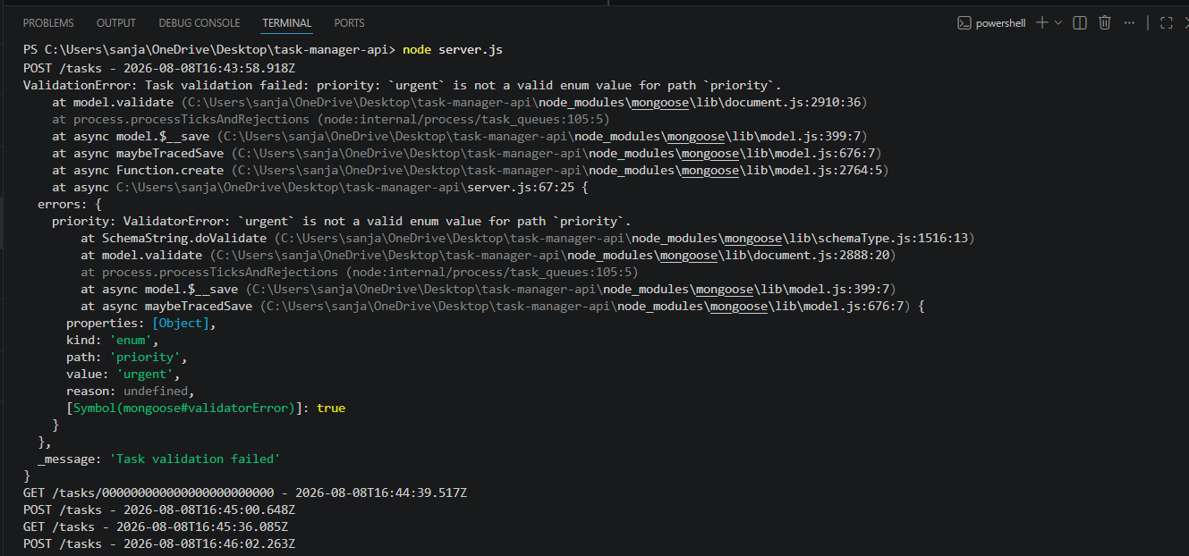
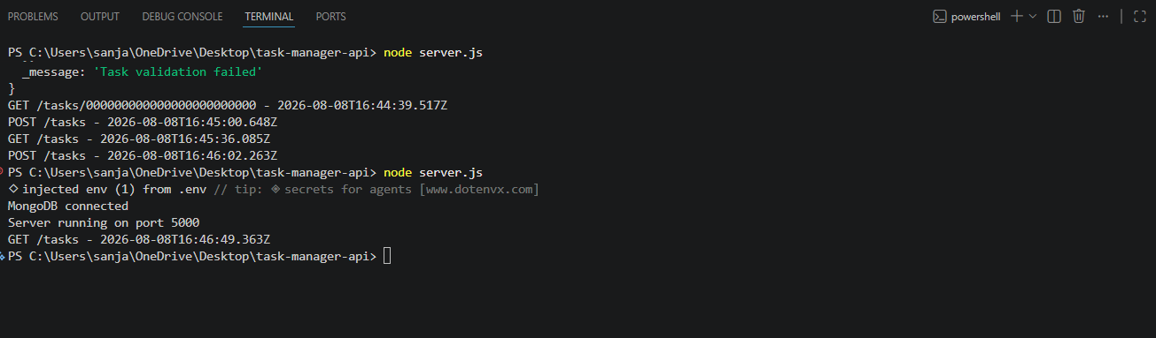
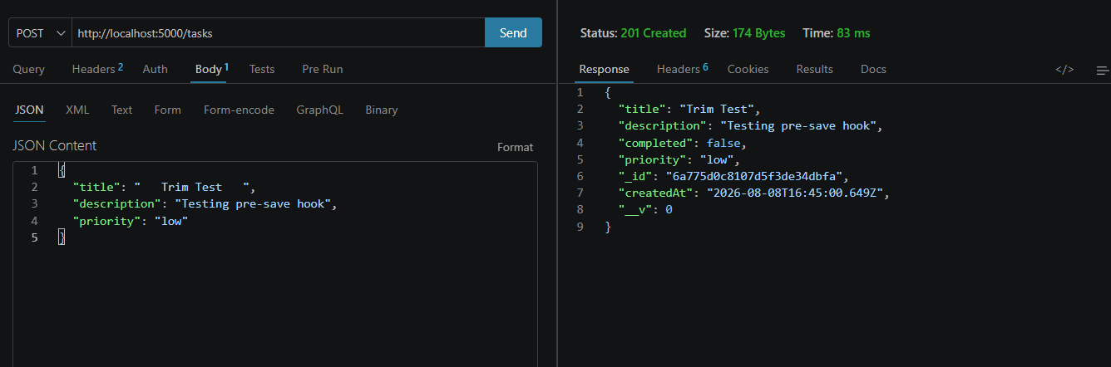
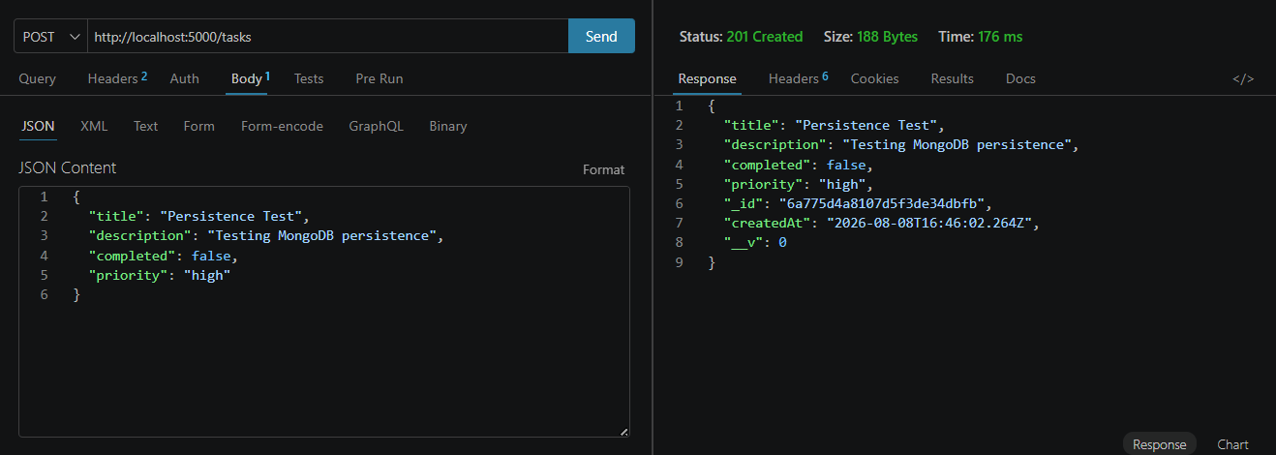
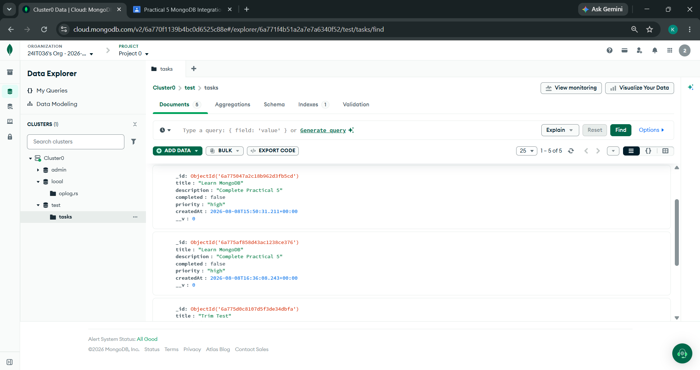

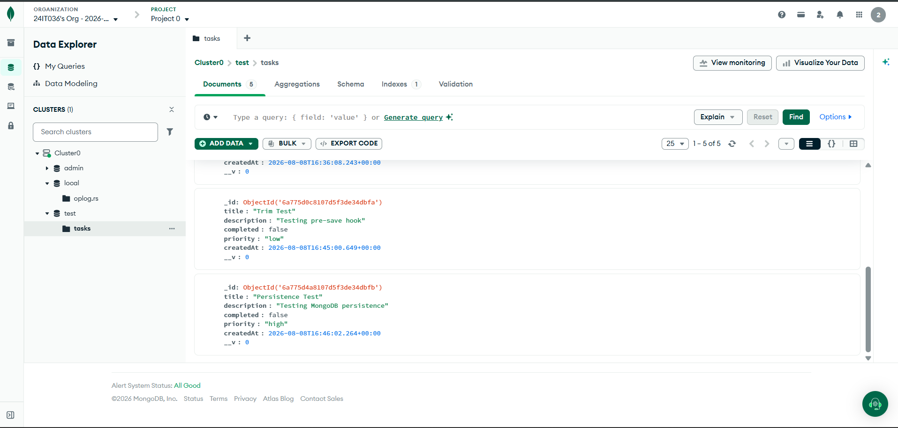

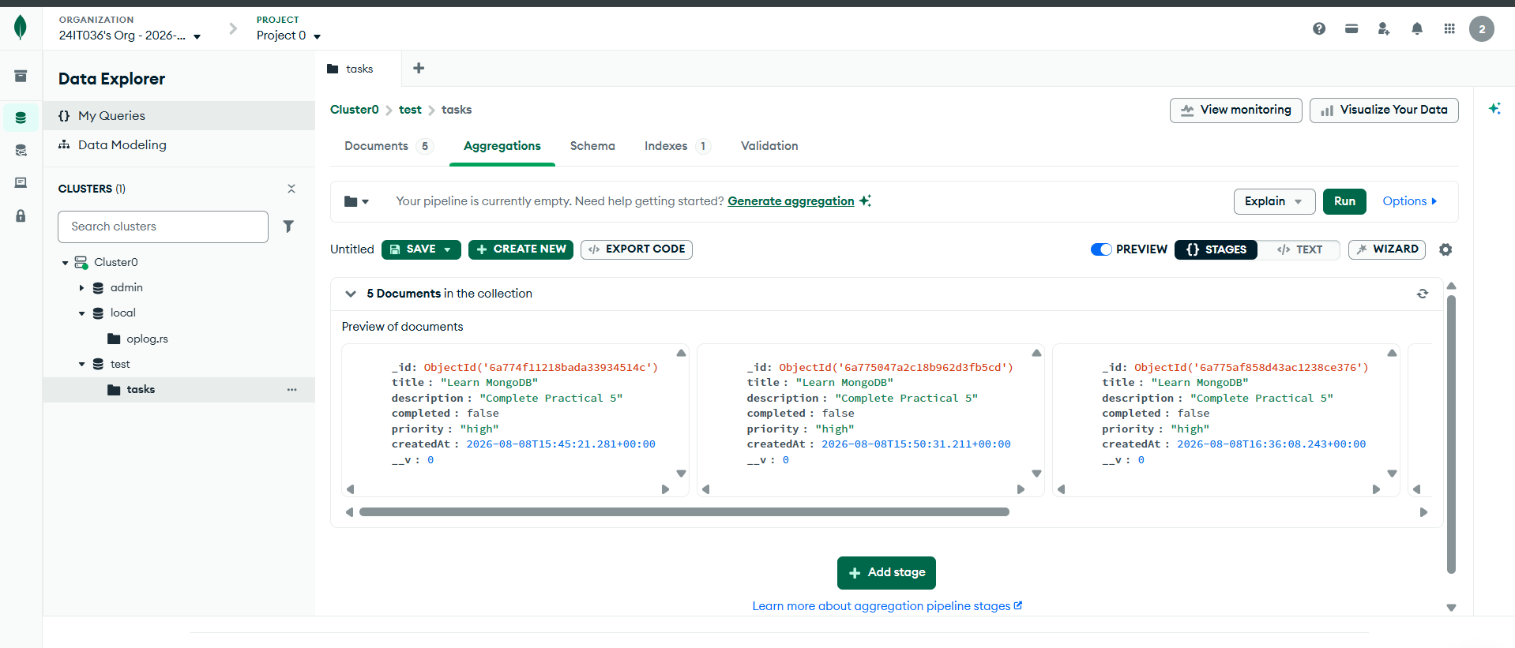
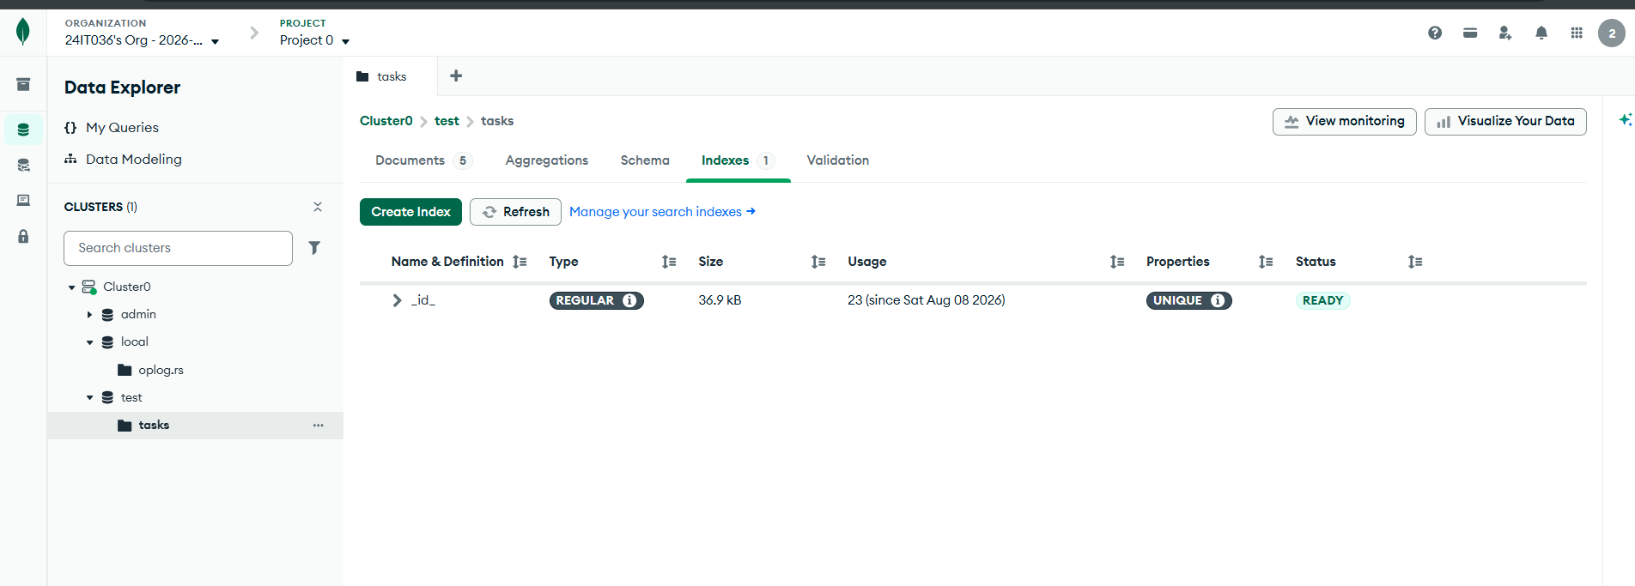

- Git hub Repo Link:
https://github.com/24it036-ai/task-manager-api-24it036.git

