PRACTICAL-6
Problem Statement:
• Connect the React Task UI to the Node+MongoDB backend built in
Practicals 4 and 5.
• Replace the GitHub repo data from Practical 3 with task data from your
own backend.
• The application must support creating, viewing, updating, and deleting
tasks from the React interface through API calls.
• All data must be persisted in MongoDB confirmed by refreshing the
browser and seeing data remain.
• Handle loading and error states for every API interaction, not just the
initial fetch.

Implementation & Output:
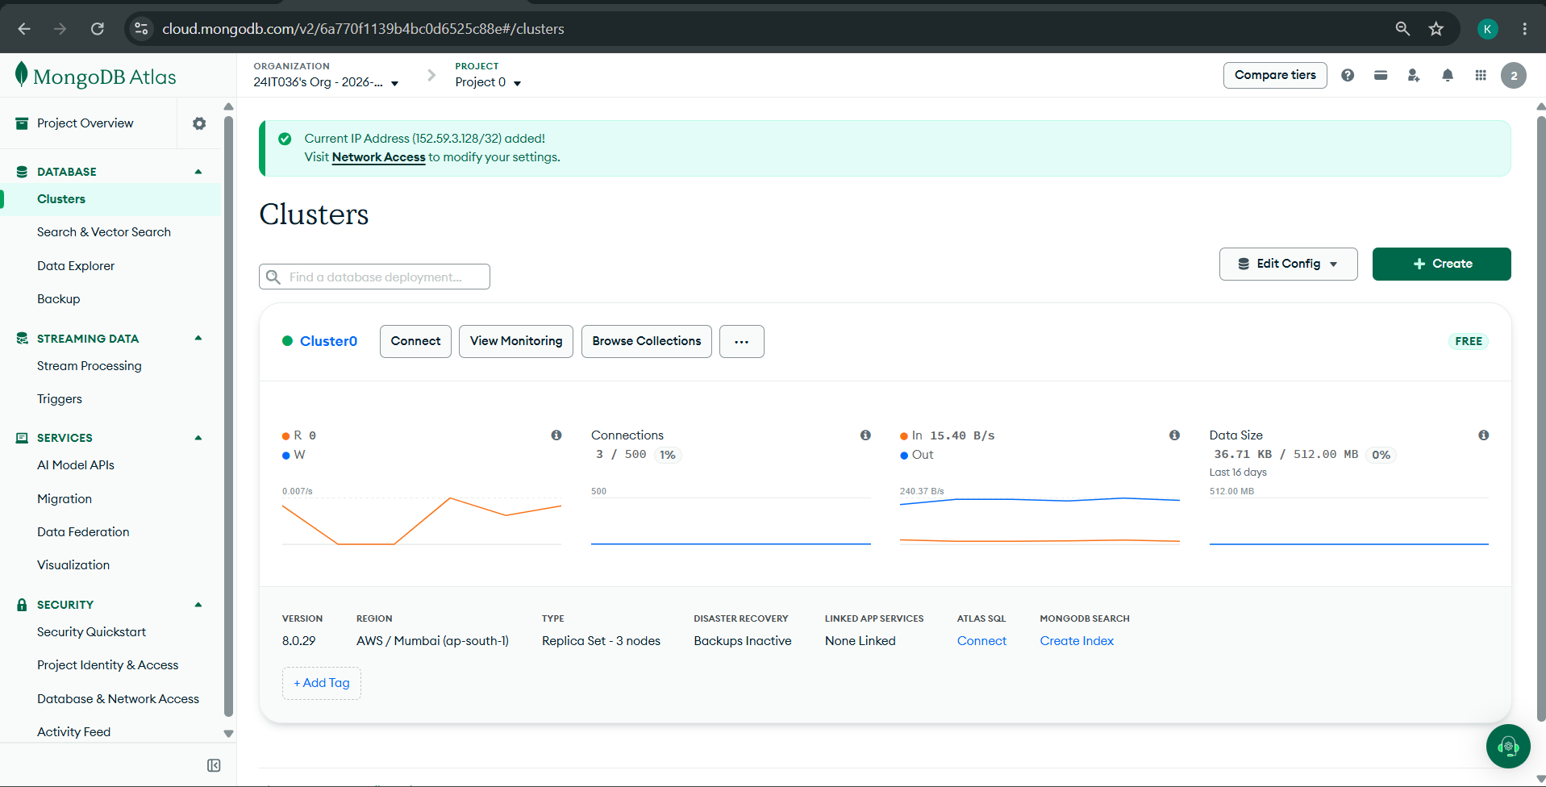

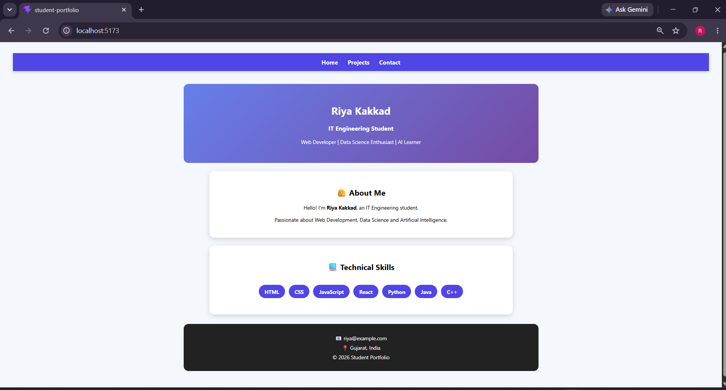

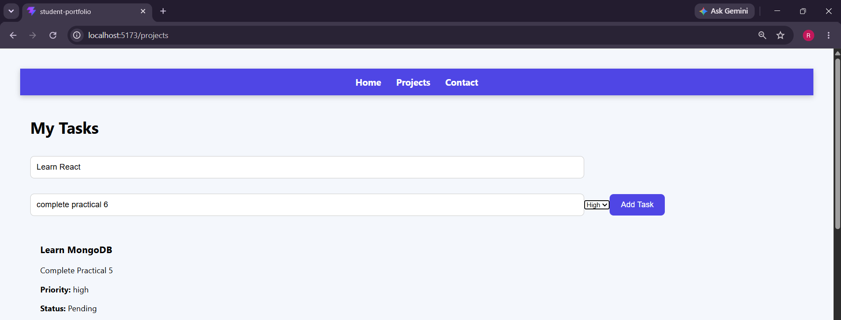
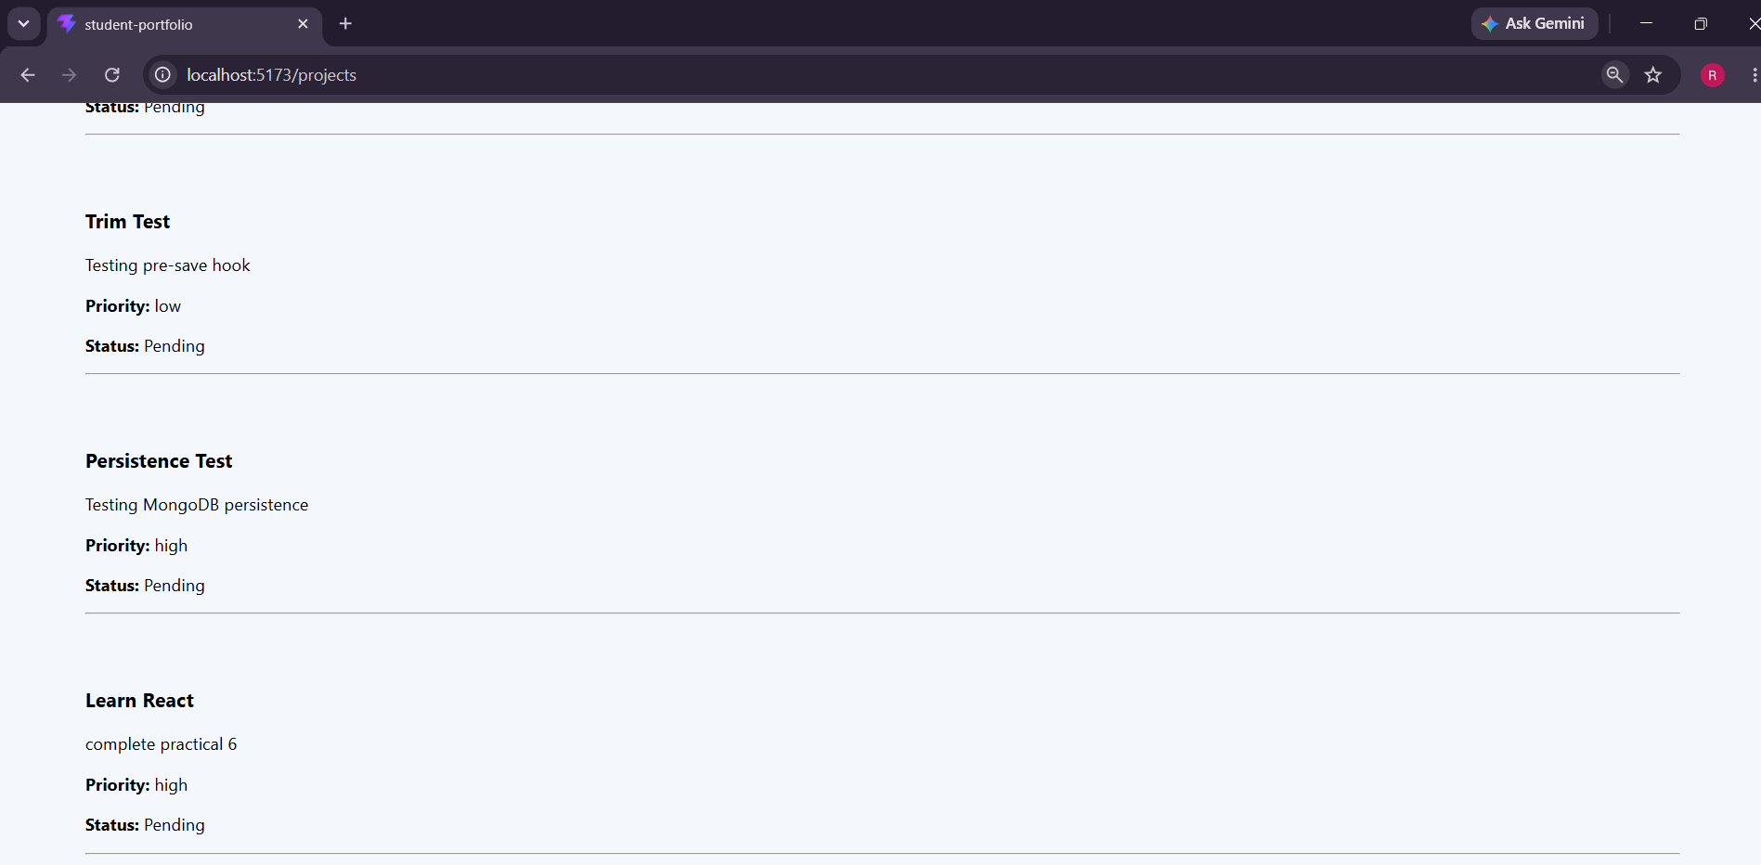

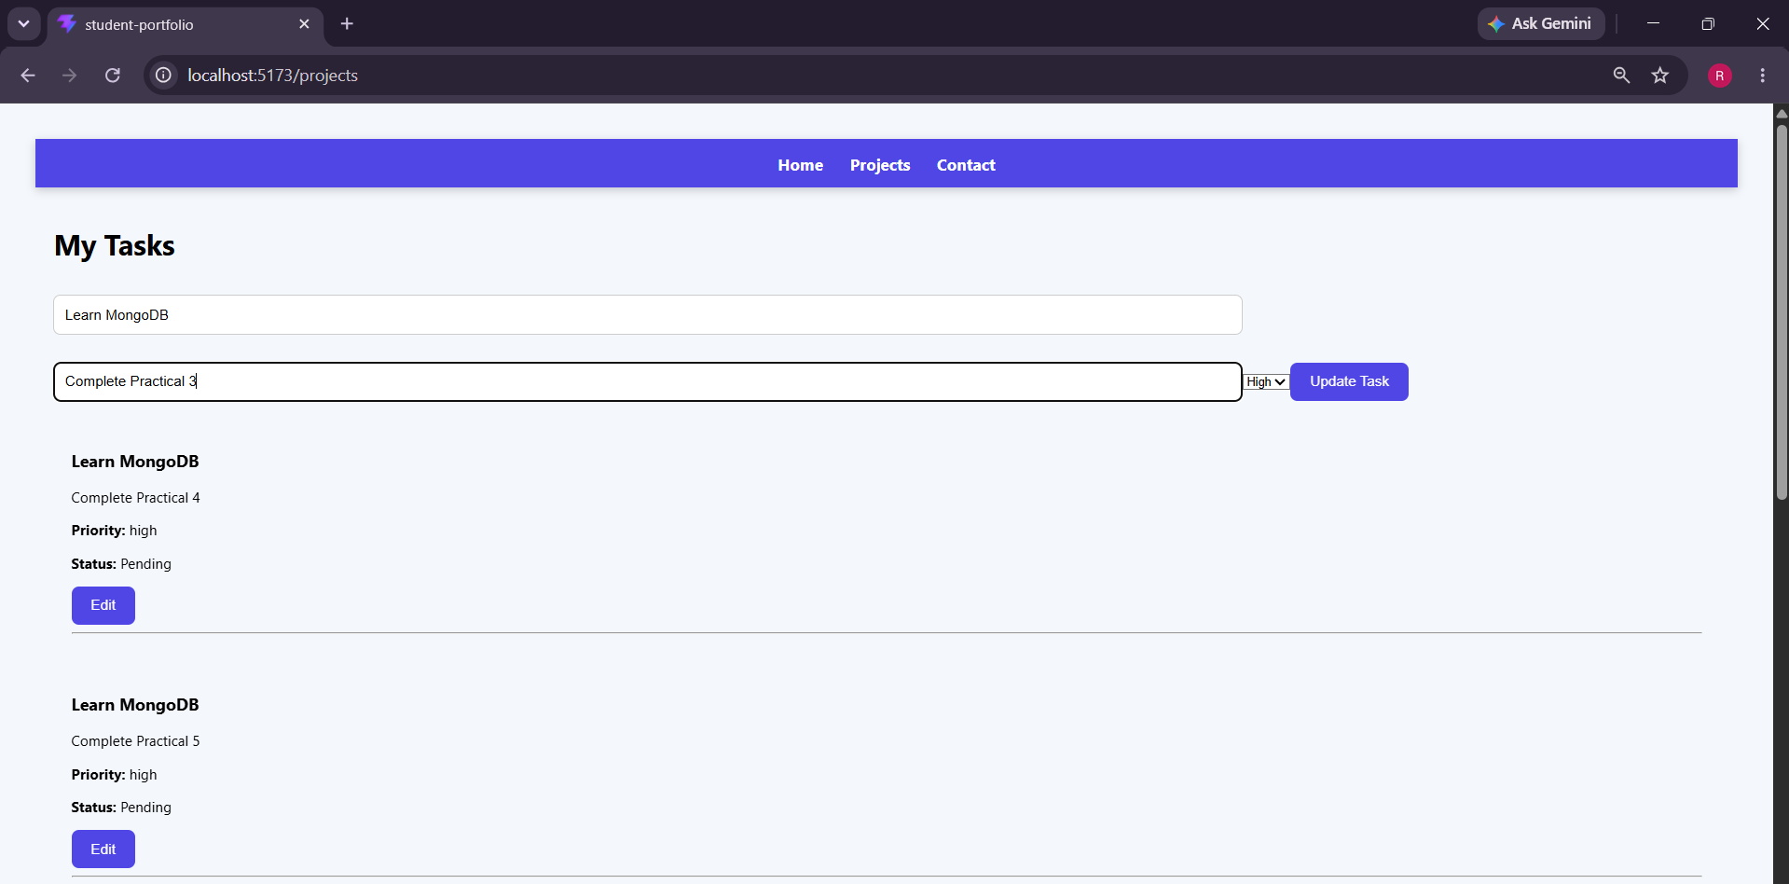
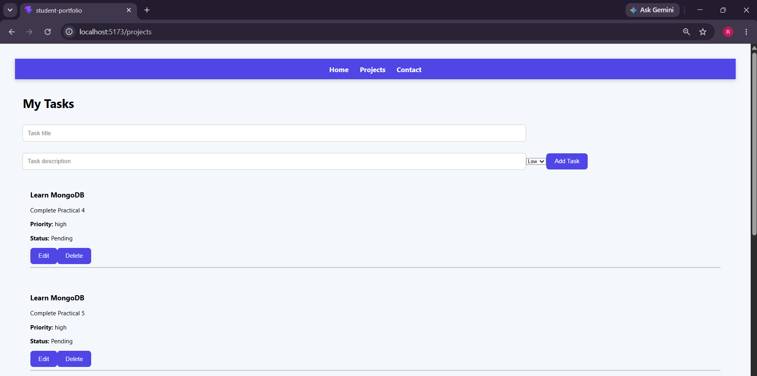

- Git hub Repo Link:
https://github.com/riyakakkad/AWDF.git

