PRACTICAL-7
Problem Statement:
• Add user registration and login functionality to the Task Management
application.
• Hash passwords using bcrypt before saving the User document to
MongoDB.
• Implement JWT token generat
ion on successful login, with a
reasonable expiry (e.g., 1 hour).
• Protect all task routes using an authentication middleware that verifies
the JWT.
• Add server-side input validation that rejects malformed requests (e.g.,
missing title) before they reach the database.

Implementation & Output:
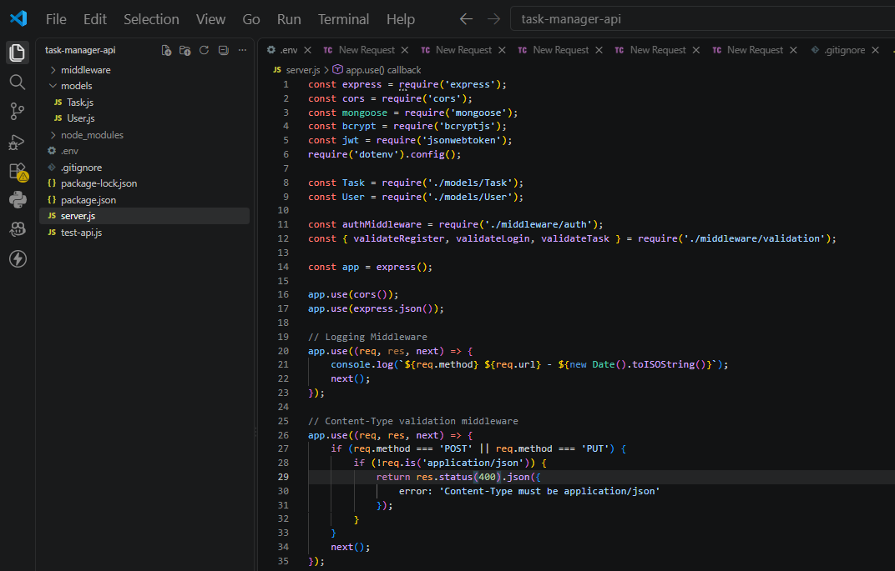
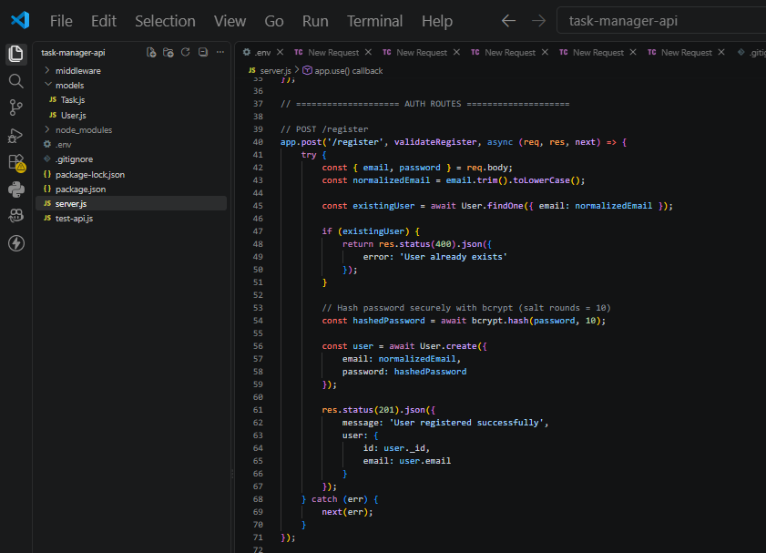
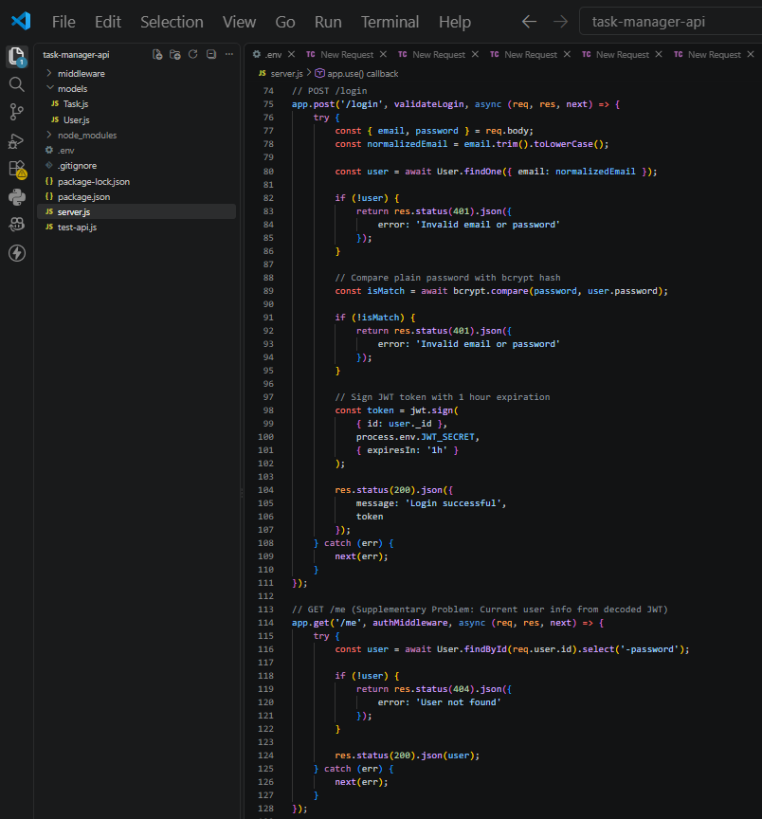
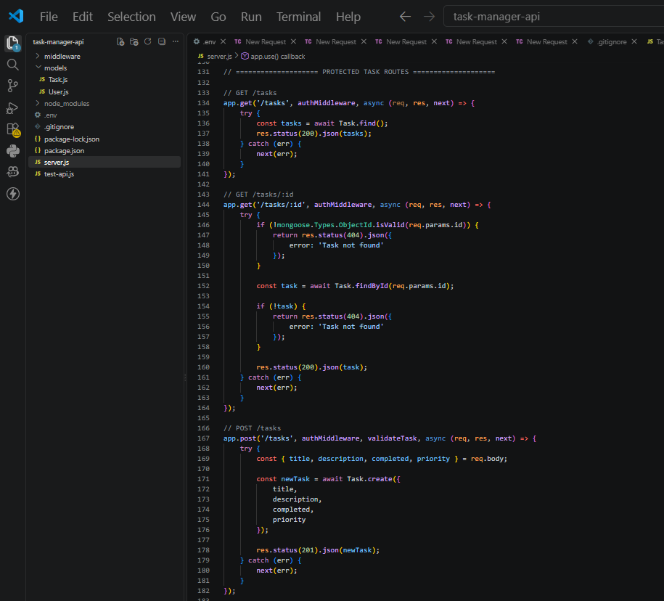
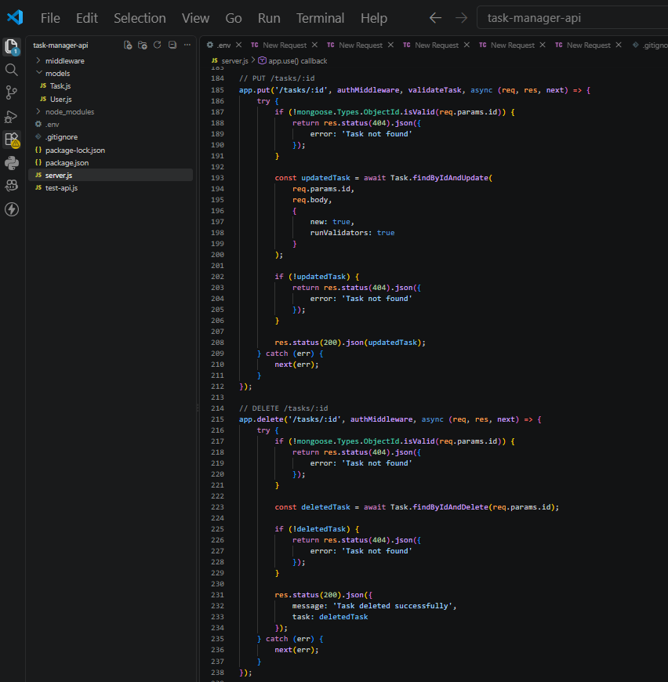
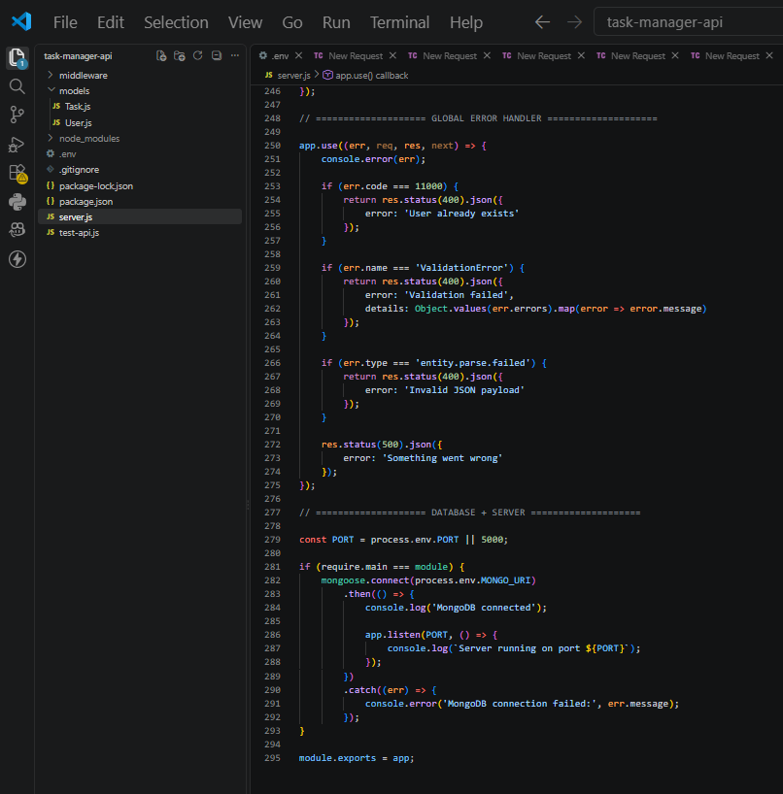
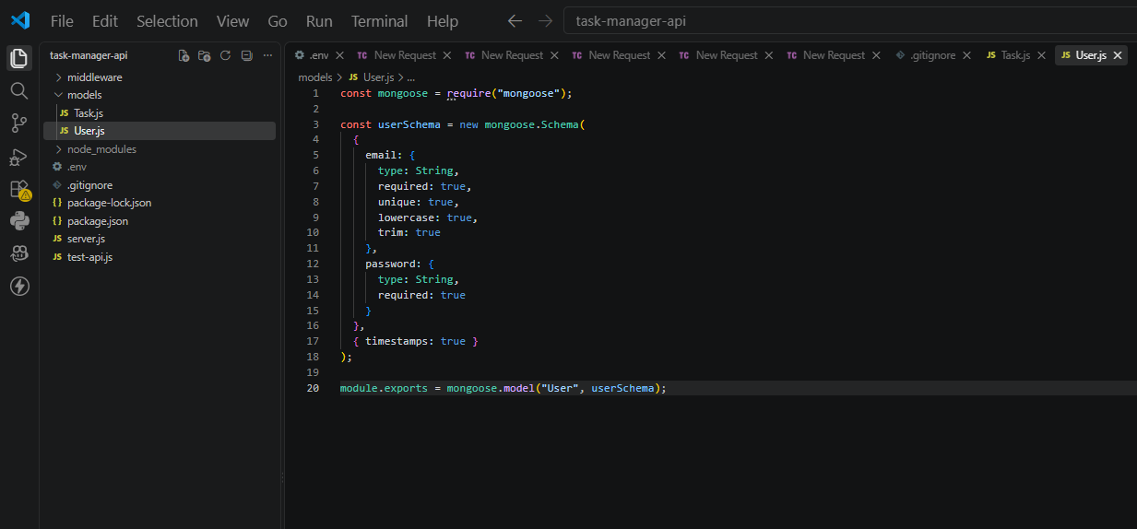
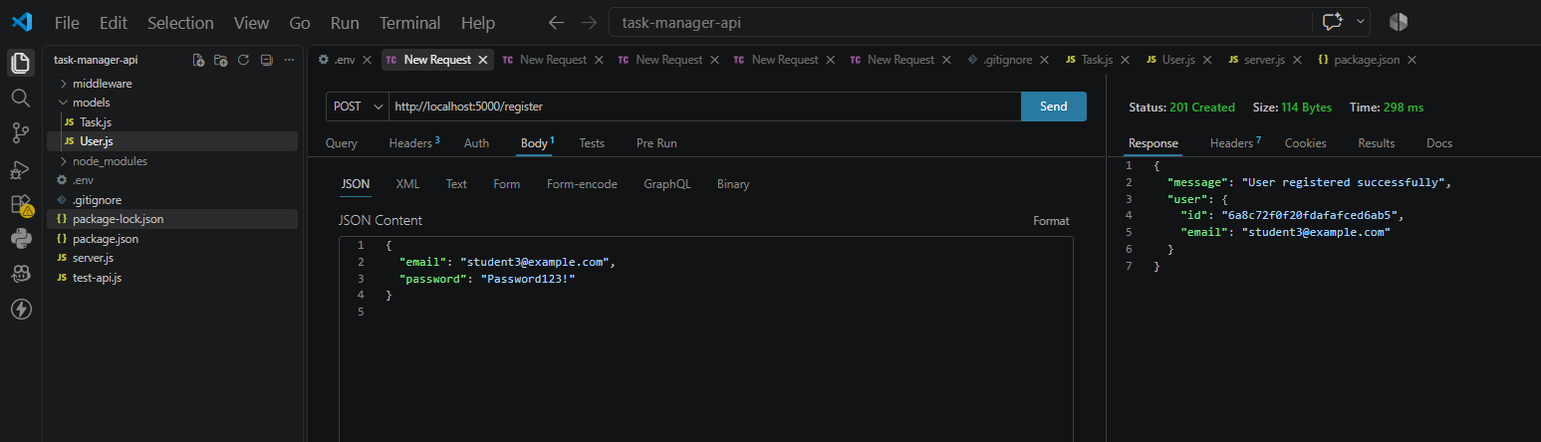
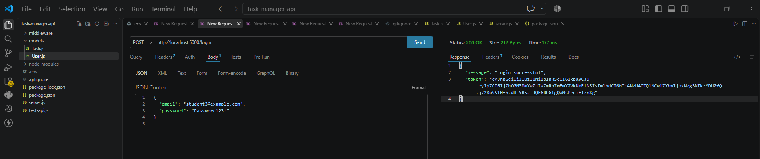
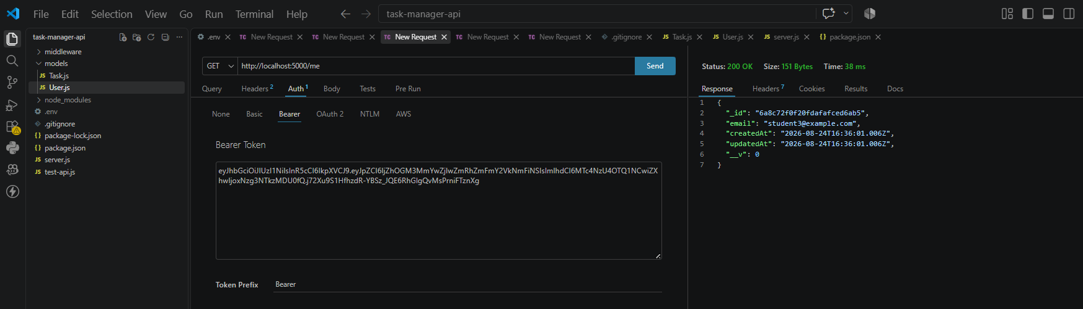
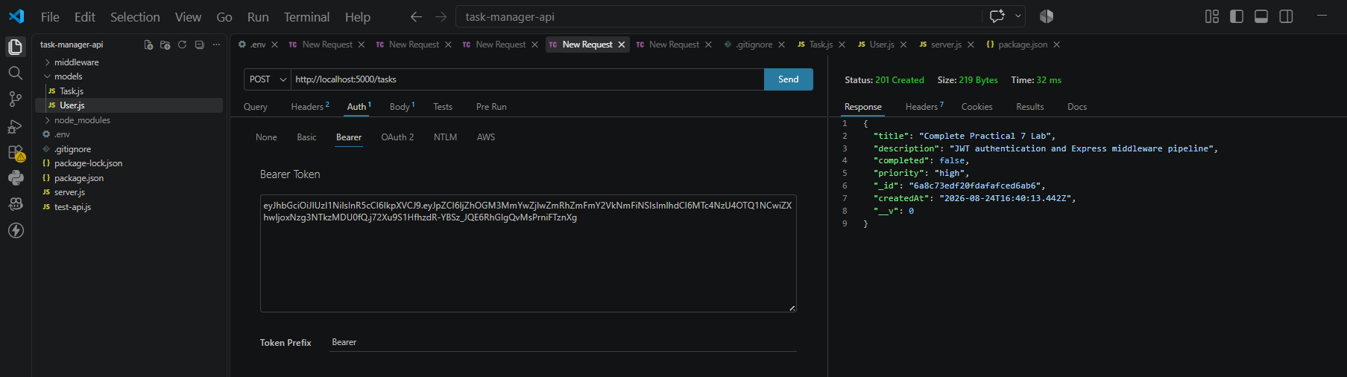
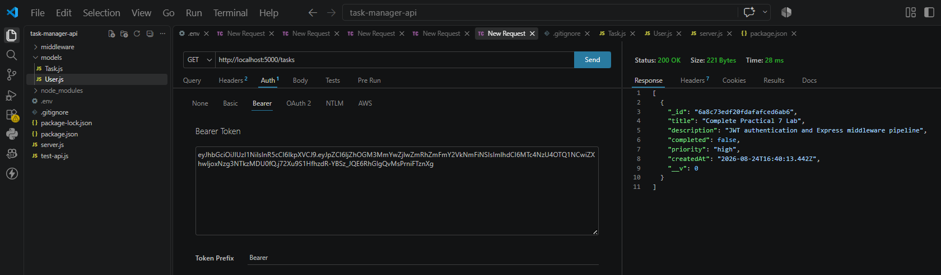

- Git hub Repo Link:
https://github.com/riyakakkad/task-manager-api-24it036.git

