PRACTICAL-8

Problem Statement:
• Optimize the React frontend of the Task Management application by
implementing lazy loading for route-based components.
• Apply React.lazy() and Suspense to at least the Projects and Contact
routes (or equivalent route-based components).
• Provide a meaningful fallback UI while a lazy-loaded chunk is loading.
• Measure and compare bundle size and load time before and after
optimization using browser developer tools.
• Document the before/after comparison with screenshots or recorded
values.

Implementation & Output:
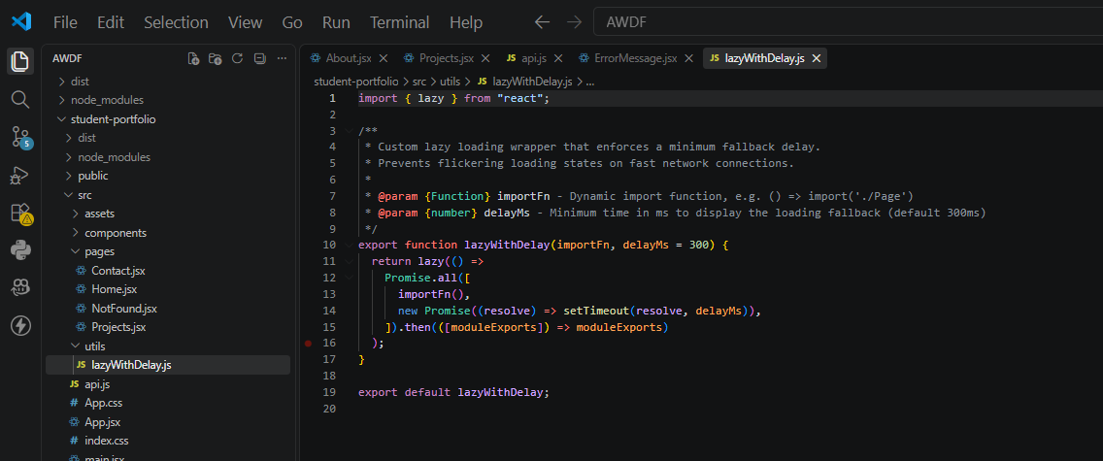
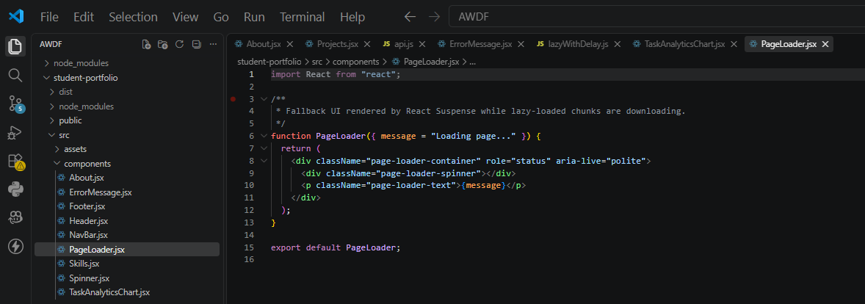
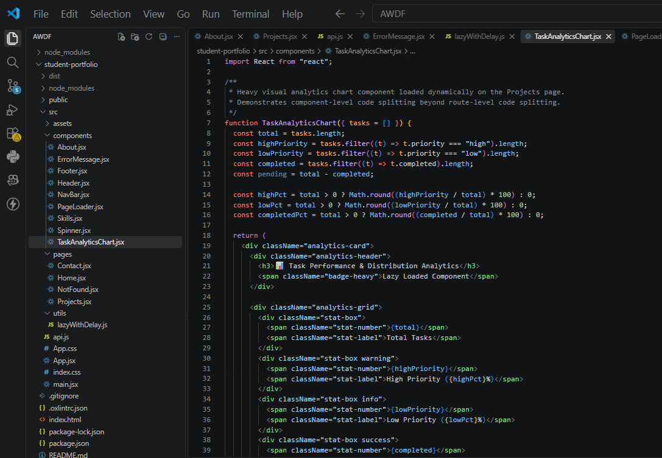
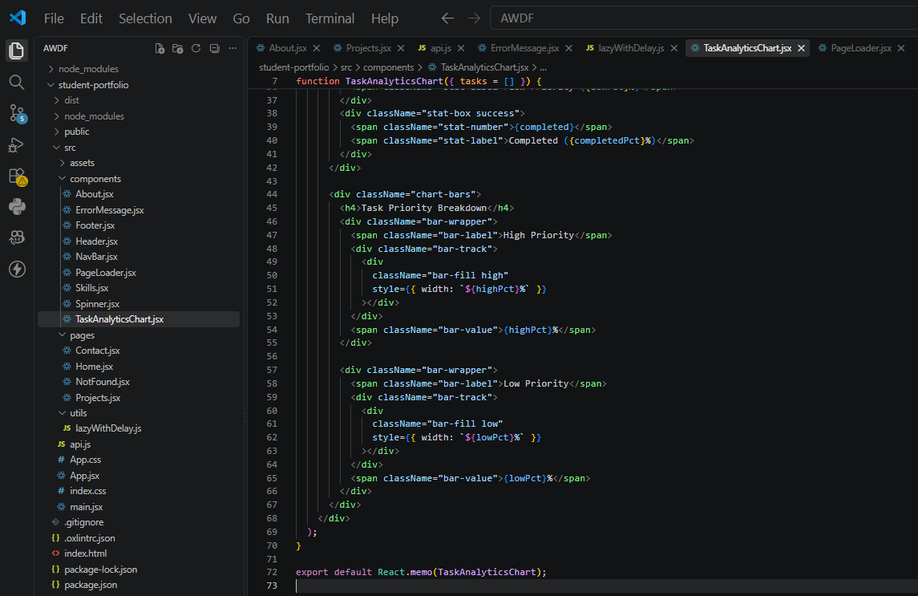
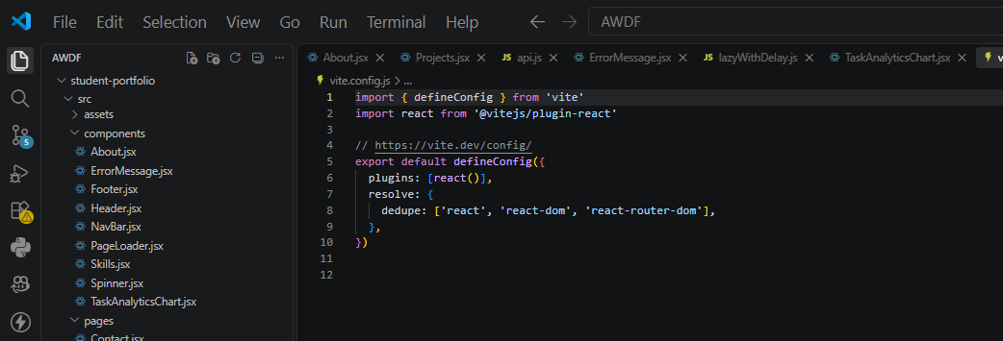
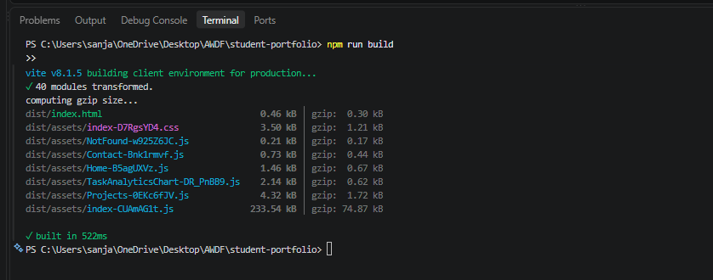
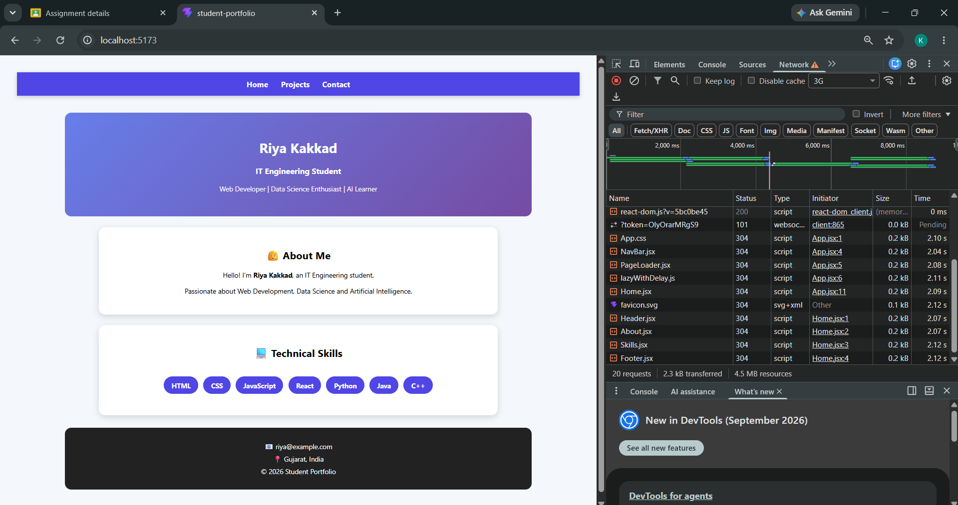
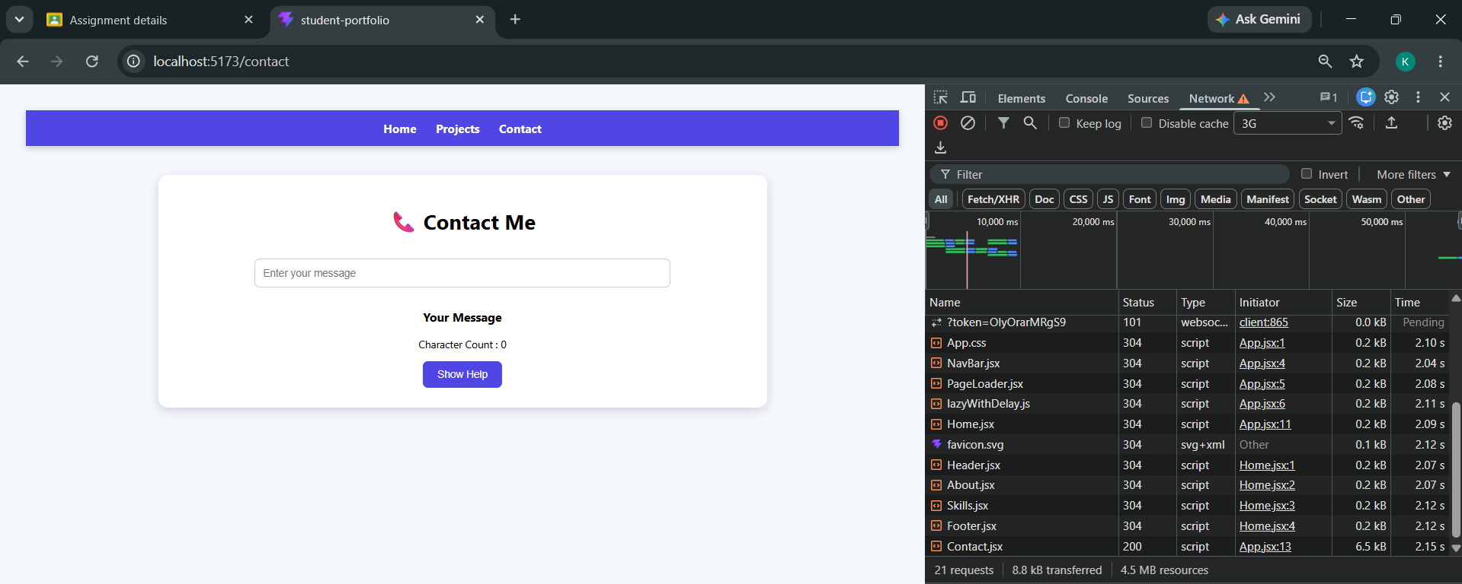
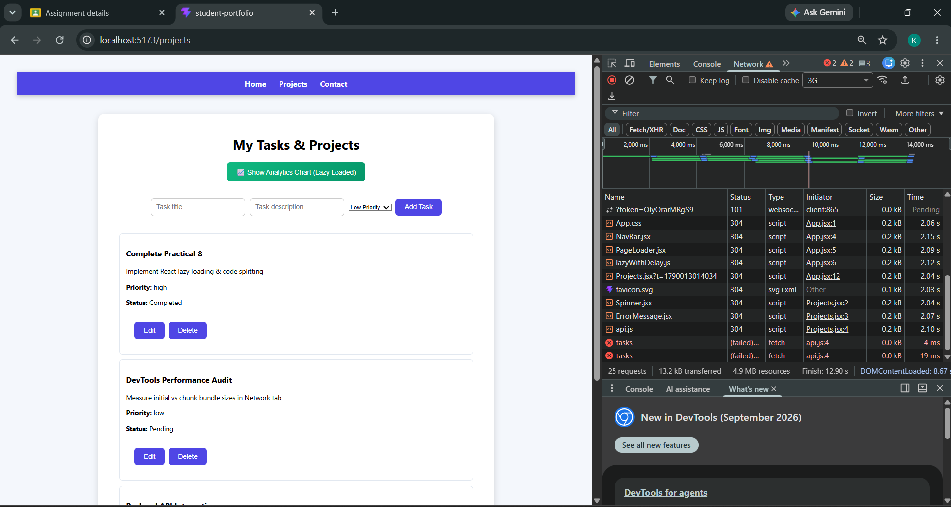
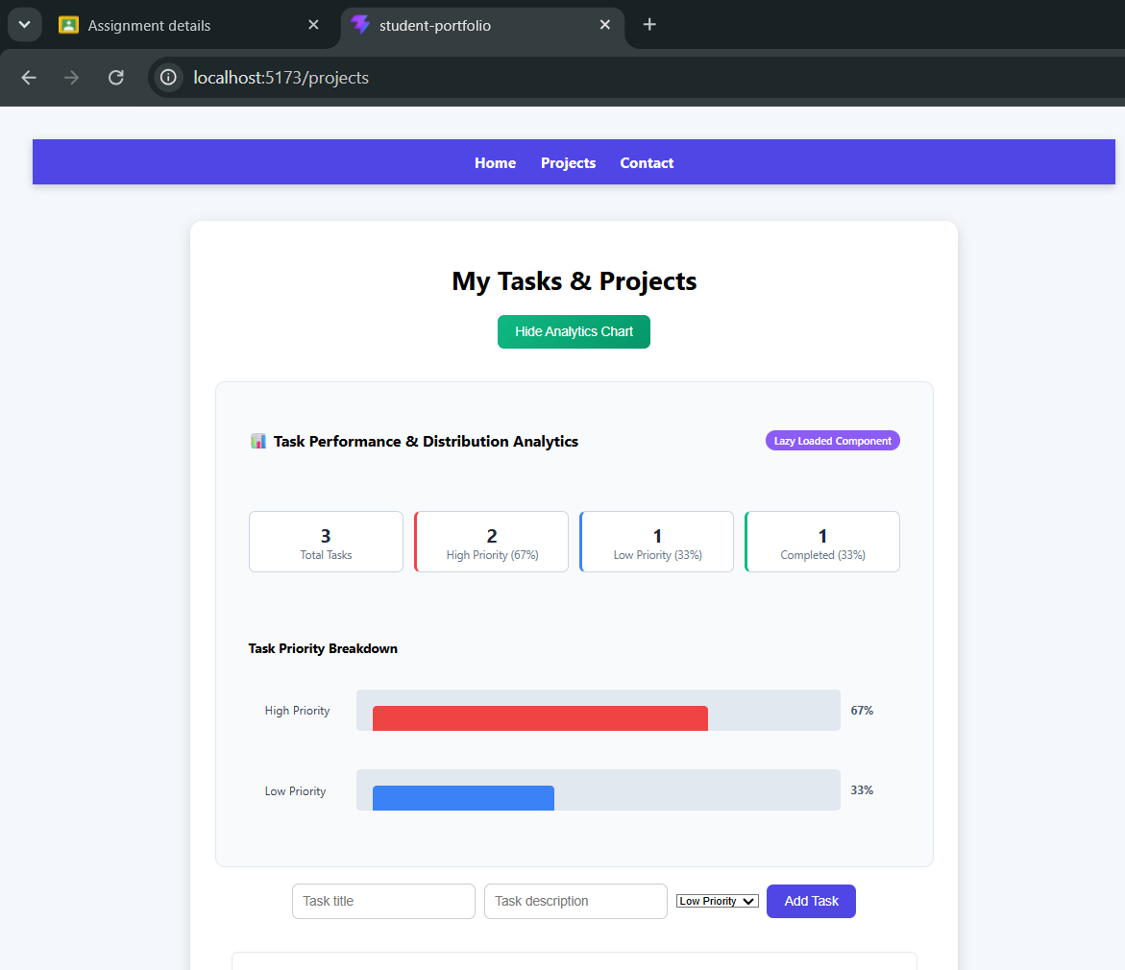
- Git hub Repo Link:
https://github.com/riyakakkad/AWDF.git

