PRACTICAL-10

Problem Statement:
• Implement asynchronous background processing using Node.js's built-in EventEmitter.
• Create a custom event for newly created tasks.
• Decouple notification processing from the main API request.
• Demonstrate that the API response can be sent before the background notification handler completes.
• Understand the practical working of Node.js event-driven architecture.
• Implement additional task-deleted and error events.

Implementation & Output:
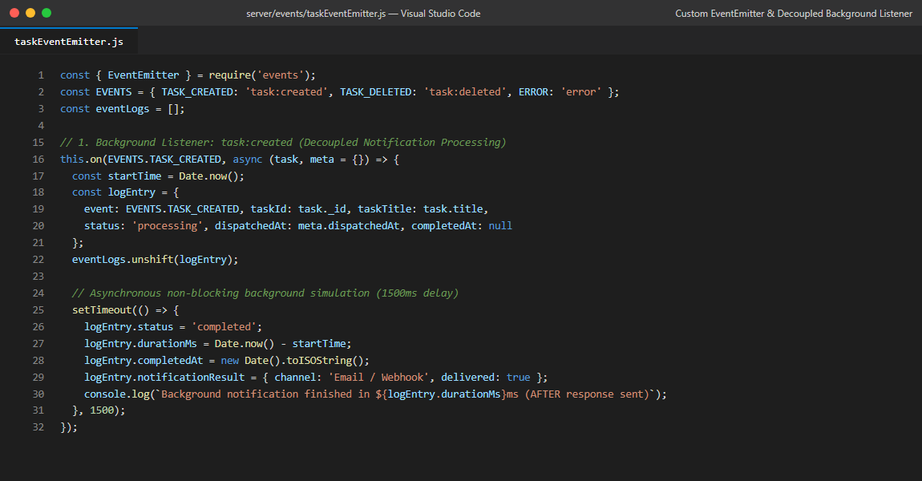
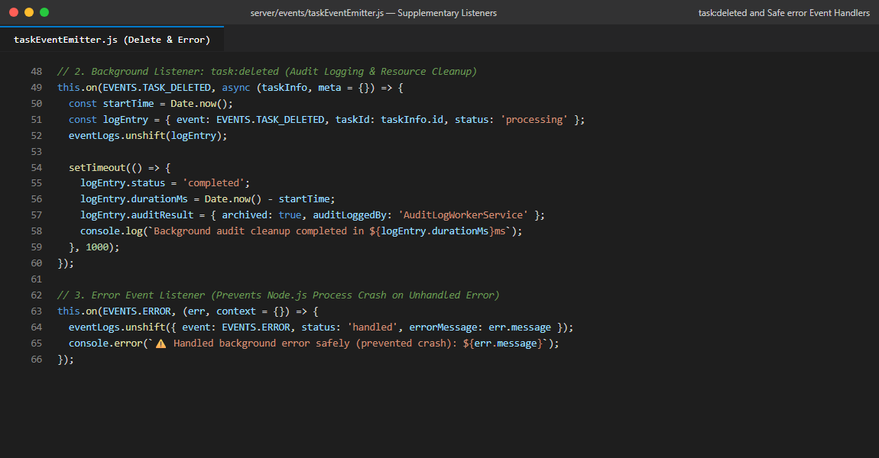
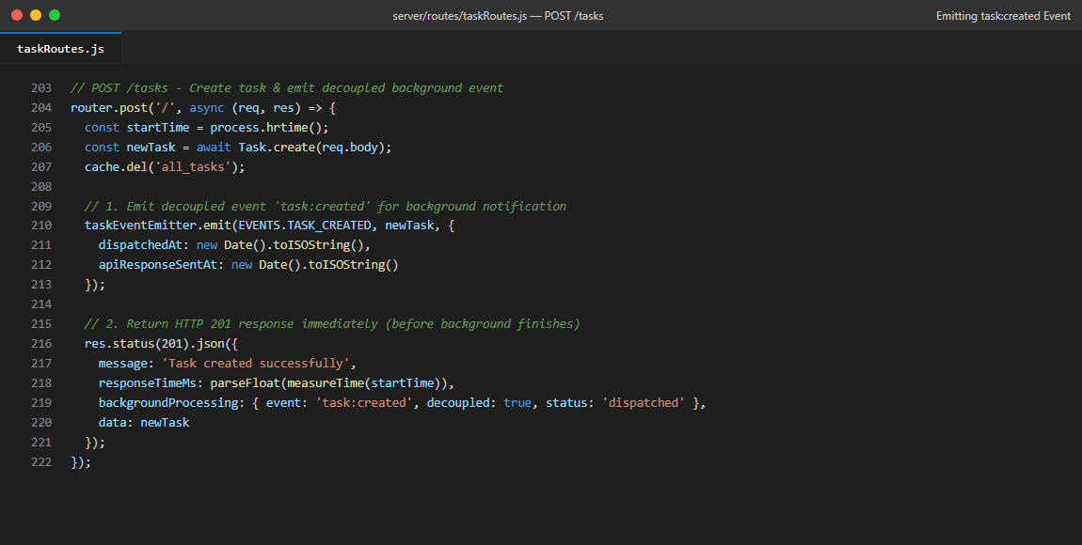
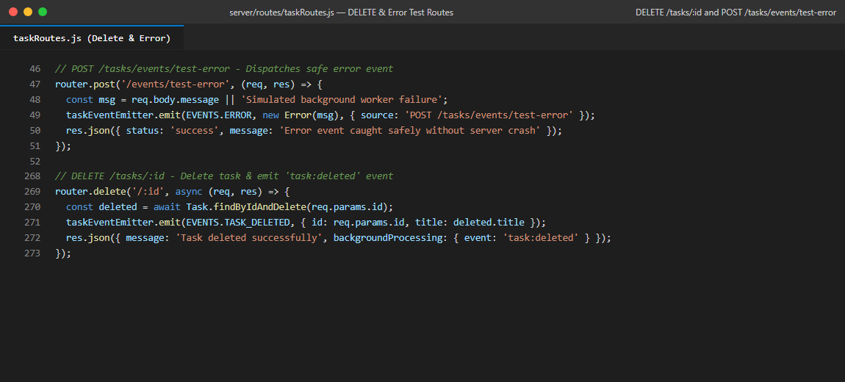
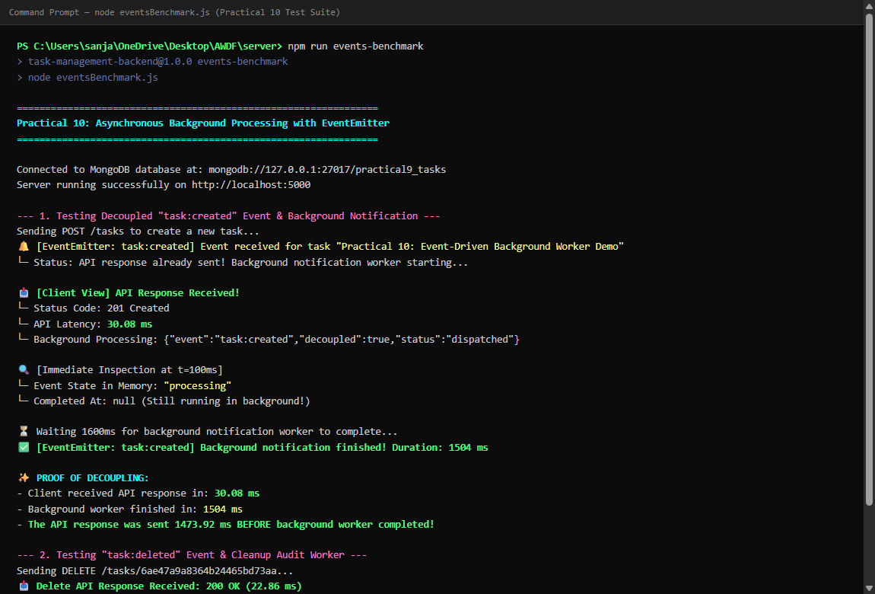
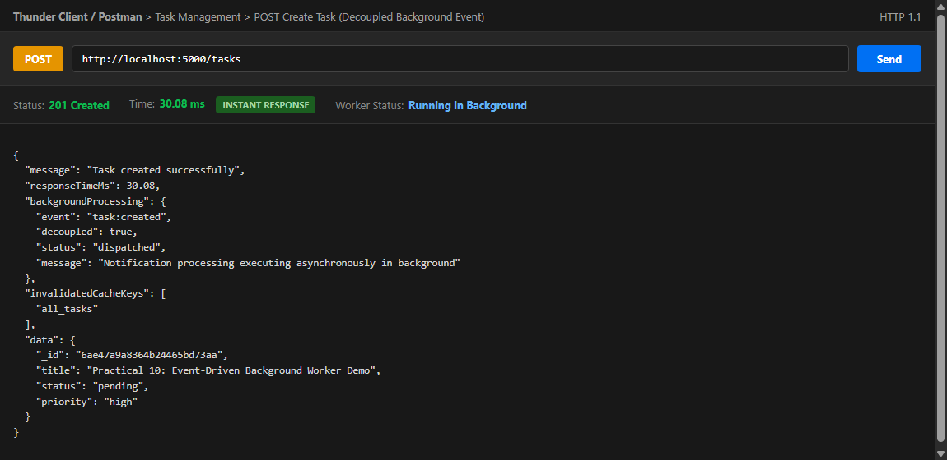
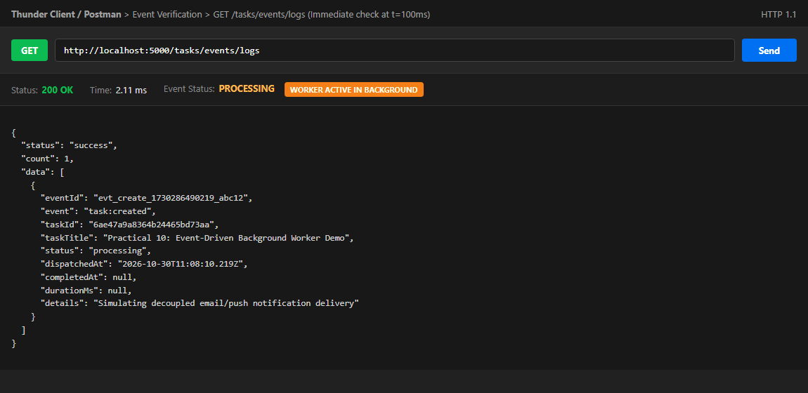
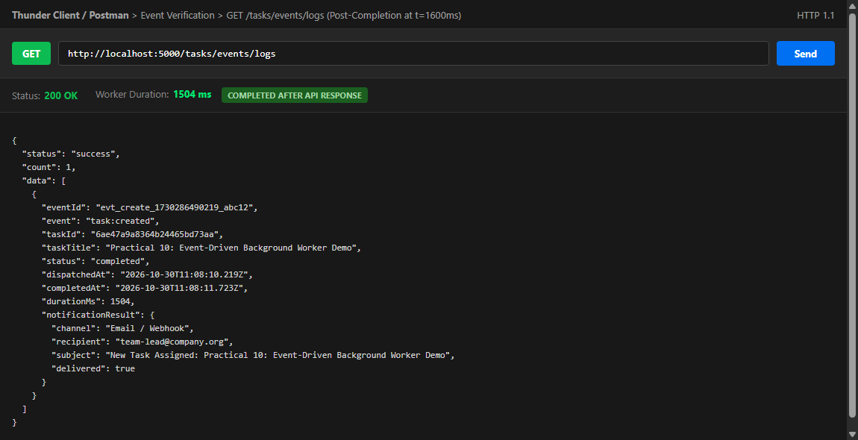
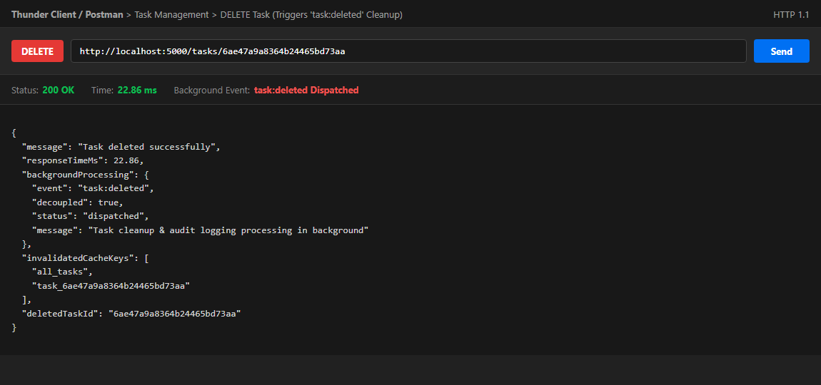
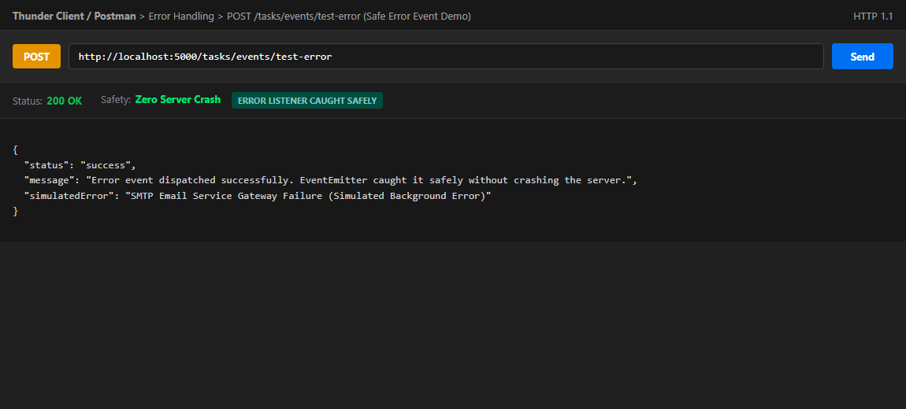

Git hub Repo Link:
https://github.com/riyakakkad/AWDF.git

