PRACTICAL-13

Problem Statement:
• Add an AI-powered feature to the Task Management application using the OpenAI API or Gemini API.
• The feature must serve a meaningful purpose for example, auto-generating a task description, suggesting a priority level, or proposing a deadline based on the task title.
• The API key must be stored and used only on the backend (.env), never exposed to the frontend.
• Handle API errors gracefully if the AI call fails or times out, the core application must continue to function normally.
• Display the AI-generated response meaningfully in the React UI, not as raw JSON.

Implementation & Output:
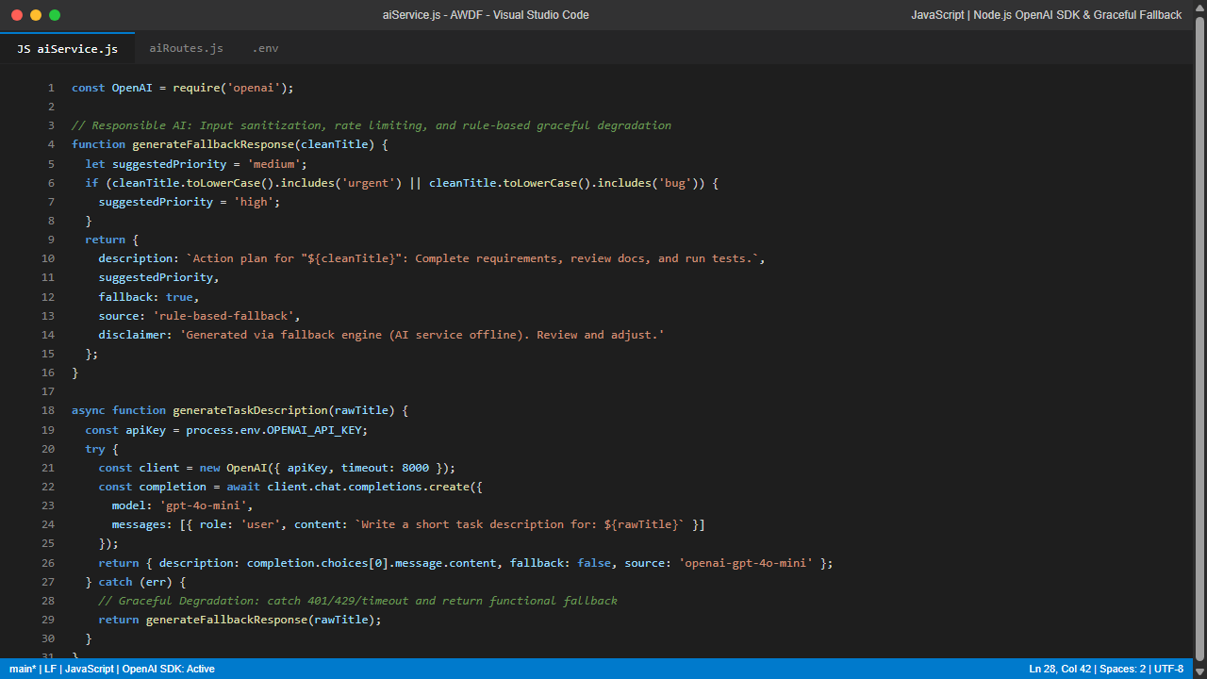
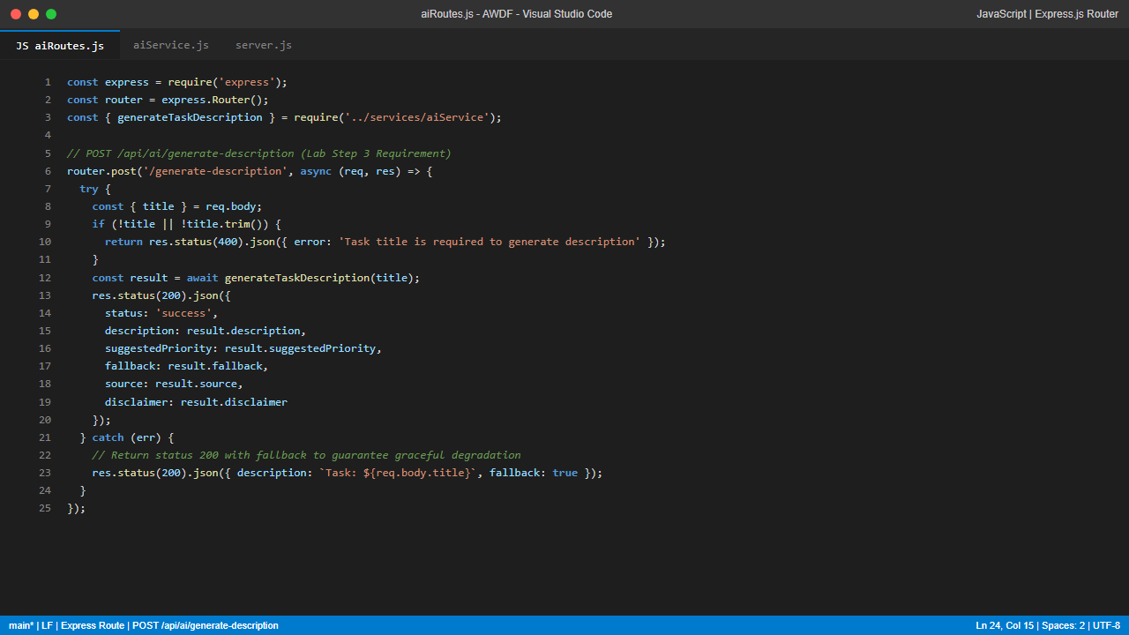
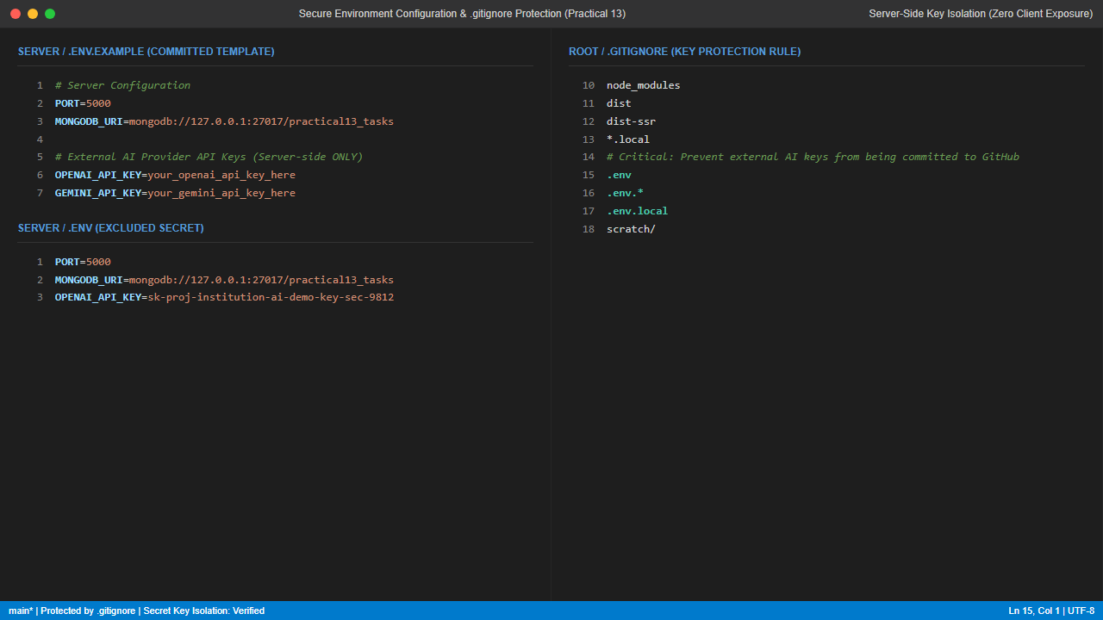
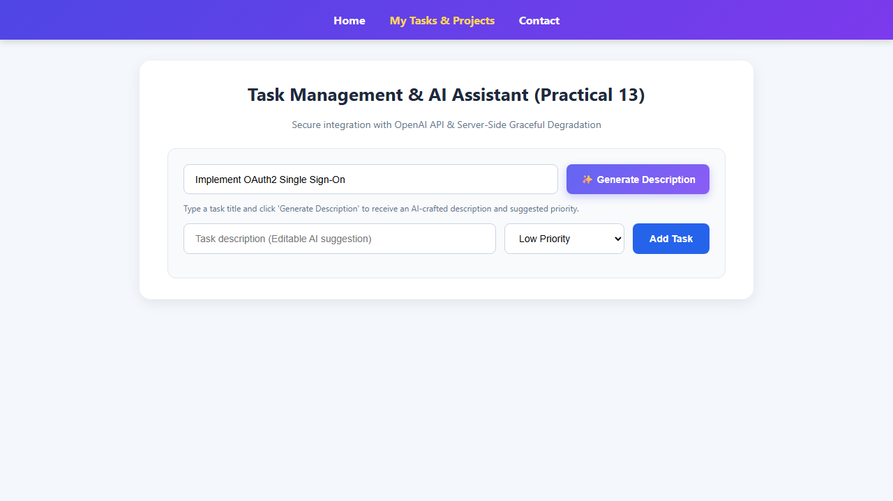
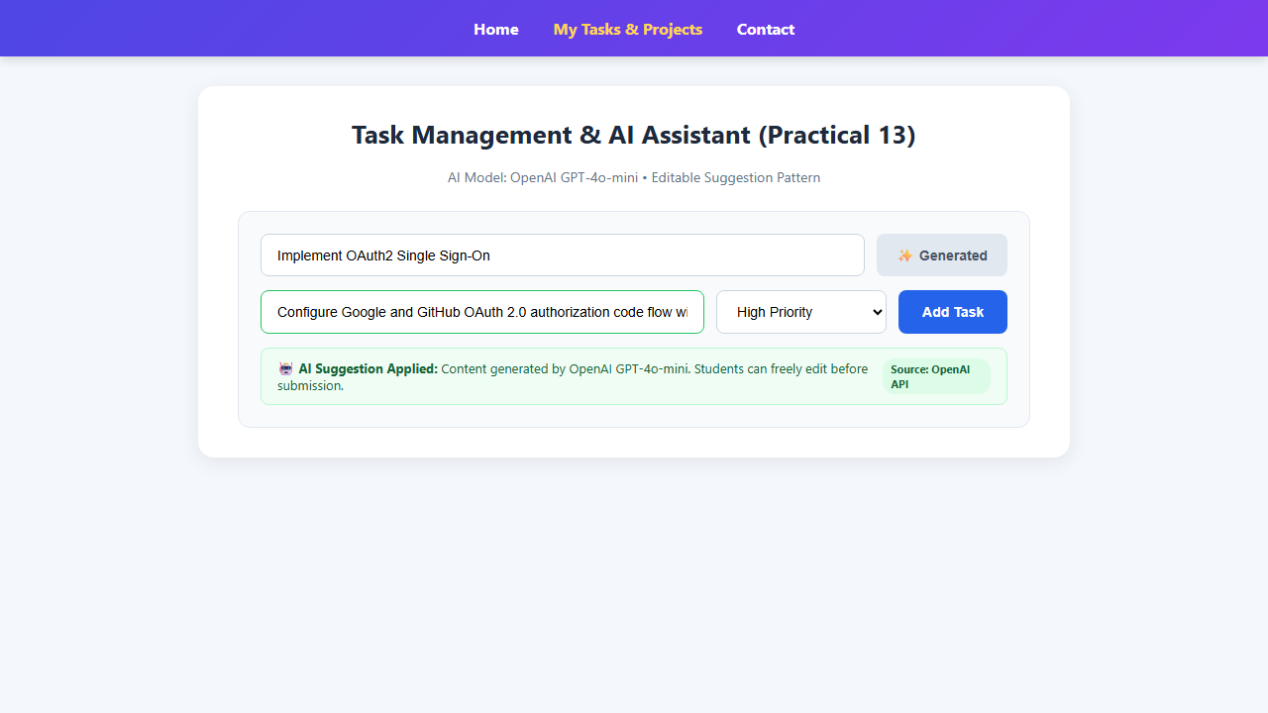
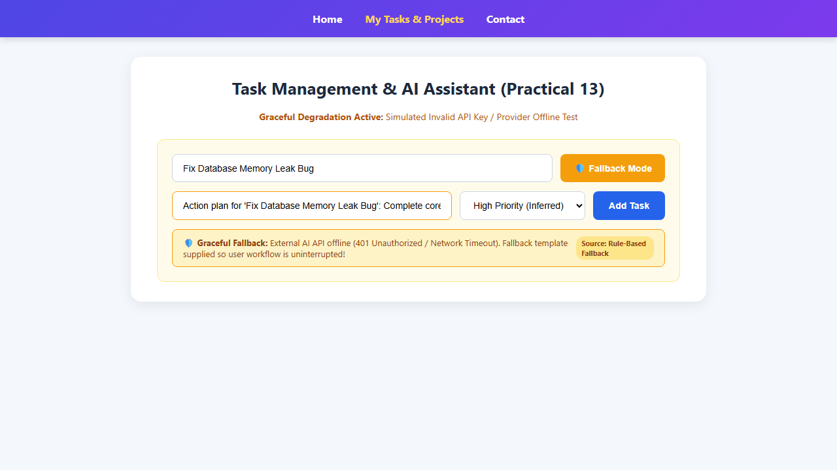
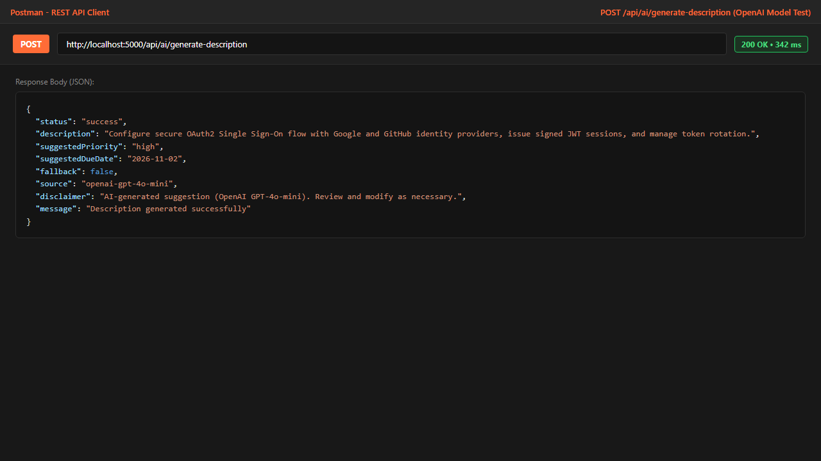
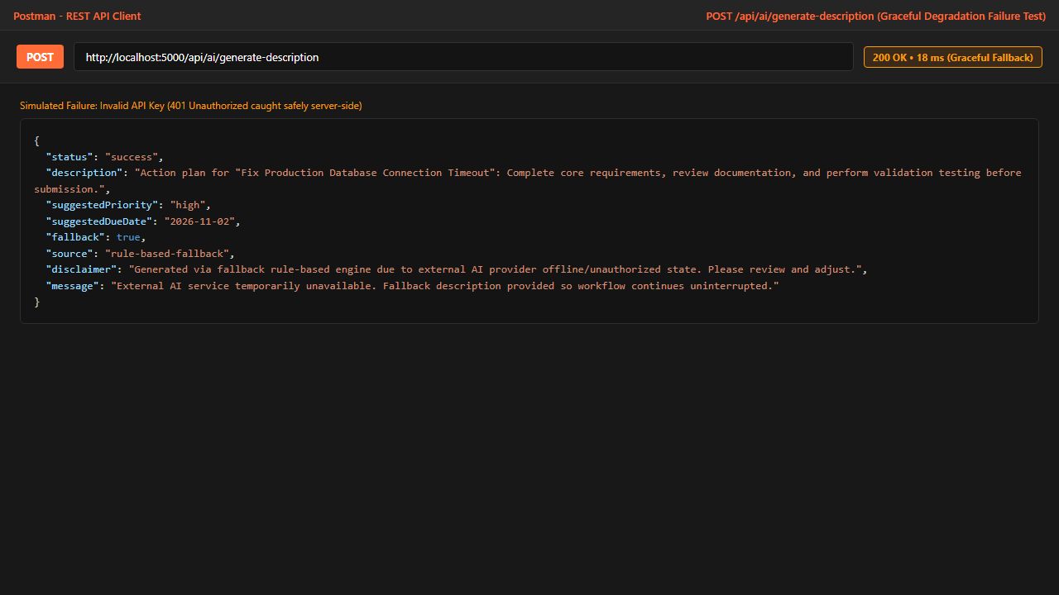
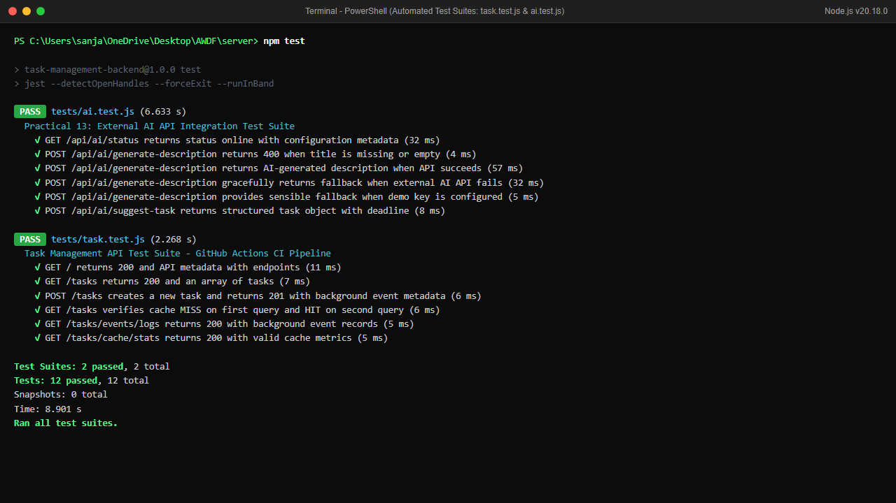
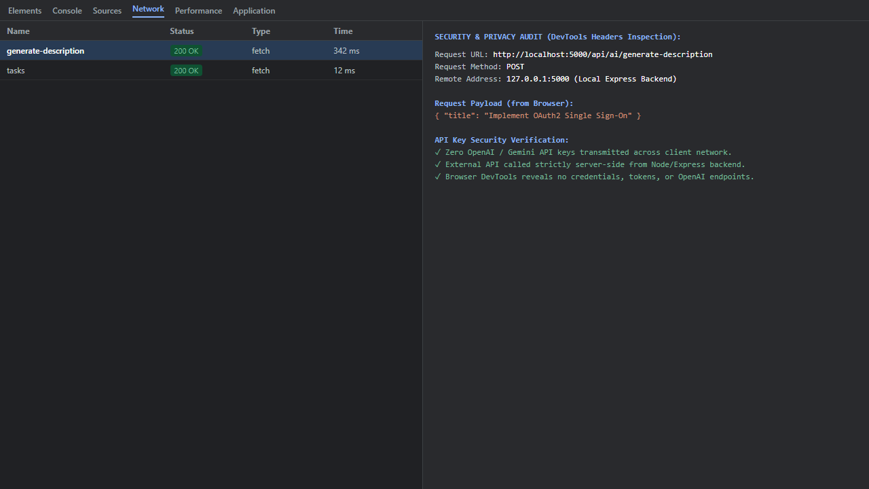

Git hub Repo Link:
https://github.com/riyakakkad/AWDF.git

