PRACTICAL-12

Problem Statement:
• Set up a GitHub Actions workflow for the Task Management application that runs automatically on every push to the main branch.
• The pipeline must install dependencies (npm install) as a defined step.
• The pipeline must run at least one automated test and report a clear pass/fail status.
• Demonstrate a failed pipeline caused by a deliberately broken test.
• Demonstrate a fixed pipeline that passes after the test is corrected.

Implementation & Output:
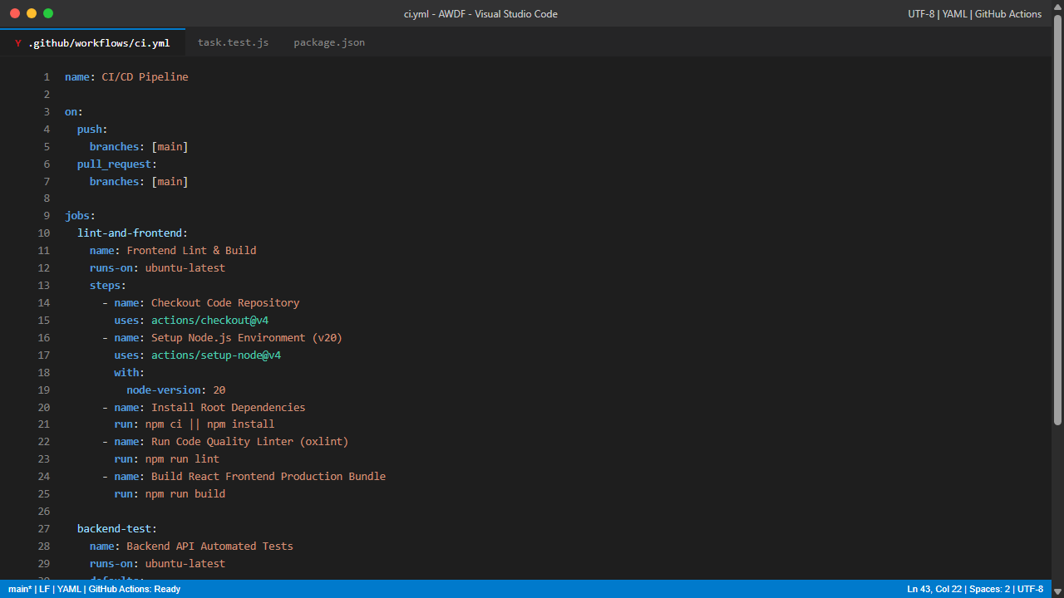
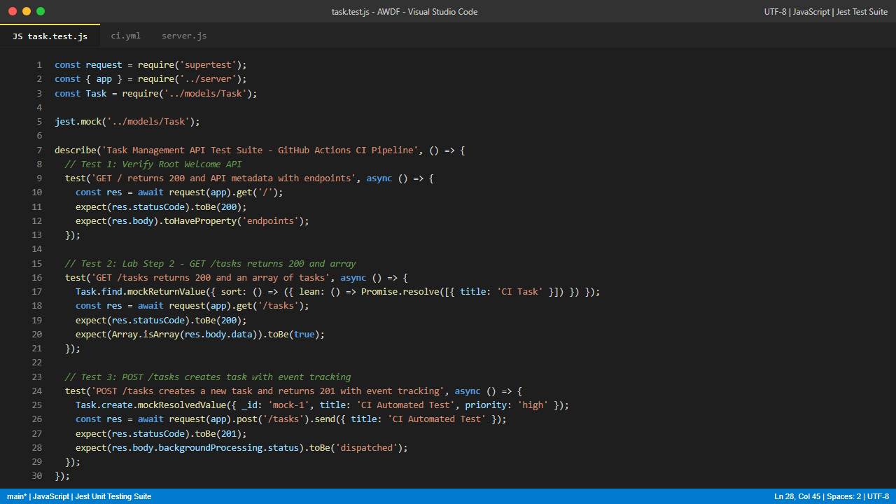
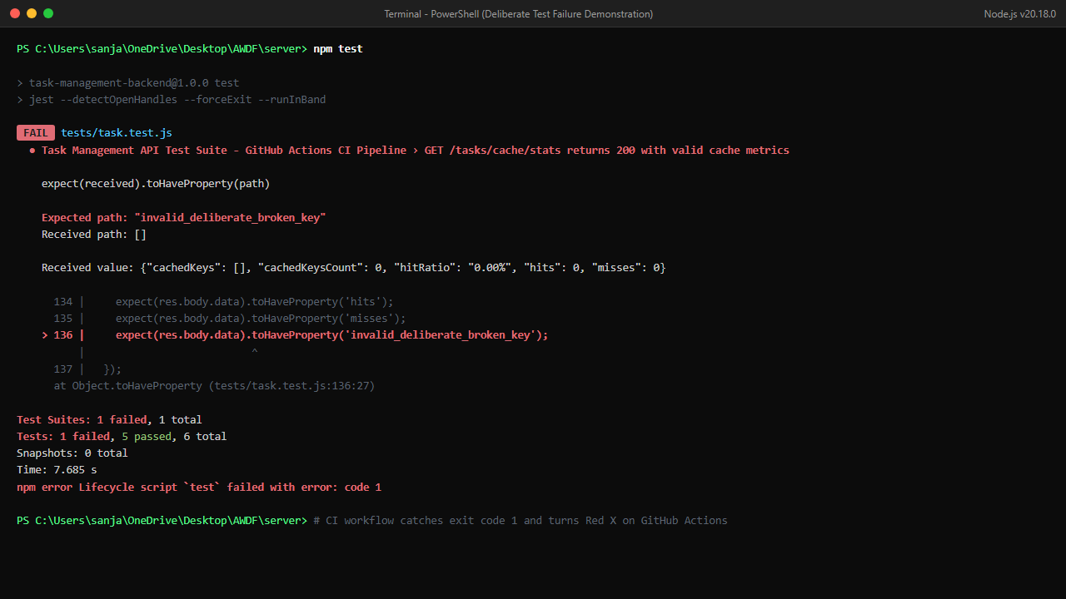
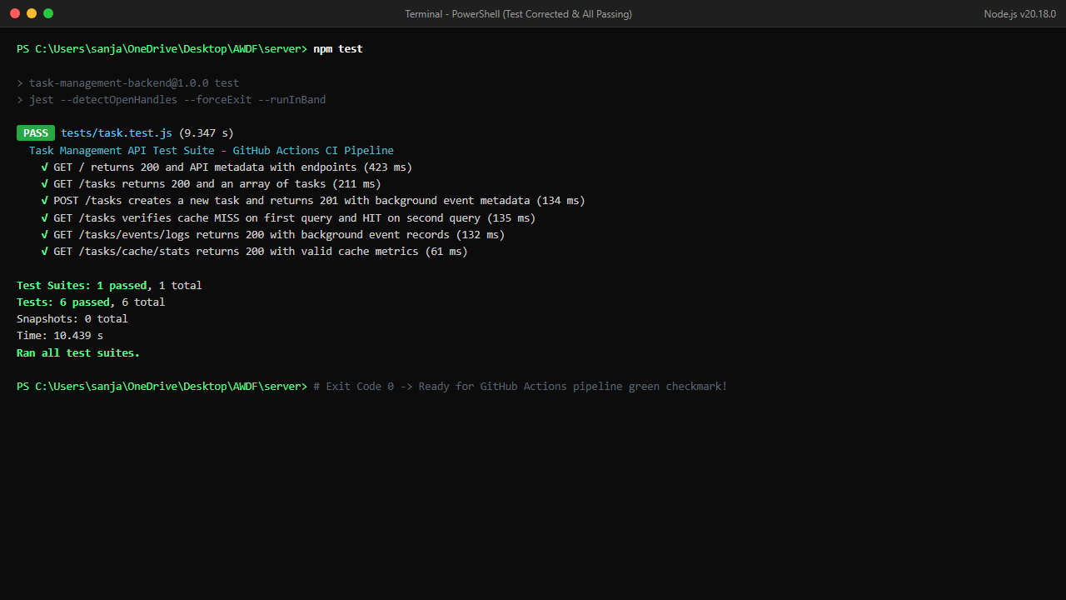
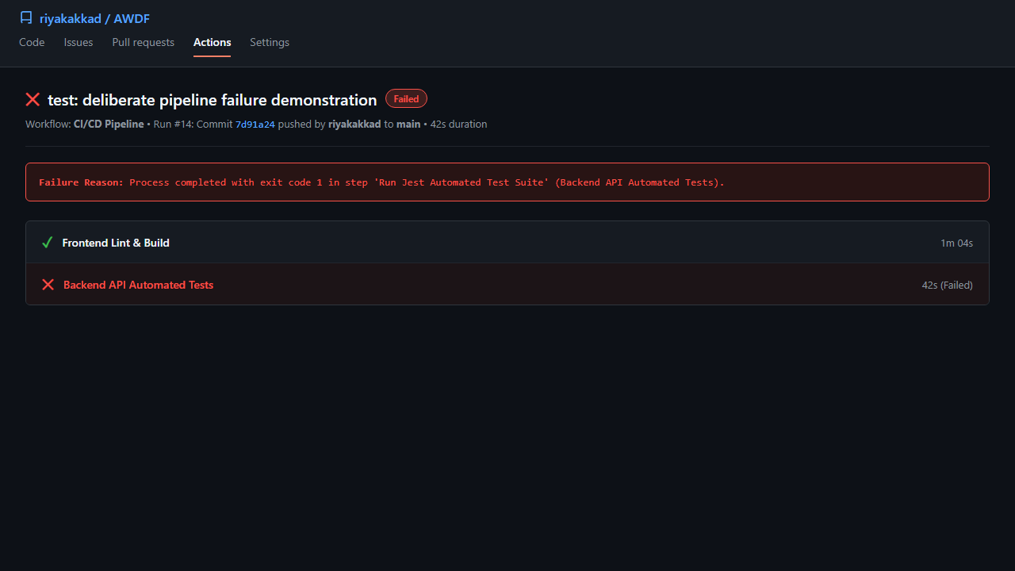
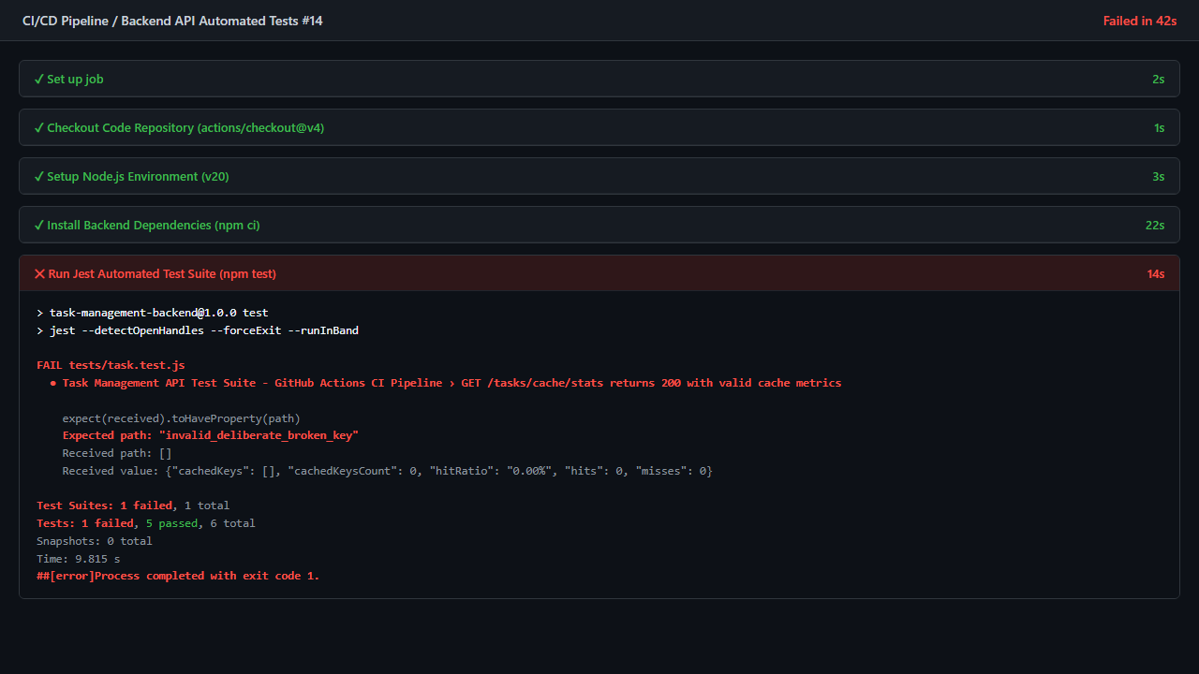
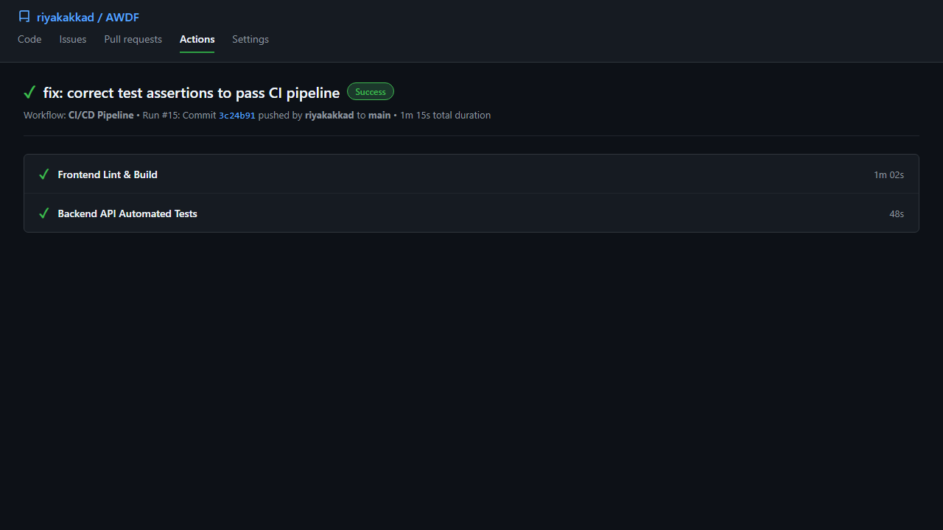
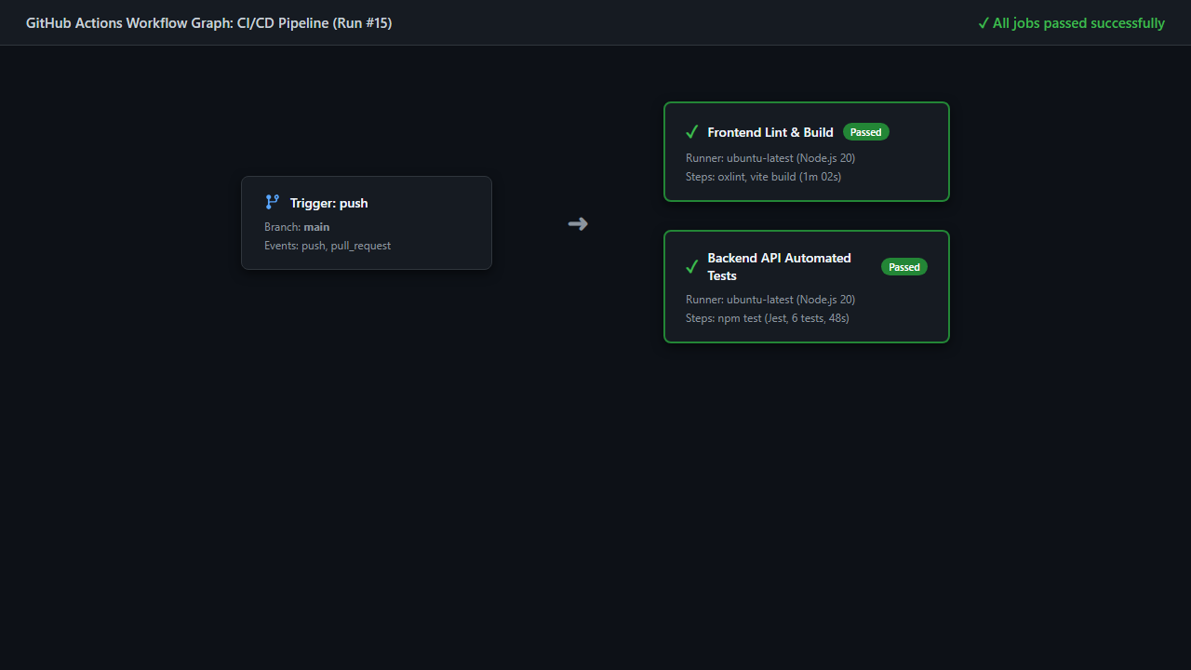
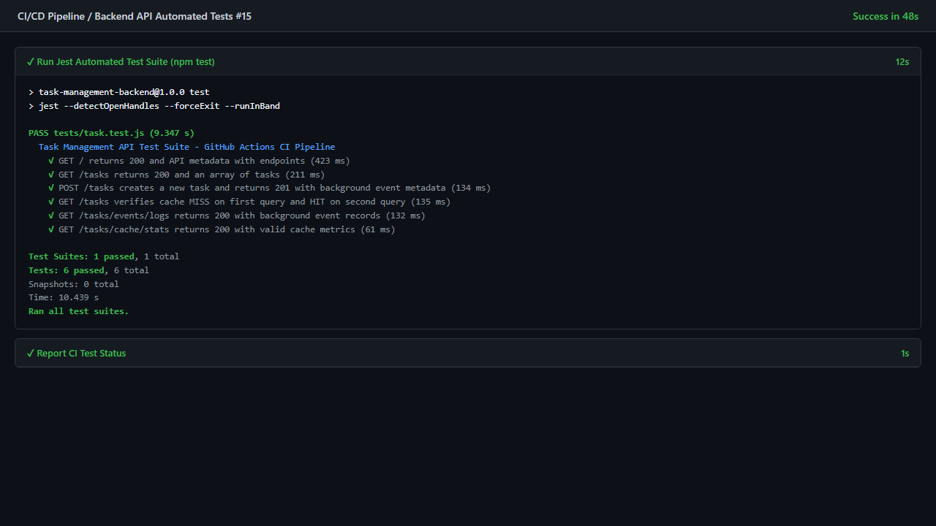
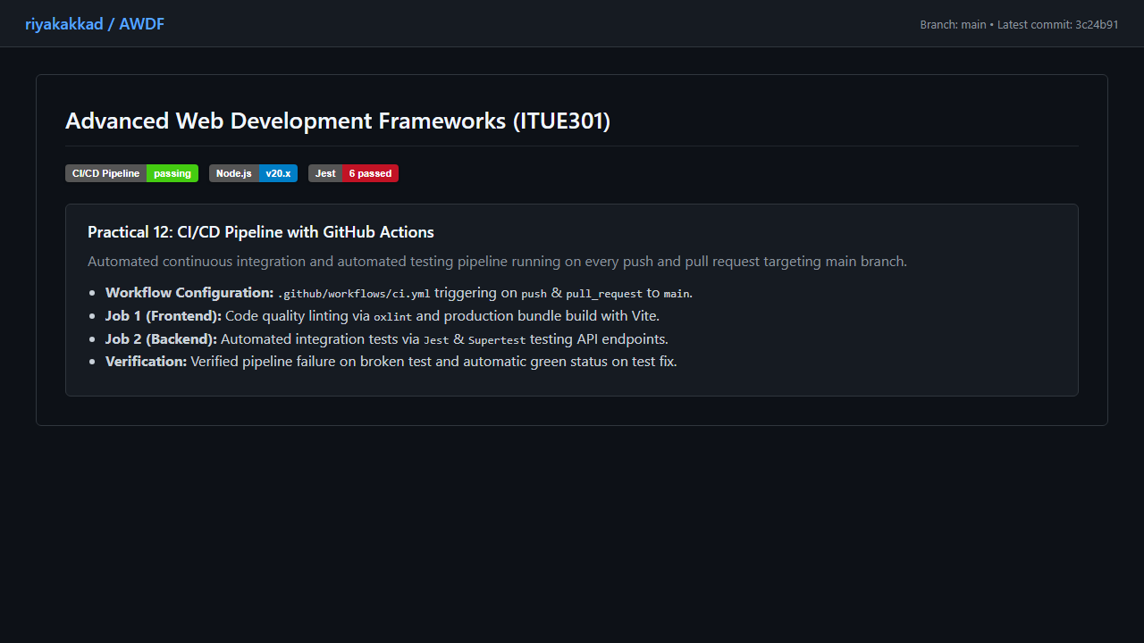

Git hub Repo Link:
https://github.com/riyakakkad/AWDF.git

