PRACTICAL-9

Problem Statement:
• Add in-memory caching to the Task Management backend using node-cache.
• Cache the response of GET /tasks (all tasks) with a reasonable TTL (e.g., 60 seconds).
• Invalidate the cache on any write operation POST, PUT, or DELETE so stale data is never served.
• Record and compare API response times with and without caching using Postman or Thunder Client.
• Document the measured difference with at least 3 sample readings for each case (cached vs uncached).

Implementation & Output:
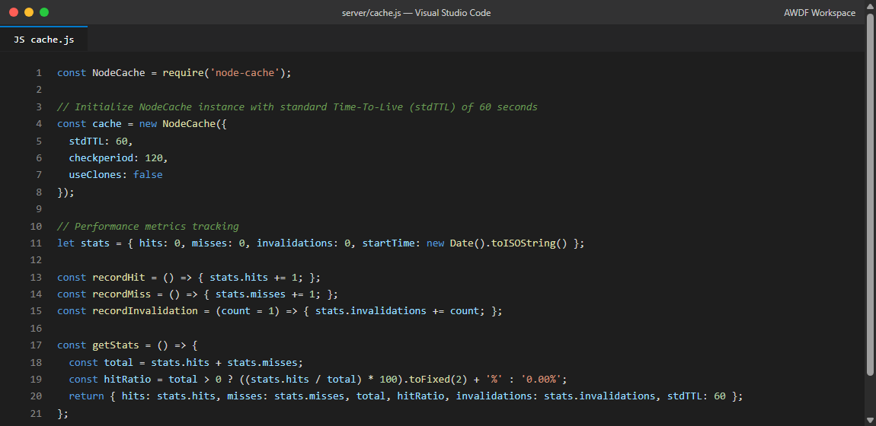
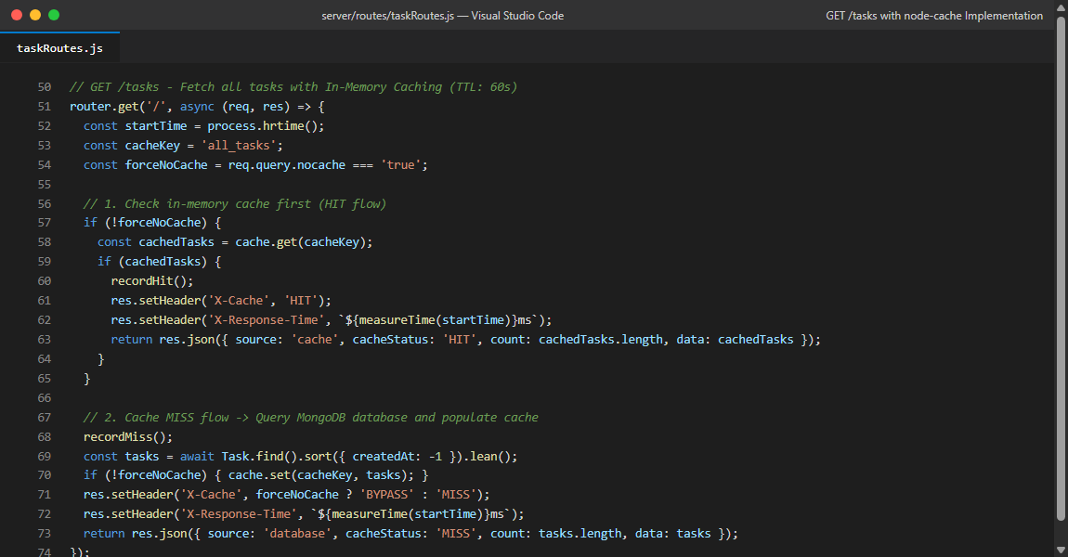
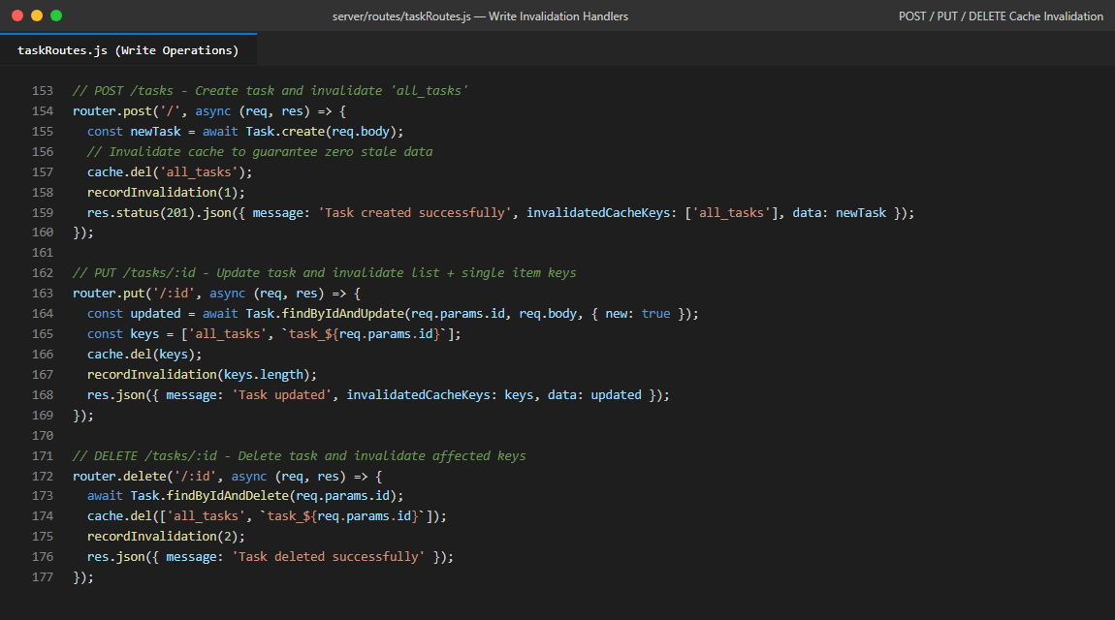
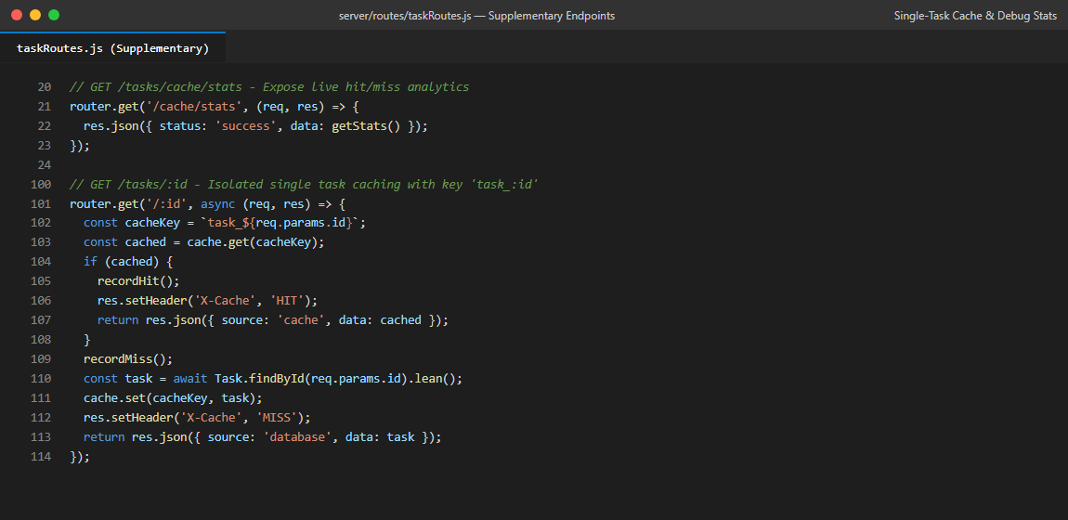
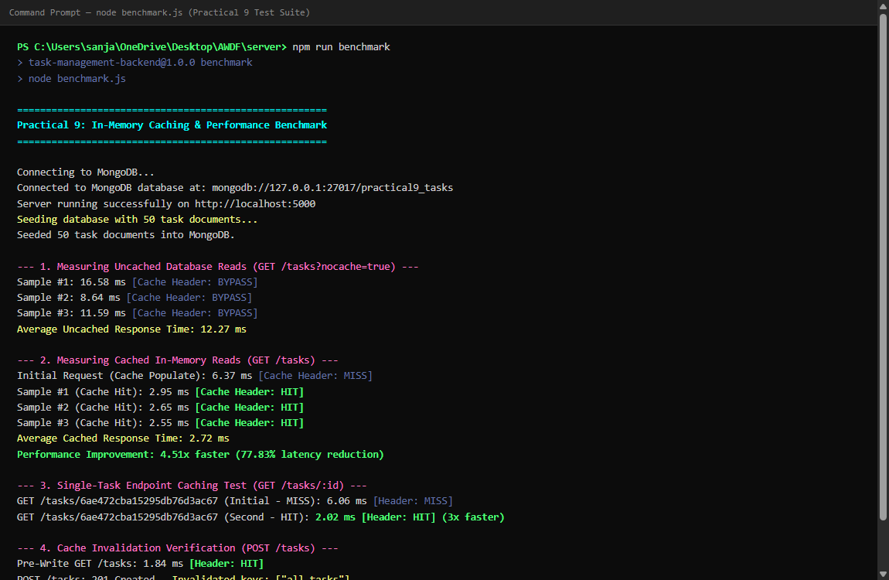
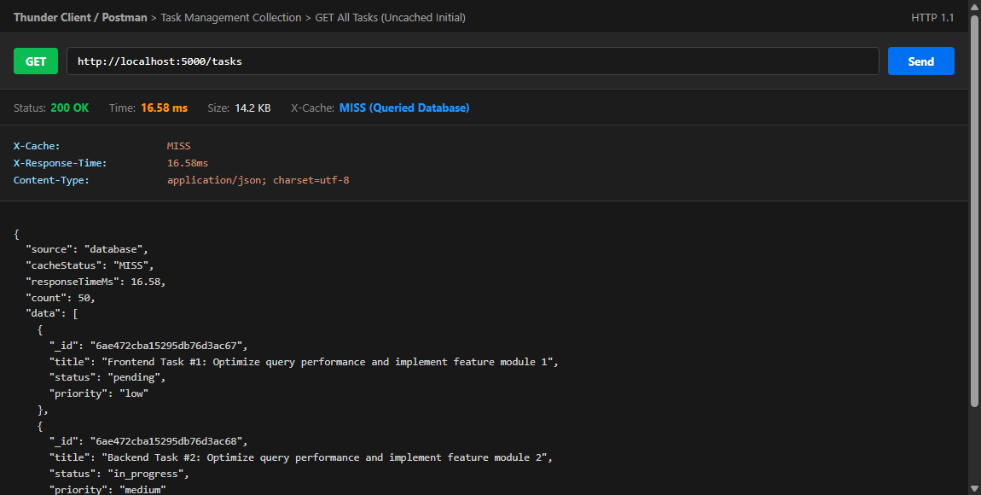
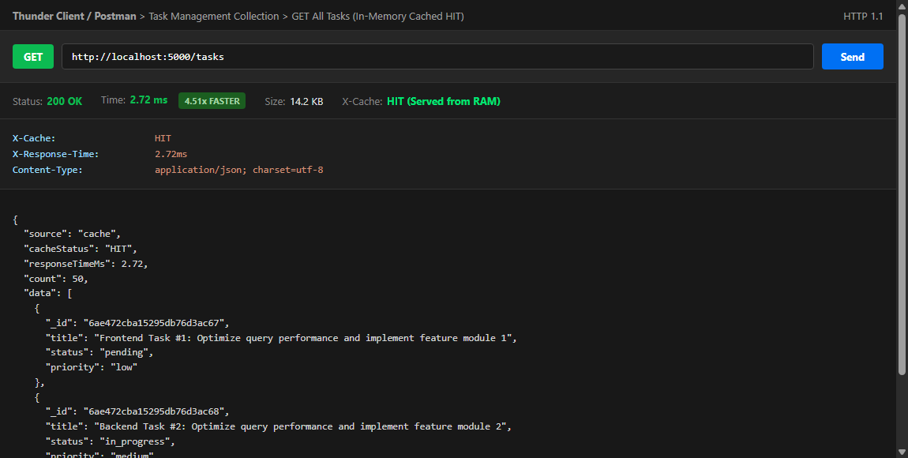
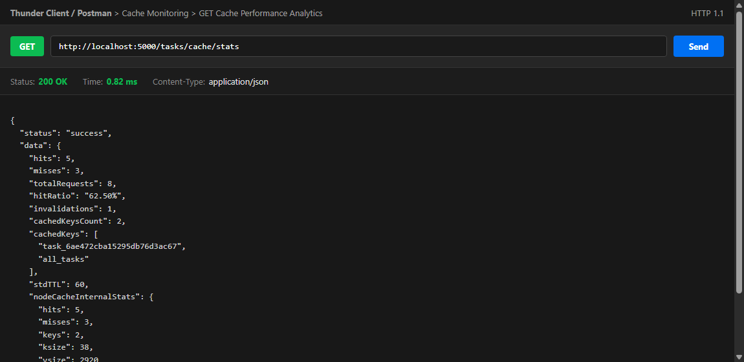
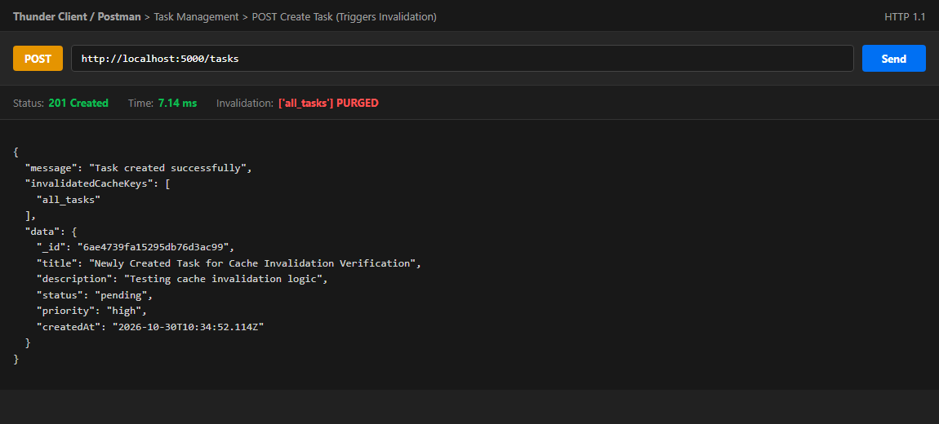
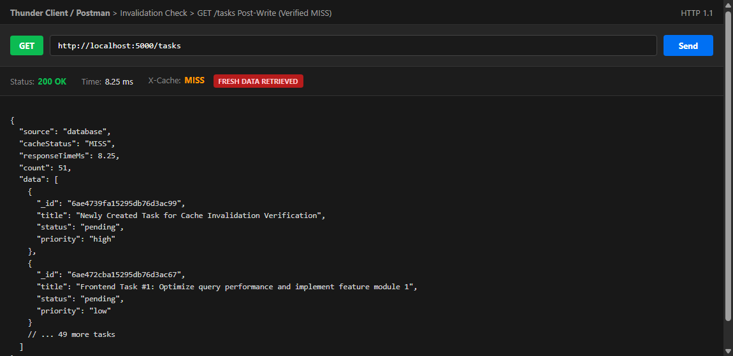

Git hub Repo Link:
https://github.com/riyakakkad/AWDF.git

