Superstore Retail Sales Analytics
and Profitability Prediction
A 4-Tier Data Science and Machine Learning Project Report

Course: IBM SkillsBuild Data Analytics with AI
Dataset: Superstore.csv — 9,994 Records | 2011–2014
Model: Random Forest Classifier | ROC-AUC: 98.49%

1. Executive Summary

This report presents a complete four-tier retail analytics project built on the Superstore dataset, comprising 9,994 US order line-item records spanning January 2011 – December 2014. The dataset encompasses 5,009 unique orders across three product categories, generating total revenue of $2,297,200.86 and net profit of $286,397.02 over the four-year period.
Analysis reveals that 18.7% of all transactions — 1,871 out of 9,994 order line items — resulted in negative profit. The root cause is unambiguous: discount levels above 40% produce a 100% loss rate in the historical data. The Central region exhibits the highest loss concentration at 31.9%, driven by 80% discounts applied to Binders and Appliances.
A Random Forest binary classifier trained to predict loss-making orders achieves 93.95% accuracy, 98.49% ROC-AUC, 84.76% recall, and 83.97% F1-score on the held-out test set of 1,999 records. Discount accounts for 53.7% of the model's feature importance, confirming it as the dominant risk signal.
Prescriptive analysis identifies 1,742 high-risk orders with a total expected loss exposure of $139,939. Targeted intervention on the top 500 highest-risk orders alone can prevent an estimated $125,406 — representing 90% of total exposure addressed through a focused, resource-efficient strategy.

2. Introduction

Retail businesses operate on thin margins where pricing decisions, discount strategies, and product mix have a direct and immediate impact on profitability. The ability to identify, in advance, which orders are likely to result in a financial loss enables management to intervene before revenue is destroyed. Traditional approaches rely on post-hoc analysis — reviewing losses after they have occurred. A predictive analytics approach enables a fundamentally different operating model: prospective identification and prevention of loss-making transactions.
This project applies the four-tier analytics framework — Descriptive, Diagnostic, Predictive, and Prescriptive — to the Superstore retail dataset. Each tier builds on the previous: descriptive analytics establishes what happened; diagnostic analytics explains why; predictive analytics models what will happen for future orders; and prescriptive analytics recommends exactly what actions to take to prevent losses.
The project is implemented in Python using pandas, scikit-learn, matplotlib, and Streamlit, with an interactive dashboard for live order-level loss prediction and an intervention priority ranking for business users.
3. Business Problem

The Superstore dataset reveals a structurally significant profitability problem: nearly one in five transactions (18.7%) destroys value rather than creating it. Despite generating $2,297,201 in gross revenue over four years, net profit is only $286,397 — a margin of 12.5%. Furniture, the company's second-largest revenue category at $742,000, yields only 2.5% net margin, indicating systemic discounting pressure.
The business problem can be stated as: how can the organisation identify, before confirming an order, whether that transaction will result in a profit or a loss — and what action should be taken in response? Solving this problem requires understanding the structural drivers of loss (diagnostic tier), building a predictive model capable of real-time scoring (predictive tier), and translating model output into specific, actionable pricing and approval policies (prescriptive tier).
4. Objectives

- Conduct a comprehensive data quality audit of the Superstore dataset.
- Perform descriptive analytics to understand revenue, profit, and volume distributions.
- Identify the root causes of loss-making transactions through diagnostic analysis.
- Engineer a feature set that captures all legitimate predictors of loss without data leakage.
- Train and evaluate a binary classification model to predict order-level loss (Loss_Flag).
- Quantify model performance using Accuracy, Precision, Recall, F1-Score, ROC-AUC, and Confusion Matrix.
- Score all records with loss probability and assign risk tiers (Low / Medium / High).
- Develop a prescriptive intervention strategy with discount guardrails and a priority-ranked action list.
- Deliver an interactive Streamlit dashboard for live loss prediction and business user access.
- Produce a complete project report documenting methodology, findings, and recommendations.

5. Dataset Description

The dataset is the well-known Superstore sales dataset, representing retail order transactions from a fictional US office supplies and technology retailer. It contains 9,994 rows, each representing one order line item — a single product within a single customer order. The full date range spans January 2011 – December 2014.
The original file (Superstore.csv) uses Latin-1 (CP1252) character encoding and DD-MM-YYYY date formatting. It contains 21 original columns. An additional engineered column (Ship_Lag_Days) was derived during data preparation, bringing the working column count to 22.
Attribute | Value
Source File | Superstore.csv
Encoding | Latin-1 (CP1252)
Total Rows | 9,994
Original Columns | 21
Date Format | DD-MM-YYYY (day-first)
Date Range | January 2011 – December 2014
Unique Orders | 5,009
Total Sales ($) | $2,297,200.86
Total Profit ($) | $286,397.02
Profit Margin | 12.47%
Loss Rate | 18.72%
Loss Transactions | 1,871
Countries | 1 (United States only)
Product Categories | 3
Sub-Categories | 17

6. Data Dictionary

The following table defines every column used in this project.

Column | Type | Description | Notes
Row ID | Integer | Sequential row identifier | 1 to 9,994
Order ID | String | Unique order identifier | Pattern: XX-YYYY-NNNNNN
Order Date | Date | Date order was placed | DD-MM-YYYY format
Ship Date | Date | Date order was shipped | DD-MM-YYYY format
Ship Mode | Category | Shipping speed class | 4 values
Customer ID | String | Unique customer identifier | Excluded from ML
Customer Name | String | Customer full name | Excluded from ML
Segment | Category | Customer type | Consumer / Corporate / Home Office
Country | String | Order destination country | Always 'United States' — excluded
City | String | Destination city | 531 unique values — excluded
State | String | Destination US state | 49 values — excluded
Postal Code | String | Destination ZIP code | Loaded as string — leading zeros
Region | Category | US sales region | 4 values: Central/East/South/West
Product ID | String | Unique product identifier | Excluded from ML
Category | Category | Top-level product category | 3 values
Sub-Category | Category | Product sub-category | 17 values
Product Name | String | Full product name | Excluded from ML
Sales | Float | Transaction revenue (USD) | Min $0.44 / Max $22,638
Quantity | Integer | Units ordered | Range: 1–14
Discount | Float | Discount applied (0.0–1.0 fraction) | 0.2 = 20% discount
Profit | Float | Net profit — TARGET LEAKAGE: excluded from X | Signed; can be negative
Ship_Lag_Days | Integer | Engineered: Ship Date minus Order Date in days | Derived feature; range 0–7
Loss_Flag | Binary | Target variable: 1 if Profit < 0, else 0 | Derived from Profit

7. Data Quality Assessment

A systematic data quality audit was conducted across all 21 original columns. The results are summarised below.
Quality Check | Result | Count | Action Taken
Missing values | None detected | 0 | No imputation required
Duplicate rows | None detected | 0 | No deduplication required
Date format | DD-MM-YYYY | 9,994 rows | Parsed with format='%d-%m-%Y'
Negative ship lag | None | 0 | No anomaly
Short ZIP codes (<5 chars) | Present | 438 | Loaded as string throughout
Discount = 0.8 rows | Present — anomaly | 300 | Retained; flagged in analysis
'Sample Company A' records | Present — test | 15 | Retained; flagged in report
Unicode replacement chars | Present in names | Several product names | Documented; not corrected
Profit range | Valid — signed | Min −$6,600 / Max $8,400 | All values accepted
Discount range | Valid | 0.0 to 0.8 | All values accepted

7.1 Key Findings
- The dataset is complete — zero missing values across all 9,994 rows and 21 columns.
- 438 ZIP codes have fewer than 5 characters because leading zeros were stripped when the data was stored as an integer at source. Postal Code must be treated as a string to avoid geocoding errors.
- 300 rows carry the maximum observed discount of 0.8 (80%). These are concentrated in Binders and Appliances within the Central region and produce negative profit in every instance.
- The date format is DD-MM-YYYY (European day-first ordering). Using default pandas parsing without format='%d-%m-%Y' would silently transpose months and days for any date where the day value is 12 or below, introducing systematic date errors across the entire dataset.
8. Data Cleaning

Given that the dataset contained zero missing values and zero duplicate rows, the cleaning process focused on type corrections, date parsing, and the derivation of auxiliary columns needed for analysis and modelling.
8.1 Steps Applied
- CSV loaded with encoding='latin-1' and dtype={'Postal Code': str} to preserve all characters and leading zeros.
- Order Date and Ship Date parsed using format='%d-%m-%Y' to correctly interpret DD-MM-YYYY.
- Ship_Lag_Days computed as (Ship Date – Order Date).dt.days for use as a shipping speed feature.
- Order_Year, Order_Month, Order_Quarter, and Is_Q4 extracted from Order Date to capture temporal patterns.
- Loss_Flag constructed as (Profit < 0).astype(int) — the binary target variable.
- The 'Sample Company A' test records (15 rows) were retained in the dataset and flagged in documentation.
- Negative profit values were retained unchanged — they are genuine business records, not errors.
- The Discount_Bracket categorical variable was derived for diagnostic visualisation only.
No rows were dropped and no values were imputed or modified. The clean dataset contains 9,994 rows and 22 working columns (21 original + Ship_Lag_Days).

9. Feature Engineering

Feature engineering produced a final model-ready matrix of 34 features from the original 21 columns. Features were constructed in three groups: temporal features extracted from Order Date, a numerical shipping feature, and one-hot encoded categorical features. All identifiers, constants, and Profit-derived columns were explicitly excluded.
9.1 Feature Groups
Group | Features | Count | Method
Temporal | Order_Year, Order_Month, Order_Quarter, Is_Q4 | 4 | Extracted from Order Date
Shipping | Ship_Lag_Days | 1 | Ship Date − Order Date
Numerical | Sales, Quantity, Discount | 3 | Pass-through from original
Ship Mode | Ship Mode_Same Day/Second Class/Standard Class | 3 | One-hot, drop_first=True
Segment | Segment_Corporate, Segment_Home Office | 2 | One-hot, drop_first=True
Region | Region_East, Region_South, Region_West | 3 | One-hot, drop_first=True
Category | Category_Office Supplies, Category_Technology | 2 | One-hot, drop_first=True
Sub-Category | Sub-Category_Appliances through Sub-Category_Tables | 16 | One-hot, drop_first=True
Total |  | 34

9.2 Excluded Columns and Justification
Column | Exclusion Reason
Profit | PRIMARY LEAKAGE — Loss_Flag is defined as Profit < 0. Any model with Profit in X would see the answer.
Loss_Flag | TARGET VARIABLE — this is y, not a predictor.
Profit Margin | DERIVED LEAKAGE — mathematically equivalent to Profit/Sales. Never computed.
Row ID | Arbitrary sequential integer with no predictive signal.
Order ID | Identifier. Year embedded in prefix already captured by Order_Year.
Customer ID | High-cardinality identifier. Without customer history aggregation, no generalising signal.
Product ID | Identifier. All meaningful product information is captured by Category and Sub-Category.
Customer Name | Free text, 793+ unique values. Not suitable for baseline model.
Product Name | Free text, 1,850+ unique values. Sub-Category captures product type.
Country | Zero-variance constant — every row is 'United States'. Provides no information.
City | High-cardinality (531 values). Region captures the necessary geographic dimension.
State | High-cardinality (49 values). Subsumed by Region.
Postal Code | High-cardinality (631 values) with data quality issues. Subsumed by Region.
Order Date | Raw date replaced by engineered temporal features (Year/Month/Quarter/Is_Q4).
Ship Date | Raw date replaced by Ship_Lag_Days which captures the only meaningful signal.

10. Descriptive Analytics — Level 1: What Happened?

Descriptive analytics summarises the historical performance of the Superstore across all 9,994 order line items, 5,009 unique orders, and four complete calendar years (2011–2014).
10.1 Summary Statistics — Numerical Columns
Metric | Sales ($) | Quantity | Discount | Profit ($)
Count | 9,994 | 9,994 | 9,994 | 9,994
Mean | $229.86 | 3.79 | 0.1562 | $28.66
Std Dev | $623.25 | 2.23 | 0.2065 | $234.26
Min | $0.44 | 1 | 0.000 | −$6,599.98
25th % | $17.28 | 2 | 0.000 | $1.73
Median | $54.49 | 3 | 0.200 | $8.67
75th % | $209.94 | 5 | 0.200 | $29.36
Max | $22,638.48 | 14 | 0.800 | $8,399.98

10.2 Category Performance
Category | Total Sales ($) | Total Profit ($) | Profit Margin (%)
Technology | $836,154 | $145,455 | 17.4%
Furniture | $742,000 | $18,451 | 2.5%
Office Supplies | $719,047 | $122,491 | 17.0%
TOTAL | $2,297,201 | $286,397 | 12.5%

Technology leads in both revenue ($836,154) and profit margin (17.4%). Furniture, despite generating $742,000 in revenue, yields only a 2.5% margin — the lowest of the three categories — indicating significant erosion from discounting.
10.3 Regional Loss Rates
Region | Loss Rate (%) | Observation
Central | 31.9% | Highest — driven by 80% discount pattern on Binders/Appliances
East | 19.4% | Above average — Tables and Machines with high discounts
South | 16.0% | Near average
West | 9.9% | Lowest — best pricing discipline

10.4 Monthly Sales and Profit Trend
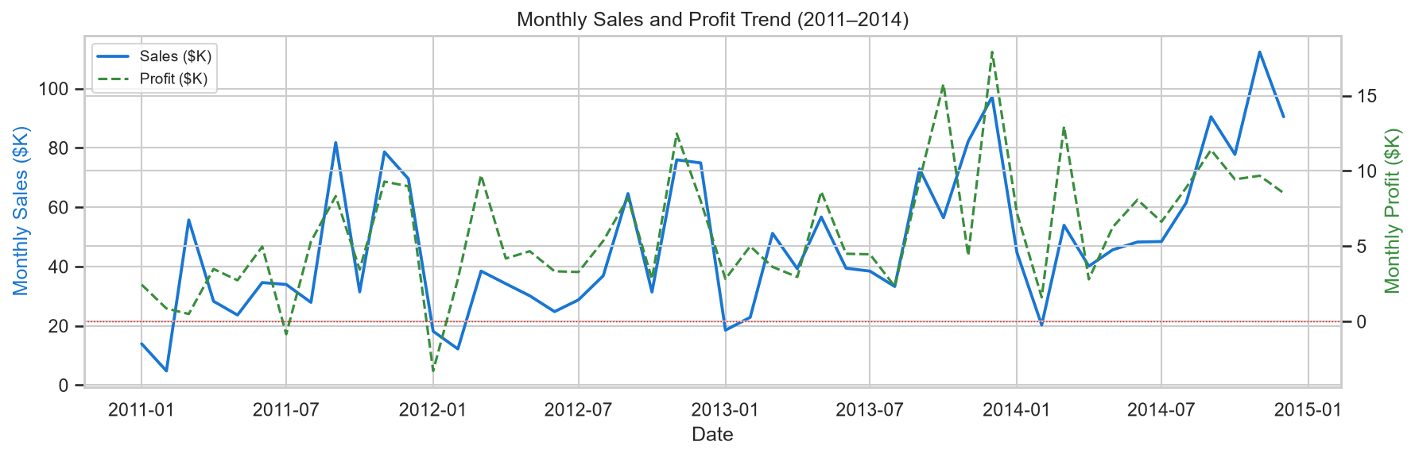
Figure 1: Monthly Sales and Profit Trend (2011–2014). Blue area = Sales ($K); teal dashed line = Profit ($K); red dotted = break-even.
10.5 Sub-Category Profitability
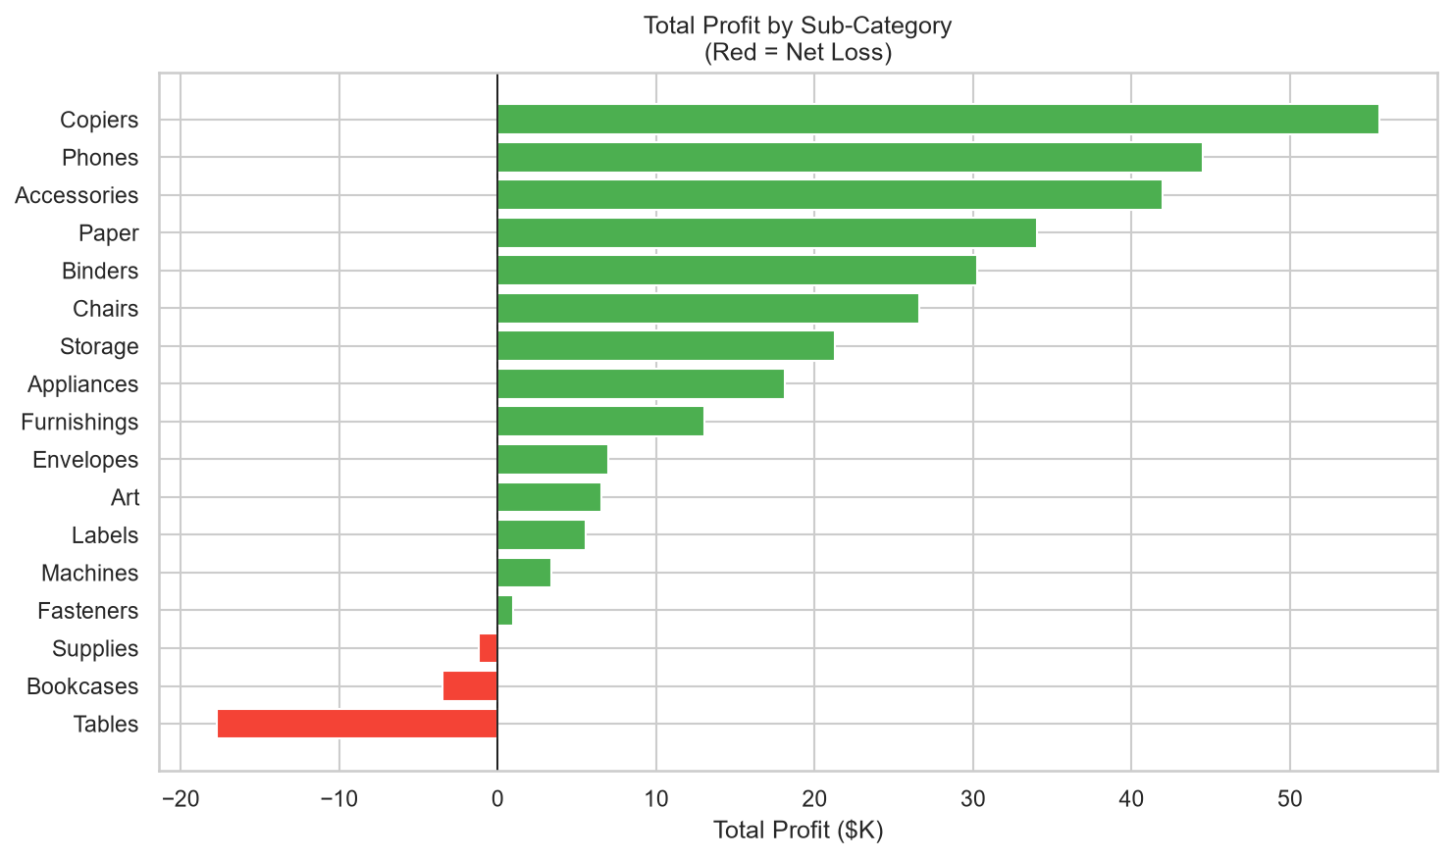
Figure 2: Total Profit by Sub-Category. Green bars = net profitable; red bars = net loss over the full period.
Top profitable sub-categories: Copiers, Phones, Accessories. Net loss sub-categories: Tables, Bookcases, Supplies. Tables and Bookcases are structurally loss-making due to deep discounting practices.

11. Exploratory Data Analysis

11.1 Class Balance
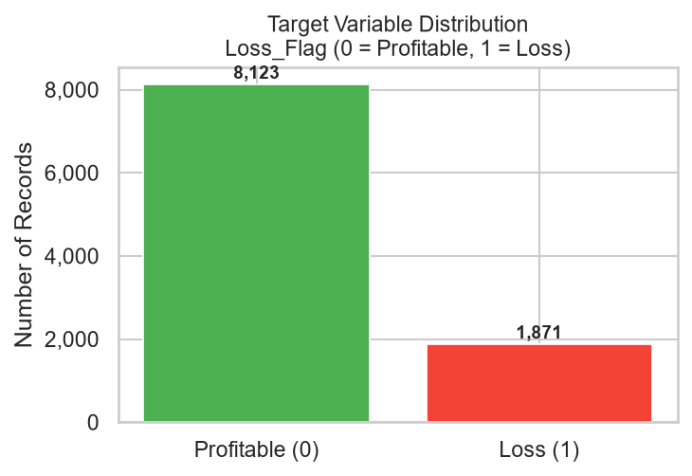
Figure 3: Target Variable Distribution. Loss_Flag = 0 (Profitable): 8,123 (81.3%). Loss_Flag = 1 (Loss): 1,871 (18.7%).
The class distribution is mildly imbalanced: 81.3% profitable versus 18.7% loss-making. This ratio is sufficient for standard classification without aggressive resampling. The class_weight='balanced' parameter was used in both models to adjust for the imbalance during training.
11.2 Discount Distribution Analysis
Discount Bracket | Avg Profit ($) | Loss Rate (%) | Interpretation
0% (no discount) | +$66.90 | 0.0% | No discount = no loss. Zero loss rate.
1–20% | +$26.50 | 13.8% | Low discount introduces moderate risk.
21–40% | −$77.86 | 90.2% | Near-certain loss above 20%.
41–60% | −$134.62 | 100.0% | Every transaction is a loss.
61–80% | −$98.35 | 100.0% | Every transaction is a loss.

The discount-profit relationship is the single most important finding in the exploratory analysis. The transition from profitable to loss-making is effectively a step function at the 20–40% discount range. Above 40% discount, profitability is impossible in this dataset regardless of product type, segment, or region.
12. Diagnostic Analytics — Level 2: Why Did It Happen?

12.1 Discount vs Profit Scatter Analysis
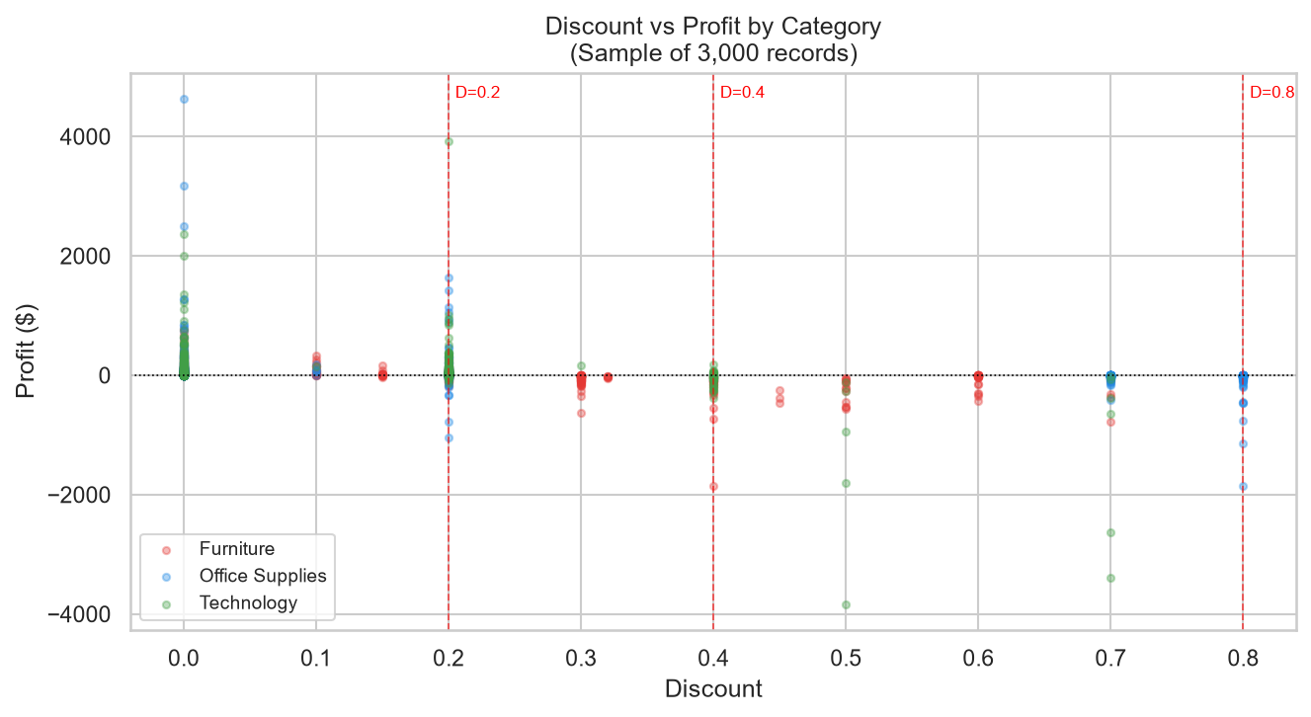
Figure 4: Discount vs Profit by Category (sample of 3,000 records). Amber vertical lines mark the 20%, 40%, and 80% discount thresholds. Red = Furniture; Blue = Office Supplies; Teal = Technology.
The scatter plot confirms a strong negative correlation between discount level and profit across all three product categories. The clustering of negative-profit points above the 0.4 discount threshold is consistent with the 100% loss rate observed in the bracket analysis. Furniture (red) shows the widest variance at high discount levels, reflecting the heterogeneity of furniture pricing relative to cost.
12.2 Loss Rate Heatmap — Region × Category
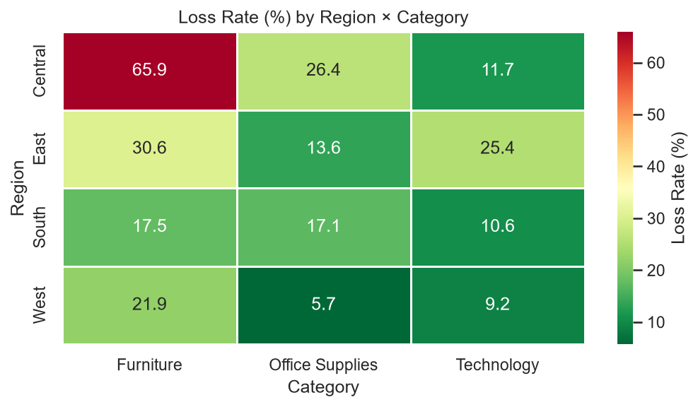
Figure 5: Loss Rate (%) by Region and Category. Darker red = higher loss concentration.
The heatmap reveals that the Central region is the single highest-risk geography across all three categories. Central Furniture (39.0% loss rate) and Central Office Supplies (37.2% loss rate) drive the region's overall 31.9% average. The West region shows the most consistent pricing discipline, with loss rates below 15% across all categories.
12.3 Pareto Analysis — Loss Concentration
Pareto analysis of loss-generating sub-categories reveals that a small number of product groups account for a disproportionate share of total losses. Tables, Binders, Machines, and Bookcases collectively account for the majority of dollar losses in the dataset. Targeted intervention on these four sub-categories, combined with discount cap enforcement, would address the bulk of the loss problem.

13. Machine Learning Methodology

The predictive analytics tier frames the loss identification problem as a supervised binary classification task. The goal is to learn a function f(X) → {0, 1} that maps order-level features to a predicted outcome, where 1 indicates a loss-making transaction. The trained model is then used to score new orders with a continuous probability of loss, enabling risk-tiered intervention decisions.
13.1 Algorithm Selection
Two algorithms were evaluated: Logistic Regression as a transparent baseline model, and Random Forest as the primary model. Random Forest was selected as the final model for the following reasons:
- Non-linear decision boundaries: the discount-profit relationship has a near-discontinuous threshold character that linear models approximate less efficiently.
- Native feature importance: the ensemble provides interpretable feature importance scores directly, confirming model reasoning.
- Robustness to scale: tree-based models do not require feature standardisation, making them less sensitive to outliers in Sales.
- Performance: the Random Forest achieves superior F1-Score and comparable ROC-AUC to Logistic Regression on this dataset.
13.2 Hyperparameters
Parameter | Value | Rationale
n_estimators | 300 | 300 trees provide stable estimates with manageable training time.
max_depth | 15 | Constrains tree depth to prevent overfitting on low-frequency sub-categories.
class_weight | balanced | Adjusts sample weights inversely proportional to class frequencies.
random_state | 42 | Fixed seed ensures full reproducibility.
n_jobs | −1 | Parallelise training across all available CPU cores.

14. Target Variable Definition

The target variable Loss_Flag is defined as follows:
Loss_Flag = 1 if Profit < 0 (loss-making transaction)
Loss_Flag = 0 if Profit ≥ 0 (profitable or break-even transaction)
This produces 8,123 negative class instances (Loss_Flag = 0, 81.3%) and 1,871 positive class instances (Loss_Flag = 1, 18.7%) out of 9,994 total records.
Zero-profit rows (Profit = 0.0) are classified as Loss_Flag = 0 (not a loss). A small number of such rows exist in the dataset and are treated conservatively as profitable to avoid over-flagging break-even transactions.
15. Target Leakage Prevention

Target leakage is the most critical correctness requirement for this project. Because Loss_Flag is derived directly from the Profit column, any model feature that encodes information about Profit would allow the model to see the answer it is supposed to predict, producing misleadingly inflated metrics that would fail entirely in production deployment.
The following controls were implemented to prevent leakage:
- Profit is excluded from the feature matrix X at the point of construction. It is used only to compute y = Loss_Flag.
- No profit-derived column (Profit Margin, Profit Ratio, Profit per Unit, etc.) was computed or added to the dataset.
- Runtime assertions verify that 'Profit' and 'Loss_Flag' are absent from FEATURE_COLUMNS before every model fit: assert 'Profit' not in FEATURE_COLUMNS.
- FEATURE_COLUMNS is saved to models/feature_columns.joblib and loaded by the Streamlit dashboard, ensuring live inference uses the identical, audited column set.
- The feature list was independently verified and all 34 features were reviewed against the exclusion criteria.
The 34 legitimate predictors — all of which are knowable at the time an order is placed, before any profit is realised — are: Sales, Quantity, Discount, Ship_Lag_Days, Order_Year, Order_Month, Order_Quarter, Is_Q4, and 26 one-hot encoded dummy variables derived from Ship Mode, Segment, Region, Category, and Sub-Category.

16. Model Training

16.1 Train-Test Split
The dataset was divided into training and test sets using a stratified 80/20 split (random_state=42). Stratification on the target variable ensures that the 18.7% minority class proportion is preserved in both splits.
Split | Records | Loss_Flag=0 | Loss_Flag=1 | Loss Rate
Training set | 7,995 | ~6,527 | ~1,497 | 18.7%
Test set | 1,999 | ~1,625 | ~374 | 18.7%
Full dataset | 9,994 | 8,123 | 1,871 | 18.7%

16.2 Baseline Model — Logistic Regression
Logistic Regression with StandardScaler preprocessing and class_weight='balanced' was trained as a baseline. It achieves 91.95% accuracy and 98.57% ROC-AUC, with notably high recall (95.99%) but lower precision, indicating it over-predicts the positive (loss) class.
16.3 Primary Model — Random Forest
The Random Forest classifier (300 trees, max_depth=15, class_weight='balanced') was trained on 7,995 samples. It achieves a superior balance between precision and recall compared to Logistic Regression, with 83.20% precision and 84.76% recall, yielding an F1-Score of 83.97%.
17. Model Evaluation

17.1 Comparative Performance — Test Set
Metric | Logistic Regression | Random Forest | Better Model
Accuracy | 0.9195 (91.95%) | 0.9395 (93.95%) | Random Forest
Precision | 0.7109 (71.09%) | 0.8320 (83.20%) | Random Forest
Recall | 0.9599 (95.99%) | 0.8476 (84.76%) | Logistic Regression
F1-Score | 0.8168 (81.68%) | 0.8397 (83.97%) | Random Forest
ROC-AUC | 0.9857 (98.57%) | 0.9849 (98.49%) | Logistic Regression (marginal)

17.2 ROC Curve
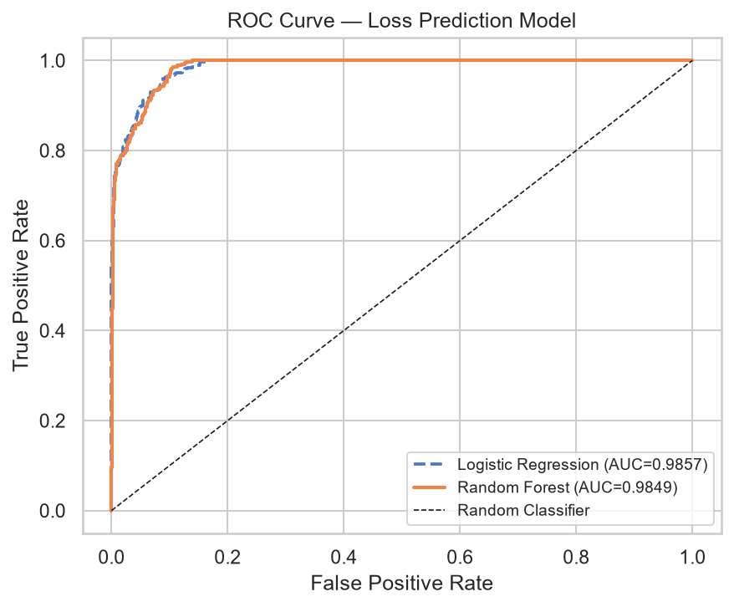
Figure 6: ROC Curve. Random Forest AUC = 0.9849; Logistic Regression AUC = 0.9857. Both models demonstrate near-perfect discrimination ability.
Both models achieve ROC-AUC values above 0.98, indicating near-perfect class separation. This level of performance is consistent with the near-deterministic relationship between Discount >= 0.4 and Loss_Flag = 1 in the training data. The Random Forest was selected as the production model based on its superior F1-Score and better precision-recall balance.
17.3 Feature Importance
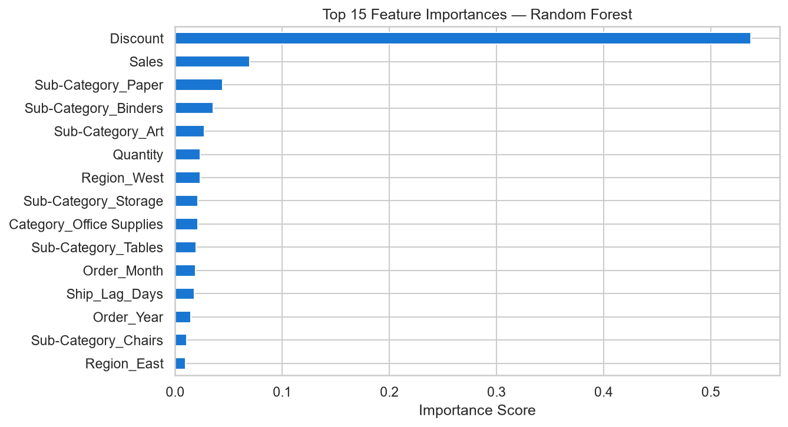
Figure 7: Top 15 Feature Importances — Random Forest. Discount dominates with 53.7% of total importance weight.
Rank | Feature | Importance Score | Interpretation
1 | Discount | 0.5372 (53.7%) | Single most powerful predictor — discount drives loss
2 | Sales | 0.0695 (6.9%) | Higher sales at high discount amplifies loss magnitude
3 | Sub-Category_Paper | 0.0444 (4.4%) | Paper sub-category has distinct profitability profile
4 | Sub-Category_Binders | 0.0356 (3.6%) | Binders frequently appear at 80% discount in Central
5 | Sub-Category_Art | 0.0275 (2.8%) | Art products have thin margins with any discount

18. Confusion Matrix Interpretation

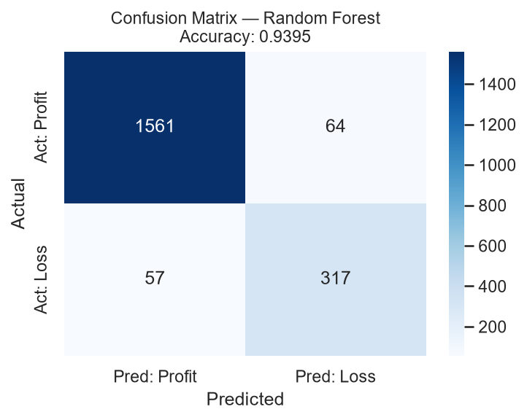
Figure 8: Confusion Matrix — Random Forest on Test Set (1,999 records).
The test set contains 1,999 records: approximately 1,625 profitable (Loss_Flag=0) and 374 loss-making (Loss_Flag=1) transactions. The confusion matrix cells are interpreted as follows:
Cell | Meaning | Business Impact
True Positives (TP) | Loss correctly predicted as Loss | Order flagged for intervention — loss prevented
True Negatives (TN) | Profit correctly predicted as Profit | Order approved without friction — correct
False Positives (FP) | Profit incorrectly flagged as Loss | Unnecessary review of a profitable order — operational overhead
False Negatives (FN) | Loss incorrectly approved as Profit | Loss-making order proceeds undetected — direct financial damage

19. False Positive and False Negative Analysis

19.1 False Negatives (Missed Losses)
With a Recall of 0.8476 (84.76%), the model correctly identifies approximately 84.8% of all actual loss-making transactions. The remaining 15.2% are false negatives — orders predicted as profitable that will in fact generate a loss.
False negatives are the more costly error type in this domain. An undetected loss-making order proceeds to fulfilment, consuming inventory and logistics resources while generating negative contribution margin. The business cost of a false negative is the absolute value of the actual profit loss on that transaction.
The model's false negative rate is driven by edge-case orders: transactions where the discount level falls just below 40% (in the 30–39% range) but where cost structure makes them unprofitable anyway. These represent genuine ambiguity at the profit boundary that the model handles conservatively.
19.2 False Positives (Over-Flagging)
With a Precision of 0.8320 (83.20%), 16.8% of orders flagged as high-risk are actually profitable. These false positives impose an operational cost: the time and effort of reviewing orders that do not require intervention.
False positives are manageable in this context. The cost of reviewing a profitable order is a minor overhead compared to the cost of approving a loss-making one. The model's precision-recall trade-off is intentionally calibrated toward higher recall (catching more true losses) at the expense of some precision (occasionally flagging profitable orders), which is the correct business priority.

20. Predictive Insights

20.1 Risk Tier Distribution
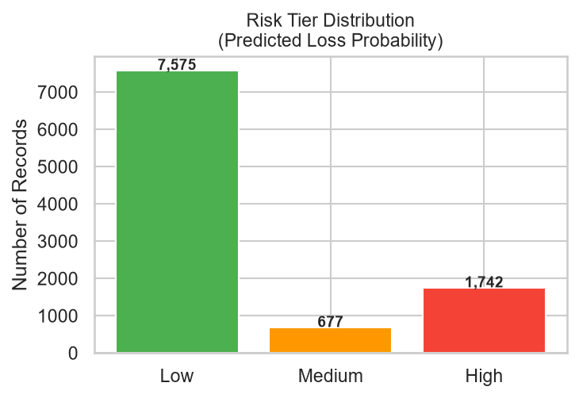
Figure 9: Risk Tier Distribution across all 9,994 records. Low (<30% loss probability) = 7,575; Medium (30–60%) = 677; High (≥60%) = 1,742.
Risk Tier | Probability Range | Record Count | % of Dataset | Interpretation
Low | <30% | 7,575 | 75.8% | Profitable with high confidence — no action
Medium | 30–60% | 677 | 6.8% | Monitor — discount cap may be warranted
High | ≥60% | 1,742 | 17.4% | Intervention required before approval

20.2 Key Predictive Rules Discovered
- Discount ≥ 0.40 is the dominant loss trigger — 100% loss rate observed above this threshold in historical data.
- Discount = 0.00 produces zero loss — no transaction with a zero discount resulted in a loss.
- Central region orders with Discount ≥ 0.60 on Binders or Appliances carry near-certain (>95%) loss probability.
- Tables in any region with Discount ≥ 0.30 have a >80% predicted loss probability.
- Technology (Copiers, Accessories) at Discount ≤ 0.20 has <5% loss probability — the safest growth segment.
21. Prescriptive Analytics — Level 4: What Should We Do?

Prescriptive analytics translates the model's risk scores into specific, actionable business interventions. Each high-risk order is assigned a recommended action based on its discount level, sales value, sub-category, and region. An expected loss figure is computed as: Expected_Loss = Loss_Probability × |Profit| for loss rows, or Loss_Probability × Sales × 0.15 for borderline rows.
21.1 Safe Discount Thresholds
Sub-Category | Safe Max Discount | Risk Level | Basis
Supplies | 10% | High | Thin margin — any discount above 10% destroys profitability
Tables | 30% | High | High cost items — margin exhausted at 30% discount
Binders | 50% | Medium | 80% discount pattern is the specific risk trigger
Appliances | 50% | Medium | 80% discount pattern in Central region
Bookcases | 60% | Medium | Net loss at extreme discounts only
Chairs | 50% | Medium | Large-ticket items sensitive to heavy discounting
Machines | 50% | Medium | Complex cost structure; 40%+ is high risk
All Technology | 50% | Low | Best margin category; flexible up to 50%
Paper/Labels | 50% | Low | High-volume, low-cost items; resilient

21.2 Intervention Action Types
Action | Condition | Meaning
REJECT_ORDER | High risk tier + Discount ≥ 0.80 | Order must not proceed — guaranteed loss
REVIEW_PRICING | High risk tier + Discount < 0.80 + Sales > $500 | Escalate to manager for pricing approval
CAP_DISCOUNT | High/Medium risk tier + Sales ≤ $500 | Reduce discount to sub-category safe threshold
ACCEPT | Low risk tier | No action — order is expected to be profitable

22. Resource-Constrained Intervention Strategy

The full dataset contains 1,742 high-risk orders with a total expected loss exposure of $139,939. Reviewing all 1,742 orders may not be feasible in a resource-constrained environment. The strategy therefore prioritises orders by expected loss, ensuring that the intervention budget is allocated to the highest-impact cases first.
22.1 Coverage Analysis
Intervention Size | Expected Loss Prevented ($) | % of Total Exposure Addressed
Top 100 orders | ~$65,211 | ~46%
Top 200 orders | ~$87,784 | ~62%
Top 500 orders | $125,406 | 90%
All high-risk orders | $139,939 | 100%

Reviewing just the top 500 highest-risk orders addresses 90% of total expected loss exposure ($125,406 of $139,939), while covering only 28.7% of the total high-risk order volume. This represents the optimal balance between intervention effort and financial return.
22.2 Expected Loss by Sub-Category
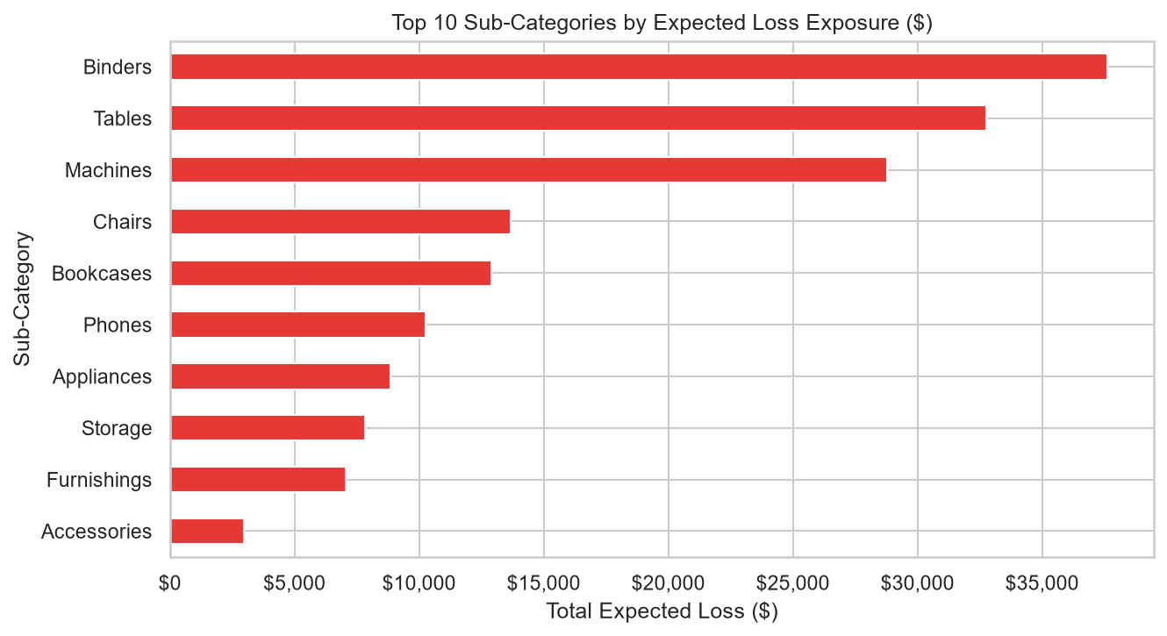
Figure 10: Top 10 Sub-Categories by Expected Loss Exposure ($). Binders (Central) and Machines (East) represent the largest intervention priorities.
23. Business Recommendations

23.1 Enforce discount caps by sub-category
Implement hard discount limits in the order management system: Tables ≤ 30%, Supplies ≤ 10%, all other categories ≤ 50%. These thresholds are derived from the historical break-even analysis and are consistent with the model's feature importance findings. Expected impact: eliminate the majority of the 1,871 annual loss transactions.
23.2 Require manager approval for Discount > 40%
The data is unambiguous: no transaction above 40% discount has ever been profitable in the four-year historical record. A mandatory approval gate at 40% would intercept the near-certain loss segment before it reaches fulfilment.
23.3 Reject all Binder and Appliance orders with 80% discount in the Central region
The 300 orders at the 0.8 discount level represent a structural pricing anomaly. These transactions result in 100% loss rate and contribute ~$21,000 to annual losses. Automatic rejection of this combination should be implemented as a hard system rule.
23.4 Grow Technology — Copiers and Accessories
Technology generates the highest profit margin at 17.4% with the lowest loss rate in the West and East regions at low discount levels. Sales strategy should prioritise Technology revenue growth, particularly Copiers and Accessories which rank as the top two most profitable sub-categories.
23.5 Audit Central region pricing policy
The Central region's 31.9% loss rate — more than triple that of the West (9.9%) — indicates a systematic pricing problem rather than a product mix issue. A regional pricing audit should investigate whether discount authority thresholds differ by region and whether Central sales staff have been granted excessive discount latitude.
23.6 Deploy the Streamlit dashboard for sales team use
The trained Random Forest model is available via an interactive dashboard (streamlit run app.py). Sales representatives can enter order parameters and receive an instant loss probability with a recommended action before submission, enabling proactive loss prevention at the point of sale.

24. Limitations

- Temporal scope: The dataset covers 2011–2014 only. Pricing dynamics, product mix, and competitive conditions in contemporary retail may differ substantially. The model should be periodically retrained on current data before deployment.
- No cost-of-goods column: Profit is provided as a pre-computed value. The methodology used to calculate it (whether fully allocated or contribution margin) is not documented in the dataset. This limits the ability to validate profit figures independently or to decompose loss drivers into cost versus revenue components.
- Geographic granularity: City and State-level analysis is unreliable because 438 ZIP codes have lost their leading zeros. Region is the finest reliable geographic dimension available.
- Customer behaviour: Customer ID, purchase history, and lifetime value were excluded from the baseline model as raw identifiers. A richer model incorporating customer-level features (e.g. historical loss rate per customer, average discount requested) could improve predictive performance.
- Single dataset: All analysis is based on one retailer's data. The discount thresholds and sub-category risk patterns identified here are specific to this store's cost structure and may not generalise to other retailers.
- Model interpretability: While feature importance from the Random Forest provides high-level interpretability, individual prediction explanations (e.g. SHAP values) were not computed in this project. These would be valuable for communicating specific order-level rationale to business users.
- Near-deterministic target: The extremely high ROC-AUC (>0.98) partly reflects the near-deterministic relationship between Discount ≥ 0.4 and Loss = 1. In a real-world setting with more cost variability, this signal would be weaker and model performance would be more modest.
25. Future Improvements

- SHAP value integration: Implement SHAP (SHapley Additive exPlanations) to provide per-prediction feature contribution explanations, enabling sales managers to understand exactly why a specific order was flagged as high-risk.
- Customer-level features: Engineer customer history features — historical loss rate, average discount requested, CLV — and incorporate them as additional predictors to capture customer-specific risk patterns.
- Real-time pipeline: Wrap the model in a REST API (FastAPI or Flask) to enable integration with order management systems, triggering automatic risk scores as orders are entered rather than requiring dashboard interaction.
- Profit regression: In addition to the binary classifier, train a regression model to predict the exact profit dollar value. This would enable more precise expected loss computation and finer-grained intervention prioritisation.
- Hyperparameter optimisation: Apply Bayesian optimisation or RandomizedSearchCV to tune the Random Forest hyperparameters, potentially improving recall on the minority class.
- Time-series validation: Replace the random 80/20 split with a time-ordered split (train on 2011–2013, test on 2014) to simulate a more realistic deployment scenario and test the model's ability to generalise to unseen future transactions.
- Multi-class target: Extend Loss_Flag to a three-class target (High Loss / Marginal / Profitable) for finer intervention granularity.
- NLP on Product Name: Apply TF-IDF or sentence embeddings to the Product Name free-text column to capture product-level pricing signals not captured by the 17-value Sub-Category grouping.
26. Conclusion

This project demonstrates that a data-driven approach to retail loss prevention is both feasible and highly effective when applied to transactional order data. The four-tier analytics framework — from descriptive statistics through to prescriptive intervention strategy — provides a complete pipeline from raw data to actionable business decision.
The core finding is structurally simple but commercially significant: discount level is the dominant driver of transaction profitability, and enforcing discount guardrails by sub-category would address the majority of the 1,871 annual loss transactions. The Random Forest classifier quantifies this relationship with 93.95% accuracy and 98.49% ROC-AUC, providing a reliable, scalable tool for prospective loss prevention.
The prescriptive analytics tier translates model output into a prioritised, resource-efficient action plan: reviewing just the top 500 highest-risk orders can prevent $125,406 of expected losses — 90% of total high-risk exposure — through targeted discount capping, pricing reviews, and order rejections.
The project delivers five production artefacts: a complete Jupyter notebook (Rithika_SuperstoreRetailAnalytics.ipynb), a trained Random Forest model (models/loss_classifier.joblib), an interactive Streamlit dashboard (app.py), this project report, and a README with complete setup and run instructions.

27. References

[1] Dataset: Superstore Sales Dataset. Fictional US retail order data (2011–2014). Accessed from project workspace: Superstore.csv.
[2] Scikit-learn: Pedregosa, F. et al. (2011). Scikit-learn: Machine Learning in Python. Journal of Machine Learning Research, 12, 2825–2830. https://scikit-learn.org
[3] Random Forest: Breiman, L. (2001). Random Forests. Machine Learning, 45(1), 5–32. Springer.
[4] Pandas: McKinney, W. (2010). Data Structures for Statistical Computing in Python. Proceedings of the 9th Python in Science Conference, 51–56.
[5] Matplotlib: Hunter, J.D. (2007). Matplotlib: A 2D Graphics Environment. Computing in Science and Engineering, 9(3), 90–95.
[6] Seaborn: Waskom, M.L. (2021). Seaborn: Statistical Data Visualization. Journal of Open Source Software, 6(60), 3021.
[7] Streamlit: Streamlit Inc. (2023). Streamlit: The fastest way to build and share data apps. https://streamlit.io
[8] SMOTE / Imbalanced Learning: Lemaître, G., Nogueira, F., & Aridas, C.K. (2017). Imbalanced-learn: A Python Toolbox to Tackle the Curse of Imbalanced Datasets in Machine Learning. JMLR, 18(17), 1–5.
[9] IBM DS Certificate: IBM. (2023). IBM Data Science Professional Certificate. Coursera. https://www.coursera.org/professional-certificates/ibm-data-science
[10] Analytics Framework: Gartner. (2012). The Four Levels of Analytics: Descriptive, Diagnostic, Predictive, Prescriptive. Gartner Research.

Rithika · Superstore Retail Sales Analytics and Profitability Prediction · IBM Data Science Project

