EMPLOYEE ATTRITION & WORKFORCE ANALYSIS

IBM SkillsBuild Data Analytics with AI Project

Submitted By:- Riya Kumari Pandey
B.Tech Computer Science & Engineering
Academic Project:- 2026

- INTRODUCTION
1.1 Project Overview
Employee attrition is an important workforce-related area that can be analyzed using employee and workplace data. Understanding how attrition varies across different employee groups can help identify patterns within an organization.
This project analyzes employee attrition using the IBM HR Analytics dataset. The analysis examines attrition across factors such as department, overtime, job role, job satisfaction, monthly income, total working years, and business travel.
Python-based exploratory data analysis and data visualization were used to examine the dataset and identify patterns in employee attrition.

1.2 Project Objective
The objective of this project is to analyze employee attrition patterns and identify how attrition varies across different employee and workplace factors.
The analysis focuses on:
• Understanding the overall employee attrition rate.
• Comparing attrition rates across departments.
• Examining the relationship between overtime and attrition.
• Comparing attrition across different job roles.
• Analyzing attrition across job satisfaction levels.
• Examining attrition across monthly income groups.
• Comparing attrition across total working experience groups.
• Analyzing attrition across business travel categories.
• Presenting the findings through clear data visualizations.

- DATASET & DATA PREPARATION
2.1 Dataset Description
The dataset used in this project is the HR Analytics dataset obtained from Kaggle. It contains information about 1,470 employees across 35 columns.
The dataset includes employee demographic information, department and job role details, job satisfaction, overtime, monthly income, total working years, business travel, and other workplace-related attributes.
The target variable used for the analysis is Attrition. It indicates whether an employee left the company (Yes) or stayed (No).

2.2 Data Cleaning & Preparation
Before performing the analysis, the dataset was checked for missing values, duplicate records, inconsistent categorical values, and constant columns.
No missing values or duplicate records were found in the dataset. The categorical values were also reviewed for consistency.
Three columns — EmployeeCount, Over18, and StandardHours — contained only one unique value and therefore did not provide variation for the analysis. These columns were not used in the analytical comparisons.
The original dataset was kept unchanged, and additional grouping columns were created only when required for analysis.

2.3 Derived Groups
Two additional grouping variables were created to support the analysis:
• IncomeGroup — Monthly income was divided into four groups: Low, Medium, High, and Very High.

• ExperienceGroup — Total working years were grouped into four categories: 0–5 years, 6–10 years, 11–20 years, and 21+ years.
These groups were created to make comparisons of attrition rates easier across different income and experience ranges.

- EXPLORATORY DATA ANALYSIS
3.1 Overall Employee Attrition
The overall distribution of employee attrition was analyzed to understand how many employees had left the company compared with those who stayed.
Out of 1,470 employees, 237 employees had left the company, while 1,233 employees remained.
This resulted in an overall attrition rate of 16.12%.

3.2 Department-wise Attrition
Attrition rates were compared across the three departments in the dataset.
The Sales department had the highest attrition rate at 20.63%, followed by Human Resources at 19.05%. Research & Development had the lowest attrition rate at 13.84%.
This shows that attrition was not evenly distributed across the departments in the dataset.

3.3 Overtime vs. Attrition
Attrition rates were compared between employees who worked overtime and those who did not.
Employees who worked overtime had an attrition rate of 30.53%, compared with 10.44% for employees who did not work overtime.
This indicates a noticeable difference in attrition rates between the two overtime groups in this dataset.

3.4 Job Role vs. Attrition
Attrition rates were analyzed across different job roles to identify variations between employee groups.
Sales Representatives had the highest attrition rate at 39.76%, while Research Directors had the lowest attrition rate at 2.50%.
The results show that attrition rates varied considerably across different job roles in the dataset.

3.5 Job Satisfaction vs. Attrition
Attrition rates were compared across the four job satisfaction levels.
Employees in Job Satisfaction level 1 had the highest attrition rate at 22.84%, while employees in level 4 had the lowest attrition rate at 11.33%.
The results show that attrition varied across the different job satisfaction levels in the dataset.

3.6 Monthly Income vs. Attrition
Employees were divided into four monthly income groups: Low, Medium, High, and Very High.
The Low income group had the highest attrition rate at 29.27%, while the Very High income group had the lowest attrition rate at 10.33%.
This shows that attrition rates differed across the income groups in the dataset.

3.7 Total Working Years vs. Attrition
Attrition rates were compared across four total working experience groups.
Employees with 0–5 years of total working experience had the highest attrition rate at 28.80%, while employees with 21+ years of experience had the lowest attrition rate at 7.73%.
The results show that attrition rates varied across different levels of total working experience.

3.8 Business Travel vs. Attrition
Attrition rates were also compared across business travel categories.
Employees in the Travel_Frequently group had the highest attrition rate at 24.91%, followed by Travel_Rarely at 14.96%. The Non-Travel group had the lowest attrition rate at 8.00%.
This shows that attrition rates differed across the business travel categories in the dataset.

- DATA VISUALIZATIONS
4.1 Overall Employee Attrition
A bar chart was used to show the number of employees who stayed with the company and those who left.
The chart shows that 1,233 employees stayed, while 237 employees left. This corresponds to an overall attrition rate of 16.12%.
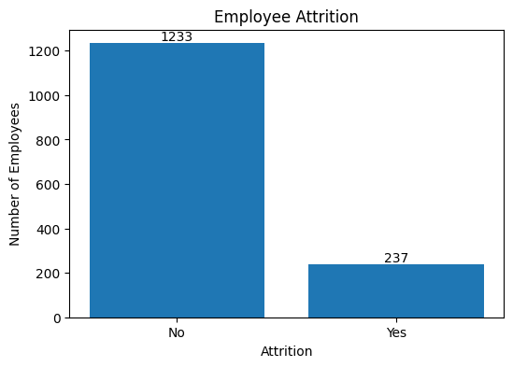

4.2 Attrition Rate by Department
A bar chart was used to compare employee attrition rates across the Sales, Human Resources, and Research & Development departments.
Sales had the highest attrition rate at 20.63%, followed by Human Resources at 19.05%. Research & Development had the lowest rate at 13.84%.
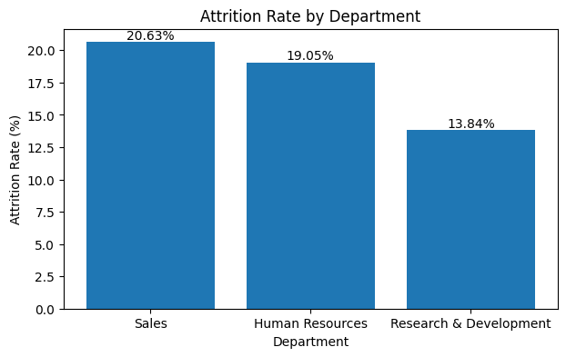

4.3 Attrition Rate by Overtime
A bar chart was used to compare attrition rates between employees who worked overtime and those who did not.
Employees who worked overtime had an attrition rate of 30.53%, compared with 10.44% for employees who did not work overtime.
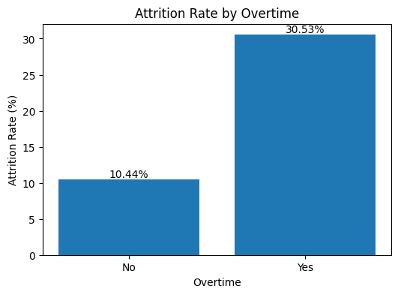

4.4 Attrition Rate by Job Role
A horizontal bar chart was used to compare attrition rates across different job roles.
Sales Representatives had the highest attrition rate at 39.76%, while Research Directors had the lowest rate at 2.50%. The chart shows considerable variation in attrition rates across job roles.
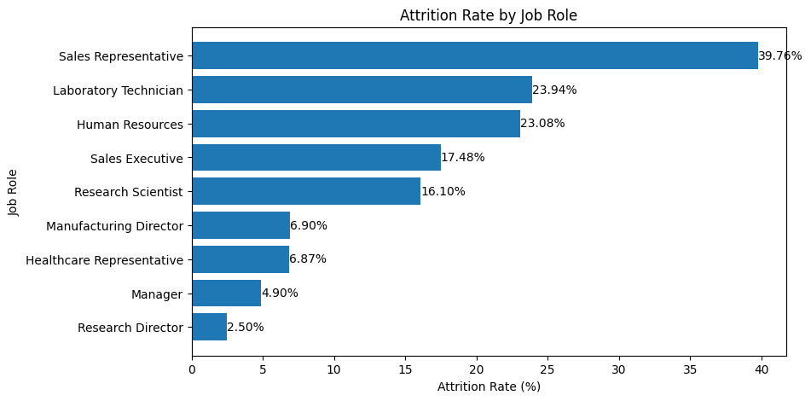

4.5 Attrition Rate by Monthly Income
A bar chart was used to compare attrition rates across the four monthly income groups.
The Low income group had the highest attrition rate at 29.27%, while the Very High income group had the lowest rate at 10.33%.
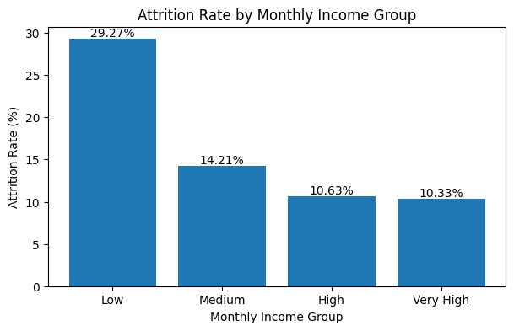

4.6 Attrition Rate by Total Working Experience
A bar chart was used to compare attrition rates across different total working experience groups.
Employees with 0–5 years of total work experience had the highest attrition rate at 28.80%, while employees with 21+ years of experience had the lowest rate at 7.73%.
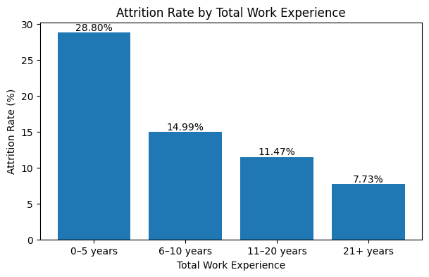

- KEY FINDINGS & BUSINESS INSIGHTS
5.1 Key Findings
The analysis identified several important patterns in employee attrition:
• The overall employee attrition rate was 16.12%, with 237 out of 1,470 employees having left the company.
• Employees who worked overtime had a higher attrition rate of 30.53%, compared with 10.44% among employees who did not work overtime.
• The Sales department had the highest attrition rate among the three departments at 20.63%, while Research & Development had the lowest at 13.84%.
• Sales Representatives had the highest attrition rate among the analyzed job roles at 39.76%, while Research Directors had the lowest at 2.50%.
• The Low income group had an attrition rate of 29.27%, while the Very High income group had the lowest rate at 10.33%.
• Employees with 0–5 years of total working experience had the highest attrition rate at 28.80%, while employees with 21+ years of experience had the lowest at 7.73%.
• Attrition rates also varied across job satisfaction levels and business travel categories.

5.2 Business Insights
The analysis indicates that employee attrition was not evenly distributed across the different groups examined.
The differences in attrition rates across overtime groups, job roles, income groups, departments, and experience groups can help identify employee segments that may require further investigation.
For example, the higher attrition rate observed among employees working overtime and among employees with 0–5 years of experience highlights areas that could be examined further using additional employee and workplace information.
These findings can support workforce analysis by helping organizations identify patterns and areas for further investigation. However, the analysis is descriptive and does not establish that any individual factor directly causes employee attrition.

6. TOOLS AND PROJECT WORKFLOW
6.1 Tools and Technologies
The following tools and technologies were used to complete this project:
- Python — Used for data analysis and calculations.
- Pandas — Used for data loading, cleaning, grouping, and analysis.
- Matplotlib — Used to create charts and visualize attrition patterns.
- Google Colab — Used to develop and execute the Python notebook.
6.2 Project Workflow
The project was completed through the following steps:
- Dataset Collection — The HR Analytics dataset was obtained from Kaggle.
- Data Loading — The dataset was loaded into Python using Pandas.
- Data Inspection — The dataset structure, columns, data types, and basic information were examined.
- Data Cleaning & Preparation — Missing values, duplicate records, categorical values, and constant columns were checked.
- Exploratory Data Analysis — Employee attrition was analyzed across different employee and workplace factors.
- Data Visualization — Charts were created using Matplotlib to present important patterns.
- Findings & Interpretation — The observed attrition patterns were summarized and interpreted.
- Conclusion — The major findings of the analysis were summarized.

7. LIMITATIONS
This project has some limitations that should be considered while interpreting the results:
- The analysis is descriptive and focuses on patterns present in the dataset. It does not establish that any particular factor directly causes employee attrition.
- The analysis is based on a single HR dataset, so the findings represent the employees included in this dataset and may not apply to every organization.
- The project focuses mainly on exploratory data analysis and visualization and does not include a predictive machine learning model for forecasting future employee attrition.
- Some columns in the dataset, such as EmployeeCount, Over18, and StandardHours, contained only one unique value and therefore were not useful for analytical comparisons.
- The analysis considers the available variables in the dataset. Other factors that may influence employee attrition may not be included in the dataset.

8. CONCLUSION
This project analyzed employee attrition patterns using the IBM HR Analytics dataset. Exploratory data analysis and data visualization were used to examine how attrition varied across different employee and workplace factors.
The analysis found an overall employee attrition rate of 16.12%. Higher attrition rates were observed among employees who worked overtime, employees in the Sales department, Sales Representatives, employees in the Low income group, and employees with 0–5 years of total working experience.
Attrition rates also varied across job satisfaction levels and business travel categories, showing that employee attrition was not evenly distributed across the different groups analyzed.
The project provided practical experience in using Python, Pandas, and Matplotlib for data cleaning, exploratory data analysis, visualization, and interpretation of results.
Overall, the project demonstrates how employee data can be analyzed to identify patterns and areas that may require further investigation. The findings are based on the available dataset and describe associations rather than proving direct causes of employee attrition.

9. REFERENCES
1. Kaggle — HR Analytics Dataset
https://www.kaggle.com/datasets/rishikeshkonapure/hr-analytics-prediction
2. Python Documentation
https://docs.python.org/3/
3. Pandas Documentation
https://pandas.pydata.org/docs/
4. Matplotlib Documentation
https://matplotlib.org/stable/

