EXECUTIVE HOTEL BOOKING
EXPLORATORY DATA ANALYSIS REPORT
Prepared for Management Review
Day 15 | Data Science Program — EDA Case Study
DATASET | Executive Hotel Booking Dataset (25,180 bookings)
SCOPE | 10 hotel locations · City & Resort hotels · 24 source countries
PERIOD COVERED | Bookings & arrivals spanning 2024–2026
OVERALL CANCELLATION RATE | 72.1% (Canceled + No-Show)
ANALYSIS TYPE | Univariate, bivariate, correlation & group-wise EDA

Executive Summary
This report presents an end-to-end exploratory data analysis (EDA) of 25,180 hotel bookings across 10 locations and two hotel types (City and Resort). The objective was to assess data quality, understand booking and cancellation behaviour, identify revenue and satisfaction drivers, and translate the findings into actionable recommendations for management.
The headline finding is that cancellations and no-shows account for 72% of all bookings in the dataset. Cancellation risk rises sharply with booking lead time and is highest among non-refundable-deposit bookings and Online TA / Group channels — patterns that point to concrete, fixable policy and process levers rather than random guest behaviour. Revenue and pricing (ADR) are concentrated in the Resort Hotel segment and a small set of top-performing leisure locations, while guest satisfaction tracks more closely with service responsiveness (special requests fulfilled) than with room price.
Five key insights and seven management recommendations are detailed in Sections 4 and 5. A companion Jupyter notebook contains the complete, reproducible analysis.

1. Data & Methodology

1.1 Dataset Overview
The dataset contains 35 attributes per booking, covering: hotel and location details, booking and arrival dates, lead time, guest composition, market segment and distribution channel, room type, deposit type, pricing (ADR), special requests, satisfaction score, cancellation status, and estimated revenue.

1.2 Analytical Workflow
- Data understanding — shape, structure, data types and summary statistics.
- Data quality assessment — missing values, duplicate records, inconsistent categorical values, illogical entries, and outliers.
- Data cleaning & preprocessing — deduplication, text standardization, type correction, missing-value treatment, and feature engineering (lead-time buckets, total guests, month fields).
- Descriptive statistics — central tendency and spread for all key numeric fields.
- Univariate analysis — distribution of hotel type, location, market segment, ADR, lead time and satisfaction.
- Bivariate & group-wise analysis — cancellation rate by hotel type, market segment, lead-time bucket and deposit type; revenue and ADR by location/hotel type; satisfaction by customer type and special requests.
- Correlation analysis — relationships between numeric features and cancellation likelihood.

2. Data Quality Findings
The raw dataset required cleaning before analysis. Key issues identified and resolved:
- 180 fully duplicated booking records (removed).
- Inconsistent category labels — e.g. 'City Hotel' / 'CITY HOTEL' / 'city hotel', and 'Online TA' / 'online ta' / 'ONLINE TA' — standardized to a single consistent format.
- Missing values across Hotel_Location, Country, Children, Agent_ID, Meal_Type, ADR and Satisfaction_Score (all under 2% of records) — imputed using median/group-median or explicit 'Unknown' categories as appropriate.
- Company_ID is missing for ~82% of bookings by design (most bookings are not corporate-billed); this was converted into a Has_Company flag rather than imputed.
- One Satisfaction_Score value exceeded the valid 1–5 scale and 6 bookings showed an arrival date before the booking date — both treated as data-entry errors and corrected to missing.
- ADR, lead time and total nights each contain a modest share of statistical outliers (high-value or long-stay bookings); these were retained as genuine business cases and flagged rather than removed.
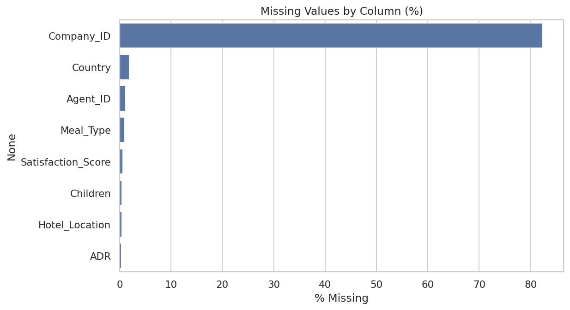
Figure 1 — Missing values by column (% of total records) before cleaning.

3. Key Visual Findings

3.1 What Drives Cancellations
Cancellation rate rises from ~43% for last-minute bookings (0–7 days lead time) to over 85% for bookings made 180+ days in advance. Non-refundable-deposit bookings cancel at a markedly higher rate (~90%) than refundable or no-deposit bookings, and Online TA / Group channels cancel more than Direct or Corporate bookings.
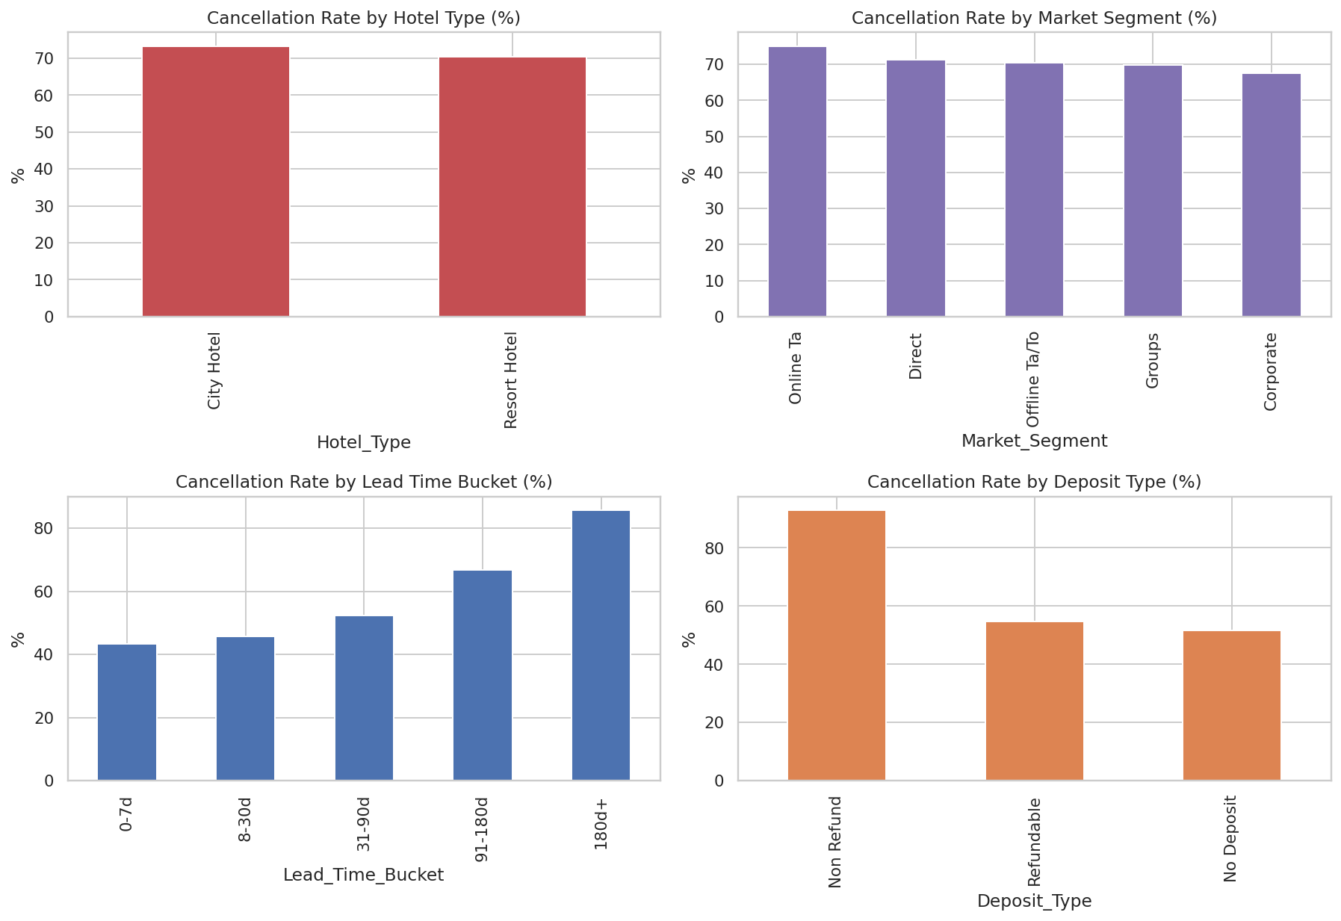
Figure 2 — Cancellation rate (%) by hotel type, market segment, lead-time bucket, and deposit type.

3.2 Revenue & Pricing Patterns
Average estimated revenue varies meaningfully by hotel location, and Resort Hotels command a notably higher average daily rate (ADR) than City Hotels, despite City Hotels taking a larger share of total bookings.
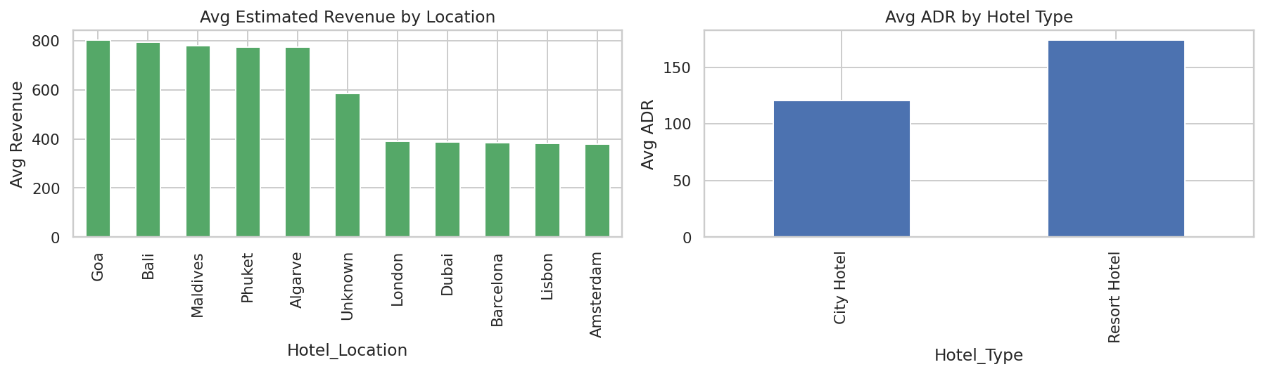
Figure 3 — Average estimated revenue by location and average ADR by hotel type.

3.3 Guest Satisfaction Drivers
Satisfaction differs modestly across customer types but increases steadily with the number of special requests a guest makes (and presumably has fulfilled), suggesting service responsiveness matters more than price in shaping the guest experience.
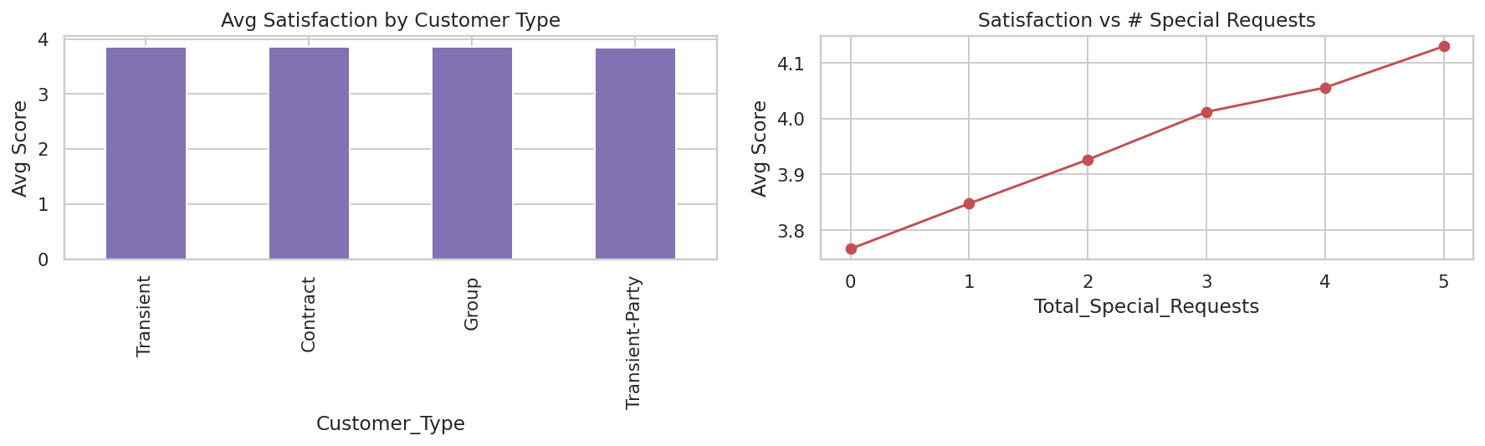
Figure 4 — Average satisfaction score by customer type and by number of special requests.

3.4 Seasonal Trend
Monthly arrival volume and cancellation rate move together — the busiest arrival months also tend to show elevated cancellation rates, consistent with speculative peak-season booking behaviour.
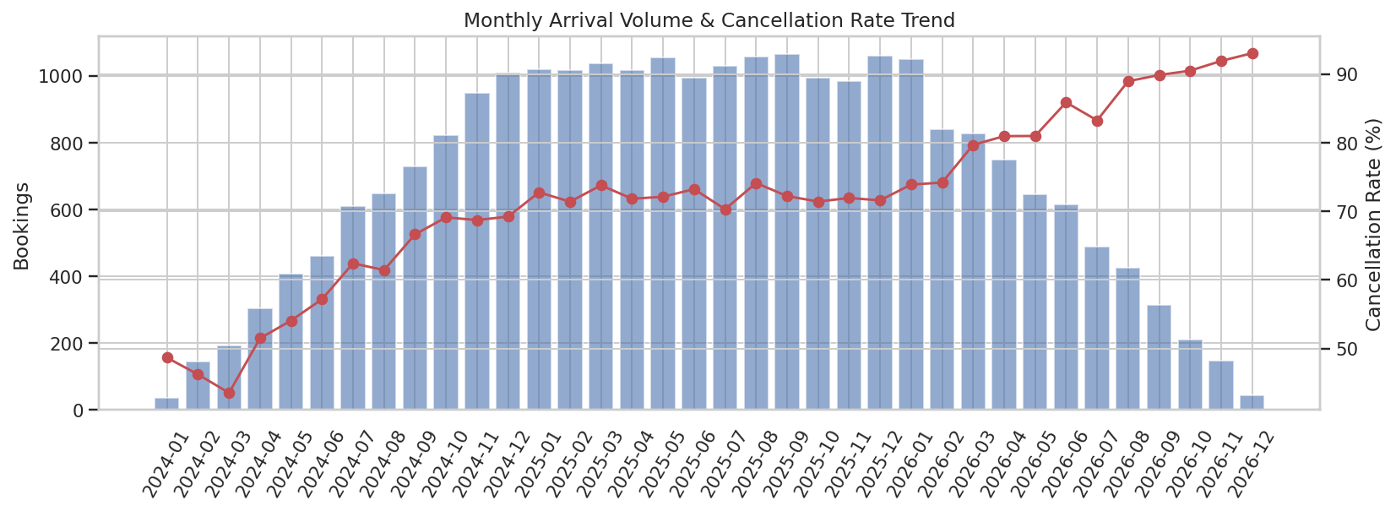
Figure 5 — Monthly arrival volume (bars) versus cancellation rate (line).

3.5 Correlation Overview
A correlation heatmap across numeric features shows lead time as the strongest positive correlate of cancellation, while previous cancellation history and booking changes also show meaningful relationships worth monitoring.
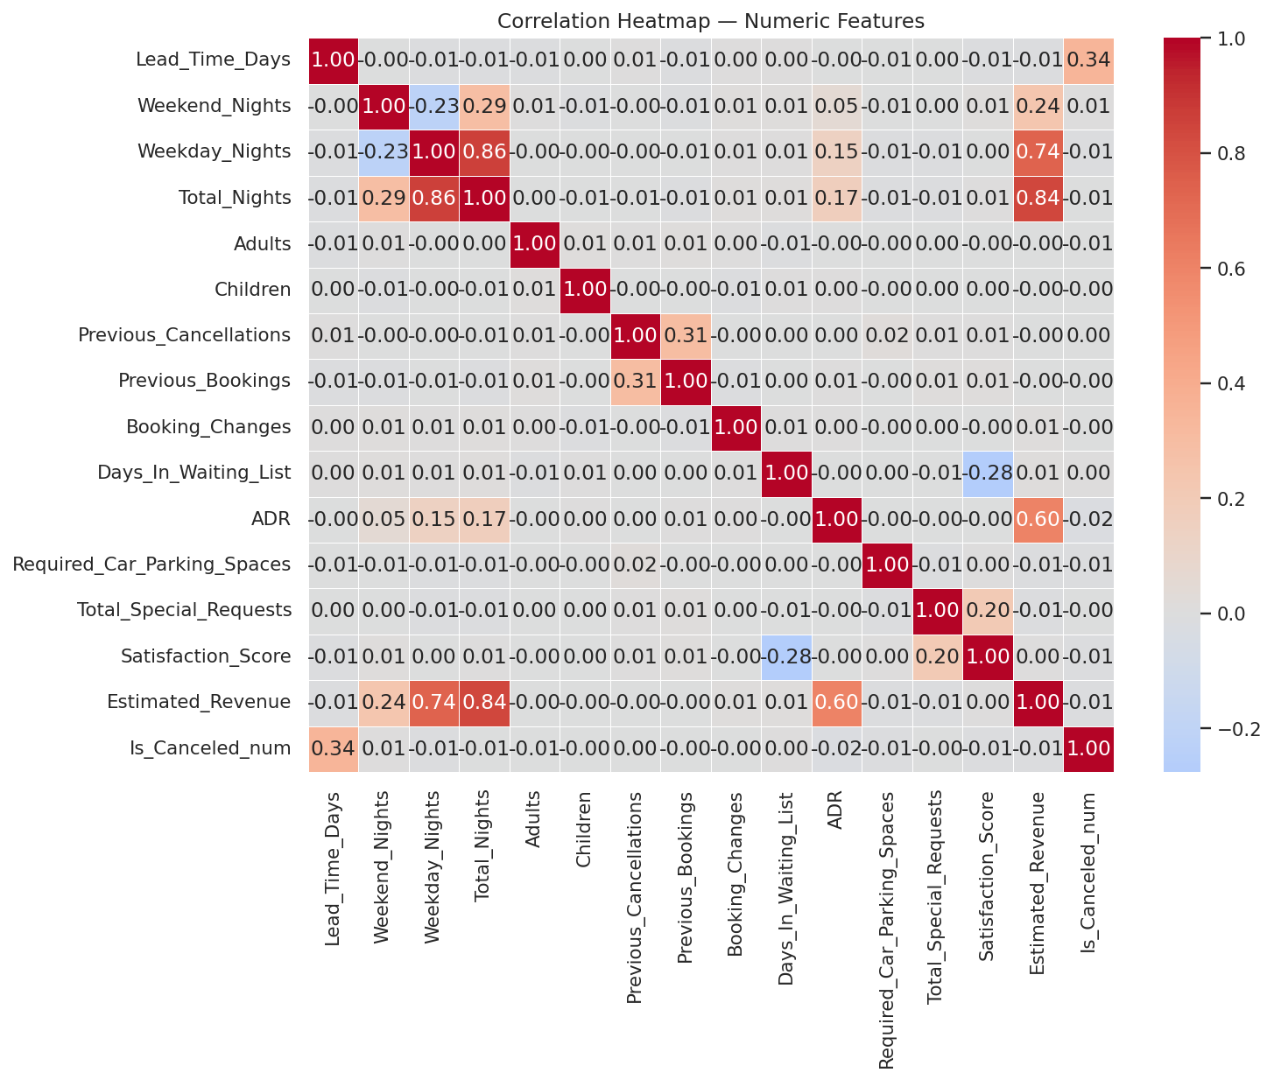
Figure 6 — Correlation heatmap of numeric booking features, including cancellation status.

4. Key Business Insights
- Cancellations are the single biggest revenue leak: 72% of bookings end in cancellation or no-show, concentrated in long-lead-time and non-refundable-deposit bookings.
- Market segment/channel is a leading indicator of cancellation risk: Online TA and Group bookings cancel more often than Direct or Corporate bookings.
- Pricing and revenue are concentrated: Resort Hotels earn a higher average ADR than City Hotels, and a subset of locations (led by beach/leisure destinations) drive disproportionately higher average revenue per booking.
- Guest satisfaction correlates more with service responsiveness (special requests fulfilled) than with room price.
- Booking volume and cancellation rate move together seasonally, pointing to peak-season overbooking or speculative reservations rather than random churn.

5. Recommendations for Management
- Tighten cancellation policy for long-lead-time bookings — require partial deposits or active confirmation for reservations made 90+ days out.
- Audit the non-refundable deposit product — its high cancellation rate suggests a policy, process, or fraud issue that needs investigation.
- Apply stricter confirmation controls on higher-risk channels (Online TA, Groups), such as card verification or shorter hold windows.
- Adopt location- and hotel-type-aware dynamic pricing, protecting the premium ADR of Resort properties and top-revenue locations while reviewing pricing strategy for underperforming City locations.
- Invest in front-line service personalization (proactively capturing and fulfilling special requests) rather than relying on price to drive satisfaction.
- Build a seasonal staffing and overbooking-buffer plan aligned to the identified high-volume, high-cancellation months.
- Fix data capture at source — standardize dropdown values for Hotel Type, Market Segment and Meal Type, and add validation rules (e.g. satisfaction score bounds, date-order checks) to prevent recurrence of the data quality issues found in this analysis.

6. Appendix
The complete, reproducible analysis — including all code, additional charts, and intermediate outputs — is provided in the companion Jupyter notebook: Hotel_Booking_EDA.ipynb.

