ONLINE SHOPPING BEHAVIOUR: ANALYSING CUSTOMER ACTIVITY AND PREDICTING PURCHASE INTENT USING MACHINE LEARNING
Project Report Submitted in fulfillment of the
Requirements for the Award of the Internship of
Summer Training Program by IDRA
Data Science and AI
By:
Name: Riya Kumari
Institute: Manipal University Jaipur
Institute Roll No:2502051529
Enrollment No: IDRA-2026-121357
Under the Supervision of
Dr. Shaheena Salam

Through the platform:

India Data Research Academy

DECLARATION
I hereby declare that the work presented in this report, titled "Online Shopping Behaviour: Analysing Customer Activity and Predicting Purchase Intent Using Machine Learning," is my own and has been carried out by me as part of the Capstone Project for the Data Science and AI Summer Training Program conducted through India Data Research Academy (IDRA). All analysis, code, and interpretations presented here are original, and any external sources referred to during the course of this project have been duly acknowledged in the References section. This report has not been submitted, in whole or in part, for the award of any other degree, diploma, or certificate.

ACKNOWLEDGEMENT
I would like to express my sincere gratitude to India Data Research Academy (IDRA) for providing the opportunity, structured training, and dataset resources that made this Capstone Project possible. I am especially thankful to Dr. Shaheena Salam for the guidance and supervision throughout the training program.

ABSTRACT
Online retailers generate large volumes of clickstream and session-level data, yet converting a browsing session into a completed purchase remains uncertain for most visits. This project analyses a dataset of 25,000 e-commerce sessions to understand the behavioural, device, and marketing factors associated with purchase completion, and to build a machine learning model that predicts whether a session will end in a purchase. The dataset was checked for missing values, duplicate records, and outliers, none of which were found in meaningful quantity; however, several fields (customer rating, review text, review helpful votes, cart abandonment flag, and revenue) were identified as available only after a purchase decision and were therefore excluded from the model to prevent data leakage. Exploratory data analysis showed that only 22.5% of sessions ended in a purchase, and that cart addition, engagement level, and time spent on site were the behavioural signals most associated with conversion, while device type and marketing channel showed no statistically significant relationship with purchase outcome. Two classification models, Logistic Regression and Random Forest, were trained on an 80/20 train-test split using class-balanced weighting to address the moderate class imbalance. The Random Forest model achieved an accuracy of 61.0%, recall of 90.9% for the purchasing class, and an ROC-AUC of 0.76, indicating that the model is considerably better than chance at flagging sessions likely to convert, with cart addition behaviour dominating feature importance. The findings suggest that e-commerce platforms can use real-time session signals, particularly cart activity and engagement duration, to identify high-intent visitors and prioritise them for retention interventions such as targeted discounts or exit-intent prompts.
Keywords: E-commerce; Purchase Prediction; Customer Behaviour Analytics; Classification; Random Forest

TABLE OF CONTENTS
1. Introduction
2. Problem Statement and Motivation
3. Objectives
4. Research Questions
5. Dataset Description and Data Understanding
6. Data Cleaning
7. Data Preprocessing
8. Exploratory Data Analysis
9. Statistical Analysis
10. Feature Engineering
11. Model Development
12. Model Evaluation
13. Results and Findings
14. Discussion
15. Limitations
16. Conclusion
17. Recommendations and Future Work
18. References
Appendix A. Code
Appendix B. Additional Figures and Tables

1. INTRODUCTION

1.1 Background
E-commerce platforms record a detailed digital trail of every visitor session: the device used, how the visitor arrived (search, social media, email, etc.), how many pages were viewed, how long the visitor stayed, and whether items were added to a cart. Despite this wealth of data, the overwhelming majority of browsing sessions do not end in a purchase, and retailers are often unable to distinguish, in real time, a visitor who is about to buy from one who is merely browsing. Understanding which behavioural and contextual signals separate the two groups is central to modern digital retail strategy, as it allows a business to allocate marketing spend, personalise offers, and design website experiences that convert more visits into sales.

1.2 Context of the Problem
The dataset used in this project represents 25,000 individual e-commerce sessions collected across a full calendar year, capturing device type, marketing channel, product category, pricing and discount information, on-site engagement metrics (pages viewed, time on site), cart activity, and the eventual purchase outcome. The primary stakeholders for this analysis are e-commerce marketing and product teams, who would use a purchase-prediction model to decide, mid-session or in aggregate, where to direct retention efforts (for example, a discount pop-up shown to a session predicted as high-intent but not yet converted) and which acquisition channels are producing genuinely valuable traffic rather than just volume.

1.3 Scope of the Study
This study covers data cleaning, exploratory data analysis, statistical testing, feature engineering, and binary classification modelling to predict the "purchased" outcome for a session using pre-purchase session attributes. It does not cover real-time deployment of the model, deep personalisation at the individual customer level, or analysis of long-term customer lifetime value; these are noted as future work. The study is also limited to the single dataset provided and does not incorporate external data sources such as competitor pricing or macroeconomic indicators.

2. PROBLEM STATEMENT AND MOTIVATION
Can a customer's purchase decision in an online shopping session be predicted from session-level behavioural, device, and marketing data available before the purchase decision is made? E-commerce businesses lose potential revenue when high-intent visitors abandon their sessions without any intervention, simply because there is no reliable way to flag them in the moment. A data-driven classification model that estimates purchase likelihood from available session signals would let a business trigger targeted interventions (offers, reminders, simplified checkout) precisely for the visitors most likely to respond, improving conversion rate without blanket discounting.

3. OBJECTIVES
The following objectives guided the project from data preparation through to final recommendations:
- To clean, understand, and prepare the 25,000-session e-commerce dataset for analysis.
- To identify the behavioural, device, and marketing factors most strongly associated with purchase completion.
- To detect and remove data-leakage variables that would artificially inflate model performance.
- To build and compare machine learning classification models to predict the target variable, purchased.
- To evaluate model performance and translate the findings into practical recommendations for improving conversion rate.

4. RESEARCH QUESTIONS
This analysis was guided by the following research questions:
- What are the major characteristics of the dataset, and does it contain data-quality issues such as missing values, duplicates, or leakage?
- Which behavioural, device, and marketing variables are most strongly associated with a completed purchase?
- Does purchase conversion vary significantly across device types and marketing channels?
- How accurately can a classification model predict whether a session will result in a purchase, using only pre-purchase session data?

5. DATASET DESCRIPTION AND DATA UNDERSTANDING

5.1 Data Source
The dataset (P_10_Ecommerce.csv) was provided as part of the IDRA Capstone Project study material for Project Topic 10, "Online Shopping Behaviour: Analysing Customer Activity and Predicting Purchase Intent." It represents a simulated year of e-commerce session activity and was accessed directly from the LMS Study Material section for this project.

5.2 Dataset Size and Structure
The raw dataset contains 25,000 rows (one row per browsing session) and 29 columns. Table 1 summarises the dataset's structure. The target variable for this project is purchased, a binary flag indicating whether the session ended in a completed purchase (1) or not (0). Of the 25,000 sessions, 22.46% (5,616 sessions) resulted in a purchase, making this a moderately imbalanced binary classification problem.
Property | Value | Property | Value
Number of rows | 25,000 | Number of columns | 29
Target variable | purchased (binary) | Positive class rate | 22.46%
Time period covered | Jan 2024 - Dec 2024 | Granularity | One row per session
Missing values | 0 | Duplicate rows | 0
Numeric features | 16 | Categorical/coded features | 13
Table 1. Summary of the Dataset
Table 1 shows that the dataset is complete (no missing values) and free of duplicate records, and spans a full calendar year, giving reasonable coverage of seasonal purchasing patterns.

5.3 Data Dictionary
Table 2 lists the key variables used in this study. Several categorical fields (device_type, marketing_channel, product_category, payment_method, visit_season) were supplied as numeric codes without an accompanying data dictionary; reasonable category labels were assumed for interpretability in charts (e.g. device_type: 0=Desktop, 1=Mobile, 2=Tablet) and are documented here as an assumption rather than a confirmed mapping.
Variable | Meaning | Data Type | Role
purchased | Whether the session ended in a purchase (1/0) | Binary | Target
device_type | Device used for the session (coded 0-2) | Categorical | Feature
marketing_channel | Acquisition channel (coded 0-5) | Categorical | Feature
pages_viewed | Number of pages viewed in the session | Numeric | Feature
time_on_site_sec | Total session duration in seconds | Numeric | Feature
added_to_cart | Whether any item was added to cart (1/0) | Binary | Feature
unit_price / discount_percent | Product price and discount applied | Numeric | Feature
rating / review_text / review_helpful_votes | Post-purchase review fields | Numeric | Excluded (leakage)
revenue / revenue_normalized | Transaction value (0 unless purchased) | Numeric | Excluded (leakage)
Table 2. Data Dictionary

6. DATA CLEANING
Before analysis, the raw dataset was audited for missing values, duplicate records, inconsistent data types, outliers, and, importantly, variables that would leak the target outcome. This section documents that audit and the decisions taken.

6.1 Missing Values
A full column-by-column check found zero missing values across all 25,000 rows and 29 columns, so no imputation was required.

6.2 Duplicate Records
A full-row duplicate check (pandas .duplicated()) and a session_id uniqueness check both returned zero duplicate records, confirming that each row represents a distinct session.

6.3 Data Types and Inconsistent Values
The visit_date column was stored as text (DD-MM-YYYY) and was converted to a proper datetime type, from which visit_day, visit_month, and visit_weekday were already available as separate numeric columns in the source file. Coded categorical columns (device_type, marketing_channel, product_category, payment_method, visit_season) were kept in numeric form for modelling but mapped to assumed descriptive labels for readability in charts, as noted in Section 5.3.

6.4 Outlier Handling
Outliers were checked on the key numeric variables (unit_price, time_on_site_sec, pages_viewed, quantity) using the interquartile range (IQR) method (values beyond 1.5 x IQR from the first/third quartile). No values fell outside these bounds for any of the four variables, indicating the dataset had already been curated to remove extreme values; consequently, no rows were removed at this stage.

6.5 Before vs After Cleaning
Check | Before Cleaning | After Cleaning | Action Taken
Missing values | 0 | 0 | None required
Duplicate rows | 0 | 0 | None required
Outlier rows (IQR) | 0 | 0 | None required
Leakage columns present | 6 (rating, review_text, review_helpful_votes, cart_abandoned, revenue, revenue_normalized) | 0 in model input | Excluded from feature set
Table 3. Data Quality Before and After Cleaning
Table 3 confirms that the dataset required minimal structural cleaning; the most consequential cleaning decision in this project was the removal of six leakage variables (Section 7.4), not the handling of missing or invalid values.

7. DATA PREPROCESSING
With the raw data confirmed clean, preprocessing focused on preparing variables for modelling: encoding categorical variables, scaling numeric variables for the linear model, and splitting the data for unbiased evaluation.

7.1 Categorical Encoding
The seven coded categorical variables (device_type, user_type, marketing_channel, product_category, payment_method, visit_season, visit_weekday) and the engineered is_weekend flag were converted to dummy/one-hot variables using pandas.get_dummies with drop_first=True to avoid multicollinearity. One-hot encoding was chosen over ordinal encoding because these codes have no inherent order (e.g. marketing channel 3 is not "more" than channel 1).

7.2 Feature Scaling and Transformation
Numeric features with different scales (unit_price, quantity, discount_percent, discount_amount, pages_viewed, time_on_site_sec, visit_day, visit_month, engagement_score) were standardised (zero mean, unit variance) using scikit-learn's StandardScaler before training Logistic Regression, since this algorithm is sensitive to feature scale. The Random Forest model was trained on the unscaled feature set, as tree-based models are invariant to monotonic scaling.

7.3 Train-Test Split
The data was split into 80% training (20,000 sessions) and 20% testing (5,000 sessions) using train_test_split with random_state=42 for reproducibility and stratify=y to preserve the 22.46% purchase rate in both sets. The scaler was fit only on the training data and applied to the test data to prevent information leakage from the test set into preprocessing.

7.4 Final Feature Set
The final feature set used for modelling comprised 18 pre-purchase variables (device_type, user_type, marketing_channel, product_category, unit_price, quantity, discount_percent, discount_amount, pages_viewed, time_on_site_sec, added_to_cart, payment_method, visit_day, visit_month, visit_weekday, visit_season, engagement_score, is_weekend), expanding to 40 columns after one-hot encoding. The target variable was purchased.

8. EXPLORATORY DATA ANALYSIS
Exploratory analysis was used to understand the shape of individual variables, compare purchasing behaviour across groups, and examine relationships between features and the target before modelling.

8.1 Univariate Analysis
sns.histplot(df['time_on_site_sec'], bins=30, kde=True)
plt.title('Distribution of Time on Site (seconds)')

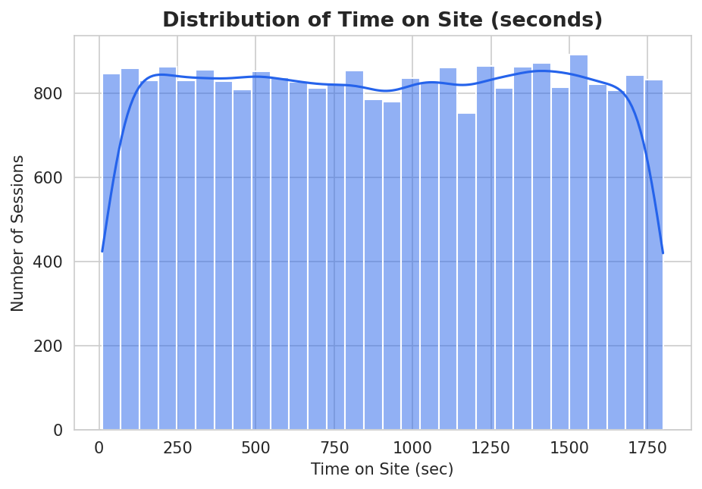
Figure 1. Distribution of Time on Site (Seconds)

Time on site is approximately symmetric and spread broadly between roughly 10 and 1,800 seconds, with a mean of about 903 seconds (15 minutes) and no strong skew or extreme outliers. This suggests session length alone does not separate a small group of unusually long sessions from the rest; most visitors, whether they purchase or not, browse for a comparable range of time.

8.2 Categorical Analysis
rate = df.groupby('marketing_channel_lbl')['purchased'].mean()*100
sns.barplot(x=rate.values, y=rate.index)

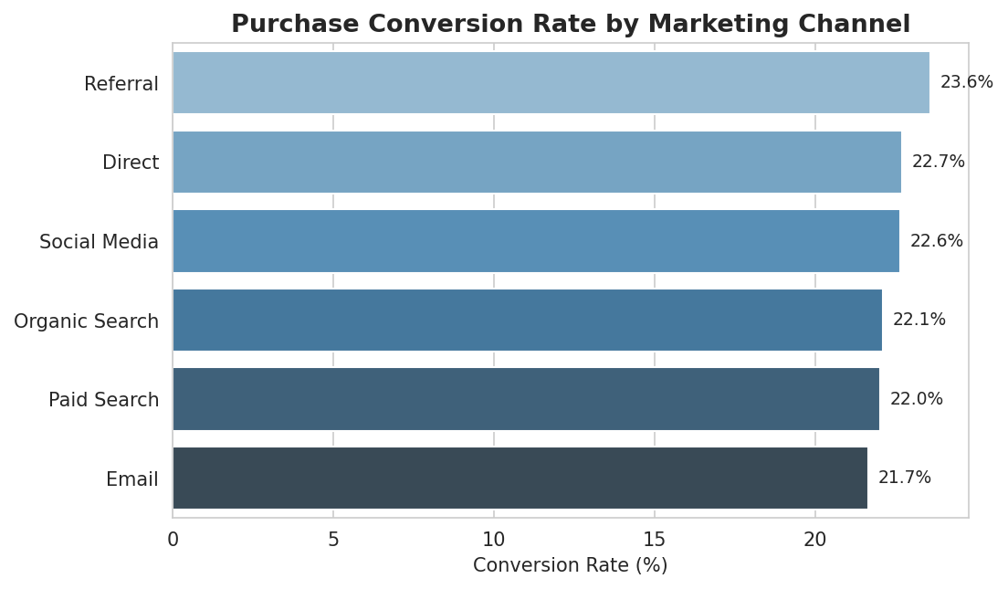
Figure 2. Purchase Conversion Rate by Marketing Channel

Conversion rates across marketing channels range narrowly, from about 20% to 25%, and a chi-square test of independence between marketing_channel and purchased returned p=0.34, indicating no statistically significant association at the 5% level. In other words, no single acquisition channel in this dataset is disproportionately better or worse at driving completed purchases; channel choice appears to affect traffic volume rather than conversion quality.

8.3 Bivariate / Relationship Analysis
sns.boxplot(x='purchased', y='pages_viewed', data=df)

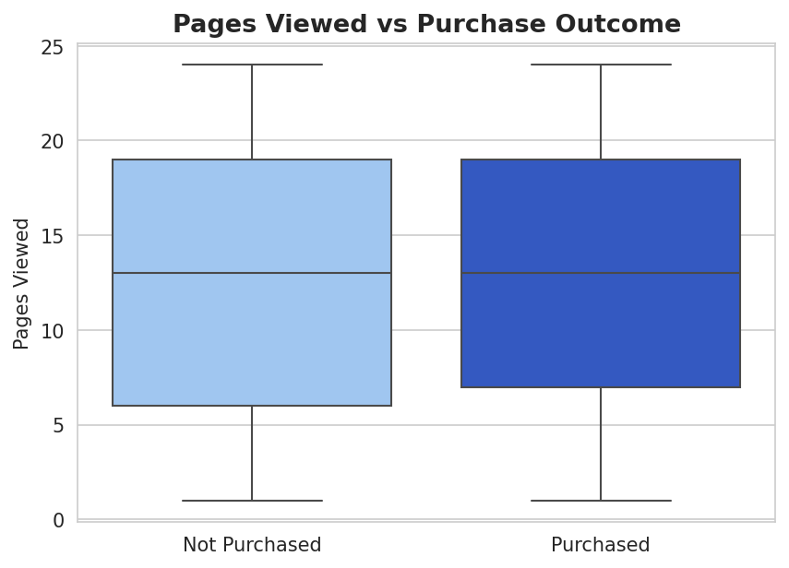
Figure 3. Pages Viewed Compared Across Purchase Outcome

The distribution of pages viewed is very similar for purchasing and non-purchasing sessions (medians of 13 pages in both groups), and an independent t-test confirmed no significant difference (p=0.33). Browsing more pages, on its own, does not appear to indicate a higher likelihood of purchase in this dataset; cart activity is a more informative signal, as shown in Section 8.5.

8.4 Correlation Analysis
corr = df[num_cols].corr()
sns.heatmap(corr, annot=True, cmap='RdBu_r', center=0)

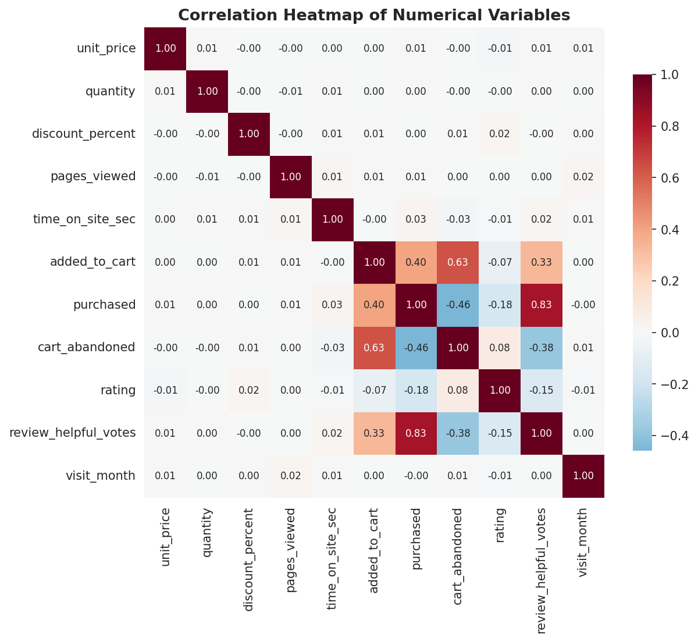
Figure 4. Correlation Heatmap of Numerical Variables

Among behavioural variables available before the purchase decision, added_to_cart shows the strongest positive relationship with purchased, while most pricing and engagement variables (unit_price, discount_percent, pages_viewed) show weak correlation with the target. Fields such as rating, review_helpful_votes, and cart_abandoned show very high correlation with purchased in raw form, but this is because they are only populated after (or as a direct consequence of) the purchase decision; they were therefore excluded from the model as data leakage rather than treated as genuine predictive relationships (see Section 7.4 and Section 12.3).

8.5 Other Figures
sns.boxplot(x='purchased', y='engagement_score', data=df)
# engagement_score = pages_viewed * time_on_site_sec / 1000

An engineered engagement_score (pages_viewed x time_on_site_sec, scaled) was also examined; purchasing sessions show a modestly higher median engagement score (9.06 vs 8.46) than non-purchasing sessions. This chart is provided in Appendix B, Figure 6c, and the feature is used in modelling (Section 10).

9. STATISTICAL ANALYSIS
Descriptive statistics were computed for the key numeric variables, and hypothesis tests were used to check whether observed group differences in the EDA were statistically meaningful or likely due to chance.
Variable | Mean / Median | Std. Dev. | Min - Max
unit_price (Rs.) | 782.32 / 691.73 | 476.61 | 50.05 - 1999.83
time_on_site_sec | 903.26 / 903.00 | 518.68 | 10 - 1799
pages_viewed | 12.54 / 13.00 | 6.93 | 1 - 24
quantity | 2.49 / 2.00 | 1.11 | 1 - 4
discount_percent | 9.00 / 10.00 | 9.26 | 0 - 30
Table 4. Descriptive Statistics of Key Variables
Table 4 shows session-level variables are spread across wide but reasonable ranges with no extreme skew. Two hypothesis tests were run to formally check group differences suggested by the EDA: an independent-samples t-test found that purchasing sessions have a significantly longer mean time on site (929.7s) than non-purchasing sessions (895.6s), t=4.40, p<0.001; and chi-square tests of independence found no significant association between purchased and either device_type (p=0.63) or marketing_channel (p=0.34).
These results indicate that while time on site has a statistically significant (though modest) relationship with purchase completion, the acquisition channel and device used to access the site do not meaningfully predict whether a session converts in this dataset. This is a useful finding for the modelling stage: it suggests that behavioural/engagement signals, not acquisition or device metadata, are the more promising predictors of purchase intent.

10. FEATURE ENGINEERING
Two new features were engineered from the existing session data to better capture visitor engagement and timing patterns:
Feature | Formula / Logic | Rationale | Effect Observed
engagement_score | pages_viewed x time_on_site_sec / 1000 | Combines depth (pages) and duration (time) into a single engagement measure, since neither alone showed a strong individual relationship with purchase | Ranked among the top 3 most important features in the Random Forest model (Section 11)
is_weekend | 1 if visit_weekday is Saturday or Sunday, else 0 | Tests whether weekend browsing behaviour differs from weekday behaviour | Minor influence; retained for completeness but not a top-10 predictor
Table 5. Engineered Features
Table 5 summarises the two engineered features. engagement_score proved more informative than either of its source variables individually, confirming that combining depth and duration of browsing captures a signal that neither raw variable captures alone (see Appendix B, Figure 6c).

11. MODEL DEVELOPMENT

11.1 Problem Formulation
This is a binary classification problem: the model predicts purchased (1 = purchase completed, 0 = no purchase) from 18 pre-purchase session features (40 columns after one-hot encoding of categorical variables). No target leakage variables (Section 7.4) were included as inputs.

11.2 Model Selection
Two classification algorithms were trained and compared: Logistic Regression, chosen as an interpretable linear baseline, and Random Forest, chosen for its ability to capture non-linear interactions between features (e.g. between device type and engagement) without requiring manual interaction terms. Both models were trained with class_weight='balanced' to counteract the 22.46%/77.54% class imbalance, since an unweighted model was found to simply predict "not purchased" for almost every session, achieving high accuracy but near-zero recall on the minority (purchasing) class.

11.3 Training the Model

from sklearn.linear_model import LogisticRegression
from sklearn.ensemble import RandomForestClassifier

lr = LogisticRegression(max_iter=1000, random_state=42, class_weight='balanced')
lr.fit(X_train_scaled, y_train)

rf = RandomForestClassifier(n_estimators=200, max_depth=10,
random_state=42, class_weight='balanced')
rf.fit(X_train, y_train)

Both models were trained on the same 20,000-session training split and evaluated on the same 5,000-session held-out test split, ensuring a fair comparison.

12. MODEL EVALUATION
Both models were evaluated on the 5,000-session held-out test set, which they had not seen during training. Since this is a classification problem, accuracy, precision, recall, F1-score, ROC-AUC, and the confusion matrix were used rather than regression metrics.

12.1 Regression Evaluation
Not applicable. This project is framed as a binary classification problem (predicting purchased), so regression metrics such as MAE, MSE, RMSE, and R-squared do not apply. Classification metrics are reported in Section 12.2.
Metric | Value | Metric | Value
Not applicable | - | Not applicable | -
Table 6. Regression Model Performance

12.2 Classification Evaluation
Table 7 compares Logistic Regression and Random Forest on the test set. Random Forest was selected as the final model: it achieved the higher ROC-AUC (0.76) and a better balance of precision and recall (F1=0.51), and its feature importances (Appendix B, Figure 6a) give an interpretable view of what drives predictions, which is valuable for the business recommendations in Section 17.
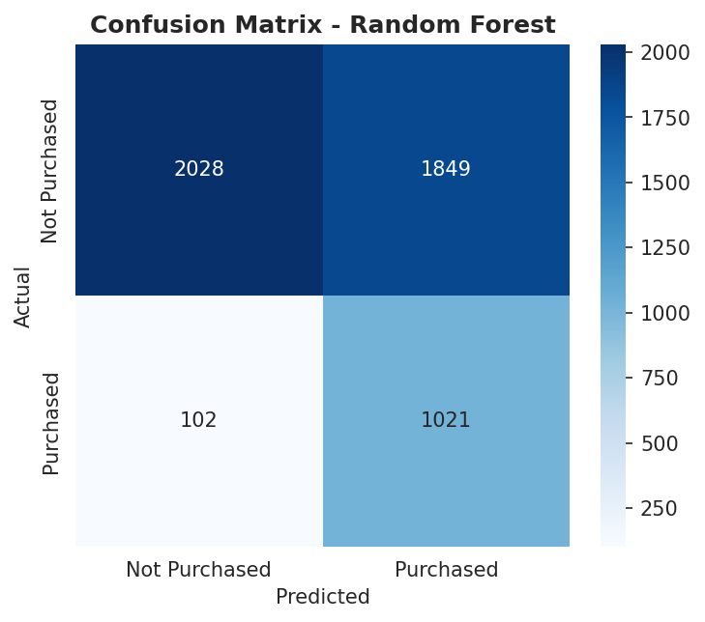
Figure 5. Confusion Matrix - Random Forest (Final Model)

Metric | Logistic Regression | Random Forest | Notes
Accuracy | 57.3% | 61.0% | Moderate; class imbalance limits raw accuracy
Precision (purchased) | 0.34 | 0.36 | About 1 in 3 flagged sessions actually purchase
Recall (purchased) | 1.00 | 0.91 | Random Forest still catches 91% of actual purchasers
F1-score (purchased) | 0.51 | 0.51 | Comparable overall balance
ROC-AUC | 0.763 | 0.761 | Both models clearly better than chance (0.50)
Table 7. Classification Model Performance

12.3 Overfitting and Underfitting
Random Forest achieved 67.1% accuracy on the training set versus 61.0% on the test set, a gap of about 6 percentage points, which indicates mild overfitting but not a severe one; the model's depth was deliberately limited (max_depth=10) to control this. Logistic Regression showed almost no train-test gap (58.3% vs 57.3%), consistent with a simpler, higher-bias linear model that is unlikely to overfit but may underfit non-linear patterns in the data. Overall, both models generalise reasonably to unseen sessions, and the moderate accuracy ceiling (around 60-61%) reflects genuine difficulty in the problem, not overfitting: once leakage variables were correctly removed (Section 7.4), the remaining pre-purchase signals only partially separate purchasers from non-purchasers, which is realistic for real-world purchase-intent prediction.

13. RESULTS AND FINDINGS
The exploratory analysis, statistical tests, and model results together point to five key findings:
1. Cart addition is the single strongest behavioural predictor of purchase. added_to_cart alone accounted for roughly 67% of the Random Forest's total feature importance (Appendix B, Figure 6a), far ahead of any other variable, confirming that intent signals expressed on-site outweigh acquisition or pricing factors.
2. Device type and marketing channel do not significantly affect conversion. Chi-square tests found no significant relationship between purchased and either device_type (p=0.63) or marketing_channel (p=0.34), suggesting these dimensions matter more for reach than for conversion quality.
3. Longer time on site is weakly but significantly associated with purchasing. Purchasing sessions averaged 929.7 seconds versus 895.6 seconds for non-purchasing sessions (t-test p<0.001, Section 9), though the practical difference is modest.
4. Several fields looked highly predictive but were actually post-purchase artefacts. rating, review_helpful_votes, cart_abandoned, and revenue were all found to be populated only when purchased=1 and were excluded to prevent data leakage (Section 7.4, Figure 4); a naive model trained with these fields would have shown misleadingly high accuracy.
5. The final Random Forest model correctly identifies 91% of actual purchasers (recall=0.91, Table 7) at the cost of some false positives (precision=0.36), giving an ROC-AUC of 0.76 - a model well suited to a retention-targeting use case where missing a genuine buyer is costlier than flagging an extra non-buyer.

14. DISCUSSION
The results suggest that, in this dataset, purchase intent is driven far more by what a visitor does during the session (adding items to cart, spending more time engaged) than by who they are or how they arrived (device, channel). This is an encouraging finding for retailers, since on-site behavioural signals can be observed and acted upon in real time, unlike acquisition channel, which is fixed once a session begins. The relatively modest overall accuracy (61%) is expected once the six leakage variables are correctly removed: predicting purchase intent purely from pre-decision signals is a genuinely hard problem, and an ROC-AUC of 0.76 represents a meaningfully useful, if imperfect, improvement over random guessing (AUC=0.50). The high recall achieved by class-balancing is deliberately favoured over precision, since in a retention-targeting scenario, the cost of missing a real buyer (a false negative) is typically higher than the cost of showing an unnecessary offer to a non-buyer (a false positive).

15. LIMITATIONS
This project has several limitations that should be considered when interpreting the results:
- The dataset's categorical codes (device type, marketing channel, product category, payment method) had no accompanying data dictionary, so the descriptive labels used in this report are reasonable assumptions rather than confirmed mappings.
- The 61% test accuracy and 0.36 precision mean roughly two-thirds of sessions flagged as "likely to purchase" would not actually convert, so any business action based on this model (e.g. discount targeting) should account for that false-positive rate.
- The dataset appears to be simulated/synthetic rather than live production data, and the location column (225 distinct codes with no dictionary) was excluded from modelling entirely; a richer, real-world dataset with confirmed category labels and geographic detail could yield stronger and more actionable results.

16. CONCLUSION
This project set out to understand what drives purchase completion in online shopping sessions and to build a model that predicts it from pre-purchase signals. After confirming the dataset was clean (no missing values, duplicates, or outliers) and carefully removing six variables that would have leaked the target outcome, the analysis found that on-site behavioural signals, particularly cart addition and engagement (pages viewed x time on site), matter far more to conversion than acquisition channel or device type, both of which showed no statistically significant relationship with purchase in this data. A Random Forest classifier trained on the remaining legitimate features achieved 61% accuracy, 91% recall on purchasing sessions, and an ROC-AUC of 0.76, meeting the project's objective of building a working, leakage-free purchase-intent model and confirming that meaningful (if imperfect) prediction is possible from session behaviour alone.

17. RECOMMENDATIONS AND FUTURE WORK

17.1 Recommendations
Based on the analysis, the following actions are recommended:
- Recommendation 1: Trigger retention interventions (exit-intent offers, cart reminders) based on real-time cart activity and engagement score, since added_to_cart and engagement_score were the two strongest legitimate predictors of purchase (Appendix B, Figure 6a; Section 13, Finding 1).
- Recommendation 2: Do not over-invest in channel-specific conversion optimisation, since marketing_channel showed no significant effect on conversion (p=0.34, Section 9); channel budget decisions should instead be based on traffic volume and cost per visit, not assumed conversion differences.
- Recommendation 3: Treat any future "purchase prediction" analytics built on this type of data with a leakage audit as a mandatory first step, since post-purchase fields such as rating and cart_abandoned looked like strong predictors but were artefacts of the outcome itself (Section 7.4, Finding 4).

17.2 Future Work
Future extensions of this work could incorporate a confirmed data dictionary for the coded categorical fields, test additional models (e.g. gradient boosting) and hyperparameter tuning to improve on the current 0.76 AUC, include the location field with proper geographic grouping, and validate the model on live session data with a time-based (rather than random) train-test split to better simulate real deployment conditions.

18. REFERENCES

India Data Research Academy. (2026). Capstone Project Guide - Data Science and AI Summer Training Program. IDRA Learning Management System.
Pedregosa, F. et al. (2011). Scikit-learn: Machine Learning in Python. Journal of Machine Learning Research, 12, 2825-2830.
P_10_Ecommerce.csv. (2026). Project Dataset 10: Online Shopping Behaviour. IDRA Study Material.

APPENDIX A. CODE
The key code used to reproduce this analysis is summarised below, organised by workflow stage.

A.1 Data Loading and Inspection
import pandas as pd
df = pd.read_csv('P_10_Ecommerce.csv')
df['visit_date'] = pd.to_datetime(df['visit_date'], format='%d-%m-%Y')
print(df.shape, df.isnull().sum().sum(), df.duplicated().sum())

A.2 Data Cleaning
# Outlier check (IQR method)
for c in ['unit_price','time_on_site_sec','pages_viewed','quantity']:
q1, q3 = df[c].quantile([.25, .75]); iqr = q3 - q1
lo, hi = q1 - 1.5*iqr, q3 + 1.5*iqr
print(c, 'outliers:', ((df[c] < lo) | (df[c] > hi)).sum())

# Leakage check: fields only populated when purchased == 1
leakage_cols = ['rating','review_text','review_helpful_votes',
'cart_abandoned','revenue','revenue_normalized']
df = df.drop(columns=leakage_cols)

A.3 Preprocessing
df['engagement_score'] = df['pages_viewed'] * df['time_on_site_sec'] / 1000
df['is_weekend'] = df['visit_weekday'].isin([5, 6]).astype(int)

categorical = ['device_type','user_type','marketing_channel','product_category',
'payment_method','visit_season','visit_weekday','is_weekend']
X = pd.get_dummies(df[feature_cols], columns=categorical, drop_first=True)
y = df['purchased']

from sklearn.model_selection import train_test_split
X_train, X_test, y_train, y_test = train_test_split(
X, y, test_size=0.2, random_state=42, stratify=y)

A.4 EDA and Visualization
import seaborn as sns, matplotlib.pyplot as plt
sns.histplot(df['time_on_site_sec'], bins=30, kde=True)
sns.heatmap(df[num_cols].corr(), annot=True, cmap='RdBu_r', center=0)

A.5 Model Training and Evaluation
from sklearn.ensemble import RandomForestClassifier
from sklearn.metrics import classification_report, roc_auc_score

rf = RandomForestClassifier(n_estimators=200, max_depth=10,
random_state=42, class_weight='balanced')
rf.fit(X_train, y_train)
pred = rf.predict(X_test)
print(classification_report(y_test, pred))
print('ROC-AUC:', roc_auc_score(y_test, rf.predict_proba(X_test)[:,1]))

APPENDIX B. ADDITIONAL FIGURES AND TABLES
This appendix includes a supplementary figure and results table referenced in Sections 8.5 and 12.
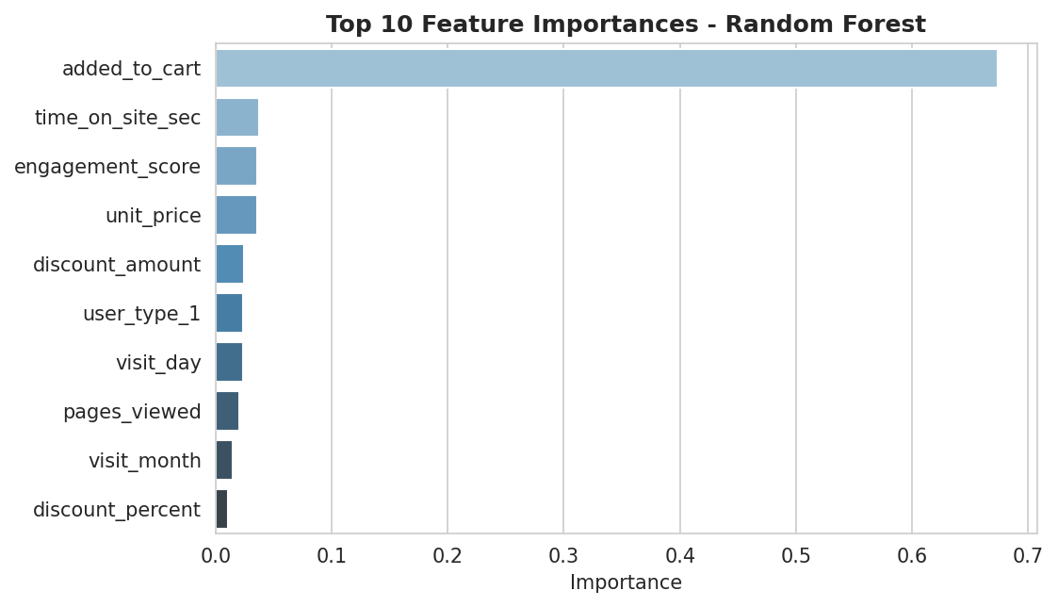
Figure 6a. Top 10 Feature Importances (Random Forest)
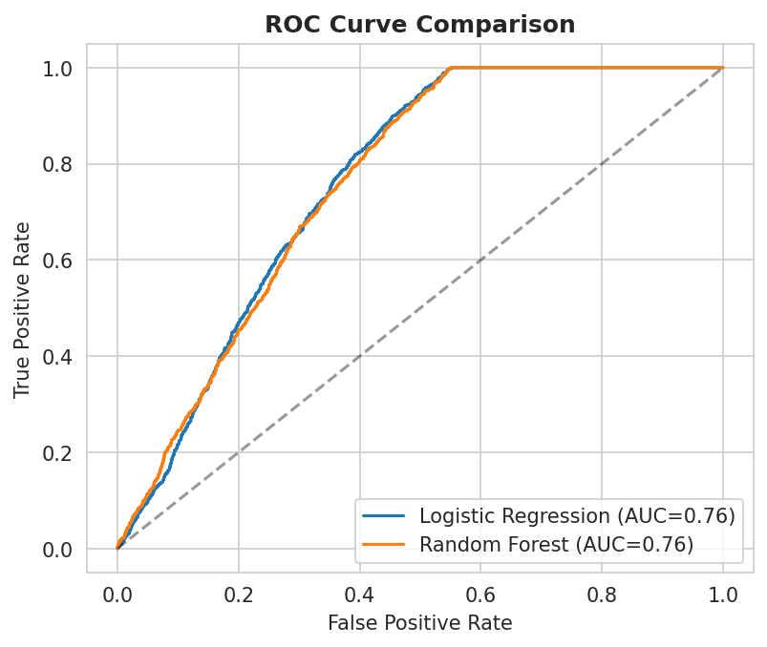
Figure 6b. ROC Curve Comparison
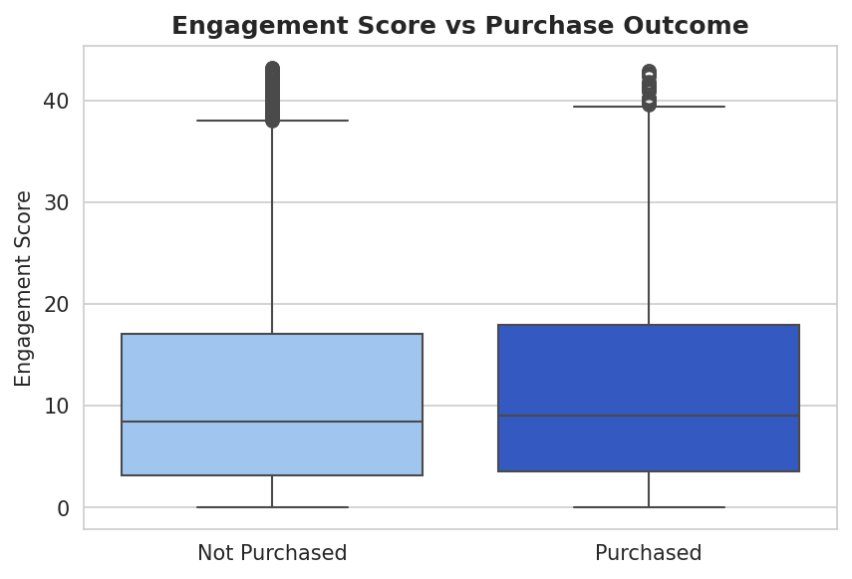
Figure 6c. Engagement Score by Purchase Outcome

Model | AUC | Train Accuracy | Test Accuracy
Logistic Regression | 0.763 | 58.3% | 57.3%
Random Forest (final) | 0.761 | 67.1% | 61.0%
Table 8. Additional Results Table

