Chapter 5 Backtracking
- Backtracking is a modified depth-first search of a tree

Depth-first search procedure in pg. 178
Fig 5.1
- State-space tree Fig 5.2
- A node is nonpromising if it cannot possibly lead to a solution. Otherwise, promising.
- Pruned state-space tree
- Backtracking do a depth-first search of a state-space tree,

Checking whether each node is promising
If it is nonpromising, backtrack to its parent
Algorithm checknode
- Example 5.1 & Figures 5.4 and 5.5
- A modified backtracking in page 184
We check whether a node is promising before passing it.
Procedure checknode(v:node);
Begin
If promising(v) then
If there is a solution at v then
Write the solution
Else
For each child u of v do
checknode(u)
End
End
End
End

Procedure expand(v:node);
Begin
For each child u of v do
If promising(u) then
If there is a solution at u then
Write the solution
Else
expand(u)
End
End
End
End

  - The n-Queens problem
- the design of promising function
Let col(i) denote the column where the queen in the i-th row is located.
the same column: col(i)=col(k)
threatening from the left: col(i)-col(k)=i-k
threatening from the left: col(i)-col(k)=k-i
Figure 5.6
- Algorithm 5.1
- Performance comparison
The size of the entire state-space tree
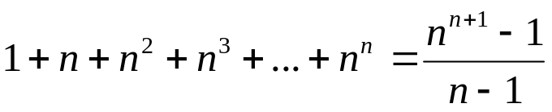
the maximum number of promising nodes
1+n+n(n-1)+n(n-1)(n-2)+…+n!
Table 5.1
  - Monte Carlo Algorithm
- we assume that nodes at the same level have the same number of children
t_{i} total number of children at level i
m_{i} the number of promising children for a randomly selected node at level i
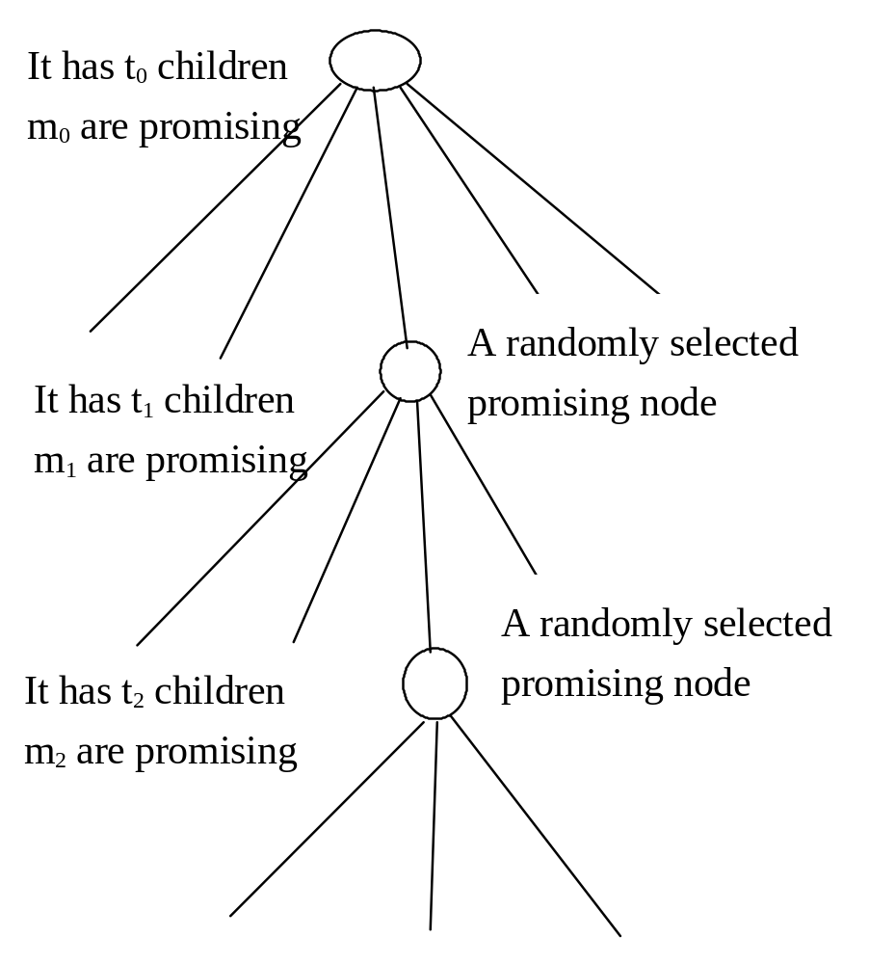
an estimate of the total number of nodes checked by the algorithm is
1+1×t₀+m₀t₁+m₀m₁t₂+m₀m₁m₂t₃+…
_{+m0m1….mi-1t}i
 | mprod | numnodes
公式 | mprod×m | numnodes+mprod×t
初始 | 1 | 1
第一層 | 1 | 1+1×t₀
第二層 | 1×m₀ | (1+t₀)+m₀t₁
第三層 | (m₀)m₁ | (1+t₀+m₀t₁) +m₀m₁t₂
第四層 | (m₀m₁)m₂ | (1+t₀+m₀t₁+m₀m₁t₂)+m₀m₁m₂t₃
第五層 | (m₀m₁m₂) m₃ | (1+t₀+m₀t₁+m₀m₁t₂+m₀m₁m₂t₃)+m₀m₁m₂ m₃t₄
Algorithm 5.2
Algorithm 5.3
When a Monte Carlo algorithm is used, the estimate should be run more then once, and the average of the results should be used as the actual estimate.
  - the sum-of-subset problem
- Problem: we have n positive integers, and we are to find all subsets that sum to W. Figure 5.2
- State-space tree in Figures 5.7 and 5.8
- Promising function design
Weight: the sum of weights that have been included up to a node at level i
Total: the total weight of the remaining weights
Sort all w_{i} such that w₁≤w₂≤…≤w_{n}
Then a node at level i in nonpromising
if weight+w_{i+1}>W or weight+total<W
Algorithm 5.4 & Example 5.4
Figure 5.9
- The number of nodes in state-space tree
1+2+2²+…+2^{n}=2^{n+1}-1
If we let 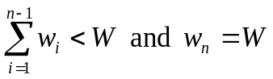 then worst case happen
  - Graph Coloring
- Problem: find all ways to color an undirected graph using at most m different colors so that no two adjacent nodes are the same color Example 5.5
- Application: map-coloring problem

Figure 5.11
- State-space tree in Figure 5.12
- Backtracking algorithm: Algorithm 5.5
- The total number of nodes in the tree
1+m+m²+…+m^{n}=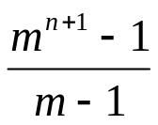
The worst case does happen if m=2 and
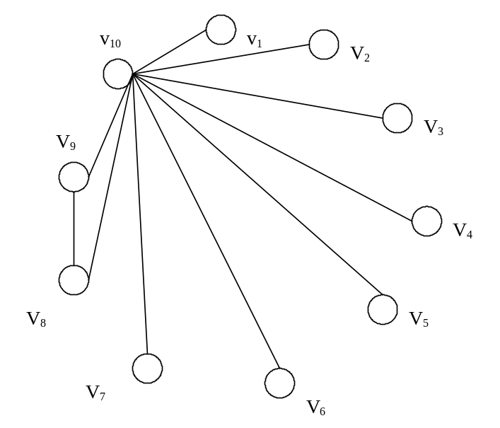
  - The hamiltonian circuit problem
- problem: is a path that visits each node exactly once and return to the starting node Figure 5.13
- promising function
the i-th node is adjacent to the (i+1)th node
the (n-1)th node is adjacent to the 0-th node
the i-th node cannot be in the first i-1 nodes
Algorithm 5.6

  - The 0-1 Knapsack problem
- a general algorithm for backtracking in case of optimization problem is in page 208
- promising function
items are sorted in nonincreasing order of p_{i}/w_{i}
weight: the sum of the weights of the items that have been included
profit: the sum of the profits of the items included up to the node
weight ≥ W is nonpromising and
bound ≤ maxprofit is nonpromising
we greedily grab items, adding their profits to bound and their weights to totweight until we get to an item that if grabed would bring totweight above W.
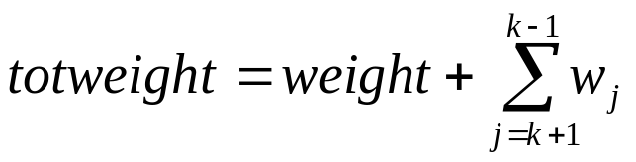
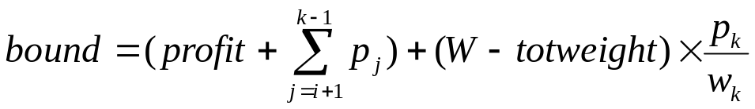
- Algorithm 5.7 and Example 5.6
- The state space tree has 2^{n+1}-1 nodes
The worst case does happen if
p_{i}=1 w_{i}=1 for 1≤i≤n-1
p_{n}=n w_{n}=n
W=n

