Testing chatbook

the quintessential basic



Riya Malushte

Pradyumna Roy

**Testing Chatbook**

Copyright © 2018 Pradyumna Roy

[**https://riyamalushte.github.io/testing/chatbook**](https://riyamalushte.github.io/testing/chatbook)

**E-ISBN** 978-93-5300-857-4

Pradyumna Roy asserts the moral right to be identified as the author of this work along with Riya Malushte as co-author.

Copies of this book or content may be made for your own use and for distribution to others, provided that each copy contains this Copyright Notice along with credits to the original author Pradyumna Roy and co-author Riya Malushte, whether distributed in print or electronically.

TAble of  
Contents

GENESIS 1

PRODUCT TESTING 8

TEST CASES 12

TEST EXECUTION 21

DEFECTS 25

MEET The Authors 30

TIPS 31

# GENESIS

**R:** Hi, I have joined the software testing team. You have been assigned my mentor. Can you please share some study material to start with?

**P:** Welcome onboard! You don't need any study material to start with.

**R:** Then?

**P:** God created testers first and then called them male and female 😀.

**P:** To start with, can you please list down different types of senses we have?

**R:** taste, touch, smell, hear, sight

**P:** Good. Now, visualize one Gupta Jee in a sweet shop, tasting different flavors of barfis and then settling down for 250 gms of jalebi 😜. Isn’t that a very common example of testing using the sense of taste 😃?

**R:** 😄😁

**P:** Now, think of a kid in a winter morning, touching the water in bucket to check if it’s too cold before taking bath. Sense of touch used for testing.

**P:** Here’s one for you. Imagine yourself at Shoppers Stop and trying different perfumes from samplers. Sense of smell used for testing.

**R:** So, I am already a tester 😇

**P:** Yes, you are 😀.

**P:** Another one. Kids in a village putting their ear on railway track to hear any sound to ascertain if a train is coming. That’s sense of hearing used for testing.

**P:** And the last one 😀. Think of one Das babu in Kolkata looking at the sky 🧐, to check if it’s cloudy, to decide on taking an umbrella before going out. Sense of sight used for testing.

**P:** So, what do you say? Didn’t God actually create testers with these 5 sense organs?

**R:** Yes, boss 👍. Perfect examples.

**P:** It's your turn to come up with some more examples.

**R:** OK, keeping in line with the examples shared earlier…here’s something that I have observed since childhood. Before going out, my father would put a big Godrej branded lock on the main door and he will pull the lock with lot of strength to make sure that it does not open up on pressure 😃.

**P:** Oh yeah, that still hold true for most of us 😃. Great example. That’s like a mechanical product going through rigorous testing on daily basis.

**R:** Here’s another one that I regularly do. Count the money after withdrawing money from a ATM machine and checking 🧐 correctness of amount of withdrawal and balance in the transaction slip.

**P:** There you go, 👍.

**R:** Have you ever travelled by local train?

**P:** Yes, 🤔.

**R:** Then you must remember checking the ticket for correctness of destination station, date of travel etc. Isn’t this also testing?

**P:** Yes, 👍.

**R:** Now, something which has "Test" in it…"**Test Drive**" of vehicles. Even though we are more or less pre-decided about the brand and model, but we still take a test drive. Needless to say, we end up testing some of the features of the vehicle for sure.

**P:** 😄😁

**R:** And the last one for the day…who can forget testing by scribbling on paper/newspaper in a stationery shop with different pens before buying one.

**P:** Perfect, perfect. You have really put forward some great examples of product testing on day to day basis. Great going 👍.

**P:**  A pictorial note on completing the session…😁.

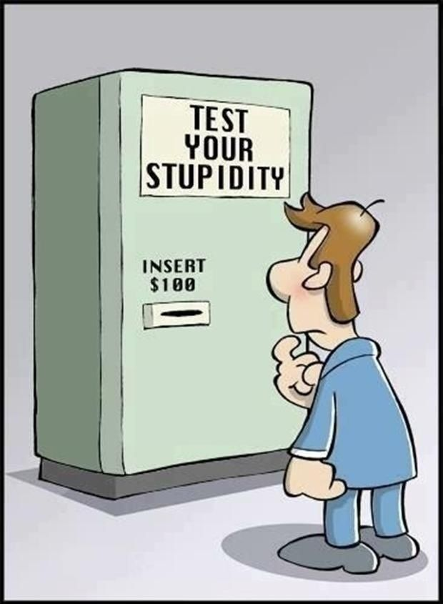

# PRODUCT TESTING

**P:** Let’s take first few steps towards becoming a pro 😁.

**P:** Please list down a few main features that you would like to test in a new mobile phone before purchasing.

**R:** (1.) Power on the phone, Switch Off the phone

**R:** (2.) Charge the phone

**R:** (3.) Make a call, Receive a call

**R:** (4.) Send SMS, Receive SMS

**R:** (5.) Connect to Internet

**P:** Good, 👍. So, if any of the above features is not working, we will not accept the phone for purchase. That is the bare minimum testing we must do. This set of tests which covers the most important features is called set of **Sanity Tests** or **Smoke Tests**.

**P:** Now list down a few features that are not most important but still helpful in operating the device.

**R:** (6.) Addition and Deletion of Contacts

**R:** (7.) Call logs or call history

**R:** (8.) Volume control

**R:** (9.) Bluetooth

**P:** And there can be many more such things within a phone to test. The point here is, a comprehensive set of tests which includes all the features of a product, like the most important ones, less important ones etc., is called set of **Regression Tests**.

**P:** Can you imagine anything to test the performance of the phone?

**R:** (10.) Battery of the phone. If I listen to Music or watch videos on the phone, how long a fully charged battery lasts before we are required to charge it again. That’s an important parameter.

**P:** And your 10th test is what we call **Performance Test** 😁**.**



# TEST CASES

**P:** We listed some tests that we would like to do on a new mobile phone. Let’s take one of the tests and elaborate it bit more.

**R:** Sure 👍.

**P:** How about "Make a call from mobile phone"? Can you describe the test and its objective in 200 characters or less?

**R:** *Verify the mobile phone can dial another telephone/mobile number and do voice communication with remote person after the call is connected.*

**P:** Wow, that’s 139 characters. You could have twitted it 😁. We call it ***Test Description****.*

**P:** Which all things you would like to be already there to conduct the test?

**R:** (1.) The mobile phone’s battery should be charged and the phone should be in Switched ON state.

(2.) The mobile phone should have an activated SIM card and a mobile number of a remote person should be available for dialing

**P:** Great, above list of items are called ***Pre-Requisites*** or ***Pre-Conditions***. Without these things, we cannot start our test or we will not be able to carry out some of the actions required to do the test.

**P:** Now, let’s jot down the list of actions we will perform to do the mentioned test.

**R:** (1.) Open the phone app or dialer app or dial pad in the phone

(2.) Type the desired phone number or mobile number using the numeric dial pad or keypad

(3.) Press or touch press the dial button in your phone app or dialer app or dial pad

(4.) Place the earpiece/speaker of the mobile phone near your ears with the mouthpiece or mic towards your mouth

**P:** That’s neat 👍. We call these as ***Test Steps***. Now, write down the results you are expecting after you have performed all the 4 steps listed above.

**R:** (1.) Should be able to hear audible ringing or ringback/ringing tone.

(2.) Once the remote person accepts the call, each other’s voice should be clearly audible to both calling and called parties

**P:** 👏👏👏these are called ***Expected Results*.**

**P:** So, the simplest **test case** should have following structure/format at least (bare minimum):

***Test case ID:***

***Test Description:***

***Pre-Conditions:***

***Test Steps:***

***Expected Results:***

**P:** How about writing a complete test case in above format for **Sending a SMS** …😎?

**R:** OK, here you go…

***Test case ID: 0001***

***Test Description:*** *Verify the mobile phone can send text messages using Short Messaging Service (SMS) to a remote person*

***Pre-Conditions:*** (1.) The mobile phone’s battery should be charged and the phone should be in Switched ON state.

(2.) The mobile phone should have an activated SIM card and a mobile number of a remote person should be available for sending SMS

***Test Steps:*** (1.) Open the messaging or SMS app in the phone

(2.) Type the remote person’s phone number or mobile number using the numeric dialpad or keypad in the "To" field

(3.) Type a short message in the "Text message" field using the alphanumeric keypad e.g. "Hello Testing sending SMS feature"

(4.) Press or touch press the ***send*** button in the messaging or SMS app

(5.) SMS should be shown as Sent. Call the remote person and ask if he received the SMS sent.

***Expected Results:*** (1.) The sender’s outbox should show the sent SMS text

(2.) The receiver or remote person should get a new SMS in his phones messaging or SMS inbox with the full text sent by the sender as it is.

**P:** Great 👍. Above is a valid example of a **test case**. At times, people call them ***manual test script*** also. However, we should stick to the term **test case**.

**R:** Here’s another one…

***Test case ID: 0002***

***Test Description:*** *Verify that the mobile phone has working feature for adding new Contacts*

***Pre-Conditions:***  The mobile phone’s battery should be charged and the phone should be in switched on state

***Test Steps:*** (1.) Open the Contacts app and click/touch press on Add New Contact icon or button

(2.) Click or touch press in the Name field and type the name of the person using alpha numeric keypad

(3.) Click or touch press in the Phone Number field and type the phone number of the person using numeric keypad

(4.) Click or touch press the save contact icon or button

***Expected Results:*** The screen should show a confirmation message like "Contact Saved"

**R:** One more…last one 😁

***Test case ID: 0003***

***Test Description:*** *Verify that the mobile phone keeps a log of all incoming and outgoing calls and can be viewed on demand*

***Pre-Conditions:***  The mobile phone’s battery should be charged and the phone should be in switched on state

***Test Steps:*** (1.) Open the Phone/Dialer app and click/touch press on Call Logs or Call History icon or button

***Expected Results:*** The screen should show a list of all calls both incoming (attended/missed) and outgoing in reverse chronological order based on time of call.

**P:** 👏👏👏**,** great show. So, the definition as worked out above is: A **test case** is a specification of the inputs, execution conditions, testing procedure, and expected results that define a single test to be executed to achieve a particular testing objective



# TEST EXECUTION

**P:** Now is the time to ***execute*** the test cases. Executing the test case means following:

(1.) fulfilling the ***pre-conditions*** by verifying or doing them manually

(2.) Doing/Performing the ***test steps*** manually or using some device/tool as required

(3.) Noting down the ***actual results*** of the test steps performed

(4.) Comparing the ***actual results*** with the ***expected results*** of the test case. If the ***actual results*** match the ***expected results***, the test case is declared ***Passed***, otherwise ***Failed***

(5.) If the test case fails, a ***failure report*** also known as ***DEFECT*** is written and presented to the responsible team for repair or corrective action.

**P:** Another important aspect of test execution needs to be understood. Have you seen any kind of logs before?

**R:** Like call logs or call history in a mobile phone 🤔?

**P:** Yes, pretty much the same 👍. What all information you can retrieve by looking at the call logs?

**R:** (1.) Caller or Called Party Id or number or contact name

(2.) Call Date, Time, duration

(3.) Call Status like Received, Missed or Outgoing Successful

**P:** Great 👍. Like call logs or call history, when we execute test cases, we need to maintain a **Test Execution Log**.

**R:** How do we do that 🤔? What kind of tool we need to use to maintain a Test Execution Log?

**P:** In its simplest form an excel sheet with following columns can be used:

|  |  |  |  |  |
| --- | --- | --- | --- | --- |
| Test ID | DescriPTION | Test Date and Time | Status | Defect ID (if any) |

**P:** In professional environments, there are sophisticated software tools to maintain ***Test Execution Logs*** also known as ***Test Cycles***. Some of the examples of tools used professionally are Test Link, Zephyr, HP Quality Centre, TestRail, TestLog etc.

**R:** I heard about them earlier. They are called **Test Management Tools.**

**P:** 👏👏👏**,** correct.

# DEFECTS

**P:** In this last session, we will discuss about DEFECTS, the most dreaded thing 👹😈☠.

**R:** I have heard, DEFECTS are bread and butter of a tester 😁.

**P:** Very true, 😁. We already learned that a failed test case in most of the cases will result in a **failure report** or ***DEFECT.***

**if** [ **actual results** not equals **expected results** ]then

report **failure** or **DEFECT;**

**end if**

**R:** How do we report a failure or defect 🤔?

**P:** Let me write a defect that I observed while executing call logs or call history related test case on my mobile phone.

**P:**  **Defect Description:** *The telecom circle description shown under mobile numbers in call logs display is erroneous or wrong.*

**Test Environment:**

Model: Moto G5 Plus

OS: Android 7.0

Build Number: NPNS25. 137-92-4

**Steps to Reproduce:**(1.) Open the Phone/Dialer app and click/touch press on Call Logs or Call History icon or button

(2.) Observe the details of each entry in call logs or call history

**Expected Result:** Each entry in call log should display

(1.) landline or fixed line phone **or** mobile number

(2.) telecom circle based on Mobile number **or** City based on STD code for landline

(3.) date of call.

**Actual Result:** Each entry in call log displays points (1.) and (3.) mentioned in the expected results correctly. But telecom circle is not shown correctly. The 1st 4 digits of a mobile number are matched with STD codes of India, and the city/state are shown accordingly. For example, a mobile number starting with 8379 is shown as from Hangal, Karnataka as that’s the STD code of that area. In actual, the series 8379 for mobile number is allocated to Idea, Maharashtra circle. The caller or called party with mobile number starting with 8379 is most likely somewhere in Maharashtra not in Karnataka.

**Evidence:** See below screenshot

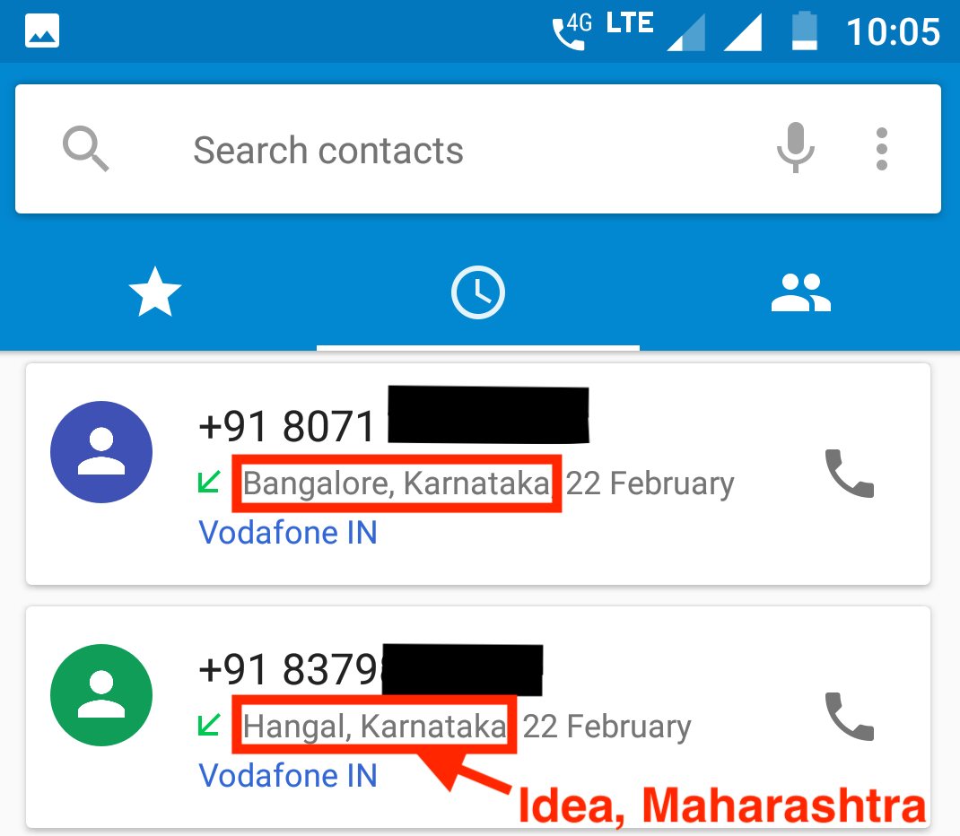

**R:** And where do we write a defect? Is there any tool or software where we write or submit a defect report?

**P:** Yes, we write it and submit in tools like Bugzilla, Jira, HP Quality Centre, Rally, Trac etc. These are called **Defect Management Tools** or **Issue Tracking Tools**. All these tools support some stages/phases of Defect like ***New***, ***Assigned***, ***In Progress***, ***Fixed***, ***Verified***, ***Closed****.* These phases or stages are also called***Defect Life Cycle****.* Google can give plenty of tutorials or notes on the topic*.*

**P:** This process is more famously known as ***raising a defect***. See the pictorial illustration below 😁.

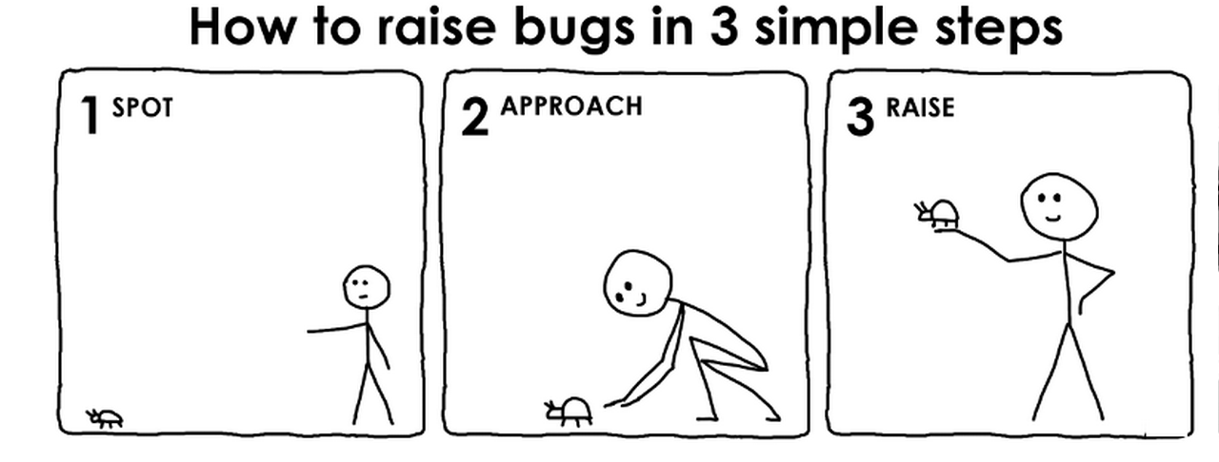

# MEET The Authors

**Riya Malushte**

[**https://www.linkedin.com/in/riyamalushte**](https://www.linkedin.com/in/riyamalushte)

**Pradyumna Roy**

[**https://www.linkedin.com/in/pradyroy**](https://www.linkedin.com/in/pradyroy)

**Useful TIPs in the next page…**

# TIPS

1. Writing and executing test cases on your partner, girlfriend or boyfriend is hazardous and raising any defect on them can be really dangerous 😈☠.

**Instead,**

1. Download a few apps from your app store on your mobile and write and execute test cases on them for practice and submit defects in Google Play or Apple App Store in the app details page as end user comments 😁.

**Test happily ever after…👍👍👍**